Supplementary information
Identification of small compounds regulating the secretion of extracellular vesicles via a TIM4-affinity ELISA
Yunfei Ma^{1,2}, *Takeshi Yoshida^{1,2}, Kazutaka Matoba³, Katsuhiko Kida³, Rito Shintani^{1,2}, Yingshi Piao⁴, Jingchun Jin⁵, Taito Nishino³, *Rikinari Hanayama^{1,2}

1. WPI Nano Life Science Institute (NanoLSI), Kanazawa University
2. Department of Immunology, Graduate School of Medical Sciences, Kanazawa University
3. Nissan Chemical Corporation
4. Key Laboratory of Science and Technology Department (Jilin Province), Cancer Research Center, Yanbian University Medical College
5. Department of Internal Medicine of Yanbian University Hospital

*Corresponding authors: Takeshi Yoshida and Rikinari Hanayama

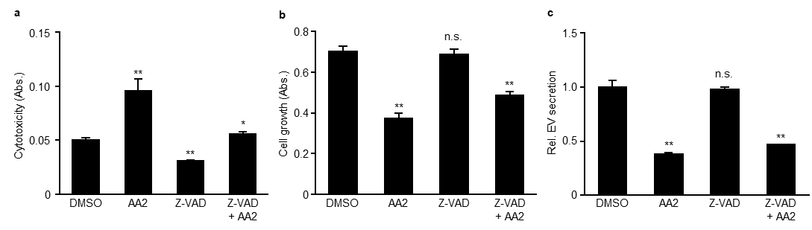

Supplementary Figure S1. AA2 inhibited EV secretion independent of caspase 3. (a–c) Jurkat cells were pre-treated with 0 or 50 μM Z-VAD(OMe)-FMK for 3 h, and then with 0 or 5 μM AA2 for 24 h. Cytotoxicity and cell growth were determined using lactate dehydrogenase (LDH) (a) and WST-8 (b) assays. (c) Secreted extracellular vesicles (EVs) were determined using a TIM4-CD81 ELISA. *; p < 0.05, vs. DMSO, Student's t-test.

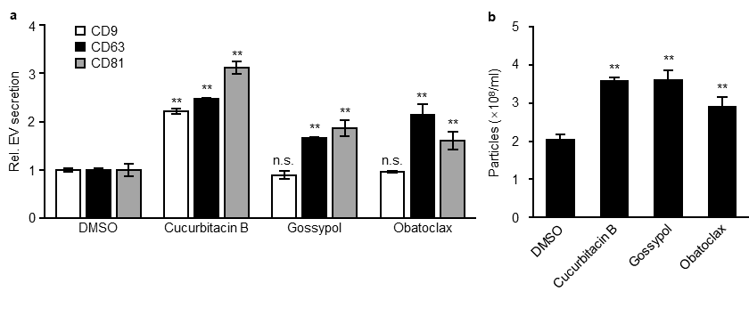Supplementary Figure S2. Cucurbitacin B, gossypol, and obatoclax induced EV secretion in HEK293 cells. (a, b) HEK293 cells were treated with 1 μM cucurbitacin B, 0.3 μM gossypol, or 0.03 μM obatoclax for 24 h and then secreted EVs were determined using TIM4-CD9 and TIM4-CD63 ELISAs (a) or NTA (b). *; p < 0.05, **; p < 0.01, vs. DMSO, Student's t-test.

