Supplementary Information
for
Southern Ocean surface pressure and winds during the 20th century from proxy-data assimilation

Gemma K. O’Connor^{1*}, Eric J. Steig^{1,2}, Gregory J. Hakim²

¹Department of Earth and Space Sciences, University of Washington, Seattle, WA, USA
²Department of Atmospheric Sciences, University of Washington, Seattle, WA, USA
*Corresponding author

Dataset | Resolution  (lats x lons) | Years available | Source
Prior datasets
iCESM Last Millennium Ensemble  “CESM” | 96 x 144 | 850-1849 | Brady et al., 2019
HadCM3 Last Millennium  “HadCM3” | 76 x 96 | 850-1850 | Collins et al., 2001
Pacemaker simulations  “PACE” | 192 x 288 | 1920-2013 | Deser et al., 2017
Datasets used for comparison
ERA5 | 721 x 1440 | 1979-2019 | Hersbach et al., 2020
NCEP-DOE AMIP-II  “NCEP2” | 73 x 144 | 1948-2019 | Kanamitsu et al., 2002
HadSLP2 | 37 x 72 | 1850-2004 | Allan and Ansell, 2006
iCESM Historical  “CESM Historical” | 96 x 144 | 1850-2005 | Brady et al., 2019
Nicolas and Bromwich | 84 x 97 | 1958-2012 | Nicolas and Bromwich, 2014
20CRv3 | 181 x 360 | 1836-2015 | Slivinski et al., 2019
ERA20C | 181 x 360 | 1900-2010 | Poli et al., 2016

Table S1. Gridded data products used in this study. Names as they are referred to in the text are given in quotes.

 | CESM  reconstruction,  all proxies | HadCM3  reconstruction,  all proxies | CESM reconstruction, no ice cores
Correlations
Abram SAM Index, 1900-2000 | 0.41, p = 0.000 | 0.44, p = 0.000 | 0.13, p = 0.290
Marshall SAM Index, 1957-2005 | 0.48, p = 0.001 | 0.35, p = 0.029 | 0.19, p = 0.247
ERA5 Circumpolar SH westerly strength, 1979-2005 | 0.71, p = 0.000 | 0.57, p = 0.003 | -
NCEP2 Circumpolar SH westerly strength, 1979-2005 | 0.62, p = 0.001 | 0.63, p = 0.001 | -
ERA5 Circumpolar SH westerly position, 1979-2005 | 0.73, p = 0.000 | 0.52, p = 0.013 | -
NCEP2 Circumpolar SH westerly position, 1979-2005 | 0.73, p = 0.000 | 0.64, p = 0.001 | -
ERA5 SLP in ASE, 1979-2005 | 0.74, p = 0.000 | 0.57, p = 0.005 | -
NCEP2 SLP in ASE, 1979-2005 | 0.73, p = 0.000 | 0.63, p = 0.001 | -
ERA5 U_{S} in ASE, 1979-2005 | 0.54, p = 0.005 | 0.49, p = 0.013 | -
NCEP2 U_{S} in ASE, 1979-2005 | 0.27, p = 0.182 | -0.04, p = 0.845 | -
Reconstructed trends
SAM, 1900-1978 (cent⁻¹) | 1.44 | 4.04 | -
SAM, 1979-2000 (cent⁻¹) | 4.38 | 12.03 | -
ASL, 1900-2005 (hPa/cent) | -1.63 | -1.81 | -
ASL, 1951-2004 (hPa/cent) | -0.71 | -1.17 | -
ASE SLP, 1900-2005 (hPa/cent) | -2.66 ± 1.30 | -2.75 ± 1.01 | -
ASE U_{S}, 1900-2005 (m/s/cent) | -0.84 ± 0.41 | -0.33 ± 0.29 | -

Table S2. Correlations between reconstructions and comparison datasets, and reconstructed trends. Correlations between the reconstructions and the Abram and SAM Indices from 1900-2005. Bolded correlations represent significance with greater than 95% confidence (Methods). Reconstructed trends are shown for the SAM index, the Amundsen Sea Low (ASL: (60°–75°S, 170°E–070°W)), and in the Amundsen Sea Embayment (ASE: 70°-72°S, 102-114°W). For ASL and ASE trends from 1900-2005, numbers are bolded to represent significance with greater than 95% confidence following the statistical methods described in Methods. Trend uncertainty reflects two standard deviations (Methods). Values and their significance are only given if referred to in the main text.

 | Trends |  |  |  |  |  | Differences
 | 1900-2005 |  | 1900-1978 |  | 1979-2005 |  | 1979-2005
 | CESM recon | HadCM3 recon | CESM recon | HadCM3 recon | CESM recon | HadCM3 recon | Recons | NCEP2-  ERA5
Position
Circum-polar | 0.09 ± .30 | -0.22 ± 0.26 | -0.33 ± 0.45 | -0.53± 0.42 | -0.01 ± 2.67 | -1.55 ± 2.39 | 1.54 | 2.92
Pacific | -0.26 ± 0.49 | -0.18 ± 0.44 | -0.83 ± 0.74 | -0.57 ± 0.61 | 1.73 ± 3.89 | -1.34 ± 2.99 | 3.07 | 5.51
Atlantic | 0.41 ± 0.37 | -0.38 ± 0.31 | 0.16 ± 0.55 | -0.38 ± 0.45 | -0.25 ± 2.32 | -1.77 ± 2.08 | 1.52 | 3.14
Indian | 0.38 ± 0.25 | -0.13 ± 0.25 | 0.14 ± 0.40 | -0.46 ± 0.41 | -0.59 ± 2.42 | -1.34 ± 2.09 | 0.75 | 0.18
Strength
Circum-polar | 0.09 ± 0.21 | 0.23 ± 0.18 | 0.18 ± 0.31 | 0.36 ± 0.25 | 0.34 ± 1.38 | 1.06 ± 1.24 | 0.72 | 1.97
Pacific | 0.64 ± 0.36 | 0.52 ± 0.26 | 1.00 ± 0.60 | 0.87 ± 0.33 | -0.06 ± 3.19 | 1.93 ± 2.03 | 1.99 | 1.76
Atlantic | -0.21 ± 0.24 | 0.01 ± .23 | -0.13 ± 0.42 | 0.18 ± 0.35 | -0.39 ± 1.82 | 0.40 ± 1.81 | 0.84 | 1.37
Indian | -0.08 ± 0.23 | 0.22 ± 0.14 | -0.20 ± 0.33 | 0.16 ± 0.21 | 0.51 ± 1.37 | 0.54 ± 1.06 | 0.68 | 0.86

Table S3. Circumpolar wind trends and differences between products. Left: trends and 2σ uncertainties (Methods) from two reconstructions, CESM recon and HadCM3 recon, generated with all proxies. Trends are broken down by region: the Pacific (150–290°E), Atlantic (290–20°E), and Indian (20–150°E) Ocean sectors. Trends are shown for the full 20th century (1900-2005), pre-satellite (1900-1978), and satellite (1979-2005) time periods. Trends are bolded if they meet the trend significance criteria (Methods). The two far right columns show the absolute value of the difference in mean trends from 1979-2005 for the reconstructions and two reanalyses, NCEP2 and ERA5.

Dataset | Wind strength corr | Wind strength bias (m/s) | Wind strength trend (m/s/cent) | Wind position corr | Wind position bias (°) | Wind position trend (°/cent)
CESM reconstruction | 0.71, 0.62 | 1.19, 0.22 | 0.09 | 0.73, 0.73 | -0.43, -0.21 | 0.09
HadCM3 reconstruction | 0.57 0.63 | -0.23, -1.19 | 0.23 | 0.52, 0.64 | 0.65, 0.86 | -0.22
20CRv3 | 0.93, 0.96 | 0.33, -0.64 | 0.96 | 0.95, 0.91 | -0.06, 0.15 | -0.41
ERA20C | 0.91, 0.89 | -0.56, -1.53 | 1.71 | 0.95, 0.95 | -0.64, -0.43 | -2.96
CESM historical model  (mean of 2 ensembles) | - | 1.60, 0.64 | - | - | -1.51, -1.30 | -
PACE model  (mean of 20 ensembles) | - | 1.46, 0.49 | - | - | -1.47, -1.25 | -
CESM LME model | - | 1.41, 0.45 | - | - | -0.79, -0.58 | -
HadCM3 model | - | -0.11, -1.08 | - | - | 0.37, 0.58 | -

Table S4. SH westerly wind latitude and strength trends, correlations, and biases. Trends are calculated from 1900-2005. Correlations (“corr”) are calculated from 1979-2005 between the reconstruction and ERA5 (first number in columns) and between the reconstruction and NCEP2 (second number in columns). The biases are relative to ERA5 (first number) and NCEP2 (second number) from 1979-2005, averaged over all longitudes (these reflect the averages of the lines in figure S7). Bold numbers denote significance with 95% confidence, following the statistical methods above. A positive position bias means the dataset is more equatorward than ERA5 and a positive strength bias means the dataset is stronger than ERA5. Values are only given for calculations that are referred to in the main text.

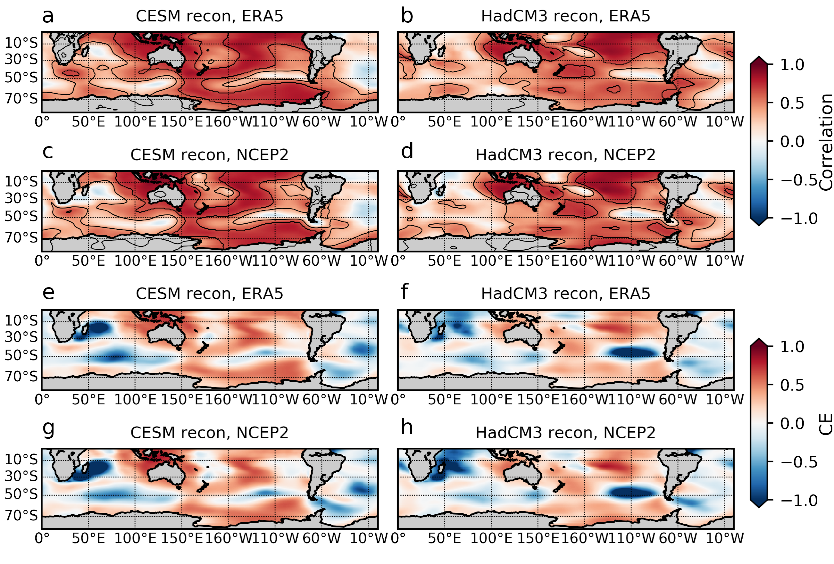

Figure S1. Panels a-d: Correlation (colors) and p-values significant with 95% confidence (contours) between sea level pressure in two reconstructions from 1979-2005 and ERA5 (left) and NCEP2 (right). Reconstructions are generated from all proxies and two different priors (CESM and HadCM3). Contour spacing is 0.05. Panels e-h: same as above, but for coefficient of efficiency (CE). Anomaly reference period is 1979-2005.

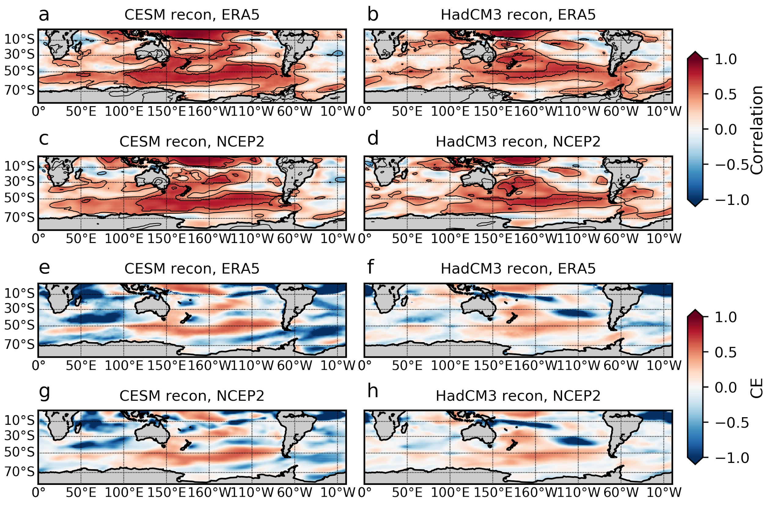
Figure S2. Same as in Figure S1, but for zonal surface winds.

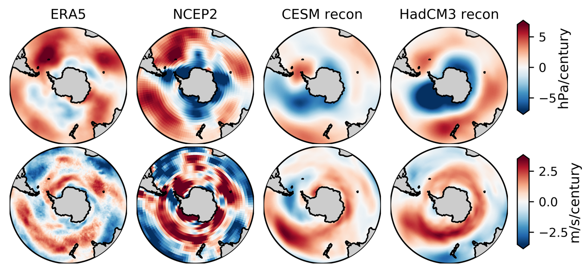

Figure S3. Trends in annual sea level pressure (top) and zonal surface winds (bottom) from 1979-2005 in ERA5, NCEP2, the CESM reconstruction, and the HadCM3 reconstruction. The reconstructions are generated by assimilating all available proxy data (primarily ice cores, corals, and tree rings). Latitude limits are 30°S to 90°S.

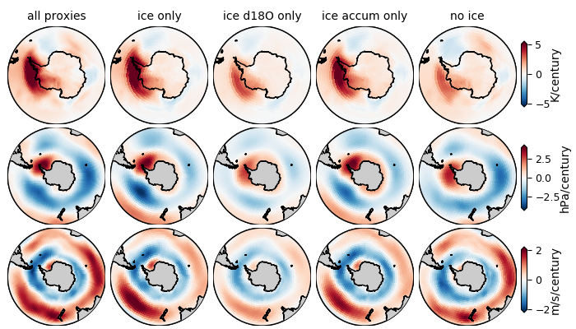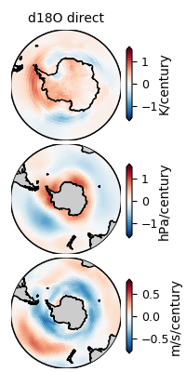

Figure S4. Trends from 1958-2005 in surface temperature (top row), sea level pressure (middle row), and zonal surface winds (bottom row) in reconstructions generated with the CESM prior and different combinations of proxies. The left five columns show reconstructions generated with calibration of proxy records to instrumental data and are all on the same scale. The far-right column shows a reconstruction with only ice core δ¹⁸O assimilated, generated with the iCESM last millennium ensemble δ¹⁸O prior (direct assimilation of ice core δ¹⁸O). It is on a different scale than the figures to the left. We use the time period 1958-2005, as it matches the period covered by Nicolas and Bromwich, 2014, which establishes the West Antarctic warming pattern.

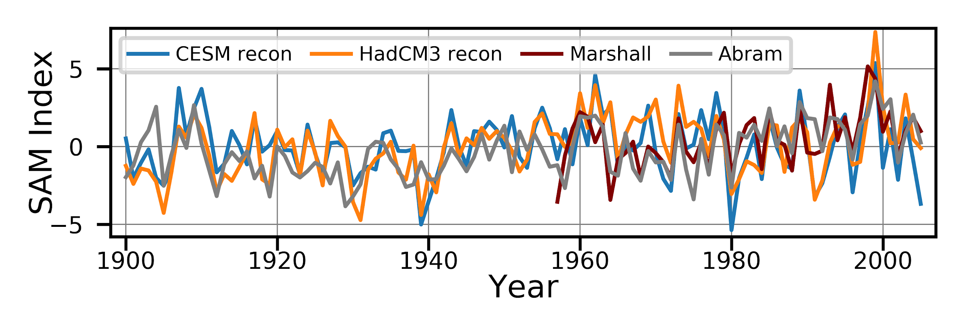
Figure S5. Reconstructed SAM Indices from the CESM reconstruction (blue), the HadCM3 reconstruction (orange), the reconstructed index by Abram et al., 2014 (gray) and the station-based index by Marshall et al., 2003 (dark red). Indices are relative to the time period 1961-1990.

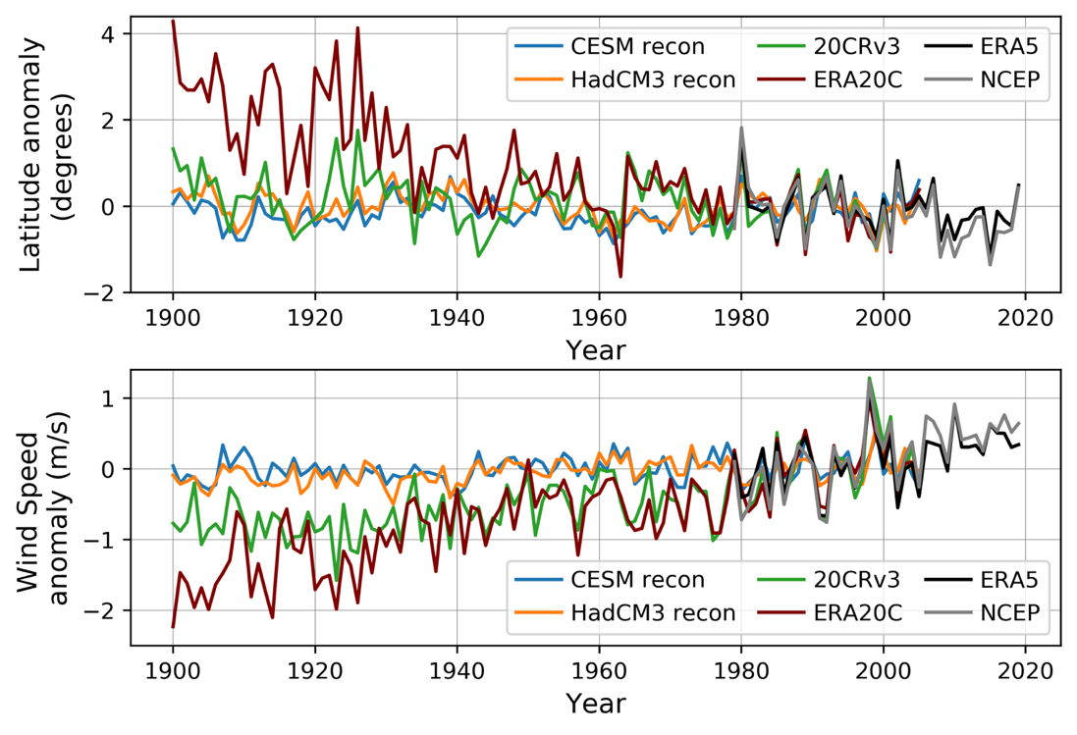
Figure S6. Anomalies of circumpolar SH surface westerly wind latitude (top) and speed (bottom) in the CESM reconstruction, HadCM3 reconstruction, 20CRv3, ERA20C, ERA5, and NCEP2. The mean from the anomaly reference period, 1979-2005, is removed last.

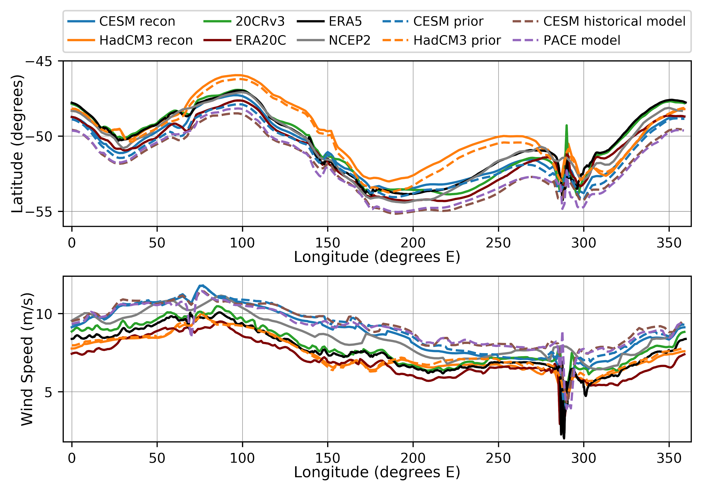
Figure S7. Circumpolar surface wind position (top) and strength (bottom) by longitude averaged over 1979-2005 in the CESM reconstruction ensemble mean, HadCM3 reconstruction ensemble mean, 20CRv3, ERA20C, ERA5, NCEP2, the CESM historical model (average of 2 ensembles) and the PACE model (average of 20 ensembles). The same is shown for the means of the CESM prior and HadCM3 prior.

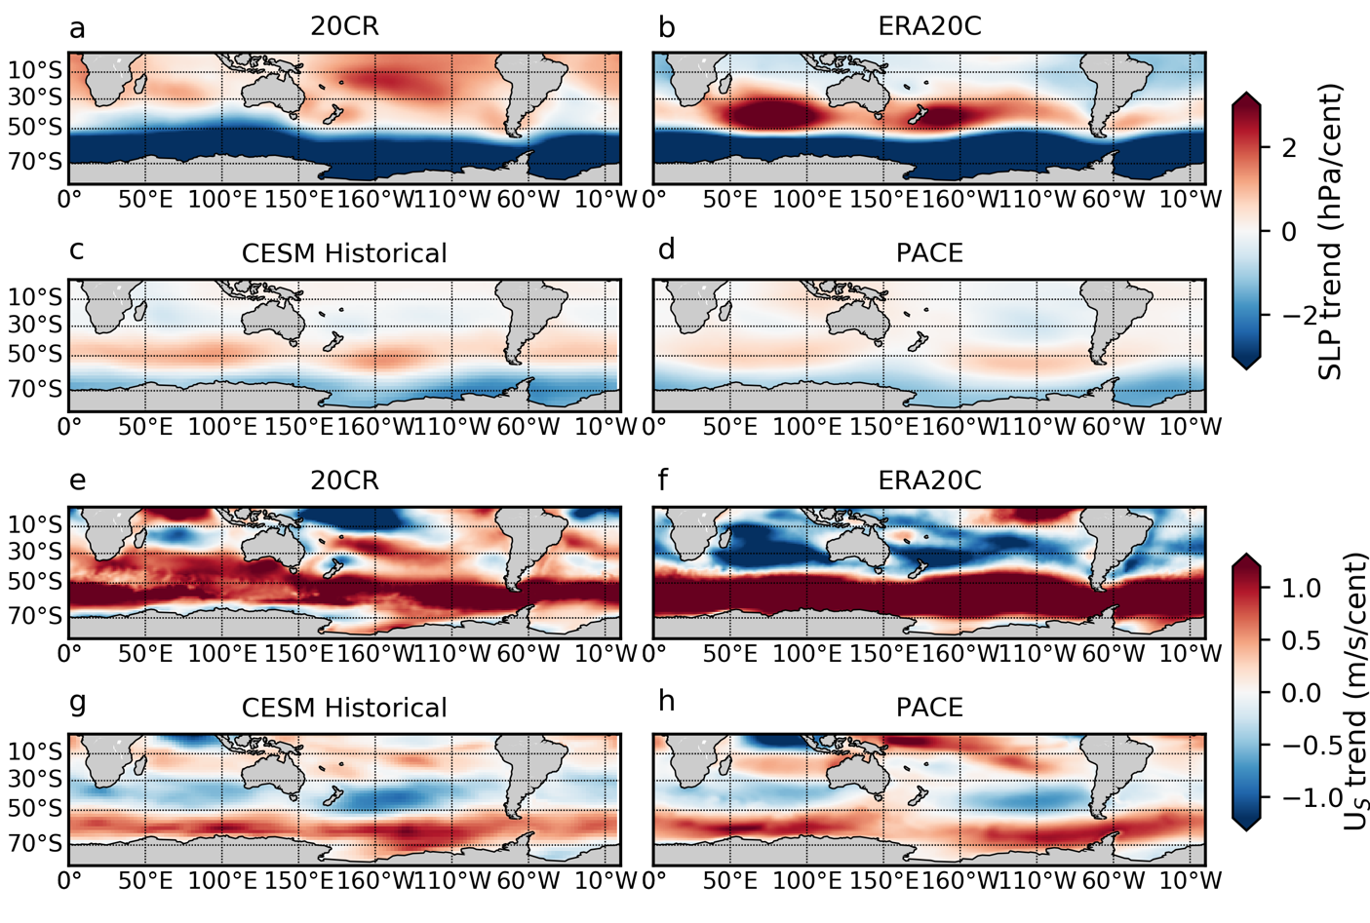
Figure S8. Sea level pressure (a-d) and zonal surface wind (e-h) trends from 1900-2005 in 20CRv3, ERA20C, and CESM historical (average of 2 ensemble members), and the same trends from 1920-2005 in PACE (average of 20 ensemble members).

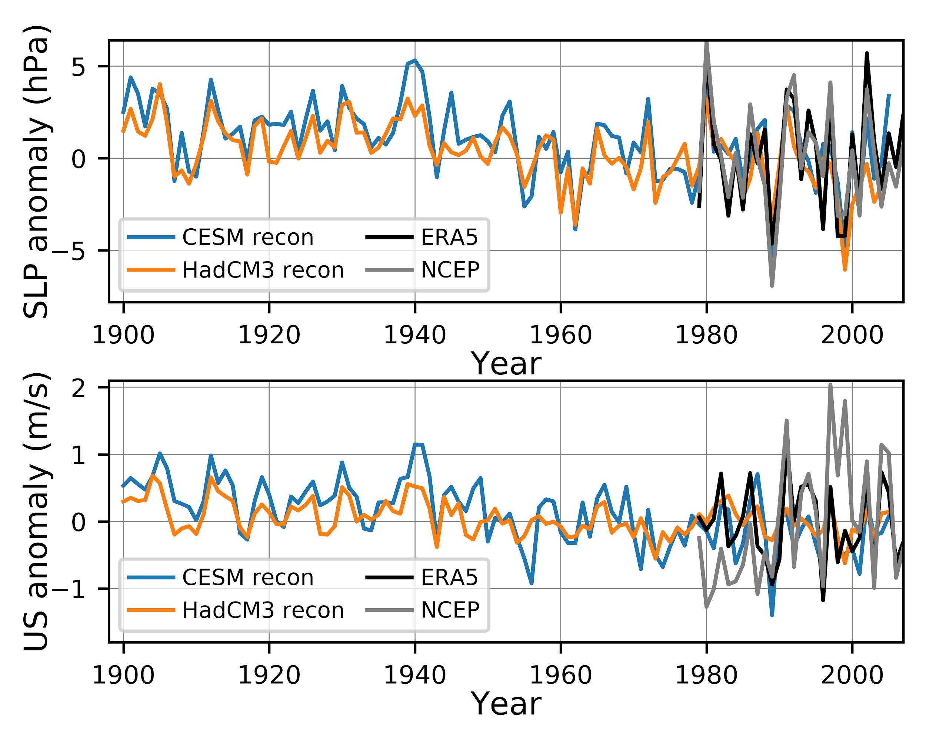
Figure S9. Same as in Figure 5, but with NCEP2.
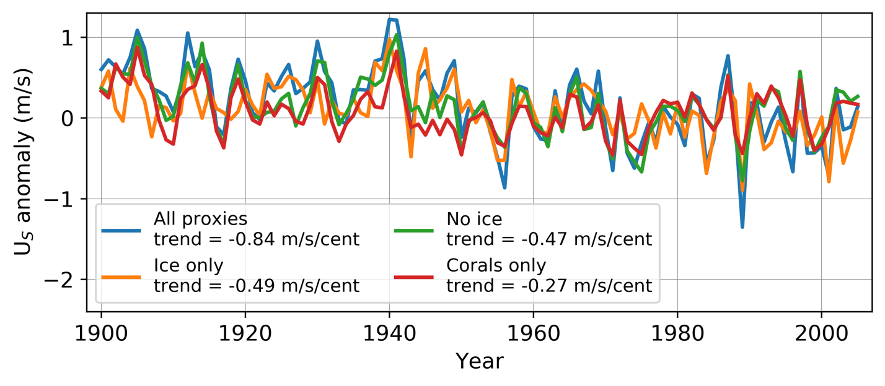
Figure S10. Reconstructed zonal surface wind (U_{S}) anomalies averaged over a region in the Amundsen Sea Embayment containing the continental shelf break (70-72°S, 102-115°W) using CESM as the prior and assimilating different subsets of proxy types. The main CESM reconstruction with assimilation of all proxies is shown in blue. Trends calculated from 1900-2005 are shown in the legend.

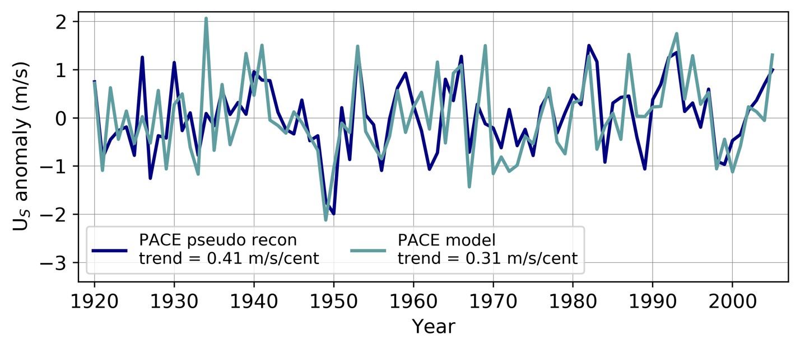
Figure S11. Zonal surface wind (U_{S}) anomalies in the same region as in Figure S10, generated using pseudoproxies drawn from PACE ensemble member 1. U_{S} anomalies from the same ensemble member in PACE are also shown. Trends calculated from 1920-2005 are shown in the legend.

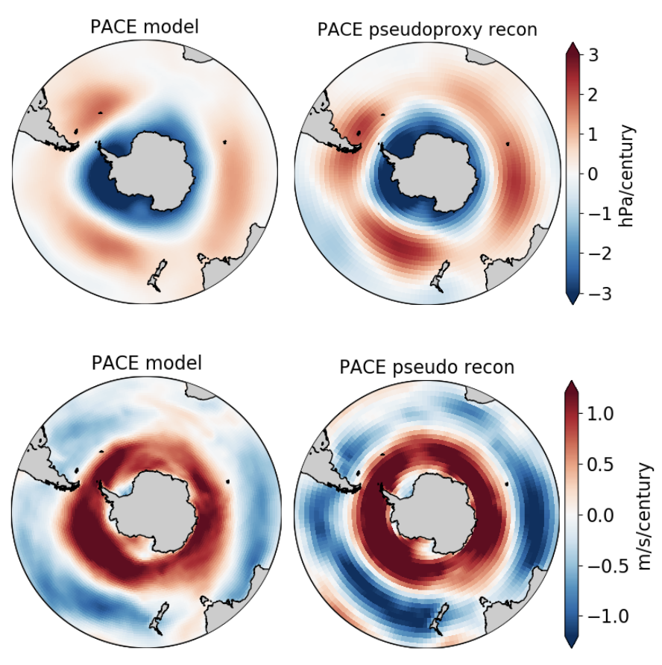

Figure S12. PACE model trends (ensemble member 1) from 1920-2005 for sea level pressure (top left) and zonal surface winds (bottom left). Reconstructed PACE pseudoproxy trends from 1920-2005 for sea level pressure (top right) and zonal surface winds (bottom right). Pseudoproxies are drawn from ensemble member 1, and the prior ensemble is drawn from concatenated ensemble members 2-20.

