Supplementary Information to: Integrating sociotechnical factors to assess efficacy of PV recycling and reuse interventions
Authors: Julien Walzberg^{1*}, Alberta Carpenter¹, Garvin Heath¹
¹ National Renewable Energy Laboratory 15013 Denver West Parkway Golden, CO 80401, United States of America
* Corresponding author: julien.walzberg@nrel.gov

This Supplementary Information presents some methodological elements and supplementary results that support the main manuscript. Model and result analysis files are available at:
https://github.com/NREL/ABSiCE

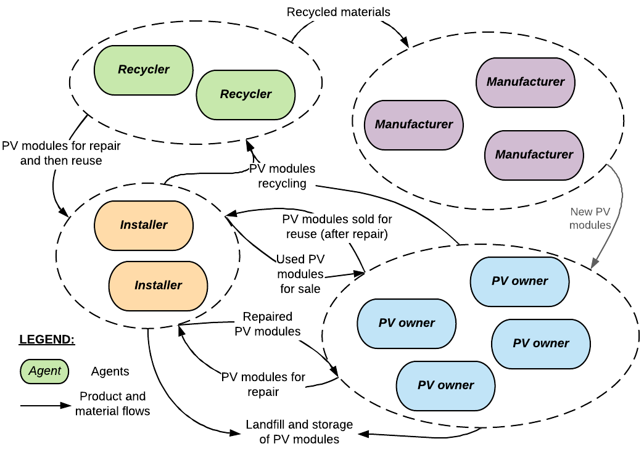
Supplementary Figure 1: Model overview. Photovoltaics (PV) owners maintain, install, or decommission PV module capacity (MW) using used or new modules. Decommissioning creates end-of-life (EOL) modules, for which owners decide among five end-of-life pathways: repair (by installers), sell for reuse, recycle, landfill, or temporarily store. Recyclers sort EOL PV modules into modules that can be repaired (by installers), modules that are recycled, and improve their recycling processes over time. Manufacturers purchase recycled materials and other manufacturers’ by-products/waste if there are established pathways to do so. Installers improve their repairing processes and handle the collection and sales of used modules as well as the disposal of modules that cannot be sold (e.g., because too damaged). (The grey arrow linking manufacturer and PV owner represents a link that is not implemented in the model but is added to represent better the relationships between PV actors in the real world).

Supplementary Table 1: The ABM submodels with their equations, parameters, and sources. Arrangements of submodels to form the agents’ behavioral rules are shown in Supplementary Figures 14, 15, 16, and 17.
Submodel name [and Figures code] | Formal definition | Parameter values (source)
Agents [E0] | $$I: set of PV owner agents and i∈I an agent of I$$  $$J:set of installer agents j∈J an agent of J$$  $$K: set of recycler agents k∈K an agent of K$$  $$L: set of manufacturer agents l∈L an agent of L$$ | $card(I)=1000$ (simplifying assumption)  $card(J)=15$¹  $card(K)=16$²  $card(L)=60$ (simplifying assumption)
Initial end-of-life pathway and purchase choice adoption rate [E1] | $$P=\{repairing, reusing, recycling,landfilling,storing\}$$  Is a set of possible end-of-life pathways and $Path_{ip}^{t}$ is 1 if PV owner $i$ has selected the path $p∈P$ at $t$ and 0 otherwise.  $$PC=\{used, new\}$$  Is a set of possible purchase choice and $Purchase_{ipc}^{t}$ is 1 if agent $i$ has selected the purchase choice $pc∈PC$ at $t$ and 0 otherwise. | $\sum_{i}{Path_{ip=repairing}^{t=0}=0.5\%×card(I)}$³  $\sum_{i}{Path_{ip=reusig}^{t=0}=1\%×card(I)}$^{3,4}  $\sum_{i}{Path_{ip=recycling}^{t=0}=10\%×card(I)}$⁵⁻⁷  $\sum_{i}{Path_{ip=landfilling}^{t=0}=44.25\%×card(I)}$ (assumed to be equal to storing)  $\sum_{i}{Path_{ip=storing}^{t=0}=44.25\%×card(I)}$ (assumed to be equal to landfilling)  $\sum_{i}{Path_{ipc=used}^{t=0}=0.05\%×card(I)}$^{3,4}  $\sum_{i}{Path_{ipc=new}^{t=0}=99.95\%×card(I)}$^{3,4}
PV owners social network [E2] | $$\begin{aligned}G=\left(V,E\right) | σ>1\#\left(1\right)\end{aligned}$$  With V set of vertices E a set of edges. E may be defined as per equation 2.  $$\begin{aligned}E_{ij}=\left\{\begin{aligned}&1 if agent i is connected to agent j \\ &0 otherwise\end{aligned}\right.\#\left(2\right)\end{aligned}$$  And:  $$\begin{aligned}σ=\frac{C/{C_{rand}}}{L/{L_{rand}}} \#\left(3\right)\end{aligned}$$  $C$ is the clustering coefficient (i.e., the proportion of edges between neighbors of a node relative to the total number of possible edges between those neighbors), $L$ is the average path length (i.e., the mean of the shortest between two nodes in the network), $C_{rand}$ and $L_{rand}$ are the clustering coefficient and average path length of the equivalent random network (see Supplementary Figure 18). | Rewiring probability, $p=0.1$⁸⁻¹⁰  Average number of neighbors, $\overline{N}=10$⁸⁻¹⁰
Transportation costs [E3] | $$\begin{aligned}TC_{ip}^{t}={ELPV}_{ip}^{t}× MP_{t}×1E+03×d_{p}×tc \#\left(4\right)\end{aligned}$$  $TC_{ip}^{t}$ and ${ELPV}_{ip}^{t}$ are the transportation cost and amount of PV modules for agent $i$ and EOL pathway $p$ at time $t$, respectively, $MP_{t}$ the PV module’s material efficiency (weight per unit of power output) at time $t$, $d_{p}$ is the distance from the agent to the EOL site (nearest installer, PV owner, landfill, or recycler), and $tc$ is the transportation cost per unit of mass and distance. $TC_{ip}^{t}$ is added to the pathways’ costs and, thus, influence PV owners’ and installers’ decisions. The nearest installer, PV owner, landfill, or recycler is determined by approximating the contiguous US as a graph (see Supplementary Figure 19) and Dijkstra’s algorithm. | $d_{p=repairing}=198 km$ (assumed one installer per contiguous state and the average distance between the center and borders of all states)  $d_{p=reusing}∈\{198⋯4000\} km$ (assumed that origin and target can be anywhere in the contiguous US)  $d_{p=recycling}∈\{198⋯1356\} km$ (16 recyclers in 8 states: Texas, Arizona, Oregon, Oklahoma, Wisconsin, Ohio, Kentucky, South Carolina²)  $d_{p=landfilling}=198 km$ (assumed one landfill per contiguous state and the average distance between the center and borders of all states)  $d_{p=storing}=0 km$ (assumed to occur in close vicinities)  $tc=0.0314$ $/t.km¹¹
Growth of cumulative PV capacity [S0] | $$\begin{aligned}{PA}_{i}^{t}=\left\{\begin{aligned}&{PA}_{i}^{t=0}×{\left(1+μ\right)}^{t} if t<γ \\ &PA_{i}^{t=γ}×{\left(1+τ\right)}^{t} if γ≤t\end{aligned}\right.\#\left(5\right)\end{aligned}$$  ${PA}_{i}^{t}$ is the cumulative amount of PV capacity installed by agent $i$ at time step $t$, $μ,$ and $τ$ are the growth rate of periods $t<γ$ and $γ≤t<δ$ respectively (see Supplementary Figure 14). | $\sum_{i}{{PA}_{i}^{t=0}}=40921$ MWp⁴ (cumulative installed capacity of crystalline Silicon PV in 2020)  $μ=0.166$⁴  $τ=0.045$⁴  $γ=10$ years⁴
Efficiency growth of PV modules [S1] | $$\begin{aligned}MP_{t}={be}^{-at} \#\left(6\right)\end{aligned}$$  $b$ and $a$ the intercept and regression coefficient (see Supplementary Figure 14). | $b=0.1$ kg/Wp^{4,12}  $a=0.03$ year¹ ⁴
Purchase choice decision (theory of planned behavior) [S2] | $$\begin{aligned}\begin{aligned}BI_{ipc}^{t}=w_{A}A_{ipc}^{t}+w_{SN}SN_{ipc}^{t}+w_{PBC}PBC_{ipc}^{t}\end{aligned}\#\left(7\right)\end{aligned}$$  $BI_{ipc}^{t}$ behavioral intention, $A_{ipc}^{t}$ attitude level, ${SN}_{ipc}^{t}$ the subjective norm, and $PBC_{ipc}^{t}$ the perceived behavioral control of agent $i$ for purchase choice $pc$ at $t$. $A_{ipc}^{t}$ of agent $i$ regarding the purchase choice is normally distributed between 0 (negative attitude) and 1 (positive attitude) (with $μ$ and $σ$ the mean and standard deviation of the distribution, respectively) for the choice of purchasing a used PV module. The attitude level for the choice of purchasing a new module is assumed to be one minus the attitude held toward a used PV module. Attitude levels are unknown and, thus, used for calibration.  $$\begin{aligned}{SN}_{ipc}^{t}=\sum_{n}{\frac{Path_{npc}^{t}}{N_{i}}}\#\left(8\right)\end{aligned}$$  With $Path_{np}^{t}$ being 1 if agent’s $i$ neighbor $n$ has selected the path $p$ and 0 otherwise and $N_{i}$ the total number of neighbors of agent $i$.  $$\begin{aligned}PBC_{ipc}^{t}=-max{(0;\frac{Cost_{ipc}^{t}}{|\max\left\{Cost_{ipc}^{t}∀ pc\right\}|}})\#\left(9\right)\end{aligned}$$  Where $Cost_{ipc}^{t}$ is the cost of choosing the purchase choice $pc$ at $t$ for agent $i$, following the approach described in Supplementary Figure 20 ($RP_{j}^{t}$, the price at which installer $j$ is selling the used modules on the second-hand market and $mr_{j}$ its margin). As purchase choice are Booleans, the purchase choice made by agent $i$ at time $t$ is assigned the value 1 (True) while the other purchase choice is assigned the value 0 (False) (see Supplementary Figure 14):  $$\begin{aligned}Path_{ipc}^{t}=\left\{\begin{aligned}&1 if pc∈PC | BI_{ipc}^{t}=\max\left\{BI_{ic}^{t}∀ c∈PC\right\} \\ &0 otherwise\end{aligned}\right. \#\left(10\right)\end{aligned}$$ | $w_{A}=0.46$¹³  $w_{SN}=0.5$¹³  $w_{PBC}=0.38$¹³  $Cost_{pc=used}^{t}=RP_{j}^{t}×(1-mr_{j})$, see Supplementary Figure 20  $Cost_{pc=new}^{t}$: see Supplementary Figure 20  $μ=0.223$ (calibrated)  $σ=0.262$ (calibrated)  $mr_{j}∈[0.4, 0.6]$¹⁴
Generation of EOL PV modules (Weibull function) [S3] | $$\begin{aligned}{ELPV}_{i}^{t}=\sum_{t}{RPA_{i}^{t}×\left(1-e^{-({t/T)}^{α}}\right)}\#\left(11\right)\end{aligned}$$  In the equations, ${ELPV}_{i}^{t}$ is the amount of PV modules of agent $i$ reaching their end-of-life at $t$, $T$ is the average lifetime of PV modules, and $α$ is the shape factor, drawn from a symmetric triangular distribution. ${RPA}_{i}^{t}$ is the remaining amount of PV modules installed by agent $i$ at time step $t$ (i.e., ${PA}_{i}^{t}-{PA}_{i}^{t-1}$ subtracted of the amount of PV modules that reached their EOL in previous time steps). For used PV modules, early failure and a shorter lifetime and/or lower efficiency (yielding a shorter lifetime of equivalent power output) (drawn from a symmetric triangular distribution) are considered, modeling imperfect substitution. (See Supplementary Figure 14). | New modules:  $T=30$ years⁴  $α∈[2.49, 5.378]$⁴  Used modules:  $T∈\left[18, 30\right]$ years^{15,16}  $α=2.49$⁴
Storage of EOL PV module [S4] | $$\begin{aligned}Path_{ip=storing}^{t+1}=0 if ms_{i}<st^{t} \#\left(13\right)\end{aligned}$$  With $ms_{i}$ the maximum storage time for agent $i$, drawn from a symmetric triangular distribution and $st^{t}$ the storage time at time $t$ of EOL PV modules (see Supplementary Figure 14). | $ms_{i}∈\{1,⋯,8\}$¹⁷
End of life decision (theory of planned behavior) [S5] | $$\begin{aligned}\begin{aligned}BI_{ip}^{t}=w_{A}A_{ip}^{t}+w_{SN}SN_{ip}^{t}+w_{PBC}PBC_{ip}^{t}\end{aligned}\#\left(14\right)\end{aligned}$$  $BI_{ip}^{t}$ behavioral intention, $A_{ip}^{t}$ attitude level, ${SN}_{ip}^{t}$ the subjective norm, and $PBC_{ip}^{t}$ the perceived behavioral control of agent $i$ for pathway $p$ at $t$. $A_{ip}^{t}$ of agent $i$ regarding circular economy (CE) pathways are normally distributed between 0 (negative attitude) and 1 (positive attitude) (with $μ$ and $σ$ the mean and standard deviation of the distribution respectively) for the circular pathways (repairing, reusing, and recycling). The attitude levels toward linear pathways (landfilling, storing) are assumed to be one minus the attitude toward circular pathways. Attitude levels are unknown and, thus, used for calibration.  $$\begin{aligned}{SN}_{ip}^{t}=\sum_{n}{\frac{Path_{np}^{t}}{N_{i}}}\#\left(15\right)\end{aligned}$$  With $Path_{np}^{t}$ being 1 if agent’s $i$ neighbor $n$ has selected the path $p$ and 0 otherwise and $N_{i}$ the total number of neighbors of agent $i$.  $$\begin{aligned}PBC_{ip}^{t}=-max{(0;\frac{Cost_{ip}^{t}}{|\max\left\{Cost_{ip}^{t}∀ p\right\}|}})\#\left(16\right)\end{aligned}$$  Where $Cost_{ip}^{t}$ is the cost of choosing the pathway $p$ at $t$ for agent $i$, drawn from a symmetric triangular distribution except for the reusing pathway where prices of used modules ($RP_{j}^{t}$, the price at which installer $j$ is selling the used modules on the second-hand market and $mr_{j}$ its margin) are normally distributed and landfill pathway where the cost is drawn randomly from existing landfill costs. As paths are Booleans, the path chosen by agent $i$ at time $t$ is assigned the value 1 (True) while the other pathways are assigned the value 0 (False) (see Supplementary Figure 14):  $$\begin{aligned}Path_{ip}^{t}=\left\{\begin{aligned}&1 if p∈P | BI_{ip}^{t}=\max\left\{BI_{ic}^{t}∀ c∈P\right\} \\ &0 otherwise\end{aligned}\right. \#\left(17\right)\end{aligned}$$ | $w_{A}=0.39$¹⁸  $w_{SN}=0.27$¹⁸  $w_{PBC}=0.33$¹⁸  $Cost_{p=repairing}^{t}∈[23, 106]$ $/module¹⁹  $Cost_{p=reusing}^{t}$= -$RP_{j}^{t}×(1-mr_{j})$, see Supplementary Figure 20 (negative as it is a source of revenue)  $Cost_{p=recycling}^{t}∈[25, 30]$ $/module²⁰  $Cost_{p=landfill}^{t}$: see Supplementary Table 8  $Cost_{p=storing}^{t}∈[0, 2]$ $/module (assumption on cost spanning between being free and the cost to lease storage space²¹)  $μ=0.544$ (calibrated)  $σ=0.1$ (calibrated)  $mr_{j}∈[0.4, 0.6]$¹⁴
Volume of PV modules being reused (secondary market model) [S6] | $$\begin{aligned}V_{j}^{t}=\frac{RR×\left(\sum_{i}{V_{i}^{t}}+\sum_{k}{V_{k}^{t}}\right)}{\sum{j}} for i and k such that RC_{i}^{t}≤RP_{j}^{t} \\ and RC_{k}^{t}≤RP_{j}^{t}\#\left(18\right)\end{aligned}$$  $$\begin{aligned}RA_{j}^{t}=\left\{\begin{aligned}&V_{j}^{t} if \sum_{j}{V_{j}^{t}} ≤\sum_{i}{DU_{i}^{t}} for i such as PU_{i}^{t}=1 \\ &0 otherwise\end{aligned}\right.\#\left(19\right)\end{aligned}$$  $V_{j}^{t}$ is the volume of modules available for sales on the secondary market from installer $j$ at time $t$, $RR$ is the modules repair rate, $V_{i}^{t}$ and $V_{k}^{t}$ are the volume of modules flowing from the PV owner $i$ and recycler $k$ at time $t$ respectively, $RC_{i}^{t}$, $RC_{k}^{t}$ are the repair costs of modules from PV owner $i$ and recycler $k$ at time $t$ respectively, $RP_{j}^{t}$ is the price at which agent $j$ is selling the used modules on the second-hand market at $t$, $RA_{j}^{t}$ is the volume of used modules handled by installer $j$ that is being reused at time $t$ which depends on the demand for used modules from PV owners ($\sum_{i}{DU_{i}^{t}}$), $PU_{i}^{t}$ is a boolean being 1 when the PV owner $i$ purchases a used module at $t$. The modules that are not sold are disposed of according to the theory of planned behavior with $w_{A}=w_{SN}=0$ (purely economic decision) (see Supplementary Figures 15 and 16). | $RR=0.55$¹⁹  $RP_{j}^{t}:$ see Supplementary Figure 20  $RC_{i}^{t}∈[23, 106]$ $/module¹⁹  $RC_{k}^{t}∈[23, 106]$ $/module¹⁹
Learning effect of installers and recyclers [S7] | $$\begin{aligned}C_{a}^{t}=C_{a}^{0}×{\left(\frac{RA_{a}^{t}}{RA_{a}^{0}}\right)}^{β}with a∈J∪K\#\left(20\right)\end{aligned}$$  $C_{a}^{t}$ is the repairing cost of installer or recycler $a$ at time $t$, $C_{a}^{0}$ is the initial repairing cost of agent $a$ (at the beginning of the simulation), $RA_{a}^{0}$ is the amount of used or recycled modules handled by agent $a$ at the beginning of the simulation (in kg), $RA_{a}^{t}$ is the amount of used or recycled modules handled by agent $a$ at $t$ (in kg), and $β$ is the scale factor (see Supplementary Figures 15 and 16). | $β=-0.31$ for installers²²  $β=-0.39$ for recyclers²³  $C_{a}^{0}=[25, 30]$ $/module²⁰
Material recovery from recyclers (total mass) [S8] | $$\begin{aligned}VM^{t}=\sum_{k}{\sum_{m}{RA_{k}^{t} ×MF_{m}×RCR_{mr}}} \#\left(21\right)\end{aligned}$$  $VM^{t}$ is the total mass of recovered materials from recyclers (in kg), $MF_{m}$ is the mass fraction of material $m$ in PV modules, $RCR_{mr}$ is the recovery fraction of material $m$ with the recycling process $r$ (see Supplementary Figure 16). | $MF_{m=Aluminum}=0.08; MF_{m=Glass}=0.76;MF_{m=Copper}=0.01;MF_{m=Cables}=0.012;MF_{m=Silicon}=0.036;MF_{m=Silver}=0.00032$⁴  $r=Baseline \left(simple mechanical separation\right): RCR_{m=Aluminum}=0.92; RCR_{m=Glass}=0.85; RCR_{m=Copper}=0.72; RCR_{m=Cables}=1;RCR_{m=Silicon}=0; RCR_{m=Silver}=0$^{5,24}  $r=High recovery process: RCR_{m=Aluminum}=0.99; RCR_{m=Glass}=0.98; RCR_{m=Copper}=0.97; RCR_{m=Cables}=1;RCR_{m=Silicon}=0.97; RCR_{m=Silver}=0.94$²⁵
Manufacturing waste generation [S9] | $$\begin{aligned}{IW}_{m}^{t}=\sum_{i}{PA_{i}^{t}}×1E+06× MP_{t}×MF_{m}×IWR_{m} \#\left(22\right)\end{aligned}$$  ${IW}_{m}^{t}$ is the amount of manufacturing waste of material $m$ generated by PV manufacturers at time $t$ (in kg) and $IWR_{m}$ is the rate of manufacturing waste for material $m$ (see Supplementary Figure 17). | $IWR_{m=Aluminum}=0; IWR_{m=Glass}=0; IWR_{m=Copper}=0; IWR_{m=Cables}=0;RCR_{m=Silicon}=0.4; RCR_{m=Silver}=0$^{5,24}
Installers’ net income [S10] | $$\begin{aligned}INI_{j}^{t}=RA_{j}^{t}×\left(RP_{j}^{t}-ARC^{t}\right) \#\left(23\right)\end{aligned}$$  $INI_{j}^{t}$ is the installer’s $j$ net income at time $t,$ $ARC^{t}$ is defined as the weighted average repair costs:  $$\begin{aligned}ARC^{t}=\frac{\sum_{i}{V_{i}^{t}×RC_{i}^{t}}+\sum_{k}{V_{k}^{t}×RC_{k}^{t}}}{\sum_{i}{V_{i}^{t}}+\sum_{k}{V_{k}^{t}}} \#\left(24\right)\end{aligned}$$
Recyclers’ net income [S11] | $$\begin{aligned}RNI_{k}^{t}=RA_{k}^{t}×\left(\left(\sum_{m}{SMV_{m} ×MF_{m}×RCR_{mr}}\right)-C_{k}^{t}\right)\#\left(25\right)\end{aligned}$$  $RNI_{k}^{t}$ is the recycler’s $k$ net income at time $t,$ $SMV_{m}$, is the price of secondary material $m$, and is drawn from a symmetric triangular distribution. | $SMV_{m=Aluminum}∈[0.66, 1.98]; SMV_{m=Glass}∈[0.01, 0.06];SMV_{m=Copper}∈[3.77, 6.75];SMV_{m=Cables}∈[3.22, 3.44];SMV_{m=Silicon}∈[2.2, 3.18];SMV_{m=Silver}∈[453, 653]$ $/kg²⁶⁻²⁹
Manufacturers’ net income [S12] | $$\begin{aligned}MNI_{l}^{t}=RA_{k}^{t}×\left(\left(\sum_{m}{\left(PMV_{m}-SMV_{m}\right)×MF_{m}×RCR_{mr}}\right)\right)\#\left(26\right)\end{aligned}$$  $MNI_{l}^{t}$ is the manufacturer’s $l$ net income at time $t,$ $PMV_{m}$, is the price of virgin material $m$, and is drawn from a symmetric triangular distribution. | $SMV_{m=Aluminum}∈[1.76, 2.51]; SMV_{m=Glass}∈[0.04, 0.07];SMV_{m=Copper}∈[4.19, 7.50];SMV_{m=Cables}∈[3.22, 3.44];SMV_{m=Silicon}∈[2.2, 3.18];SMV_{m=Silver}∈[453, 653]$ $/kg^{26-28,30,31}
ABM scheduler | In the ABM approach, a system is described by a set of functions involving $n$ state variables (of which, one or several state variables may define an agent) such as³²:  $$\begin{aligned}f=\left(f_{1},⋯, f_{s}\right):X→X \#\left(27\right)\end{aligned}$$  Where $X$ ( $X=X_{1}×⋯×X_{s}$) denotes all the possible states for all the state variables $x_{h}, h=1,⋯, s$, and for all $h$, $f_{h}$ is a function (for agents, called behavioral rule) that updates the state variable $x_{h}$ such as $f_{h}:X→X_{h}$. Dynamics are generated by iterations of $f$. In our ABM, iterations of $f$ are generated with the scheduler from the python library Mesa³³ according to the algorithm below:  Input: $x_{h}^{t=0}$, $h=1,⋯, s$  Output: $x_{h}^{t=steps}$, $h=1,⋯, s$  1: for r=0 to E do  2: select concerned agent type T  3: for a=0 to card(T) do  4: Er  5: for t=0 to steps do  6: for q=0 to S do  7: select concerned agent type T  8: for a=0 to card(T) do  9: Sq  10: return $x_{h}^{t=steps}$, $h=1,⋯, s$  Where Er or Sq is one of the submodels above (e.g., for q=5, S5 is the End of life decision (theory of planned behavior) submodel) | steps =30  E=4  S=13  T $∈\{I,J,K,L\}$

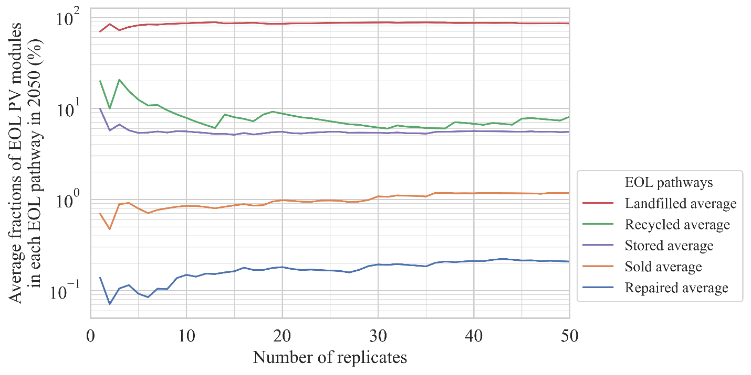
Supplementary Figure 2: Average fractions of EOL PV modules in each EOL pathway in 2050 as a function of the number of replicates. After 25 simulations, the average fractions do not vary with the number of replicates; thus, 30 replicates are deemed sufficient to account for the model’s stochasticity.

Supplementary Table 2: Shares of PV modules in the ABM five EOL pathways in 2050, according to the scenarios of Figure 1 in the manuscript. *Although landfill is not a pathway available for PV owners, manufacturing waste from manufacturers is still assumed to be landfilled.
Scenario | % Repair | % Reuse | % Recycle | % Landfill | % Storage
a) Landfill ban | 0.2 | 2.6 | 91.4 | 1.6* | 4.2
b) High material recovery (96%) & $18/module | 0.0 | 1.7 | 52.2 | 41.9 | 4.2
c) Lower recycling costs ($18/module) | 0.0 | 1.7 | 44.2 | 49.8 | 4.3
d) Higher landfill costs ($2.75/module) | 0.9 | 1.8 | 40.5 | 48.3 | 8.5
e) Improved lifetime (from 30 to 60 years in 2050) | 0.1 | 1.8 | 0.7 | 91.9 | 5.5
f) Improved learning effect (learning parameter = 0.6) | 0.2 | 1.4 | 19.1 | 74.0 | 5.3
g) Reuse warranties (equal new/used attitude) | 0.0 | 22.6 | 0.0 | 77.2 | 0.2
h) Seeding reuse (5% of population) | 0.9 | 6.9 | 4.7 | 78.0 | 9.5
i) Baseline | 0.2 | 1.2 | 7.7 | 85.1 | 5.8

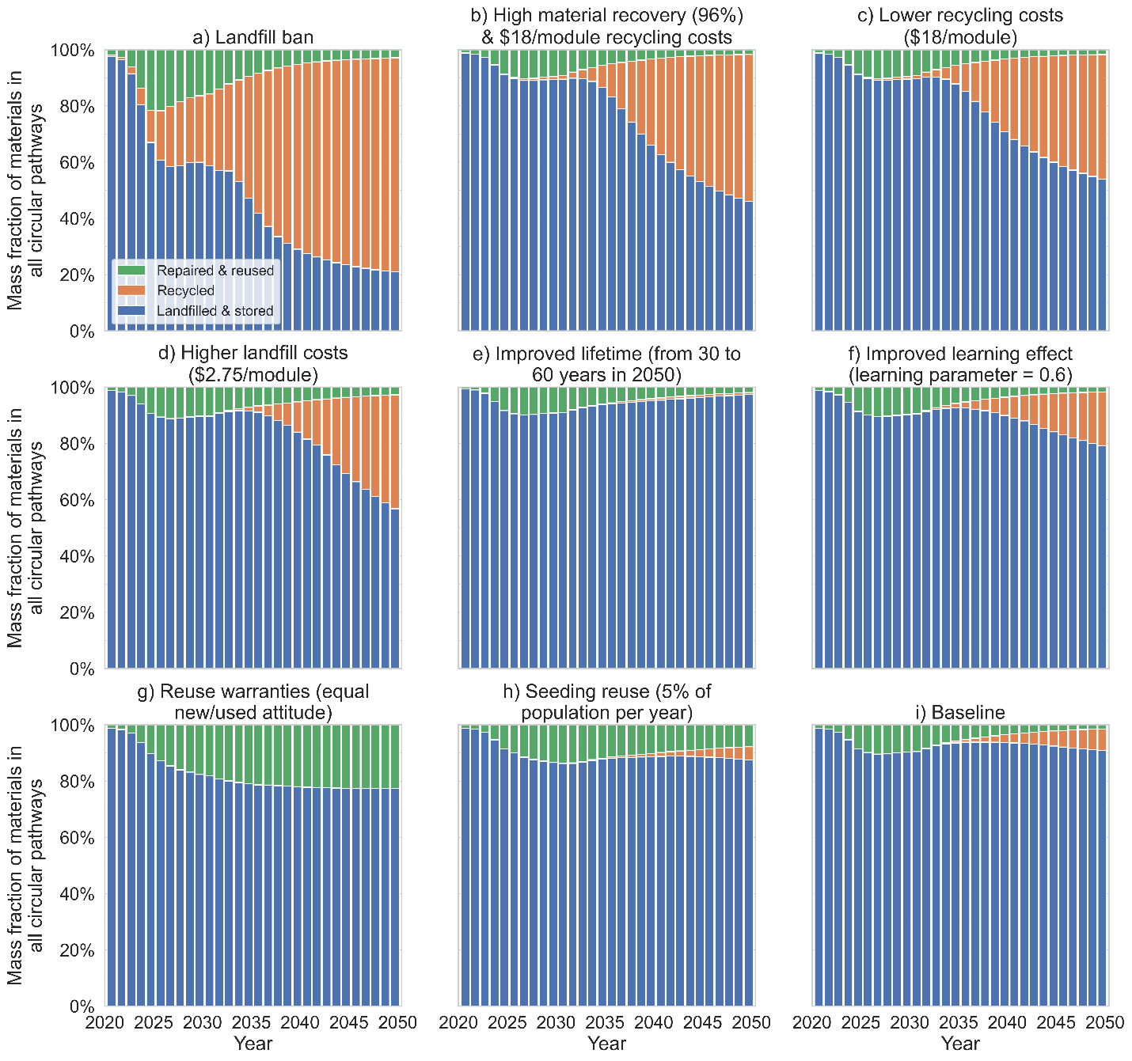
Supplementary Figure 3: Percentage of material mass from EOL PV modules recovered. Reuse and recycling are limited in the baseline and improved lifetime and learning effect scenarios. Reuse is higher in the improved warranties and the seeding of used modules scenarios but still limited by technical (only 55% of modules can be repaired) and economic (repair costs are between $23/module and $106/module) factors. Finally, recycling is substantial when initial recycling costs are about 66% lower than in the baseline scenario ($18/module instead of $27.5/module), when landfill costs are doubled, and in the landfill ban scenario.

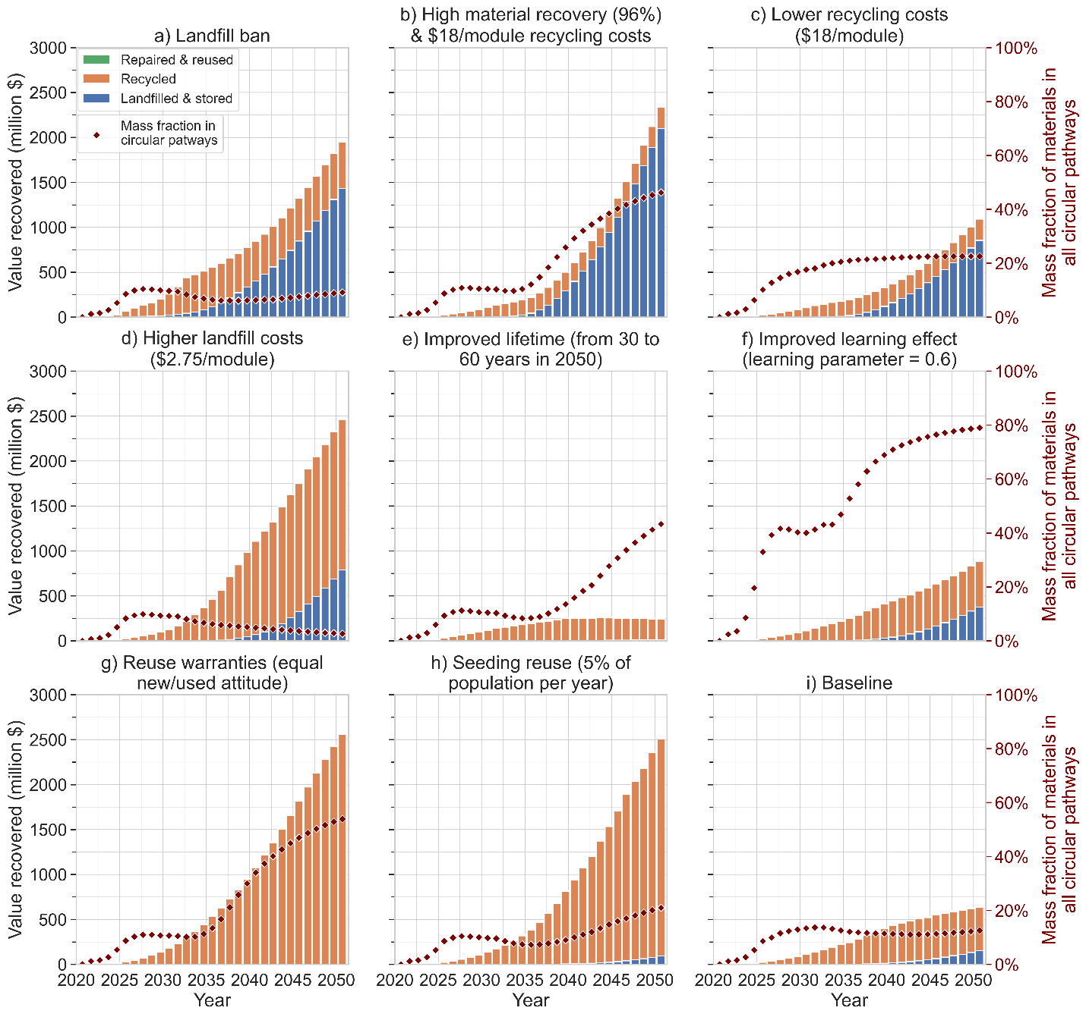
Supplementary Figure 4: Value recovered from circular end-of-life pathways. Reuse creates more value as used modules can be sold for about 40% of their original price. (While materials are, at best, sold at the price of their virgin counterpart – leaving out the value-added from PV manufacturing). A higher total material recovery fraction that recovers silver and silicon also creates more value, doubling the total recovered value when initial recycling costs are $18/module.

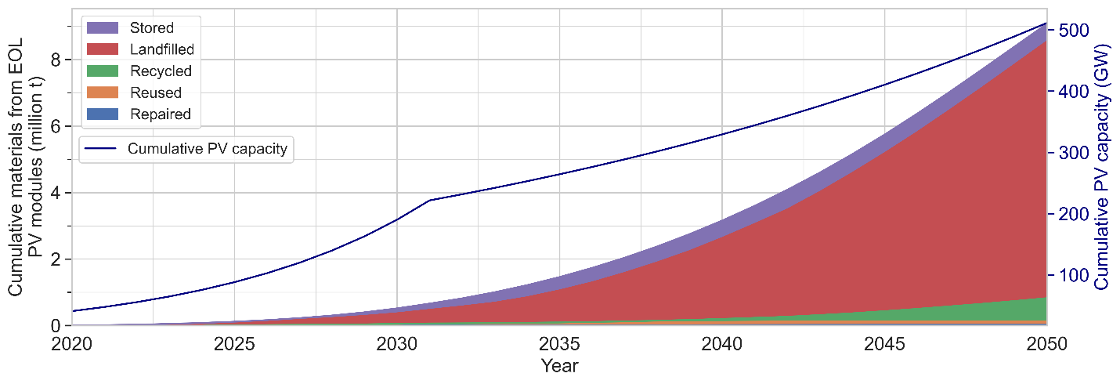
Supplementary Figure 5: Cumulative materials from end-of-life PV modules (million tonnes) and cumulative installed PV capacity (GW) for the calibrated model (baseline scenario). The cumulative materials from EOL PV modules and PV capacity match with the literature⁴. In the baseline scenario, recycling is not profitable, with recyclers’ net income of -$0.21/kg and cumulative net income of -160 million $ in 2050.

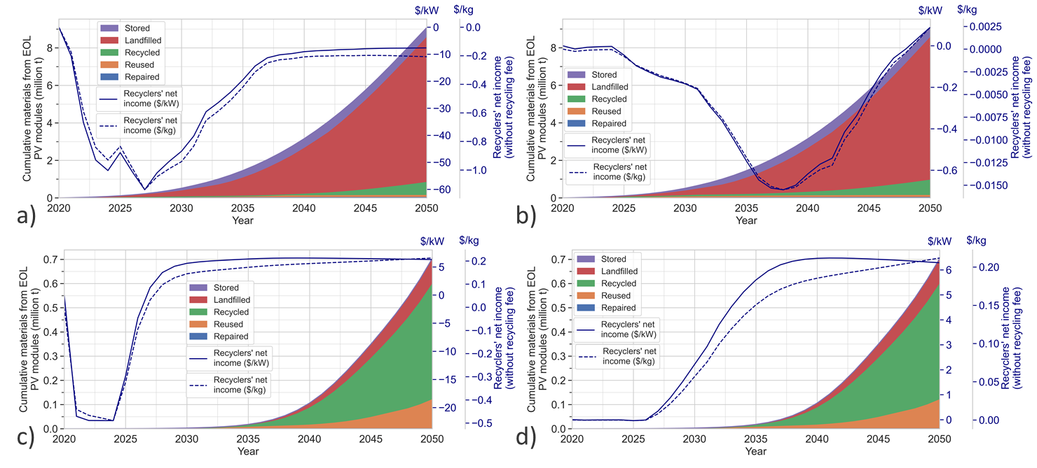
Supplementary Figure 6: Manufacturing waste recycling. a) Baseline scenario, manufacturing waste is landfilled. b) Same as the baseline scenario, but manufacturing waste is recycled. c) Cadmium-Telluride PV modules case, manufacturing waste is landfilled. d) Same as the Cadmium-Telluride PV modules case, but manufacturing waste is recycled. Recycling manufacturing waste could generate economic benefits for manufacturers by eclipsing some of the costs related to purchasing raw materials. Recycling manufacturing waste avoids about 300 million $ and 0.8 million $ for the baseline and the Cadmium-Telluride PV modules case. For both the baseline and the Cadmium-Telluride PV modules case, manufacturing waste recycling means that recyclers become profitable (see the secondary axes of the Figure). It is worth noting that the material recycling rate is higher in the Cadmium-Telluride PV modules case due to an already existing infrastructure and past US voluntary enhanced producer responsibility programs³⁴. Overall, the co-location of manufacturing sites and recycling facilities may help facilitate recycling and reduce manufacturing waste. (Parameters’ values and source for the Cadmium-Telluride PV modules case are reported in Supplementary Table 9.)

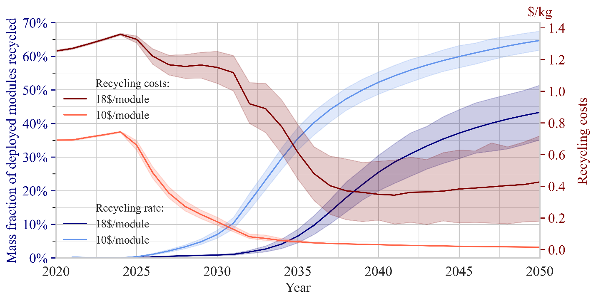
Supplementary Figure 7: Recycling costs and recycling rate as a function of time for two initial recycling costs. The recycling costs are expressed in $/kg.

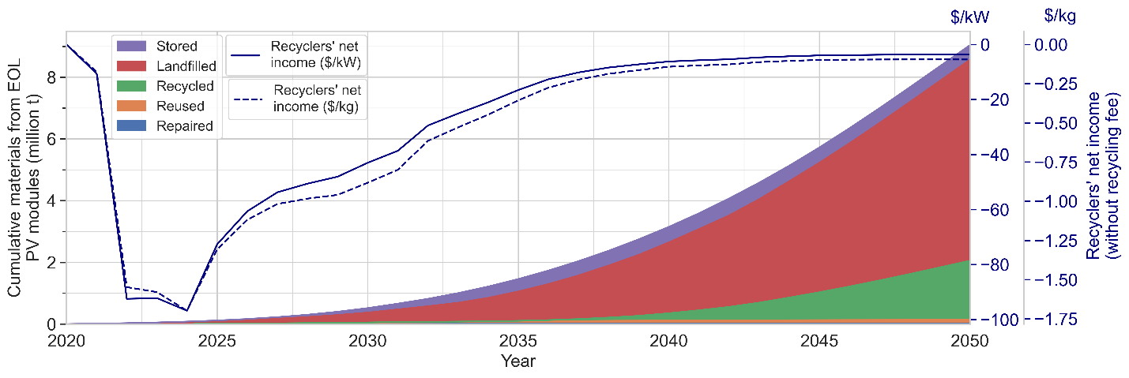
Supplementary Figure 8: A “seeding” strategy where 10% of PV owners pay a lower initial recycling fee ($18/module) enhances the material recycling rate to 21%.

Supplementary Table 3: First-order sensitivity indices obtained from the variance-based (or Sobol) sensitivity analysis and moment independent sensitivity analysis for three output metrics: the fraction of modules in CE pathways, the fraction of modules recycled, the fraction of modules being reused, and the societal costs. NS means “Non-Significant”. Societal costs are computed as:
$$Societal costs=Installers' net income+Recyclers' net income+Manufacturers' net income$$
 |  | Fraction of modules in CE pathways | Fraction recycled | Fraction reused | Societal costs
 |  | Sobol first-order sensitivity indices (and confidence interval)
Technical factors | Material recovery fraction | NS | NS | NS | NS
 | Learning effect | 0.037 (+/- 0.013) | 0.042 (+/- 0.014) | NS | NS
Economic factors | Initial recycling costs | 0.479 (+/- 0.029) | 0.334 (+/- 0.028) | 0.079 (+/- 0.013) | 0.094 (+/- 0.015)
 | Landfill costs | 0.325 (+/- 0.026) | 0.119 (+/- 0.017) | 0.142 (+/- 0.017) | 0.210 (+/- 0.020)
Social factors | Attitude toward reuse | 0.011 (+/- 0.009) | 0.217 (+/- 0.028) | 0.657 (+/- 0.028) | 0.565 (+/- 0.027)
 | Number of recycling facilities | NS | NS | NS | NS
 |  | Moment independent sensitivity indices (and confidence interval)
Technical factors | Material recovery fraction | NS | NS | NS | 0.057 (+/- 0.002)
 | Learning effect | 0.088 (+/- 0.002) | 0.175 (+/- 0.002) | 0.079 (+/- 0.002) | 0.065 (+/- 0.002)
Economic factors | Initial recycling costs | 0.327 (+/- 0.003) | 0.303 (+/- 0.003) | 0.196 (+/- 0.002) | 0.178 (+/- 0.002)
 | Landfill costs | 0.262 (+/- 0.003) | 0.219 (+/- 0.003) | 0.193 (+/- 0.002) | 0.207 (+/- 0.003)
Social factors | Attitude toward reuse | 0.169 (+/- 0.002) | 0.212 (+/- 0.002) | 0.496 (+/- 0.003) | 0.322 (+/- 0.002)
 | Number of recycling facilities | 0.063 (+/- 0.001) | 0.152 (+/- 0.002) | 0.078 (+/- 0.002) | NS

Supplementary Table 4: Percentage of second-order interactions linked to the initial recycling costs for the fraction of modules in CE pathways metric.
Second-order interactions | Percentage of second-order interactions
Initial recycling costs - Material recovery fraction | 2.7%
Initial recycling costs - Number of recycling facilities | 4.2%
Initial recycling costs - Landfill costs | 40.4%
Initial recycling costs - Attitude toward reuse | 28.9%
Initial recycling costs - Learning effect | 23.7%

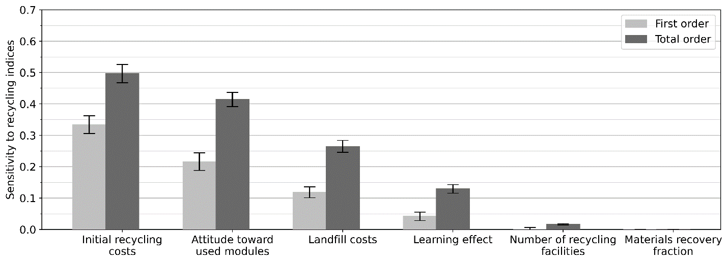
Supplementary Figure 9: The Figure shows parameter importance for the recycling of EOL PV modules in the ABM. The y-axis shows the first and total order Sobol indices on the effect of a parameter on EOL PV modules circularity. Error bars represent the 95% confidence interval.
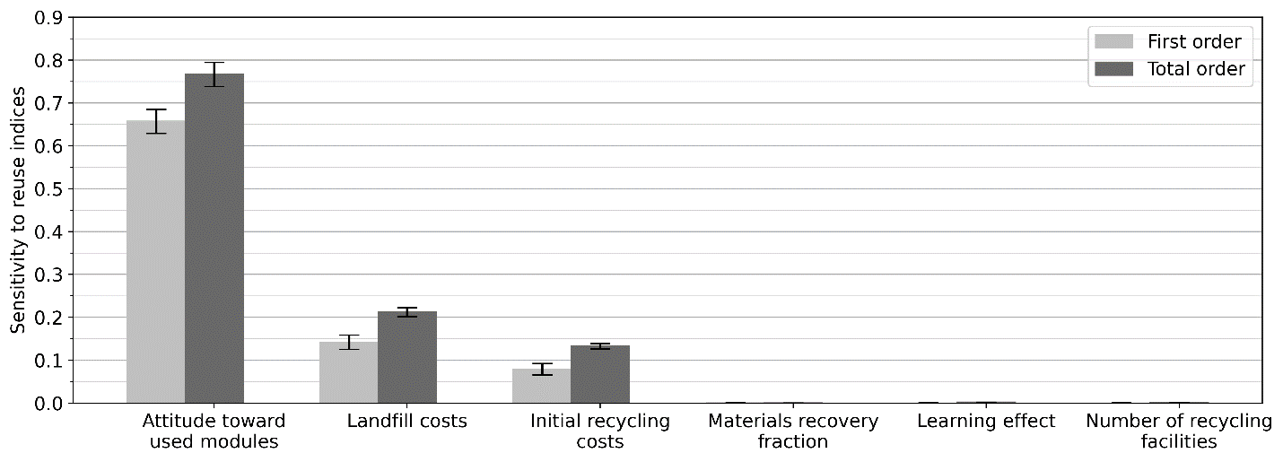
Supplementary Figure 10: The Figure shows parameter importance for the reuse of EOL PV modules in the ABM. The y-axis shows the first and total order Sobol indices on the effect of a parameter on EOL PV modules circularity. Error bars represent the 95% confidence interval.

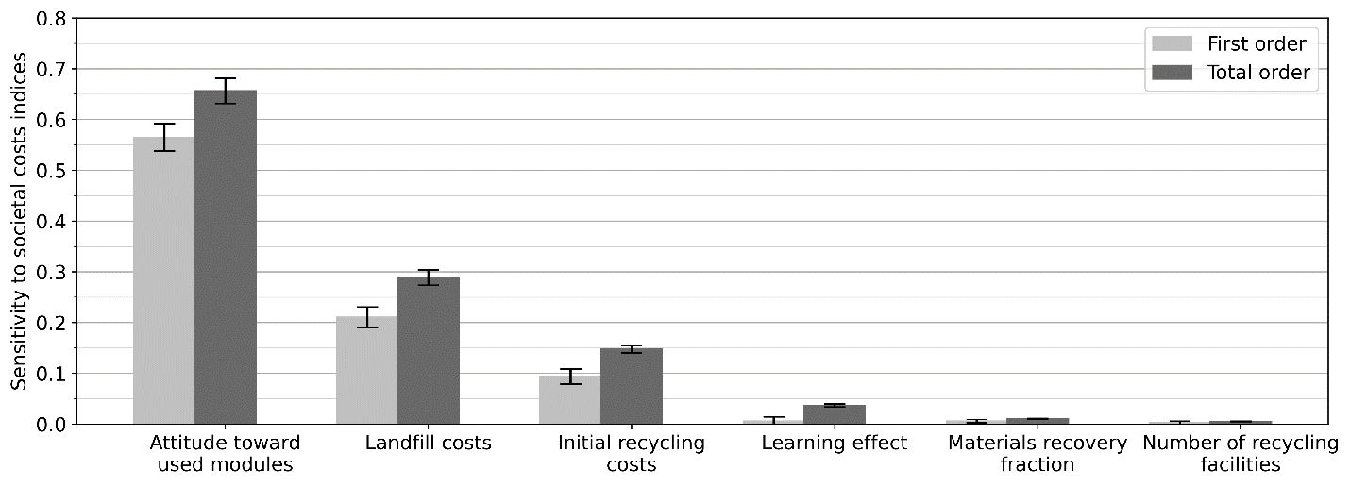
Supplementary Figure 11: The Figure shows parameter importance for the societal costs in the ABM. The y-axis shows the first and total order Sobol indices on the effect of a parameter on EOL PV modules circularity. Error bars represent the 95% confidence interval.

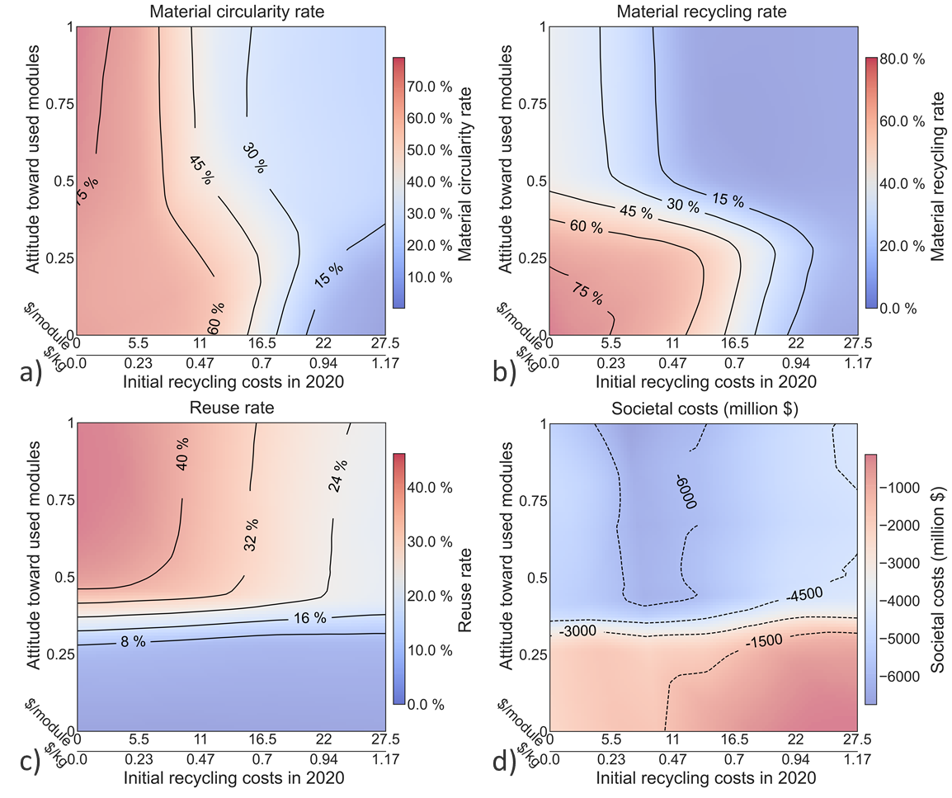
Supplementary Figure 12: Effect of the initial recycling costs (x-axis) and the attitude toward used modules (y-axis) on different output metrics: a) material circularity rate, b) recycling rate, c) reuse rate, and d) societal costs (negative costs indicate economic benefits for the PV stakeholders (installers, recyclers, and manufacturers)). Societal costs are computed as:
$$Societal costs=Installers' net income+Recyclers' net income+Manufacturers' net income$$
Note that the left boundary of the -6000 “pocket” in d) may be an artifact due to the use of the machine learning metamodel.
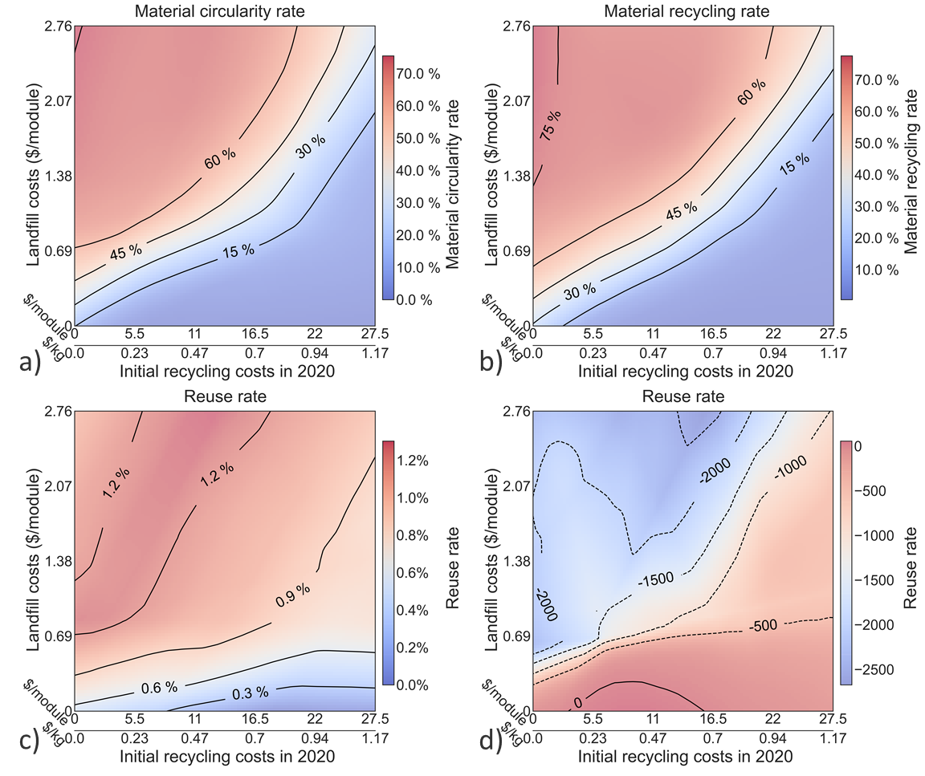
Supplementary Figure 13: Effect of the initial recycling costs (x-axis) and the landfill costs (y-axis) on different output metrics: a) material circularity rate, b) recycling rate, c) reuse rate, and d) societal costs (negative costs indicate economic benefits for the PV stakeholders (installers, recyclers, and manufacturers)). Societal costs are computed as:
$$Societal costs=Installers' net income+Recyclers' net income+Manufacturers' net income$$
Note that the right boundary of the 0 “pocket” in d) and the lower material recycling rate than the material circularity rate in b) may be artifacts due to the use of the machine learning metamodel.

Supplementary Table 5: Selected results of an experimental design (7⁶) with parameters bounds of:
$number of recycling failities=\left[16, 96\right], initial recycling costs=\left[0, 28\right]\$/module, landfill costs=\left[0, 2.76\right]\$/module$
$attitude toward used modules=\left[0, 1\right], learning effect parameter=\left[0,0.6\right]$
(and thus, the samples are uniformly distributed between those bounds). Combining low recycling costs, high landfill costs, and high learning effect yields the best result when first maximizing material circularity and then social costs (first ten best results shown in this Table).
Number of recycling facilities | Initial recycling costs | Landfill costs | Attitude toward used modules | Learning effect parameter | Material circularity (%) | Social costs (million $)
16 | 0 | 2.76 | 0 | 0.6 | 90.055 | 2341.205
16 | 0 | 2.76 | 1 | 0.6 | 90.035 | 6222.129
16 | 0 | 2.76 | 1 | 0.6 | 90.032 | 5175.835
16 | 0 | 2.76 | 0 | 0.6 | 90.023 | 2612.241
96 | 0 | 2.76 | 1 | 0.6 | 90.007 | 5800.942
16 | 0 | 2.76 | 1 | 0.6 | 89.999 | 5791.756
29 | 0 | 2.76 | 1 | 0.6 | 89.99 | 6151.545
16 | 0 | 2.76 | 1 | 0.6 | 89.989 | 5064.403
16 | 0 | 2.76 | 0 | 0.6 | 89.984 | 2949.788
29 | 0 | 2.76 | 0 | 0.6 | 89.979 | 2452.926

Supplementary Table 6: Shares of PV modules in the ABM five EOL pathways in 2050, according to the baseline and several extreme scenarios. *Although landfill is not a pathway available for PV owners, manufacturing waste from manufacturers is still assumed to be landfilled. **PV modules are assumed to be reused only once; thus, after their second life, PV modules are discarded in other pathways than the repair and reuse pathways (landfilled in this scenario).
Scenario | % Repair | % Reuse | % Recycle | % Landfill | % Storage
Baseline | 0.2 | 1.2 | 9.5 | 83.3 | 5.8
CE pathways unavailable | 0.0 | 0.0 | 0.0 | 99.4 | 0.6
Landfill ban | 0.2 | 2.6 | 91.4 | 1.6* | 4.2
No attitude and peer effect (EOL decisions) | 0.0 | 0.7 | 0.0 | 79.5 | 19.8
No economic effect | 4.0 | 1.6 | 55.7 | 38.5 | 0.2
No reuse threshold, low repair costs, no attitude and peer effect (purchase and EOL decisions) | 0.0 | 89.1 | 0.0 | 10.9** | 0.0
No learning effect | 0.3 | 1.2 | 0.1 | 93.0 | 5.4

Supplementary Table 7: Machine learning coefficient of determination (R²) in 10-fold cross-validation for different machine learning algorithms and output metrics. The multilayer perceptron regressor algorithm (neural network) yields the best coefficient of determination for all output metrics except for the reuse rate. The multilayer perceptron regressor algorithm was kept to generate data for Figure 5 and Figure 6 of the main manuscript as well as for Supplementary Figures 9-13 and Supplementary Tables 3-5.
 | Average R² in the 10-fold cross-validation | Standard deviation R² in the 10 cross-validation
Material circularity
Random forest | 0.87 | 0.05
Support vector machine | 0.92 | 0.02
Neural network | 0.95 | 0.02
K-nearest neighbors | 0.84 | 0.06
Recycling rate
Random forest | 0.79 | 0.08
Support vector machine | 0.88 | 0.04
Neural network | 0.94 | 0.03
K-nearest neighbors | 0.78 | 0.08
Reuse rate
Random forest | 0.97 | 0.009
Support vector machine | 0.81 | 0.04
Neural network | 0.92 | 0.02
K-nearest neighbors | 0.83 | 0.04
Societal costs
Random forest | 0.92 | 0.02
Support vector machine | 0.88 | 0.03
Neural network | 0.93 | 0.08
K-nearest neighbors | 0.78 | 0.04

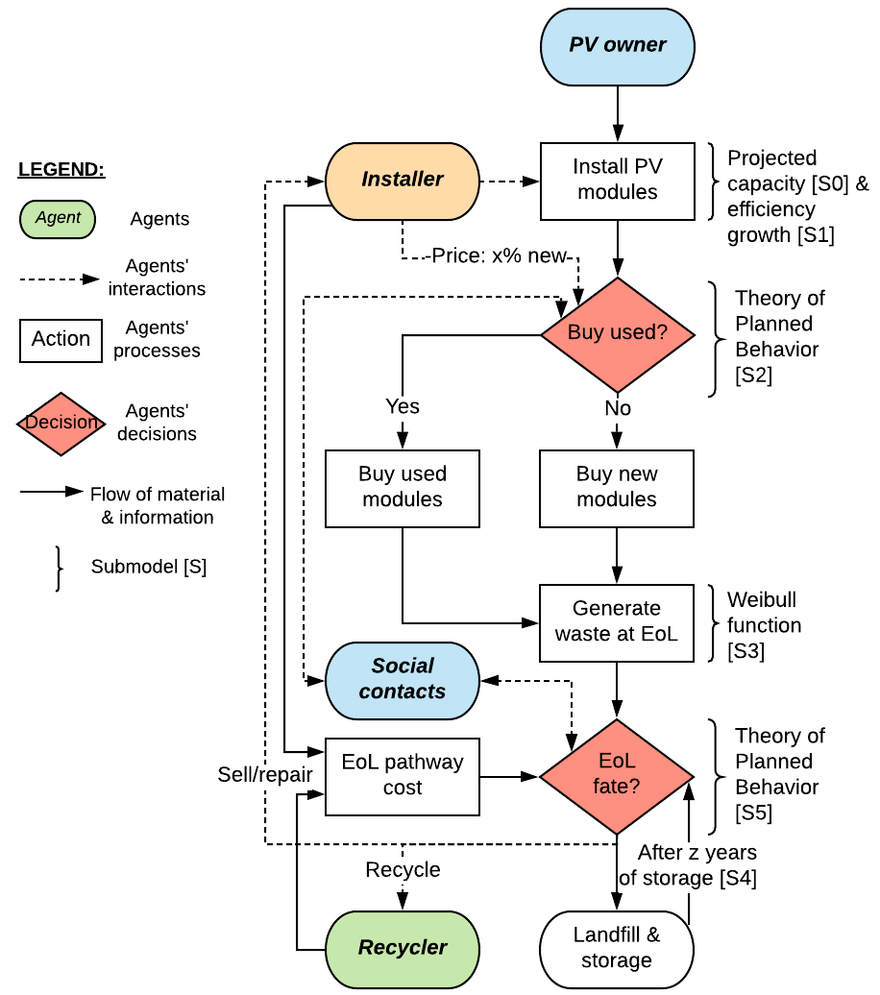
Supplementary Figure 14: PV owner’s decision tree.

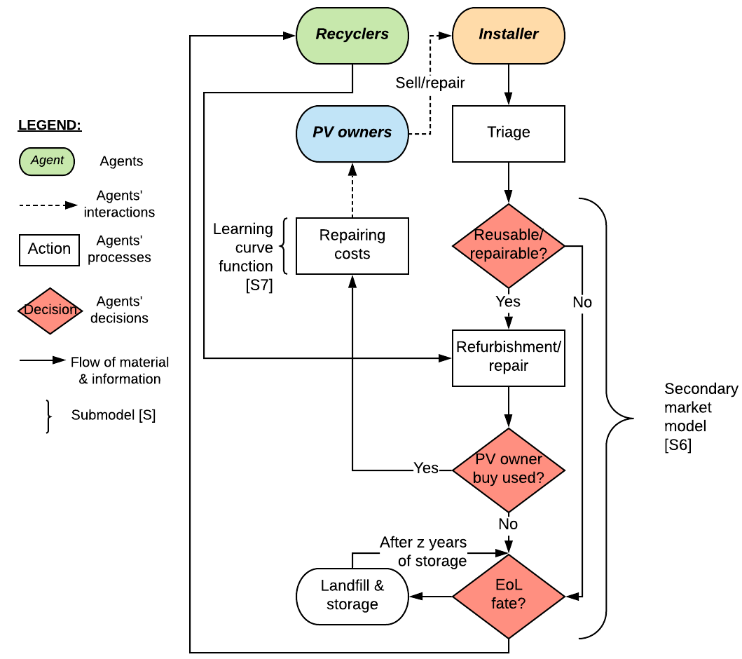
Supplementary Figure 15: Installer’s decision tree.

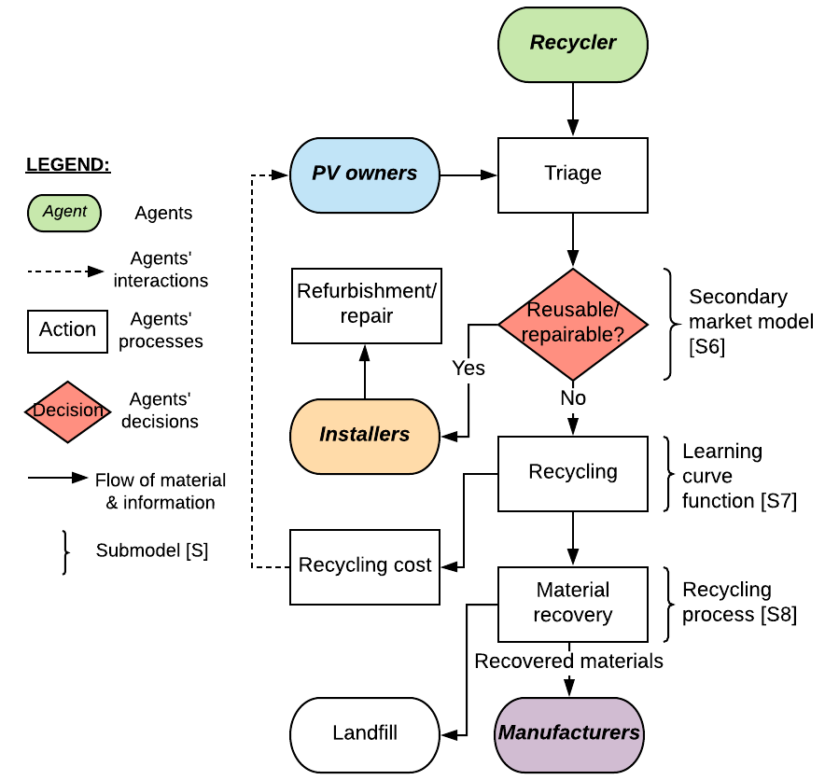
Supplementary Figure 16: Recycler’s decision tree.

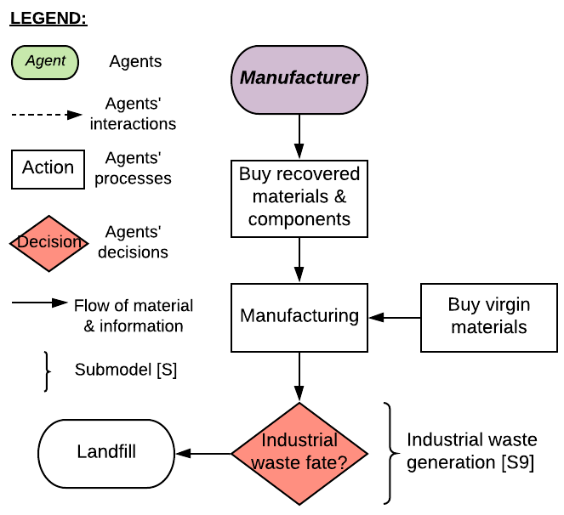
Supplementary Figure 17: Manufacturer’s decision tree.

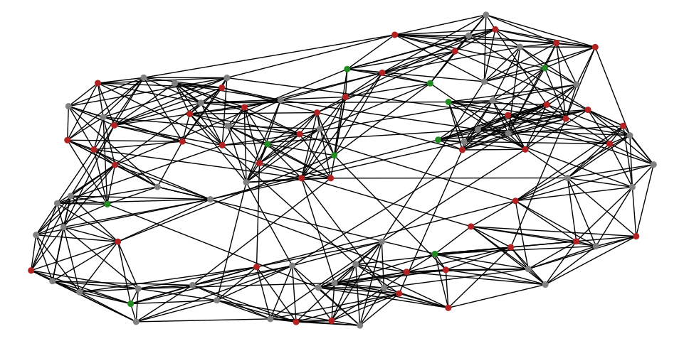
Supplementary Figure 18: Small world network of 100 PV owners ($p=0.1, \overline{N}=10, σ=4.75$) as a conceptual representation of the actual network of 1000 PV owners used in the model (for the latter ($p=0.1, \overline{N}=10, σ=46.7$)). At the beginning of the simulations, most agents are landfilling (red dots) or storing (grey dots), while a few have already adopted circular behaviors (green dots)

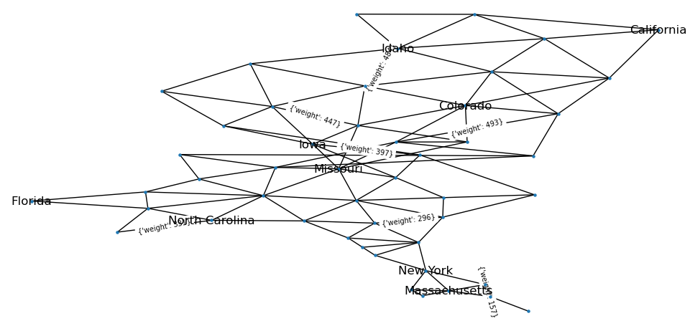
Supplementary Figure 19: The contiguous US represented as a simplified graph where the states are the nodes (only some of them labeled) and the edges the distance (in km) between two neighboring states (only some of them labeled), which are assumed to be the sum of half the square roots of the surfaces of these two neighboring states.

Supplementary Table 8: Landfill costs in the contiguous United States (data for Vermont, Connecticut, and Massachusetts were not available)³⁵
State | $/module | State | $/module
Washington | 2.1 | Minnesota | 1.5
Nevada | 1.7 | Missouri | 1.5
Oregon | 1.7 | Illinois | 1.2
Idaho | 1.6 | Iowa | 1.1
California | 1.3 | Indiana | 1.1
Arizona | 1.0 | Ohio | 1.0
Rhode Island | 2.6 | Michigan | 1.0
Delaware | 2.0 | Kansas | 0.9
New Jersey | 1.9 | Nebraska | 0.9
Maine | 1.8 | Florida | 1.3
New Hampshire | 1.7 | Tennessee | 1.2
Maryland | 1.6 | Georgia | 1.1
New York | 1.6 | South Carolina | 1.0
Pennsylvania | 1.6 | North Carolina | 1.0
Virginia | 1.2 | Mississippi | 0.9
West Virginia | 1.2 | Alabama | 0.8
Wyoming | 1.8 | Kentucky | 0.7
Colorado | 1.5 | Oklahoma | 1.2
Montana | 1.2 | Arkansas | 0.9
South Dakota | 1.2 | Texas | 0.9
North Dakota | 1.1 | New Mexico | 0.9
Utah | 0.8 | Louisiana | 0.8
Wisconsin | 1.5

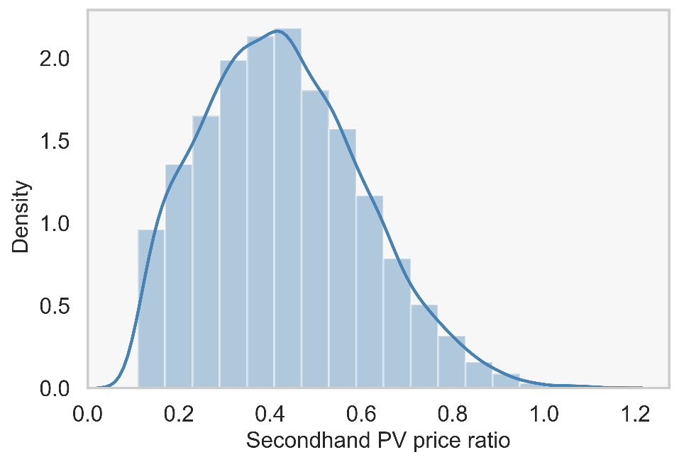
Supplementary Figure 20: Truncated normal distribution of the ratio between the price for used modules (numerator) and the price for new modules (denominator) used in the theory of planned behavior submodel (for $RP_{j}^{t}$). Parameters of the probability density function: Mean = 0.36, Standard Deviation = 0.2, Lower Bound =0.11, Upper Bound =1.14. The distribution and its parameters were inferred from primary data and the literature. Primary data for used module prices were collected from KinectSolar.com, EnergyBin.com, and GreatSolarPanels.com (112 data points) (see Supplementary File 2), and new module prices were determined using exponential regression and data from³⁶. The exponential function parameters are: 1 $/Wp for the intercept and 0.04 year⁻¹ for the regression coefficient. Finally, $RP_{j}^{t}$ is determined by multiplying the used/new price ratio with the price of new modules at time $t$.

Supplementary Table 9: Parameters’ values and sources that are different in the Cadmium-Telluride PV modules case from the Baseline scenario. (See Supplementary Table 1 for the parameters’ definitions).
Parameter | Parameter values (source)
Number of recycler agents | $card(K)=1$³⁷
Recycling facility location | $d_{p=recycling}∈\{198⋯2732\} km$ (1 recycler in 1 state: Ohio³⁷)
Installed capacity | $\sum_{i}{{PA}_{i}^{t=0}}=9408$ MWp⁴ (cumulative installed capacity of Cadmium-Telluride PV in 2020)
Efficiency growth | $b=0.08$ kg/Wp³⁷
Waste generation | New modules:  $T=25$ years³⁷  $α∈[8.2, 12.8]$⁴
Costs and learning parameter | $Cost_{p=recycling}^{t}=\$8$/module^{38,39}, $β=-0.57$³⁸
Mass & recovery fractions | $MF_{m=Glass}=0.97;MF_{m=Copper}=0.005;MF_{m=Cables}=0.012;MF_{m=Cadmium}=0.0007;MF_{m=Tellurium}=0.0007$⁴  $RCR_{m=Glass}=0.99; RCR_{m=Copper}=1; RCR_{m=Cables}=1;RCR_{m=Cadmium}=0.95; RCR_{m=Tellurium}=0.95$^{5,24,40}
Manufacturing waste | $IMF_{m=Glass}=0;MF_{m=Copper}=0;MF_{m=Cables}=0;MF_{m=Cadmium}=0.3;MF_{m=Tellurium}=0.3$⁴¹
Secondary and virgin materials prices | Secondary materials:  $SMV_{m=Glass}∈[0.01, 0.06];SMV_{m=Copper}∈[3.77, 6.75];SMV_{m=Cables}∈[3.22, 3.44];SMV_{m=Cadmium}∈[1.34, 2.89];SMV_{m=Tellurium}∈[36, 80]$ $/kg²⁶⁻²⁹  Virgin materials:  $SMV_{m=Glass}∈[0.04, 0.07];SMV_{m=Copper}∈[4.19, 7.50];SMV_{m=Cables}∈[3.22, 3.44];SMV_{m=Cadmium}∈[1.34, 2.89];SMV_{m=Tellurium}∈[36, 80]$ $/kg^{26-28,30,31}

1 Wood Mackenzie. 2018 global PV operations and maintenance. (2019).
2 SEIA. PV end-of-life management (2019).
3 Seyring, N. et al. Study on WEEE recovery targets, preparation for reuse targets and on the method for calculation of the recovery targets. EU Commission (2015).
4 IRENA & IEA. End-of-Life Management: Solar Photovoltaic Panels. Report No. IEA-PVPS Task 12. Report #T12-06:2016, (2016).
5 Ardente, F., Latunussa, C. E. L. & Blengini, G. A. Resource efficient recovery of critical and precious metals from waste silicon PV panel recycling. Waste Management 91, 156-167, doi:https://doi.org/10.1016/j.wasman.2019.04.059 (2019).
6 Lunardi, M. M., Alvarez-Gaitan, J. P., Bilbao, J. I. & Corkish, R. A review of recycling processes for photovoltaic modules. Solar Panels and Photovoltaic Materials (2018).
7 Farrell, C. C. et al. Technical challenges and opportunities in realising a circular economy for waste photovoltaic modules. Renewable and Sustainable Energy Reviews 128, 109911, doi:https://doi.org/10.1016/j.rser.2020.109911 (2020).
8 Watts, D. J. & Strogatz, S. H. Collective dynamics of ‘small-world’networks. nature 393, 440-442 (1998).
9 Byrka, K., Jȩdrzejewski, A., Sznajd-Weron, K. & Weron, R. Difficulty is critical: The importance of social factors in modeling diffusion of green products and practices. Renewable and Sustainable Energy Reviews 62, 723-735, doi:http://dx.doi.org/10.1016/j.rser.2016.04.063 (2016).
10 Jalili, M. Social power and opinion formation in complex networks. Physica A: Statistical Mechanics and its Applications 392, 959-966, doi:https://doi.org/10.1016/j.physa.2012.10.013 (2013).
11 ATRI. An Analysis of the Operational Costs of Trucking: 2019 Update. (2019).
12 Mahmoudi, S., Huda, N., Alavi, Z., Islam, M. T. & Behnia, M. End-of-life photovoltaic modules: A systematic quantitative literature review. Resources, Conservation and Recycling 146, 1-16, doi:https://doi.org/10.1016/j.resconrec.2019.03.018 (2019).
13 Singhal, D., Jena, S. K. & Tripathy, S. Factors influencing the purchase intention of consumers towards remanufactured products: a systematic review and meta-analysis. International Journal of Production Research 57, 7289-7299, doi:10.1080/00207543.2019.1598590 (2019).
14 investopedia. Sectors & Industries Analysis <www.investopedia.com> (2020).
15 Wang, K., Smeets, A., De Regel, S., Rommens, T. & Heath, G. Financial viability of PV reuse. (IEA Photovoltaic Power Systems Task 12, (under preparation).
16 Schmid, M. Used Solar Panels Change the Game in the 2020s as Used Cars Did in the 1930s, <https://resources.energybin.com> (2020).
17 Wilson, G. T. et al. The hibernating mobile phone: Dead storage as a barrier to efficient electronic waste recovery. Waste Management 60, 521-533, doi:https://doi.org/10.1016/j.wasman.2016.12.023 (2017).
18 Geiger, J. L., Steg, L., van der Werff, E. & Ünal, A. B. A meta-analysis of factors related to recycling. Journal of Environmental Psychology 64, 78-97, doi:https://doi.org/10.1016/j.jenvp.2019.05.004 (2019).
19 Tsanakas, J. A. et al. Towards a circular supply chain for PV modules: Review of today’s challenges in PV recycling, refurbishment and re-certification. Progress in Photovoltaics: Research and Applications 28, 454-464, doi:10.1002/pip.3193 (2020).
20 EPRI. Solar PV module end of life: options and knowledge for utility-scale plants. Report No. 3002014407, (2018).
21 Cisco-Eagle. What Does It Cost to Store a Pallet in Third-Party Storage, <https://www.cisco-eagle.com/blog/2012/09/24/the-cost-of-managing-a-skid-or-pallet/> (2020).
22 Dodd, N., Espinosa, N., Van Tichelen, P., Peeters, K. & Soares, A. Preparatory study for solar photovoltaic modules, inverters and systems – Task 6 Assessment of BAT, design options and improvement potential. (European Commission, Joint Research Centre, 2019).
23 Qiu, Y. & Suh, S. Economic feasibility of recycling rare earth oxides from end-of-life lighting technologies. Resources, Conservation and Recycling 150, 104432, doi:https://doi.org/10.1016/j.resconrec.2019.104432 (2019).
24 Wambach, K., Heath, G. A. & Libby, C. Life Cycle Inventory of Current Photovoltaic Module Recycling Processes in Europe. Report No. NREL/TP-6A20-73846 United States 10.2172/1561522 NREL English, Medium: ED (Paris, France: International Energy Agency (IEA); National Renewable Energy Lab. (NREL), Golden, CO (United States), 2018).
25 Heath, G. A. et al. Research and development priorities for silicon photovoltaic module recycling to support a circular economy. Nature Energy, doi:10.1038/s41560-020-0645-2 (2020).
26 USGS. 16 (2019).
27 Infomine. 5 Year Silver Prices and Price Charts, <http://www.infomine.com/investment/metal-prices/silver/5-year/> (2019).
28 Infomine. 5 Year Copper Prices and Price Charts, <http://www.infomine.com/investment/metal-prices/copper/5-year/> (2019).
29 The Balance Small Business. Facts About Copper Recycling, <https://www.thebalancesmb.com> (2019).
30 Butler, J. & Hooper, P. Dilemmas in optimising the environmental benefit from recycling: A case study of glass container waste management in the UK. Resources, Conservation and Recycling 45, 331-355, doi:https://doi.org/10.1016/j.resconrec.2005.02.006 (2005).
31 Newlove, T. Keeping Glass Recycling Financially Sustainable: A Cost-Benefit Analysis. (2017).
32 Hinkelmann, F., Murrugarra, D., Jarrah, A. S. & Laubenbacher, R. J. B. o. M. B. A Mathematical Framework for Agent Based Models of Complex Biological Networks. 73, 1583-1602, doi:10.1007/s11538-010-9582-8 (2011).
33 Masad, D. & Kazil, J. in 14th PYTHON in Science Conference. 53-60.
34 Fthenakis, V. Sustainability of photovoltaics: The case for thin-film solar cells. Renewable and Sustainable Energy Reviews 13, 2746-2750, doi:https://doi.org/10.1016/j.rser.2009.05.001 (2009).
35 EREF. Analysis of MSW Landfill Tipping Fees, <https://erefdn.org/> (2019).
36 Fraunhofer, I. & Energiewende, A. Current and future cost of photovoltaics. Long-term Scenarios for Market Development, System Prices and LCOE of Utility-Scale PV systems. Agora Energiewende 82 (2015).
37 First Solar. <http://www.firstsolar.com/> (2020).
38 Raju, S. in Solar Power International 2013 Conference.
39 Wade, A., Sinha, P., Drozdiak, K. & Brutsch, E. J. c. r. E. P. Beyond waste–the fate of end-of-life photovoltaic panels from large scale PV installations in the EU the socio-economic benefits of high value recycling compared to reuse. (2017).
40 Stolz, P., Frischknecht, R., Wambach, K., Sinha, P. & Heath, G. Life cycle assessment of current photovoltaic module recycling. IEA PVPS Task 12, International Energy Agency Power Systems Programme, Report IEA-PVPS T12 13, 2018 (2017).
41 Fthenakis, V. M. Life cycle impact analysis of cadmium in CdTe PV production. Renewable and Sustainable Energy Reviews 8, 303-334, doi:https://doi.org/10.1016/j.rser.2003.12.001 (2004).

