Appendix
Figure A1 A change in the number of degrees of freedom at intervals of 2 within a range of 4 to 10 df, for time trend, temperature and relative humidity respectively, during all-year (top), warm season(middle), and cold season(bottom).
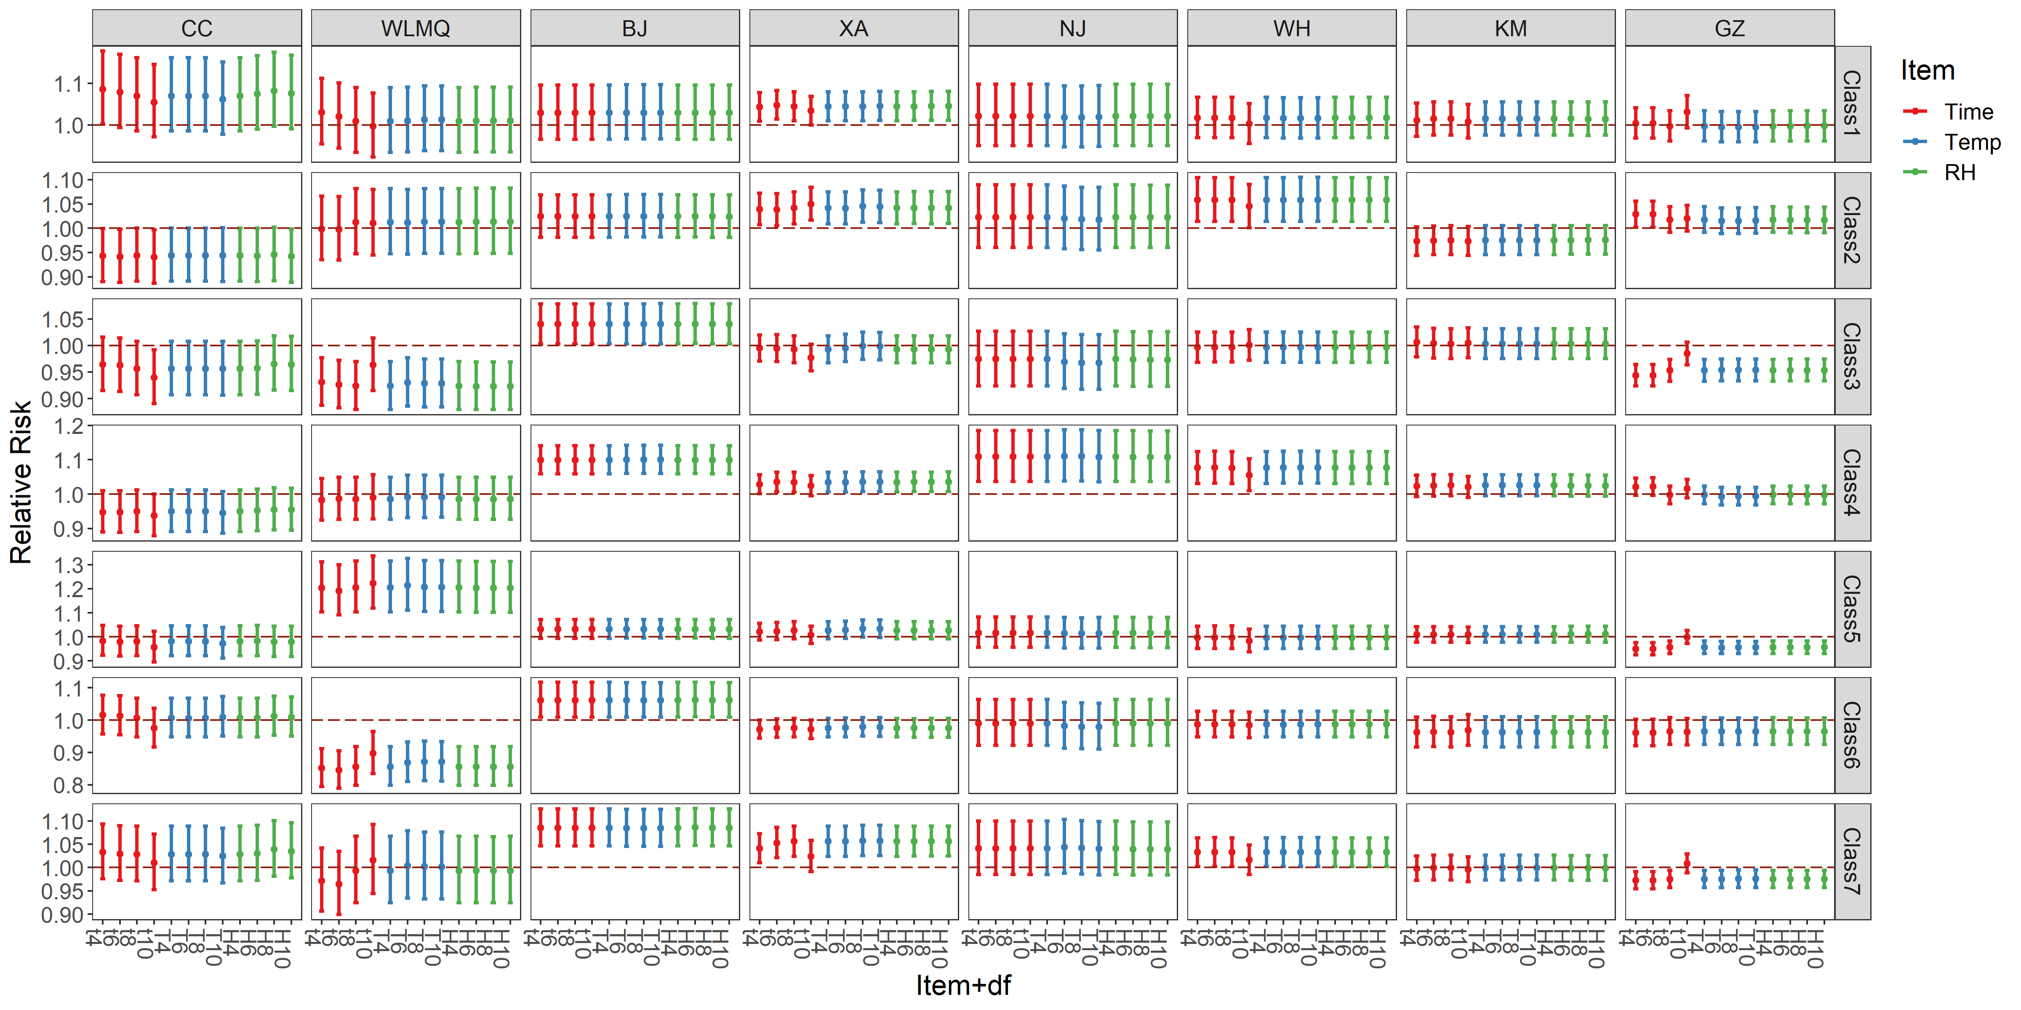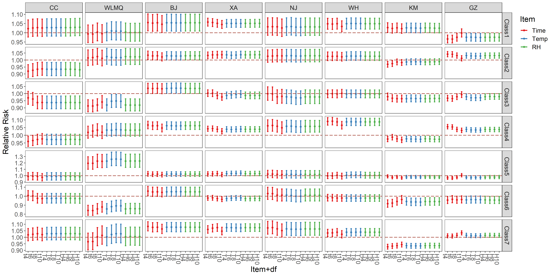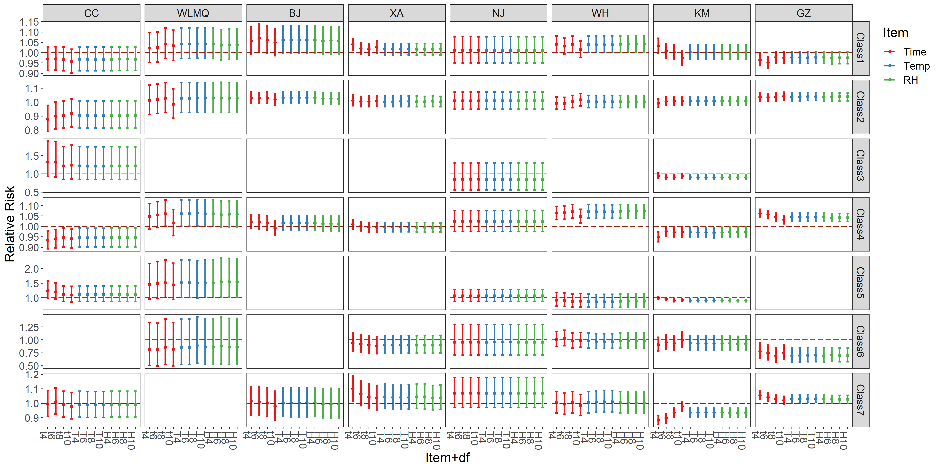

Table A1. Annual average of daily mean concentrations (standard deviation) for air pollution, meteorological variables, and daily all-cause mortality for each pollutant type in 8 Chinese cities, 2013-2016.
City | Type | All (Mean±SD) | O₃_1h (Mean±SD, µg/m³） | PM25 (Mean±std, µg/m³） | NO₂ (Mean±std, µg/m³） | TEM(mean±std, ℃) | RH(mean±std, %)
All | 0 | 62.5±40.9 | 76.6±28.4 | 27.2±12.0 | 30.3±8.3 | 15.5±10.1 | 69.4±21.0
 | 1 | 60.5±42.7 | 71.3±31.6 | 73.3±33.2 | 36.0±7.8 | 9.0±11.1 | 71.7±17.2
 | 2 | 63.3±42.5 | 74.0±29.5 | 37.3±12.2 | 50.8±11.2 | 13.5±8.7 | 66.6±19.4
 | 3 | 53.8±36.6 | 157.9±41.1 | 32.8±11.2 | 33.2±7.9 | 24.8±4.6 | 61.6±16.5
 | 4 | 64.2±44.5 | 63.7±32.5 | 113.8±71.3 | 67.4±20.9 | 5.9±10.3 | 69.6±15.2
 | 5 | 56.7±35.2 | 175.1±47.5 | 70.9±31.3 | 34.0±8.2 | 23.8±4.9 | 64.6±15.5
 | 6 | 49.5±34.0 | 163.1±40.5 | 39.1±11.0 | 53.0±9.8 | 22.7±4.3 | 57.3±17.4
 | 7 | 65.0±40.2 | 170.9±46.5 | 80.8±41.5 | 60.3±18.2 | 20.3±5.8 | 63.2±16.9
BJ | 0 | 49.0±10.0 | 83.8±25.5 | 25.9±14.8 | 30.9±9.7 | 11.8±10.5 | 41.7±22.3
 | 1 | 49.9±10.5 | 76.3±28.3 | 92.6±38.5 | 40.5±5.0 | 11.7±10.5 | 62.1±21.5
 | 2 | 50.9±9.0 | 72.8±29.6 | 44.6±11.5 | 57.2±7.5 | 9.6±9.4 | 45.0±15.4
 | 3 | 44.8±7.5 | 195.5±40.5 | 38.2±13.9 | 35.2±6.8 | 25.7±3.1 | 56.0±13.7
 | 4 | 52.8±8.8 | 54.4±36.5 | 146.9±74.6 | 81.1±22.5 | 6.6±8.2 | 61.6±17.2
 | 5 | 44.1±7.8 | 216.8±43.2 | 101.3±30.4 | 36.6±5.9 | 26.3±3.4 | 66.4±11.7
 | 6 | 45.9±6.2 | 196.0±38.7 | 45.8±11.7 | 55.8±6.6 | 24.8±3.6 | 45.1±12.9
 | 7 | 46.8±7.3 | 203.3±47.5 | 121.1±52.4 | 64.7±17.0 | 21.8±4.4 | 56.2±12.5
CC | 0 | 20.8±6.5 | 79.4±18.4 | 26.1±9.4 | 29.2±6.1 | 7.1±12.4 | 63.9±17.1
 | 1 | 21.9±6.6 | 76.5±19.4 | 63.2±22.7 | 33.2±5.9 | -2.9±11.8 | 60.0±15.1
 | 2 | 18.9±5.8 | 86.4±18.8 | 31.8±8.5 | 46.4±6.3 | 11.6±9.8 | 59.5±16.1
 | 3 | 19.7±6.8 | 142.5±26.7 | 27.5±8.4 | 31.1±5.5 | 21.6±4.5 | 62.2±15.9
 | 4 | 20.6±6.7 | 69.9±19.7 | 107.8±65.2 | 56.2±13.0 | -5.6±9.9 | 63.3±13.9
 | 5 | 19.9±7.0 | 155.2±21.8 | 66.6±20.6 | 30.6±6.2 | 21.3±5.6 | 57.4±19.4
 | 6 | 21.0±6.5 | 146.9±26.2 | 31.2±7.4 | 47.9±7.1 | 21.1±4.0 | 57.0±15.2
 | 7 | 21.3±6.6 | 148.1±30.7 | 96.9±60.9 | 58.4±14.9 | 14.0±8.9 | 51.9±15.6
GZ | 0 | 124.7±23.6 | 77.7±36.2 | 23.1±7.1 | 32.4±6.7 | 22.5±6.5 | 81.7±10.1
 | 1 | 121.4±21.5 | 90.3±36.3 | 50.3±11.4 | 35.4±6.6 | 18.6±6.7 | 73.9±12.8
 | 2 | 130.7±23.1 | 61.4±35.3 | 30.0±4.8 | 51.7±6.3 | 21.1±5.1 | 86.2±8.4
 | 3 | 115.6±17.3 | 178.6±36.3 | 27.1±5.2 | 32.6±5.5 | 28.6±1.4 | 78.3±5.2
 | 4 | 134.4±26.3 | 79.6±35.2 | 66.3±23.5 | 68.5±19.3 | 17.7±4.8 | 78.7±11.8
 | 5 | 114.4±14.0 | 199.1±43.3 | 50.0±11.1 | 39.5±3.9 | 27.3±2.4 | 75.5±8.3
 | 6 | 114.7±17.7 | 186.8±38.9 | 32.7±5.3 | 50.2±7.0 | 25.3±2.8 | 81.8±10.8
 | 7 | 122.5±20.1 | 196.9±46.7 | 63.8±20.7 | 64.3±19.6 | 23.4±4.7 | 77.7±7.9
KM | 0 | 85.8±17.3 | 71.6±19.5 | 18.1±4.7 | 21.9±4.5 | 17.6±4.4 | 74.0±13.5
 | 1 | 98.1±22.8 | 79.9±18.0 | 35.1±6.5 | 23.9±4.4 | 13.6±5.5 | 71.9±13.5
 | 2 | 87.6±21.6 | 71.5±20.3 | 22.6±4.0 | 33.6±3.7 | 15.2±4.2 | 74.5±13.4
 | 3 | 85.2±13.9 | 120.3±16.4 | 22.5±3.6 | 21.5±4.6 | 19.8±3.2 | 64.2±13.6
 | 4 | 96.7±24.0 | 74.1±21.5 | 43.8±13.0 | 40.1±7.6 | 11.8±4.4 | 71.5±12.2
 | 5 | 90.8±14.1 | 127.1±16.8 | 35.8±7.3 | 21.8±4.3 | 18.7±3.6 | 57.8±13.6
 | 6 | 79.4±10.8 | 122.8±14.4 | 23.9±3.2 | 33.6±4.8 | 18.5±2.6 | 69.1±11.8
 | 7 | 84.9±13.4 | 134.3±23.0 | 49.4±15.1 | 41.4±9.6 | 18.0±3.1 | 57.9±15.6
NJ | 0 | 21.4±5.4 | 83.7±28.6 | 30.1±12.1 | 32.3±7.6 | 18.2±9.3 | 78.6±14.6
 | 1 | 22.5±5.6 | 84.4±29.4 | 80.5±29.5 | 36.5±6.1 | 13.7±9.1 | 78.3±12.2
 | 2 | 22.6±5.5 | 78.8±31.8 | 42.0±9.3 | 55.9±8.4 | 13.6±8.1 | 69.5±15.3
 | 3 | 20.9±5.5 | 185.2±37.4 | 36.1±10.9 | 33.8±7.7 | 25.7±4.9 | 68.4±9.6
 | 4 | 24.0±5.8 | 77.9±31.9 | 106.4±46.6 | 71.4±18.3 | 9.8±6.2 | 69.8±12.7
 | 5 | 20.4±4.3 | 187.8±36.0 | 74.0±18.6 | 36.5±5.7 | 24.4±4.6 | 73.6±8.3
 | 6 | 20.9±5.6 | 178.5±31.4 | 41.1±9.7 | 54.7±10.4 | 22.2±5.1 | 62.7±11.7
 | 7 | 21.3±5.4 | 185.8±42.2 | 87.9±30.2 | 65.8±16.1 | 20.6±5.2 | 64.8±10.9
WH | 0 | 55.8±10.7 | 85.4±35.9 | 34.2±13.3 | 30.6±7.7 | 19.6±8.3 | 82.9±12.0
 | 1 | 60.6±13.0 | 74.8±36.5 | 95.7±39.8 | 38.3±6.2 | 12.2±7.8 | 83.3±9.3
 | 2 | 59.8±11.2 | 85.0±36.5 | 50.4±9.0 | 54.1±9.3 | 14.6±7.4 | 79.7±10.3
 | 3 | 53.9±10.3 | 178.7±24.4 | 40.2±10.8 | 33.1±7.0 | 27.4±3.9 | 74.7±8.5
 | 4 | 64.4±13.5 | 73.5±35.0 | 125.1±58.8 | 72.6±19.0 | 9.0±6.0 | 78.7±9.5
 | 5 | 52.3±8.3 | 186.3±31.2 | 79.7±21.0 | 38.3±6.0 | 25.1±3.3 | 76.2±7.1
 | 6 | 54.3±9.5 | 185.8±31.2 | 49.5±9.0 | 58.3±9.3 | 22.4±4.5 | 73.5±9.1
 | 7 | 53.6±9.4 | 193.5±33.4 | 93.9±29.0 | 68.1±16.9 | 21.5±4.5 | 77.2±6.8
WLMQ | 0 | 22.0±5.8 | 61.1±18.9 | 29.2±9.8 | 35.2±8.6 | 10.1±9.0 | 58.3±20.4
 | 1 | 21.5±5.6 | 43.6±23.2 | 74.4±25.1 | 41.6±7.9 | 2.4±9.4 | 70.3±22.0
 | 2 | 21.7±5.3 | 60.9±18.3 | 37.5±8.1 | 60.1±9.9 | 7.9±11.0 | 54.5±18.4
 | 3 | 21.1±6.3 | 118.1±22.1 | 29.6±8.7 | 37.9±8.4 | 22.6±4.0 | 41.9±13.1
 | 4 | 21.7±6.0 | 37.2±21.1 | 145.3±76.2 | 77.2±18.2 | -3.6±9.4 | 70.5±16.7
 | 5 | 24.0±16.3 | 113.6±20.2 | 65.8±36.4 | 42.0±6.8 | 22.6±4.3 | 38.5±11.3
 | 6 | 18.7±5.3 | 125.6±25.8 | 37.8±7.1 | 58.2±5.8 | 23.1±4.0 | 34.5±9.0
 | 7 | 19.0±5.8 | 120.6±24.8 | 66.8±14.2 | 65.5±12.6 | 21.5±5.2 | 34.3±8.6
XA | 0 | 103.1±25.6 | 66.9±27.0 | 34.9±12.2 | 32.0±7.3 | 14.5±8.4 | 70.2±19.6
 | 1 | 111.2±25.2 | 57.6±27.5 | 84.9±30.6 | 36.7±6.4 | 9.1±8.0 | 69.8±16.9
 | 2 | 110.8±25.6 | 74.0±27.6 | 44.4±9.5 | 53.2±9.6 | 12.1±8.1 | 59.8±16.7
 | 3 | 94.8±19.3 | 162.0±32.4 | 36.7±11.1 | 33.6±6.6 | 26.1±3.6 | 61.4±10.6
 | 4 | 112.5±25.8 | 54.4±27.3 | 139.4±86.2 | 65.7±15.6 | 6.5±6.9 | 64.9±15.0
 | 5 | 87.9±20.4 | 166.8±31.1 | 79.6±23.3 | 35.8±5.8 | 25.6±3.8 | 62.6±11.5
 | 6 | 92.7±17.9 | 174.0±40.8 | 42.4±9.8 | 54.3±8.5 | 24.1±3.9 | 58.2±10.2
 | 7 | 94.4±23.8 | 156.8±28.4 | 100.9±47.4 | 65.7±14.6 | 20.7±4.5 | 60.5±12.6

