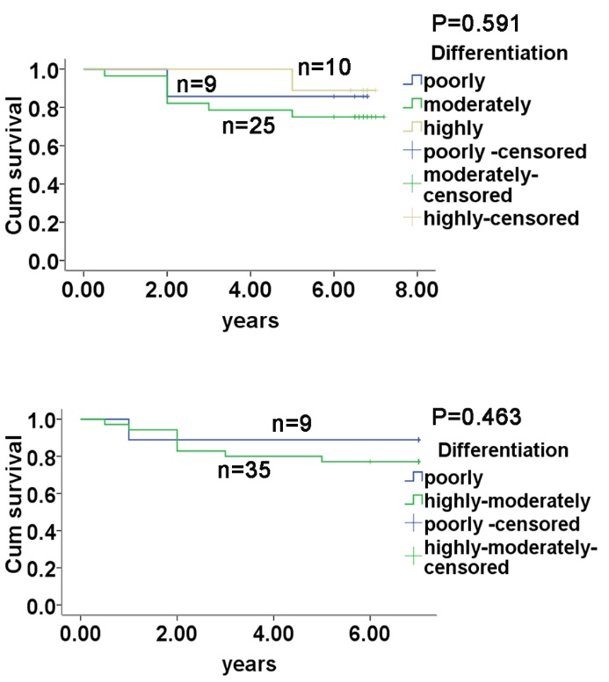

Figure S3. Cumulative survival curves for the grades of tumor differentiation. The 44 patients were divided into two (poorly and moderately-highly differentiated, upper panel) or three subgroups (poorly, moderately and highly differentiated, lower panel), there was no significant difference in cumulative survival relevant to the differentiation status.

