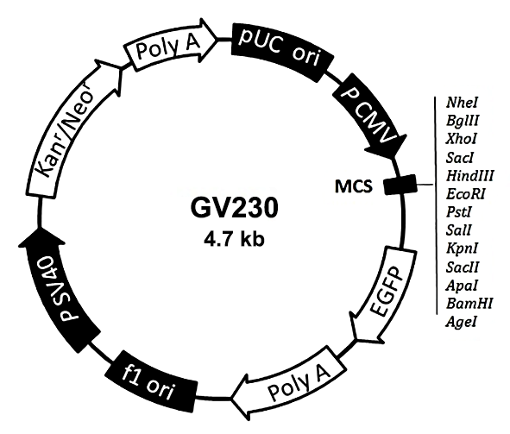
Supplementary Figures

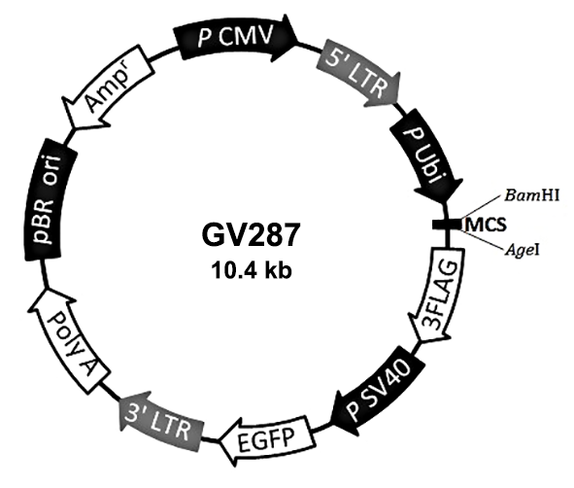
Fig. S1. Scheme of AP-1 over-expression plasmid

Fig. S2. Scheme of lentivirus for KIT over-expression

