Supplementary Information
Multiple Quantum-Coherent Energy Transfer Pathways in Photosynthesis: Electronic-Vibrational Mixing within Photosystem II CP43/CP47 Antenna
Valentin Maffeis^{1,3}, Patricia Lorente², Rafael Picorel², Elisabet Romero^{1,*}
¹Institute of Chemical Research of Catalonia, Barcelona Institute of Science and Technology, 43007 Tarragona, Spain
²Consejo Superior de Investigaciones Científicas, 50059 Zaragoza, Spain
³Present address: Université Lyon, ENS Lyon, CNRS, 69364 Lyon, France
*eromero@iciq.es

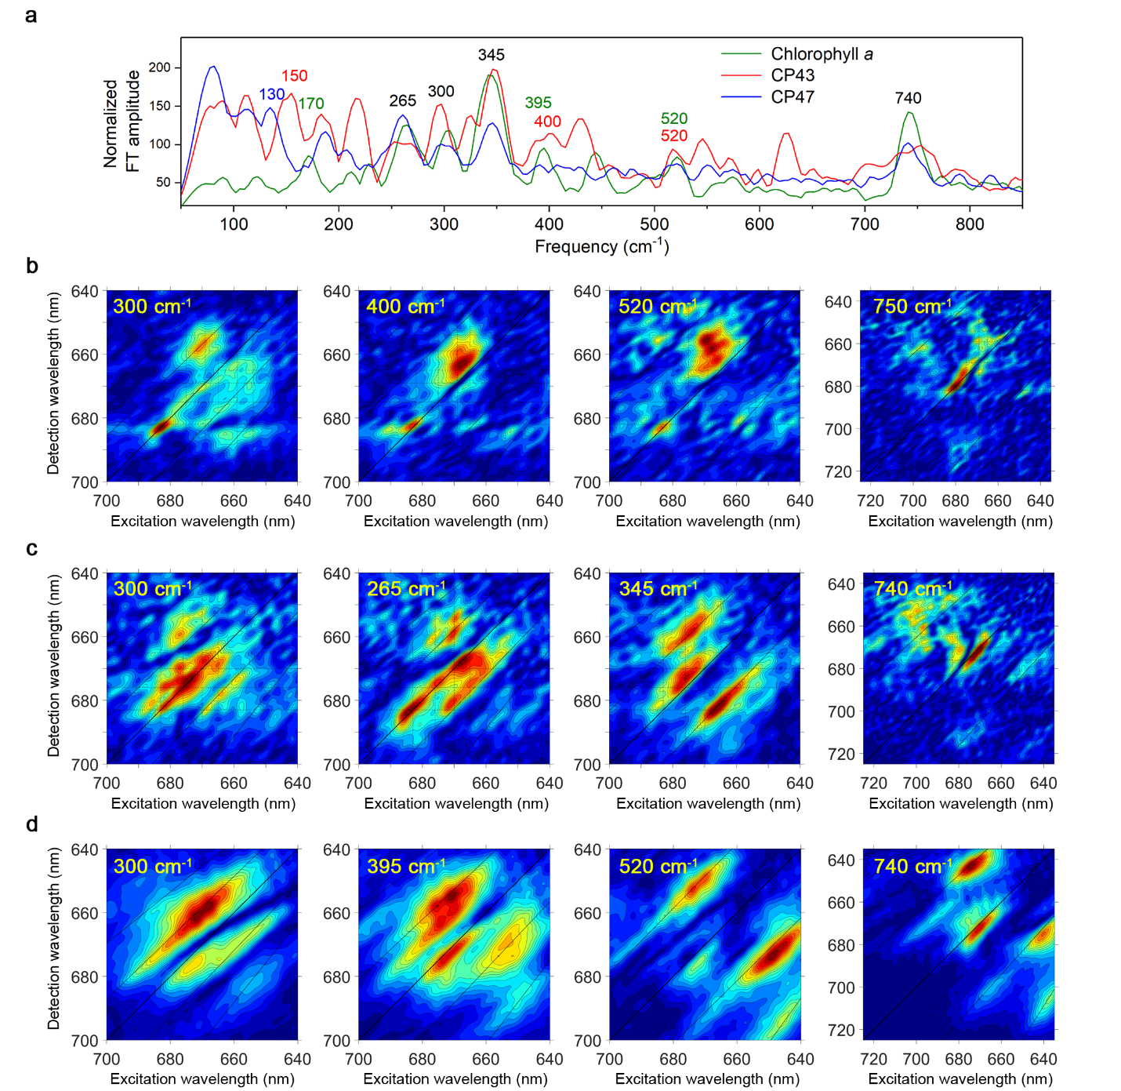
Fig. S1 Oscillation frequencies and real rephasing 2D frequency maps for CP43, CP47 and monomeric Chl at 77 K. (a) Fourier transform (FT) of the real rephasing 2D spectral traces where the maximum amplitude value of each frequency across the full 2D spectra dataset is displayed. The FT is performed over a population time window 104 – 1504 fs (frequency resolution ± 20 cm⁻¹) with a step of 8 fs (maximum probed frequency ≈ 2100 cm⁻¹). Note that the monomeric Chl data has been divided by a factor of two to facilitate the comparison among the three datatsets. (b) Real rephasing 2D frequency maps for CP43 at 300, 400, 520, and 750 cm⁻¹ oscillation frequencies. (c) Real rephasing 2D frequency maps for CP47 at 300, 265, 345, and 740 cm⁻¹ oscillation frequencies. (d) Real rephasing 2D frequency maps for monomeric Chl at 305, 395, 520, and 740 cm⁻¹ oscillation frequencies.
The 2D frequency maps for several oscillation frequencies are shown in Fig.S1. Note that some major frequencies displayed in Fig.3 are kept in Fig.S1 for comparison.
For CP43, the 300 cm⁻¹ oscillation frequency has significant amplitude in the FT even thought this frequency only appears as a weak band in the FLN spectrum¹. This energy corresponds to the CP₆₆₉₋₆₈₂ and it has an amplitude distribution similar to the 265 cm⁻¹ shown in Fig.3b, yet with much lower amplitude at the CP position. Therefore, this frequency map can be assigned to a combination of both vibrational²⁻⁷ and vibronic^{6,8,9} coherence, but with lower vibronic contribution than observed in 265 cm⁻¹ map. The 400 and 520 cm⁻¹ maps display similar amplitude distribution, both show an intense Diagonal₆₈₂ feature together with minor amplitude around the line below diagonal at the position 682 nm on the detection axis; that is, at (665,682) and (659,682) nm, respectively. These features, which are also present in the 740 cm⁻¹ frequency map around (650,680) nm, indicate that these maps correspond to vibrational coherence.
For CP47, only one frequency map different from the ones displayed in Fig. 3c is shown: the one corresponding to the 300 cm⁻¹ frequency, which similarly to CP43, only appears as a weak band in the FLN spectrum¹⁰. The 300 cm⁻¹ frequency map amplitude distribution is similar to the one found in the 265 cm⁻¹ map, yet with lower CP amplitude. Hence, this map is interpreted as the 265 cm⁻¹ map: it corresponds to vibronic coherence between the 670 and 683 nm states as well as between the 665 and 676 nm states (CP₆₇₀₋₆₈₃ and CP₆₆₅₋₆₇₆, respectively).
For monomeric Chl, all the frequency maps correspond to vibrational coherence, the 300 and 395 cm⁻¹ maps represent vibrational coherence generated via de SE, whereas the 520 and 740 cm⁻¹ maps indicate vibrational coherence generated via GSB and SE⁶.

References
1 Groot, M.-L. et al. Spectroscopic properties of the CP43 core antenna protein of photosystem II. Biophys. J. 77, 3328-3340 (1999).
2 Senlik, S. S., Policht, V. R. & Ogilvie, J. P. Two-color nonlinear spectroscopy for the rapid acquisition of coherent dynamics. J. Phys. Chem. Lett. 6, 2413-2420, doi:10.1021/acs.jpclett.5b00861 (2015).
3 Moca, R., Meech, S. R. & Heisler, I. A. Two-dimensional electronic spectroscopy of chlorophyll a: solvent dependent spectral evolution. J. Phys. Chem. B 119, 8623-8630, doi:10.1021/acs.jpcb.5b04339 (2015).
4 Romero, E. et al. Quantum coherence in photosynthesis for efficient solar-energy conversion. Nat. Phys. 10, 676-682 (2014).
5 Romero, E., Novoderezhkin, V. I. & van Grondelle, R. Quantum design of photosynthesis for bio-inspired solar-energy conversion. Nature 543, 355-365 (2017).
6 Biswas, S., Kim, J., Zhang, X. & Scholes, G. D. Coherent two-dimensional and broadband electronic spectroscopies. Chem. Rev. 122, 4257-4321, doi:10.1021/acs.chemrev.1c00623 (2022).
7 Policht, V. R. et al. Hidden vibronic and excitonic structure and vibronic coherence transfer in the bacterial reaction center. Sci. Adv. 8, eabk0953, doi:doi:10.1126/sciadv.abk0953 (2022).
8 Schlau-Cohen, G. S., Dawlaty, J. M. & Fleming, G. R. Ultrafast multidimensional spectroscopy: Principles and applications to photosynthetic systems. IEEE J. Sel. Topics Quantum Electron. 18, 283-295 (2012).
9 Collini, E. Spectroscopic signatures of quantum-coherent energy transfer. Chem. Soc. Rev. 42, 4932-4947 (2013).
10 de Weerd, F. L., Palacios, M. A., Andrizhiyevskaya, E. G., Dekker, J. P. & van Grondelle, R. Identifying the lowest electronic states of the chlorophylls in the CP47 core antenna protein of photosystem II. Biochemistry 41, 15224-15233 (2002).

