Supplementary Material

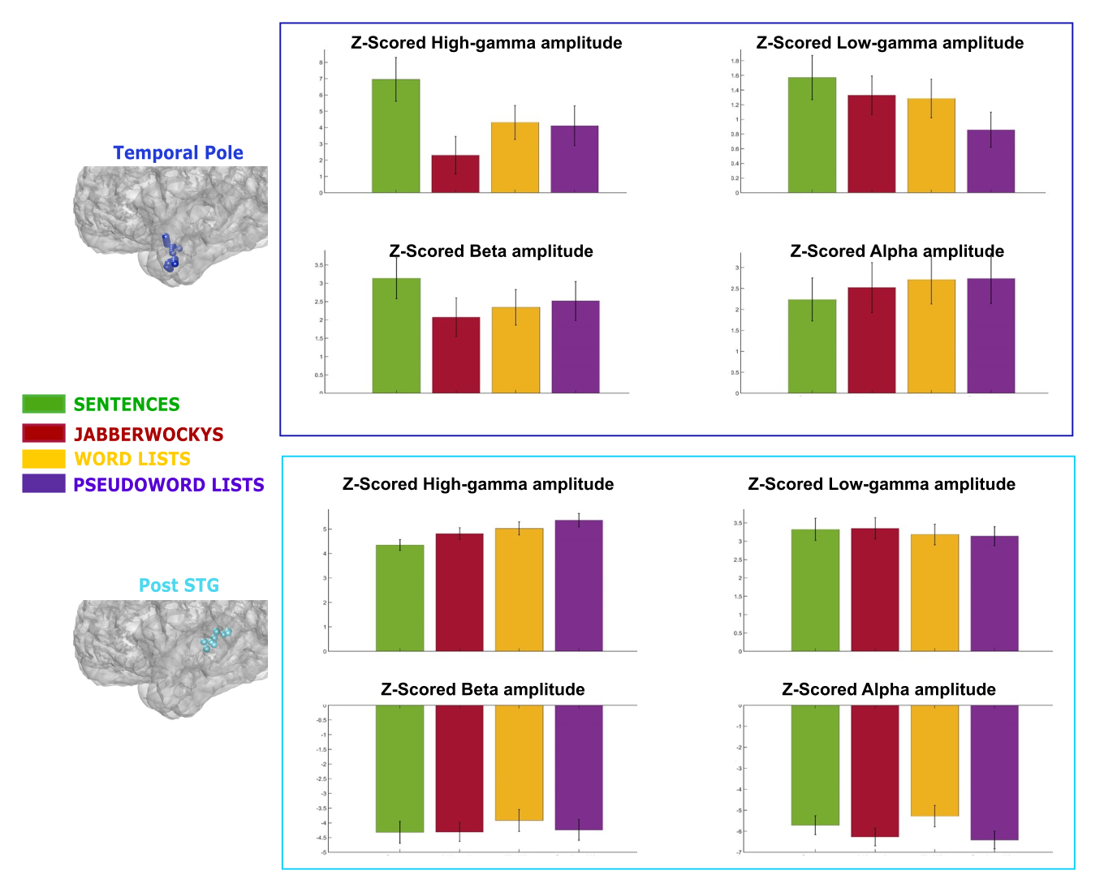
Figure S1: Z-Score amplitude responses for each language condition and each frequency band assessed in the Temporal Pole and Post STG

