Supplementary materials

Paleohydrological change during the Early-Middle Eocene: Insights from Long-lived Green River Formation

Ryusei Kuma^{1,2,*}, Hitoshi Hasegawa³, Jessica H. Whiteside⁴, Amy L. Elson⁴, Koshi Yamamoto⁵, Koichi Mimura¹

¹ Graduate School of Environmental Studies, Nagoya University, Nagoya 464-8601, Japan.
² Institute for Space–Earth Environmental Research, Nagoya University, Nagoya 464-8601, Japan.
³ Faculty of Science and Technology, Kochi University, Kochi 780-8520, Japan.
⁴ University of Southampton, National Oceanography Centre, Southampton SO14 3ZH, UK.
⁵ Material Research Section, University Museum, Nagoya University, Nagoya 464-8601, Japan.

* Correspondence and requests for materials should be addressed to R.K. (e-mail: kuma.ryusei.p8@f.mail.nagoya-u.ac.jp).

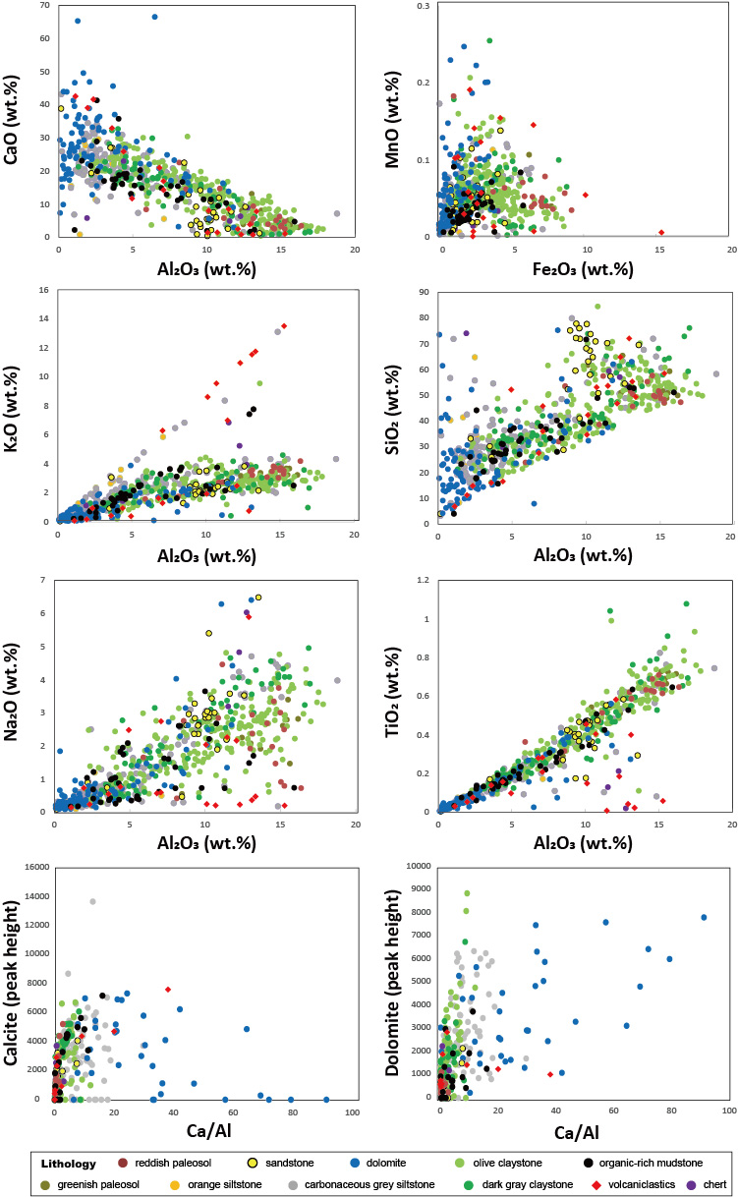
Fig. S1. Bivariate plots of each element and mineral.
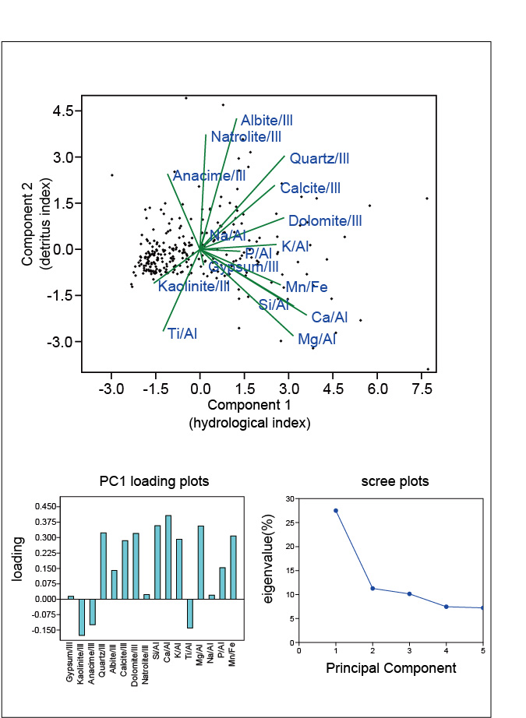
Fig. S2. Results of the principal component analysis. For the principal component analysis, all the elements were divided by Al, and all the mineral contents were divided by the illite contents, prior to normalization.
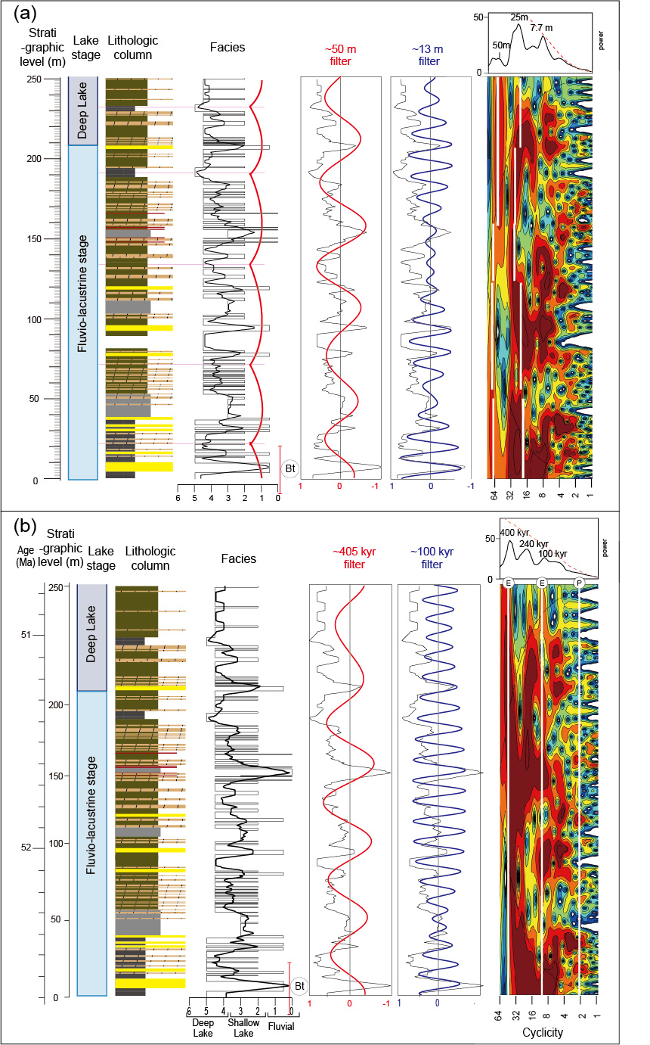
Fig. S3. (a) Lithologic column, lithofacies, and periodicity from the fluvio-lacustrine to deep lake stages. (b) Lithological changes after orbital tuning from the first fluvio-lacustrine to deep lake stages and their periodicity.
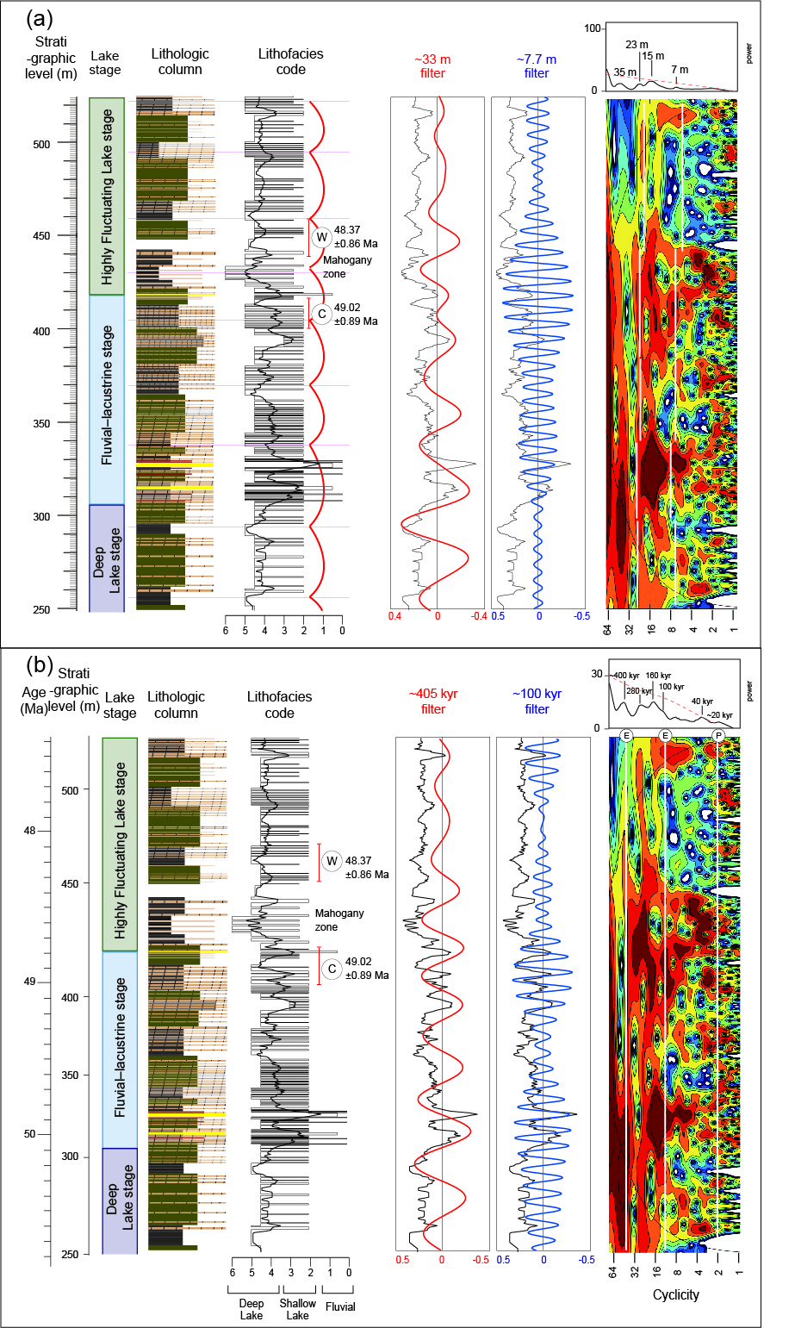
Fig. S4. (a) Lithologic column, lithofacies, and periodicity from the deep lake to highly fluctuating lake stages. (b) Lithological changes after orbital tuning from the first to second deep lake stages and their periodicity.
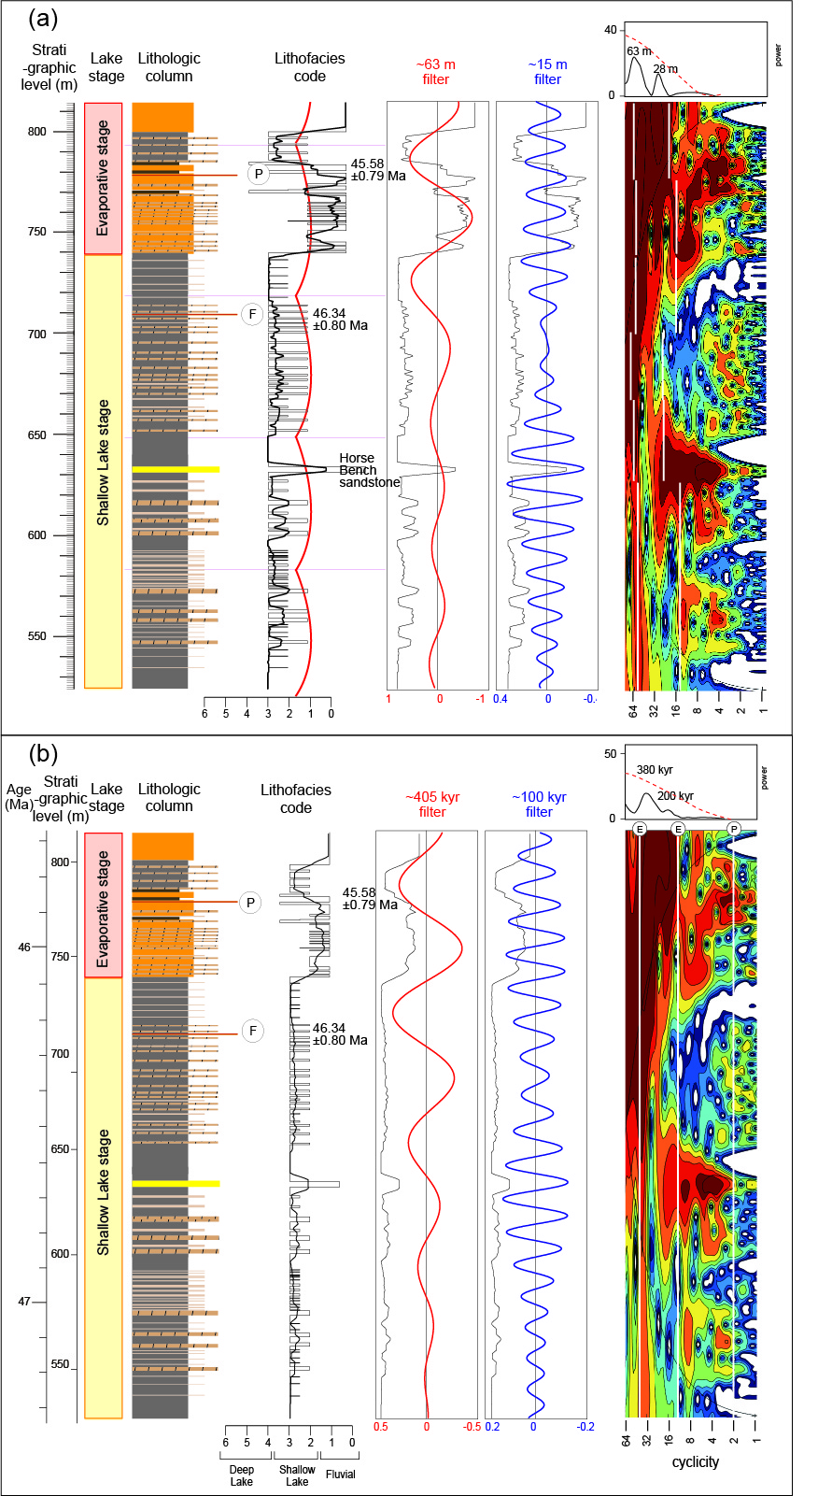
Fig. S5. (a) Lithologic column, lithofacies, and periodicity from the shallow lake to evaporative lake stages. (b) Lithological changes after orbital tuning from the shallow lake to evaporative lake stages and their periodicity.
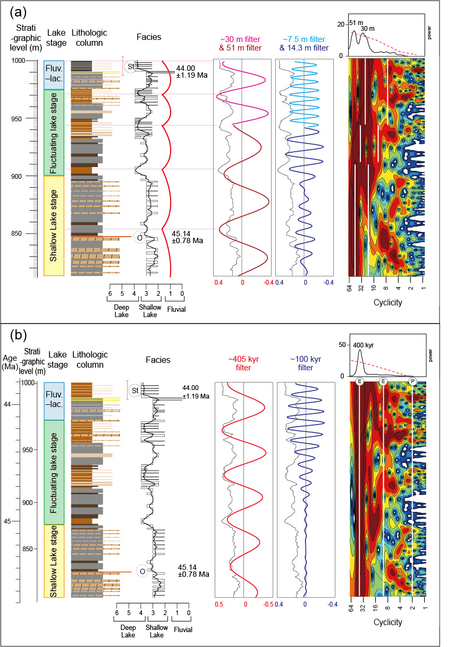
Fig. S6. (a) Lithologic column, lithofacies, and periodicity from the second shallow lake to the uppermost fluvio-lacustrine stages. (b) Lithological changes after orbital tuning from the second shallow lake to the uppermost fluvio-lacustrine stages and their periodicity.
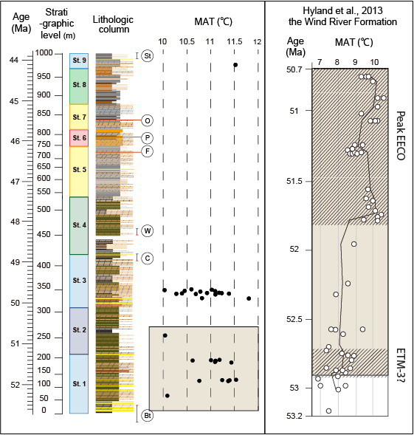
Fig. S7. The reconstructed paleotemperatures (10°C‒12°C) obtained from paleosol mudstone samples in Indian Canyon section (~40°N, ~110°W), Utah and the reconstructed paleotemperatures (6.8°C‒10.7°C) obtained from the Wind River Formation (~43°N, ~109°W), Wyoming (Hyland et al. 2013).

