Extended Data

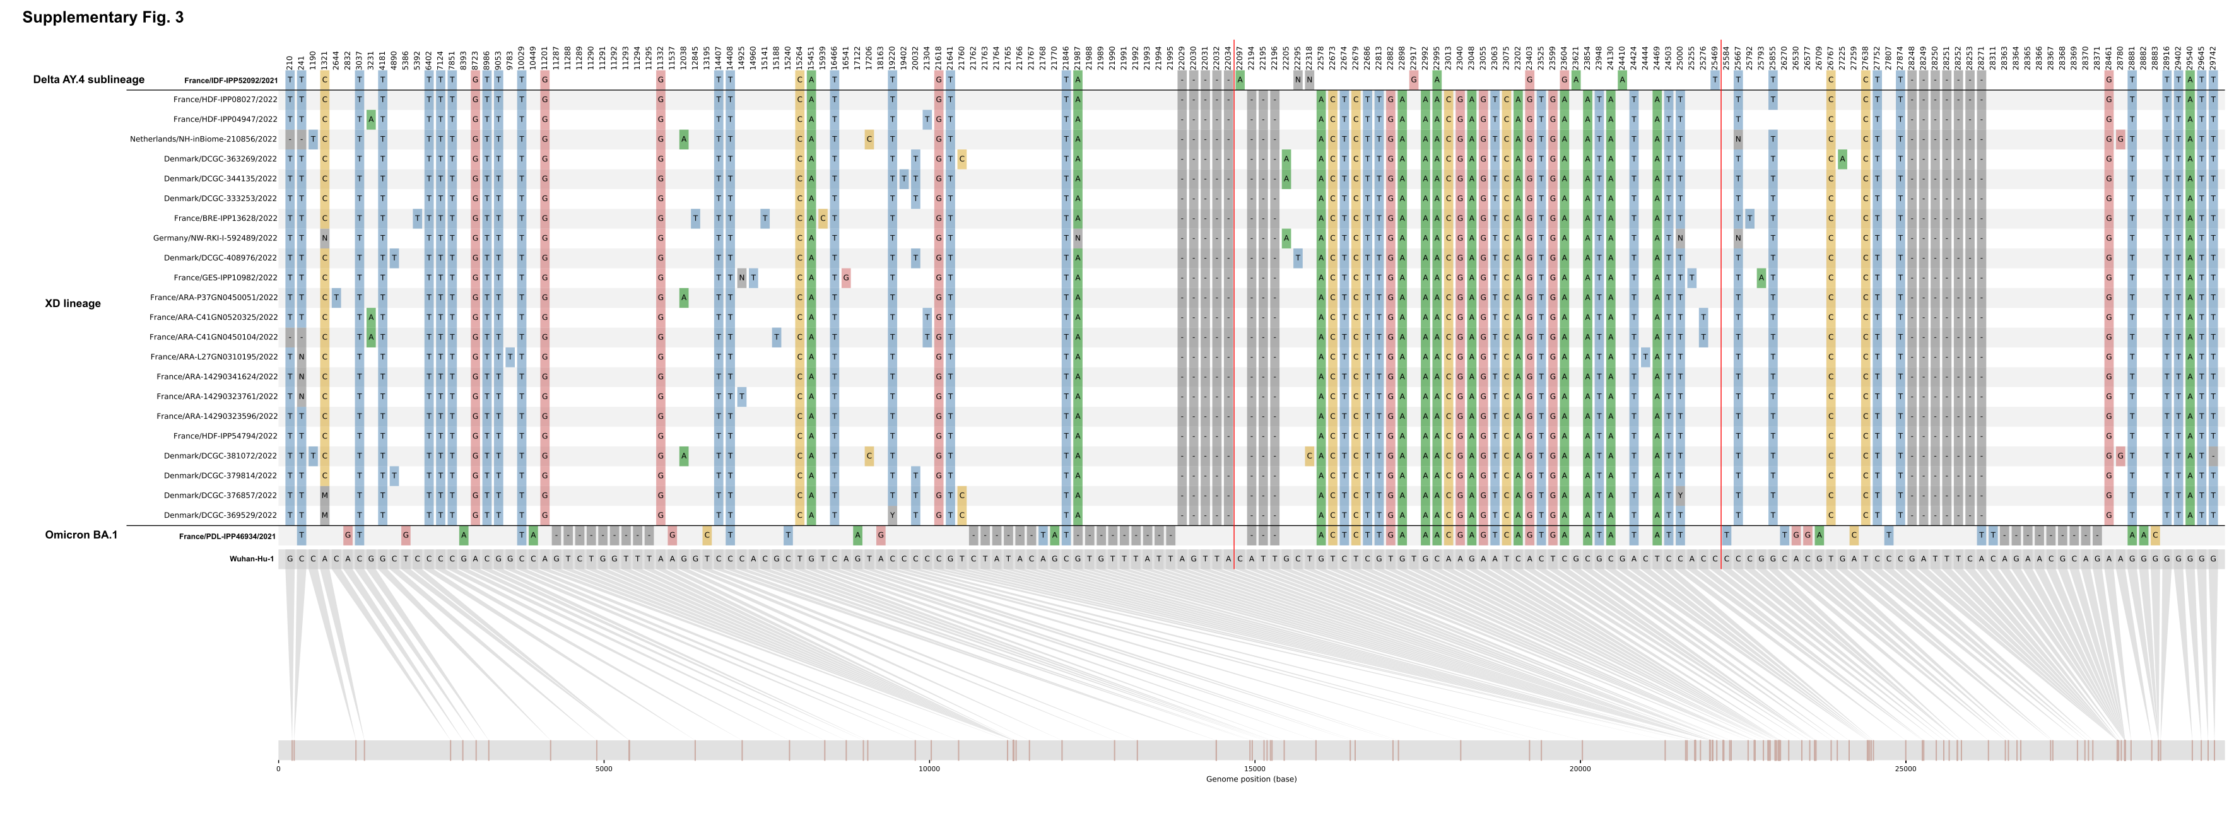
Extended Data Fig. 1. Comparisons of single nucleotide polymorphisms between XD genomes and the putative parental sequences. The ancestral sequence Wuhan-Hu-1 used as reference is shown in grey at the bottom, and the position is shown graphically. Recombination breakpoints are noted with a red line.

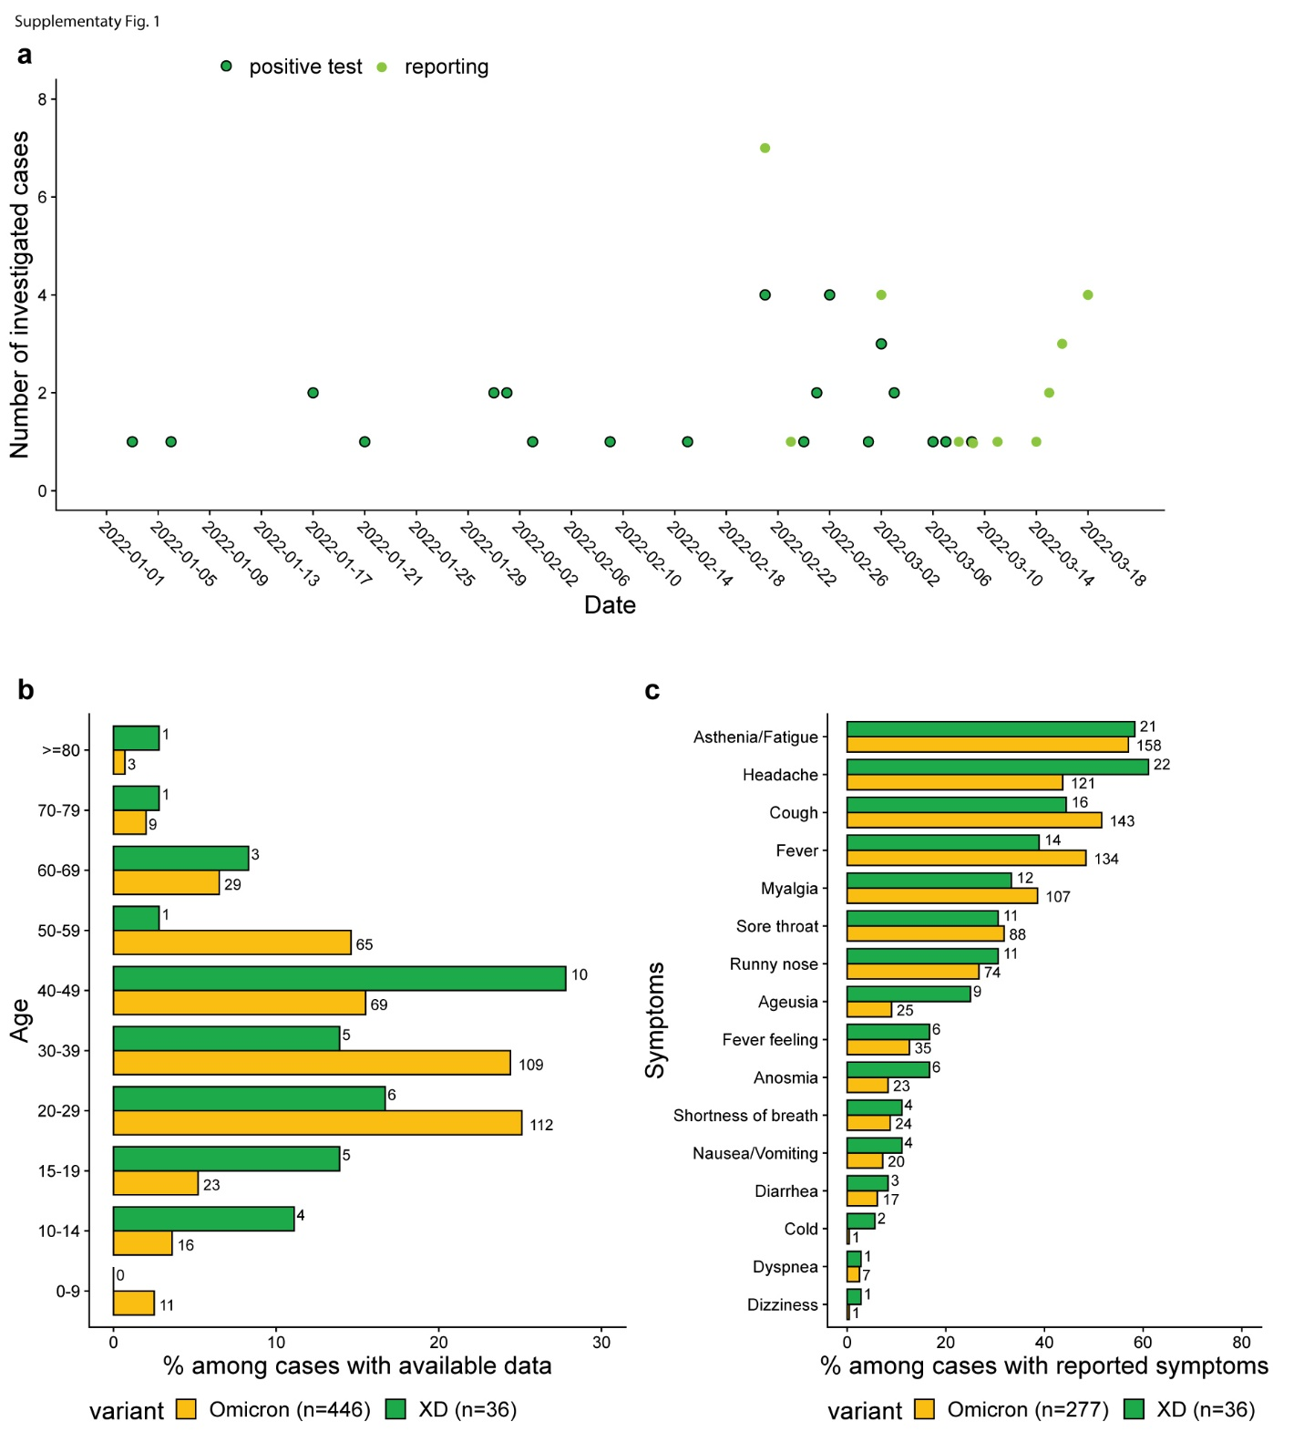
Extended Data Fig. 2. a. Distribution of investigated XD cases, by date of positive test and date of reporting. b. Age distribution and c. clinical presentation of investigated cases infected by XD (N = 38) or by Omicron (N = 469). Bars indicate the percentage of each category among cases with available data and number of cases are shown next to the corresponding bars.
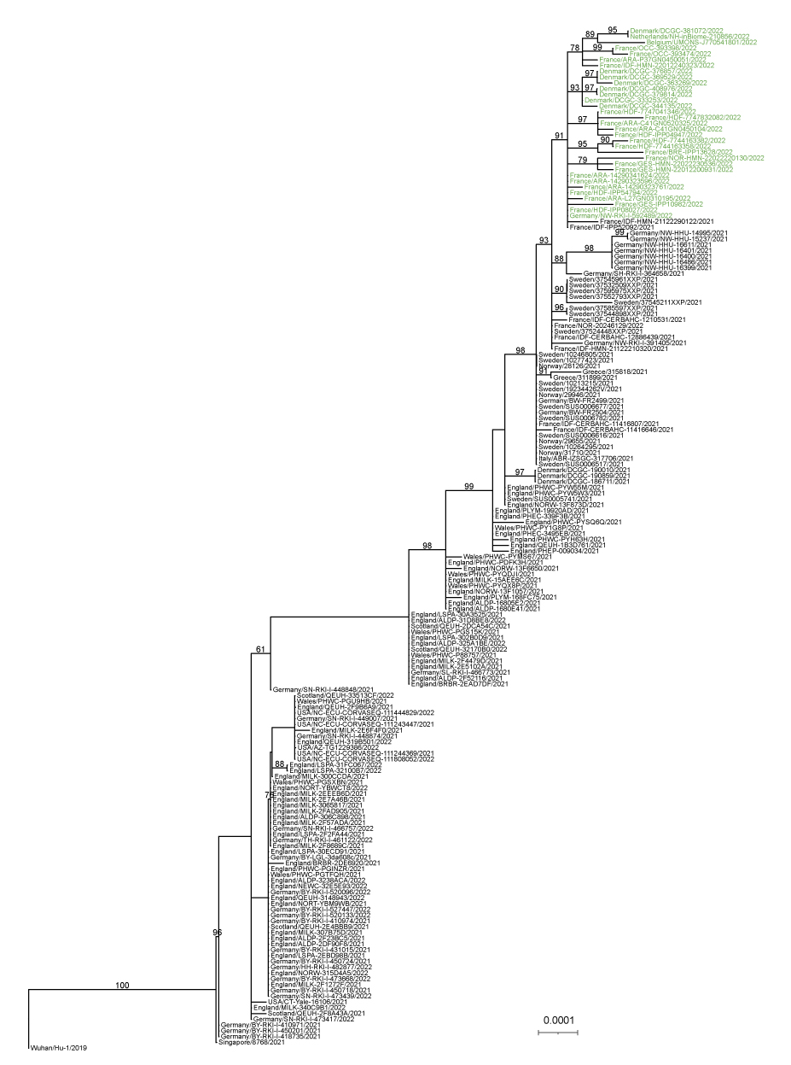
Extended Data Fig. 3. Maximum likelihood phylogeny contextualizing the parental (Delta AY.4) lineage of the XD recombinant. Branch support (higher than 60%) is shown on the tree nodes. The tips corresponding to XD recombinant genomes are coloured in green. The tree is rooted using Wuhan/Hu-1/2019. Branch lengths are proportional to the number of substitutions per site.

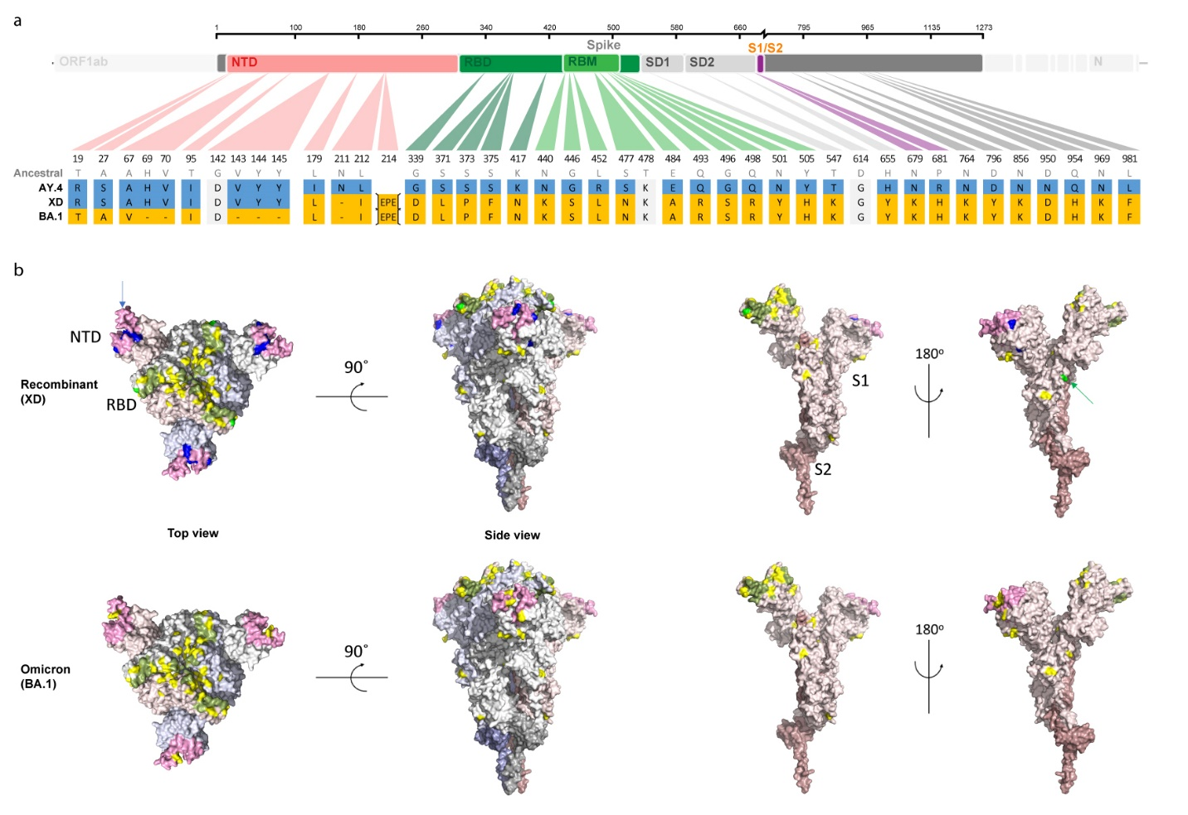
Extended data Fig. 4. a. Scheme of the SARS-CoV-2 spike, highlighting the differences between Delta AY.4 (blue) and Omicron (yellow) and the resulting XD recombinant. Spike domains are color-coded. The receptor binding domain (RBD is in shades of green), the N-terminal Domain (NTD) is in pink, and the furin cleavage site is in purple. b. Structural modelling. The spike is coloured by protomer; lighter and darker shades indicate S1 and S2. The hACE2 binding motif in the RBD is coloured green, and the NTD antigenic supersite is in pink. Omicron mutations are shown in yellow, and Delta mutations (only in the NTD) are in blue. Mutations common to Omicron and Delta are shown in bright green, (arrows). The rotations to generate the different views are indicated. Generated by PyMol (Schrödinger, L. & DeLano, W., 2020. PyMOL, Available at: http://www.pymol.org/pymol) using the PDB accession code 6XR8.

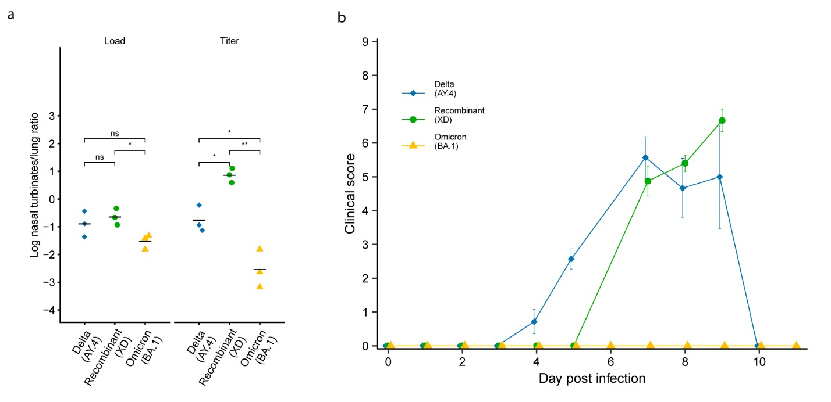
Extended Data Fig. 5. a. Nasal turbinate to lung ratio of viral load and viral titer (same data as in Fig. 3 a,b). b. Kinetics of the composite clinical score in mice infected with Delta AY.4 (n=7), XD recombinant (n=8) or Omicron BA.1 (n=6). See the Methods section for the score definition.

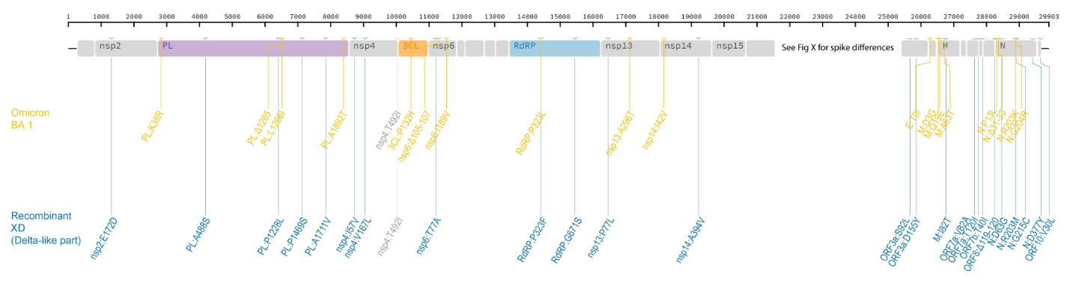
Extended Data Fig. 6. Non-spike differences between Delta AY.4 (blue) and Omicron BA.1 (yellow).

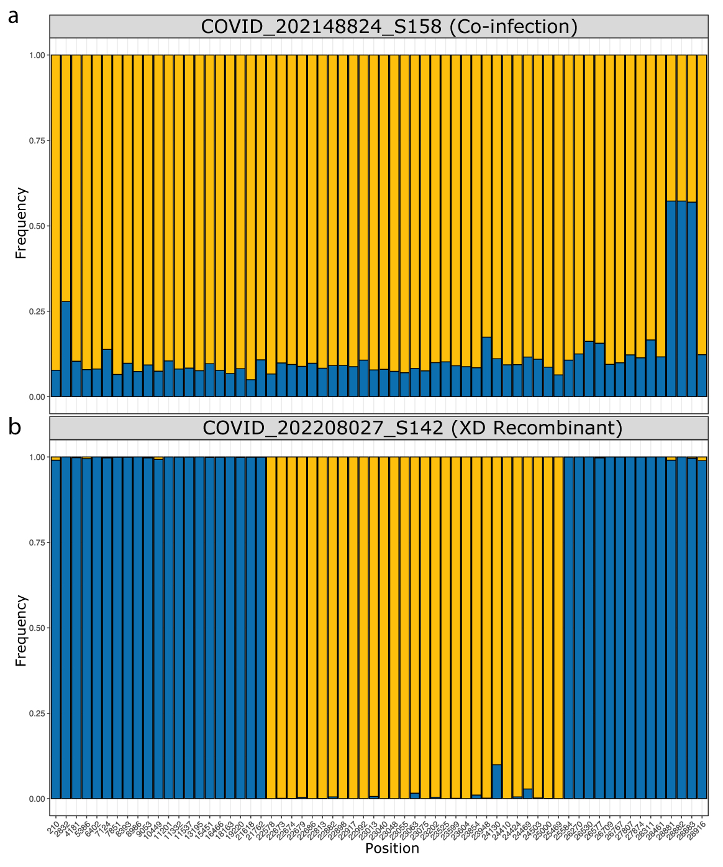
Extended Data Fig. 7. Example of within-sample nucleotide frequencies. a. co-infection. b. recombinant. The frequency of the nucleotides at positions that differ between Delta and Omicron BA.1 are plotted. In yellow, frequency of the nucleotide corresponding to Omicron BA.1, and in blue to Delta AY.4.

