Table S1: Back-trajectories of air masses sampled in this study. Samples #2-5 are composited of several sampling days pooled together. Samples #6-10 represent a single sampling day each.

|  |  |  |  |
| --- | --- | --- | --- |
| Dust 2 | Dust 3 | Dust 4 | Dust 5 |
|  |  |  |  |
|  |  |  |  |
|  |  |  |  |
|  |  |  |  |
|  |  |  |  |

|  |  |  |
| --- | --- | --- |
| Dust 6 | Dust 7 | Dust 8 |
|  |  |  |

|  |  |
| --- | --- |
| Dust 9 | Dust 10 |
|  |  |

Table S2: AMOVA Fs values based on community composition of the different datasets (a) and sample types (b). All pair-wise comparisons resulted in significant q-values (under 0.05).

|  |  |  |  |  |  |  |  |
| --- | --- | --- | --- | --- | --- | --- | --- |
| **a** | Clouds | Dust IL | Dust Red Sea | IL soils | Med Sea | Red Sea | Urban air |
| Beijing smog | 19.1 | 16.0 | 19.2 | 64.6 | 37.1 | 51.4 | 14.1 |
| Clouds |  | 18.3 | 24.9 | 59.0 | 25.3 | 36.0 | 3.3 |
| Dust IL |  |  | 3.7 | 17.0 | 17.7 | 24.4 | 10.6 |
| Dust Red Sea |  |  |  | 15.8 | 18.8 | 23.6 | 14.1 |
| IL soils |  |  |  |  | 28.0 | 35.4 | 32.2 |
| Med Sea |  |  |  |  |  | 16.5 | 11.4 |
| Red Sea |  |  |  |  |  |  | 21.0 |

|  |  |  |  |  |
| --- | --- | --- | --- | --- |
| **b** | Dust | Sea | Smog | Soil |
| Air | 21.2 | 21.5 | 12.4 | 33.9 |
| Dust |  | 22.4 | 17.7 | 15.5 |
| Sea |  |  | 31.1 | 18.2 |
| Smog |  |  |  | 64.6 |

Table S3: AMOVA Fs values based on functional gene profile of the different datasets (a) and ssample types (b). All pair-wise comparisons resulted in significant q-values (under 0.05), except for Urban air and Clouds, marked with *.

|  |  |  |  |  |  |  |  |
| --- | --- | --- | --- | --- | --- | --- | --- |
| **a** | Clouds | Dust IL | Dust Red Sea | IL soils | Med Sea | Red Sea | Urban air |
| Beijing smog | 17.5 | 8.8 | 11.9 | 33.8 | 12.6 | 23.4 | 9.6 |
| Clouds |  | 15.1 | 22.7 | 49.1 | 16.6 | 33.3 | *3.1 |
| Dust IL |  |  | 3.1 | 14.4 | 7.3 | 15.5 | 7.0 |
| Dust Red Sea |  |  |  | 9.6 | 7.4 | 18.6 | 10.6 |
| IL soils |  |  |  |  | 13.6 | 27.1 | 26.8 |
| Med Sea |  |  |  |  |  | 5.4 | 7.7 |
| Red Sea |  |  |  |  |  |  | 14.9 |

|  |  |  |  |  |
| --- | --- | --- | --- | --- |
| **b** | Dust | Sea | Smog | Soil |
| Air | 18.4 | 18.1 | 13.1 | 40.4 |
| Dust |  | 14.3 | 10.9 | 13.0 |
| Sea |  |  | 16.1 | 18.3 |
| Smog |  |  |  | 33.8 |

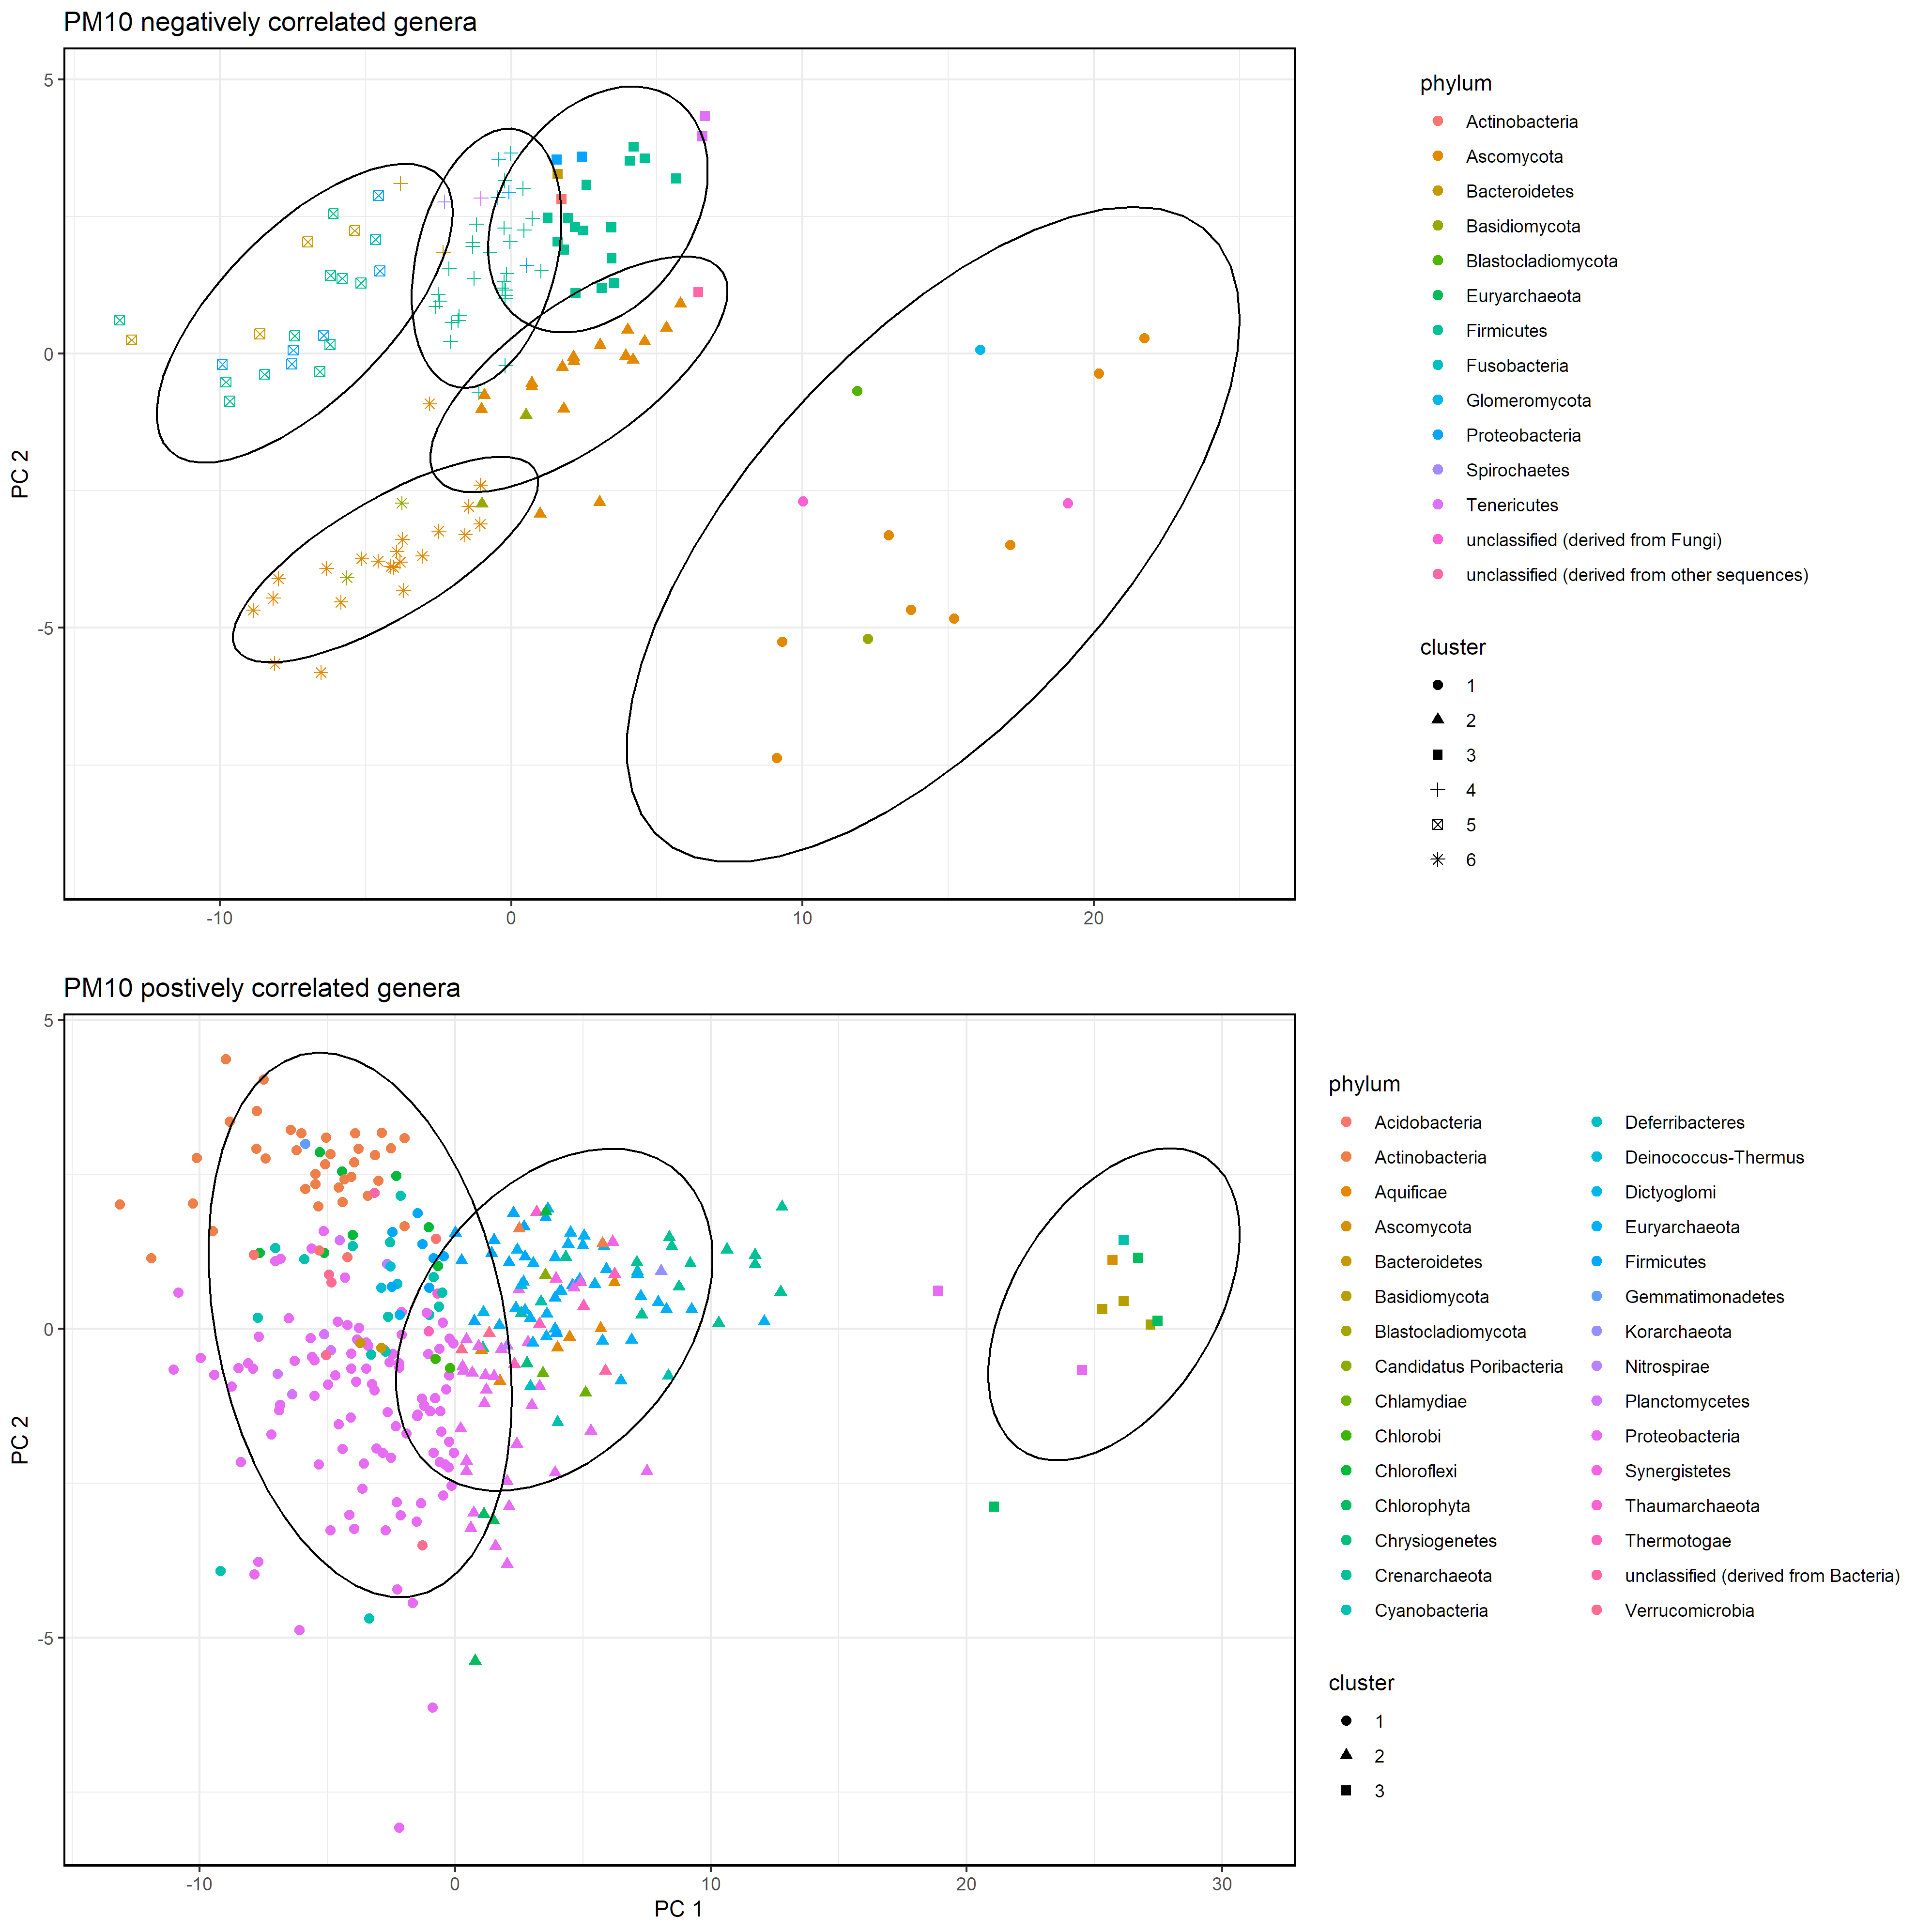

Figure S1: K-means clusters of genera that negatively or positively correlated PM10 concentrations of Dust IL samples

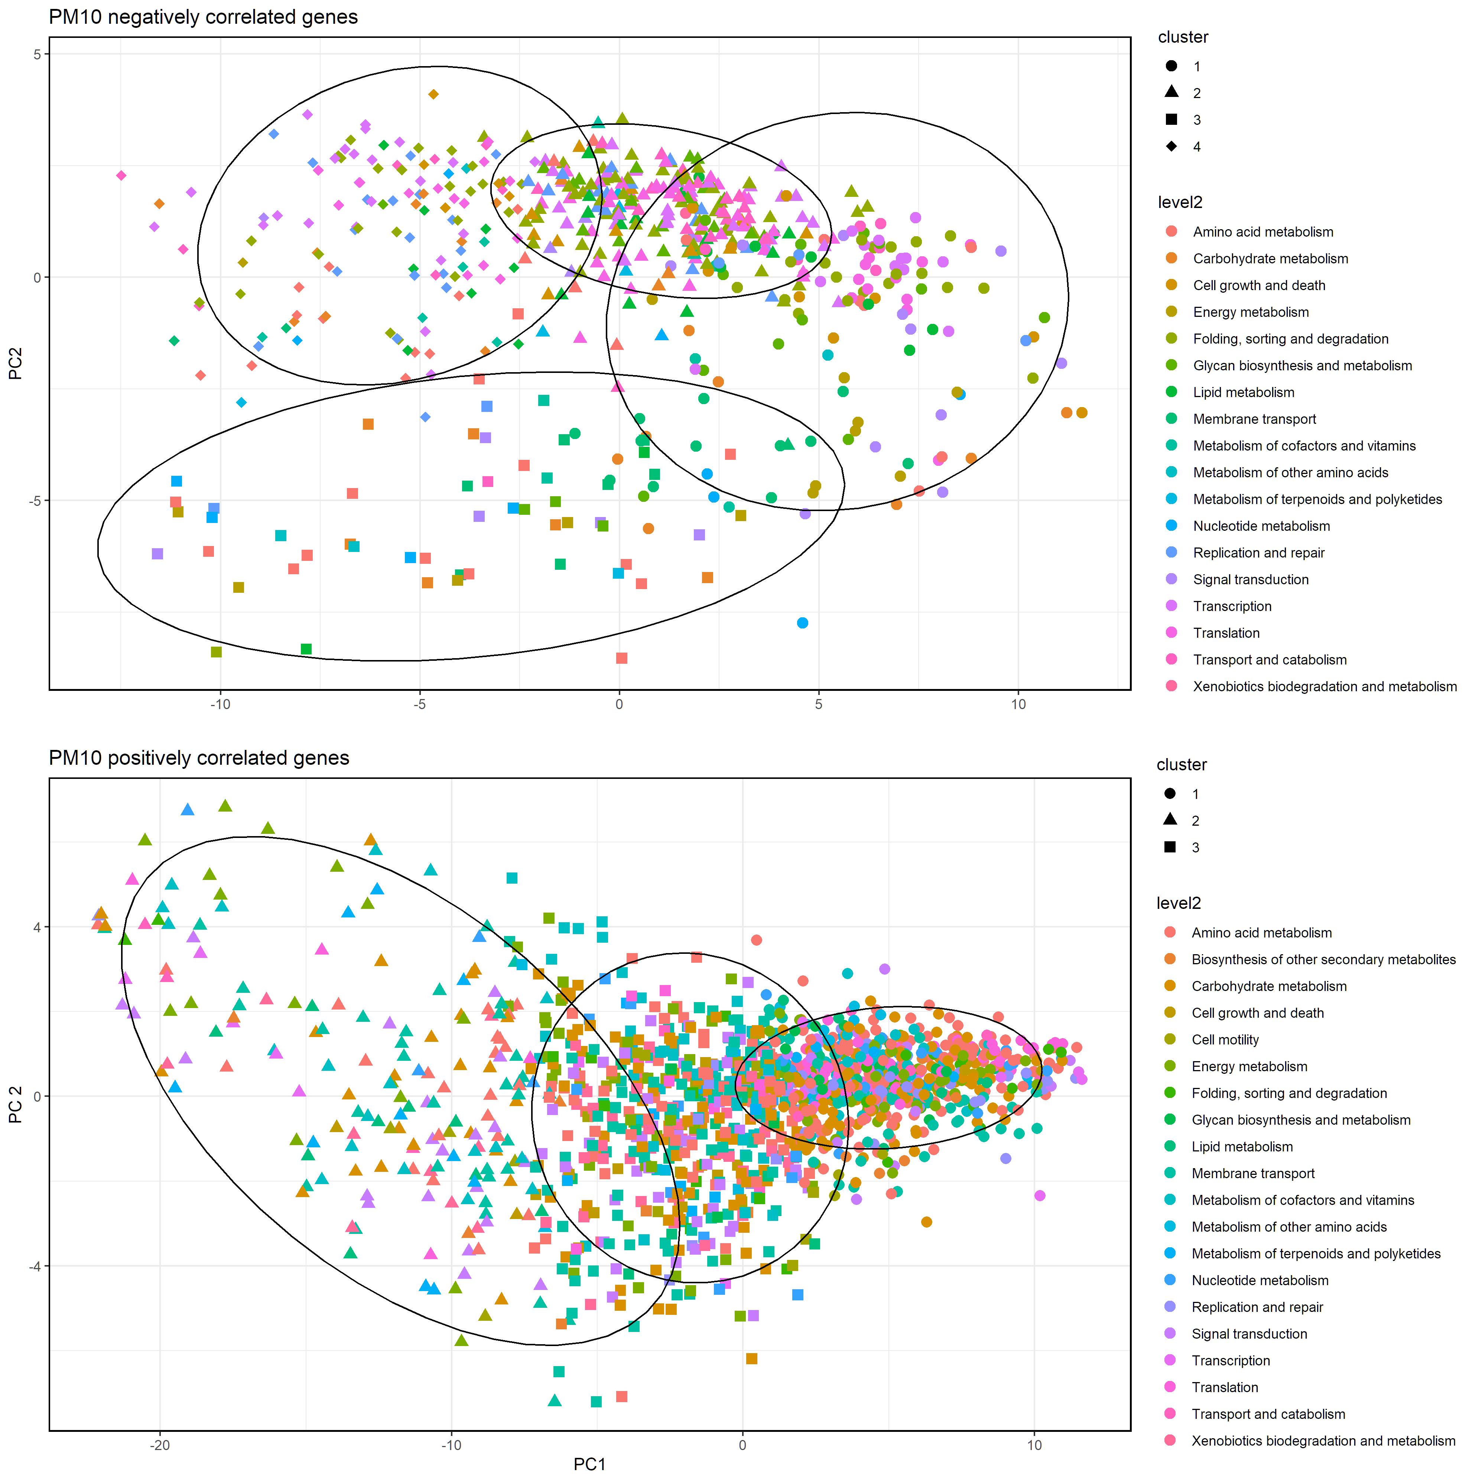

Figure S2: K-means clusters of genes that negatively or positively correlated PM10 concentrations of Dust IL samples