Appendices

Health Capabilities and the Determinants of Infant Mortality in Brazil, 2004-2015: an innovative methodological framework
Alexandre Bugelli¹* - Roxane Borgès Da Silva² - Ladislau Dowbor³ - Claude Sicotte⁴
Appendix 1 Correlation Matrix
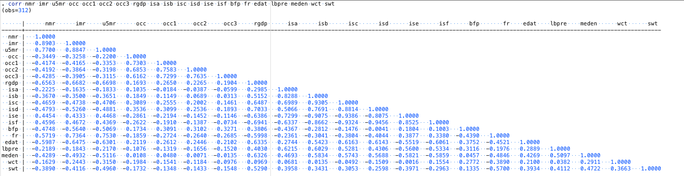
Appendix 2 Estimation with fixed effect clustering by
"macro-regions" and "year", absorbing "year"

