Table S1. Summary Statistics for the Follow-up Time in Years.
Group | N | Years (Means±Standard Deviation)
Total | 463 | 9.56±6.82
Sleep Disturbance | 357 | 8.47±6.14
Normal Sleep | 106 | 12.16±7.61

Table S2. Time Linear Mixed-Effects Model of PACC (trails B).
Fixed effects | Coef. | Std. Err. | z | P | 95% CI
Education | 0.28 | 0.04 | 6.48 | <0.001 | 0.19 | 0.36
Gender | -1.06 | 0.22 | -4.78 | <0.001 | -1.49 | -0.62
Year | -0.17 | 0.01 | -24.32 | <0.001 | -0.18 | -0.15
Sleep Disturbance | 1.80 | 0.31 | 5.82 | <0.001 | 1.19 | 2.41
Sleep Disturbance*Year | -0.15 | 0.01 | -13.77 | <0.001 | -0.18 | -0.13
Constant | -3.51 | 0.70 | -5.00 | <0.001 | -4.88 | -2.13
LR test vs. linear model: chi2(2) = 8411.95 P <0.001
AIC=15774

Table S3. Time Linear Mixed-Effects Model of MMSE.
Fixed effects | Coef. | Std. Err. | z | P | 95% CI
Education | 0.06 | 0.02 | 3.62 | <0.001 | 0.03 | 0.09
Gender | -0.29 | 0.09 | -3.28 | 0.001 | -0.46 | -0.12
Year | -0.05 | 0.00 | -13.85 | <0.001 | -0.06 | -0.05
Sleep Disturbance | 0.94 | 0.15 | 6.09 | <0.001 | 0.64 | 1.24
Sleep Disturbance*Year | -0.10 | 0.01 | -16.04 | <0.001 | -0.12 | -0.09
Constant | 28.33 | 0.28 | 102.44 | <0.001 | 27.79 | 28.87
LR test vs. linear model: chi2(2) = 5340.85 P <0.001
AIC=12062

Table S4. Time Linear Mixed-Effects Model of LDELTOT.
Fixed effects | Coef. | Std. Err. | z | P | 95% CI
Education | 0.37 | 0.05 | 7.25 | <0.001 | 0.27 | 0.47
Gender | -0.87 | 0.26 | -3.29 | 0.001 | -1.38 | -0.35
Year | -0.10 | 0.01 | -13.95 | <0.001 | -0.11 | -0.08
Sleep Disturbance | 0.64 | 0.30 | 2.12 | 0.034 | 0.05 | 1.24
Sleep Disturbance*Year | <0.01 | 0.01 | 0.00 | 0.999 | -0.02 | 0.02
Constant | 8.08 | 0.84 | 9.60 | <0.001 | 6.43 | 9.73
LR test vs. linear model: chi2(2) = 8911.44 P <0.001
AIC=13919

Table S5. Time Linear Mixed-Effects Model of ADAS13.
Fixed effects | Coef. | Std. Err. | z | P | 95% CI
Education | -0.13 | 0.07 | -1.91 | 0.057 | -0.27 | 0.00
Gender | 1.36 | 0.36 | 3.74 | <0.001 | 0.65 | 2.07
Year | 0.49 | 0.01 | 46.56 | <0.001 | 0.47 | 0.51
Sleep Disturbance | -3.97 | 0.47 | -8.48 | <0.001 | -4.88 | -3.05
Sleep Disturbance*Year | 0.20 | 0.02 | 11.51 | <0.001 | 0.16 | 0.23
Constant | 10.37 | 1.15 | 9.01 | <0.001 | 8.12 | 12.63
LR test vs. linear model: chi2(2) = 8099.26 P <0.001
AIC=18589

Table S6. Time Linear Mixed-Effects Model of CDRSB.
Fixed effects | Coef. | Std. Err. | z | P | 95% CI
Year | 0.05 | 0.00 | 17.02 | <0.001 | 0.04 | 0.05
Sleep Disturbance | -0.81 | 0.13 | -6.20 | <0.001 | -1.06 | -0.55
Sleep Disturbance*Year | 0.11 | 0.00 | 23.71 | <0.001 | 0.10 | 0.12
Constant | -0.07 | 0.03 | -2.31 | 0.021 | -0.14 | -0.01
LR test vs. linear model: chi2(2) = 6989.24 P <0.001
AIC=10458

Table S7. Time Linear Mixed-Effects Model of Ventricles ICV.
Fixed effects | Coef. | Std. Err. | z | P | 95% CI
Gender | 0.68 | 0.16 | 4.14 | <0.001 | 0.36 | 1.00
Year | 0.09 | 0.00 | 55.55 | <0.001 | 0.09 | 0.09
Sleep Disturbance | -0.06 | 0.07 | -0.92 | 0.358 | -0.19 | 0.07
Sleep Disturbance*Year | 0.01 | 0.00 | 5.04 | <0.001 | 0.01 | 0.02
Constant | 2.84 | 0.12 | 24.58 | <0.001 | 2.61 | 3.06
LR test vs. linear model: chi2(2) = 15991.66 P <0.001
AIC=2023

Table S8. Time Linear Mixed-Effects Model of Hippocampus ICV.
Fixed effects | Coef. | Std. Err. | z | P | 95% CI
Education | 0.00 | 0.00 | -2.24 | 0.025 | -0.01 | 0.00
Gender | -0.02 | 0.01 | -3.37 | 0.001 | -0.03 | -0.01
Year | 0.00 | 0.00 | -24.61 | <0.001 | 0.00 | 0.00
Sleep Disturbance | -0.01 | 0.00 | -1.65 | 0.098 | -0.01 | 0.00
Sleep Disturbance*Year | 0.00 | 0.00 | 1.52 | 0.128 | 0.00 | 0.00
Constant | 0.78 | 0.02 | 39.74 | <0.001 | 0.74 | 0.82
LR test vs. linear model: chi2(2) = 11295.86 P <0.001
AIC=-7460

Table S9. Time Linear Mixed-Effects Model of ABETA.
Fixed effects | Coef. | Std. Err. | z | P | 95% CI
APOE4 | -314.71 | 41.11 | -7.65 | <0.001 | -395.29 | -234.12
Year | -9.55 | 1.01 | -9.47 | <0.001 | -11.52 | -7.57
Sleep Disturbance | -29.93 | 25.34 | -1.18 | 0.238 | -79.60 | 19.74
Sleep Disturbance*Year | 6.51 | 1.81 | 3.61 | <0.001 | 2.97 | 10.05
Constant | 1315.87 | 24.83 | 53.00 | <0.001 | 1267.21 | 1364.53
LR test vs. linear model: chi2(2) = 2908.92 P <0.001
AIC=12260

Table S10. Time Linear Mixed-Effects Model of TAU.
Fixed effects | Coef. | Std. Err. | z | P | 95% CI
APOE4 | 20.43 | 9.39 | 2.17 | 0.030 | 2.02 | 38.84
Year | 2.53 | 0.16 | 15.89 | <0.001 | 2.22 | 2.84
Sleep Disturbance | 2.26 | 6.05 | 0.37 | 0.709 | -9.60 | 14.11
Sleep Disturbance*Year | 0.51 | 0.29 | 1.76 | 0.078 | -0.06 | 1.09
Constant | 227.51 | 5.65 | 40.24 | <0.001 | 216.43 | 238.60
LR test vs. linear model: chi2(2) = 3934.52 P <0.001
AIC=9206.6

Table S11. Time Linear Mixed-Effects Model of P-TAU.
Fixed effects | Coef. | Std. Err. | z | P | 95% CI
APOE4 | 3.03 | 0.97 | 3.11 | 0.002 | 1.12 | 4.94
Year | 0.30 | 0.02 | 17.98 | <0.001 | 0.27 | 0.33
Sleep Disturbance | 0.33 | 0.66 | 0.51 | 0.613 | -0.96 | 1.62
Sleep Disturbance*Year | <0.01 | 0.03 | -0.01 | 0.994 | -0.06 | 0.06
Constant | 20.39 | 0.59 | 34.72 | <0.001 | 19.24 | 21.54
LR test vs. linear model: chi2(2) = 4072.69 P <0.001
AIC=5144.3

Table S12. Time Linear Mixed-Effects Model of FDG.
Fixed effects | Coef. | Std. Err. | z | P | 95% CI
Family History of AD | 0.01 | 0.01 | 1.20 | 0.228 | -0.01 | 0.04
Gender | -0.02 | 0.01 | -2.13 | 0.034 | -0.04 | 0.00
Year | -0.01 | 0.00 | -17.07 | <0.001 | -0.01 | 0.00
Sleep Disturbance | 0.00 | 0.01 | -0.06 | 0.951 | -0.02 | 0.02
Sleep Disturbance*Year | 0.00 | 0.00 | -1.66 | 0.097 | 0.00 | 0.00
Constant | 1.33 | 0.01 | 155.92 | <0.001 | 1.31 | 1.34
LR test vs. linear model: chi2(2) = 3700.89 P <0.001
AIC=-2219.6

Table S13. Time Linear Mixed-Effects Model of AV45.
Fixed effects | Coef. | Std. Err. | z | P | 95% CI
Gender | -0.04 | 0.02 | -2.37 | 0.018 | -0.07 | -0.01
APOE4 | 0.10 | 0.02 | 6.39 | <0.001 | 0.07 | 0.13
Year | 0.00 | 0.00 | 15.03 | <0.001 | 0.00 | 0.00
Sleep Disturbance | 0.00 | 0.01 | -0.20 | 0.839 | -0.02 | 0.02
Sleep Disturbance*Year | 0.00 | 0.00 | 1.01 | 0.310 | 0.00 | 0.00
Constant | 1.10 | 0.01 | 86.94 | <0.001 | 1.07 | 1.12
LR test vs. linear model: chi2(2) = 11142.61 P <0.001
AIC=-3706.3

Table S14. Time Linear Mixed-Effects Model of cognitive profiles in the participants without elevated CSF beta.
Continuous time Models | Sleep Disturbance |  | Year |  | Sleep Disturbance*Year
Cognitive Profiles | Beta (95%CI) | P-Value | Beta (95%CI) | P-Value | Beta (95%CI) | P-Value
PACC (z score composite) ª | 1.73 (1.12, 2.34) | ＜0.001 | -0.17 (-0.18, -0.15) | ＜0.001 | -0.15 (-0.18, -0.13) | ＜0.001
MMSE ª | 0.92 (0.61, 1.22) | ＜0.001 | -0.05 (-0.06, -0.05) | ＜0.001 | -0.10 (-0.12, -0.09) | ＜0.001
Logical Memory Delayed Recall ª | 0.55 (-0.05, 1.15) | 0.071 | -0.10 (-0.11, -0.08) | ＜0.001 | 0.00 (-0.02, 0.02) | 0.861
CDR-Sum of Boxes ª | -0.81 (-1.06, -0.55) | ＜0.001 | 0.05 (0.04, 0.05) | ＜0.001 | 0.11 (0.10, 0.12) | ＜0.001
ª Model was adjusted for gender and education which were selected by AIC.

Table S15. Time Linear Mixed-Effects Model of amyloid markers Profiles and FDG in the participants without elevated CSF beta.
Continuous time Models | Sleep Disturbance |  | Year |  | Sleep Disturbance*Year
Amyloid markers and FDG | Beta (95%CI) | P-Value | Beta (95%CI) | P-Value | Beta (95%CI) | P-Value
CSF Aβ42 ª | -31.40 (-81.12, 18.32) | 0.216 | -9.54 (-11.51, -7.56) | ＜0.001 | 6.50 (2.96, 10.03) | ＜0.001
Amyloid PET SUVR ^{b} | 0.00 (-0.02, 0.02) | 0.809 | 0.00 (0.00, 0.00) | ＜0.001 | 0.00 (0.00, 0.00) | 0.305
FDG ^{c} | 0.00 (-0.02, 0.02) | 0.974 | -0.01 (-0.01, 0.00) | ＜0.001 | 0.00 (0.00, 0.00) | 0.091
ª Model was adjusted for APOE4 which were selected by AIC.
^{b} Model was adjusted for gender which were selected by AIC.
^{c} Model was adjusted for gender andFamily History of AD4 which were selected by AIC.

Table S16. Time Linear Mixed-Effects Model of Neurodegeneration Profiles in the participants without elevated CSF beta.
Continuous time Models | Sleep Disturbance |  | Year |  | Sleep Disturbance*Year
Neurodegeneration Profiles | Beta (95%CI) | P-Value | Beta (95%CI) | P-Value | Beta (95%CI) | P-Value
CSF t-Tau ª | 2.05 (-9.82, 13.93) | 0.735 | 2.53 (2.22, 2.84) | ＜0.001 | 0.52 (-0.05, 1.09) | 0.076
CSF p-Tau ª | 0.34 (-0.95, 1.63) | 0.609 | 0.30 (0.27, 0.33) | ＜0.001 | 0.00 (-0.06, 0.06) | 0.999
Hippocampal Volume ^{b} | -0.01 (-0.01, 0.00) | 0.090 | 0.00 (0.00, 0.00) | ＜0.001 | 0.00 (0.00, 0.00) | 0.129
Ventricular Volume ^{c} | -0.06 (-0.19, 0.07) | 0.342 | 0.09 (0.09, 0.09) | ＜0.001 | 0.01 (0.01, 0.02) | ＜0.001
ª Model was adjusted for APOE4 which were selected by AIC.
^{b} Model was adjusted for gender and education which were selected by AIC.
^{c} Model was adjusted for gender and APOE4 which were selected by AIC.

Table S17. The hazard ratio of Sleep Disturbance for the AD in the Cox regression model in the participants without elevated CSF beta.
Fixed effects | Haz. Ratio | Std. Err. | z | P | 95% CI
Family History of Dementia | 0.78 | 0.23 | -0.84 | 0.404 | 0.43 | 1.40
Family History of AD | 1.19 | 0.36 | 0.57 | 0.567 | 0.66 | 2.15
Gender | 1.39 | 0.28 | 1.63 | 0.103 | 0.94 | 2.06
APOE4 | 2.47 | 0.45 | 4.90 | 0.000 | 1.72 | 3.54
Education | 0.95 | 0.03 | -1.68 | 0.094 | 0.89 | 1.01
Sleep Disturbance | 1.70 | 0.33 | 2.76 | 0.006 | 1.17 | 2.49

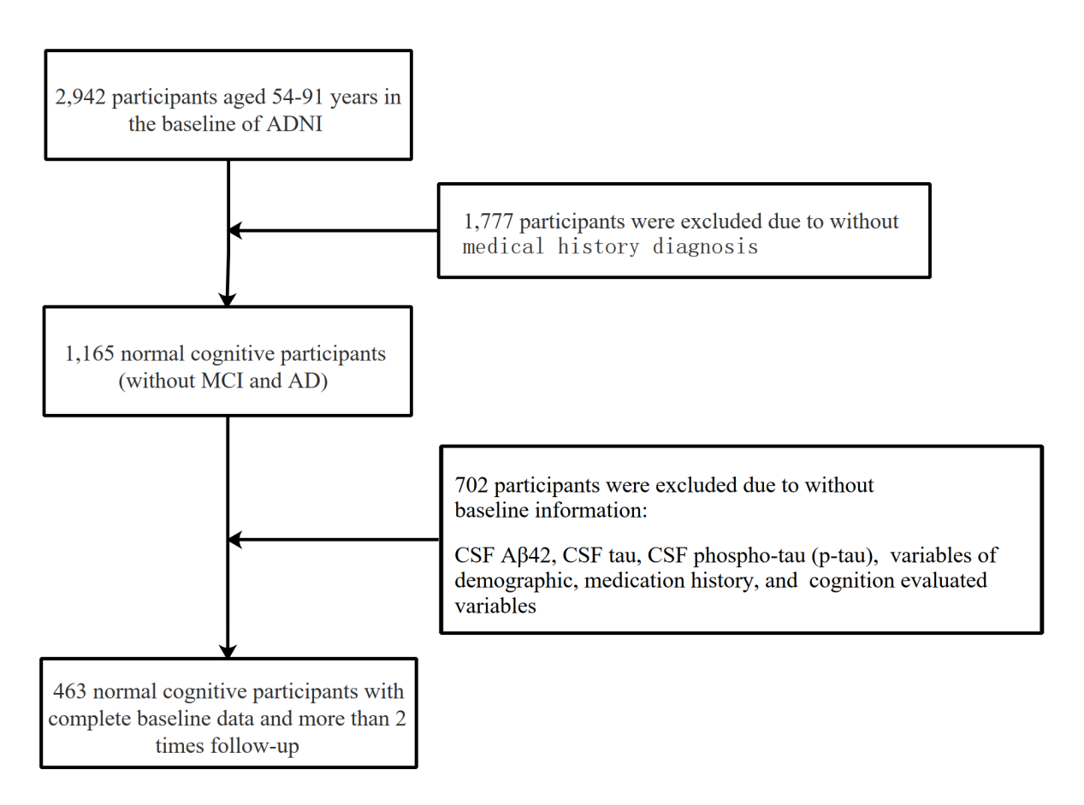
Figure S1. Study Flow Chart.

