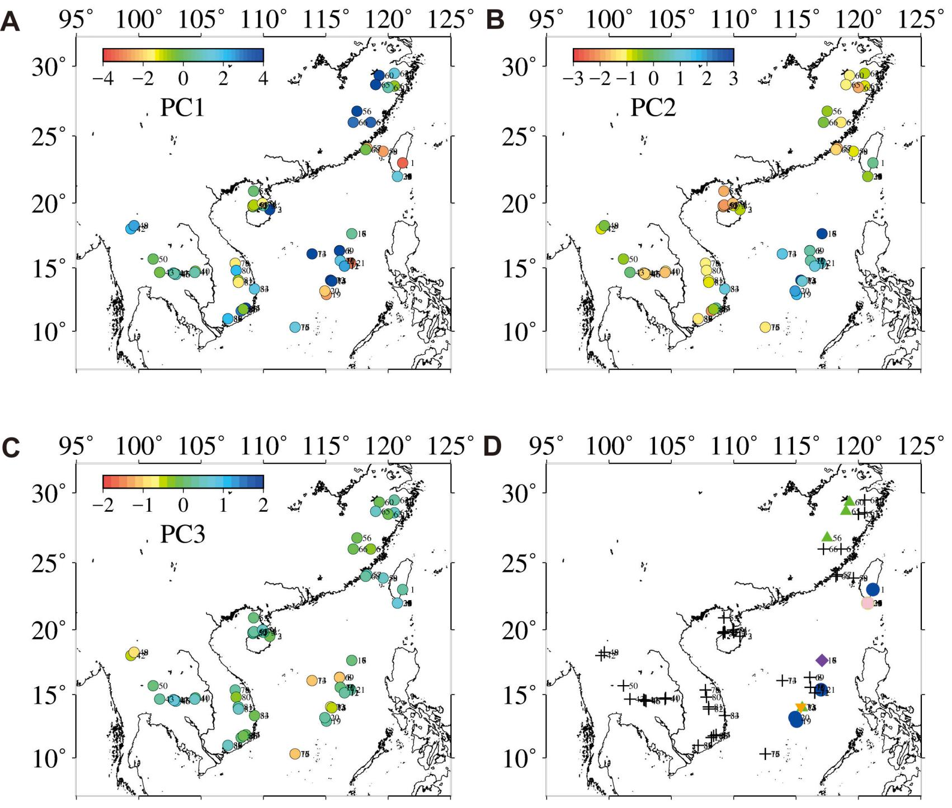

Fig. S1 The spatial distribution of <33Ma volcanic rocks from the Southeast Asian based on principal component values calculated by trace elements.

