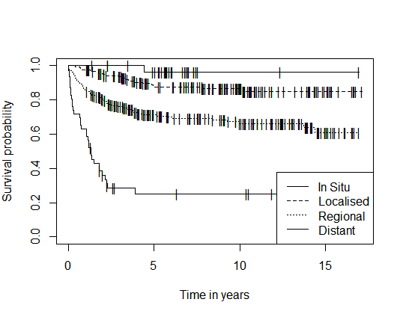
Supplementary Figure 1 (S1): Kaplan-Meier Survival Curve of Cervical Cancer Patients by SEER Staging

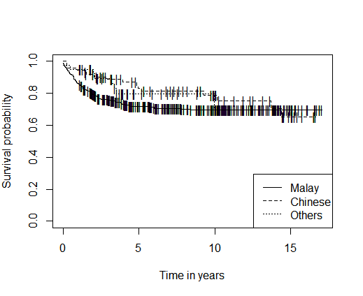
Supplementary Figure 2 (S2): Kaplan-Meier Survival Curve of Cervical Cancer Patients by Ethnic Groups

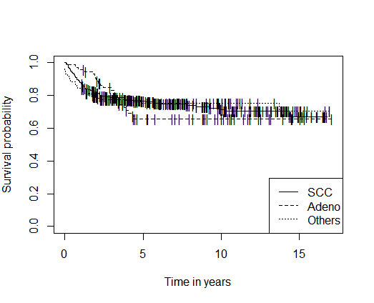
Supplementary Figure 3 (S3): Kaplan-Meier Survival Curve of Cervical Cancer Patients by Cancer Histopathology

