Supplementary figures
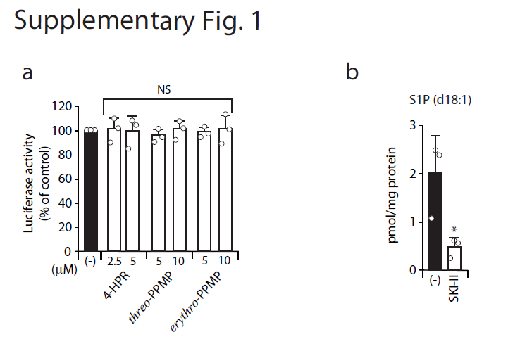
Supplementary Fig. 1 | Effect of compounds on Renilla luciferase activity and SKase inhibitor SKI-II on cellular sphingosine-1-phosphate (S1P) level. (a) HEK293FT cells expressing dual split protein (DSP)1-7 and DSP8-11 were treated for 2 days with the indicated concentrations of the compounds. Cells were resuspended in 6 μM EnduRen, a substrate for Renilla luciferase, and incubated at 37 °C for 4 h. Luciferase activity was measured using the SpectraMax i3x Microplate Reader. Statistical significance was determined by one-way ANOVA followed by the Dunnett test for multiple comparisons when compared with vehicle/dimethyl sulfoxide (DMSO)-treated cells. (b) Effect of SKase inhibitor SKI-II on cellular S1P levels. 293FT/ACE2/TMPRSS2/DSP1-7 cells were treated for 2 days with 10 μM SKI-II. Cellular levels of S1P were quantified by liquid chromatography with tandem mass spectrometry (LC-MS/MS) analysis according to Saigusa et al. Simultaneous quantitation of sphingoid bases and their phosphates was performed on biological samples by LC/electrospray ionization tandem MS. Anal. Bioanal. Chem. 403, 1897-1905 (2012). Statistical significance was determined by the Student’s t test. * p < 0.05. Abbreviations: 4-HPR, N-(4-hydroxyphenyl)retinamide; NS, not significant

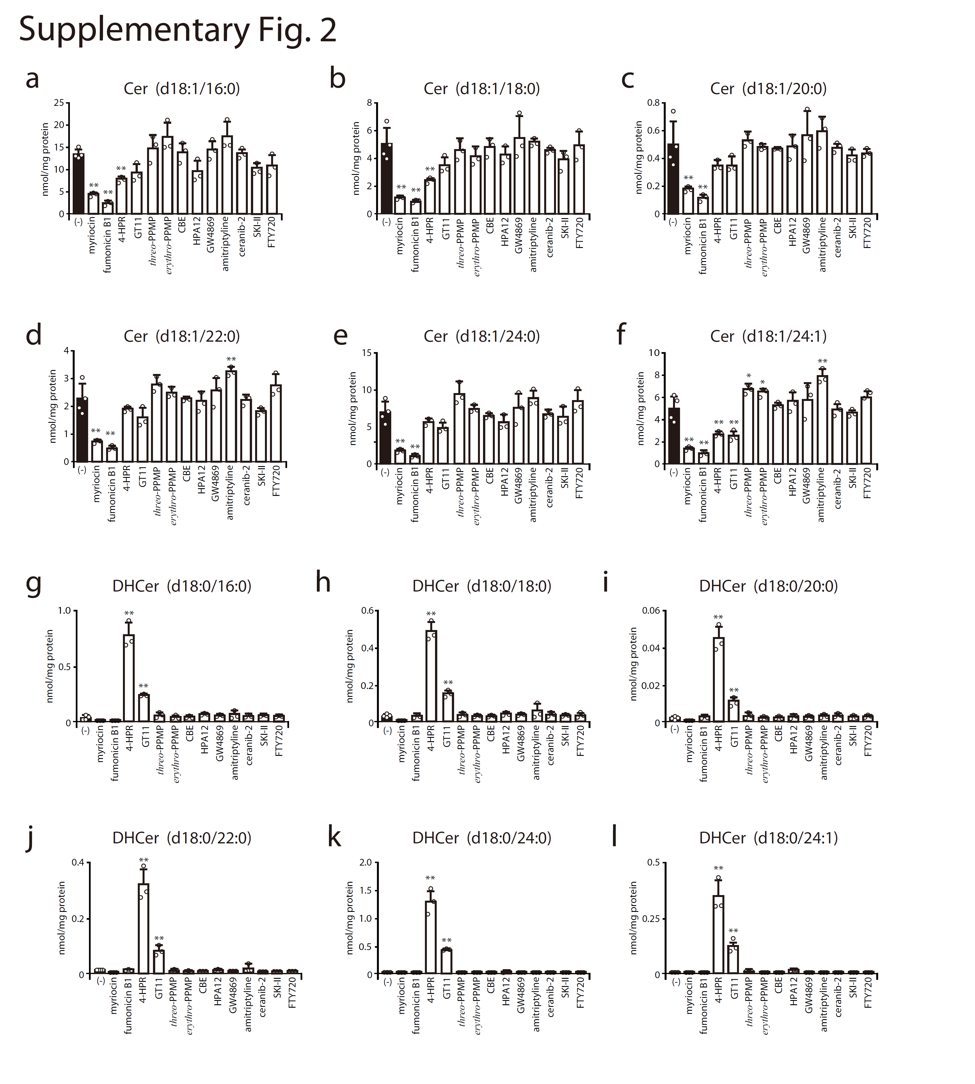

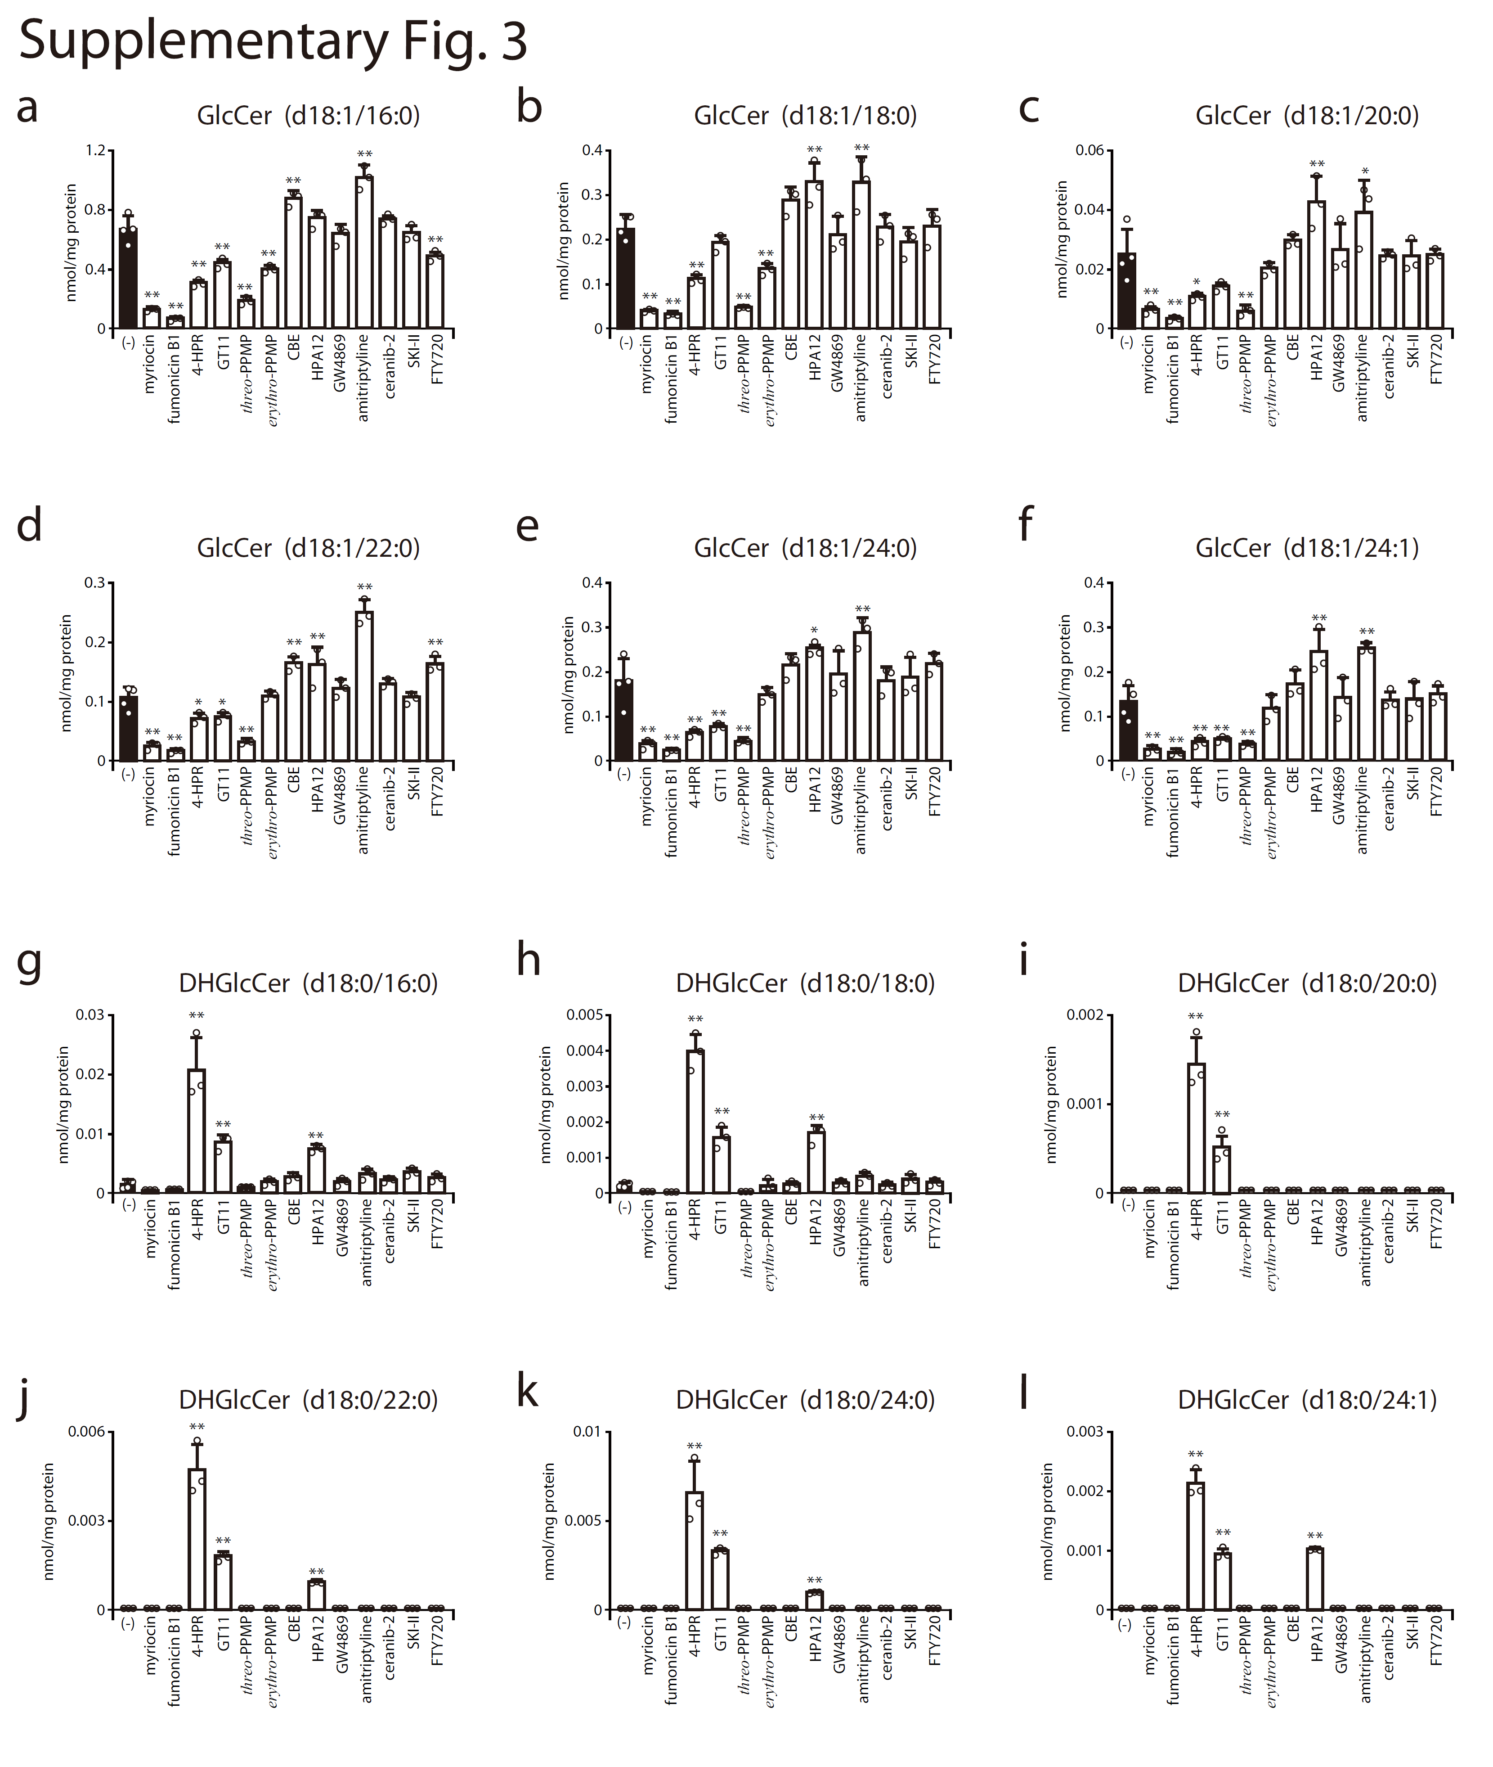

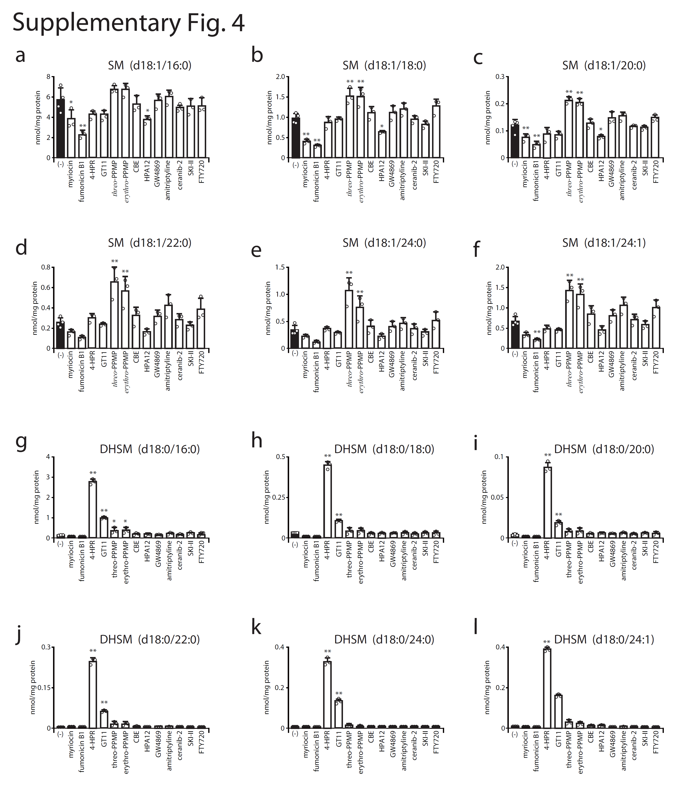

Supplementary Figs. 2-4 | Effect of inhibitors of sphingolipid-metabolizing enzymes on cellular sphingolipid species in 293FT/ACE2/TMPRSS2/DSP1-7 cells. 293FT/ACE2/TMPRSS2/DSP1-7 cells were treated for 2 days with each of the compounds as follows: 40 μM myriocin, 40 μM fumonicin B1, 5 μM 4-HPR, 10 μM GT11, 10 μM threo-PPMP, 10 μM erythro-PPMP, 40 μM CBE, 40 μM HPA12, 10 μM GW4869, 40 μM amitriptyline, 1.3 μM ceranib-2, 10 μM SKI-II, and 5 μM FTY720. The cellular levels of sphingolipid species with a distinct acyl chain were quantified by liquid chromatography with tandem mass spectrometry (LC-MS/MS) analysis. The bar graphs show levels of Cer (panels a-f) and DHCer (panels g-l) in Supplementary Fig. 2, those of GlcCer (panels a-f) and DHGlcCer (panels g-l) in Supplementary Fig. 3, and those of SM (panels a-f) and DHSM (panels g-l) in Supplementary Fig. 4. Statistical significance was determined by one-way ANOVA followed by Dunnett test for multiple comparisons; * p < 0.05, ** p < 0.01 when compared with vehicle/dimethyl sulfoxide (DMSO)-treated cells. Abbreviations: CBE, conduritol B epoxide; 4-HPR, N-(4-hydroxyphenyl)retinamide; Cer, ceramide; DHCer, dihydroceramide; GlcCer, glucosylceramide; DHGlcCer, dihydroglycosylceramide; SM, sphingomyelin; DHSM, dihydrosphingomyelin

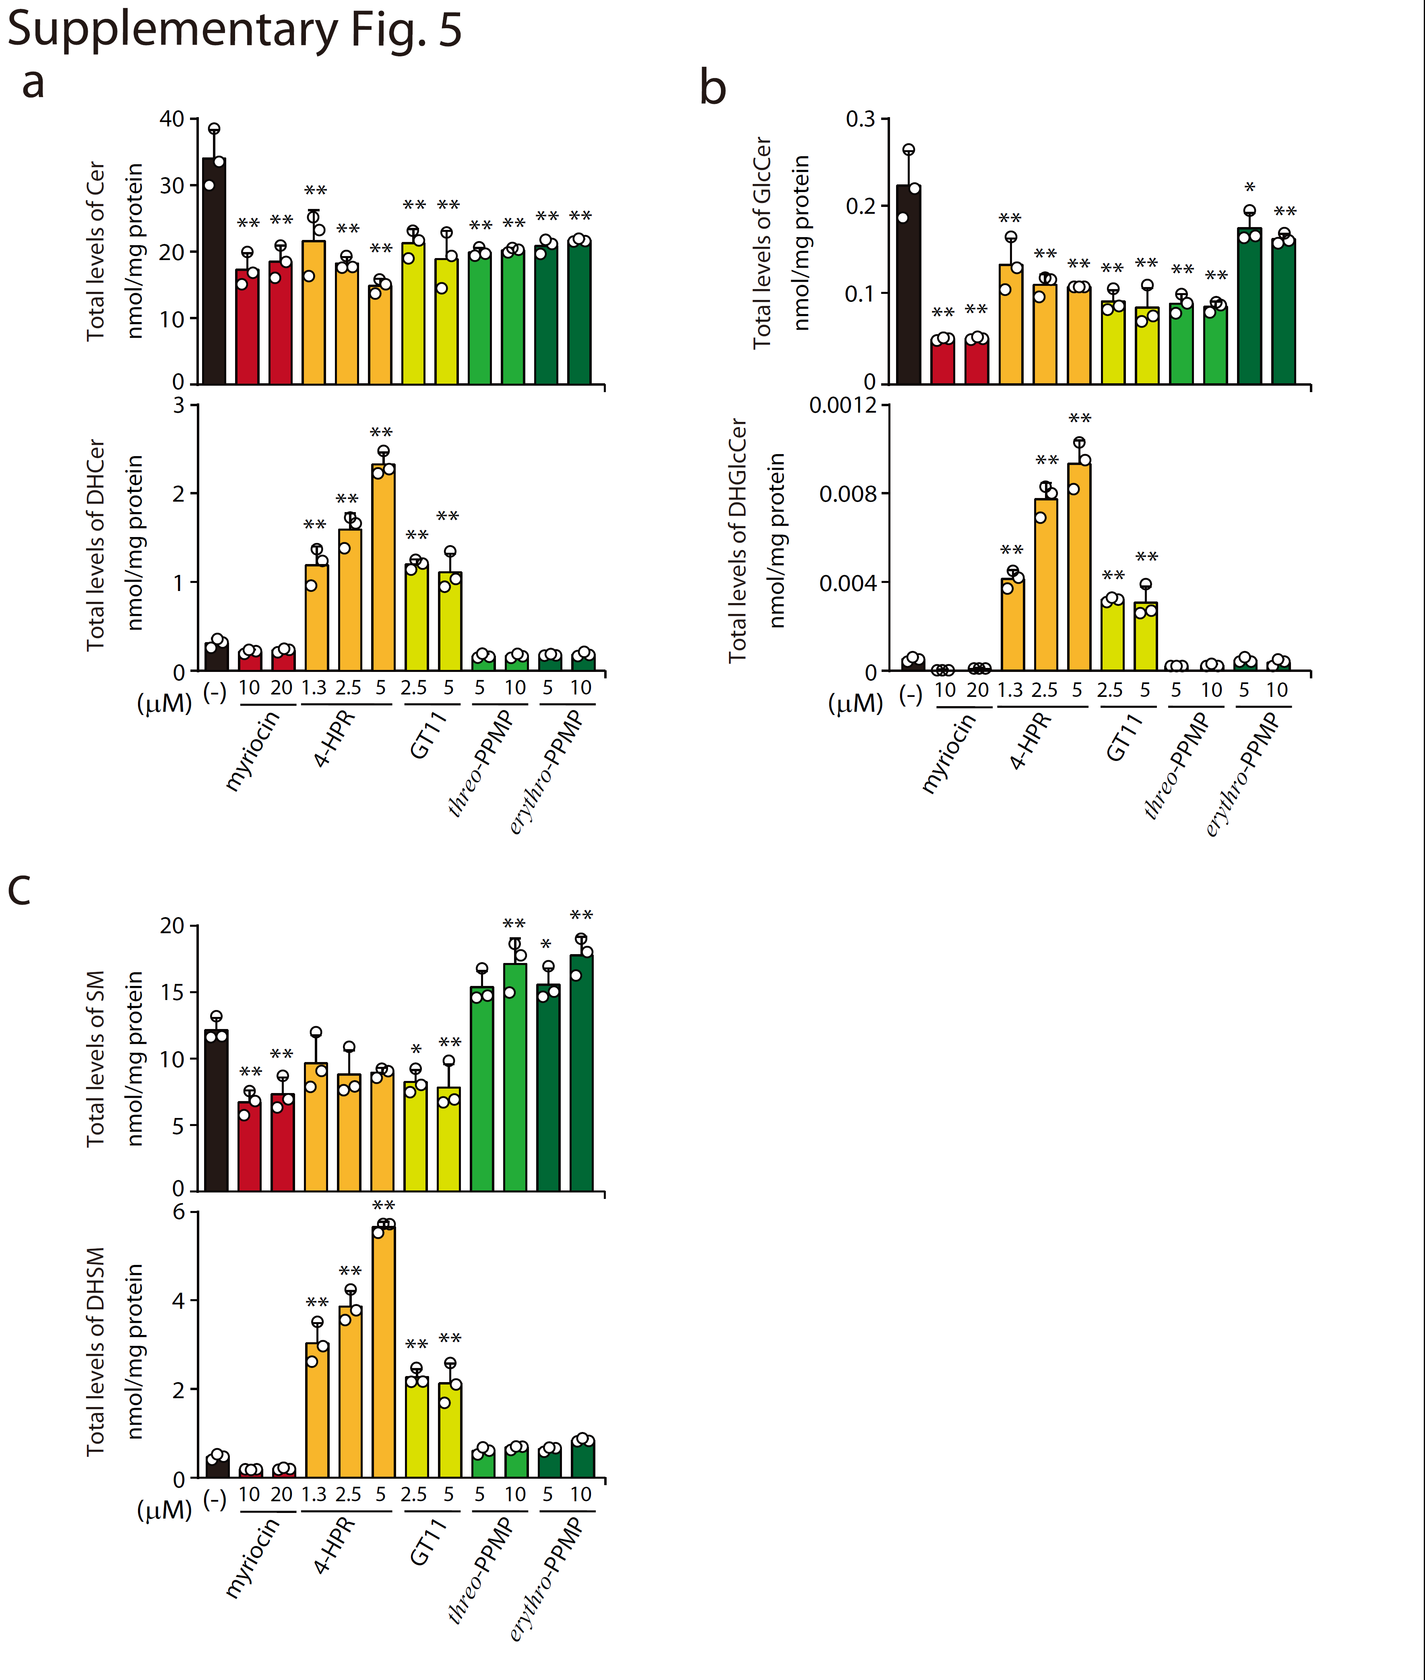

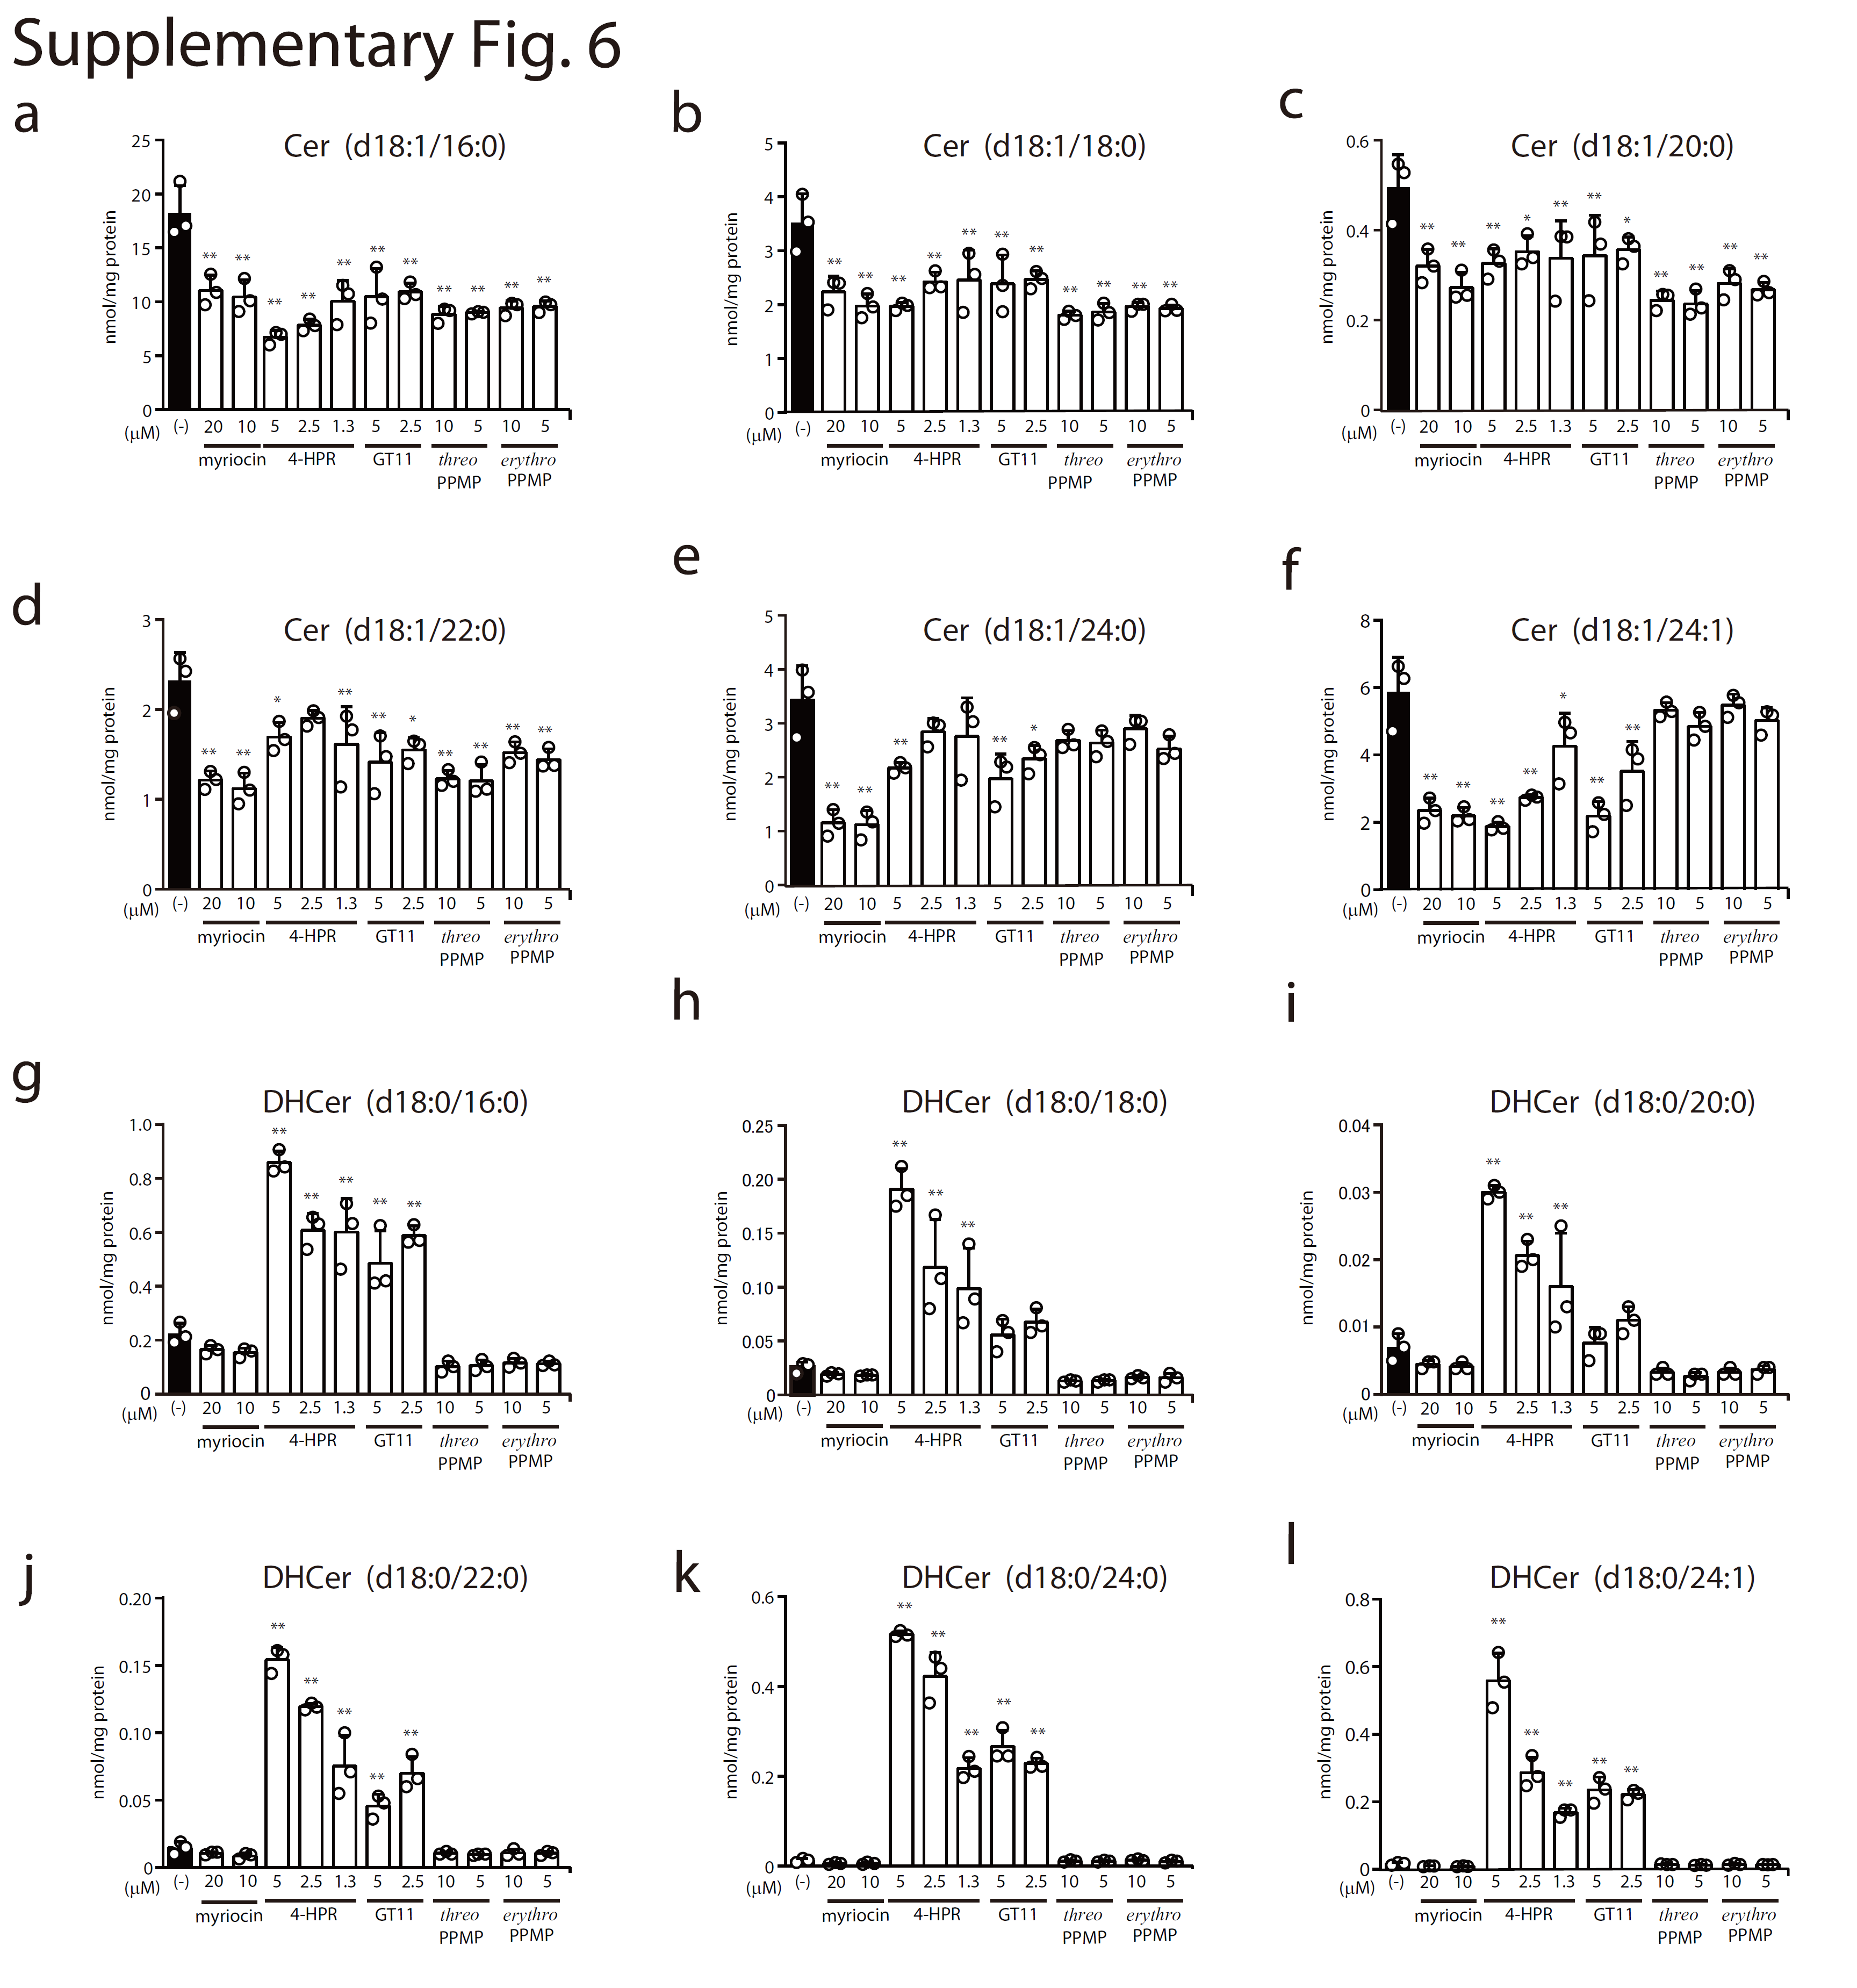

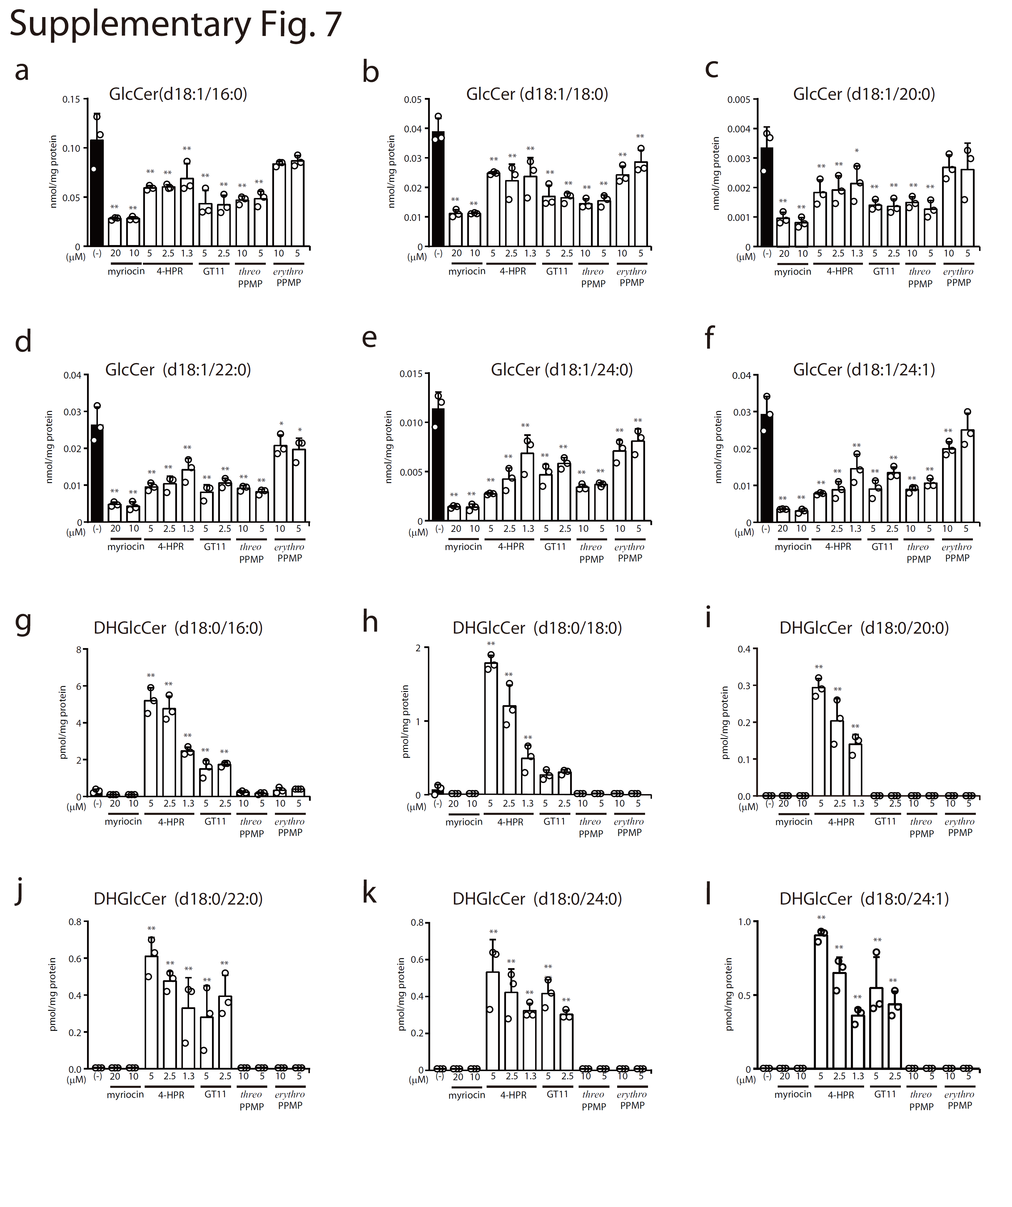

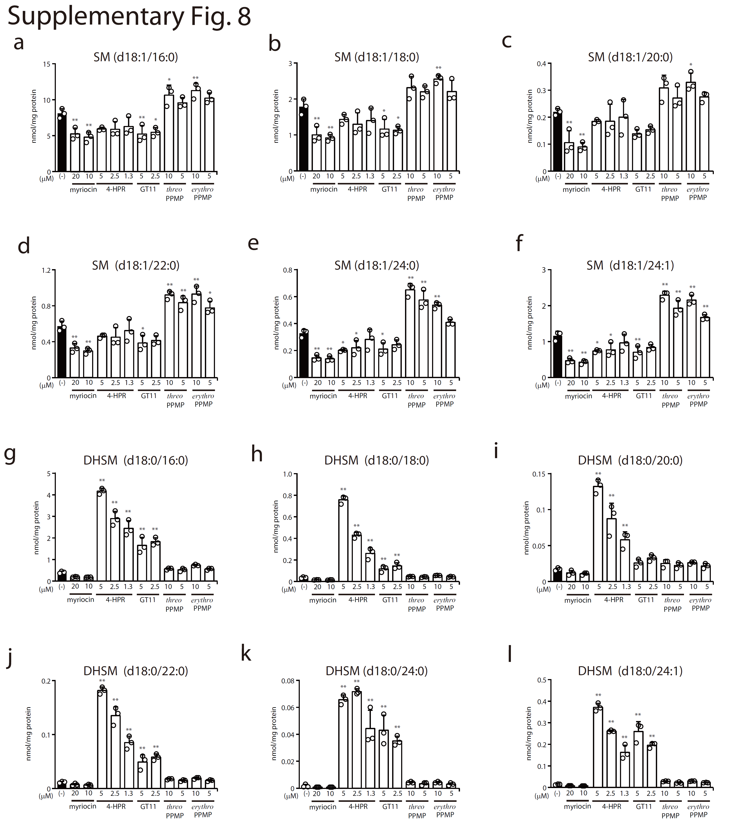

Supplementary Figs. 5-8 | Effect of inhibitors of sphingolipid-metabolizing enzymes on cellular sphingolipid species in VeroE6^{TMPRSS2} cells. VeroE6^{TMPRSS2} cells were treated for 3 days with the indicated concentrations of the compounds. The cellular levels of sphingolipid species were quantified by liquid chromatography with tandem mass spectrometry (LC-MS/MS) analysis. The bar graphs show levels of Cer (upper panel) and DHCer (lower panel) (a), those of GlcCer (upper panel) and DHGlcCer (lower panel) (b), and those of SM (upper panel) and DHSM (lower panel) (c) in Supplementary Fig. 5. Furthermore, the cellular levels of sphingolipid species with a distinct acyl chain were quantified by LC-MS/MS analysis. The bar graphs show levels of Cer (panels a-f) and DHCer (panels g-l) in Supplementary Fig. 6, those of GlcCer (panels a-f) and DHGlcCer (panels g-l) in Supplementary Fig. 7, and those of SM (panels a-f) and DHSM (panels g-l) in Supplementary Fig. 8. Statistical significance was determined by one-way ANOVA followed by Dunnett test for multiple comparisons; * p < 0.05, ** p < 0.01 when compared with vehicle/dimethyl sulfoxide (DMSO)-treated cells. Abbreviations: 4-HPR, N-(4-hydroxyphenyl)retinamide; Cer, ceramide; DHCer, dihydroceramide; GlcCer, glucosylceramide; DHGlcCer, dihydroglycosylceramide; SM, sphingomyelin; DHSM, dihydrosphingomyelin

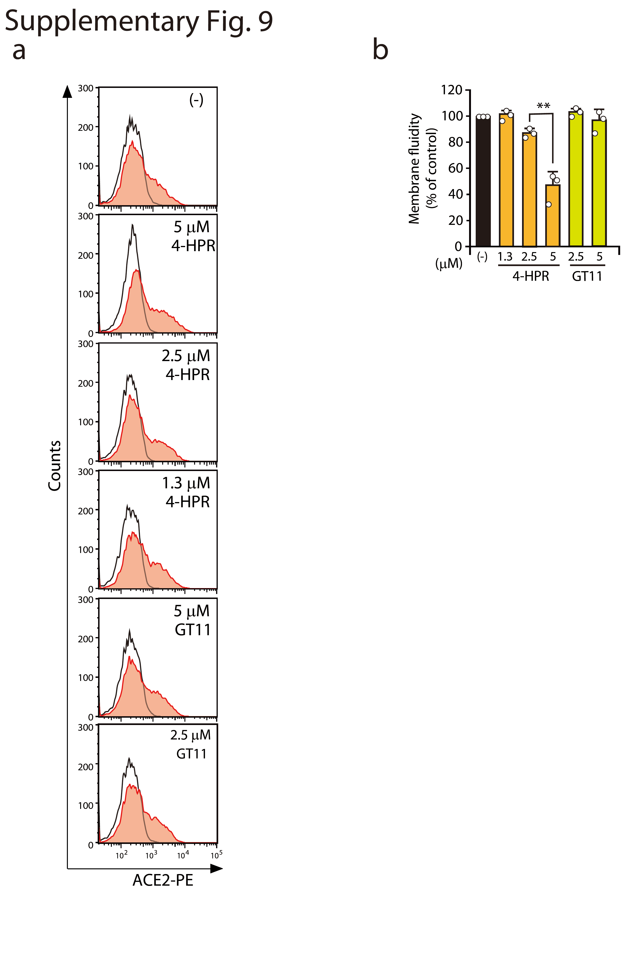
Supplementary Fig. 9 | Effect of 4-HPR on cell-surface levels of ACE2 and membrane fluidity in VeroE6^{TMPRSS2} cells. VeroE6^{TMPRSS2} cells were treated for 3 days with the indicated concentrations of the compounds. (a) Cell-surface expression levels of ACE2 in compound-treated cells were analysed by flowcytometry using an anti-ACE2 antibody (filled histogram). Open histograms indicate the isotype control. One representative experiment is shown, and similar results were obtained in three independent experiments. (b) Membrane fluidity in compound-treated cells was examined with a fluorescent lipophilic pyrene probe. Results are normalised to the rate of membrane fluidity in vehicle/dimethyl sulfoxide (DMSO)-treated cells. Values represent the mean ± S.D. from three independent experiments. Statistical significance was determined by one-way ANOVA followed by the Tukey-Kramer test; ** p < 0.01. Abbreviations: 4-HPR, N-(4-hydroxyphenyl)retinamide

Supplementary tables
Supplementary Table 1 | Multiple reaction monitoring transition for Cer, DHCer, GlcCer, DHGlcCer, SM, and DHSM.
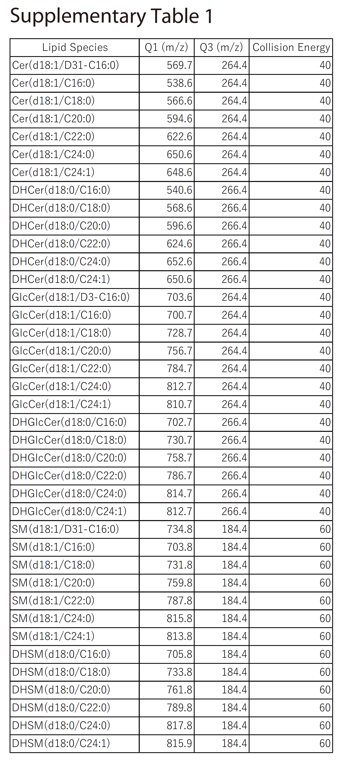
Abbreviations: Cer, ceramide; DHCer, dihydroceramide; GlcCer, glucosylceramide; DHGlcCer, dihydroglycosylceramide; SM, sphingomyelin; DHSM, dihydrosphingomyelin

