Tables
Table 1. The selected 10 compounds from Folium sennae
Molecule ID | Molecule Name | Molecular Structure | OB% ¹ | DL ²
MOL002259 | Physciondiglucoside | 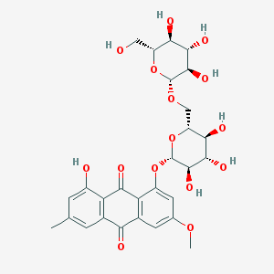 | 41.65 | 0.63
MOL002268 | rhein | 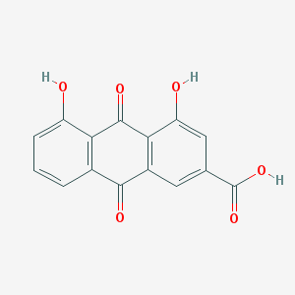 | 47.07 | 0.28
MOL002276 | Sennoside E_qt | 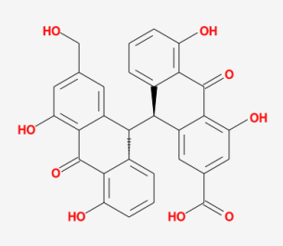 | 50.69 | 0.61
MOL002288 | Emodin-1-O-beta-D-glucopyranoside | 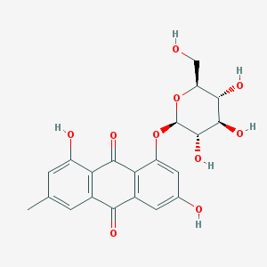 | 44.81 | 0.80
MOL002293 | Sennoside D_qt | 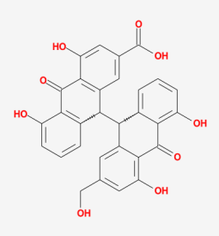 | 61.06 | 0.61
MOL002369 | Dihydroxydianthrone | 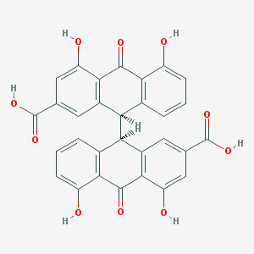 | 74.55 | 0.57
MOL002372 | (6Z,10E,14E,18E)-2,6,10,15,19,23-hexamethyltetracosa-2,6,10,14,18,22-hexaene | 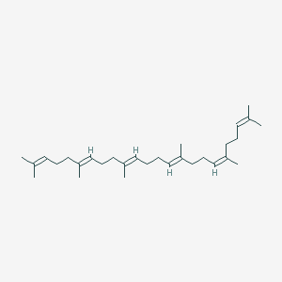 | 33.55 | 0.42
MOL000359 | sitosterol | 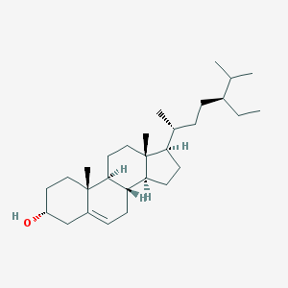 | 36.91 | 0.75
MOL000422 | kaempferol | 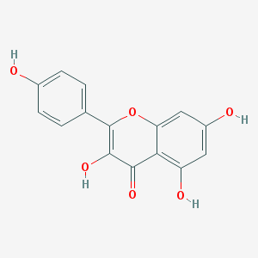 | 41.88 | 0.24
MOL000449 | Stigmasterol | 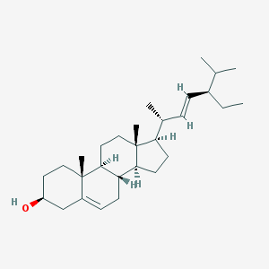 | 43.83 | 0.76
¹ oral bioavailability; ² drug-likeness.
Table 2. VMH simulation of tryptophan metabolism in intestinal flora.
Bacteria | Reactions |  | Score | Metabolites
 | Abbreviation | Description |  | Abbreviation | Description
Streptococcus | 5HLTDL | 5-Hydroxy-L-Tryptophan Decarboxy-Lyase | 4 | Trp-L  5htrp | L-Tryptophan  5-Hydroxy-L-tryptophan
 | LTDCL | L-Tryptophan Decarboxy-Lyase | 4
 | 5HXKYNDCL | 5-Hydroxykynurenamine Decarboxy-Lyase | 1
 | EX_5htrp(e) | Exchange of 5-Hydroxy-L-Tryptophan | 1
 | EX_trp_L(e) | Exchange of L-Tryptophan | 1
 | ACACT1r | Acetyl Coenzyme A C-Acetyltransferase | 0
 | TRPt2r | L-tryptophan reversible transport via proton symport | 0
Sutterella | FKYNH | N-Formyl-L-Kynurenine Amidohydrolase | 4 | Trp-L | L-Tryptophan
 | EX_trp_L(e) | Exchange of L-Tryptophan | 1
 | TRPS1 | Tryptophan synthase (indoleglycerol phosphate) | 0
 | TRPS2 | tryptophan synthase (indole) | 0
 | TRPS3 | tryptophan synthase (indoleglycerol phosphate) | 0
 | TRPt2r | L-tryptophan reversible transport via proton symport | 0
Dorea | EX_trp_L(e) | Exchange of L-Tryptophan | 1 | Trp-L | L-Tryptophan
 | ANPRT | Anthranilate phosphoribosyltransferase | 0
 | ANS | Anthranilate synthase | 0
 | ANS2 | Anthranilate synthase 2 | 0
 | IGPS | Indole-3-glycerol-phosphate synthase | 0
 | PRAI | Phosphoribosylanthranilate isomerase | 0
 | TRPS1 | Tryptophan synthase (indoleglycerol phosphate) | 0
 | TRPS2 | tryptophan synthase (indole) | 0
 | TRPS3 | tryptophan synthase (indoleglycerol phosphate) | 0
 | TRPt2r | L-tryptophan reversible transport via proton symport | 0
 | TRPTA | tryptophan transaminase | 0
Lactobacillus | EX_trp_L(e) | Exchange of L-Tryptophan | 1 | Trp-L | L-Tryptophan
 | ACACT1r | Acetyl Coenzyme A C-Acetyltransferase | 0
 | TRPt2r | L-tryptophan reversible transport via proton symport | 0
Mycoplasma | EX_trp_L(e) | Exchange of L-Tryptophan | 1 | Trp-L | L-Tryptophan
 | TRPt2r | L-tryptophan reversible transport via proton symport | 0
Adlercreutzia | EX_trp_L(e) | Exchange of L-Tryptophan | 1 | Trp-L | L-Tryptophan
 | TRPt2r | L-tryptophan reversible transport via proton symport | 0
Paraprevotella | ANPRT | Anthranilate phosphoribosyltransferase | 0 | Trp-L | L-Tryptophan
 | ANS | Anthranilate synthase | 0
 | ANS2 | Anthranilate synthase 2 | 0
 | IGPS | Indole-3-glycerol-phosphate synthase | 0
 | PRAI | Phosphoribosylanthranilate isomerase | 0
 | TRPS1 | Tryptophan synthase (indoleglycerol phosphate) | 0
 | TRPS2 | tryptophan synthase (indole) | 0
 | TRPS3 | tryptophan synthase (indoleglycerol phosphate) | 0
 | TRPTA | tryptophan transaminase | 0

