# Supplementary information

**Time-resolved single-shot revealing pulse evolution dynamics in ultrafast lasers**

Tianhao Xian, Wenchao Wang, and Li Zhan*

State Key Laboratory of Advanced Optical Communication Systems and Networks, School of Physics and Astronomy, Shanghai Jiao Tong University, Shanghai 200240, China.

* Correspondence author, email: [lizhan@sjtu.edu.cn](mailto:lizhan@sjtu.edu.cn)

## Supplementary Note 1 | Retrieve time separation and phase from interferograms

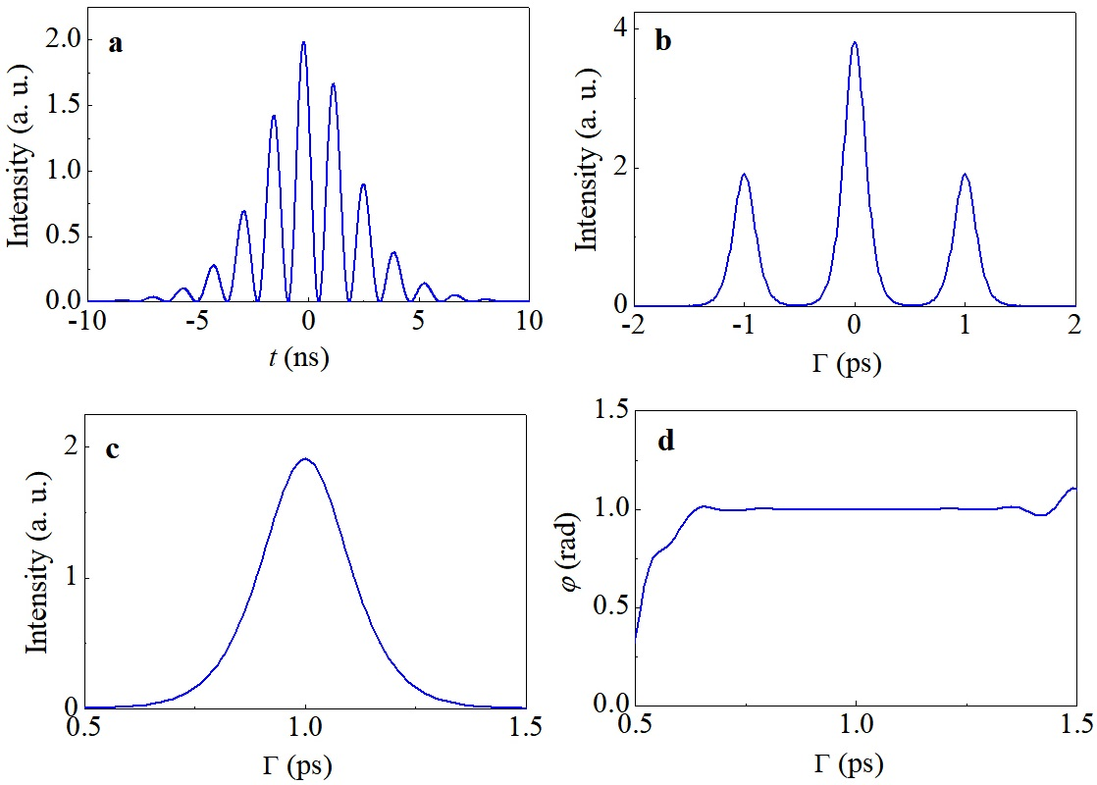

Fig. S1. Retrieve time separation and phase from interferogram. a. Time interferogram. b, Fourier transform of time interferogram. c, Envelop near  in b. d, Phase information corresponding to c.

Here we show the time separation and relative phase retrieval in the case of closely spaced double pulse with uniform envelop. The time interferogram detected by the oscilloscope can be written as Eq. (1) and fig. S1a shows one typical interferogram. In Eq. (1), the interferometric fringe period encoding the time separation and the fringe location encoding the relative phase by:

 (S1)

where *k* is an integer that makes, and the other parameters is the same as that in Eq. 1. Hence, we calculate the Fourier transform of the time interferogram by:

 (S2)

where . The Fourier transform of Fig. S1a is plotted in Fig S1b. Figure S1c displays the absolute of  item in Eq. (s2). Then, we obtain  by  and , where *imag* means the imaginary part.

## Supplementary Note 2 | Output pulses of the mode-locked fiber laser

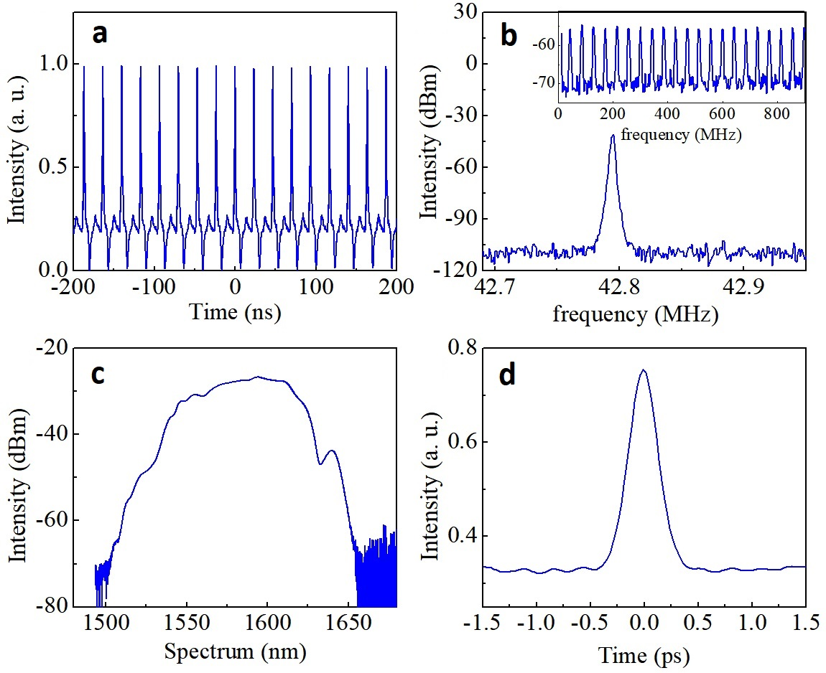

Fig. S2. Pulses generated in the mode-locked fiber laser. (a) The pulse train of the mode-locked pulse. (b) Repetition frequency spectrum. The inset is the repetition frequency spectrum over large range. (c) Optical spectrum. (d) Autocorrelation trace detected by an autocorrelator.

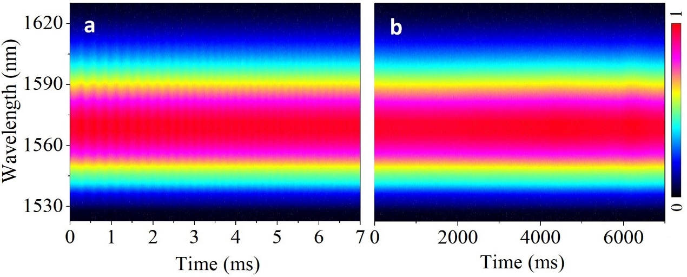

Fig. S3. Spectrum after the mode-locking buildup. The spectrum is detected employing DFT technique. (a) Spectrum evolution over 7ms. (b) Spectrum evolution over 7s.