Study of the dynamic changes in the chemical constituents of Soapberry (Sapindus mukorossi Gaertn.) pericarp during fruit development by a non-targeted metabolomics approach
Yuanyuan Xu^{1,2,3}, Gao Yuan^{1,2,3}, Zhong Chen^{1,2,3,4}, Guochun Zhao^{1,2,3}, Jiming Liu^{1,2,3}, Xin Wang^{1,2,3}, Shilun Gao^{1,2,3}, Duanguang Zhang⁵, Liming Jia^{1,2,3⁎}
¹ Key Laboratory of Silviculture and Conservation of the Ministry of Education, College of Forestry, Beijing Forestry University, Beijing 100083, China;
² National Energy R&D Center for Non-food Biamass, Beijing Forestry University, Beijing 100083, China;
³ National Innovation Alliance of Sapindus Industry, Beijing Forestry University, Beijing 100083, China;
⁴ Beijing Advanced Innovation Center for Tree Breeding by Molecular Design, Beijing Forestry University, Beijing 100083, China;
⁵ Yuanhua Forestry Biotechnology Co., Ltd, Sanming 354500, China
These authors contributed equally: Yuanyuan Xu, Yuan Gao.
⁎Corresponding to: Professor Liming Jia, Ph.D.
College of Forestry, Beijing Forestry University, 35 E Qinghua Road, Beijing 100083, China
E-mail address: jlm@bjfu.edu.cn (L. Jia).
Tel.: +86-010-6233-7055
E-mail address of other authors: yuanyuanxu_2016@163.com (Y. Xu); gaoyuan@bjfu.edu.cn (Y. Gao); sharazhonger@126.com (Z. Chen); zhaoguochun1122@126.com (G. Zhao); 18289143108@163.com (J. Liu); 1796850445@qq.com (X. Wang)；gaoshilun7@sohu.com (S. Gao); 774629608@qq.com (D. Zhang).

Supplemental file 2:
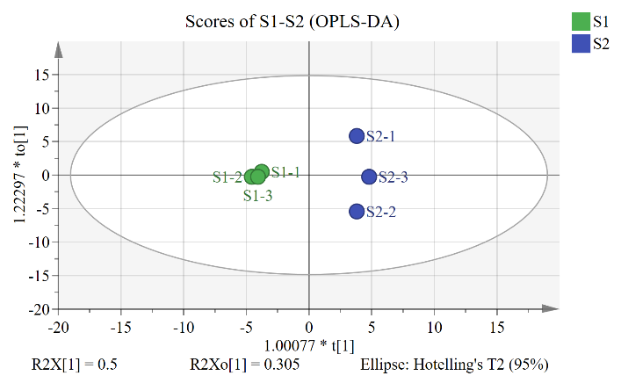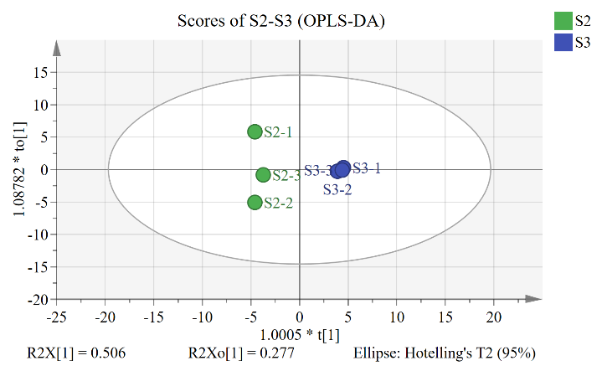
A.S1-S2 B.S2-S3
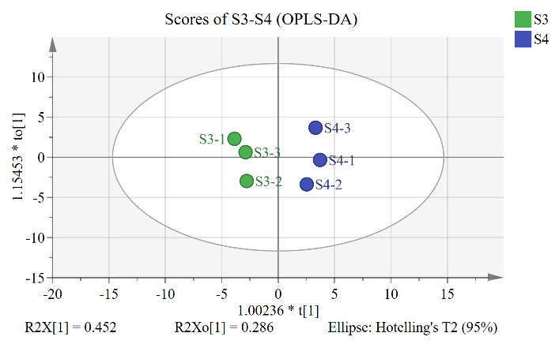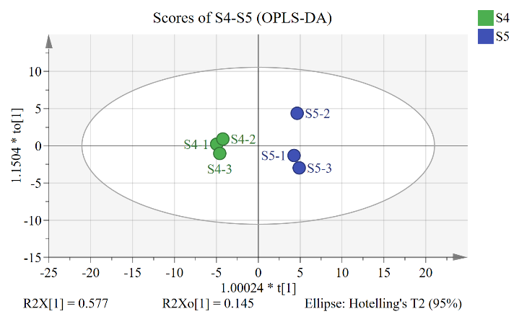
C.S3-S4 D.S4-S5
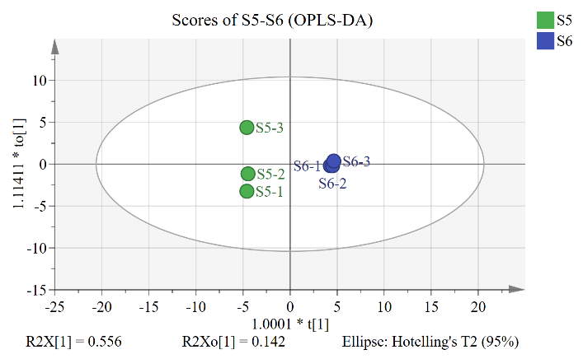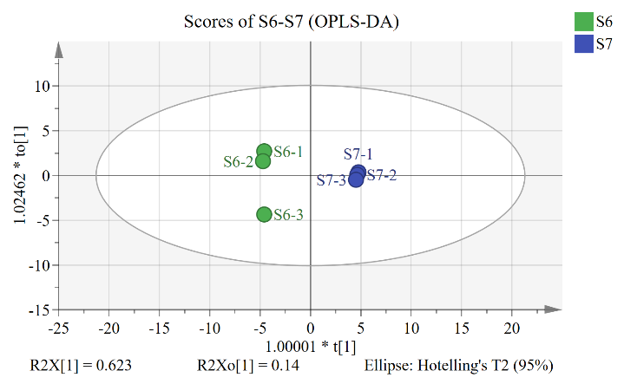
E.S5-S6 F.S6-S7
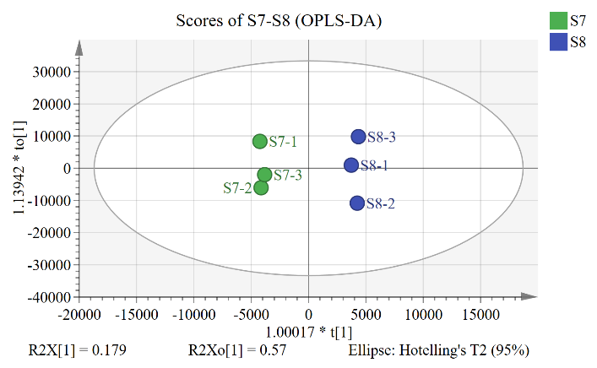
Fig. S1 OPLS-DA score plot
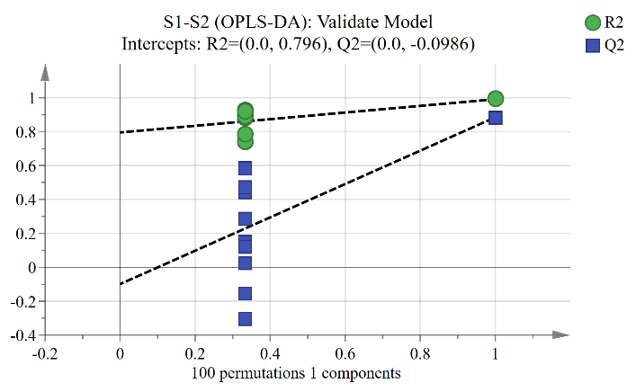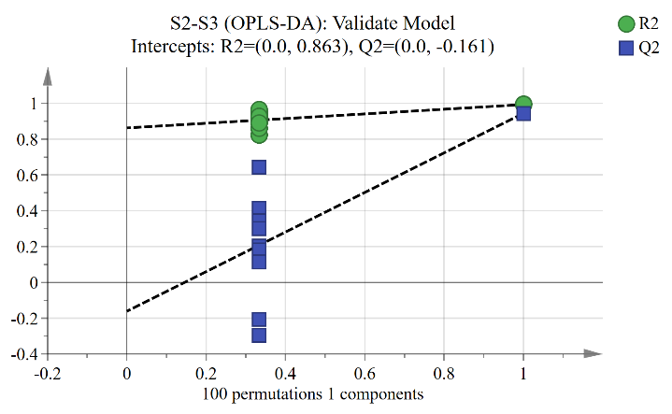
A.S1-S2 B.S2-S3
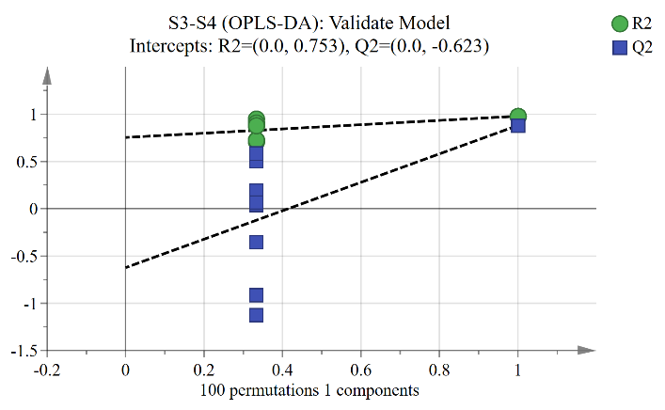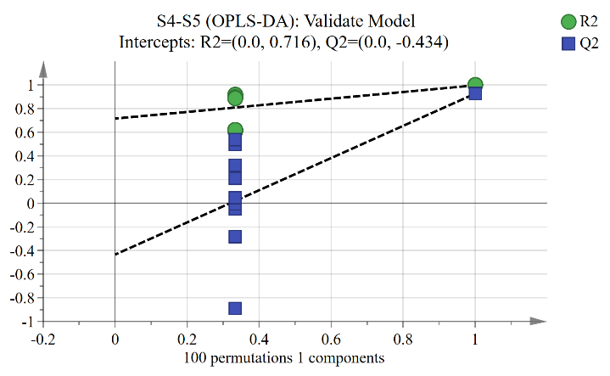
C.S3-S4 D.S4-S5
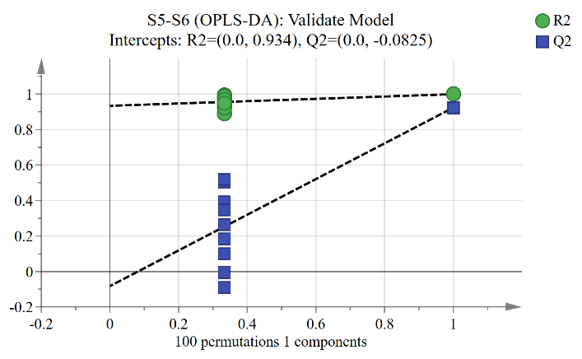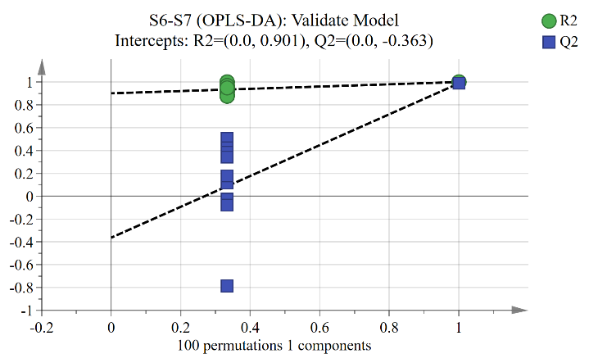
E.S5-S6 F.S6-S7
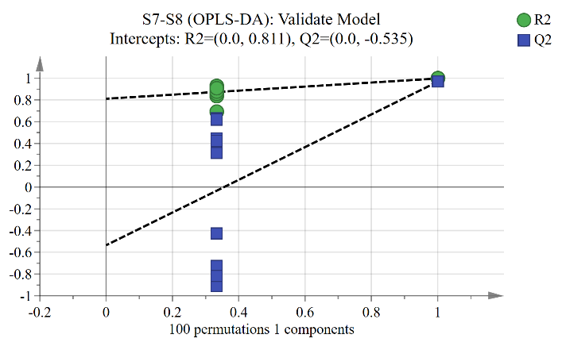
G.S7-S8
Fig. S2 OPLS-DA permutation test graph
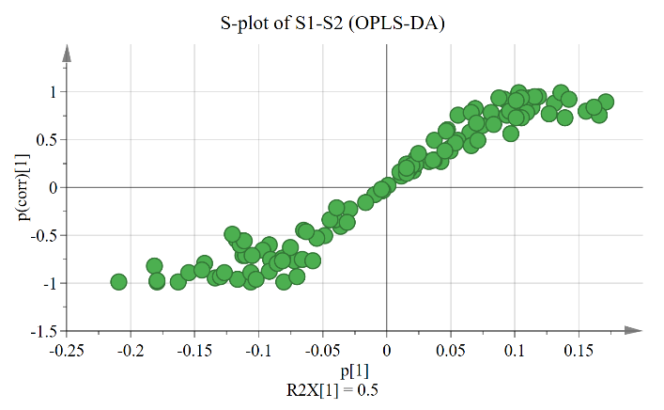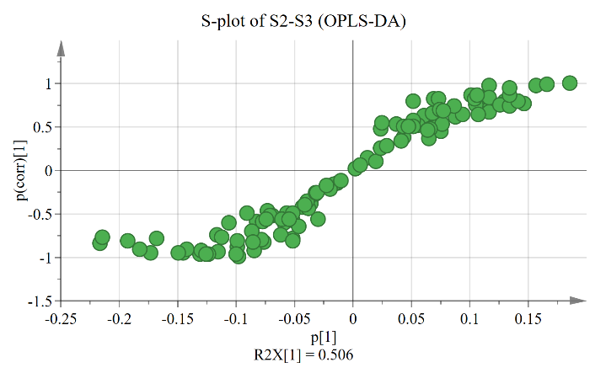
A.S1-S2 B.S2-S3
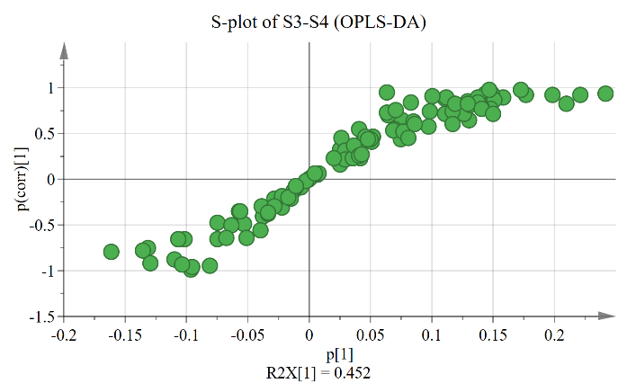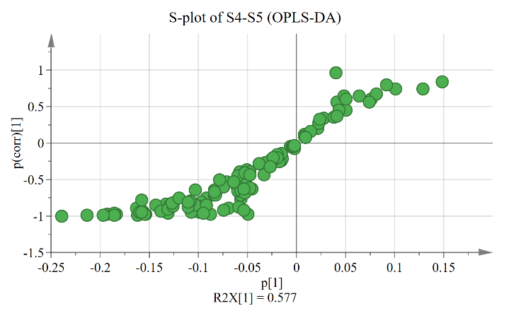
C.S3-S4 D.S4-S5
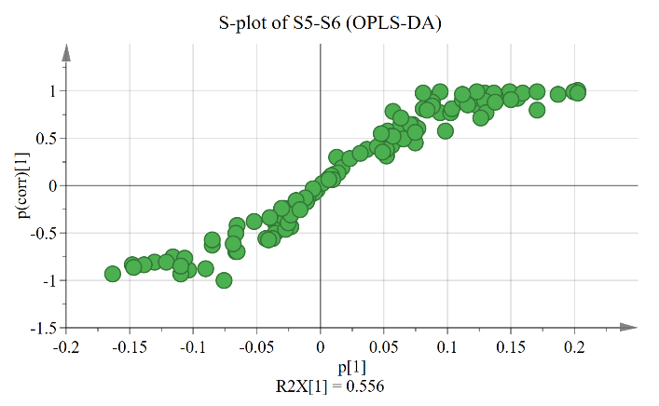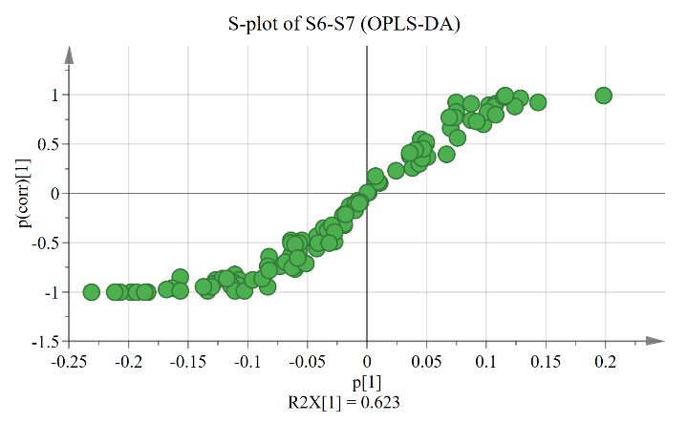
E.S5-S6 F.S6-S7
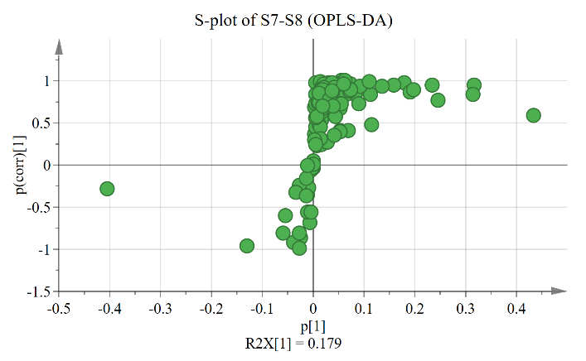
G.S7-S8
Fig. S3 OPLS-DA S-plot graph
Table S1 Annotated compounds
Test type | No | Name | RT /min | Molecular Formula | Monoisotopic mass/Da | Molecular Weight/(g/mol) | Classification
C18_neg | 1 | Quercitrin | 7.491 | C₂₁H₂₀O₁₁ | 448.1006 | 448.1016 | Flavonoids
 | 2 | Protocatechuic acid | 6.015 | C₇H₆O₄ | 154.0266 | 154.0260 | Organic acids
 | 3 | Leucodelphinidin | 6.613 | C₁₅H₁₄O₈ | 322.0689 | 322.0696 | Flavonoids
 | 4 | L-2-succinylamino-6-oxoheptanedioic acid | 1.776 | C₁₁H₁₅NO₈ | 289.0798 | 289.0803 | Organic acids
 | 5 | L-(+)-tartaric acid | 1.164 | C₄H₆O₆ | 150.0164 | 150.0157 | Organic acids
 | 6 | Haplopine | 6.820 | C₁₃H₁₁NO₄ | 245.0688 | 245.0692 | Alkaloids
 | 7 | Glucose 1-phosphate | 1.022 | C₆H₁₃O₉P | 260.0297 | 260.0297 | Phosphorylated intermediates
 | 8 | Furamizole | 1.750 | C₁₂H₈N₄O₅ | 288.0495 | 288.0488 | Alkaloids
 | 9 | Dodecanedioic acid | 17.993 | C₁₂H₂₂O₄ | 230.1518 | 230.1520 | Fatty acids
 | 10 | DL-histidine | 1.076 | C₆H₉N₃O₂ | 155.0695 | 155.0688 | Amino acids
 | 11 | Citreoisocoumarin | 6.110 | C₁₄H₁₄O₆ | 278.079 | 278.0795 | Phenylpropanoids
 | 12 | 4-Hydroxy-2-oxoglutaric acid | 1.356 | C₅H₆O₆ | 162.0164 | 162.0157 | Organic acids
 | 13 | 3-Hydroxy-L-glutamic acid | 1.213 | C₅H₉NO₅ | 163.0481 | 163.0473 | Amino acids
 | 14 | 3-Hydroxy-3-(methoxycarbonyl)pentanedioic acid | 1.306 | C₇H₁₀O₇ | 206.0426 | 206.0423 | Organic acids
 | 15 | 1-O-acetyl-alpha-maltose | 1.603 | C₁₄H₂₄O₁₂ | 384.1268 | 384.1267 | Carbohydrates
 | 16 | 1-Methyl-1,2,3,4-tetrahydro-beta-carboline-3-carboxylic acid | 6.620 | C₁₃H₁₄N₂O₂ | 230.1055 | 230.1057 | Alkaloids
 | 17 | 3-Dehydroquinic acid | 1.806 | C₇H₁₀O₆ | 190.0477 | 190.0474 | Organic acids
 | 18 | 1,1-Diethyl-3-oxo-2-triazanolate | 6.902 | C₄H₁₀N₃O₂⁻ | 132.0779 | 132.0779 | Others
 | 19 | Uridine-5'-diphosphate-glucose | 1.224 | C₁₅H₂₄N₂O₁₇P₂ | 566.0550 | 566.0550 | Nucleotides
HILIC_pos | 1 | (+)-7-epi-12-hydroxyjasmonoyl-L-isoleucine | 2.214 | C₁₈H₂₉NO₅ | 339.2046 | 339.2047 | Amino acid derivative
 | 2 | (Z)-12,13-dihydroxyoctadec-9-enoic acid | 1.785 | C₁₈H₃₄O₄ | 314.2457 | 314.2458 | Fatty acids
 | 3 | (11S,12E,14Z)-11-Hydroxy-12,14-icosadienoic acid | 1.358 | C₂₀H₃₆O₃ | 324.2664 | 324.2664 | Fatty acids
 | 4 | (15Z)-9,12,13-Trihydroxy-15-octadecenoic acid | 2.291 | C₁₈H₃₄O₅ | 330.2406 | 330.2407 | Fatty acids
 | 5 | N-(1-Deoxy-1-fructosyl)threonine | 8.354 | C₁₀H₁₉NO₈ | 281.1111 | 281.1111 | Amino acid derivative
 | 6 | N-(1-Deoxy-1-fructosyl)valine | 7.467 | C₁₁H₂₁NO₇ | 279.1318 | 279.1320 | Amino acid derivative
 | 7 | N-(1-Deoxy-1-fructosyl)leucine | 6.817 | C₁₂H₂₃NO₇ | 293.1475 | 293.1476 | Amino acid derivative
 | 8 | (9Z,12Z)-6,8-Dihydroxy-9,12-octadecadienoic acid | 1.657 | C₁₈H₃₂O₄ | 312.2301 | 312.2302 | Fatty acids
 | 9 | α-Aminoadipic acid | 5.641 | C₆H₁₁NO₄ | 161.0688 | 161.0688 | Amino acids
 | 10 | g-L-Glutamyl-L-pipecolic acid | 3.223 | C₁₁H₁₈N₂O₅ | 258.1216 | 258.1218 | Organic acids
 | 11 | 1-[(3-Carboxypropyl)amino]-1-deoxy-beta-D-fructofuranose | 8.916 | C₁₀H₁₉NO₇ | 265.1162 | 265.1163 | Amino acid derivative
 | 12 | 1-Stearoyl-sn-glycero-3-phosphoethanolamine | 2.214 | C₂₃H₄₈NO₇P | 481.3168 | 481.3169 | Phosphorylated intermediates
 | 13 | Eupatolitin 3-O-glucoside | 5.494 | C₂₃H₂₄O₁₃ | 508.1217 | 508.1217 | Flavonoids
 | 14 | Genipinic Acid | 1.941 | C₁₁H₁₄O₆ | 242.0790 | 242.0790 | Organic acids
 | 15 | α-Tocopherol quinone | 1.254 | C₂₉H₅₀O₃ | 446.3760 | 446.3761 | Vitamins
 | 16 | S-(1,2-Dicarboxyethyl)cysteine | 10.563 | C₇H₁₁NO₆S | 237.0307 | 237.0308 | Amino acid derivative
 | 17 | Glycerophosphatidylethanolamine | 8.885 | C₅H₁₄NO₆P | 215.0559 | 215.0559 | Phosphorylated intermediates
 | 18 | N-acetyl-alpha-fucosamine | 7.305 | C₈H₁₅NO₅ | 205.095 | 205.0945 | Amines
 | 19 | 2-Acetamido-2-deoxy-D-glucono-1,5-lactone | 8.466 | C₈H₁₃NO₆ | 219.0743 | 219.0744 | Amines
 | 20 | 2-Acetamido-2-deoxyglucose | 7.767 | C₈H₁₅NO₆ | 221.0899 | 221.0899 | Amines
 | 21 | 2-Acrylamido-2-methyl-1-propane sulfonic acid | 6.877 | C₇H₁₃NO₄S | 207.0565 | 207.0564 | Amines
 | 22 | 2-Amino-2,3,7-trideoxy-D-lyxo-hept-6-ulosonic acid | 8.051 | C₇H₁₃NO₅ | 191.0794 | 191.0795 | Organic acids
 | 23 | 3-(Butylsulfinyl)-L-alanin | 6.829 | C₇H₁₅NO₃S | 193.0773 | 193.0772 | Amino acid derivative
 | 24 | Sinensin | 8.154 | C₂₁H₂₂O₁₁ | 450.1162 | 450.1163 | Flavonoids
 | 25 | 3-Hydroxy-3,5,5-trimethyl-4-(3-oxo-1-buten-1-ylidene)cyclohexyl β-D-glucopyranoside | 2.387 | C₁₉H₃₀O₈ | 386.1941 | 386.1942 | Others
 | 26 | 4-Methoxybenzaldehyde N-[6-(tert-butyl)thieno[3,2-d]pyrimidin-4-yl]hydrazone | 6.704 | C₁₈H₂₀N₄OS | 340.1358 | 340.1373 | Others
 | 27 | 4-Pyridoxic acid | 2.216 | C₈H₉NO₄ | 183.0532 | 183.0525 | Organic acids
 | 28 | 5,7-Dihydroxy-4-methylcoumarin | 1.817 | C₁₀H₈O₄ | 192.0423 | 192.0417 | Phenylpropanoids
 | 29 | 5'-O-beta-D-Glucosylpyridoxine | 6.700 | C₁₄H₂₁NO₈ | 331.1267 | 331.1267 | Others
 | 30 | 8-Hydroxy-deoxyguanosine | 7.299 | C₁₀H₁₃N₅O₅ | 283.0917 | 283.0917 | Nucleotides
 | 31 | 8-Hydroxyhexadecanedioic acid | 2.277 | C₁₆H₃₀O₅ | 302.2093 | 302.2094 | Fatty acids
 | 32 | Acetylarginine | 8.513 | C₈H₁₆N₄O₃ | 216.1222 | 216.1224 | Amino acids
 | 33 | Adenosine | 5.085 | C₁₀H₁₃N₅O₄ | 267.0967 | 267.0969 | Nucleotides
 | 34 | Agnuside | 5.841 | C₂₂H₂₆O₁₁ | 466.1475 | 466.1473 | Terpenoids
 | 35 | Anticapsin | 2.185 | C₉H₁₃NO₄ | 199.0845 | 199.0843 | Amino acids
 | 36 | Argininosuccinic acid | 9.217 | C₁₀H₁₈N₄O₆ | 290.1226 | 290.1227 | Amino acids
 | 37 | Ascorbyl glucoside | 8.972 | C₁₂H₁₈O₁₁ | 338.0849 | 338.0850 | Others
 | 38 | 2-[(2-Amino-3-carboxypropanoyl)amino]-4-methylpentanoic acid | 8.430 | C₁₀H₁₈N₂O₅ | 246.1216 | 246.1215 | Others
 | 39 | Azidamfenicol | 9.539 | C₁₁H₁₃N₅O₅ | 295.0917 | 295.0904 | Others
 | 40 | Betulin | 1.252 | C₃₀H₅₀O₂ | 442.3811 | 442.3811 | Terpenoids
 | 41 | (10E,15Z)-9,12,13-Trihydroxy-10,15-octadecadienoic acid | 2.210 | C₁₈H₃₂O₅ | 328.2250 | 328.2252 | Fatty acids
 | 42 | Cytidine | 6.804 | C₉H₁₃N₃O₅ | 243.0855 | 243.0856 | Nucleotides
 | 43 | D-(+)-Tryptophan | 6.894 | C₁₁H₁₂N₂O₂ | 204.0899 | 204.0894 | Amino acids
 | 44 | Dammarenediol-II | 1.254 | C₃₀H₅₂O₂ | 444.3967 | 444.3967 | Terpenoids
 | 45 | Edotecarin | 4.744 | C₂₉H₂₈N₄O₁₁ | 608.1755 | 608.1744 | Alkaloids
 | 46 | Eglumetad | 6.284 | C₈H₁₁NO₄ | 185.0688 | 185.0690 | Amino acids
 | 47 | Etilevodopa | 2.369 | C₁₁H₁₅NO₄ | 225.1001 | 225.1001 | Amino acid derivatives
 | 48 | Glycyl-L-leucine | 5.627 | C₈H₁₆N₂O₃ | 188.1161 | 188.1160 | Amino acid derivatives
 | 49 | Hexadecanedioic acid | 1.916 | C₁₆H₃₀O₄ | 286.2144 | 286.2145 | Fatty acids
 | 50 | Jasmonic acid | 2.043 | C₁₂H₁₈O₃ | 210.1256 | 210.1251 | Organic acids
 | 51 | L-(+)-Citrulline | 9.000 | C₆H₁₃N₃O₃ | 175.0957 | 175.0958 | Amino acids
 | 52 | L-Leucyl-L-leucine | 2.284 | C₁₂H₂₄N₂O₃ | 244.1787 | 244.1788 | Amino acid derivatives
 | 53 | L-Leucyl-L-valine | 3.482 | C₁₁H₂₂N₂O₃ | 230.1630 | 230.1631 | Amino acid derivatives
 | 54 | L-Tyrosine | 7.698 | C₉H₁₁NO₃ | 181.0739 | 181.074 | Amino acids
 | 55 | Luteolin | 3.307 | C₁₅H₁₀O₆ | 286.0477 | 286.0478 | Flavonoids
 | 56 | Mebutamate | 5.447 | C₁₀H₂₀N₂O₄ | 232.1423 | 232.1423 | Amines
 | 57 | Meprobamate | 5.857 | C₉H₁₈N₂O₄ | 218.1267 | 218.1266 | Amines
 | 58 | Methyldopa | 8.565 | C₁₀H₁₃NO₄ | 211.0845 | 211.0842 | Amino acid derivatives
 | 59 | DL-Alanyl-DL-leucine | 4.892 | C₉H₁₈N₂O₃ | 202.1317 | 202.1318 | Amino acid derivatives
 | 60 | 2,3-Dinor-8-epi-prostaglandin F2alpha | 2.211 | C₁₈H₃₀O₅ | 326.2093 | 326.2095 | Others
 | 61 | Muramic acid | 8.987 | C₉H₁₇NO₇ | 251.1005 | 251.1006 | Organic acids
 | 62 | N-(3-Carboxypropanoyl)-5-hydroxynorvaline | 8.450 | C₉H₁₅NO₆ | 233.0899 | 233.0901 | Amino acid derivatives
 | 63 | N2-Succinyl-L-glutamic acid 5-semialdehyde | 2.336 | C₉H₁₃NO₆ | 231.0743 | 231.0741 | Amino acid derivatives
 | 64 | N-Acetyl-DL-glutamic acid | 9.179 | C₇H₁₁NO₅ | 189.0637 | 189.0633 | Amino acid derivatives
 | 65 | N-Acetyl-L-carnosine | 7.057 | C₁₁H₁₆N₄O₄ | 268.1172 | 268.1159 | Amino acid derivatives
 | 66 | N-Acetyl-L-glutamine | 7.590 | C₇H₁₂N₂O₄ | 188.0797 | 188.0796 | Amino acids
 | 67 | N-Acetylornithine | 7.928 | C₇H₁₄N₂O₃ | 174.1004 | 174.0997 | Amino acids
 | 68 | 5'-N-Ethylcarboxamidoadenosine | 8.182 | C₁₂H₁₆N₆O₄ | 308.1233 | 308.1220 | Nucleotides
 | 69 | N-glycoloyl-D-mannosaminolactone | 1.955 | C₈H₁₃NO₇ | 235.0692 | 235.0690 | Others
 | 70 | Nitrilotriacetic acid | 9.705 | C₆H₉NO₆ | 191.0430 | 191.0430 | Others
 | 71 | N-Undecanoylglycine | 2.324 | C₁₃H₂₅NO₃ | 243.1834 | 243.1833 | Amino acid derivatives
 | 72 | Pantothenic acid | 6.514 | C₉H₁₇NO₅ | 219.1107 | 219.1104 | Vitamins
 | 73 | Pinolenic acid | 1.675 | C₁₈H₃₀O₂ | 278.2246 | 278.2248 | Fatty acids
 | 74 | Pre-acinetobactin | 2.264 | C₁₆H₁₈N₄O₅ | 346.1277 | 346.1264 | Others
 | 75 | Rutin | 8.315 | C₂₇H₃₀O₁₆ | 610.1534 | 610.1537 | Flavonoids
 | 76 | Sulfadimethoxine | 2.027 | C₁₂H₁₄N₄O₄S | 310.0736 | 310.0737 | Others
 | 77 | Troxipide | 4.676 | C₁₅H₂₂N₂O₄ | 294.1580 | 294.1581 | Amines
 | 78 | Uridine monophosphate (UMP) | 9.511 | C₉H₁₃N₂O₉P | 324.0359 | 324.0359 | Nucleotides
 | 79 | Ursolic acid | 1.442 | C₃₀H₄₈O₃ | 456.3604 | 456.3604 | Terpenoids
 | 80 | 2-[(2-Amino-3-methylbutanoyl)amino]-3-hydroxypropanoic acid | 6.545 | C₈H₁₆N₂O₄ | 204.1110 | 204.1106 | Amino acid derivatives
 | 81 | Valylvaline | 4.170 | C₁₀H₂₀N₂O₃ | 216.1474 | 216.1475 | Amino acid derivatives
 | 82 | Vorinostat | 2.321 | C₁₄H₂₀N₂O₃ | 264.1474 | 264.1472 | Amines
 | 83 | Zonampanel anhydrous | 8.147 | C₁₃H₉N₅O₆ | 331.0553 | 331.0540 | Alkaloids
 | 84 | α,α-Trehalose | 8.683 | C₁₂H₂₂O₁₁ | 342.1162 | 342.1165 | Carbohydrates
 | 85 | N-(β-Glucosyl)-(oxindol-3-yl)acetyl-aspartate | 9.424 | C₂₀H₂₂N₂O₁₁ | 468.1382 | 468.1382 | Amino acid derivatives
 | 86 | 6-O-Benzoylphlorigidoside B | 7.829 | C₂₆H₃₂O₁₄ | 568.1792 | 568.1793 | Others
 | 87 | 2-Acetamido-2,6-dideoxy-alpha-D-galactopyranose | 7.834 | C₈H₁₅NO₅ | 205.0950 | 205.0951 | Carbohydrates
 | 88 | 1-(1-Deoxy-D-fructos-1-yl)-L-proline | 7.733 | C₁₁H₁₉NO₇ | 277.1162 | 277.1162 | Amino acid derivatives
HILIC_neg | 1 | α-Eleostearic acid | 1.393 | C₁₈H₃₀O₂ | 278.2246 | 278.2248 | Fatty acids
 | 2 | Sucrose | 8.688 | C₁₂H₂₂O₁₁ | 342.1162 | 342.1164 | Carbohydrates
 | 3 | Ascorbic acid | 8.939 | C₆H₈O₆ | 176.0321 | 176.0315 | Vitamins
 | 4 | Allantoic acid | 9.236 | C₄H₈N₄O₄ | 176.0546 | 176.0546 | Amines

Table S2 Parameters of OPLS-DA
Compare group | Number of components | R²X | R²Y | Q²
S1-S2 | 1+1+0 | 0.805 | 0.991 | 0.885
S2-S3 | 1+1+0 | 0.783 | 0.993 | 0.944
S3-S4 | 1+1+0 | 0.738 | 0.979 | 0.881
S4-S5 | 1+1+0 | 0.722 | 0.997 | 0.926
S5-S6 | 1+1+0 | 0.699 | 0.999 | 0.923
S6-S7 | 1+1+0 | 0.763 | 1 | 0.987
S7-S8 | 1+2+0 | 0.962 | 0.997 | 0.968

Table S3 Differential metabolites pathway analysis
Pathway name | Metabolite number | P value | FDR | Impact
Flavonoid biosynthesis | 1 | 2.70E-04 | 3.51E-03 | 1.69E-03
Histidine metabolism | 1 | 5.22E-02 | 2.26E-01 | 4.26E-02
Aminoacyl-tRNA biosynthesis | 1 | 5.22E-02 | 2.26E-01 | 0
Flavone and flavonol biosynthesis | 1 | 2.28E-01 | 6.05E-01 | 1.50E-01
Phenylalanine, tyrosine and tryptophan biosynthesis | 1 | 2.33E-01 | 6.05E-01 | 5.41E-02
Pentose and glucuronate interconversions | 1 | 6.37E-01 | 7.68E-01 | 9.38E-02
Glycerolipid metabolism | 1 | 6.37E-01 | 7.68E-01 | 5.96E-02
Zeatin biosynthesis | 1 | 6.37E-01 | 7.68E-01 | 2.71E-02
Ascorbate and aldarate metabolism | 1 | 6.37E-01 | 7.68E-01 | 0
Amino sugar and nucleotide sugar metabolism | 2 | 6.68E-01 | 7.68E-01 | 1.42-01
Starch and sucrose metabolism | 2 | 7.09E-01 | 7.68E-01 | 1.56E-01
Galactose metabolism | 3 | 7.09E-01 | 7.68E-01 | 7.49E-02
Lysine degradation | 1 | 7.92E-01 | 7.92E-01 | 0

