Nuclear Morphology Optimized Deep Hybrid Learning (NUMODRIL) for accurate diagnosis and prognosis of Ovarian Cancer
Duhita Sengupta^{1#}, SkNishan Ali^{2#}, Aditya Bhattacharya^{2#}, Joy Mustafi^{2#}, Asima Mukhopadhyay^{3,4¶} & Kaushik Sengupta¹*
- Biophysics and Structural Genomics Division, Saha Institute of Nuclear Physics, Kolkata, India ; Homi Bhaba National Institute, Mumbai, India
- Artificial Intelligence and Machine Learning Division, MUST Research Trust, Flat 301, Block 4, Hyderabad 500046, Telangana, India
- Chittaranjan National Cancer Institute, Kolkata, West Bengal 700156, India
- Northern Gynaecological Oncology Centre, Queen Elizabeth Hospital, Gateshead, United Kingdom

# Authors contributed equally
¶Formerly at Tata Medical Center, Kolkata, West Bengal 700156, India
*To whom correspondence should be addressed: kaushik.sengupta@saha.ac.in

Supplementary Figure:

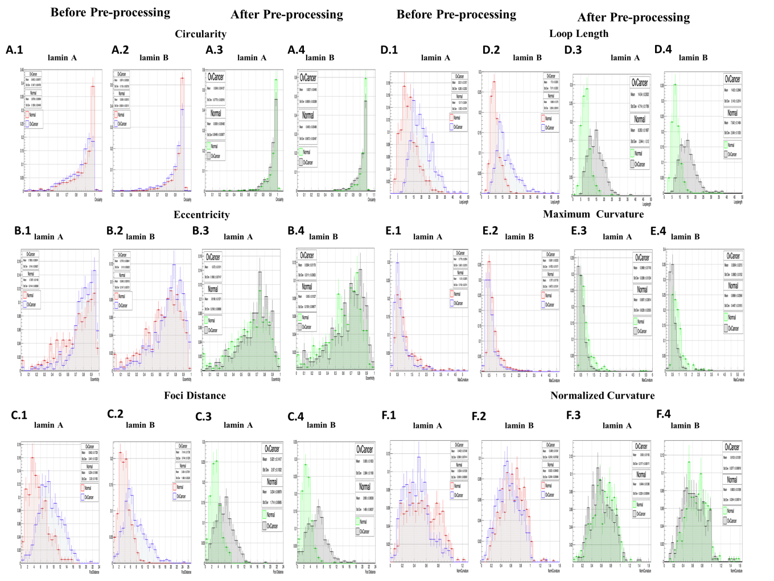

Figure 1: Histograms showing distributions of the normal and Ovarian Cancer nuclei based on different morphometric parameters obtained from lamin A and B stained tissue sample images before and after pre-processing. X axis denotes the normalised number of nuclei with respect to the total number of nuclei calculated. Y axis denotes the measure of the parameter.
A. 1.Comparative distribution of the number of normal (Mean±Std error of mean:0.8796± 0.005994) (Std Dev:0.1285±0.00495) and ovarian cancer (Mean±Std error of mean:0.8452± 0.006767) (Std Dev:0.1347±0.004785) nuclei based on Circularity values acquired from lamin A stained tissue images before pre-processing.
A. 2. Comparative distribution of the number of normal (Mean±Std error of mean:0.9309± 0.003013) (Std Dev:0.8024±0.002131) and ovarian cancer (Mean±Std error of mean:0.8974± 0.005269) (Std Dev:0.1135±0.003726) nuclei based on Circularity values acquired from lamin B stained tissue images before pre-processing.
A. 3.Comparative distribution of the number of normal (Mean±Std error of mean:0.9309± 0.005482) (Std Dev:0.09496±0.003877) and ovarian cancer (Mean±Std error of mean:0.9248± 0.004127) (Std Dev:0.0776±0.002918) nuclei based on Circularity values acquired from lamin A stained tissue images after pre-processing.
A. 4. Comparative distribution of the number of normal (Mean±Std error of mean:0.9455± 0.002488) (Std Dev:0.06072±0.002467) and ovarian cancer (Mean±Std error of mean:0.9227± 0.004665) (Std Dev:0.08395±0.03328) nuclei based on Circularity values acquired from lamin B stained tissue images after pre-processing.
B. 1.Comparative distribution of the number of normal (Mean±Std error of mean:0.7067± 0.01169) (Std Dev:0.2144±0.008269) and ovarian cancer (Mean±Std error of mean:0.7885± 0.008241) (Std Dev:0.164±0.005827) nuclei based on Eccentricity values acquired from lamin A stained tissue images before pre-processing.
B. 2. Comparative distribution of the number of normal (Mean±Std error of mean:0.6348± 0.008105) (Std Dev:0.2147±0.005731)and diseased (Mean±Std error of mean:0.7076± 0.008841) (Std Dev:0.19±0.006252)nuclei based on Eccentricity values acquired from lamin B stained tissue images before pre-processing.
B. 3.Comparative distribution of the number of normal (Mean±Std error of mean:0.6196± 0.01271) (Std Dev:0.2186±0.00896) and ovarian cancer (Mean±Std error of mean:0.672±0.01011) (Std Dev:0.1895±0.0071471) nuclei based on Eccentricity values acquired from lamin A stained tissue images after pre-processing.
B. 4.Comparative distribution of the number of normal (Mean±Std error of mean:0.605± 0.01227) (Std Dev:0.2108±0.00867) and ovarian cancer (Mean±Std error of mean:0.6584±0.01178) (Std Dev:0.2111±0.00833) nuclei based on Eccentricity values acquired from lamin B stained tissue images after pre-processing.
C. 1.Comparative distribution of the number of normal (Mean±Std error of mean:5.204± 0.1648) (Std Dev:3.03±0.1165) and ovarian cancer (Mean±Std error of mean:8.942± 0.1729) (Std Dev:3.441±0.1223) nuclei based on Foci Distance values acquired from lamin A stained tissue images before pre-processing.
C. 2. Comparative distribution of the number of normal (Mean±Std error of mean:3.934± 0.07391) (Std Dev:1.968±0.05226) and diseased (Mean±Std error of mean:7.414± 0.1738) (Std Dev:3.744±0.1229)nuclei based on Foci Distance values acquired from lamin B stained tissue images before pre-processing.
C. 3.Comparative distribution of the number of normal (Mean±Std error of mean:3.234± 0.09879) (Std Dev:1.714±0.06985) and ovarian cancer (Mean±Std error of mean:5.921±0.1417) (Std Dev:2.67±0.1002) nuclei based on Foci Distance values acquired from lamin A stained tissue images after pre-processing.
C. 4.Comparative distribution of the number of normal (Mean±Std error of mean:2.895± 0.8538) (Std Dev:1.486±0.06037) and ovarian cancer (Mean±Std error of mean:5.995±0.1653) (Std Dev:2.984±0.1169) nuclei based on Foci Distance values acquired from lamin B stained tissue images after pre-processing.
D. 1.Comparative distribution of the number of normal (Mean±Std error of mean:12.17± 0.3004) (Std Dev:5.523±0.2124) and ovarian cancer (Mean±Std error of mean:20.01± 0.3152) (Std Dev:6.282±0.2232) nuclei based on Loop Length values acquired from lamin A stained tissue images before pre-processing.
D. 2. Comparative distribution of the number of normal (Mean±Std error of mean:9.869± 0.1275) (Std Dev:3.396±0.09018)and diseased (Mean±Std error of mean:17.5± 0.3255) (Std Dev:7.011±0.2302)nuclei based on Loop Length values acquired from lamin B stained tissue images before pre-processing.
D. 3.Comparative distribution of the number of normal (Mean±Std error of mean:8.263± 0.1697) (Std Dev:2.944±0.12) and ovarian cancer (Mean±Std error of mean:14.54±0.2502) (Std Dev:4.714±0.1769) nuclei based on Loop Length values acquired from lamin A stained tissue images after pre-processing.
D. 4.Comparative distribution of the number of normal (Mean±Std error of mean:7.542± 0.1464) (Std Dev:2.549±0.1035) and ovarian cancer (Mean±Std error of mean:14.82±0.2848) (Std Dev:5.143±0.2014) nuclei based on Loop Length values acquired from lamin B stained tissue images after pre-processing.
E. 1.Comparative distribution of the number of normal (Mean±Std error of mean:1.1015± 0.03876) (Std Dev:0.7105±0.02741) and ovarian cancer (Mean±Std error of mean:0.7776± 0.02854) (Std Dev:0.5651±0.02018) nuclei based on Maximum Curvature values acquired from lamin A stained tissue images before pre-processing.
E. 2. Comparative distribution of the number of normal (Mean±Std error of mean:0.797± 0.01755) (Std Dev:0.4672±0.01241)and diseased (Mean±Std error of mean:0.6361± 0.0222) (Std Dev:0.4782±0.01571)nuclei based on Maximum Curvature values acquired from lamin B stained tissue images before pre-processing.
E. 3.Comparative distribution of the number of normal (Mean±Std error of mean:0.9067± 0.03614) (Std Dev:0.6228±0.02555) and ovarian cancer (Mean±Std error of mean:0.5868±0.01745) (Std Dev:0.3288±0.01234) nuclei based on Maximum Curvature values acquired from lamin A stained tissue images after pre-processing.
E. 4.Comparative distribution of the number of normal (Mean±Std error of mean:0.8898± 0.02566) (Std Dev:0.4467±0.01815) and ovarian cancer (Mean±Std error of mean:0.5804±0.0215) (Std Dev:0.3882±0.0152) nuclei based on Maximum Curvature values acquired from lamin B stained tissue images after pre-processing.
F. 1.Comparative distribution of the number of normal (Mean±Std error of mean:0.5354± 0.01359) (Std Dev:0.2496±0.009609) and ovarian cancer (Mean±Std error of mean:0.4402± 0.01048) (Std Dev:0.2086±0.007414nuclei based on Normalized Curvature values acquired from lamin A stained tissue images before pre-processing.
F. 2. Comparative distribution of the number of normal (Mean±Std error of mean:0.6323± 0.008435) (Std Dev:0.2246±0.005964)and diseased (Mean±Std error of mean:0.5489± 0.01401) (Std Dev:0.2243±0.007362) nuclei based on Normalized Curvature values acquired from lamin B stained tissue images before pre-processing.
F. 3.Comparative distribution of the number of normal (Mean±Std error of mean:0.6464± 0.01286) (Std Dev:0.2224±0.009094) and ovarian cancer (Mean±Std error of mean:0.605±0.01156) (Std Dev:0.2177±0.008171) nuclei based on Normalized Curvature values acquired from lamin A stained tissue images after pre-processing.
F. 4.Comparative distribution of the number of normal (Mean±Std error of mean:0.6803± 0.01289) (Std Dev:0.2244±0.009114) and ovarian cancer (Mean±Std error of mean:0.6103±0.01261) (Std Dev:0.2277±0.0.008918) nuclei based on Normalized Curvature values acquired from lamin B stained tissue images after pre-processing.

