Supplementary Note 1: Questionnaire on ownership of durable assets and housing characteristics in 2017-18 and corresponding availability in different study waves
The next set of questions is about where you live in the past 3 months.
Note: If the participant lives in a university or employment residence, the following questions only refer to their room or apartment in the residence.
Question | Options | 1967 | 1975 | 1987 | 2002 | 2015-16 | 2017-18
Number of persons in the house
Ownership of land | No  Yes  Do not know  Not responded  Not applicable
Legal title of house | No  Yes  Do not know  Not responded  Not applicable
Number of rooms
Floor | 1, Earth  2, Brick or clay  3, Cement cake  4, Mosaic  5, Wood  Do not know  Not responded  Not applicable
Roof | 1, Thatched or similar material  2, Tile  3, Metal  4, Concrete  6, Tile brand - Duralite
Wall | 1, Cane or similar material  2, Mix of clay, cane and wood  3, Mix of clay, cane wood and cement  4, Mud brick  5, Mud brick with cement  6, Wooden  7, Brick  8, Metal
Location of kitchen | 0, No kitchen  1, In the bedroom  2, In separate place  3, Built-in housing
Method of cooking | 0, Without means to cook  1, On the floor  2, Low removable wood and charcoal stove  3, High removable wood and charcoal stove  4, Low fixed wood and charcoal stove  5, High fixed wood and charcoal stove  6, Wood stove  7, Gas stove  8, Electric stove
Electricity | No  Yes  Do not know  Not responded  Not applicable
Sanitary installation | 1, No sanitary installation  2, Toilet  3, Latrine  4, Septic tank  5, Toilet  6, Other  7, Pit latrine
Sewage system | 1, No sewage drain  2, Cesspit system  3, Sewerage system  4, Septic tank  5, Piping for a stream
Water source | 1, Spring or river  2, Public pile or full of pitchers  3, Well in the house or neighborhood  4, Public water system in the house
Garbage disposal | 1, Throw in yard  2, Bury it  3, Burn  4, Throw into ravine  5, Public dump  6, Other

THE PROPERTY OF THE HOUSE
Now we are going to talk about the characteristics and assets of the house where you live.

Question | Options | 1967 | 1975 | 1987 | 2002 | 2015-16 | 2017-18
Telephone/Fixed line | No  Yes
Cell phone | No  Yes
Radio | No  Yes
Sound equipment/CD player | No  Yes
Ipod /Ipad | No  Yes
TV | No  Yes
Video / DVD player | No  Yes
Computer | No  Yes
Cable | No  Yes
Residential internet | No  Yes
Direct TV/Netflix/Others | No  Yes
Bicycle | No  Yes
Motorcycle | No  Yes
Car | No  Yes
Sewing machine | No  Yes
Refrigerator | No  Yes
Washing machine | No  Yes
Microwave | No  Yes
Blender | No  Yes
Poultry | No  Yes
Pigs | No  Yes

Supplementary Note 2: Comparison of approaches used to create asset indices
 | Type of variable | What is a factor/component? | Relation between components | What does it explain? | Variable loadings | Estimation procedure | Error term
Principal Component Analysis | Bivariate Normal | Components are linear combinations of observed variables and vice versa | Uncorrelated | Overall variance (diagonal and off-diagonal in correlation matrix) | Covariance of component and variable. | Eigen Decomposition or Singular Value Decomposition | Not applicable since this is included in variance explained by components
Exploratory Factor Analysis | Bivariate Normal | Underlying latent factor(s) which gives rise to observed variables | Can be correlated or uncorrelated | Common variance (communality; off-diagonal in correlation matrix) | Regression coefficient (correlation) of observed variable on factor | Iterative (Maximum Likelihood Estimation) | Considered as measurement error in latent variable model (uniqueness)
Multiple Correspondence Analysis | Dichotomous | Components explain inertia (how much values differ from expected if independent) | Uncorrelated | Overall inertia | Coordinates of centroids of categories of variables | Iterative; uses Singular Value Decomposition | Not applicable

Supplementary Table 1. Definitions of durable assets and housing characteristics
Item | Categorization for harmonized index | Categorization for S4
Radio | Yes, No | Yes, No
Record player | Yes, No | Yes, No
Sewing machine | Yes, No | Yes, No
Refrigerator | Yes, No | Yes, No
Television | Yes, No | Yes, No
Bicycle | Yes, No | Yes, No
Motorcycle | Yes, No | Yes, No
Automobile | Yes, No | Yes, No
Owns land | Yes, No | Yes, No
Owns house | Yes, No | Yes, No
Crowding (Rooms per member) | Continuous | Continuous
Floor quality | Low: Earth  High: Brick or clay, cement, mosaic, wood | Low: Earth  Medium: Brick or clay, cement  High: Mosaic, wood
Roof quality | Low: Thatched or similar  High: Tile, metal, concrete | Low: Thatched or similar  Medium: Tile, metal  High: Concrete
Wall quality | Low: Cane, mix of clay-cane-wood, mix of clay-cane-wood-cement  High: Mud brick (w/o cement), wooden, brick, metal | Low: Cane, mix of clay-cane-wood, mix of clay-cane-wood-cement, metal  Medium: Mud brick (w/o cement), wooden, metal  High: Brick
Separate kitchen | Low: No kitchen, in bedroom  High: Separate place, built-in | Low: No kitchen, in bedroom  Medium: Separate place  High: Built-in
Formal cooking medium | Low: No formal means, floor, low or high removable wood & charcoal stove  High: Low or high fixed wood & charcoal stove, wood/gas/electric stove | Low: Low: No formal means, floor  Medium: Low or high removable wood & charcoal stove, low or high fixed wood & charcoal stove  High: Wood/gas/electric stove
Sanitary installation | Yes: Latrine (pit/other), Toilet, Septic tank  No: No sanitary installation | Low: No sanitary installation  Medium: Latrine (pit/other)  High: Toilet, Septic tank
Electricity | Yes, No | Yes, No
Improved water source | High: Well or public water system  Low: Otherwise | High: Public water system  Medium: Well or public pile/pitchers  Low: Spring or river
 | Additional assets for S5
Video player | Yes, No
Sound system | Yes, No
Computer | Yes, No
Telephone | Yes, No
Washing machine | Yes, No
Sewage | High: Public system or septic tank  Low: Otherwise

Supplementary Table 2. Rank correlation with harmonized index on pairwise dropping of items
 | Radio | Record Player | Sewing Machine | Refrigerator | Television | Bicycle | Motorcycle | Automobile | Owns land | Owns house | Rooms per member | High quality floor | High quality roof | High quality walls | Separate kitchen | Formal cooking medium | Sanitary installation | Electricity | Improved water source
Radio | 0.99
Record Player | 0.99 | 0.99
Sewing Machine | 0.99 | 0.99 | 0.99
Refrigerator | 0.97 | 0.97 | 0.97 | 0.97
Television | 0.98 | 0.98 | 0.98 | 0.96 | 0.98
Bicycle | 0.98 | 0.98 | 0.98 | 0.96 | 0.97 | 0.98
Motorcycle | 0.98 | 0.98 | 0.98 | 0.97 | 0.97 | 0.97 | 0.98
Automobile | 0.98 | 0.98 | 0.98 | 0.97 | 0.97 | 0.97 | 0.98 | 0.98
Owns land | 0.99 | 0.99 | 0.98 | 0.97 | 0.98 | 0.98 | 0.98 | 0.98 | 0.99
Owns house | 0.99 | 0.99 | 0.98 | 0.97 | 0.98 | 0.98 | 0.98 | 0.98 | 0.98 | 0.99
Rooms per member | 0.99 | 0.99 | 0.99 | 0.97 | 0.99 | 0.99 | 0.99 | 0.98 | 0.99 | 0.99 | 0.99
High quality floor | 0.98 | 0.98 | 0.98 | 0.96 | 0.97 | 0.97 | 0.98 | 0.98 | 0.98 | 0.98 | 0.98 | 0.98
High quality roof | 0.99 | 0.99 | 0.98 | 0.97 | 0.98 | 0.98 | 0.98 | 0.98 | 0.98 | 0.99 | 0.99 | 0.98 | 0.99
High quality walls | 0.98 | 0.98 | 0.98 | 0.97 | 0.97 | 0.98 | 0.98 | 0.98 | 0.98 | 0.98 | 0.99 | 0.98 | 0.98 | 0.98
Separate kitchen | 0.99 | 0.99 | 0.98 | 0.97 | 0.98 | 0.98 | 0.98 | 0.98 | 0.98 | 0.98 | 0.99 | 0.98 | 0.98 | 0.98 | 0.99
Formal cooking medium | 0.98 | 0.98 | 0.98 | 0.97 | 0.97 | 0.97 | 0.98 | 0.98 | 0.98 | 0.98 | 0.98 | 0.97 | 0.98 | 0.98 | 0.98 | 0.98
Sanitary installation | 0.98 | 0.98 | 0.98 | 0.97 | 0.97 | 0.97 | 0.98 | 0.98 | 0.98 | 0.98 | 0.99 | 0.98 | 0.98 | 0.98 | 0.98 | 0.98 | 0.98
Electricity | 0.98 | 0.98 | 0.98 | 0.97 | 0.97 | 0.97 | 0.98 | 0.98 | 0.98 | 0.98 | 0.99 | 0.98 | 0.98 | 0.98 | 0.98 | 0.98 | 0.98 | 0.98
Improved water source | 0.98 | 0.98 | 0.98 | 0.97 | 0.97 | 0.97 | 0.98 | 0.98 | 0.98 | 0.98 | 0.99 | 0.98 | 0.98 | 0.98 | 0.98 | 0.98 | 0.98 | 0.98 | 0.98

Supplementary Table 3. Rank correlation with harmonized index using 19 items on pairwise dropping of study waves
 | 1967 | 1975 | 1987 | 2002 | 2016 | 2018
1967 | 0.97
1975 | 0.91 | 0.98
1987 | 0.96 | 0.96 | 0.98
2002 | 0.97 | 0.98 | 0.98 | 0.99
2016 | 0.98 | 0.99 | 0.99 | 0.99 | 0.99
2018 | 0.98 | 0.99 | 0.99 | 0.99 | 1.00 | 0.99

Supplementary Table 4. Rank correlation with harmonized index using 19 items on joint dropping of study wave and asset

 | 1967 | 1975 | 1987 | 2002 | 2016 | 2018
Radio | 0.97 | 0.98 | 0.98 | 0.99 | 0.99 | 0.99
Record Player | 0.97 | 0.98 | 0.98 | 0.99 | 0.99 | 0.99
Sewing Machine | 0.97 | 0.98 | 0.98 | 0.98 | 0.99 | 0.99
Refrigerator | 0.95 | 0.96 | 0.97 | 0.98 | 0.98 | 0.99
Television | 0.95 | 0.96 | 0.97 | 0.98 | 0.99 | 0.99
Bicycle | 0.96 | 0.96 | 0.97 | 0.98 | 0.99 | 0.99
Motorcycle | 0.97 | 0.97 | 0.98 | 0.98 | 0.99 | 0.99
Automobile | 0.96 | 0.97 | 0.98 | 0.98 | 0.99 | 0.99
Owns land | 0.98 | 0.98 | 0.98 | 0.98 | 0.99 | 0.99
Owns house | 0.97 | 0.98 | 0.98 | 0.99 | 0.99 | 0.99
Rooms per member | 0.98 | 0.98 | 0.99 | 0.99 | 0.99 | 0.99
High quality floor | 0.96 | 0.97 | 0.98 | 0.98 | 0.99 | 0.99
High quality roof | 0.97 | 0.98 | 0.98 | 0.98 | 0.99 | 0.99
High quality walls | 0.97 | 0.98 | 0.98 | 0.98 | 0.99 | 0.99
Separate kitchen | 0.97 | 0.98 | 0.98 | 0.98 | 0.99 | 0.99
Formal cooking medium | 0.97 | 0.97 | 0.98 | 0.98 | 0.99 | 0.99
Sanitary installation | 0.97 | 0.97 | 0.98 | 0.98 | 0.99 | 0.99
Electricity | 0.97 | 0.97 | 0.98 | 0.98 | 0.99 | 0.99
Improved water source | 0.97 | 0.97 | 0.98 | 0.98 | 0.99 | 0.99

Supplementary Figure 1. Distribution of harmonized asset index at study waves for all households included

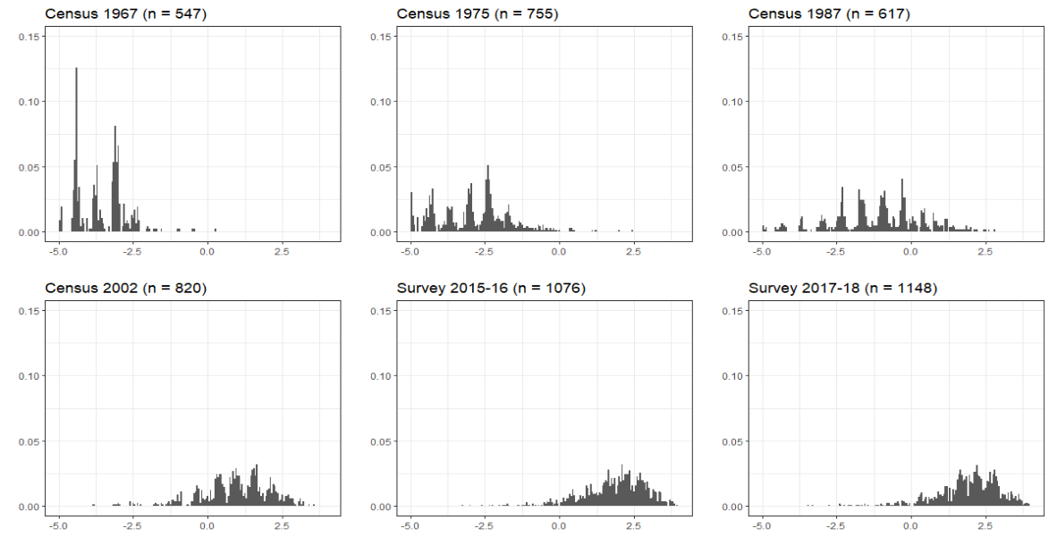
Supplementary Figure 2. Flowchart of cohort members (n = 2392)

Participation in surveys of cohort members who were alive at the time and residing in Guatemala conducted in 1988-89 and 2002-04 were 1577 (73%) and 1571 (85%) respectively. The numbers in the above flow-chart are for those who provided asset data in census and study waves

