Supplementary information (SI)

Observation and identification of autofluorescent urine crystals in urolithiasis patients

Syue-Liang Lin,^{1,2} Chen-Yuan Chung,¹ Yi-Hsiu Huang,³ Zih-Ting Chen,¹ Chih-Chia Huang,⁴ Yun-Zhen Li,¹ Huihua Kenny Chiang^{1,2,*}
¹Department of Biomedical Engineering, National Yang Ming Chiao Tung University, Taipei 112, Taiwan (ROC)
²Biomedical Engineering Research and Development Center, National Yang Ming Chiao Tung University, Taipei 112, Taiwan (ROC)
³Department of Urology, Taipei Veterans General Hospital, Taipei 112, Taiwan (ROC)
⁴Department of Photonics, National Cheng Kung University, Tainan 701, Taiwan (ROC)
*Huihua Kenny Chiang, E-mail: chiang@nycu.edu.tw

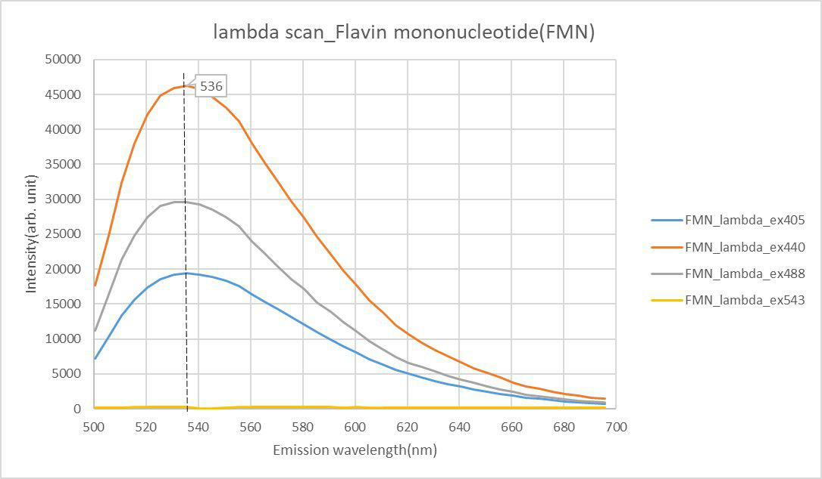
Fig. S1 The emission spectra of riboflavin fluorophore at different excitation wavelengths (λ_{ex}: 405, 440, 488, and 543 nm).

