Supplementary Information

Table S1: Species association with host order clades. A ﻿multi-level pattern analysis was used to evaluate the association of gut microbial species with each of the four host order clades in the dataset (multipatt in R package ﻿indicspecies, func = "r.g", control = how(nperm=999), regress out effect of location on species). The analysis identified 66 species with significant specificity (out of 603 tested) to any one combination of host order clades (p.adj<0.05). The table shows associations to one or more host order clades for every tested microbial species, along with statistics from multipatt analysis and species annotation.

Table S2: Species phylogenetic relatedness. Analysis of phylogenetic relatedness for 538 species identified 224 significant species (ses.mpd function in Phylocomr, abundance weighted MPD model, 999 permutations, p.adj<0.05). The table show statistics from the ses.mpd analysis for each species (rows) and the species annotation. The statistics columns; ntaxa: Number of taxa in community, mpd.obs: Observed mpd in community, mpd.rand.mean: Mean mpd in null communities, mpd.rand.sd: Standard deviation of mpd in null communities, mpd.obs.rank: Rank of observed mpd vs. null communities, mpd.obs.z: Standardized effect size of mpd vs. null communities (= (mpd.obs - mpd.rand.mean) / mpd.rand.sd, equivalent to -NRI), mpd.obs.p: p-value (quantile) of observed mpd vs. null communities (= mpd.obs.rank / runs + 1), mpd.obs.p.adj: multiple testing adjusted p-value.

Table S3: Microbial species community association with host phylogenetic groups and location. ﻿Permutational Multivariate Analysis of Variance Using Distance Matrices (ADONIS) was used to evaluate the association between gut microbiome composition and host clades and location (species-level microbiome, 999 permutations, min. 5 animals per host clade). The analysis was performed for hosts grouped at order to species levels (rows) and adjusting for location when analyzing phylogeny, and visa versa. All analysis supported a significant and dominating role of host phylogeny in shaping the gut microbiome, but also highlighted a role of location.

Table S4: Species association with host subgroups in the Hominidae family. A ﻿multi-level pattern analysis was used to evaluate the association of gut microbial species with each of the four host groups; humans from Guinea-Bissau or Germany, Pan and Pongo (multipatt in R package ﻿indicspecies, func = "r.g", control = how(nperm=999)) Effect of location was not regressed out due to the unvaried sampling of humans in Guinea-Bissau or Germany. The analysis found 93 species (out of 353 analyzed) with significant specificity, with 22 assigned to Guinea-Bissau humans, 40 to German humans, 23 to Pan and 31 to Pongo (multipatt p.adj<0.05). The table shows associations to one or more host order clades for every tested microbial species, along with statistics from multipatt analysis and species annotation.
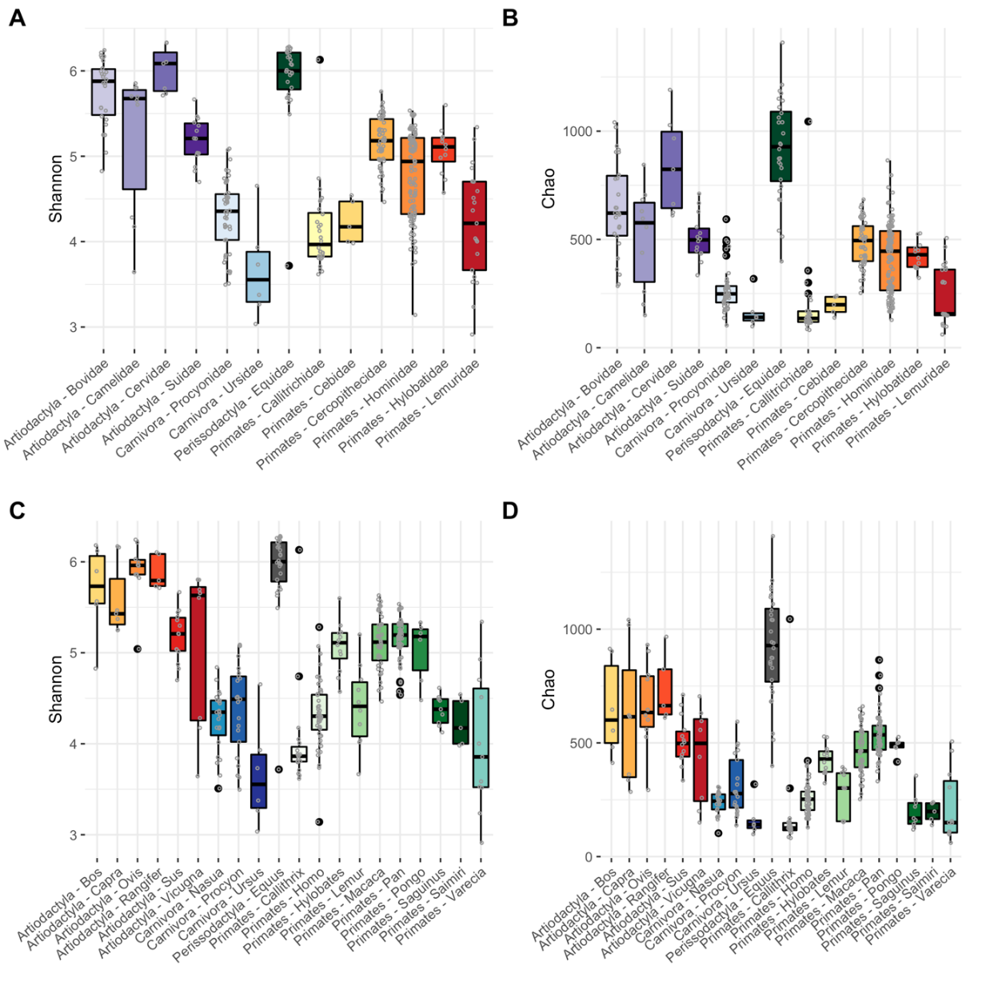
Figure S1: Microbial alpha diversity along host family clades and location. Comparison of the alpha diversity measures Shannon (A, C) and Chao (B, D) between host clades (A-B) at family-level and (C-D) genera-level.

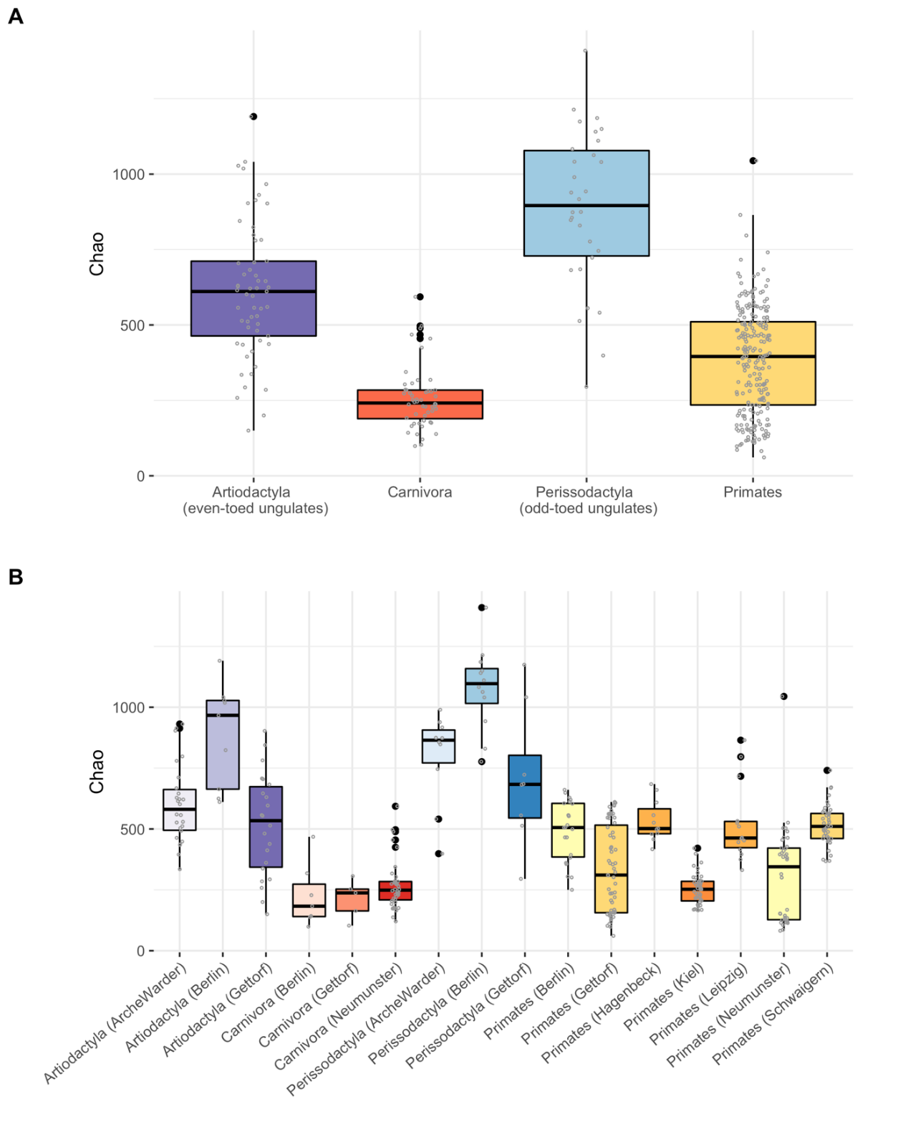
Figure S2: Microbial Chao alpha diversity along host order clades and location. Comparison of the alpha diversity measure Chao between host clades (A) at order-level and (B) sub-stratified by sampling location.
Bray-Curtis |  | Jaccard
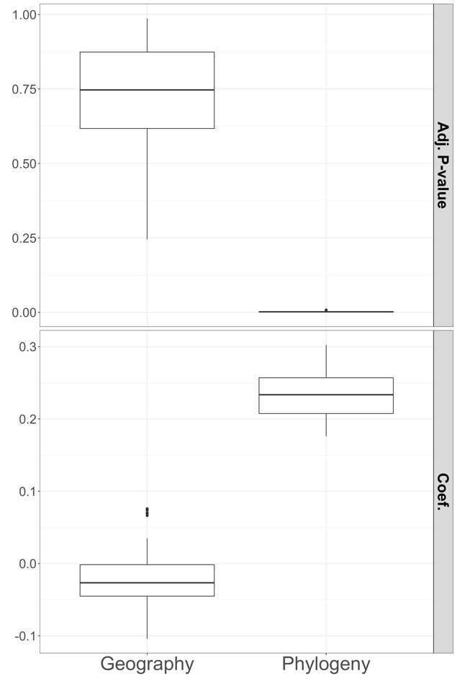 |  | 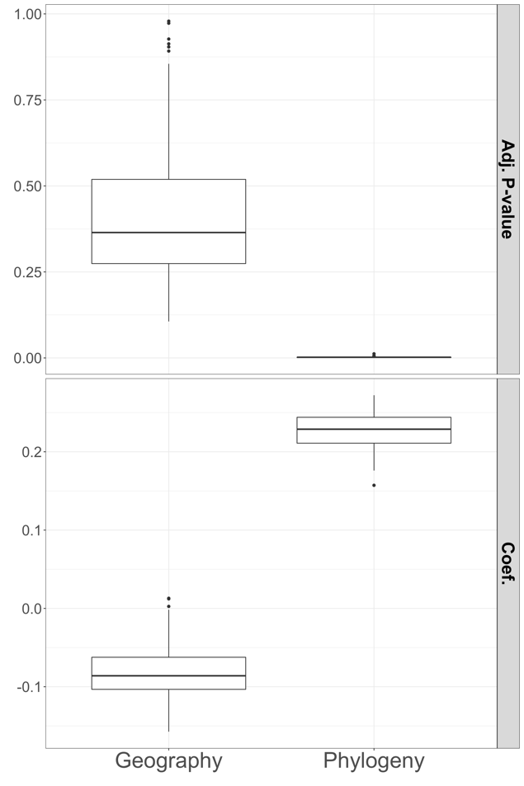
Figure S3: Gut microbiota community variation mainly explained by mammal phylogeny as oppose to location. Multiple regression on matrices (MRMs) was used to evaluate the gut microbiome (species) variation that associated with phylogeny and location, with location given by the Zoo’s geographical locations and humans home-country. The analysis was performed for both relative abundances (left) and presence/absence (right) of the microbiota species composition. In both analyses, host phylogeny explained a significant amount of variation (median p-value<0.05), while the variation explained by location was insignificant (median p-value>0.05).
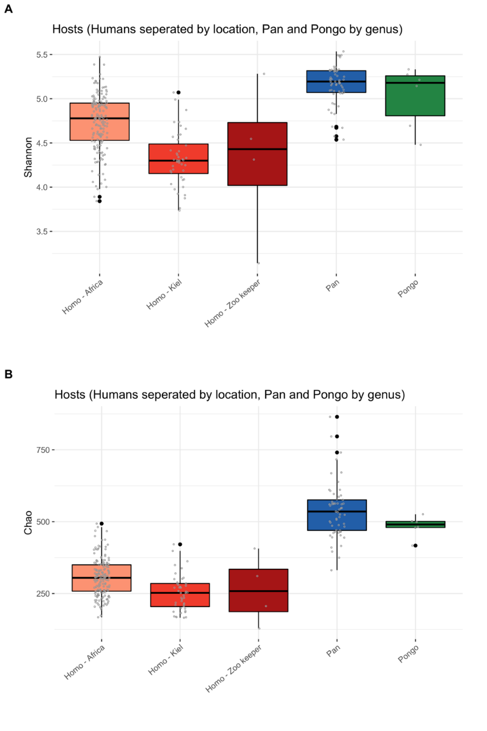
Figure S4: Microbial Shannon (A) and Chao (B) alpha diversity along hosts grouped by genus with humans further segregated by location. Comparison of the alpha diversity measure Shannon between host clades and location for humans, showed a higher diversity for the none-human mammals, followed by none-westernized Guinea-Bissau human subjects and then westernized German human subjects. A small subgroup of zookeepers (n=4) showed a large spread in diversity.

