Supplementary Materials for

Nanocell COVID-19 vaccine elicits iNKT-licensed dendritic cells to produce high affinity antibodies neutralizing Variants of Concern

Steven Y. Gao^{1†}, Nancy B. Amaro-Mugridge^{1†}, Jocelyn Madrid-Weiss¹, Nikolina Petkovic¹, Natasha Vanegas¹, Bryan R. G. Williams², Vinod Ganju^{2,3}, Jennifer A. MacDiarmid^{1¥}, Himanshu Brahmbhatt^{1¥*}

*Corresponding author. Email: hbrahmbhatt@engeneic.com

This PDF file includes:

Figs. S1 to S3
Tables S1 to S3

Table S1. An example of plasmid copy number analysis of a batch of EDV-COVID-αGC.

ELISA Antibodies
Mouse TNFα | DuoSet R&D Systems | DY41005
Mouse IFNαall subtype | Verikine-HS PBL | 42115
Mouse IFNγ | DuoSet R&D Systems | DY48505
Mouse IL12/p40 | DuoSet R&D Systems | DY239805
Mouse IL4 | DuoSet R&D Systems | DY40405
Mouse IL10 | DuoSet R&D Systems | DY41705
Mouse IL6 | DuoSet R&D Systems | DY40605
Mouse IL2 | DuoSet R&D Systems | DY402
Mouse IL21 | LEGEND MAX Mouse IL-21 ELISA Kit (Biolegend) | 446107
Table S2. ELISA kits used for cytokine analysis.

Marker | Antibody | Quantity  µg/500µl/1x10⁶ cells | Manufacturer
CD45 | Anti-mouse CD45-AF488 | 1.5 µg | Biolegend 103122
CD4 | Anti-mouse CD4 [GK1.5] (PE-Texas Red®) | 0.15 µg | Abcam ab51467
OX40 | Anti-mouse CD134 (OX-40)-APC | 0.3 µg | Biolegend 119413
CD3 | Anti-mouse CD3-PE-Cy7 | 0.75 µg | Biolegend 100220
CD8 | Anti-human/mouse CD8-AF647 | 0.75 µg | Biolegend 372906
CD69 | Anti-mouse CD69-BV421 | 0.075 µg | Biolegend 104527
7-AAD | Viability Staining Solution | 4 µl | Biolegend 420404
Table S3. T cell staining panel.

Fig. S1. SARS-CoV-2 spike protein quantification using ELISA.

Fig. S2. LC-MS αGC quantitation standard curve and area under the peak for EDV-COVID-αGC extracted particles.

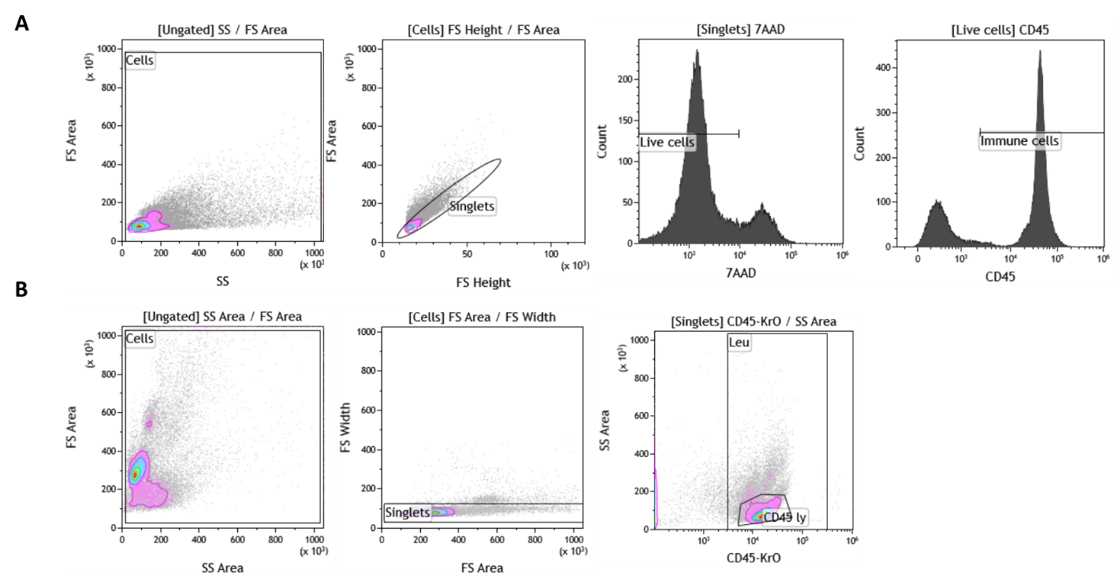
Fig. S3. Examples of the gating strategy used for FACS (A) in mouse studies, (B) in human volunteers.

