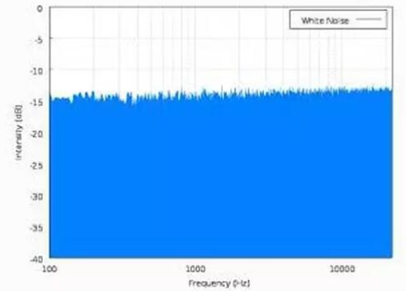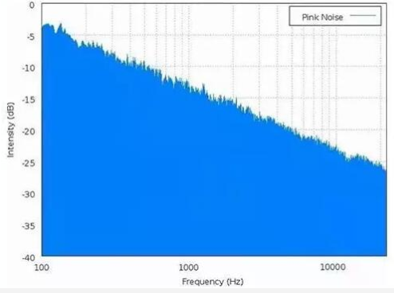
Figure 1 Spectrum comparison of white noise and pink noise
Judging
tinnitus level
Following
Recommendations
for treatment
Counseling
Adjusting
Stress
management
Developing treatment plan
Level 3-5: Use APP more than twice a day
Level 1-2: Use APP
1-2 times a day
Level 5: +77
Level 4: 58-76
Level 3: 37-57
Level 2: 18-36
Level 1: 0-17

Hearing assessment and tinnitus assessment
(THI survey assessment)
Level 5+: Go hospital
Level 1-5:
Tinnitus Rehabilitation Products
Tinnitus mechanism; Relationship between tinnitus and deafness; Factors affecting tinnitus; users' questions

Adjust the voice
according to the patient's hearing test
Guide relaxation exercises according to
the users’ situations
interview each sample patient and evaluate their THI 1, 3, 6 months respectively after the treatment; give guidance for next step based on the final results

Figure 2 Flow chart of tinnitus rehabilitation treatment

