Supplementary Information

Asymmetrical response of summer rainfall in East Asia to CO₂ forcing
Se-Yong Song¹, Sang-Wook Yeh¹, Soon-II An², Jong-Seong Kug³, Seung-Ki Min³,
Seok-Woo Son⁴, and Jongsoo Shin²
¹Department of Marine Sciences and Convergence Technology, Hanyang University, Ansan, South Korea
²Department of Atmospheric science, Yonsei University, Seoul, South Korea
³POSTECH, Pohang, South Korea
⁴School of Earth and Environmental Science, Seoul National University, Seoul, South Korea

Supplementary Information
Supplementary Figures 1-3

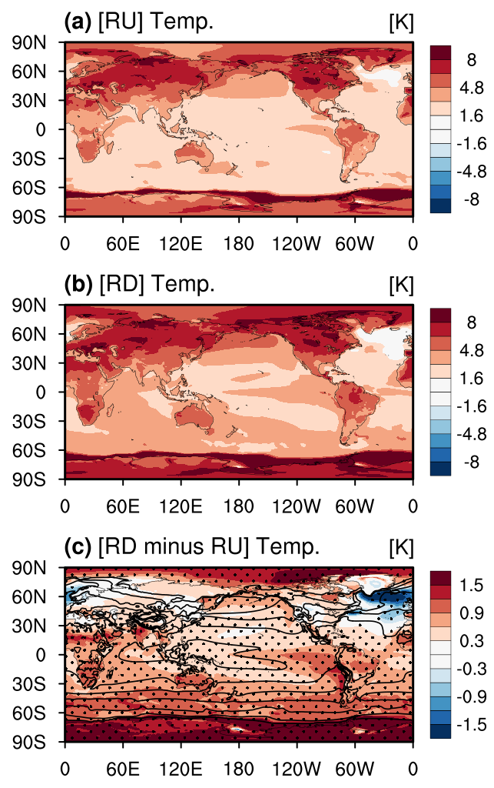
Supplementary Figure 1. Surface temperature anomalies (K) during the (a) ramp-up (2090-2139) and (b) ramp-down (2141-2190) periods during boreal summer. (c) Differences in surface temperature (shading, K) anomalies between the ramp-down and ramp-up periods. Black contours in (c) indicate the climatological surface temperature patterns obtained from the PD simulation. Black dots denote that the regions are significant at a 95% confidence level.
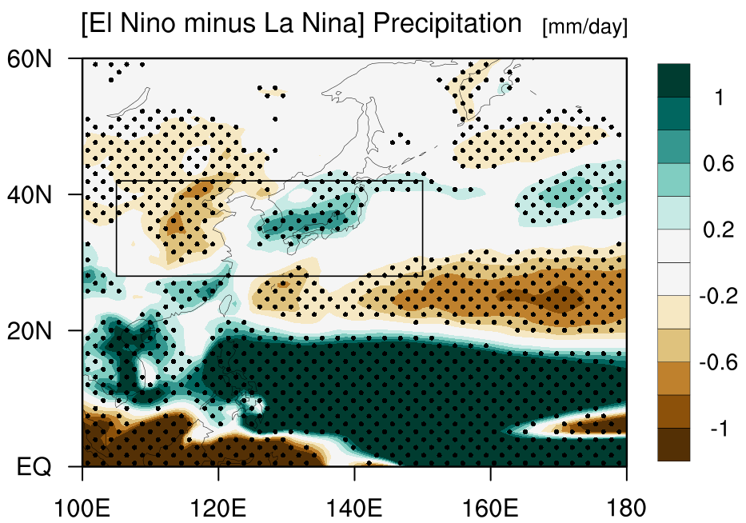
Supplementary Figure 2. Difference of composited rainfall anomalies between El Niño and La Niña years during boreal summer in a PD simulation. The El Niño (La Niña) years are selected when the SST anomaly averaged over the eastern tropical Pacific (5$°$S-5$°$N, 190$°$-250$°$E) during boreal summer is higher (less) than (-) 0.5 standard deviation. Black dots denote that the regions are significant at a 95% confidence level. The black box indicates the East Asia (28°-42°N, 105°-150°E) region.
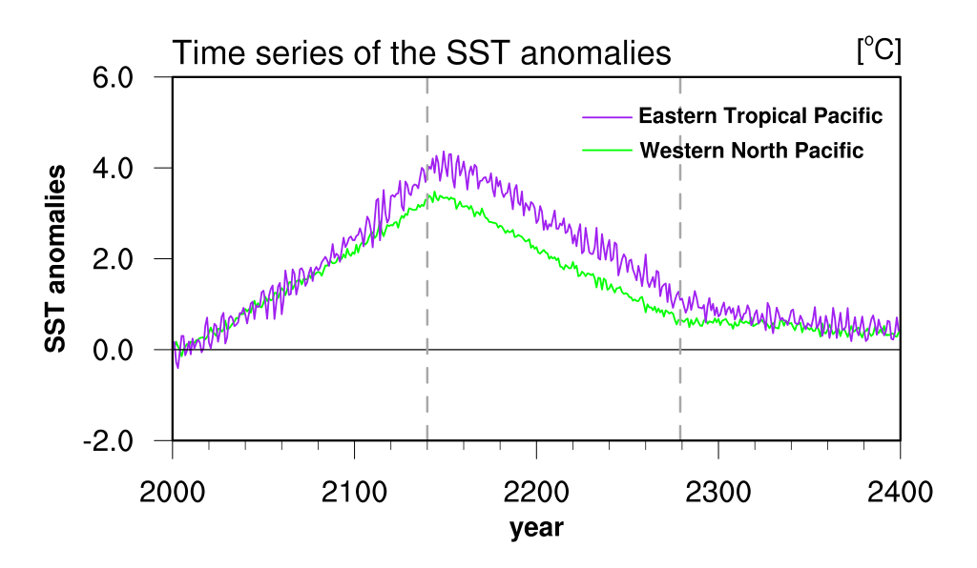
Supplementary Figure 3. Time series of the SST anomalies averaged over the eastern tropical Pacific (purple, 5$°$S-5$°$N, 190$°$-250$°$E) and western North Pacific (green, 15$°$-25$°$N, 120$°$-150$°$E) during boreal summer. Grey vertical dotted line denotes the CO₂ peak and stabilization start year.

