Supplementary Materials
Appropriateness of Empirical Antibiotic Therapy in Bacterial Culture-Positive Inpatients: a retrospective cohort study
Yuting Luo¹, Zhaowang Guo², Ying Li1, Hui Ouyang¹, Shanfeng Huang¹, Yuanli Chen³, Kenan Li¹, Yuxin Ji¹, Hongqiong Zhu¹, Wentao Luo¹, Jinyu Xia¹, and Xi Liu¹
¹Department of Infectious Diseases, The Fifth Affiliated Hospital, Sun Yat-sen University, Zhuhai, China
²Clinical Laboratory, The Fifth Affiliated Hospital, Sun Yat-sen University, Zhuhai, China
³Department of Hospital Infection Control, The Fifth Affiliated Hospital, Sun Yat-sen University, Zhuhai, China
Corresponding author: Xi Liu and Jinyu Xia, Department of Infectious Diseases, The Fifth Affiliated Hospital, Sun Yat-sen University, Zhuhai, China, 52 Meihua East Road, Xiangzhou District, zip code 519000.
e-mail address: liuxi26@mail.sysu.edu.cn; xiajinyu@mail.sysu.edu.cn

Figure S1: Drug sensitivity test report of culture-positive bacteria
Figure S2: The common culture positive bacteria in patients with respiratory/urinary tract infection, and the different therapeutic regimens and drug sensitivity results of different bacterial species.
Table S1: The Laboratory Indicators Related with EAT
Table S2: Pathogen Distribution and Site of Infection in Patients infected with MDRO and received IEAT
Table S3: Antibiotic Use in Patients infected with MDRO and received IEAT
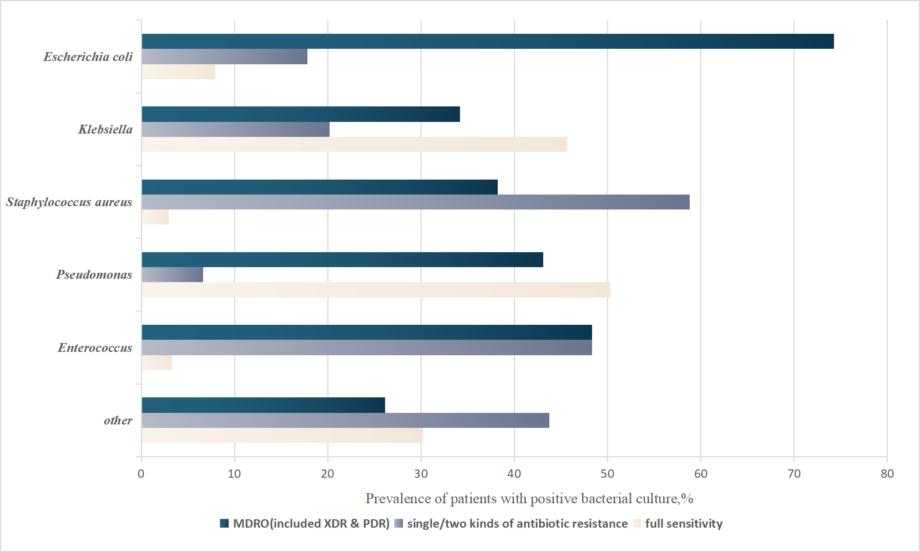
MDRO: multidrug-resistant organism; XDR: extensively drug resistant; PDR: pandrug resistant. These are the same in the following figures.
Figure S1: Drug sensitivity test report of culture-positive bacteria
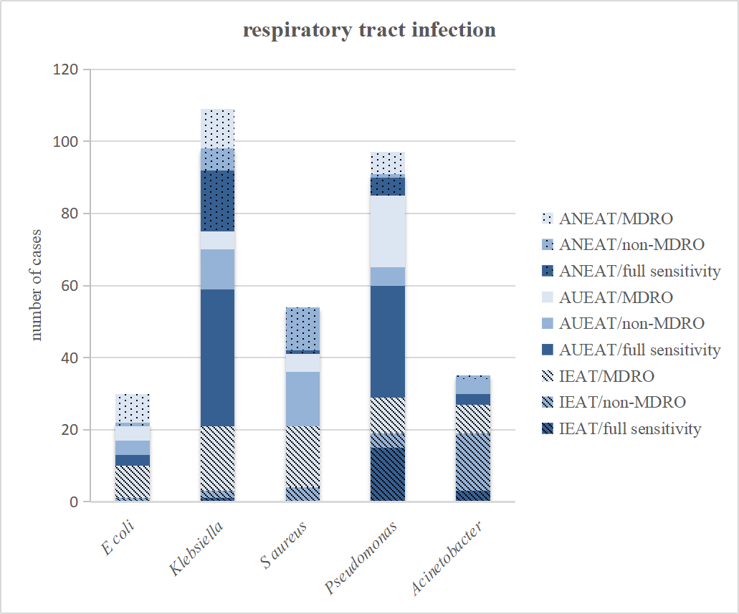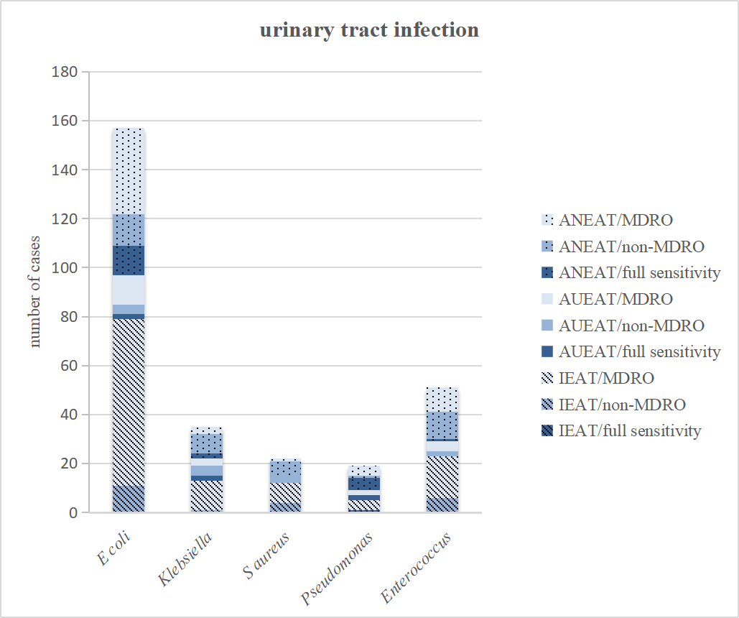
Figure S2: The common culture positive bacteria in patients with respiratory/urinary tract infection, and the different therapeutic regimens and drug sensitivity results of different bacterial species.
ANEAT: appropriate and necessarily empirical antibiotic therapy; AUEAT: appropriate but unnecessarily broad-spectrum empirical antibiotic therapy; IEAT: inappropriate empirical antibiotic therapy. The MDRO in the table included patients of XDR and PDR, and non-MDRO included patients of one or two kinds of antibiotic resistance.
Table S1: The Laboratory Indicators Related with EAT
 | Total (n=1257) | ANEAT (n=390) | AUEAT (n=398) | P value | IEAT (n=469) | P value
White blood cell count (×10⁹/L) | 8.4(6.1-12.1) | 7.9(5.9-11.6) | 9.2(6.3-13.4) | .002 | 8.1(6.0-11.7) | .962
Neutrophil count (×10⁹/L) | 6.0(3.8-9.9) | 5.5(3.7-9.5) | 7.3(4.2-11.1) | ＜.001 | 5.7(3.6-9.4) | .981
Proportion of neutrophils (%) | 75% (63%-85%) | 74% (63%-83%) | 79% (67%-87%) | ＜.001 | 73% (61%-85%) | .863
Lymphocyte count (×10⁹/L) | 1.2(0.8-1.8) | 1.3(0.8-1.9) | 1.1(0.7-1.6) | ＜.001 | 1.2(0.8-1.8) | .173
Platelet count (×10⁹/L) | 223(163-295) | 231(170-298) | 206(149-295) | .041 | 225(170-293) | .826
Hemoglobin (g/L) | 117(98-133) | 121(105-137) | 113(92-131) | ＜.001 | 118(99-134) | .076
Procalcitonin, PCT ª (ng/ml) | 0.22(0.10-1.14) | 0.16(0.10-0.83) | 0.37(0.10-2.53) | ＜.001 | 0.18(0.10-0.79) | .751
0-0.5 | 620(49.3%) | 180(68.4%) | 190(54.0%) | ＜.001 | 250(69.8%) | .564
＞0.5-10 | 268(21.3%) | 68(25.9%) | 118(33.5%) |  | 82(22.9%)
＞10 | 85(6.8%) | 15(5.7%) | 44(12.5%) |  | 26(7.3%)
C-reactive protein (mg/L) | 33.7(5.5-97.5) | 29.8(3.5-89.3) | 48.9(11.0-111.9) | .010 | 24.4(3.9-84.7) | .781
Erythrocyte sedimentation rate (mm/H) | 50.0(19.0-85.0) | 42.5(14.0-83.0) | 53.5(26.5-96.0) | .067 | 49.0(16.3-82.8) | .684
Prothrombin time (s) | 12.2(11.3-13.5) | 12.0(11.1-13.1) | 12.5(11.5-14.2) | ＜.001 | 12.0(11.1-13.2) | .557
Activated partial thromboplastin time (s) | 30.6(28.3-33.2) | 30.7(28.2-32.9) | 31.0(28.2-33.9) | .096 | 30.3(28.3-32.8) | .441
D-dimer (ng/ml) | 442(176-1146) | 331(133-843) | 569(224-1320) | ＜.001 | 441(163-1229) | .006
Urea (mmol/L) | 5.5(4.1-7.9) | 5.3(4.1-7.1) | 5.9(4.1-9.1) | .016 | 5.2(4.1-7.5) | .952
Serum creatinine (μmol/L) | 73(57-99) | 73(58-99) | 75(57-108) | .662 | 71(56-94) | .460
Cystatin-C (mg/L) | 1.05(0.90-1.39) | 1.05(0.88-1.35) | 1.14(0.94-1.66) | .012 | 1.04(0.91-1.38) | .522
Alanine aminotransferase (U/L) | 16(10-30) | 16(11-27) | 17(10-37) | .530 | 16(10-29) | .645
Aspartate aminotransferase (U/L) | 21(16-34) | 20(15-31) | 23(17-41) | ＜.001 | 21(15-32) | .775
Total bilirubin (g/L) | 9.1(6.4-14.1) | 8.9(6.5-13.7) | 9.6(7.0-16.7) | .019 | 8.7(6.2-12.8) | .225
Albumin (g/L) | 36(32-40) | 38(32-41) | 34(30-39) | ＜.001 | 37(32-40) | .367
Troponin I (μg/L) | 35.39(-33.74-104.52) | 0.26(-0.13-0.65) | 90.2(-86.8-267.21) | .014 | 0.05(0.02-0.07) | .695
Brain natriuretic peptide (pg/ml) | 395(129-1440) | 343(129-1193) | 638(154-2370) | .017 | 305(114-1128) | .886
Creatine kinase (U/L) | 73(41-145) | 72(43-134) | 79(42-158) | .501 | 64(37-150) | .467
Lactate dehydrogenase (U/L) | 191(158-253) | 185(154-231) | 205(165-292) | .001 | 188(157-246) | .276
EAT: empirical antibiotic therapy; ANEAT: appropriate and necessarily empirical antibiotic therapy; AUEAT: appropriate but unnecessarily broad-spectrum empirical antibiotic therapy; IEAT: inappropriate empirical antibiotic therapy. These are the same in the following tables. Laboratory indicators that reflected the general state of the patient and correlate with infection specificity were collected. As some patients were not tested for all indexes at the first blood draw on admission, the test results were collected for the first time in His system during the study period.
ª Procalcitonin (PCT) is an index with high specificity of bacterial infection. The concentration of procalcitonin could reflect the severity of infection and guide clinicians in the formulation of antibiotic treatment plan, including dosage and duration¹⁻³. PCT was not tested in some patients during the study period, and only valid PCT data were included for statistical analysis.
Table S2: Pathogen Distribution and Site of Infection in Patients infected with MDRO and received IEAT
Pathogen |  | Number of strains/cases(n=305)
Gram-negative bacteria (GNB)
Enterobacteriaceae | Escherichia coli | 116(38.0%)
 | Klebsiella species | 38(12.5%)
 | Enterobacter | 13(4.3%)
 | Proteus species | 8(2.6%)
 | Salmonella species | 3(1.0%)
Non-fermenting Gram-negative Bacilli | Pseudomonas species | 24(7.9%)
 | Acinetobacter species | 11(3.6%)
 | Stenotrophomonas | 2(0.7%)
 | Comamonas | 1(0.3%)
 | Achromobacter | 1(0.3%)
Flavobacteriaceae | Elizabethkingia species | 1(0.3%)
Total |  | 218(71.5%)
Gram-positive bacteria (GPB)
Staphylococcaceae | Staphylococcus aureus | 23(7.5%)
 | Coagulase-negative Staphylococci | 38(12.5%)
Enterococcaceae | Enterococcus species | 26(8.5%)
Total |  | 87(28.5%)
Site of infection
Urinary tract |  | 123(40.3%)
Respiratory |  | 74(24.3%)
Skin or soft tissue |  | 29(9.5%)
Blood |  | 29(9.5%)
Abdomen |  | 27(8.9%)
Multisite |  | 17(5.6%)
Catheter-related bloodstream infection |  | 3(1.0%)
Other |  | 3(1.0%)
Table S3: Antibiotic Use in Patients infected with MDRO and received IEAT
Antimicrobial Spectrum ^{b} | Total (n=304) ^{c} | Enterobacteriaceae (n=178) | Non-fermenting Gram-negative Bacilli (n=39) | Staphylococcaceae (n=61) | Enterococcaceae (n=26)
Non-multidrug resistant GNB | 86(28.3%) | 53(24.4%) | 7(3.2%) | 18(20.7%) | 8(9.2%）
Non-multidrug resistant GPB | 66(21.7%) | 44(20.3%) | 7(3.2%) | 13(14.9%) | 2(2.3%)
Cover both GNB and GPB | 128(42.7%) | 66(30.4%) | 21(9.7%) | 26(29.9%) | 15(17.2%)
Non-multidrug resistant bacteria | 64(21.1%) | 50(23.0%) | 4(1.8%) | 4(4.6%) | 6(6.9%)
Multidrug resistant GNB | 63(20.7%) | 15(6.9%) | 17(7.8%) | 22(25.3%) | 9(10.3%)
Multidrug resistant GPB | 1(0.3%) | 1(0.5%) | 0(0.0%) | 0(0.0%) | 0(0.0%)
Other ^{d} | 24(7.9%) | 15(6.9%) | 4(1.8%) | 4(4.6%) | 1(1.1%)
GNB: Gram-negative bacteria; GPB: Gram-positive. ^{b} Classified according to antibacterial spectrum and antimicrobial susceptibility testing report (e.g., the first and second generation cephalosporins mainly acted on Gram-positive cocci, and the third generation cephalosporins mainly acted on Gram-negative bacilli; β-lactam /β-lactamase inhibitor antibiotics (e.g., cefoperazone sodium sulbactam) can cover Enterobacteriaceae, Pseudomonas Aeruginosa sensitive strains and methicillin-sensitive Staphylococcus aureus, as well as extended-spectrum β-lactamase (ESBL) Gram-negative organism; Carbapenems can cover most Gram-positive cocci and Gram-negative bacilli, and also have effects on Gram-negative bacilli that are multidrug-resistant but sensitive to them). ^{c} 1 multidrug resistant Elizabethkingia-meningosepticum was not included in the analysis. ^{d} Other included use anti-fungal or anti-mycobacterial drug.
References
1. de Jong Evelien, van Oers Jos A., Beishuizen Albertus, et al. Efficacy and safety of procalcitonin guidance in reducing the duration of antibiotic treatment in critically ill patients: a randomised, controlled, open-label trial. The Lancet Infectious Diseases. 2016;16(7):819-827.
2. Schuetz Philipp, Wirz Yannick, Sager Ramon, et al. Effect of procalcitonin-guided antibiotic treatment on mortality in acute respiratory infections: a patient level meta-analysis. The Lancet Infectious Diseases. 2018;18(1):95-107.
3. Bouadma Lila, Luyt Charles-Edouard, Tubach Florence, et al. Use of procalcitonin to reduce patients' exposure to antibiotics in intensive care units (PRORATA trial): a multicentre randomised controlled trial. The Lancet. 2010;375(9713):463-474.

