**Supplementary Information**

**Ultra-strong comprehensive radiation effects tolerance in carbon nanotube electronics**

*Maguang Zhu1,* †*, Peng Lu2,* †*, Xuan Wang3,4,* †*, Chen Qian3,4, Huiping Zhu2, Yajie Zhang1, Jianshuo Zhou1, Haitao Xu5, Zhengsheng Han2,4, Jianwei Han3,4, Rui Chen3,4*, Bo Li2*, Lian-Mao Peng1,5 and Zhiyong Zhang1,5\**

1 Key Laboratory for the Physics and Chemistry of Nanodevices and Center for Carbon-based Electronics, School of Electronics, Peking University, Beijing 100871, China.

2 Institute of Microelectronics, Chinese Academy of Sciences, Beijing 100029, China.

3 National Space Science Center, Chinese Academy of Sciences, Beijing, China.

4 University of Chinese Academy of Sciences, Beijing, China.

5 Beijing Institute of Carbon-based Integrated Circuits, Beijing, China.

*Correspondence to: (R. C.) [chenrui2010@nssc.ac.cn](mailto:chenrui2010@nssc.ac.cn), (B. L.) libo3@ime.ac.cn,and (Z. Z.) [zyzhang@pku.edu.cn](mailto:zyzhang@pku.edu.cn).

**The laser-equivalent linear energy transfer (ELET) vs heavy ion LET**

As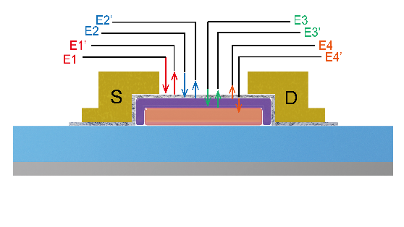 shown in Scheme 1, the laser is incident to the CNT layer and the initial energy is E1. Laser induced energy can be reflected by the CNT(*E*1') or transmit through the CNT(*E*2) and reach the surface of HfO2. Then *E*2 can be reflected by HfO2 (*E*2’) or transmit through the HfO2 (*E*3) and reach the surface of gate metal (Pd). After that the *E*3 can be completely reflected by the gate metal (*E*3’), reach the surface of HfO2 and be absorbed by the HfO2 again (*E*4’). Finally, the pulsed-laser (*E*4) reach the CNT surface again.

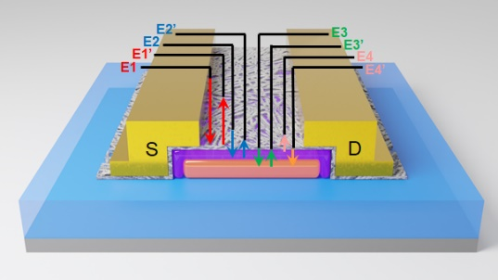

**Scheme 1|** Energy of the single event effect induced by 1064 nm laser deposited on the local gated CNT FETs.

Through the analysis of laser propagation process, the effective laser energy which induced single event for CNT FET can be defined as follows:

 (1)

By calculating the parameters in Equation (1), it can be found that the main energy of *E*eff comes from *E*2.

The effective energy equivalent LET as the function of laser energy can be described as follow:

 (2)

Here, *e*f is the ratio of energy required to generate *e-h* pairs for heavy ions and 1064 nm laser which is estimated to be 3.6 eV/1.17 eV, -1.3g/cm3 is the density of CNT, *d* is the thickness of CNT film,(2.4x105 cm-1 @1064nm)1 is the laser absorption coefficient of CNT,  is the internal quantum efficiency (IQE) of CNT which is estimated to be ~0.11 %2 and the *E*eff is the effective laser energy deposited on CNT FET. Therefore, we have to analysis the effective laser energy deposit on the local-gate CNT FET in order to calculate the threshold LET.

With the threshold energy of single event effect for CNT based SRAM shown in Fig. 3c (*E*1= 5.2 nJ) and 0.18μm local-bottom gated CNT FET shown in Fig. 2c (*E*1=3.8 nJ), the LETeff of CNT SRAM and 0.18μm CNT FETs are 1.49x104 MeV·cm2/mg and 1.08 x104 MeV·cm2/mg respectively. At present, some factors may not be taken into accounts, and this ELET equivalent model of CNT ICs can be optimized and modified in the future.

**References**

1 Liu, Y., Zhang, J. & Peng, L.-M. Three-dimensional integration of plasmonics and nanoelectronics. *Nature Electronics* **1**, 644-651 (2018).

2 Yang, L. *et al.* Efficient photovoltage multiplication in carbon nanotubes. *Nature Photonics* **5**, 672-676 (2011).

(a)

(b)

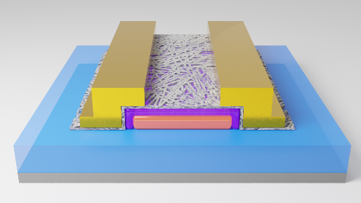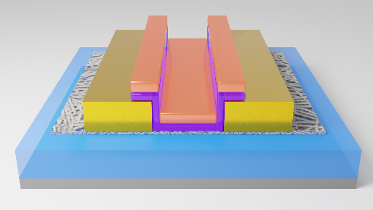

**Supplementary Fig. 1| Schematic dirgram of CNT FET. a,** A schematic diagram of the local bottom gate CNT FET used in this work. **b,** Schematic diagram of top-gated CNT FETs used in this work.

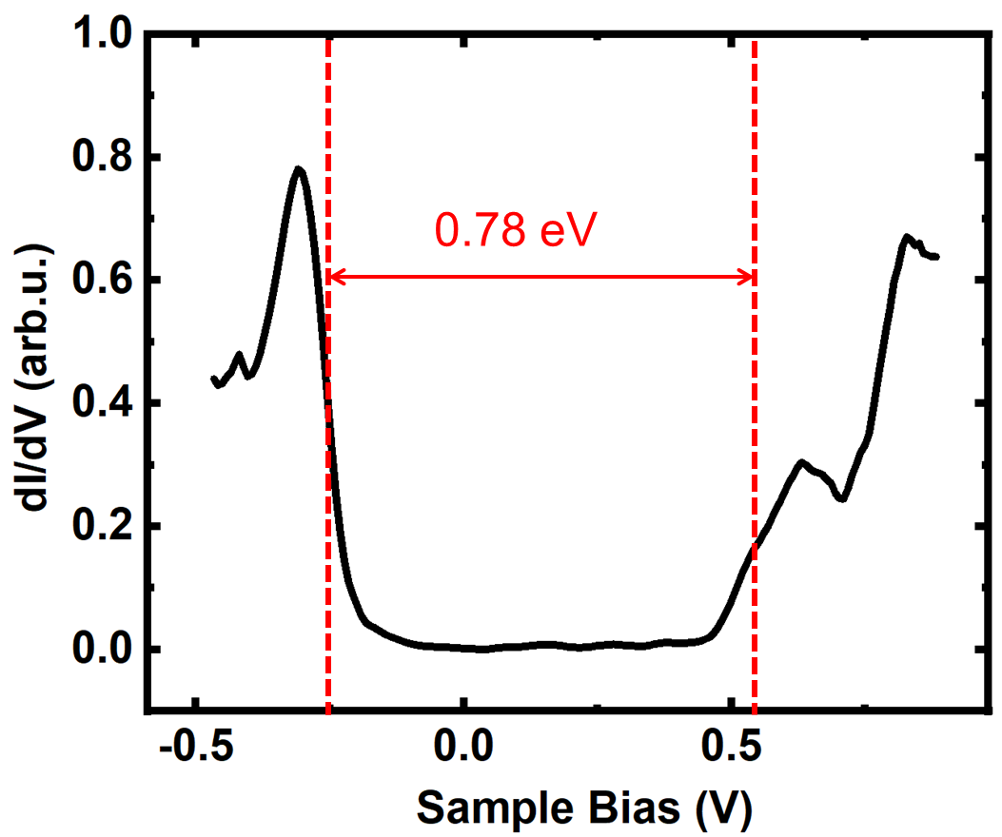

**Supplementary Fig. 2|** The d*I*/d*V* spectre measured with the STM tip positioned over the centers of CNT network.



**Supplementary Fig. 3|** Transfer characteristics of local bottom gate CNT FET.

(a)

(b)

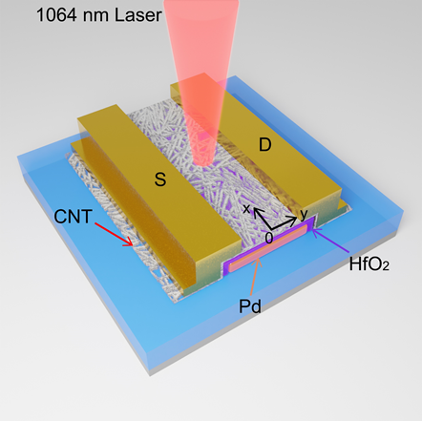

**Supplementary Fig. 4| SET sensitive regions of CNT FET. a,** The defination of the position (x, y)=(0, 0) in local bottom gate CNT FET being exposed to 1064 nm laser to test the single event transisents effects. The CNT FET presents channel length/width of 1 μm /10 μm, and is measured under a bias condition of Vds= -1 V and Vgs= 0 V. **b,** The laser induced single event peak current on the Ids as a function of the laser location during SPA irradiation for the CNT FET. Along the direction of x, the peak drain current is higher when laser strikes on the channel edge of CNT FETs. Along the direction of y, the peak drain current is higher when laser strikes on the channel center of CNT FETs.

(a)

(b)



**Supplementary Fig. 5| Transfer characteristics of CNT based SRAM. a,** Read margin of the CNT SRAM. **b,** Write margin of the CNT SRAM.

(a)

(c)

(d)

(b)

(e)

(f)

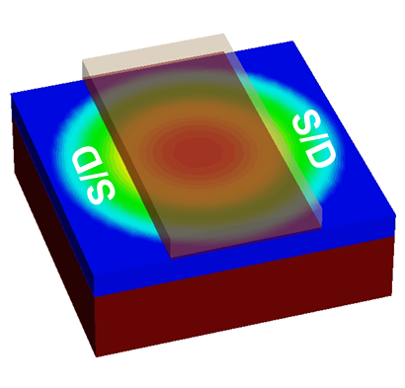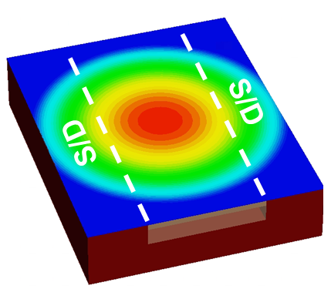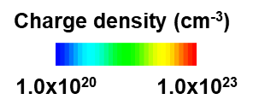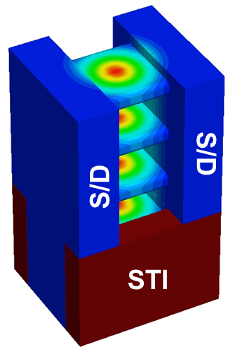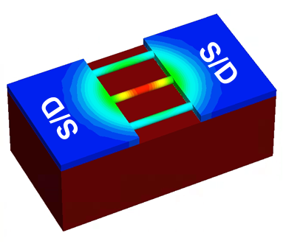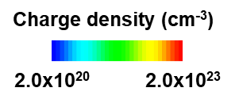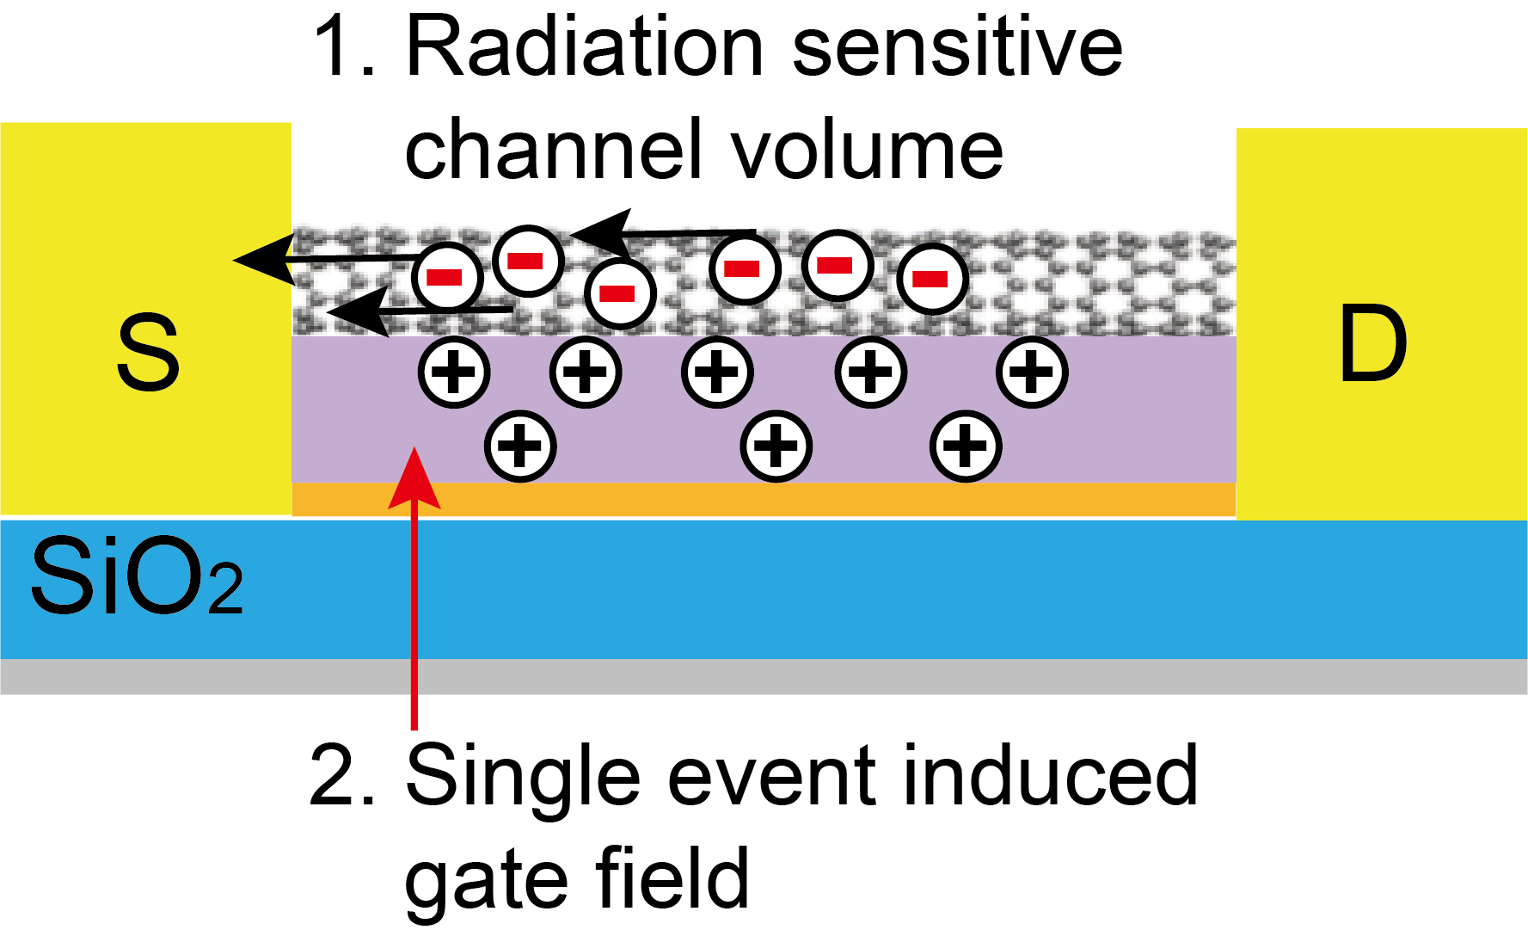

**Supplementary Fig. 6| Simulated single event effects of CNT FET. a,** Schematic of the single event effects mechanisms for CNT FETs. **b,** Charge density profiles due to single event strike for LET= 104 MeV·cm2/mg in 180 nm p-type FDSOI FET. **c,** Charge density profiles due to single event strike for LET= 104 MeV·cm2/mg in 180 nm p-type CNT FET. **d,** Charge density profiles due to single event strike for LET= 100 MeV·cm2/mg in 5 nm p-type nanosheet FET. **e,** Charge density profiles due to single event strike for LET= 100 MeV·cm2/mg in 5 nm p-type CNT FET. **f,** Simulated drain current transient of 5 nm nanosheet FET and CNT FET.

(a)

(b)

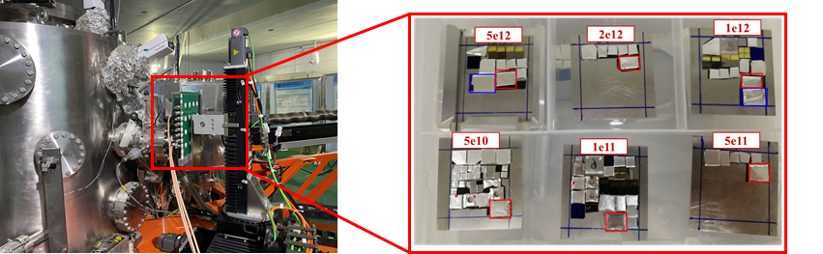

**Supplementary Fig. 7| Displacement damage testing of CNT FET with Xe+. a,** A schematic diagram of the heavy ion accelerator used in this work. **b,** Schematic diagram of the placement for the CNT FETs and solution-derived CNT films with different heavy ion fluences.



**Supplementary Fig. 8|** Raman spectra of top-gated CNT FETs before and after Xe+ heavy-ion irradiation with different ion fluences excited by a 785 nm laser.

(a)



(b)

(c)

(d)



**Supplementary Fig. 9| Displacement damage testing results of CNT FET with Xe+. a,** The over laid transfer characteristics of the CNT FETs with different heavy ion fluences. **b,** The statictics of the transconductance for CNT FETs with different Xe irradiation fluences of 0, 1×1012 and 5×1012 /cm2. **c,** The statictics of the on/off ratio for CNT FETs with different Xe irradiation fluences of 0, 1×1012 and 2×1012 /cm2. **d,** Leakage currents of the top-gated CNT FETs at Vds = -1 V, Vgs = 0 V as a function of heavy ion fluences.

(a)

(b)

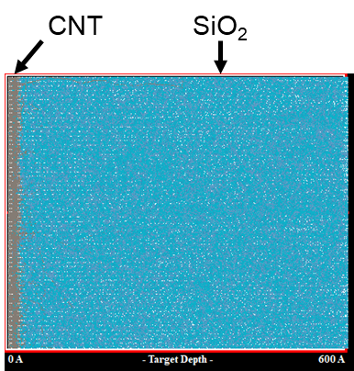

**Supplementary Fig. 10| Simulation results of the distribution of Xe+ heavy ion distribution in CNT FETs.** **a,** Simulation results of the distribution of Xe+ heavy ion distribution in the solution-derived CNT film deposited on a Si/SiO2 substrate. **b,** Simulation results of the number of vacancies in the contact region for the radiation-harden CNT FETs.

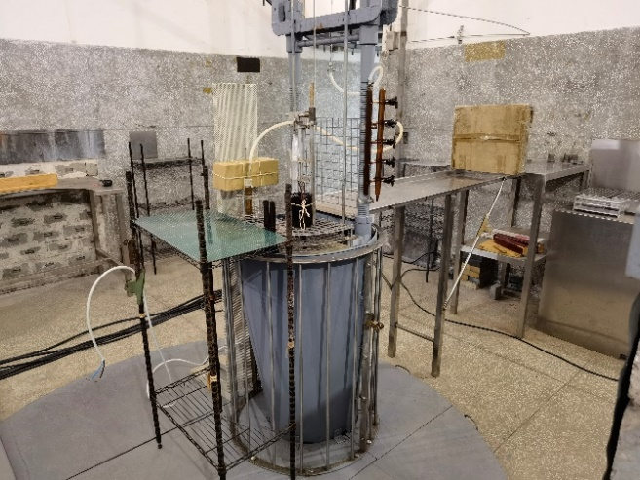

**Supplementary Fig. 11|** Schematic of the experimental method to decouple the displace damage radiation effects on a CNT top-gated FET.

(a)

(d)

(e)

(b)



(c)



**Supplementary Fig. 12| Transfer characteristics of local bottom gate CNT FET and SRAM after being exposed to DD, TID and SEEs irradiation.** **a,** Transfer characteristics of the rad-hard CNT FETs with different Xe ion fluences displace damage. **b,** Butterfly curves for rad-hard CNT SRAMs during read operation with different Xe ion fluences displace damage. **c,** Transfer curves of rad-hard CNT FETs at Vds=-1 V with different TID after being exposed to Xe heavy ions. **d,** The read margins of rad-hard CNT SRAM with different TID after being exposed to Xe heavy ions. e, Single event upsets of the rad-hard CNT SRAM which being exposed to Xe heavy-ion irradiation and γ-ray TID.