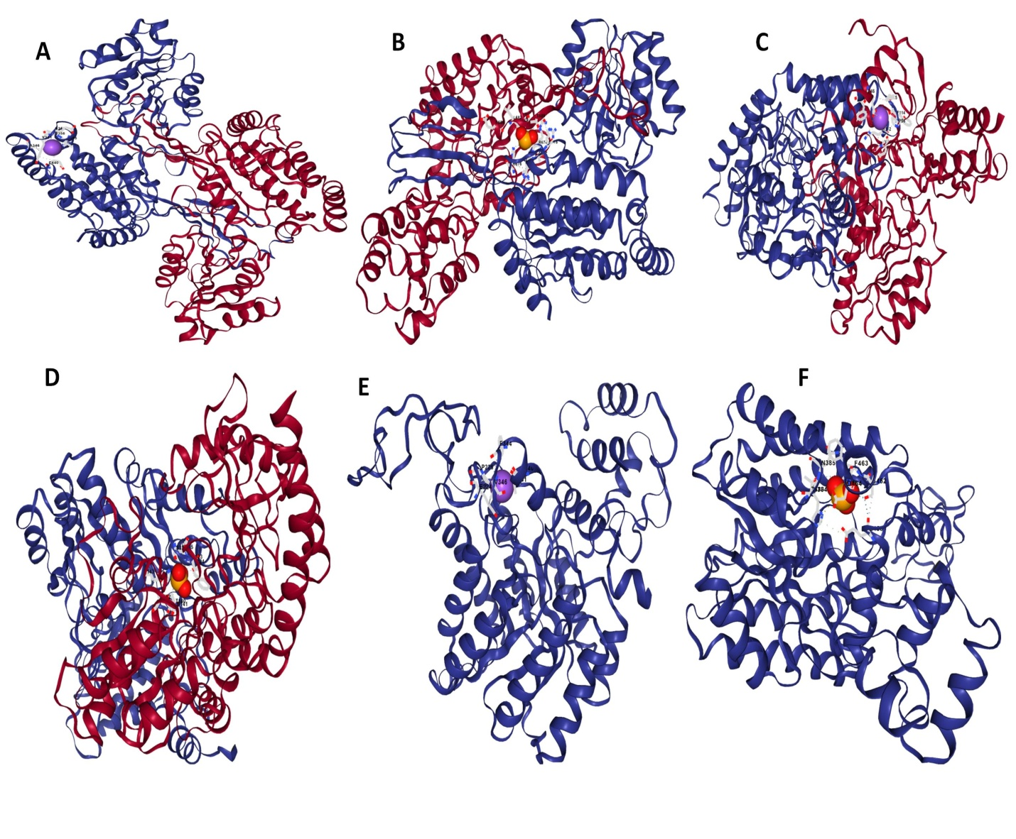
Supplementary Fig. 1: Molecular docking structures: (A) P5CS with salt (B) P5CS with Se (C) OAT with salt (D) OAT with Se (E) ProDH with salt (F) ProDH with Se.

