Figures and Tables in online appendices [Supplementary Information (SI)]
Table 1S The dereplication results of the extract of Glycomyces sediminimaris
m/z | Rt (min) | Molecular formula | Compound
261.1232 | 12.3 | C₁₄H₁₆N₂O₃ | 6
197.1286 | 12.4 | C₁₀H₁₆N₂O₂ | 4
219.1131 | 13.0 | C₁₂H₁₄N₂O₂ | 8
211.1444 | 13.9 | C₁₁H₁₈N₂O₂ | 1
211.1445 | 14.2 | C₁₁H₁₈N₂O₂ | 2
245.1289 | 14.6 | C₁₄H₁₆N₂O₂ | 3
284.1395 | 14.8 | C₁₆H₁₇N₃O₂ | 7
185.1288 | 15.0 | C₉H₁₆N₂O₂ | 5
213.1600 | 16.8 | C₁₁H₂₀N₂O₂ | 9

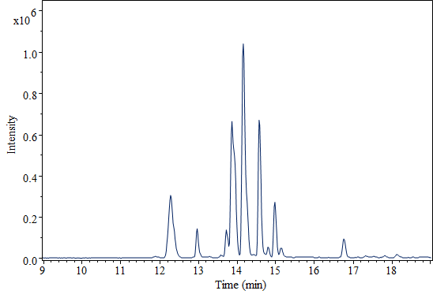
Fig. 1S UHPLC-ESI-Q-TOF-MS spectrum of Glycomyces sediminimaris extract

