Supplementary information for
N-th Nanoframes
Sungjae Yoo¹†, Jaewon Lee¹†, Hajir Hilal¹, Insub Jung¹, Woongkyu Park³, Joong Wook Lee⁴, Soobong Choi², and Sungho Park*¹
¹Department of Chemistry, Sungkyunkwan University; Suwon, 2066, Republic of Korea.
²Department of Physics, Incheon National University; Incheon,155, Republic of Korea.
³Medical & Bio Photonics Research Center, Korea Photonics Technology Institute (KOPTI); Gwangju, 61007, Republic of Korea
⁴ Department of Physics and Optoelectronics Convergence Research Center, Chonnam National University; Gwangju 61186, Republic of Korea
*Corresponding author. Email: spark72@skku.edu
†These authors contributed equally to this work

This pdf file includes :

Materials and instruments
Supplementary Fig. 1 to 14
Supplementary Table 1 to 4
Supplementary Video 1 to 3
References

Materials and instruments

Materials
Hydrogen tetrachloroaurate (III) hydrate (HAuCl₄·nH₂O, 99%) and hydrogen hexachloroplatinate (IV) hydrate (H₂PtCl₆·nH₂O, 99%) were purchased from Kojima. Sodium borohydride (NaBH₄, 98%) and silver nitrate (AgNO₃, 99.8%) were purchased from Junsei. Sodium iodide (NaI, 99.5%) and L-ascorbic acid (AA, C₆H₈O₆, 99.5%) were supplied by Sigma Aldrich. Hydrochloric acid (HCl, 35%), sodium hydroxide (NaOH, 98%), and sodium bromide (NaBr, 99.0%) were purchased from Samchun. Cetyltrimethylammonium bromide (CTAB, C₁₉H₄₂BrN, 95%) was purchased from Sigma-Aldrich. Cetyltrimethylammonium chloride (CTAC, C₁₉H₄₂ClN, 95%) was purchased from Tokyo Chemical Industry. All chemical materials were dissolved in distilled water (18.2 MΩ) prepared using a water purification system (Milli-Q, Millipore).

Instruments
Field emission scanning electron microscopy (FESEM) images were obtained using JSM-7100F and JSM-7800F instruments (JEOL). JEM-2100F and JEM-ARM 200F instruments (JEOL) were used to acquire transmission electron microscopy (TEM) images. UV-vis-NIR absorption spectra were acquired using a spectrophotometer (Shimadzu UV-3600). Raman spectra and images were recorded on a Raman microscope (Ntegra, NT-MDT).

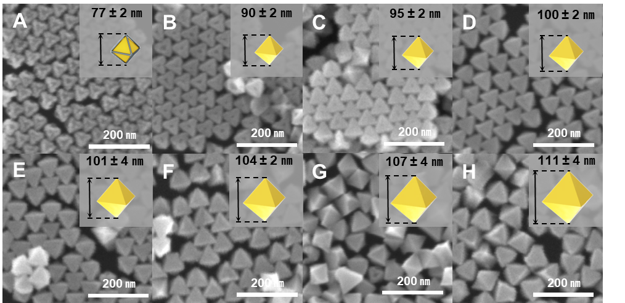

Supplementary Fig. 1 | (A to H) Monitoring the shape evolution after well-faceted overgrowth of Au on the 1st-Au@Pt-O-NPs through SEM images.

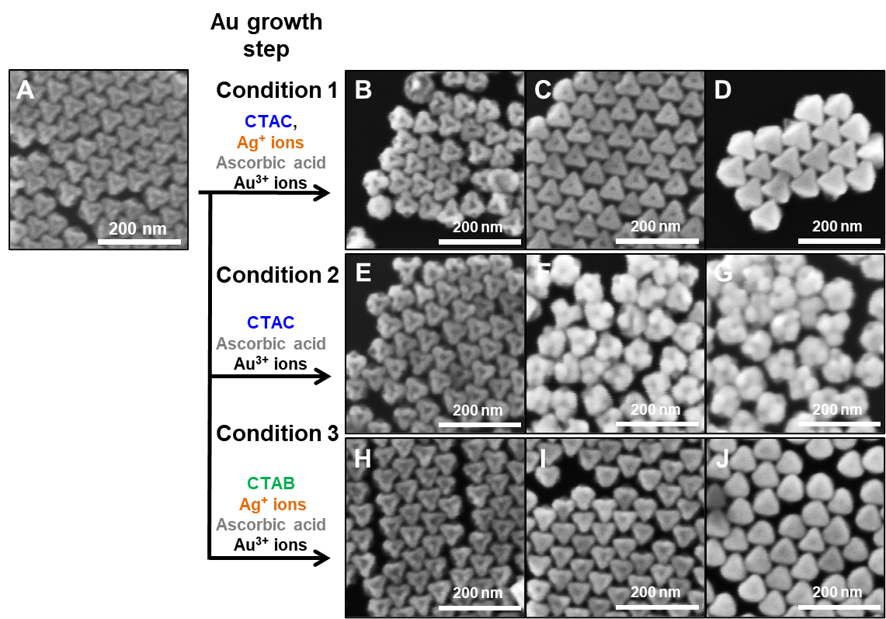

Supplementary Fig. 2 | Investigation of mechanism of the well-faceted overgrowth of Au. (A) SEM image of 1st-Au@Pt-O-NPs. SEM images of the resulting Au nanostructure after well-faceted overgrowth of Au with increasing amounts of Au³⁺ ions (B to D) in CTAC environment with Ag⁺ ions, (E to G) in CTAC environment without Ag⁺ ions, and (H to J) in CTAB environment with Ag⁺ ions.
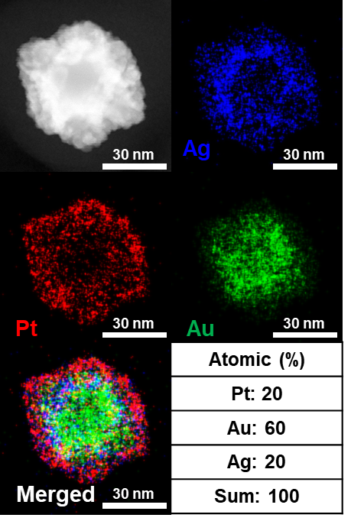

Supplementary Fig. 3 | Analysis of the elemental distribution of Ag-deposited 1st-Au@Pt-O-NP using energy dispersive X-ray spectroscopy (EDS) in scanning transmission electron microscopy (STEM).

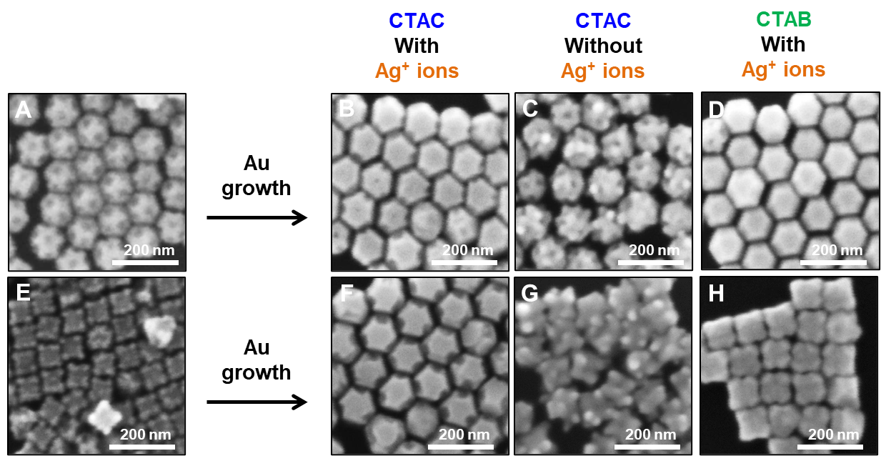

Supplementary Fig. 4 | Applicability of well-faceted overgrowth of Au for differently shaped Au@Pt NPs. (A and E) SEM images of 1st-Au@Pt-TO-NPs and 1st-Au@Pt-C-NPs. (B to H) SEM images of the resulting Au nanostructures after well-faceted overgrowth of Au on Au@Pt nanoparticles (B and F) in CTAC environment with Ag⁺ ions, (C and G) in CTAC environment without Ag⁺ ions, and (D and H) in CTAB environment with Ag⁺ ions.

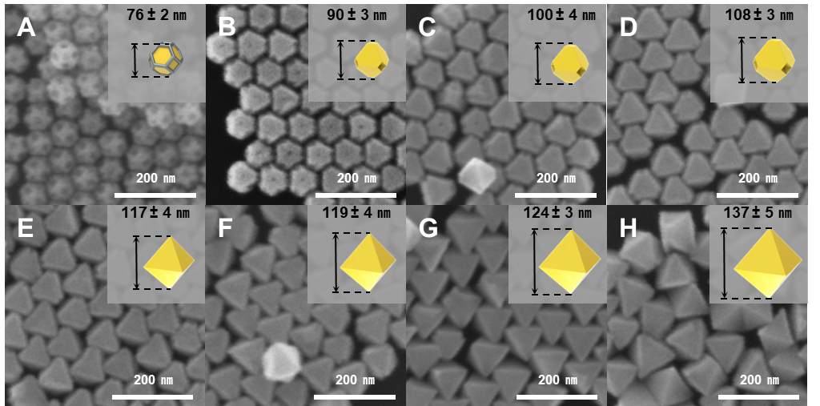

Supplementary Fig. 5 | (A to H) Monitoring the shape evolution after well-faceted overgrowth of Au on 1st-Au@Pt-TO-NPs through SEM images.

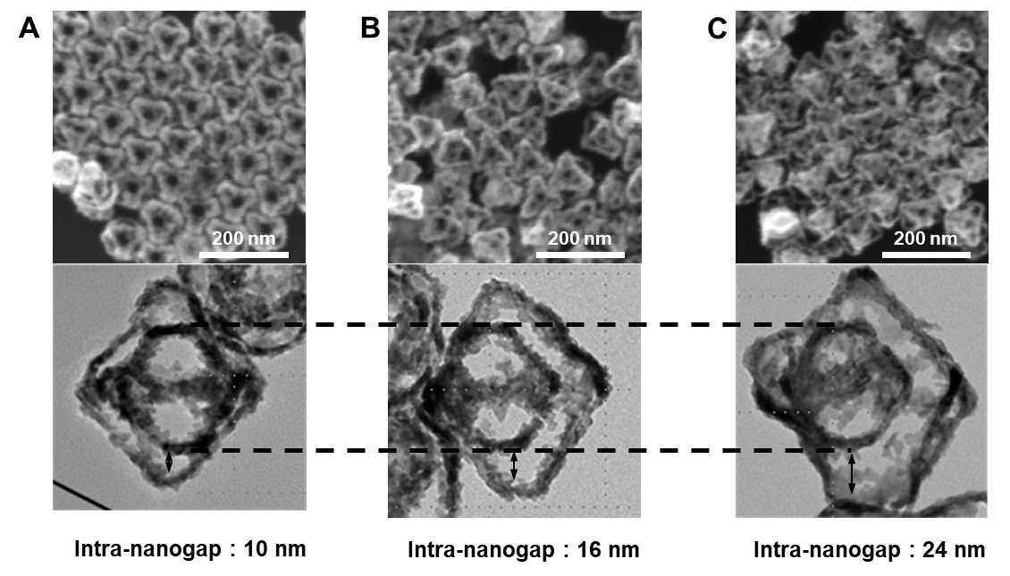

Supplementary Fig. 6 | Controlling the intra-nanogap distance of 2nd-Pt-TO:O-NFs by tailoring the degree of well-faceted overgrowth of Au. (A to C) Low-magnification SEM and zoomed-in TEM images of 2nd-Pt-TO:O-NFs with intra-nanogap distances of (A) 10 nm, (B) 16 nm, and (C) 24 nm.

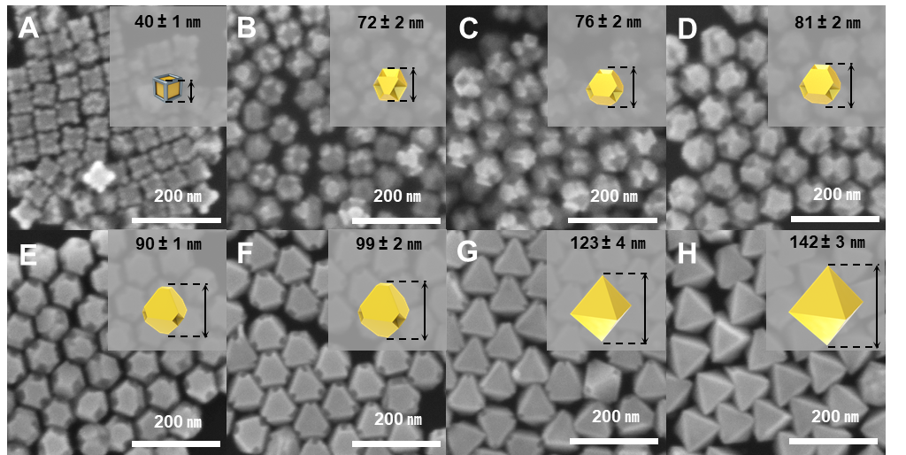

Supplementary Fig. 7 | (A to H) Monitoring the shape evolution after well-faceted overgrowth of Au on the 1st-Au@Pt-C-NPs as illustrated by SEM images.

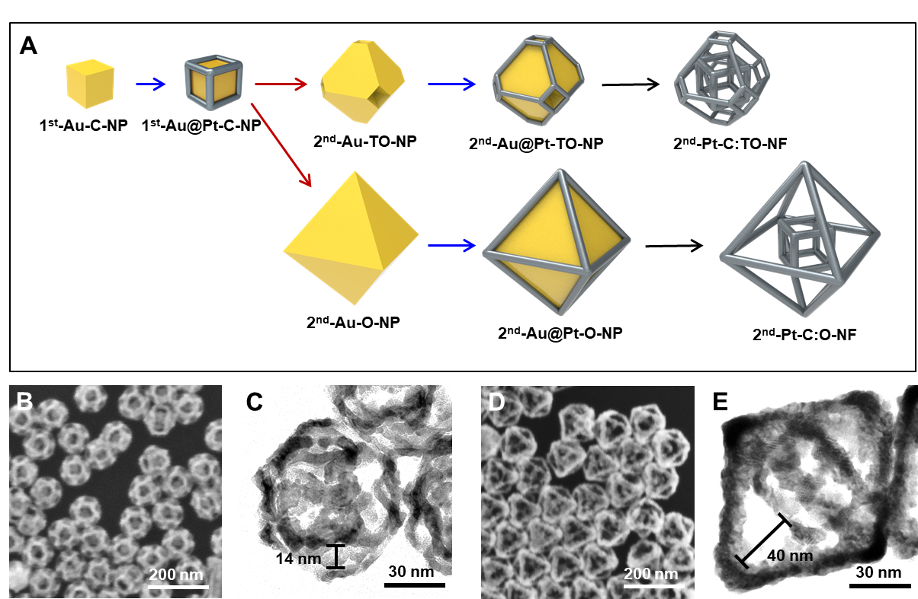

Supplementary Fig. 8 | Controlling the outer shape of nanoframes of 2nd nanoframe. (A) Schematic illustration of synthetic pathways for 2nd nanoframes with different outer shapes. SEM image of (B and C) 2nd-Pt-C:TO-NFs and (D and E) 2nd-Pt-C:O-NFs.

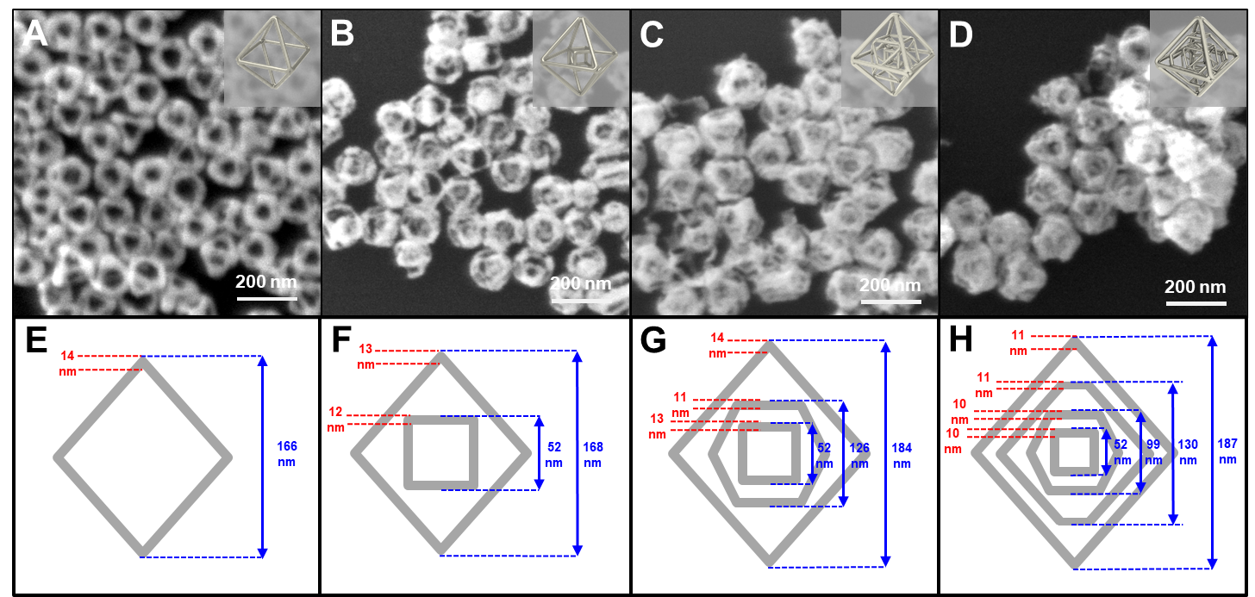

Supplementary Fig. 9 | (A to D) SEM images of 4D complex Ag nanoframe with different numbers of frames and (E to H) their corresponding dimension information.

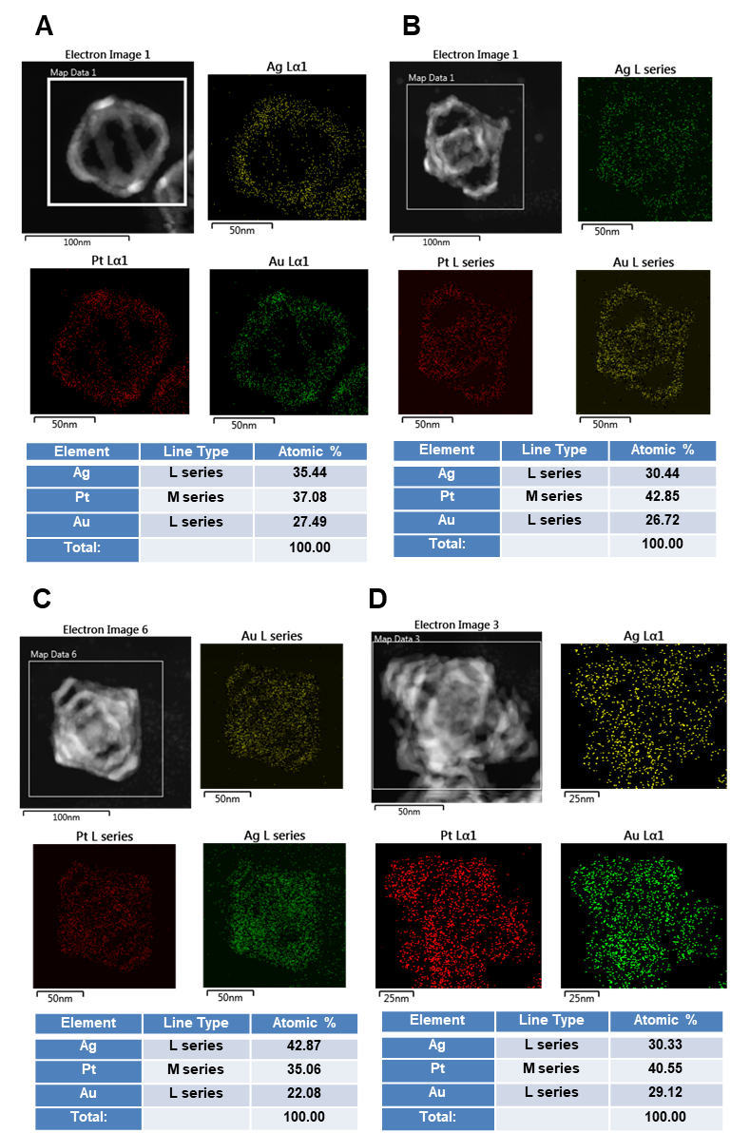

Supplementary Fig. 10 | Element distribution of 4D complex Ag nanoframes with different numbers of nanoframes.

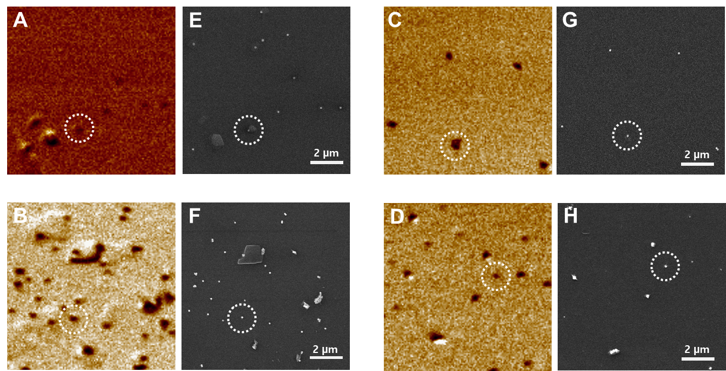

Supplementary Fig. 11 | (A to H) Rayleigh scattering images and the corresponding SEM images of (A and E) 1st, (B and F) 2nd, (C and G) 3rd, and (D and H) 4th Ag nanoframes. The dotted circles represent the single nanoparticles described in Fig. 5.

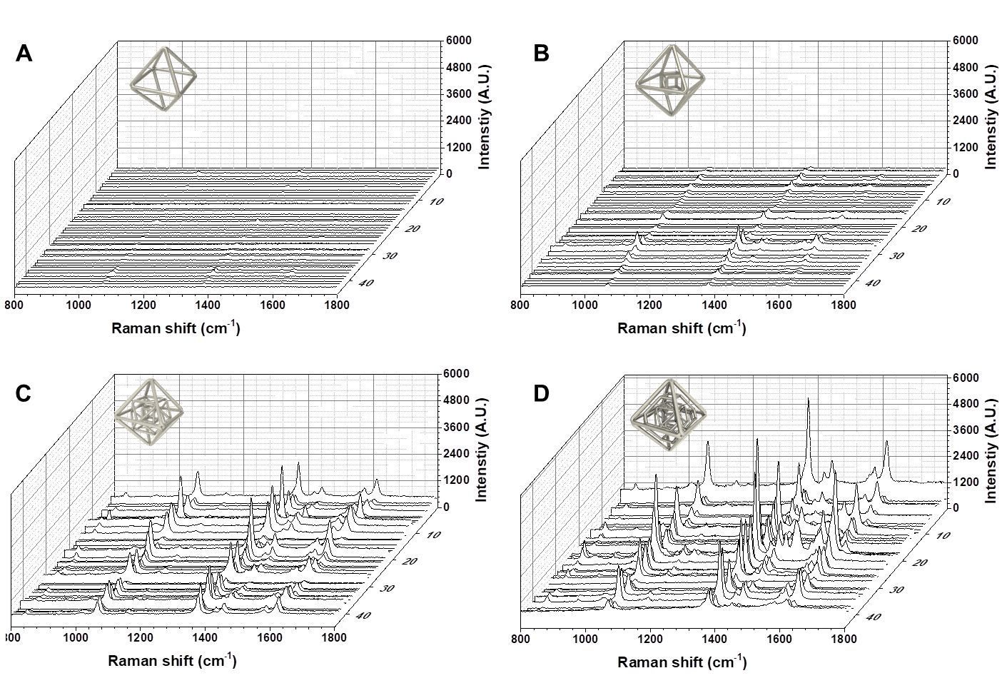

Supplementary Fig. 12 | Single-particle SERS data of 4D complex Ag nanoframes with different numbers of frames.

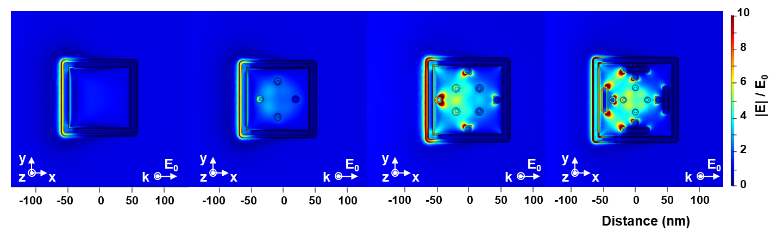
Supplementary Fig. 13 | Near electromagnetic field contour maps (in the XY cross-section) of 4D complex Ag nanoframes for different numbers of nanoframes (single to quadruple) obtained by a FEM simulation (Excitation wavelength: 633 nm).

Supplementary Table 1 | Added reagents volume for Pt deposition on Au nanoparticles in synthetic process of 3rd-Pt-TO:TO:O-NF.

Order | Au  Nanoparticles  volume | 50 mM  CTAB (I⁻) volume (mL) | 2 mM  AgNO₃ volume (µL) | 0.1 M  AA and HCl volume (µL) | 1 mM  H₂PtCl₆ volume (µL)
1st | 4 mL | 25 | 25 | 480 and 480 | 250
2nd | 250 µL | 1 | 2.6 | 48 and 48 | 26
3rd | 250 µL | 1 | 2.4 | 48 and 48 | 24

Supplementary Table 2 | Added reagents volume for well-faceted overgrowth of Au on Au@Pt nanoparticles in synthetic process of 3rd-Pt-TO:TO:O-NF.

Order | Au@Pt nanoparticles volume (µL) | 0.2 M  CTAC  volume (mL) | 2 mM  AgNO₃  volume (µL) | 0.1 M  AA  volume (µL) | 2 mM  HAuCl₄ volume (µL)
2nd | 250 µL | 1 | 30 | 3 | 30
3rd | 250 µL | 1 | 50 | 5 | 50

Supplementary Table 3 | Added reagents volume for Pt deposition on Au nanoparticles in synthetic process of 4th-Pt-C:CO:TO:O-NF.

Order | Au  Nanoparticles  volume | 50 mM  CTAB (I⁻)  volume (mL) | 2 mM  AgNO₃ volume (µL) | 0.1 M  AA and HCl volume (µL) | 1 mM  H₂PtCl₆ volume (µL)
1st | 4 mL | 25 | 25 | 200 and 380 | 250
2nd | 250 µL | 1 | 1.7 | 48 and 48 | 34
3rd | 250 µL | 1 | 1.9 | 48 and 48 | 38
4th | 250 µL | 1 | 2 | 48 and 48 | 40

Supplementary Table 4 | Added reagents volume for well-faceted overgrowth of Au on Au@Pt nanoparticles in synthetic process of 4th-Pt-C:CO:TO:O-NF.

Order | Au@Pt nanoparticles volume | 0.2 M  CTAC volume  (mL) | 2 mM  AgNO₃ volume (µL) | 0.1 M  AA volume  (µL) | 2 mM  HAuCl₄ volume (µL)
2nd | 250 µL | 1 | 30 | 3 | 30
3rd | 250 µL | 1 | 50 | 5 | 50
4th | 250 µL | 1 | 110 | 11 | 110
Supplementary Video 1 | Tilt series of TEM images (taken from -60 ° to + 60 °) of 2nd-Pt-O:O-NF.

Supplementary Video 2 | Tilt series of TEM images (taken from -60 ° to + 60 °) of 3rd-Pt-TO:TO:O-NF.

Supplementary Video 3 | Tilt series of TEM images (taken from -60 ° to + 60 °) of 4th-Pt-C:CO:TO:O-NF.

References
31. Park, J. E.; Lee, Y.; Nam, J. M. Precisely Shaped, Uniformly Formed Gold Nanocubes with Ultrahigh Reproducibility in Single-Particle Scattering and Surface-Enhanced Raman Scattering. Nano Lett. 18, 6475–6482 (2018).
32. P. B. Johnson and R. W. Christy, Optical Constants of the Noble Metals. Phys. Rev. B., 6, 4370 (1972).
33. Aleksandar D. Rakić et al., Optical properties of metallic films for vertical-cavity optoelectronic devices. Appl. Opt. 37, 5271-5283 (1998).

