Supplementary Information
Predicting European Cities’ Climate Mitigation Performance using Machine Learning

Angel Hsu^{1,2}, Xuewei Wang^{1,2}, Jonas Tan³, Wayne Toh³, and Nihit Goyal⁴
¹Department of Public Policy, University of North Carolina-Chapel Hill, Abernethy Hall, Chapel Hill, NC, 27599
²Data-Driven EnviroLab, University of North Carolina-Chapel Hill, Chapel Hill, NC 27599
³Yale-NUS College, Singapore, 10 College Ave W, 138609
⁴Faculty of Technology, Policy and Management, TU Delft, Building 31 Jaffalaan 5, 2628 BX Delft, Netherlands

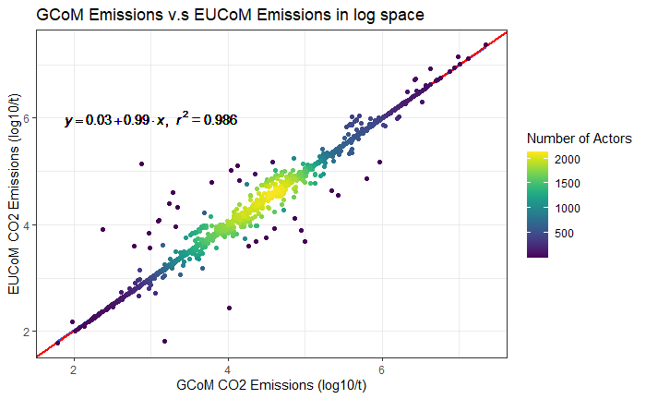
Figure S1. Comparison of logged emissions data points between the two primary self-reported emissions data from Kona et al. (2021) and the EU Covenant of Mayors for Climate and Energy website. Where a city had self-reported emissions data in both Kona et al. (2021) and the EUCoM website for the same years, we prioritized data from Kona et al. (2021), since they provide a series of validation and checks on these data.

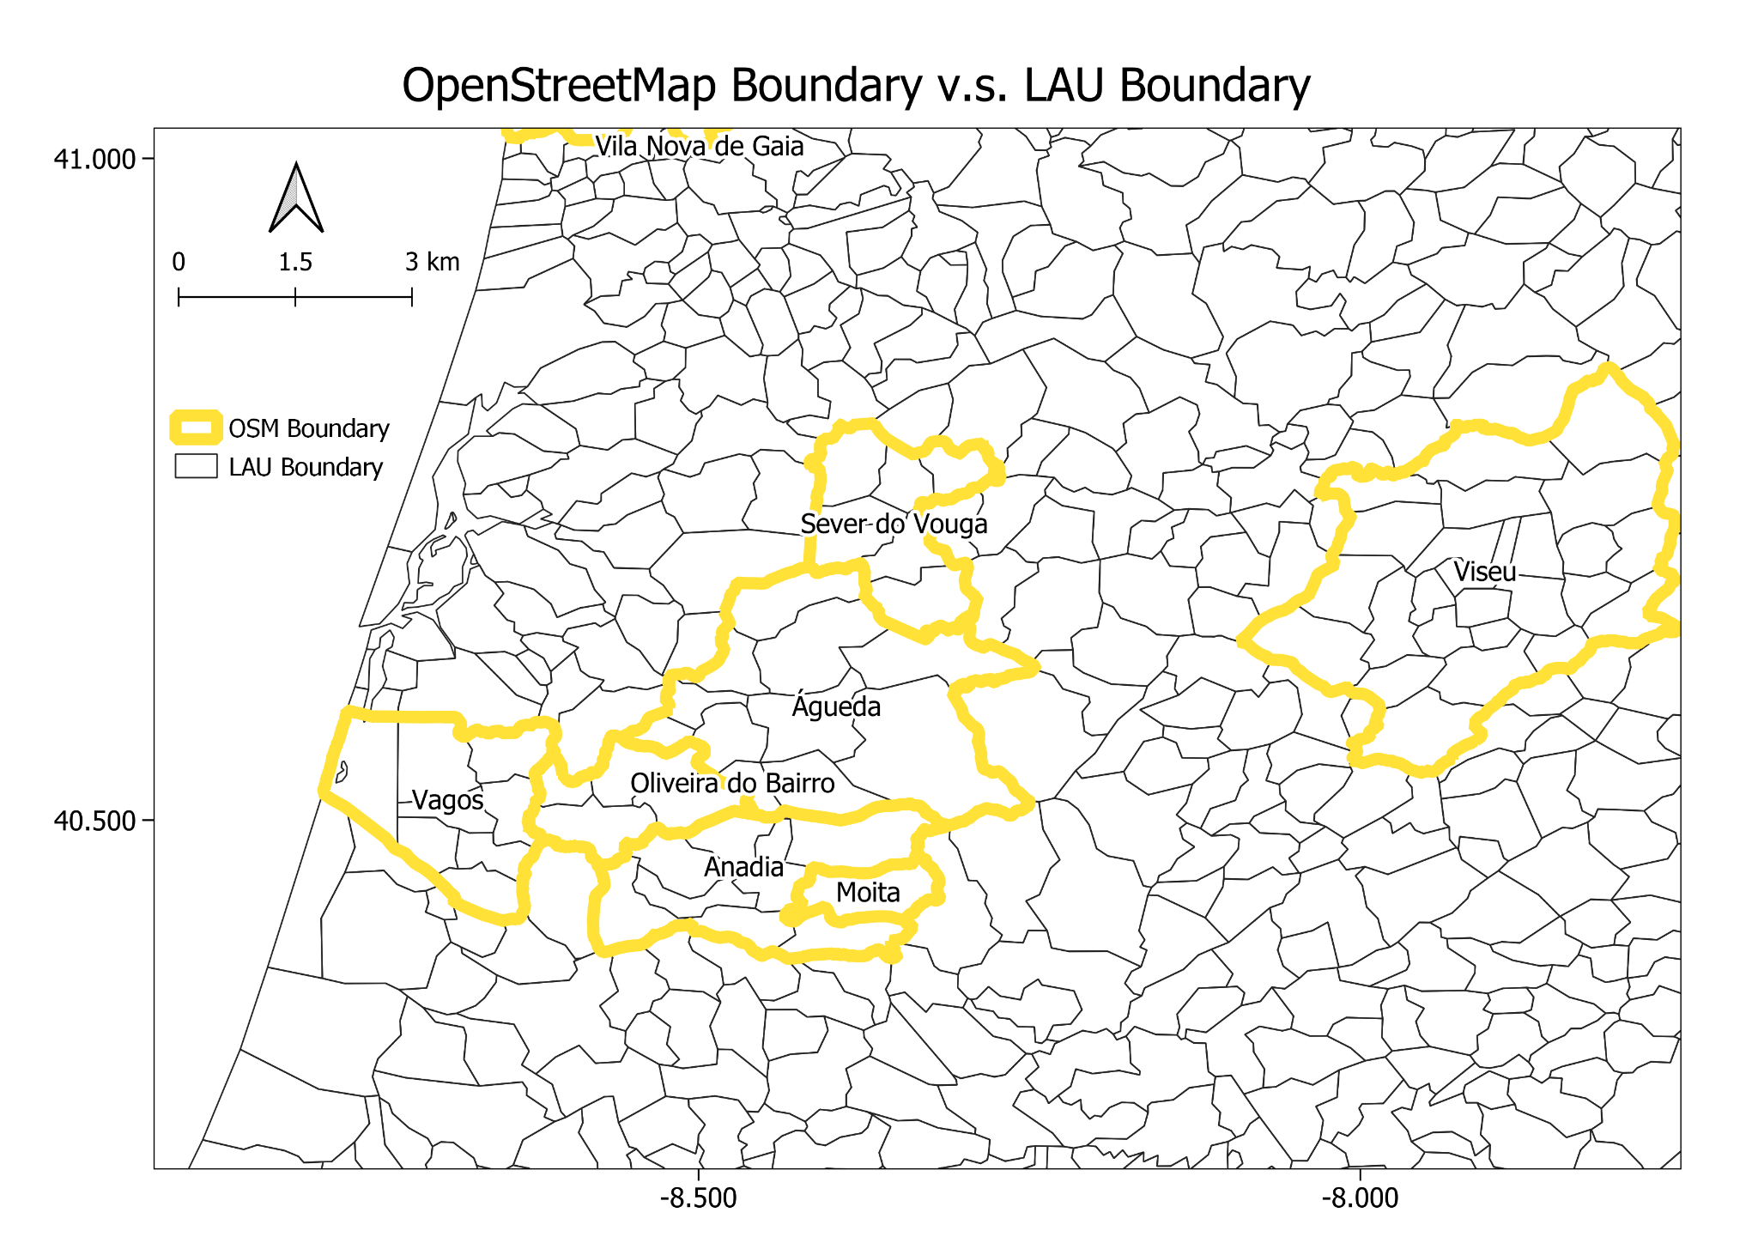
Figure S2. Comparison of city boundaries from OpenStreetMap (yellow polygons) v.s. LAU Units (black polygons) in Portugal.
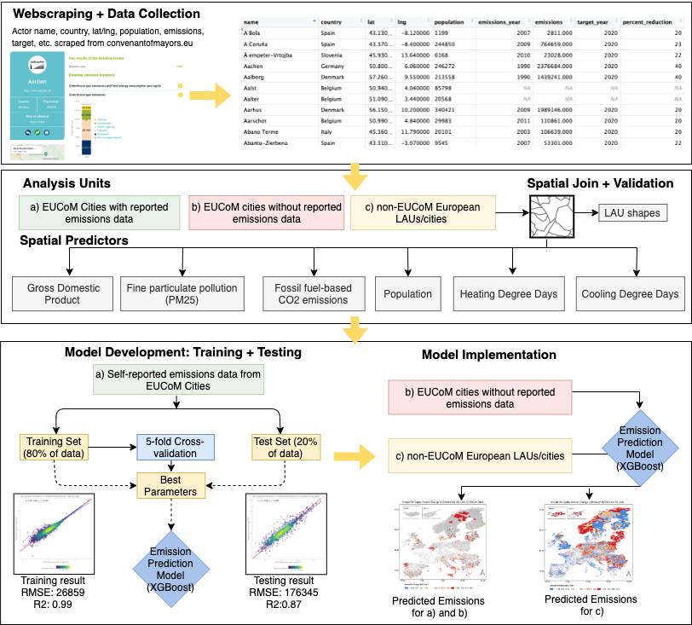

Figure S3. Overview of methodological workflow and data processing steps. Source: authors.

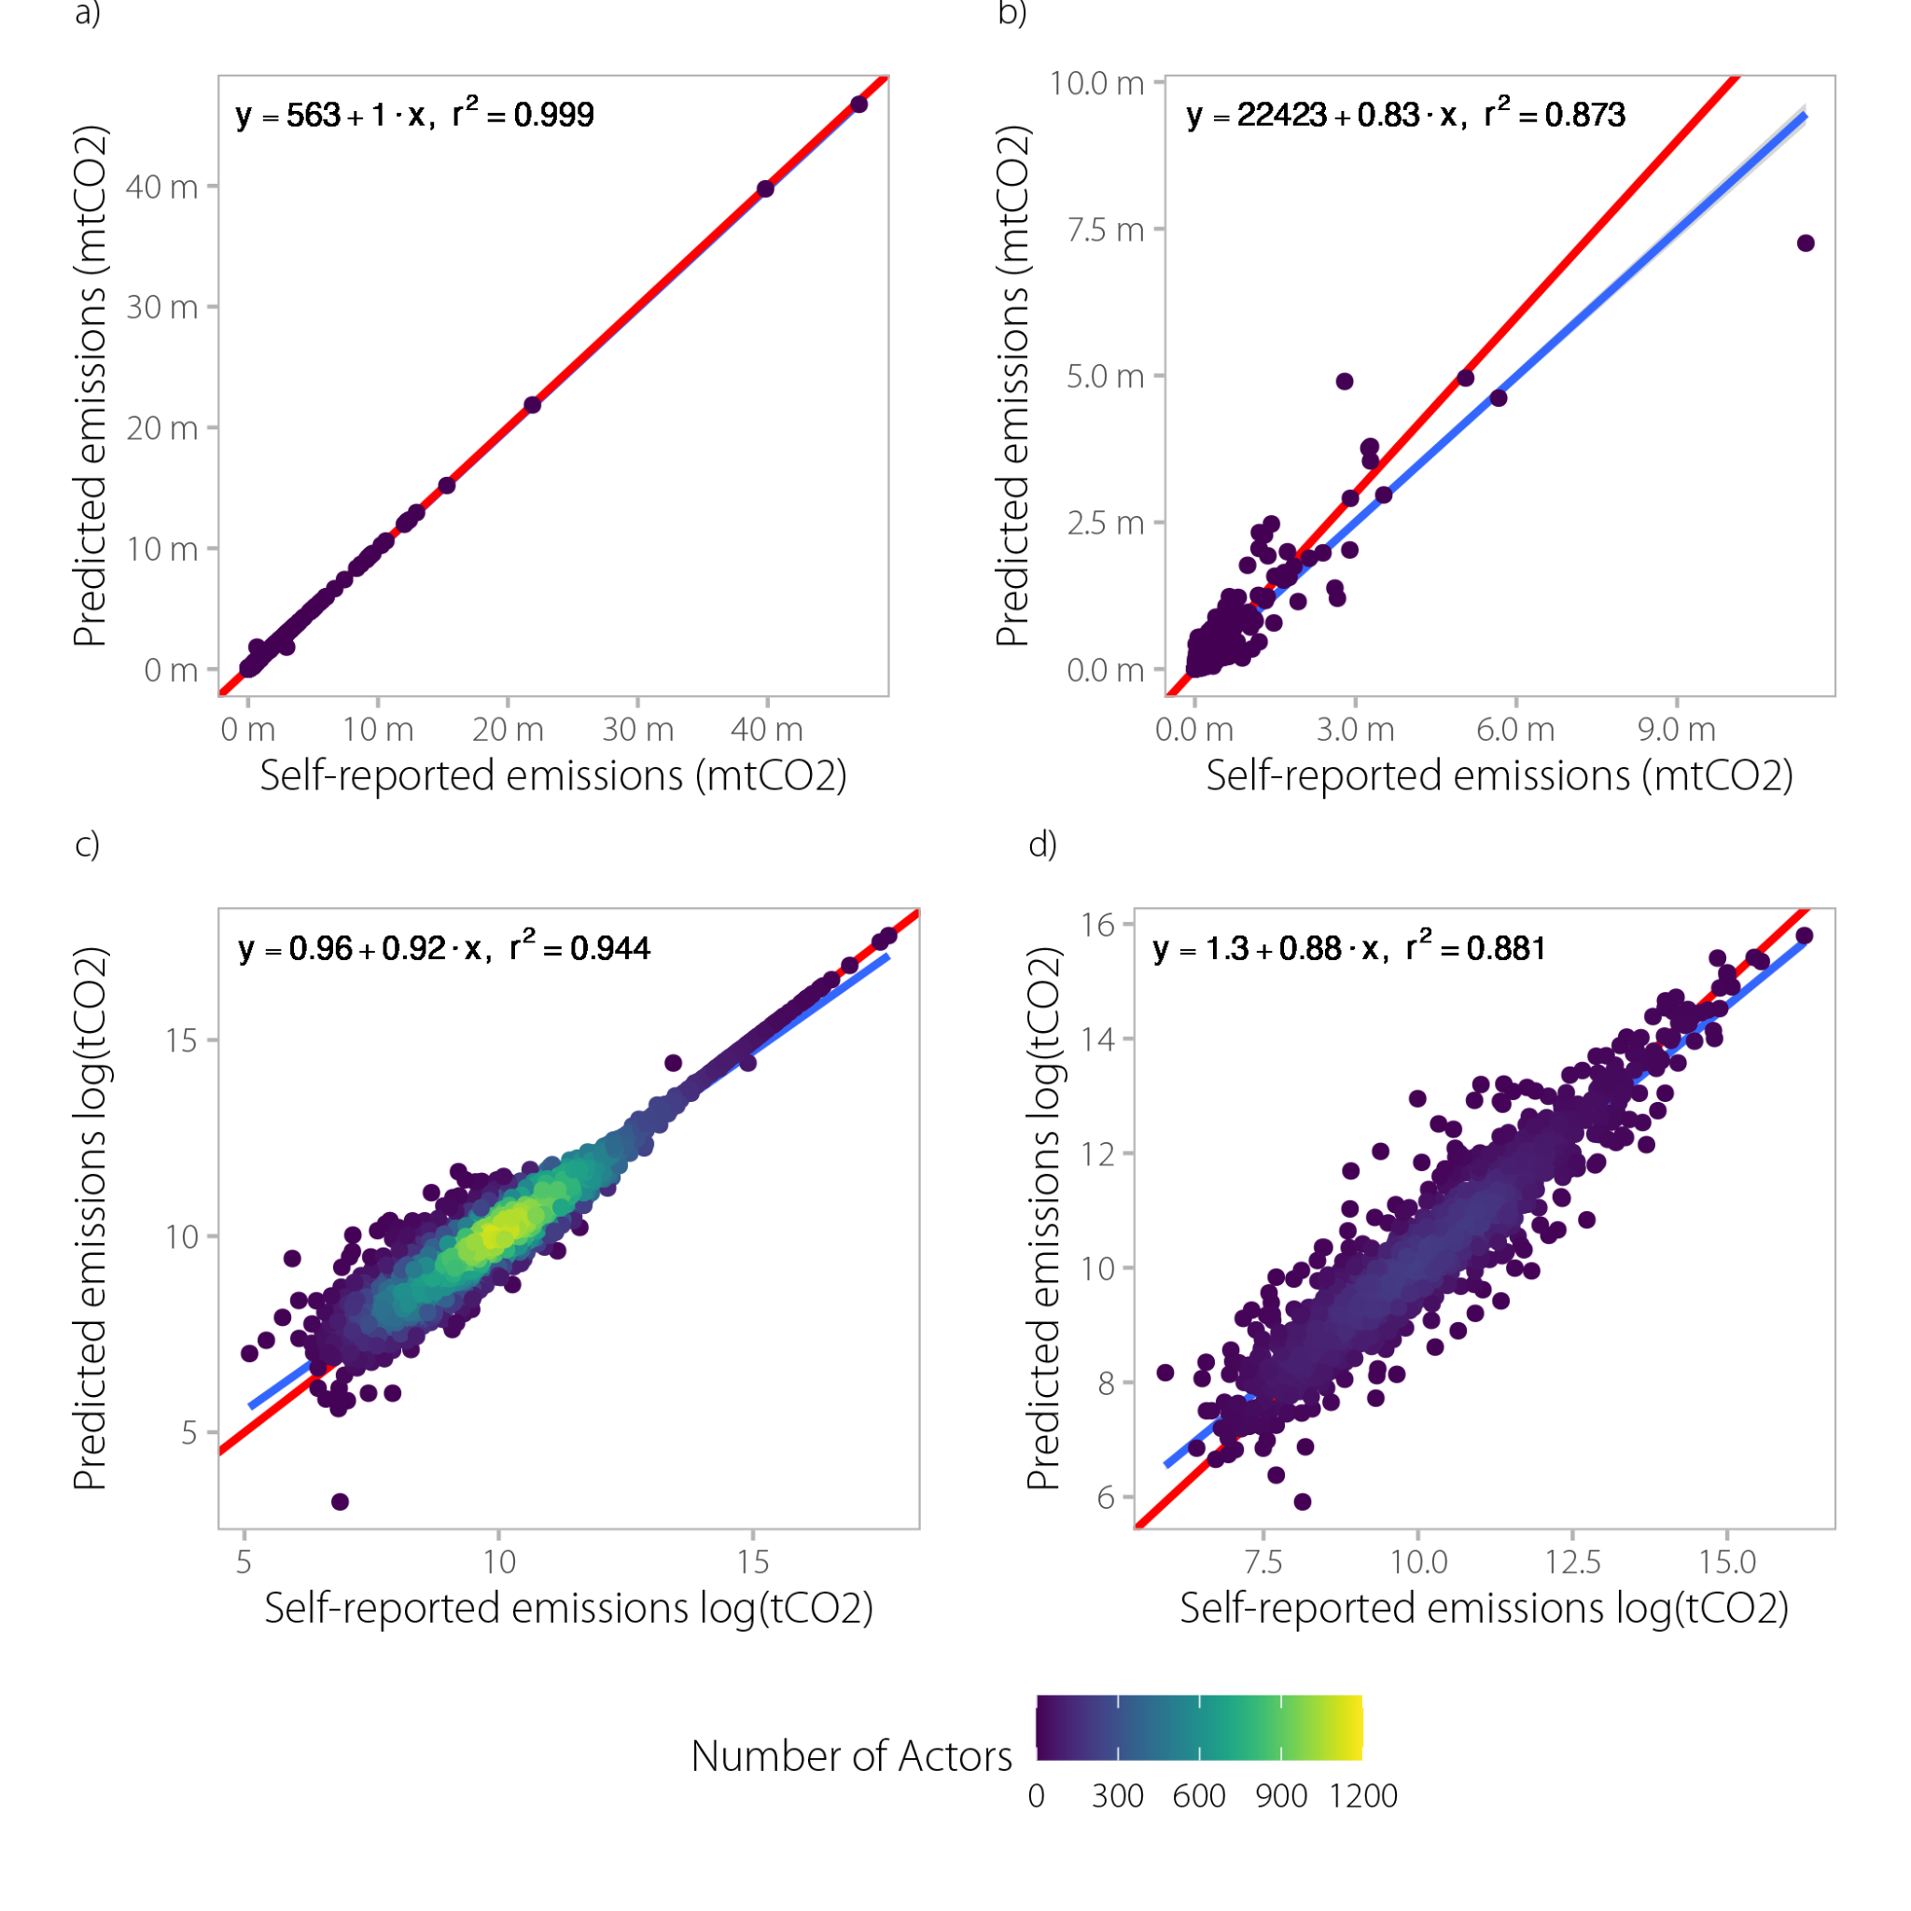
Figure S4. Scatterplots comparing self-reported emissions and emissions predicted by the model for both training (80 percent) and test (20 percent) datasets in both normal and log space. Panel a shows self-reported emissions compared to predicted emissions in normal space for the training dataset; Panel b shows self-reported emissions compared to predicted emissions in normal space for the test dataset; Panel c shows self-reported emissions compared to predicted emissions in log space for the training dataset; and Panel d shows self-reported emissions compared to predicted emissions in log space for the test dataset.

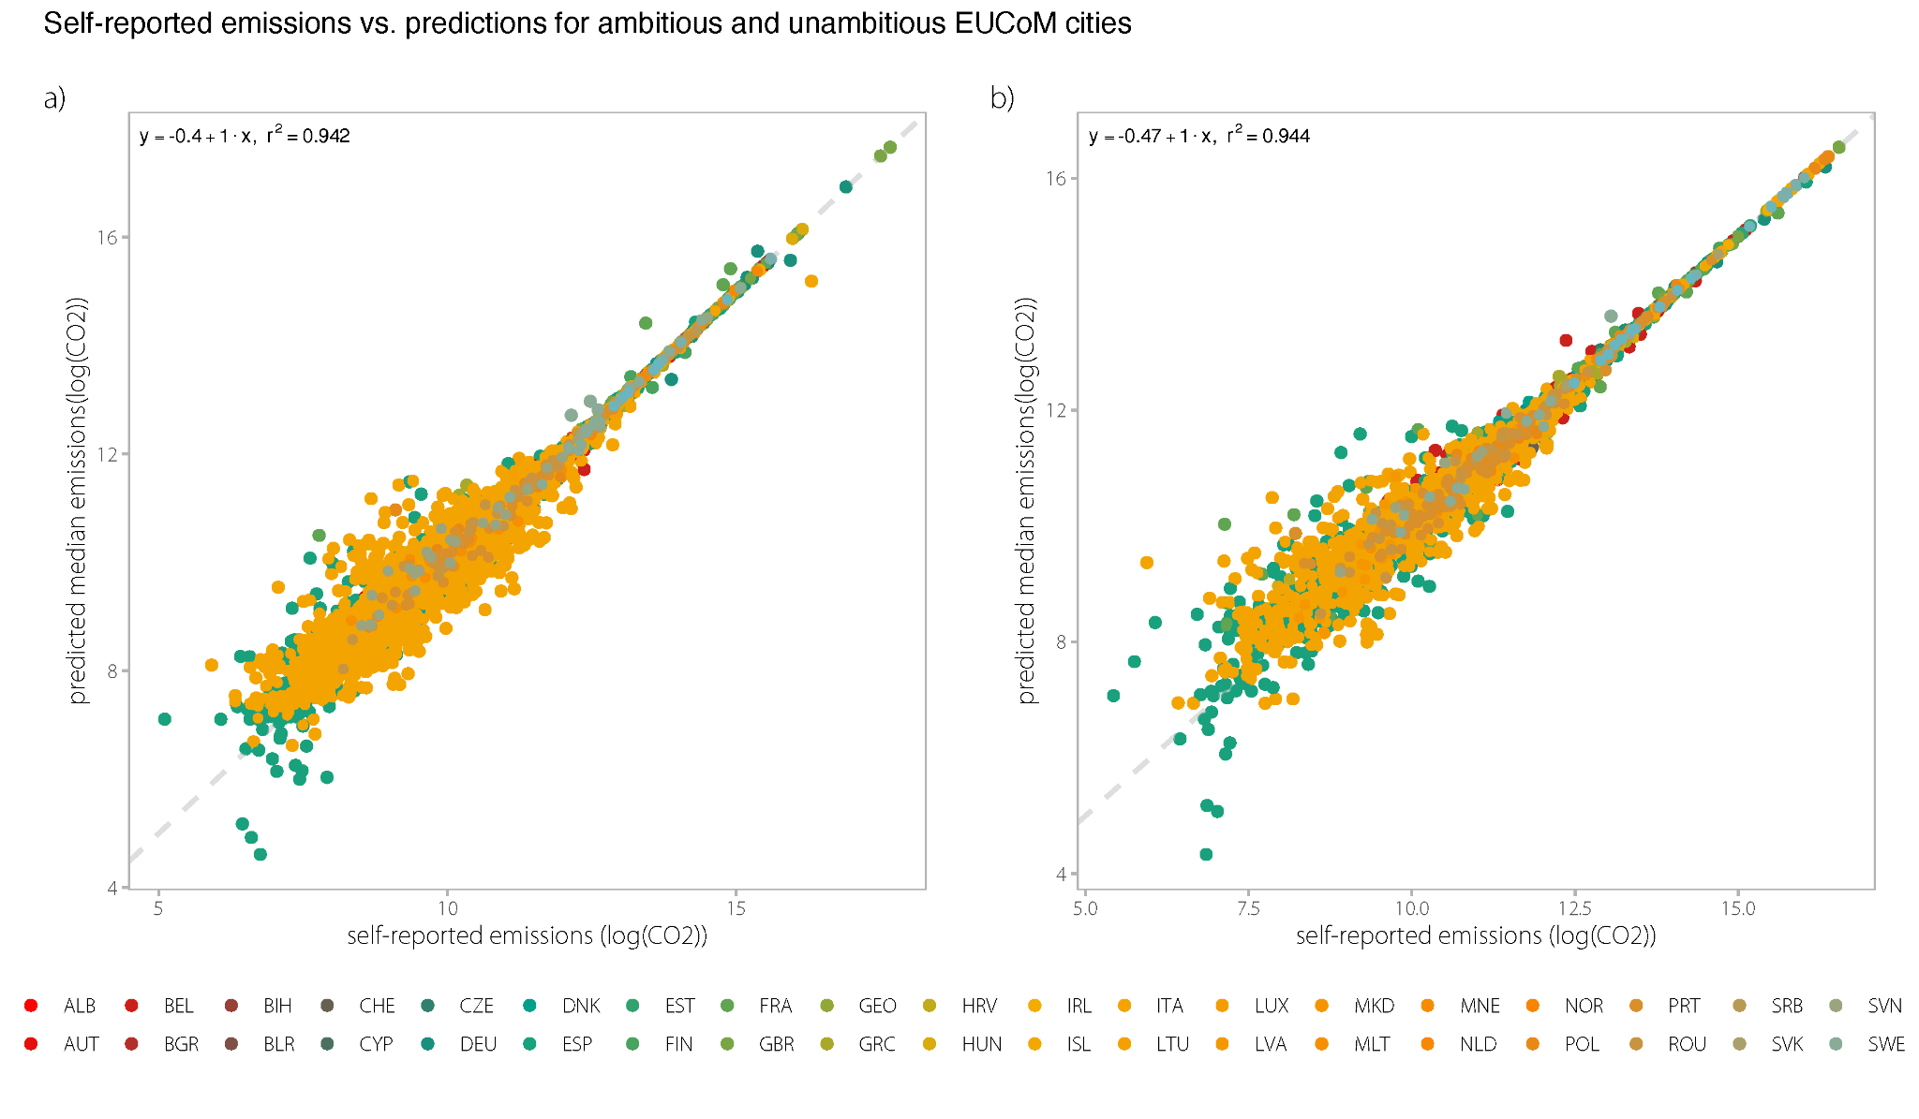
Figure S5. Scatterplots comparing self-reported emissions and emissions predicted by the model for a) ambitious (n=3,495) vs. b) unambitious EUCoM cities (n=2,013) in log space. Ambitious cities are defined as those that have committed to a 2020 emissions reduction target that exceeds that of the EU as a whole (greater than 20 percent), while unambitious cities are those that have only pledged the minimum consistent with the EU 20 percent reduction target.

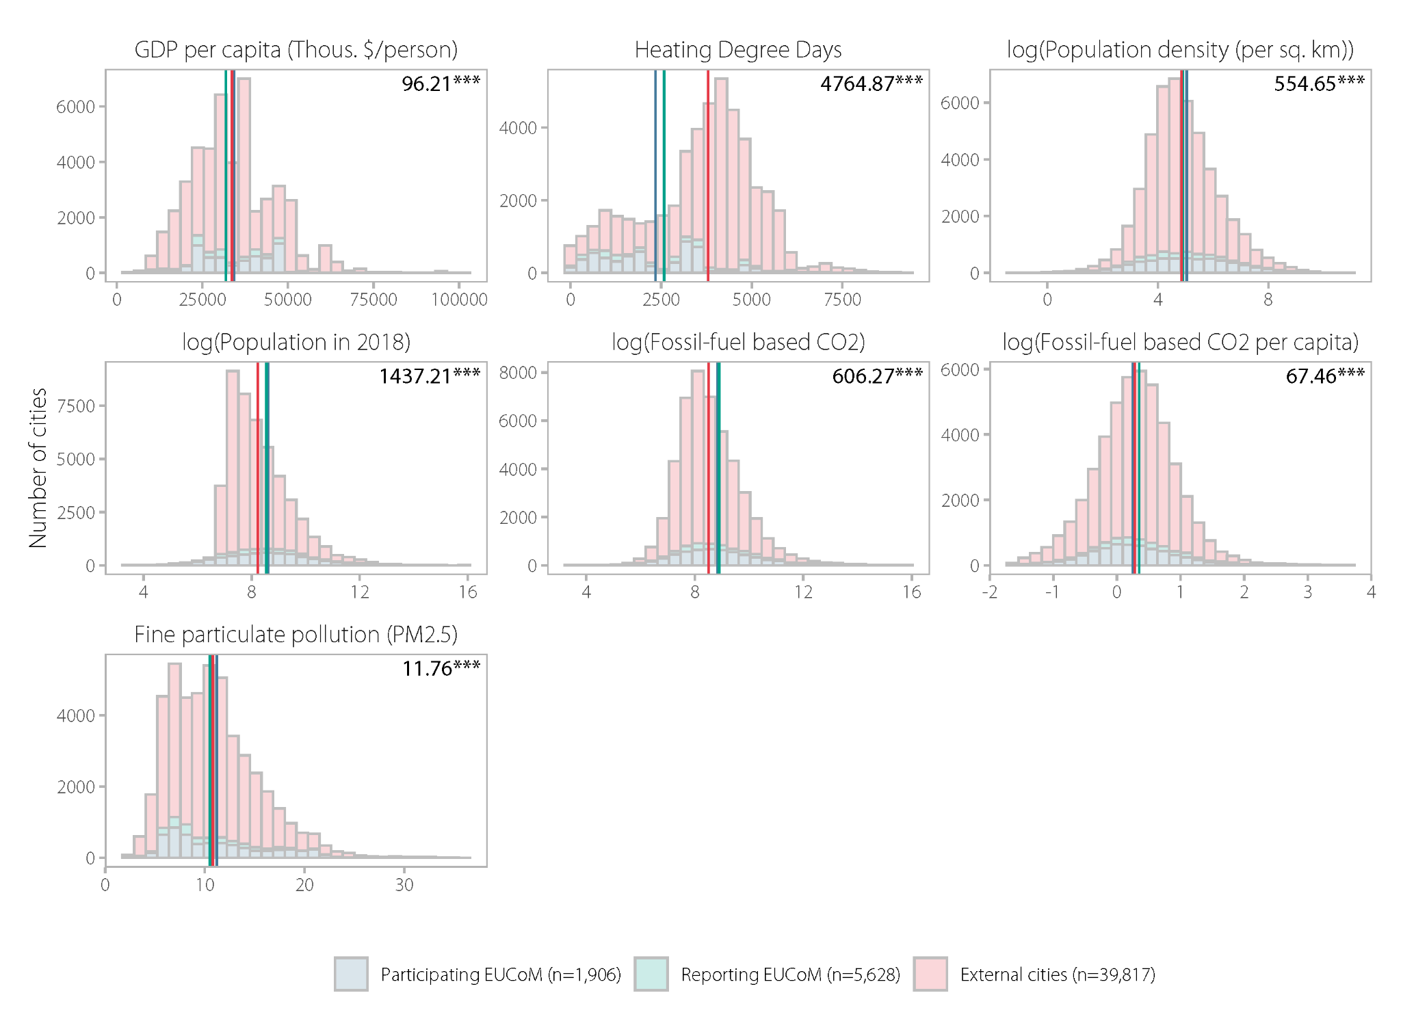
Figure S6. Histograms comparing attributes of the study’s three groups of cities 1) reporting (n=5,628); participating (n=1,936) and external cities (n=39,817). Krustal-wallis test statistics and significance comparing differences in group means reported in the top right-hand corner of each panel.

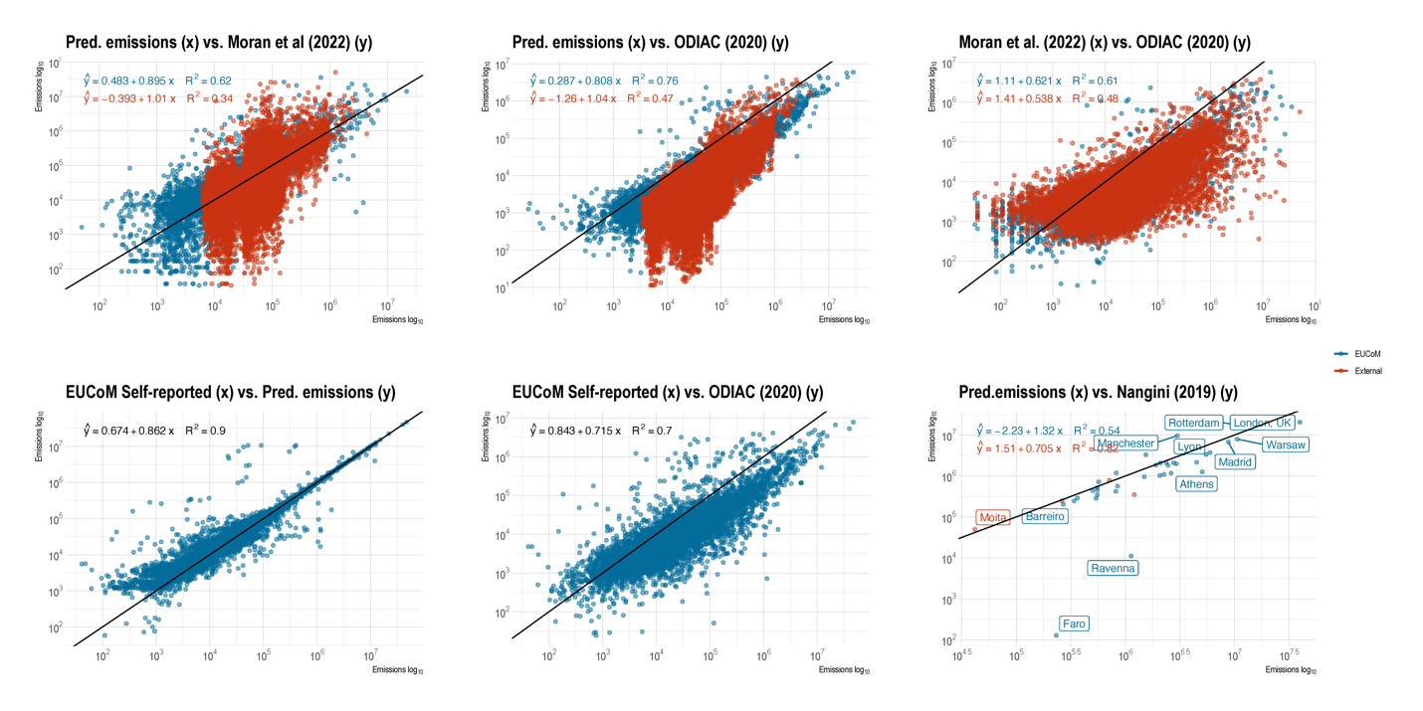Figure S7. Comparisons and validation of the predicted emissions data in our study and other studies estimating city carbon emissions Moran et al. (2022) and Nangini et al. (2019), and other datasets (Oda, 2020; and Kona et al.’s (2021) harmonized EUCoM dataset.

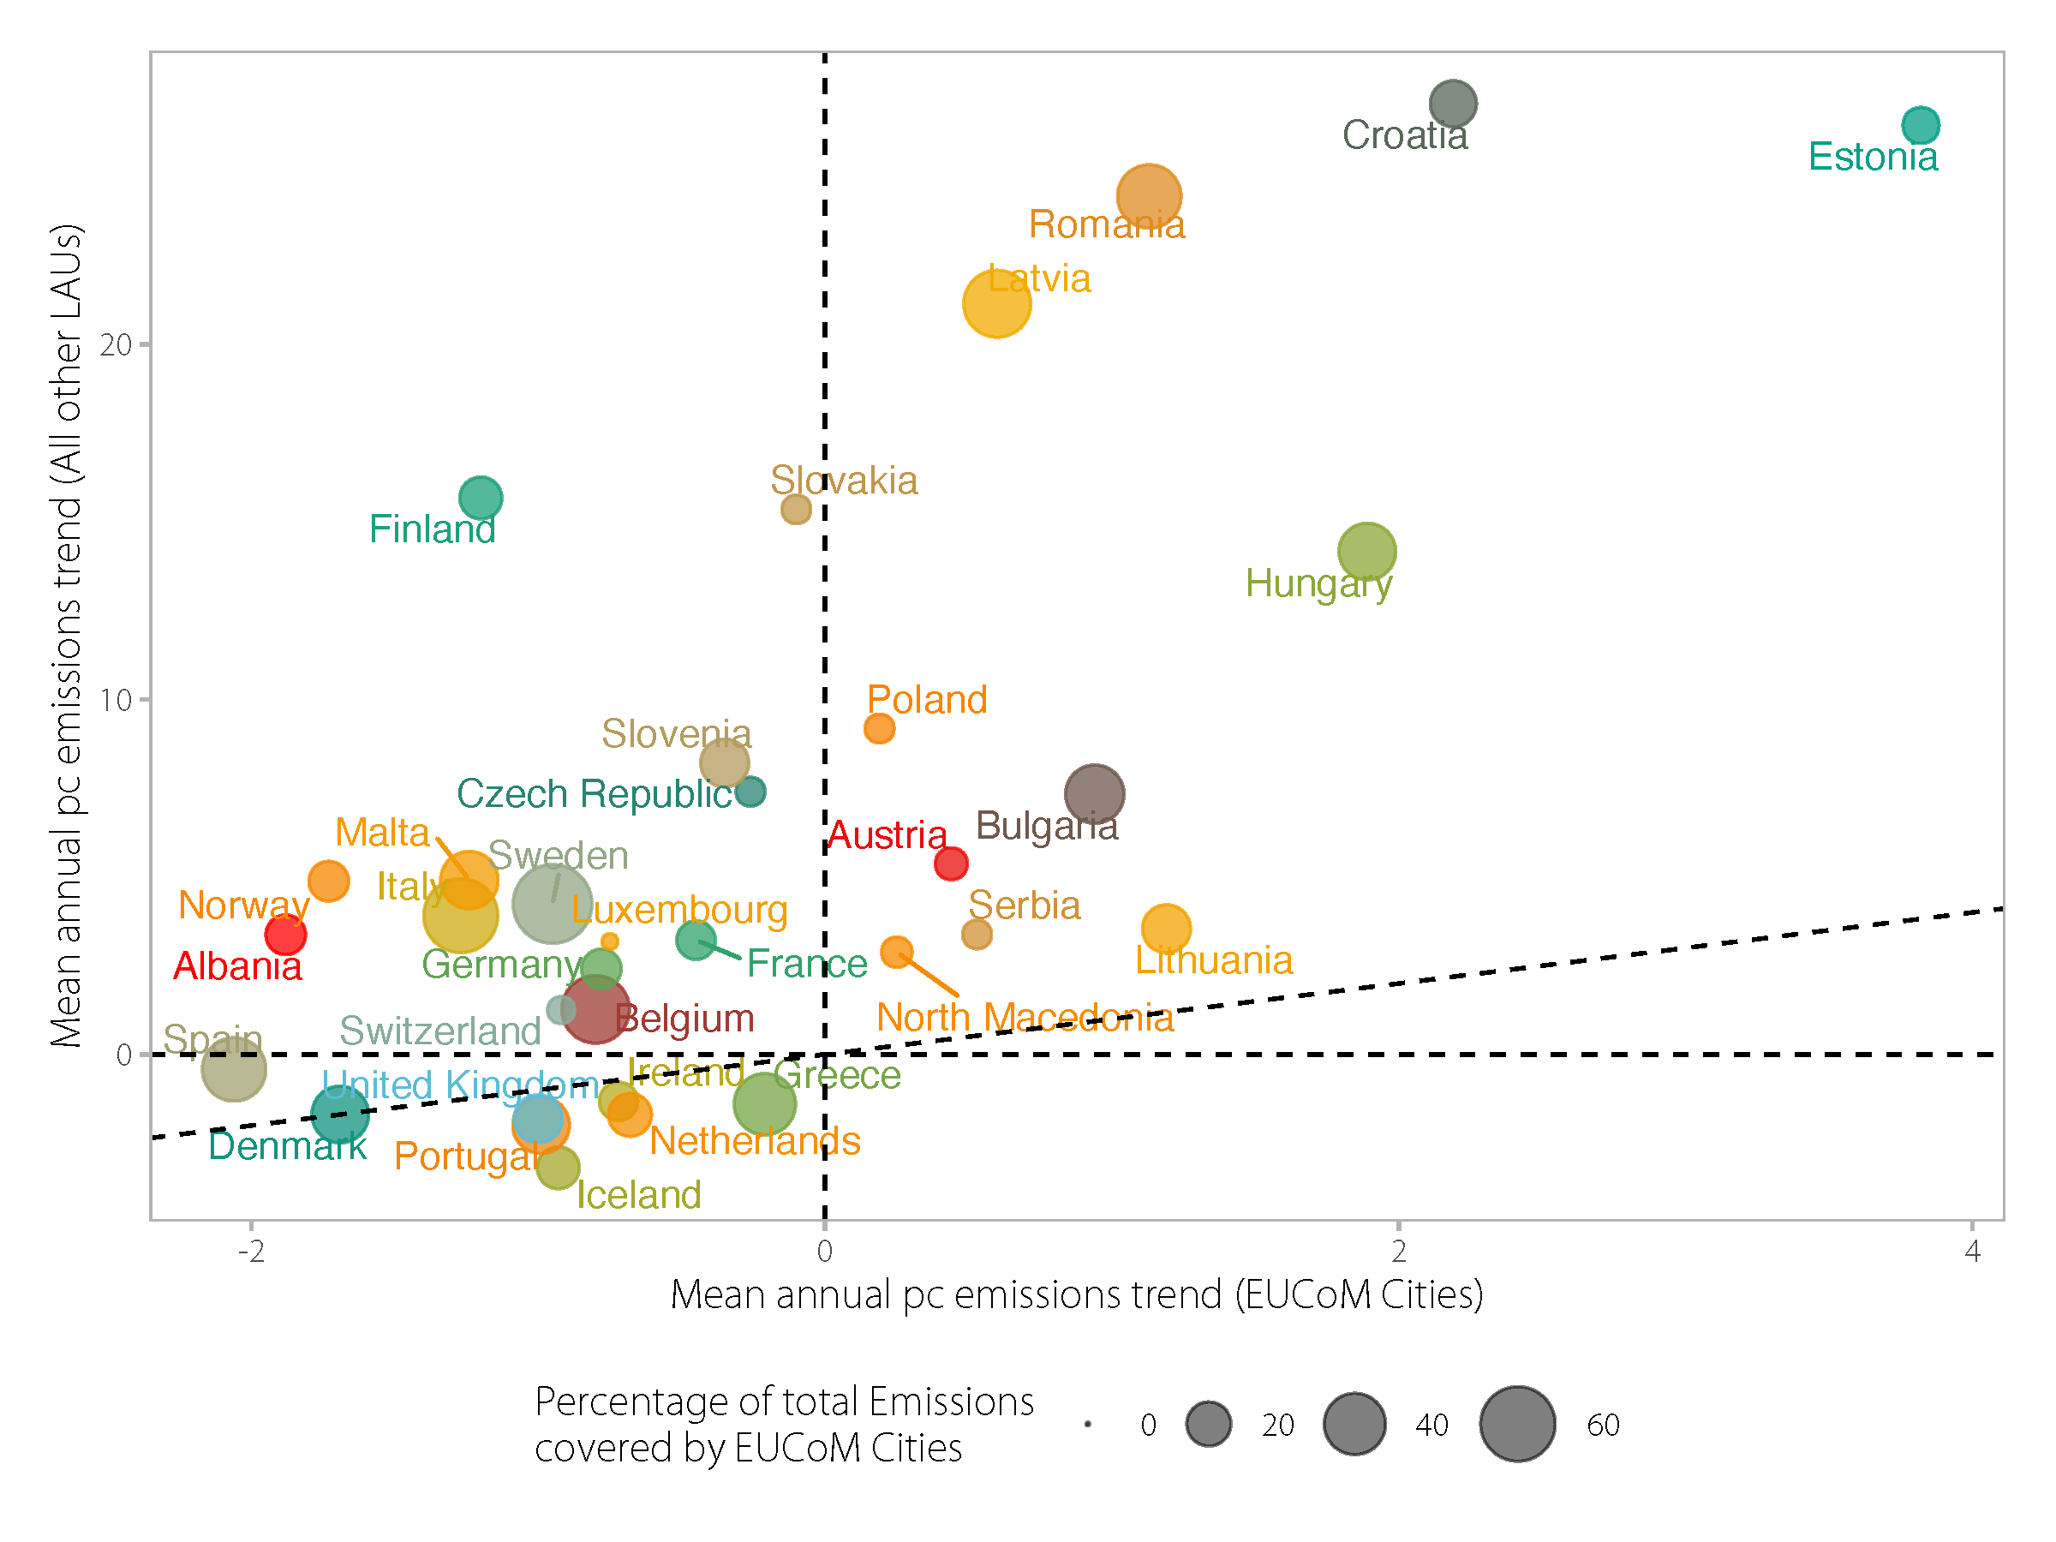
Figure S8. Mean annual per capita emissions reduction of EUCoM cities versus mean annual per capita emissions trend of all other local administrative units (LAUs), sized by the percentage of total national emissions covered by cities participating in the EUCoM. Points are shaded by country.

Supplementary Table 1. Predictor variables included in machine-learning model

Variable - long name | Variable - short name | Definition | Temporal Resolution | Spatial Resolution | Source
Heating and Cooling Degree Days | HDD / CDD | Number of monthly-averaged temperature estimates that deviate from a baseline temperature | 2000-2018 | 0.65x0.5 degree  (72.15x55 km) | NASA MERRA-2 - satellite derived and processed
Fossil-fuel-based CO2 emissions | ODIAC | Emissions arising from combustion of fossil-fuels, cement production and gas flaring | 2000-2018 | 1 km | ODIAC (Oda, 2020)
Fine-particulate air pollution | PM25 | Exposure to fine particulate air pollution | 2001-2018 | ~1 km | Van Donkelaar et al (2020)
Population | POP | Annual interpolated population | 2000-2020, in 5-year increments | 1 km | CIESIN (2018)
Gross Domestic Product | GDP | Gross Domestic Product per capita | 1990 to 2015 | 1 km | Kummu et al., (2018)

Supplementary Table 2. Grid Search Hyperparameters for the emissions prediction model

Parameter | Search Range | Best Parameter Value
max_depth | 1,3,5,8,9,11 | 11
min_child_weight | 1,3,5 | 1
eta | 0.001,0.01,0.05,0.1,0.3,0.5 | 0.01
gamma | 0.5,1,5 | 0.5
nrounds | 999 | 999
early_stopping_rounds | 5 | -
objective | "reg:squarederror" | "reg:squarederror"

Supplementary Table 3. Grid Search Hyperparameters for comparison models
Model | Parameter | Search Range | Best Parameter Value
Random Forest | mtry | 3,5,7 | 5
 | min.node.size | 1,3,5 | 1
 | num.trees | 700 | 700
 | splitrule | "variance" | "variance"
SVM* | Cost | 0.5, 1,5,7,10,15 | 15
 | sigma | 0.05,0.1,0.5 | 0.05
*Support Vector Machines with with Radial Basis Function Kernel

Supplementary Table 4. Training and Test results of multiple comparison models.
Model | Train_RMSE | Test_RMSE | Train_Rsquared | Test_Rsquared
XGBoost-w/ NA | 24202.05 | 155865.63 | 0.9995 | 0.8999
Random Forest | 197987.79 | 157619.88 | 0.9799 | 0.9005
XGBoost-w/o NA | 24632.40 | 171360.38 | 0.9995 | 0.8799
SVM | 524193.32 | 174429.23 | 0.8527 | 0.8923
Multilinear Regression | 476764.12 | 200363.18 | 0.8302 | 0.8479

Supplementary Table 5. Kruskal-Wallis test comparing difference in group means for reporting, participating, and external EUCoM cities.

variable | n | statistic | df | p
interpolated_population | 46,908 | 358.596 | 2 | 0
interpolated_pop_density | 46,908 | 79.942 | 2 | 0
odiac_c | 46,908 | 255.788 | 2 | 0
odiac_pc | 46,908 | 57.673 | 2 | 0
gdp_pc | 46,908 | 96.211 | 2 | 0
hdd | 46,908 | 4,764.874 | 2 | 0
pm25 | 46,908 | 11.755 | 2 | 0.003
Note: *p<0.1; **p<0.05; ***p<0.01

Supplementary Table 6. Wilcoxon rank-sum test comparing difference in group means for reporting and participating EUCoM cities.

variable | group1 | group2 | n1 | n2 | statistic | p
interpolated_population | Reporting cities | Participating cities | 5,377 | 1,638 | 4,675,494.000 | 0.0002
interpolated_pop_density | Reporting cities | Participating cities | 5,377 | 1,638 | 4,692,974.000 | 0.0001
odiac_c | Reporting cities | Participating cities | 5,377 | 1,638 | 4,488,232.000 | 0.239
odiac_pc | Reporting cities | Participating cities | 5,377 | 1,638 | 3,936,582.000 | 0
gdp_pc | Reporting cities | Participating cities | 5,377 | 1,638 | 5,042,392.000 | 0
hdd | Reporting cities | Participating cities | 5,377 | 1,638 | 3,967,593 | 0
pm25 | Reporting cities | Participating cities | 5,377 | 1,638 | 4,562,097 | 0.003
Note: *p<0.1; **p<0.05; ***p<0.01

