Supplementary Material
Core-shell Au@Ag Nanoparticles Synthetized with Polyphenols as
Antimicrobial Agents

Mauro Villalobos-Noriegaª, Ericka Rodríguez-Leónª, César Rodríguez-Beasª, Eduardo Larios-Rodríguez^{c}, Maribel Plascencia-Jatomea^{b}, Aarón Martínez-Higueraª, Heriberto Acuña-Campa and Ramón A. Iñiguez-Palomaresª*
ªPhysics Department, University of Sonora, Rosales and Transversal 83000, Hermosillo, Sonora, México.
^{b}Department of Research and Postgraduate in Food, University of Sonora, Rosales and Transversal 83000, Hermosillo, Sonora, México.
^{c}Department of Chemical Engineering and Metallurgy, University of Sonora, Rosales and Transversal 83000, Hermosillo, Sonora, México.
^{d}Department of Polymers and Materials Research, University of Sonora, Rosales and Transversal 83000, Hermosillo, Sonora, México.

*Corresponding author: ramonalfonso.iniguez@gmail.com

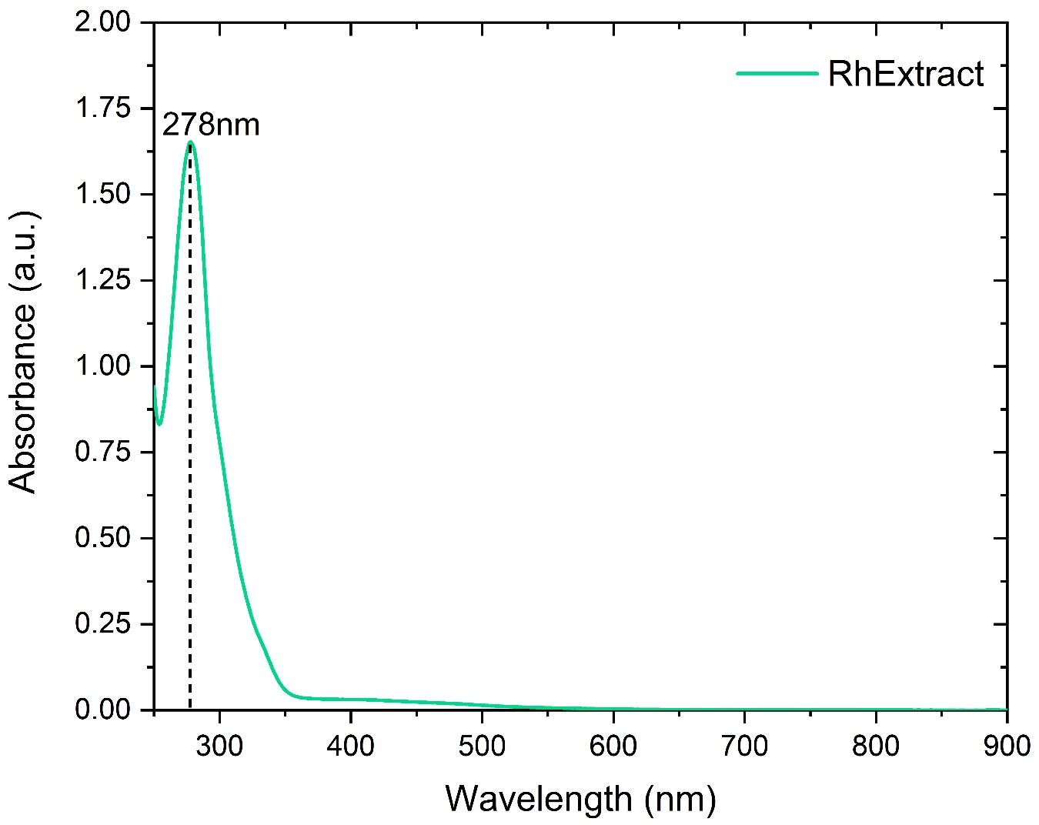
Figure S1 corresponds to Rumex hymenosepalus aqueous solution absorption spectrum.

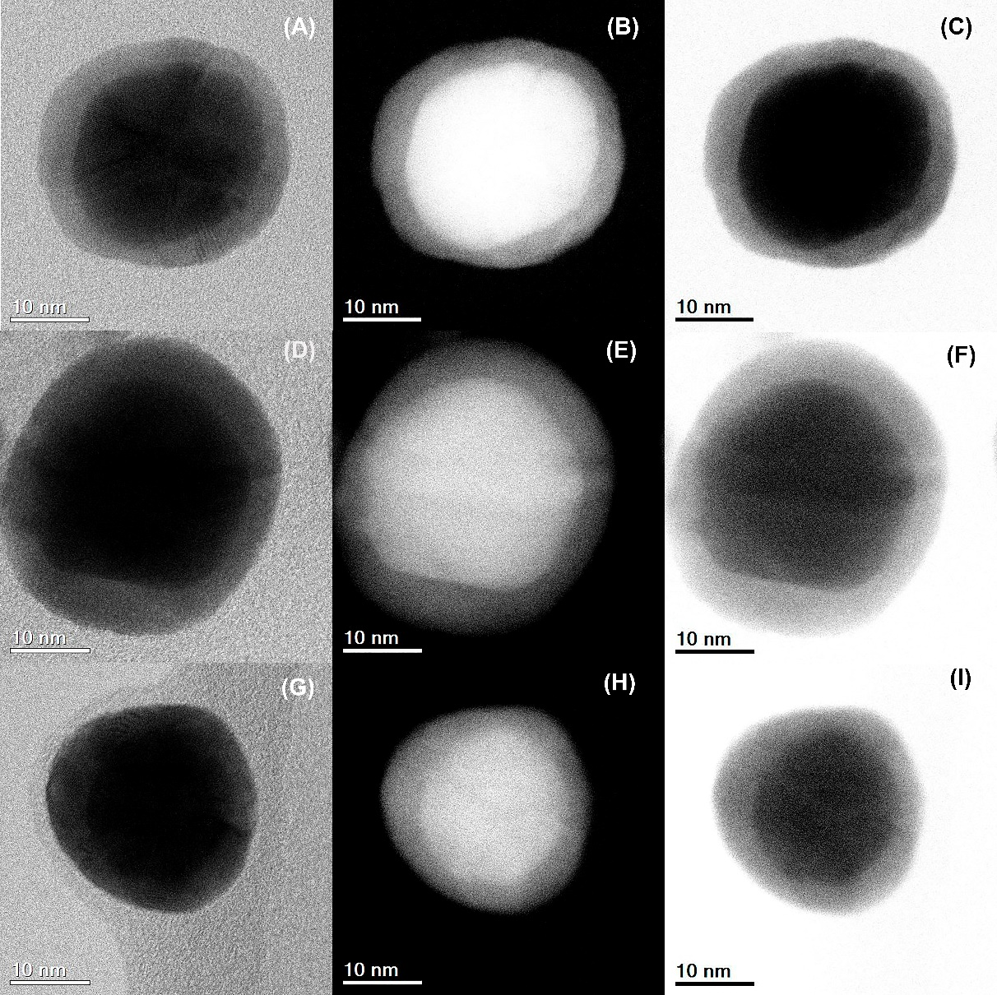
Figure S2 STEM images gallery of individual Au@AgNPs. The first column corresponds to Bright Field images and the middle column to HAADF. The last column is shown manipulated images using ImageJ to enhance contrast. We can observe the uniformity of Ag-shell.
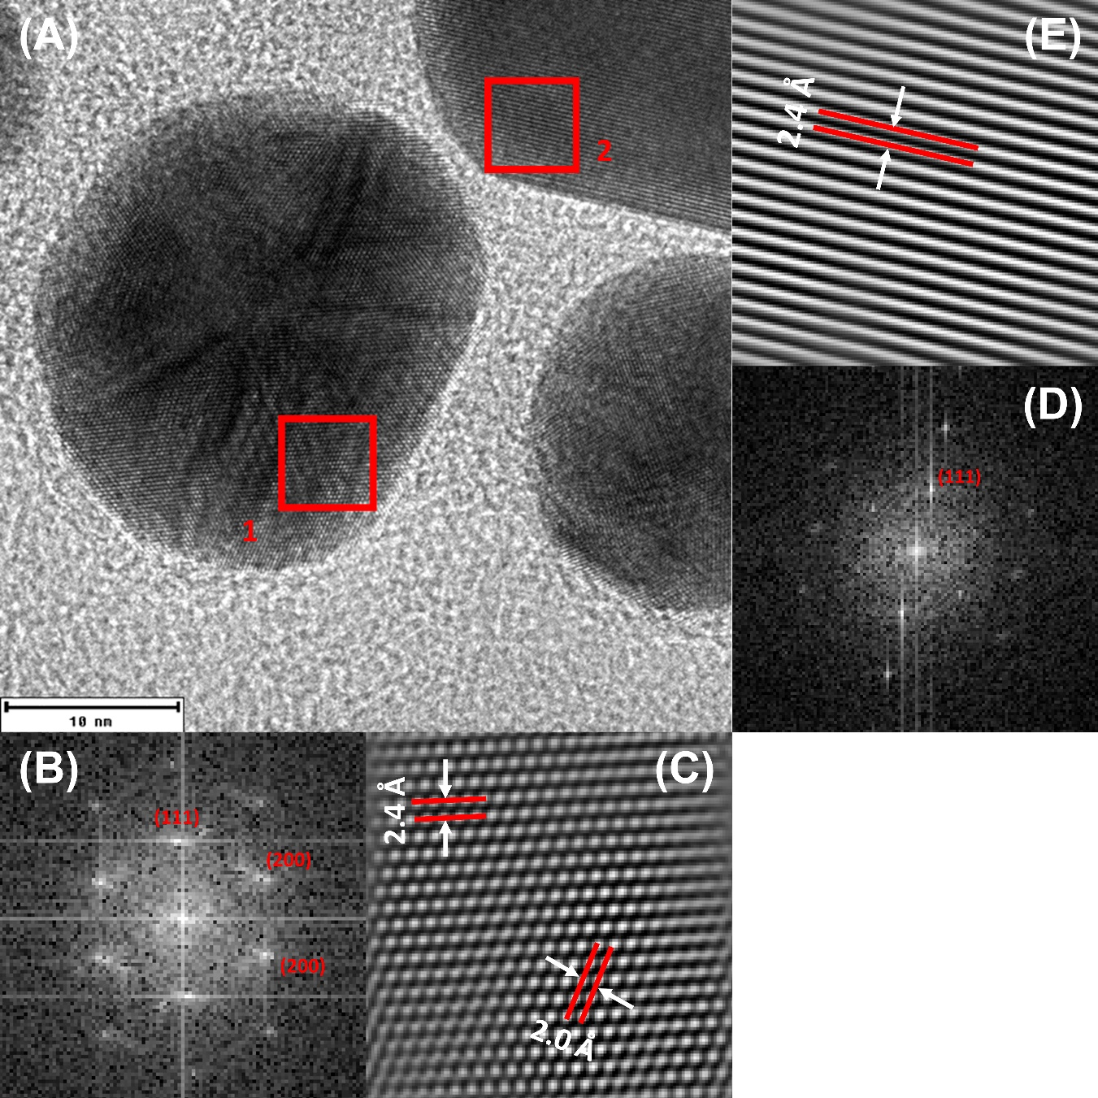
Figure S3. AuNPs HRTEM (A), region 1 FFT plot (B), and integrated image from FFT (C). Region 2 FFT plot is shown in (D) and integrated image from FFT with interplanar distances in (E).
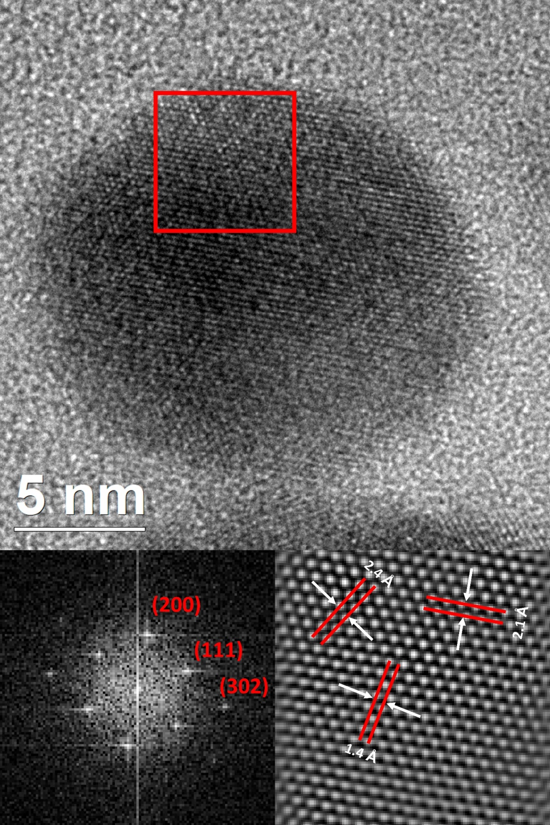

Figure S4. AgNPs HRTEM (A), FFT plot (B) and, integrated image from FFT with interplanar distances (C).

Figure S5. C. albicans dose-response curve comparative between Ag and Au@AgNPs.

Bacterial growth analysis using a modified Gompertz model and origin 2018 software. The parameters obtained of adjust are a, x_{c} y k, which are related to the following equations:
$$μ=\frac{ka}{e}$$
Growth Rate µ
$$λ=\frac{k*x_{c}-1}{a}$$
and Time LagPhase $λ$.
S.aureus + AuNPs
S.aureus without AuNPs
Table S1. Adjust parameters of the curve by modified Gompertz Model (Origin 2018 software)
Parameter | Mean Value | Standard Deviation
a | 1.15528 | 0.00734
Xc | 289.0 | 0.50
k | 0.0090 | 1.3E-4
R^2 ADJUST | 0.9801

Table S2. Physical Parameters of Bacterial Growth obtained with Adjust Parameters
Parameter | Mean Value | Standard Deviation
Growth Rate µ ($D.O./minutes)$ | $$0.00383$$ | $$7.95526E-5$$
Time LagPhase $λ$ (minutes) | 177.8888 | $$5.4467$$

Table S3. S.aureus + 1µg/mL AuNPs
Adjust parameters of the curve by modified Gompertz Model (Origin 2018 software)
PARAMETER | MEAN VALUE | STANDARD DEVIATION
a | 0.98751 | 0.00431
Xc | 291.599 | 3.17369
k | 0.0075 | 2.05E-4
R^2 ADJUST | 0.99153

Table S4. PHYSICAL PARAMETERS OF BACTERIAL GROWTH OBTAINED WITH ADJUST PARAMETERS
PARAMETER | Mean Value | Standard Deviation
Growth Rate µ ($D.O./minutos)$ | $$0.00272$$ | $$8.44162E-5$$
Time LagPhase $λ$ (minutes) | 158.2366 | $$10.16166$$

S.aureus + 10µg/mL AuNPs
Table S5. Adjust parameters of the curve by modified Gompertz Model (Origin 2018 software)
PARAMETER | MEAN VALUE | STANDARD DEVIATION
a | 0.91793 | 0.00471
Xc | 315.5396 | 2.72545
k | 0.0068 | 1.01252E-4
R^2 ADJUST | 0..98746

Table S6. PHYSICAL PARAMETERS OF BACTERIAL GROWTH OBTAINED WITH ADJUST PARAMETERS
PARAMETER | Mean Value | Standard Deviation
Growth Rate µ ($D.O./minutos)$ | $$0.0023$$ | $$4.5974E-5$$
Time LagPhase $λ$ (minutes) | 168.48078 | $$6.4726$$

S.aureus + 50µg/mL AuNPs
Table S7. Adjust parameters of the curve by modified Gompertz Model (Origin 2018 software)
PARAMETER | MEAN VALUE | STANDARD DEVIATION
a | 0.51 | 0.012
Xc | 787.111 | 11.825
k | 0.00615 | 3.989E-4
R^2 ADJUST | 0..8844

Table S8. PHYSICAL PARAMETERS OF BACTERIAL GROWTH OBTAINED WITH ADJUST PARAMETERS
PARAMETER | Mean Value | Standard Deviation
Growth Rate µ ($D.O./minutos)$ | $$0.00115$$ | $$1.01991E-4$$
Time LagPhase $λ$ (minutes) | 624.50937 | $$90.39578$$

S.aureus + AgNPs

Table S9. S.aureus without AgNPs
Adjust parameters of the curve by modified Gompertz Model (Origin 2018 software)
PARAMETER | MEAN VALUE | STANDARD DEVIATION
a | 1.1122 | 0.00304
Xc | 274.6266 | 1.69846
k | 0.00904 | 1.77493E-4
R^2 ADJUST | 0.9971

Table S10. PHYSICAL PARAMETERS OF BACTERIAL GROWTH OBTAINED WITH ADJUST PARAMETERS
PARAMETER | Mean Value | Standard Deviation
Growth Rate µ ($D.O./minutos)$ | $$0.0037$$ | $$8.27335E-5$$
Time LagPhase $λ$ (minutes) | 164.00716 | $$7.45461$$

S.aureus 1µg/mL AgNPs
Table S11. Adjust parameters of the curve by modified Gompertz Model (Origin 2018 software)
PARAMETER | MEAN VALUE | STANDARD DEVIATION
a | 0.90218 | 0.00282
Xc | 269.47342 | 0.88062
k | 0.01016 | 1.0549E-4
R^2 ADJUST | 0.99931

Table S12. PHYSICAL PARAMETERS OF BACTERIAL GROWTH OBTAINED WITH ADJUST PARAMETERS
PARAMETER | Mean Value | Standard Deviation
Growth Rate µ ($D.O./minutes)$ | $$0.00337$$ | $$4.55516E-5$$
Time LagPhase $λ$ (minutes) | 171.04822 | $$4.11092$$

S.aureus 10µg/mL AgNPs
Table S13. Adjust parameters of the curve by modified Gompertz Model (Origin 2018 software)
PARAMETER | MEAN VALUE | STANDARD DEVIATION
a | 0.79089 | 0.01121
Xc | 224.28364 | 2.04417
k | 0.01616 | 6.61164E-4
R^2 ADJUST | 0.98434

Table S14. PHYSICAL PARAMETERS OF BACTERIAL GROWTH OBTAINED WITH ADJUST PARAMETERS
PARAMETER | Mean Value | Standard Deviation
Growth Rate µ ($D.O./minutes)$ | $$0.0047$$ | $$2.5901E-4$$
Time LagPhase $λ$ (minutes) | 162.40245 | $$14.76911$$

S.aureus 50µg/mL AgNPs
Table S15. Adjust parameters of the curve by modified Gompertz Model (Origin 2018 software)
PARAMETER | MEAN VALUE | STANDARD DEVIATION
a | 0.74 | 0.001
Xc | 967.54471 | 6.30715
k | 0.00587 | 3.49063E-4
R^2 ADJUST | 0.973

Table S16. PHYSICAL PARAMETERS OF BACTERIAL GROWTH OBTAINED WITH ADJUST PARAMETERS
PARAMETER | Mean Value | Standard Deviation
Growth Rate µ ($D.O./minutes)$ | $$0.0016$$ | $$9.71851E-5$$
Time LagPhase $λ$ (minutes) | 797.18696 | $$100.00702$$

S.aureus + Au@AgNPs
S.aureus without Au@AgNPs
Table S17. Adjust parameters of the curve by modified Gompertz Model (Origin 2018 software)
PARAMETER | MEAN VALUE | STANDARD DEVIATION
a | 1.1122 | 0.00304
Xc | 274.6266 | 1.69846
k | 0.00904 | 1.77493E-4
R^2 ADJUST | 0.9971

Table S18. PHYSICAL PARAMETERS OF BACTERIAL GROWTH OBTAINED WITH ADJUST PARAMETERS
PARAMETER | Mean Value | Standard Deviation
Growth Rate µ ($D.O./minutes)$ | $$0.0037$$ | $$8.27335E-5$$
Time LagPhase $λ$ (minutes) | 164.00716 | $$7.45461$$

S.aureus 1µg/mL Au@AgNPs
Table S19. Adjust parameters of the curve by modified Gompertz Model (Origin 2018 software)
PARAMETER | MEAN VALUE | STANDARD DEVIATION
a | 0.90551 | 9.2098E-4
Xc | 268.4542 | 1.16359
k | 0.00926 | 1.20901E-4
R^2 ADJUST | 0.99959

Table S20. PHYSICAL PARAMETERS OF BACTERIAL GROWTH OBTAINED WITH ADJUST PARAMETERS
PARAMETER | Mean Value | Standard Deviation
Growth Rate µ ($D.O./minutes)$ | 0.00308 | 4.34117E-5
Time LagPhase $λ$ (minutes) | 160.46284 | 4.8856

S.aureus 10µg/mL Au@AgNPs
Table S21. Adjust parameters of the curve by modified Gompertz Model (Origin 2018 software)
PARAMETER | MEAN VALUE | STANDARD DEVIATION
a | 0.76728 | 0.00446
Xc | 283.117 | 2.55475
k | 0.00968 | 1.9955E-4
R^2 ADJUST | 0.99754

Table S22. PHYSICAL PARAMETERS OF BACTERIAL GROWTH OBTAINED WITH ADJUST PARAMETERS
PARAMETER | Mean Value | Standard Deviation
Growth Rate µ ($D.O./minutes)$ | 0.00273 | 7.22087E-5
Time LagPhase $λ$ (minutes) | 179.81121 | 9.03605

S.aureus 50µg/mL Au@AgNPs
Table S23. Adjust parameters of the curve by modified Gompertz Model (Origin 2018 software)
PARAMETER | MEAN VALUE | STANDARD DEVIATION
a | 0.73517 | 0.01493
Xc | 802.288 | 14.5
k | 0.00797 | 0.00104
R^2 ADJUST | 0.99428

Table S24. PHYSICAL PARAMETERS OF BACTERIAL GROWTH OBTAINED WITH ADJUST PARAMETERS
PARAMETER | Mean Value | Standard Deviation
Growth Rate µ ($D.O./minutes)$ | 0.00216 | 3.25047E-4
Time LagPhase $λ$ (minutes) | 676.81749 | 188.86726

E.coli + AuNPs
E.coli without AuNPs
Table S25. Adjust parameters of the curve by modified Gompertz Model (Origin 2018 software)
PARAMETER | MEAN VALUE | STANDARD DEVIATION
a | 0.83539 | .00546
Xc | 284.94644 | 4.2278
k | 0.00651 | 2.43998E-4
R^2 ADJUST | 0.98643

Table S26. PHYSICAL PARAMETERS OF BACTERIAL GROWTH OBTAINED WITH ADJUST PARAMETERS
PARAMETER | Mean Value | Standard Deviation
Growth Rate µ ($D.O./minutes)$ | 0.002 | 8.80623E-5
Time LagPhase $λ$ (minutes) | 131.33661 | 11.79379

E.coli + 1µg/mL AuNPs
Table S27. Adjust parameters of the curve by modified Gompertz Model (Origin 2018 software)
PARAMETER | MEAN VALUE | STANDARD DEVIATION
a | .75065 | .00531
Xc | 275.93547 | 4.77869
k | 0.00666 | 2.79881E-4
R^2 ADJUST | 0.98267

Table S28. PHYSICAL PARAMETERS OF BACTERIAL GROWTH OBTAINED WITH ADJUST PARAMETERS
PARAMETER | Mean Value | Standard Deviation
Growth Rate µ ($D.O./minutes)$ | 0.00184 | 9.02987E-5
Time LagPhase $λ$ (minutes) | 125.78532 | 12.75042

E.coli + 10µg/mL AuNPs
Table S29. Adjust parameters of the curve by modified Gompertz Model (Origin 2018 software)
PARAMETER | MEAN VALUE | STANDARD DEVIATION
a | 0.76901 | 0.00527
Xc | 267.52651 | 4.67208
k | 0.00658 | 2.67281E-4
R^2 ADJUST | 0.98318

Table S30. PHYSICAL PARAMETERS OF BACTERIAL GROWTH OBTAINED WITH ADJUST PARAMETERS
PARAMETER | Mean Value | Standard Deviation
Growth Rate µ ($D.O./minutes)$ | 0.00186 | 8.83714E-5
Time LagPhase $λ$ (minutes) | 115.55083 | 11.40538

E.coli + 50µg/mL AuNPs
Table S31. Adjust parameters of the curve by modified Gompertz Model (Origin 2018 software)
PARAMETER | MEAN VALUE | STANDARD DEVIATION
a | 0.76171 | 0.00367
Xc | 304.8801 | 3.18269
k | 0.00644 | 1.77262E-4
R^2 ADJUST | 0.99301

Table S32. PHYSICAL PARAMETERS OF BACTERIAL GROWTH OBTAINED WITH ADJUST PARAMETERS
PARAMETER | Mean Value | Standard Deviation
Growth Rate µ ($D.O./minutes)$ | 0.0018 | 5.83667E-5
Time LagPhase $λ$ (minutes) | 149.6006 | 9.79726

E.coli + 100µg/mL AuNPs
Table S33. Adjust parameters of the curve by modified Gompertz Model (Origin 2018 software)
PARAMETER | MEAN VALUE | STANDARD DEVIATION
a | 0.89091 | 0.00462
Xc | 299.24812 | 3.447
k | 0.00496 | 1.21086E-4
R^2 ADJUST | 0.99318

Table S34. PHYSICAL PARAMETERS OF BACTERIAL GROWTH OBTAINED WITH ADJUST PARAMETERS
PARAMETER | Mean Value | Standard Deviation
Growth Rate µ ($D.O./minutes)$ | 0.00163 | 4.81157E-5
Time LagPhase $λ$ (minutes) | 97.63522 | 5.89169

E.coli + AgNPs
E.coli without AgNPs
Table S35. Adjust parameters of the curve by modified Gompertz Model (Origin 2018 software)
PARAMETER | MEAN VALUE | STANDARD DEVIATION
a | 1.11606 | 0.00401
Xc | 260.85241 | 2.32122
k | 0.00795 | 1.90302E-4
R^2 ADJUST | 0.99519

Table S36. PHYSICAL PARAMETERS OF BACTERIAL GROWTH OBTAINED WITH ADJUST PARAMETERS
PARAMETER | Mean Value | Standard Deviation
Growth Rate µ ($D.O./minutes)$ | 0.00326 | 8.98612E-5
Time LagPhase $λ$ (minutes) | 135.06625 | 7.66816

E.coli + 1µg/mL AgNPs
Table S37. Adjust parameters of the curve by modified Gompertz Model (Origin 2018 software)
PARAMETER | MEAN VALUE | STANDARD DEVIATION
a | 0.8839 | 0.00112
Xc | 251.07818 | 0.84028
k | 0.00844 | 7.54709E-5
R^2 ADJUST | 0.99932

Table S38. PHYSICAL PARAMETERS OF BACTERIAL GROWTH OBTAINED WITH ADJUST PARAMETERS
PARAMETER | Mean Value | Standard Deviation
Growth Rate µ ($D.O./minutes)$ | 0.00274 | 2.80183E-5
Time LagPhase $λ$ (minutes) | 132.59477 | 2.81509

E.coli + 10µg/mL AgNPs
Table S39. Adjust parameters of the curve by modified Gompertz Model (Origin 2018 software)
PARAMETER | MEAN VALUE | STANDARD DEVIATION
a | 0.88798 | 0.00202
Xc | 331.74964 | 1.4728
k | .00579 | 6.8597E-5
R^2 ADJUST | 0.99873

Table S40. PHYSICAL PARAMETERS OF BACTERIAL GROWTH OBTAINED WITH ADJUST PARAMETERS
PARAMETER | Mean Value | Standard Deviation
Growth Rate µ ($D.O./minutes)$ | 0.00189 | 2.67112E-5
Time LagPhase $λ$ (minutes) | 159.03807 | 4.47445

E.coli + 50µg/mL AgNPs
Table S41. Adjust parameters of the curve by modified Gompertz Model (Origin 2018 software)
PARAMETER | MEAN VALUE | STANDARD DEVIATION
a | 0.24357 | 0.00853
Xc | 999.37678 | 8.83407
k | 0.00703 | 6.84646E-4
R^2 ADJUST | 0.96459

Table S42. PHYSICAL PARAMETERS OF BACTERIAL GROWTH OBTAINED WITH ADJUST PARAMETERS
PARAMETER | Mean Value | Standard Deviation
Growth Rate µ ($D.O./minutes)$ | 6.29919E-4 | 8.34075E-5
Time LagPhase $λ$ (minutes) | 857.12927 | 174.52691

E.coli + 100µg/mL AgNPs
Table S43. Adjust parameters of the curve by modified Gompertz Model (Origin 2018 software)
PARAMETER | MEAN VALUE | STANDARD DEVIATION
a | 0.16375 | 0.02129
Xc | 1263.27391 | 14.211
k | 0.01491 | 7.126E-4
R^2 ADJUST | 0.64714

Table S44. PHYSICAL PARAMETERS OF BACTERIAL GROWTH OBTAINED WITH ADJUST PARAMETERS
PARAMETER | Mean Value | Standard Deviation
Growth Rate µ ($D.O./minutos)$ | 8.98182E-4 | 1.59705E-4
Time LagPhase $λ$ (minutes) | 1196.20483 | 127.79797

E.coli + Au@AgNPs
E.coli without Au@AgNPs
Table S45. Adjust parameters of the curve by modified Gompertz Model (Origin 2018 software)
PARAMETER | MEAN VALUE | STANDARD DEVIATION
a | 1.11762 | .00371
Xc | 267.82612 | 2.214
k | 0.0077 | 1.68698E-4
R^2 ADJUST | 0.99587

Table S46. PHYSICAL PARAMETERS OF BACTERIAL GROWTH OBTAINED WITH ADJUST PARAMETERS
PARAMETER | Mean Value | Standard Deviation
Growth Rate µ ($D.O./minutes)$ | 0.00317 | 7.98693E-5
Time LagPhase $λ$ (minutes) | 137.95599 | 7.18533

E.coli + 1µg/mL Au@AgNPs
Table S47. Adjust parameters of the curve by modified Gompertz Model (Origin 2018 software)
PARAMETER | MEAN VALUE | STANDARD DEVIATION
a | 0.90492 | .00157
Xc | 258.17945 | 1.15103
k | 0.00812 | 9.64081E-5
R^2 ADJUST | 0.99879

Table S48. PHYSICAL PARAMETERS OF BACTERIAL GROWTH OBTAINED WITH ADJUST PARAMETERS
PARAMETER | Mean Value | Standard Deviation
Growth Rate µ ($D.O./minutes)$ | 0.0027 | 3.67843E-5
Time LagPhase $λ$ (minutes) | 135.02674 | 3.80831

E.coli + 10µg/mL Au@AgNPs
Table S49. Adjust parameters of the curve by modified Gompertz Model (Origin 2018 software)
PARAMETER | MEAN VALUE | STANDARD DEVIATION
a | 0.88673 | 0.00207
Xc | 432.0806 | 1.3607
k | 0.00578 | 6.48403E-5
R^2 ADJUST | 0.99907

Table S50. PHYSICAL PARAMETERS OF BACTERIAL GROWTH OBTAINED WITH ADJUST PARAMETERS
PARAMETER | Mean Value | Standard Deviation
Growth Rate µ ($D.O./minutes)$ | 0.00189 | 2.55531E-5
Time LagPhase $λ$ (minutes) | 259.07022 | 6.62838

E.coli + 50µg/mL Au@AgNPs
Table S51. Adjust parameters of the curve by modified Gompertz Model (Origin 2018 software)
PARAMETER | MEAN VALUE | STANDARD DEVIATION
a | 0.48624 | .02697
Xc | 1355.71203 | 4.580
k | 0.01526 | 9.04012E-4
R^2 ADJUST | 0.98815

Table S52. PHYSICAL PARAMETERS OF BACTERIAL GROWTH OBTAINED WITH ADJUST PARAMETERS
PARAMETER | Mean Value | Standard Deviation
Growth Rate µ ($D.O./minutos)$ | 0.00273 | 3.13113E-4
Time LagPhase $λ$ (minutes) | 1290.18123 | 157.22091

E.coli + 100µg/mL Au@AgNPs
Table S53. Adjust parameters of the curve by modified Gompertz Model (Origin 2018 software)
PARAMETER | MEAN VALUE | STANDARD DEVIATION
a | 0.03487 | 3.31568E-4
Xc | 1721.68697 | 5.0138
k | 0.00351 | 2.81594E-5
R^2 ADJUST | 0.99414

Table S54. PHYSICAL PARAMETERS OF BACTERIAL GROWTH OBTAINED WITH ADJUST PARAMETERS
PARAMETER | Mean Value | Standard Deviation
Growth Rate µ ($D.O./minutes)$ | 4.50261E-5 | 7.89367E-7
Time LagPhase $λ$ (minutes) | 1436.78669 | 27.23772

