Supplementary Information

Cardiomyocyte precursors generated by direct reprogramming and molecular beacon selection attenuate ventricular remodeling after experimental myocardial infarction

Dipthi Bachamanda-Somesh, Kristin Klose, Janita A. Maring, Désirée Kunkel, Karsten Jürchott, Stephanie I. Protze, Matthias Becker, Ulrike Krüger, Timo Z. Nazari-Shafti, Volkmar Falk, Andreas Kurtz, Manfred Gossen, Christof Stamm

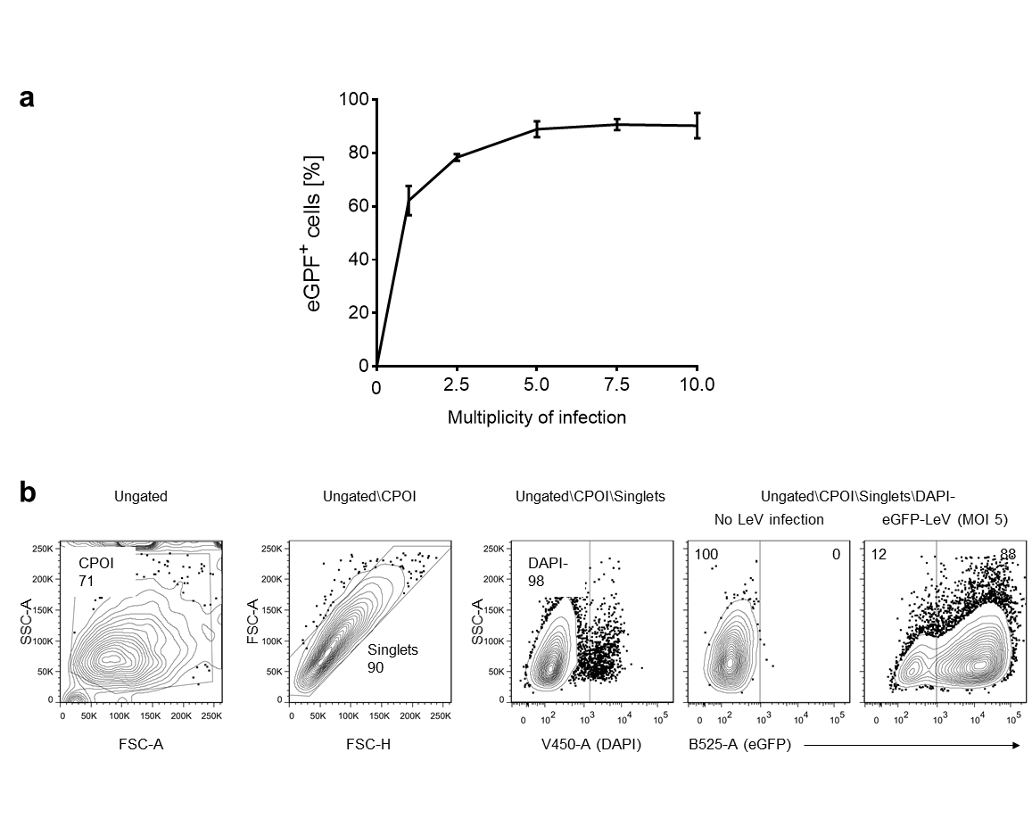

Fig. S1
Fig. S1 Lentiviruses enable efficient transgene delivery into primary cardiac fibroblasts. a Assessment of lentiviral transduction efficiency in cardiac fibroblasts by flow cytometry 3 days after eGFP-lentivirus (LeV) infection. At a multiplicity of infection (MOI) of 5, the transduction efficiency was 89 ± 3 %. Increasing the multiplicity of infection beyond 5 did not increase the transduction efficiency, but did increase cell death. Line graph shows mean ± SD (n=2). b Contour plots (contour level 5 %) show gating strategy used for flow cytometric analysis of eGFP expression in live, DAPI-negative cells. Quantitative data in all gates are given as percentage of the respective parent population. CPOI, cell population of interest
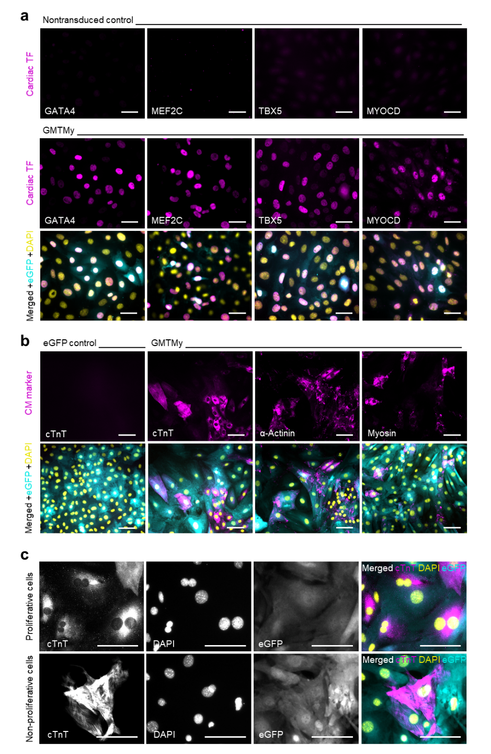

Fig. S2
Fig. S2 GMTMy induces CM-specific protein expression. a Immunofluorescent staining for GATA4, MEF2C, TBX5, or MYOCD (magenta) in nontransduced cardiac fibroblasts (marginal) and in fibroblasts (strong) 3 days after lentivirus infection confirms nuclear overexpression of cardiac transcription factors (TF). Similar overexpression patterns were observed in GMTMy-cotransduced cardiac fibroblasts. eGFP (cyan) marks transduced cells, DAPI (yellow) marks cell nuclei. Scale bars, 50 µm. b Immunofluorescent staining for cTnT, α-actinin, and myosin (magenta) in combination with eGFP (cyan) 14 days after infection with the GMTMy-lentivirus-cocktail indicates beginning transition toward CM fate. DAPI (yellow) marks cell nuclei. Scale bars, 100 µm. c Immunofluorescent staining for CM marker cTnT (magenta) in combination with eGFP (cyan) 14 days after GMTMy-lentivirus infection. DAPI (yellow) marks cell nuclei. Scale bars, 100 µm. Black-and-white images represent single channels, color images represent merged channels of high-magnification immunofluorescence images provided in Fig. 1b, showing that GMTMy coinduced immature, proliferating and more mature, nonproliferative cTnT-positive cells
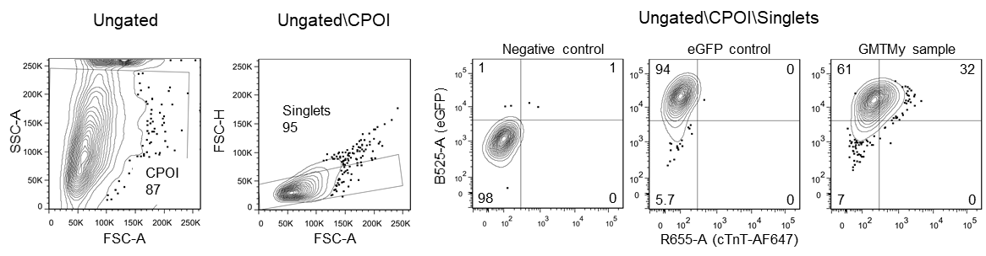

Fig. S3
Fig. S3 Gating strategy used for flow cytometric analysis of cTnT protein expression. Shown are contour plots (contour level 5 %). Quantitative data in all gates are given as percentage of the respective parent population. CPOI, cell population of interest
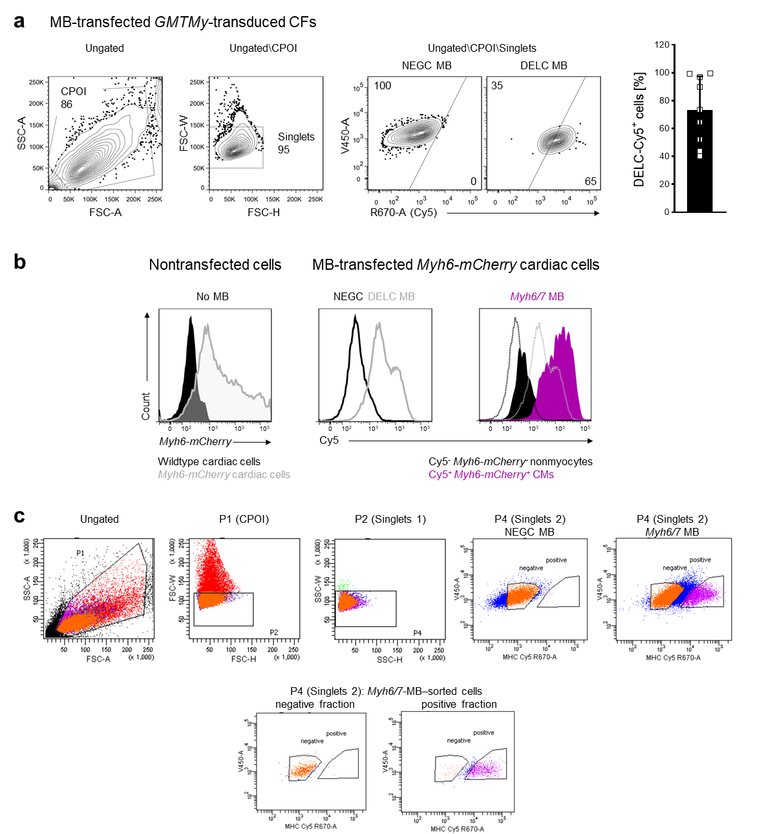

Fig. S4
Fig. S4 Myh6/7 molecular beacons can be efficiently delivered into adherent cells and specifically label CMs. a The Myh6/7-beacon–based sorting protocol was established using negative control (NEGC, no sequence match, Cy5-BHQ2 label), delivery control (DELC, nonspecific sequence, Cy5-Cy5 label, no quencher), and Myh6/7 probes (Cy5-BHQ2 label), which produce Cy5-fluorescence either after probe degradation (negative control), regardless of conformation (delivery control), or after hybridization to Myh6/7 mRNA (Myh6/7). Molecular beacon (MB) transfection efficiency determined by flow cytometry using GMTMy-transduced cardiac fibroblasts transfected with negative and delivery control probes amounted to 73.3 ± 24.2 %, respectively. Contour plots (contour level 5 %) show the gating strategy and representative samples. Quantitative data in all gates are given as percentage of the respective parent population. The scatter plot with bar graph presents the proportion of Cy5-positive cells; shown are replicates and mean ± SD (n=9). b Assessment of molecular beacon specificity using cardiac cells isolated from wildtype and Myh6-mCherry–transgenic neonatal mice, transfected with negative control and Myh6/7 probes and analyzed by flow cytometry. The overlayed histograms show that Cy5 fluorescence overlaps with mCherry positivity, demonstrating the specificity of the Myh6/7 probes for myocytes. c Dot plots show gating strategy used for iCMP sorting. P1, population1; CPOI, cell population of interest
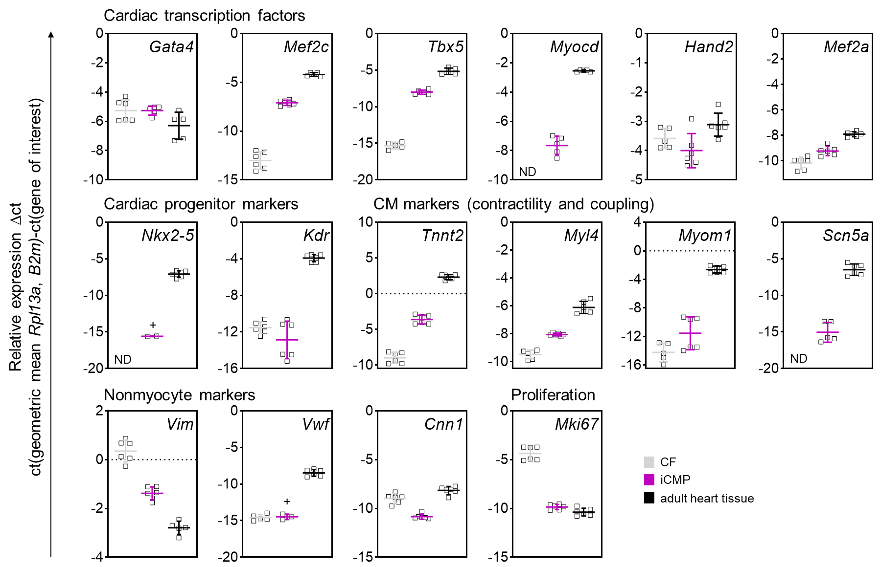

Fig. S5
Fig. S5 Gene expression analyses using RNA sequencing and reverse transcription-quantitative PCR reveal similar expression patterns. Validation of RNA sequencing data for selected genes by reverse transcription-quantitative PCR. Relative gene expression levels of cardiac transcription factors, cardiac progenitor markers, CM markers, nonmyocyte markers, and a proliferation marker are shown for cardiac fibroblasts (CF), purified iCMPs, and adult heart tissue. Gene expression was quantified using the ∆ct-method and was normalized to two references genes (B2m, Rpl13a). The simultaneous upregulation of progenitor and CM gene expression in iCMPs was confirmed. Nonmyocyte gene expression was not induced in iCMPs compared to fibroblasts. Skeletal muscle marker myogenic differentiation 1 (Myod1) was not detectable in any group. Proliferation marker gene expression was markedly reduced but still detectable, supporting the observation of continuous cell proliferation. Scatter plot graphs present replicates and mean ± SD (n=6) (ND, not detected; +, detected in a subset of samples)
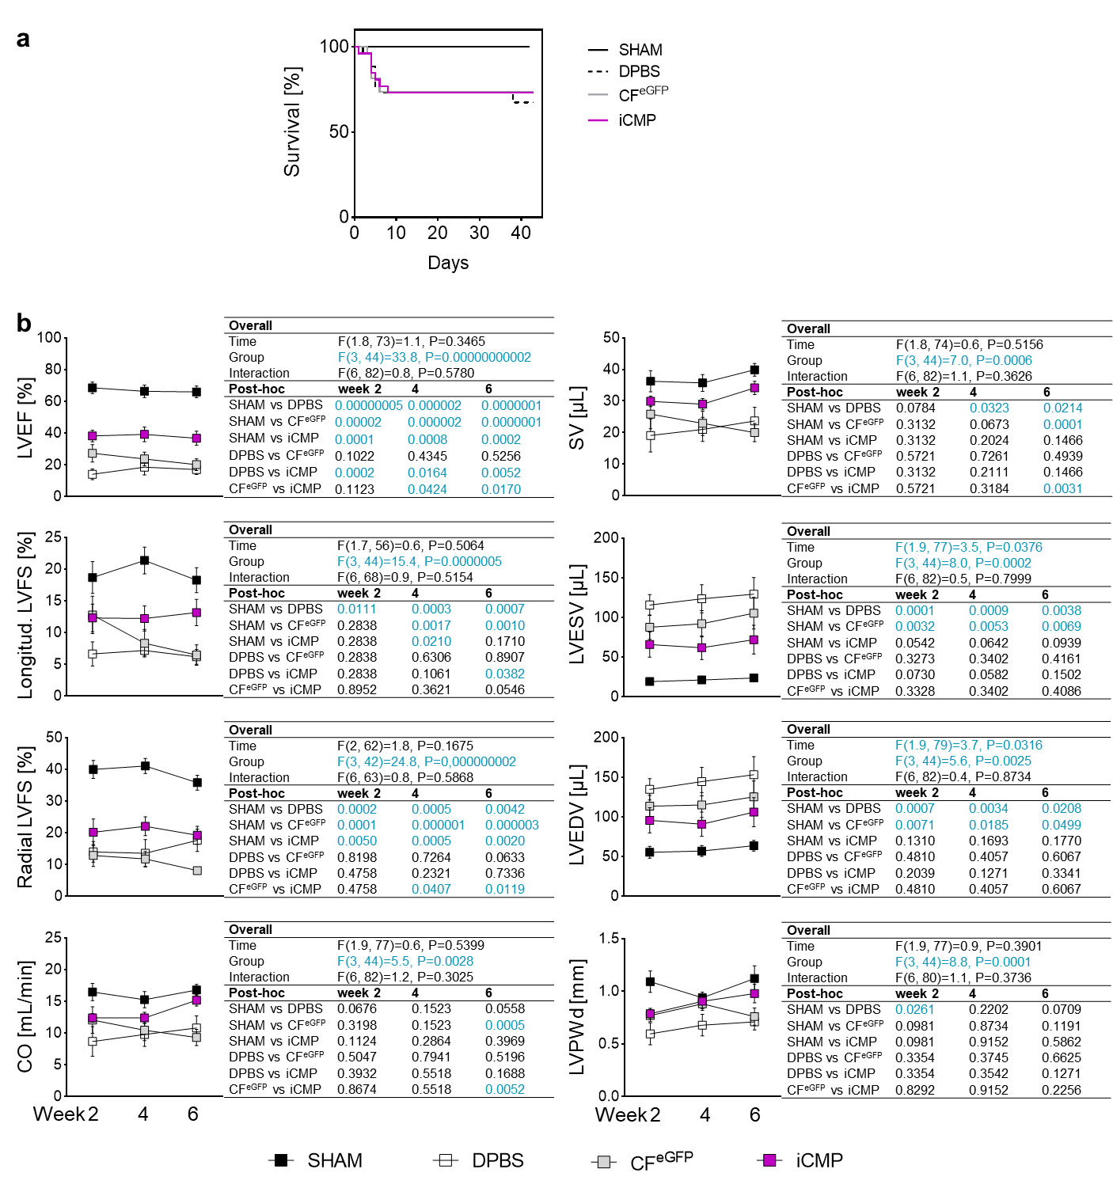

Fig. S6
Fig. S6 iCMP transplantation after myocardial infarction preserves left ventricular performance. a Kaplan-Meier survival analysis (n_{SHAM}=10, n_{DPBS}=12, n_{CFeGFP}=14, n_{iCMP}=13 mice). Staircase graph shows that iCMP transplantation is not associated with increased mortality, supporting their safety for therapeutic application. b Analysis of cardiac function and geometry by transthoracic echocardiography. Provided are complete sets of longitudinal data and corresponding statistical analysis results for in vivo experiments outlined in Fig. 5. Cardiac pump function is given as LVEF. Heart contractility is given as longitudinal and radial left ventricular fractional shortening (LVFS). Blood volume supplied to the body is given as cardiac output (CO) and stroke volume (SV). Ventricle geometry is given as left ventricular end-systolic volume (LVESV), left ventricular end-diastolic volume (LVEDV), and left ventricular posterior wall thickness at end diastole (LVPWd). Line graphs show mean ± SEM (n_{SHAM}=10, n_{DPBS}=12, n_{CFeGFP}=14, n_{iCMP}=13 mice). Data were analyzed using a mixed-effects model and Holm-Sidak's post-hoc tests. Significant results with P<0.05 are shown in cyan
Table S1 Antibody details

Supplementary Table S1
Immunogen, conjugate | Host | Company | Catalog no. | Application | Dilution factor
Primary antibodies (clone)
α-Actinin (EA-53) | Mouse | Sigma-Aldrich | A7811 | IC | 800
α-SMA (4A4) | Mouse | Abcam | ab119952 | IC | 200
CXCR4 (4G10) | Mouse | Santa Cruz Biotechnology | sc-53534 | IC | 200
GATA4 (polyclonal) | Goat | Santa Cruz Biotechnology | sc-1237 | IC | 200
GFP (polyclonal) | Chicken | Abcam | ab13970 | IC/IHC; FC | 1,000; 2,000
ISL1 (B-1) | Mouse | Santa Cruz Biotechnology | sc-390793 | IC | 200
KDR (A-3) | Mouse | Santa Cruz Biotechnology | sc-6251 | IC | 200
c-Kit (E-3) | Mouse | Santa Cruz Biotechnology | sc-365504 | IC | 200
MEF2C (D80C1) | Rabbit | New England Biolabs | 5030 | IC | 200
Myosin (MF-20) | Mouse | Dev. Studies Hybridoma Bank | MF-20 | IC | 200
MYOCD (polyclonal) | Goat | Santa Cruz Biotechnology | sc-21561 | IC | 200
NKX2-5 (A-3) | Mouse | Santa Cruz Biotechnology | sc-376565 | IC | 200
CD31 (polyclonal) | Rabbit | Abcam | ab28364 | IC | 200
CD31 (H-3) | Mouse | Santa Cruz Biotechnology | sc-376764 | IHC | 1,600
TBX5 (polyclonal) | Goat | Santa Cruz Biotechnology | sc-17866 | IC | 200
cTnT (1C11) | Mouse | Abcam | ab8295 | IC/FC | 200
cTnI (polyclonal) | Goat | HyTest | 4T21/2 | IHC | 1,000
Secondary antibodies
Chicken, FITC | Donkey | Invitrogen | SA1-72000 | IHC | 250
Chicken, Alexa Fluor 488 | Goat | Invitrogen | A11039 | IC | 2,000
Goat, Alexa Fluor 647 | Donkey | Invitrogen | A-21447 | IHC | 250
Goat, Alexa Fluor 647 | Rabbit | Abcam | AB169347 | IC | 1,000
Mouse, Alexa Fluor 555 | Donkey | Invitrogen | A-31570 | IHC | 250
Mouse, Alexa Fluor 647 | Goat | New England Biolabs | 4410 | IHC | 1,000
Rabbit, Alexa Fluor 647 | Goat | Invitrogen | A-21245 | IC | 1,000
Abbreviations: IC, immunocytology; IHC, immunohistology; FC, flow cytometry.

Table S2 Reverse transcription-quantitative PCR primer sequences

Supplementary Table S2
Gene | Forward primer 5' → 3' | Reverse primer 5' → 3'
B2m | TTCTGGTGCTTGTCTCACTGA | CAGTATGTTCGGCTTCCCATTC
Cnn1 | GGCCCAGAAATACGACCATCA | GGTGCCAGTTCTGAGTTGACT
Gata4 | GCCTGTATGTAATGCCTGCG | CATTGCTGGAGTTACCGCTG
Hand2 | TCATGGATCTGCTGGCCAAG | TCTTGTCGTTGCTGCTCACT
Kdr | GGCGACTATGTTTGCTCTGC | CGCCAATGGTTGTTGTCTGA
Mef2a | CTAGGACAAGCAGCCCTCAG | GGAGGTGAAATTGGCTCTGACT
Mef2c | ACGAGGATAATGGATGAGCGT | TGCAATCTCACAGTCGCACA
Mki67 | ACCTGGTCTTAGTTCCGTTGAT | CTTGGTTGGCGTTTCTCCTC
Myl4 | CAAACCCAAGCCTGAAGAGATG | ACCCATGACTGTGCCGTT
Myocd | AGAATGATGCAGCCTCCCAG | CGGTTCTTACTGTCACCCAAAG
Myod1 | CTGCTCTGATGGCATGATGGAT | CGCTCCACTATGCTGGACAG
Myom1 | GGGCGACACTTACGTTCTCTC | CACCACATCCAAGGGTGCA
Nkx2-5 | CCCAAGTGCTCTCCTGCTTT | CCATCCGTCTCGGCTTTGT
Rpl13a | TGAAGCCTACCAGAAAGTTTGC | TCCGATAGTGCATCTTGGCC
Scn5a | GAGATGCTGCTCAAGTGGGT | TCTCGGCAAAGCCTAAGGTG
Tbx5 | ATGAACGTGAACTGTGGCTGA | GGCCAGTCACCTTCACTTTGT
Tnnt2 | CAGAGGAGGCCAACGTAGAAG | CTCCATCGGGGATCTTGGGT
Vim | GATCAGCTCACCAACGACAAG | GTTCAAGGTCAAGACGTGCC
Vwf | GTATGGCCCACTACCTCACC | CTGCAACCCTCATTTCCCAC

