Supplementary Data

Supplementary Figures
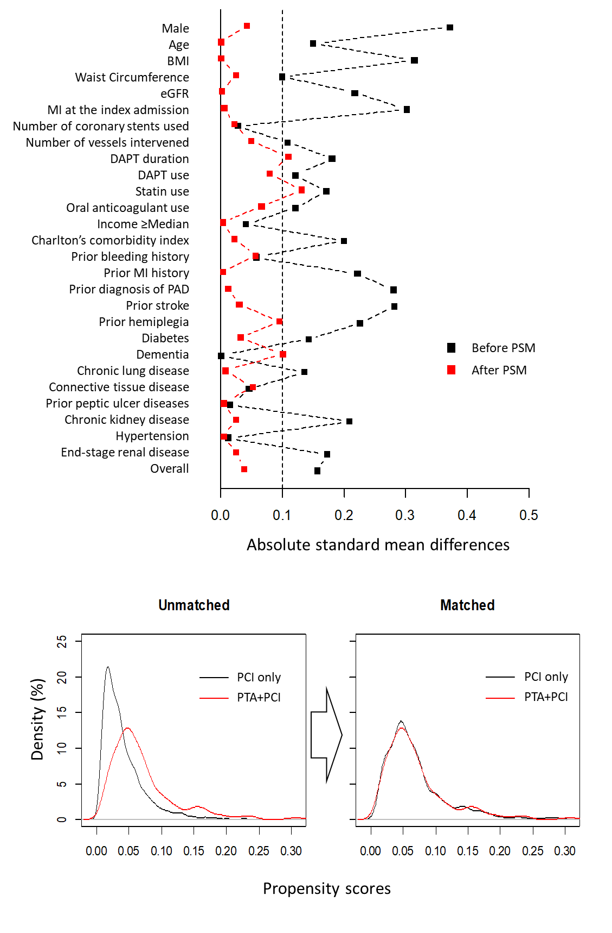
Supplementary figure 1. Quality of the PSM procedure.
Absolute standard mean differences were reduced to <0.1 in all variables (the upper panel) and the histograms of the propensity scores were overlapped (the lower panel) after PSM.
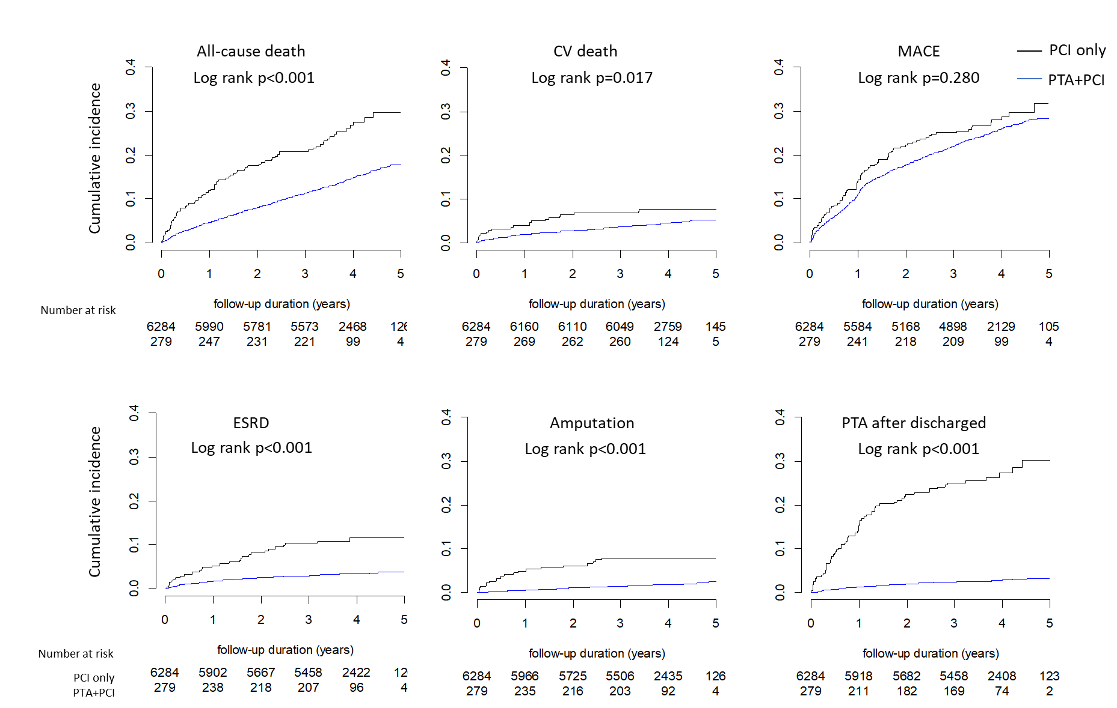
Supplementary figure 2. Cumulative incidences of clinical outcomes according to the treatments in the unmatched cohort.
All-cause death, CV death, the development of ESRD, amputation and PTA after discharge were more frequent in the PTA+PCI group than in the PCI only group, whereas the cumulative incidence of MACE was not different between the two groups.

Supplementary Tables

Supplementary Table 1. The Korean Classification of Disease -7 Codes used to define the comorbidities and the Charlson's comorbidity index
 | Clinical situations | Korean Classification of Disease -7 Codes
Comorbidities  or CCI parameters | Myocardial infarction | I21-I24
 | Heart failure | I43, I50, I099, I110, I130, I132, I255, I420, I425, I426, I427, I428, I429, P290
 | Peripheral artery diseases | I70-I71, K551, K558, K559, Z958, Z959, I731, I738, I739, I771, I790, I792
 | Cerebrovascular diseases | G45, G46, I60, I61, I62, I63, I64, I65, I66, I67, I68, I69, H340
 | Dementia | F00, F01, F02, F03, G30, G311, F051
 | Hemiplegia | G81, G82, G041, G114, G801, G802, G830, G831, G832, G833, G834, G839
 | Chronic lung diseases | J40, J41, J42, J43, J44, J45, J46, J47, J60, J61, J62, J63, J64, J65, J66, J67, I278, I279, J684, J701, J703
 | Connective tissue diseases | M05, M06, M32, M33, M34, M315, M351, M353, M360
 | Peptic ulcer diseases | K25, K26, K27, K28
 | Mild liver diseases | B18, K73, K74, K700-K703, K709, K713-K715, K717, K760, K762 K763, K764, K768, K769, Z944
 | Moderate to severe liver diseases | K704, K711, K721, K729, K765-K767
 | Diabetes without complications | E100, E101, E106, E107, E109-E111, E116, E118-E121, E126, E129-E131, E136, E138-E141, E146, E148, E149
 | Diabetes with complications | E102-E105, E112-E115, E107, E117, E122-E125, E127, E132-E135, E137, E142-E145, E147
 | Chronic kidney diseases | N18, N19, I120, I131, N032-N037, N052-N057, N250, Z490-Z492, Z940, Z992
 | End-stage renal disease | N18.5
 | Hematologic malignancy | C00-C97 (except C77, C78, C79, C80)
 | Metastatic solid tumor | C77, C78, C79, C80
 | Acquired Immunodeficiency syndrome | B20 B21, B22, B24
Exclusion criteria/  outcomes | Diabetic foot ulcer | E1070, E1071, E1170, E1171, E1270, E1271, E1370, E1371, E1470, E1471, L97
 | Amputation of extremities | E1070, E1071, E1170, E1171, E1270, E1271, E1370, E1371, E1470, E1471, L97
 | Bleedings | I850, K221, K228, K252, K254, K256, K260, K262, K264, K266, K270, K272, K274, K276, K280, H052, K356, K431, J942, M250, K282, K284, K286, K290, K318, K552, K570-K575, K578, K579, K625, K661, K920, K921, K922, D62, R04
 | Cardiovascular death | Death by I20-I74

Supplementary Table 2. The National Health Insurance claim codes for PCI and CABG
 | Claim codes | Procedure
PCI | M6561 | Elective PCI with coronary stent implantation (Single vessel)
 | M6562 | Elective PCI with coronary stent implantation (Multi-vessel)
 | M6563 | Elective PCI with coronary stent implantation+ atherectomy (Single vessel)
 | M6564 | Elective PCI with coronary stent implantation+ atherectomy (Multi-vessel)
 | M6565 | Primary PCI with coronary stent implantation for acute myocardial infarction
 | M6566 | Elective PCI with coronary stent implantation for chronic total occlusion
 | M6567 | Elective PCI with coronary stent implantation for chronic total occlusion + atherectomy
 | M6571 | Atherectomy for single vessel diseases
 | M6572 | Atherectomy for multi-vessel disease
 | M6551 | Elective PCI without coronary stent implantation (Single vessel)
 | M6552 | Elective PCI without coronary stent implantation (Multi-vessel)
 | M6553 | Primary PCI without coronary stent implantation for acute myocardial infarction
 | M6554 | Elective PCI without coronary stent implantation for chronic total occlusion
CABG | O1640 | CABG for 2 vessels
 | O1641 | CABG for 1 vessel
 | O1645 | CABG using autologous vessels
 | O1646 | CABG using artificial vessels
 | O1647 | Repeat CABG using autologous vessels
 | O1648 | CABG using autologous vessels for 3 vessels
 | O1649 | CABG using autologous vessels for 4 or more vessels
 | OA640 | Off-Pump CABG for 2 vessels
 | OA641 | Off-Pump CABG for 1 vessel
 | OA647 | Repeat Off-Pump CABG
 | OA648 | Repeat Off-Pump CABG for 3 vessels
 | OA649 | Repeat Off-Pump CABG for 4 or more vessels
PCI, percutaneous coronary intervention; CABG, coronary artery bypass graft

Supplementary Table 3. Insurance claim codes for the devices used in PCI and PTA
 | Categories | Insurance claim codes
PCI | Coronary artery balloon | J4081, J8081
 | Coronary drug-eluting stent* | J5083, J8083, J5084
 | Coronary drug-coated balloon | J4080, J8080
 | Others (bare-metal stents, cutting balloon, coronary stent graft) | J5231, J8231, J4082, J5603
PTA | Peripheral artery balloon | J4071-J4073, J8071-J8074
 | Peripheral artery drug-coated balloon | J4077
 | Peripheral artery stent (bare-metal) | J5233-J5234, J8233
 | Others (drug-coated stent, cutting balloon, stent graft beside aorta graft) | J5238, J5502-J5503, J8074, J4074
* coronary drug-eluting stent includes bioabsorbable scaffold
PCI, percutaneous coronary intervention; PTA, percutaneous transluminal angioplasty

Supplementary Table 4. Associations of concomitant PTA at the time of PCI with clinical outcomes and the E-values.
 |  |  | Univariate model |  |  |  | Multivariate model*
 | Event (%) |  | Statistics |  | E-values |  | Statistics |  | E-values
 | PTA+PCI | PCI only | HR (95% CI) | P-value | for HR | for CI | HR (95% CI) | P-value | for HR | for CI
Before PSM | N=279 | N=6284
Death | 73 (26.2) | 919 (14.6) | 1.96 (1.54-2.48) | <0.001 | 2.56 | 2.03 | 1.69 (1.32-2.15) | <0.001 | 2.77 | 1.97
CV death | 21 (7.5) | 283 (4.5) | 1.71 (1.10-2.66) | 0.018 | 2.81 | 1.43 | 1.54 (0.99-2.42) | 0.058 | 2.45 | 1.00
MACEs | 79 (28.3) | 1611 (25.6) | 1.13 (0.90-1.42) | 0.280 | 1.40 | 1.00 | 1.11 (0.89-1.40) | 0.358 | 1.46 | 1.00
Myocardial infarction | 13 (4.7) | 414 (6.6) | 0.76 (0.44-1.32) | 0.326 | 1.96 | 1.00 | 0.87 (0.50-1.52) | 0.625 | 1.56 | 1.00
Revascularization | 49 (17.6) | 962 (15.3) | 1.27 (0.95-1.69) | 0.105 | 1.64 | 1.00 | 1.25 (0.93-1.66) | 0.136 | 1.61 | 1.00
Stroke | 16 (5.7) | 344 (5.5) | 1.14 (0.69-1.89) | 0.602 | 1.54 | 1.00 | 1.09 (0.66-1.81) | 0.727 | 1.41 | 1.00
Any bleeding | 9 (3.2) | 209 (3.3) | 1.06 (0.54-2.05) | 0.876 | 1.31 | 1.00 | 0.97 (0.50-1.89) | 0.920 | 1.40 | 1.00
ESRD | 28 (10.0) | 206 (3.3) | 3.37 (2.27-4.99) | <0.001 | 6.20 | 3.97 | 2.05 (1.37-3.06) | <0.001 | 3.51 | 2.08
Amputation | 20 (7.2) | 108 (1.7) | 4.77 (2.96-7.68) | <0.001 | 9.01 | 5.37 | 3.81 (2.36-6.16) | <0.001 | 7.08 | 5.97
PTA after discharge | 68 (24.4) | 168 (2.7) | 11.3 (8.52-15.0) | <0.001 | 22.10 | 16.52 | 9.27 (6.93-12.4) | <0.001 | 18.02 | 13.30
After PSM | N=279 | N=1385
Death | 73 (26.2) | 273 (19.7) | 1.34 (1.02-1.76) | 0.034 | 2.01 | 1.17 | 1.52 (1.17-1.98) | 0.002 | 2.41 | 1.62
CV death | 21 (7.5) | 69 (5.0) | 1.56 (0.95-2.56) | 0.082 | 2.49 | 1.00 | 1.59 (0.97-2.59) | 0.065 | 2.56 | 1.00
MACEs | 79 (28.3) | 393 (28.4) | 1.03 (0.81-1.32) | 0.804 | 1.21 | 1.00 | 1.00 (0.78-1.27) | 0.969 | 1.00 | 1.00
Myocardial infarction | 13 (4.7) | 80 (5.8) | 0.85 (0.46-1.58) | 0.614 | 1.63 | 1.00 | 0.85 (0.47-1.53) | 0.591 | 1.63 | 1.00
Revascularization | 49 (17.6) | 237 (17.1) | 1.09 (0.79-1.50) | 0.615 | 1.32 | 1.00 | 1.09 (0.80-1.48) | 0.594 | 1.32 | 1.00
Stroke | 16 (5.7) | 101 (7.3) | 0.87 (0.51-1.49) | 0.608 | 1.56 | 1.00 | 0.88 (0.52-1.50) | 0.639 | 1.53 | 1.00
Any bleeding | 9 (3.2) | 49 (3.5) | 0.93 (0.44-1.93) | 0.836 | 1.36 | 1.00 | 0.91 (0.44-1.85) | 0.787 | 1.43 | 1.00
ESRD | 28 (10.0) | 93 (6.7) | 1.57 (1.03-2.40) | 0.036 | 1.52 | 1.21 | 1.60 (1.05-2.45) | 0.029 | 2.57 | 1.28
Amputation | 20 (7.2) | 34 (2.5) | 3.51 (1.96-6.30) | <0.001 | 6.48 | 3.33 | 3.41(1.96-5.92) | <0.001 | 6.27 | 3.33
PTA after discharge | 68 (24.4) | 70 (5.1) | 5.78 (4.14-8.07) | <0.001 | 11.04 | 7.75 | 5.94 (4.25-8.30) | <0.001 | 11.36 | 7.97
PSM, propensity score matching; PCI, percutaneous coronary intervention; PTA, percutaneous transluminal angioplasty; CV cardiovascular; MACE, major adverse cardiovascular events; ESRD, end-stage renal disease; HR, hazard ratio; CI, confidence interval
* The multivariate model includes age, sex, BMI, waist circumference, MI at index admission, number of coronary stents used, income ≥median, prior bleeding events, MI, PAD, stroke, diabetes, hypertension, peptic ulcer, DAPT duration and statin use as covariates. The model was reduced using a backward selection method (cut-off criterion, p>0.1).

Supplementary Table 5. Associations between concomitant PTA at the time of PCI and clinical outcomes in various subgroups
 |  |  | MACE |  |  | ESRD |  |  | Amputation + PTA after discharge
Group criteria |  | N | event | HR (95% CI)* | p** | event | HR (95% CI)* | p** | event | HR (95% CI)* | p**
Age | <70 years | 680 | 213 (31.3) | 1.07 (0.67-1.71) | 0.61 | 64 (9.4) | 1.12 (0.50-2.51) | 0.51 | 75 (11.0) | 6.52 (3.25-13.1) | 0.50
 | ≥70 years | 984 | 259 (26.3) | 1.05 (0.72-1.51) |  | 57 (5.8) | 2.03 (0.98-4.20) |  | 90 (9.1) | 6.15 (3.45-11.0)
Sex | Male | 1303 | 375 (28.8) | 1.06 (0.80-1.42) | 0.88 | 88 (6.8) | 1.17 (0.67-2.04) | 0.16 | 129 (9.9) | 4.24 (2.85-6.32) | 0.05
 | Female | 361 | 97 (26.9) | 0.95 (0.46-1.98) |  | 34 (9.4) | 2.46 (0.83-7.34) |  | 36 (10.0) | 38.4 (5.06-290)
MI at index PCI | No | 1363 | 375 (27.5) | 1.04 (0.78-1.39) | 1.00 | 101 (7.4) | 1.61 (0.99-2.62) | 0.72 | 139 (10.2) | 4.97 (3.41-7.25) | 0.60
 | Yes | 301 | 97 (32.2) | 1.13 (0.51-2.53) |  | 20 (6.6) | 1.00 (0.16-6.14) |  | 26 (8.6) | 2.85 (0.75-10.9)
Diabetes | No | 339 | 92 (27.1) | 0.96 (0.44-2.10) | 0.77 | 9 (2.7) | 1.41 (0.19-10.3) | 0.53 | 17 (5.0) | 17.4 (0.76-402) | 0.07
 | Yes | 1325 | 380 (28.7) | 1.02 (0.76-1.36) |  | 112 (8.5) | 1.56 (0.97-2.51) |  | 66 (5.0) | 4.89 (3.34-7.16)
CKD | No | 1281 | 346 (27.0) | 0.75 (0.37-1.53) | 0.13 | 48 (3.7) | 1.04 (0.44-2.48) | 0.18 | 74 (5.8) | 3.18 (1.29-7.85) | 0.01
 | Yes | 383 | 126 (32.9) | 1.07 (0.80-1.45) |  | 73 (19.1) | 2.24 (1.12-4.47) |  | 91 (23.8) | 7.90 (4.71-13.2)
multi-vessel CAD | No | 1357 | 376 (27.7) | 1.08 (0.80-1.44) | 0.40 | 99 (7.3) | 1.61 (0.97-2.67) | 0.89 | 128 (9.4) | 5.07 (3.38-7.59) | 0.92
 | Yes | 307 | 96 (31.3) | 1.35 (0.59-3.13) |  | 22 (7.2) | 1.16 (0.19-7.03) |  | 37 (12.1) | 12.6 (1.60-99.3)
CCI | ≤3 | 458 | 115 (25.1) | 0.88 (0.44-1.73) | ref | 9 (2.0) | 3.24 (0.29-36.6) | ref | 18 (3.9) | 19.7 (2.48-156) | ref
 | 4-6 | 705 | 195 (27.7) | 0.78 (0.48-1.26) | 0.87 | 21 (3.0) | 14.4 (1.71-121) | 0.71 | 61 (8.7) | 23.3 (7.07-77.0) | 0.80
 | ≥7 | 501 | 165 (32.9) | 1.48 (0.83-2.65) | 0.75 | 91 (18.2) | 1.68 (0.83-3.40) | 0.97 | 86 (17.2) | 2.58 (1.23-5.41) | 0.04
* Univariate Cox proportional hazard models in each subgroup of propensity score-matched cohort.
** P-values for the interaction between the categories in each subgroup. For CCI, p-values stand for the interaction of the categories with the reference category (CCI ≤3).
MACE, major adverse cardiovascular events; ESRD, end-stage renal disease; PTA, percutaneous transluminal angioplasty; HR, hazard ratio; MI, myocardial infarction; PCI, percutaneous coronary intervention; CKD, chronic kidney disease; CAD, coronary artery diseases; CCI, Charlson's comorbidity index

Supplementary Table 6. Model summary for mediators of the association between the concomitant PTA and all-cause death
 |  |  |  |  | Mediation analysis summary
Mediators | Model outcome | Covariates | Estimates (95% CI) | p-value | Effects | Estimate (95% CI) | p-value
PTA after discharge | All-cause death | concomitant PTA | -0.083 (-0.187 - 0.021) | 0.120 | Total effect | -1.03 (-1.39 --0.64) | <0.001
 |  | PTA after discharge | 1.519 ( 1.467 - 1.746) | <0.001 | Direct effect | -0.09 (-0.19 - 0.02) | 0.120
 |  | Log(scale) | -0.495 (-0.420 --0.570 | <0.001 | Indirect effect | -0.94 (-1.30 --0.57) | <0.001
 | PTA after discharge | concomitant PTA | -0.589 (-0.808 --0.370) | <0.001 | % mediated | 91.7% (81.6% - 100%) | <0.001
 |  | Log(scale) | -0.108 (-0.191 --0.025) | 0.011
Amputation | All-cause death | concomitant PTA | -0.070 (-0.129 --0.010) | 0.022 | Total effect | -1.18 (-1.73 --0.69) | <0.001
 |  | Amputation | 1.869 ( 1.738 - 2.000) | <0.001 | Direct effect | -0.07 (-0.13 --0.01) | 0.012
 |  | Log(scale) | -1.068 (-1.143 --0.992) | <0.001 | Indirect effect | -1.11 (-1.66 --0.62) | <0.001
 | Amputation | concomitant PTA | -0.593 (-0.874 --0.312) | <0.001 | % mediated | 93.9% (87.0% - 99%) | <0.001
 |  | Log(scale) | -0.253 (-0.372 --0.134) | <0.001
ESRD | All-cause death | concomitant PTA | -0.091 (-0.201 - 0.018) | 0.100 | Total effect | -0.20 (-0.49 - 0.08) | 0.190
 |  | ESRD | 1.083 ( 0.933 - 1.231) | <0.001 | Direct effect | -0.09 (-0.20 - 0.02) | 0.120
 |  | Log(scale) | -0.457 (-0.533 --0.382) | <0.001 | Indirect effect | -0.11 (-0.38 - 0.15) | 0.420
 | ESRD | concomitant PTA | -0.098 (-0.346 - 0.150) | 0.438 | % mediated | 59.7% (-231% - 371%) | 0.250
 |  | Log(scale) | -0.150 (-0.237 --0.063) | <0.001
All models are time-varying survival regression models (Gaussian)

