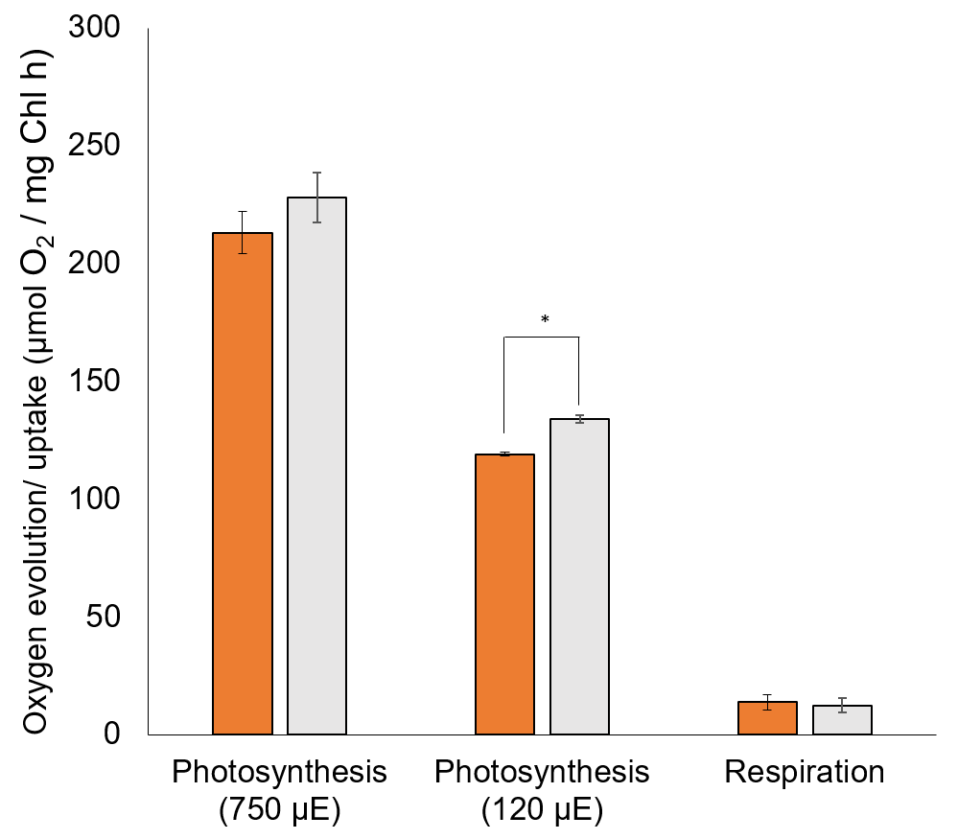
Supplementary Figure 1. Photosynthetic and respiratory activity of slr0688i and dCas9.
Rates of photosynthesis and respiration of slr0688i (orange bars) and dCas9 (gray bars) are expressed as oxygen evolution and uptake, respectively. Presented are average values of three biological replicates ± SD. An asterisk indicates a statistically significant difference (p<0.05).

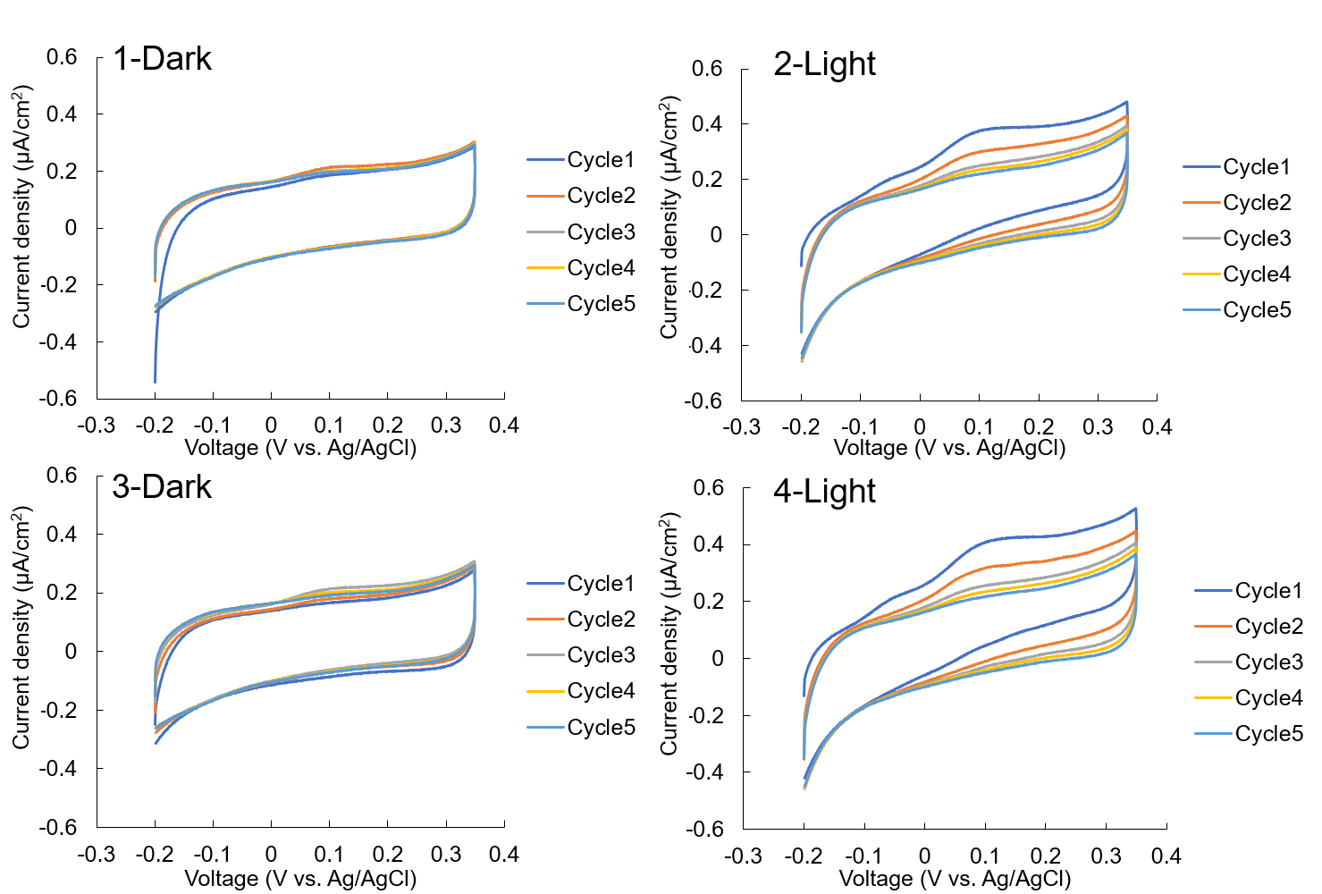

Supplementary Figure 2. Cyclic voltammograms of slr0688i in the dark and under illumination (100 µmol photons m⁻² s⁻¹).
Data were obtained sequentially (1-Dark→2-Light→3-Dark→4-Light) after the chronoamperometry measurement shown in Fig. 2(b).

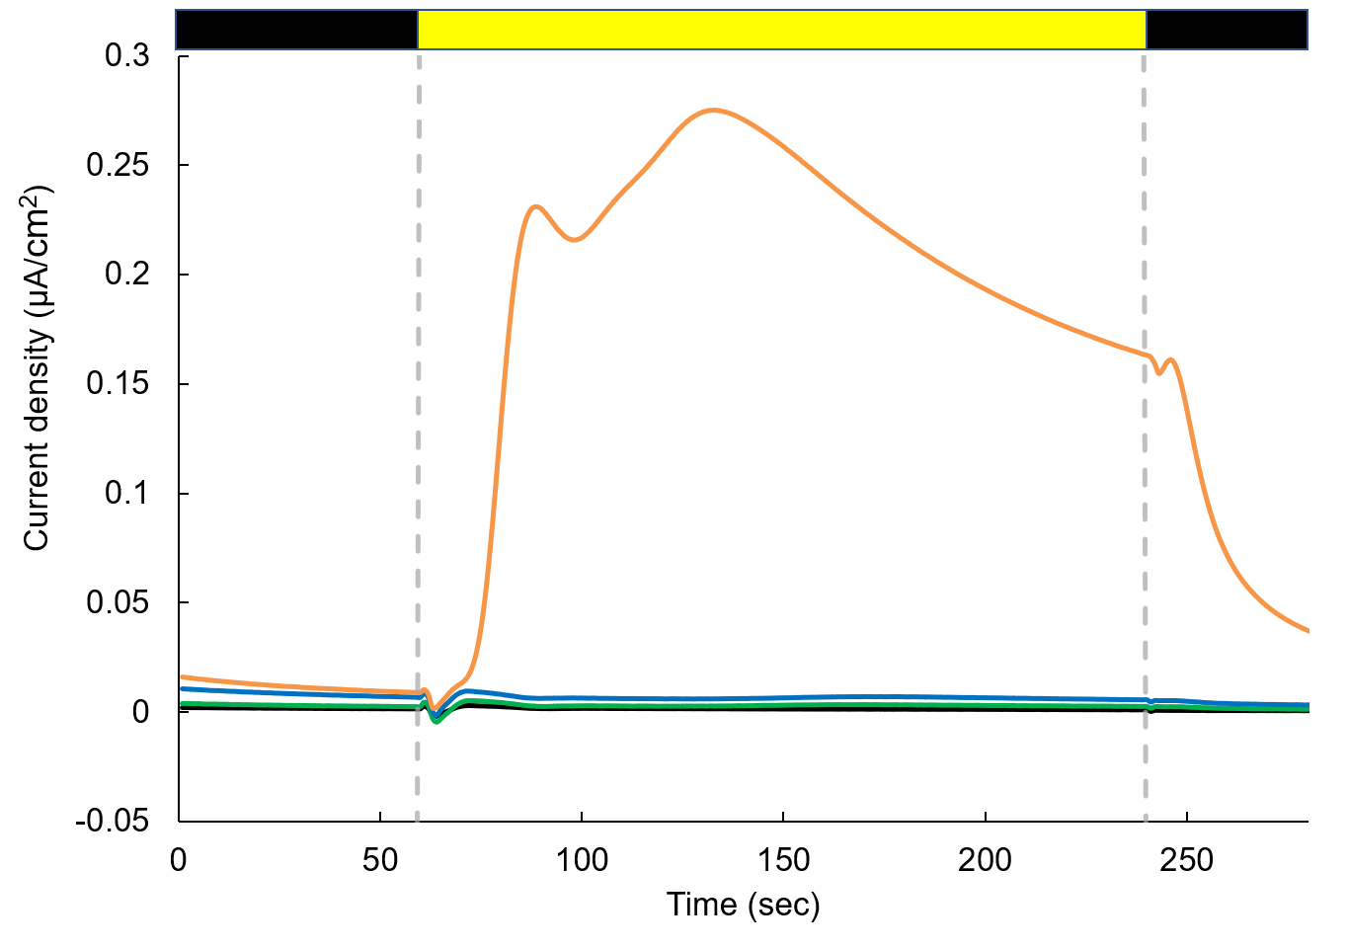
Supplementary Figure 3. Generation of photocurrent from slr0688i suspended in size-fractionated supernatants.
Slr0688i cells (OD₇₃₀ = 2.1) were collected and resuspended in 0.1× concentration of supernatants containing compounds with molecular weight > 50,000 (black), > 10,000 (green), > 3,000 (blue) and < 3,000 (orange). For details, see Materials and Methods. +0.25 V vs Ag/AgCl was applied. The black and yellow rectangles indicate dark and light (120 µmol photons m⁻² s⁻¹) conditions, respectively.

(a)
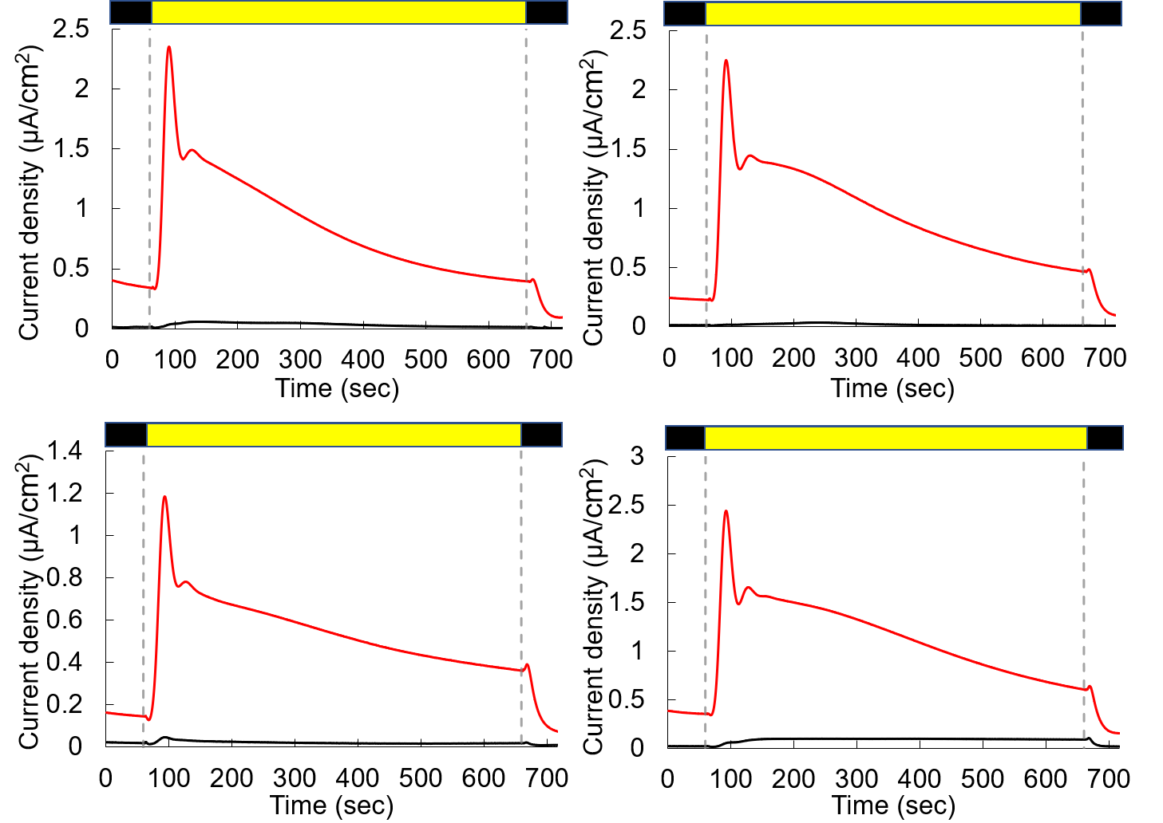
(b)
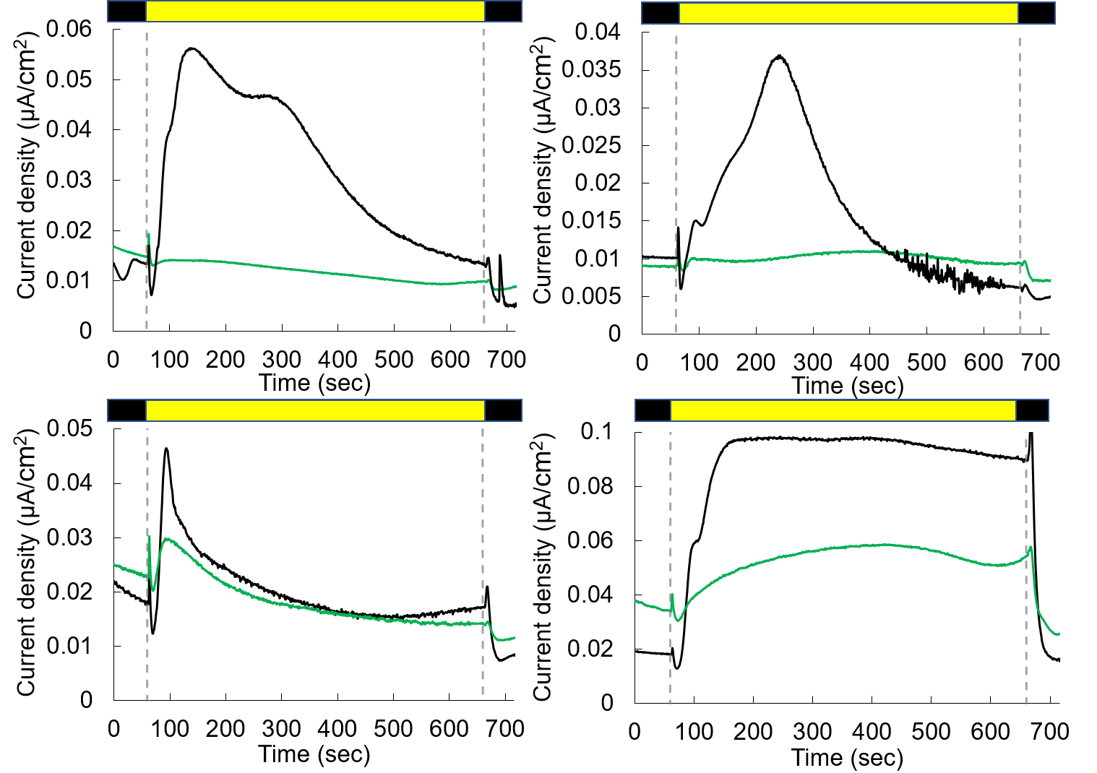
(c)
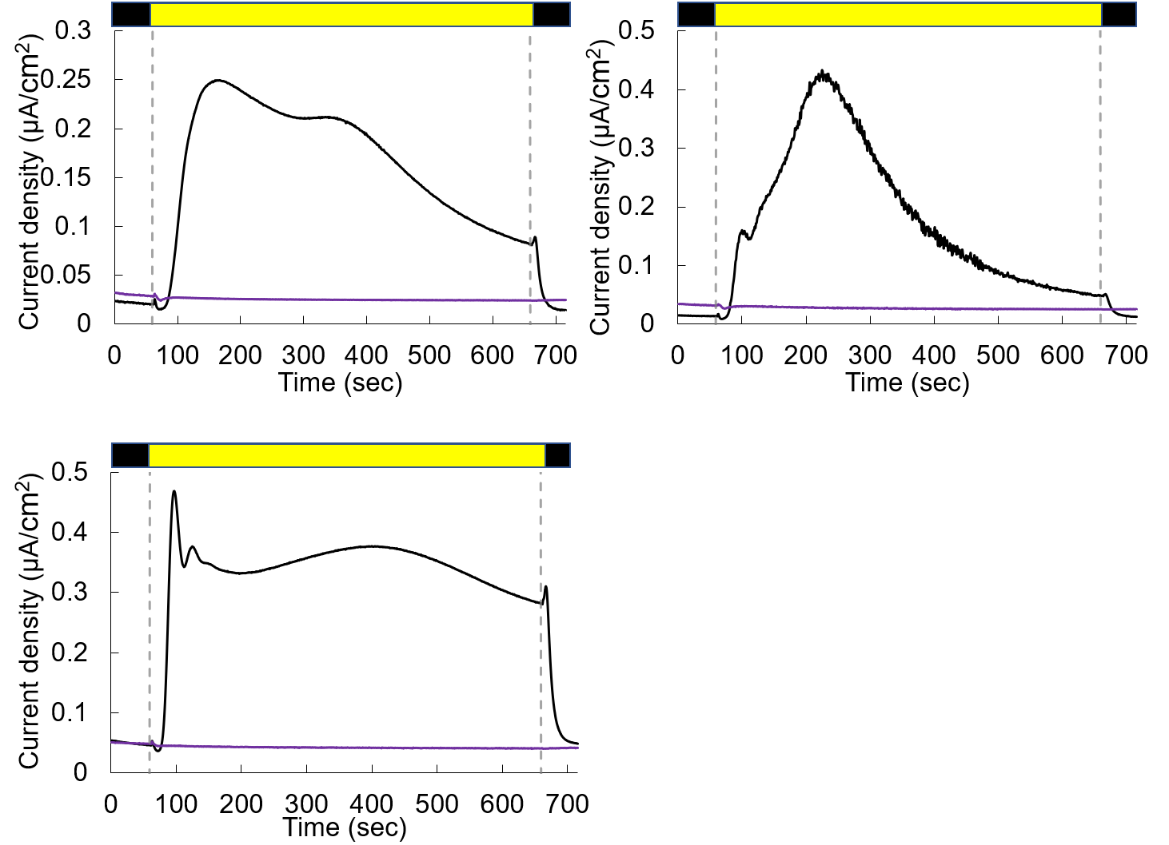
Supplementary Figure 4. Effects of photosynthesis inhibitors on current generation from slr0688i.
Current generation from cell suspensions of slr0688i treated with (a) 100 µM pCMB (red), (b) 10 µM DCMU (green), and (c) 5mM KCN (purple) was measured at +0.25 V vs. Ag/AgCl. The results obtained with cell suspensions treated with the solvent DMSO and without any addition are shown in black in (a, b) and (c), respectively. Shown are three to four independent biological replicates, which were used to calculate total coulombs produced during illumination shown in Fig. 3(a). The black and yellow rectangles indicate dark and light (70 µmol photons m⁻² s⁻¹) conditions, respectively.
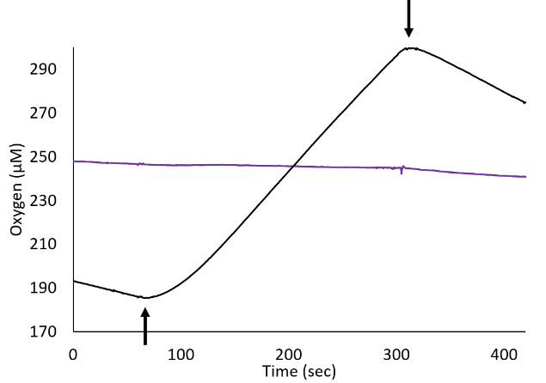
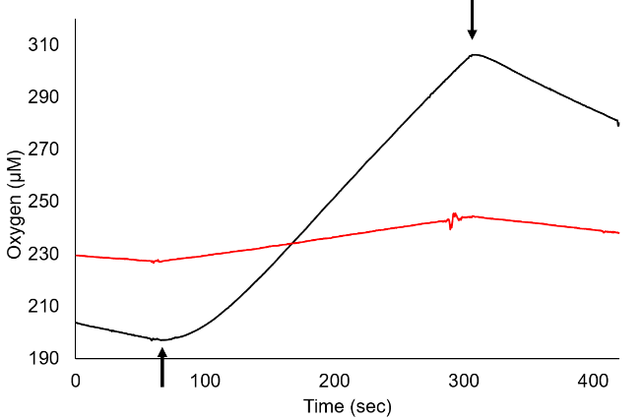
- (b)

Supplementary Figure 5. Effects of photosynthesis inhibitors on whole chain electron transport activity of slr0688i.
Oxygen evolving activity of slr0688i (12 µg chl/ml in BG11) in the presence of 5 mM NaHCO₃ was measured following (a) 1.5 h-incubation either with 100 µM pCMB (red) or its solvent DMSO (black), and (b) addition of either 5 mM KCN (purple) or its solvent water (black). The beginning and the end of illumination are indicated by upward and downward arrows, respectively.

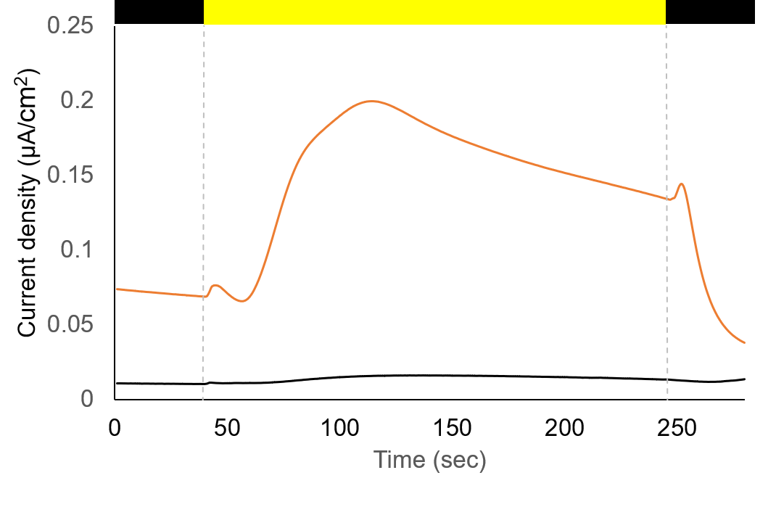

Supplementary Figure 6. The effect of PMA on current generation from slr0688i.
Photocurrent generation from cell suspensions of slr0688i treated either with 50 µM PMA (orange) or its solvent DMSO (black) was measured at +0.25 V vs. Ag/AgCl. The black and yellow rectangles indicate dark and light (70 µmol photons m⁻² s⁻¹) conditions, respectively.

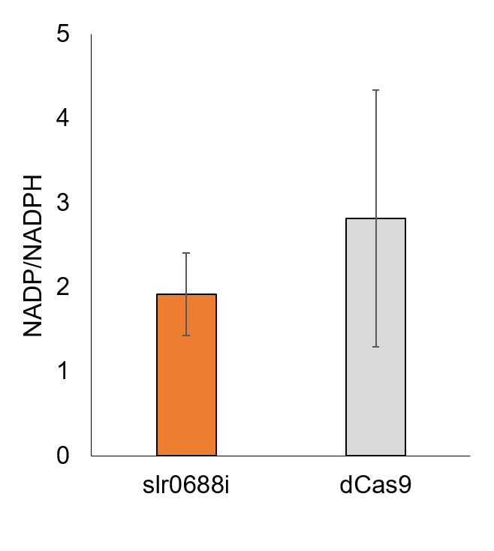
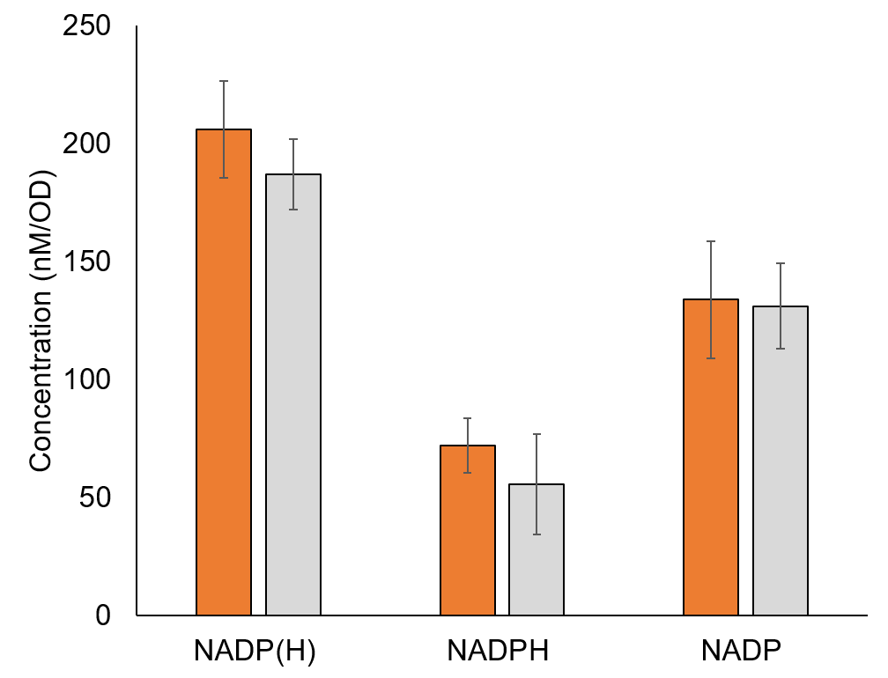

Supplementary Figure 7. Intracellular amounts of NADP(H) in slr0688i and dCas9.
(a) NADP(H) contents in slr0688i (orange bars) and dCas9 (gray bars). (b) NADP⁺/NADPH ratios calculated from NADP(H) contents. Presented are average values of six biological replicates ± SD.

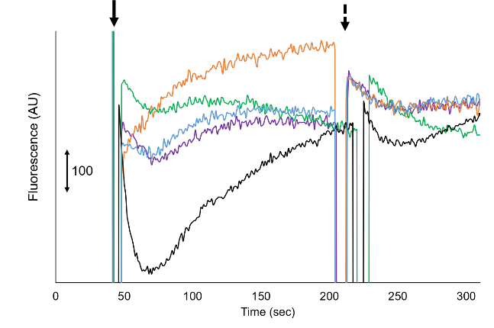
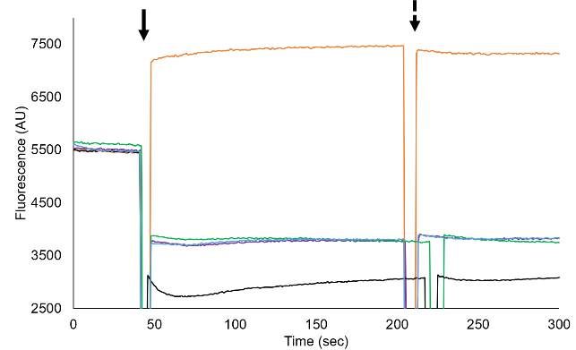
- (b)

Supplementary Figure 8. The effect of slr0688i supernatant on changes in membrane potential of Bacillus membrane vesicles.
Changes in membrane potential of membrane vesicles isolated from Bacillus subtilis (73 µg protein / mL, 0.9 mL) were monitored following addition of each sample (0.9 mL) at the time indicated by bold arrows: 5× concentrated supernatants with MW > 3,000 of slr0688i (orange) and dCas9 (green), a 0.5× concentration of supernatants with MW < 3,000 of slr0688i (purple), fresh BG11 (blue), and 2.5 µM PMS / 10 mM ascorbate in BG11 (black). For better comparison, traces shown in (a) are enlarged and normalized in (b). The measurements were performed following the procedures of the experiments with living Bacillus cells.

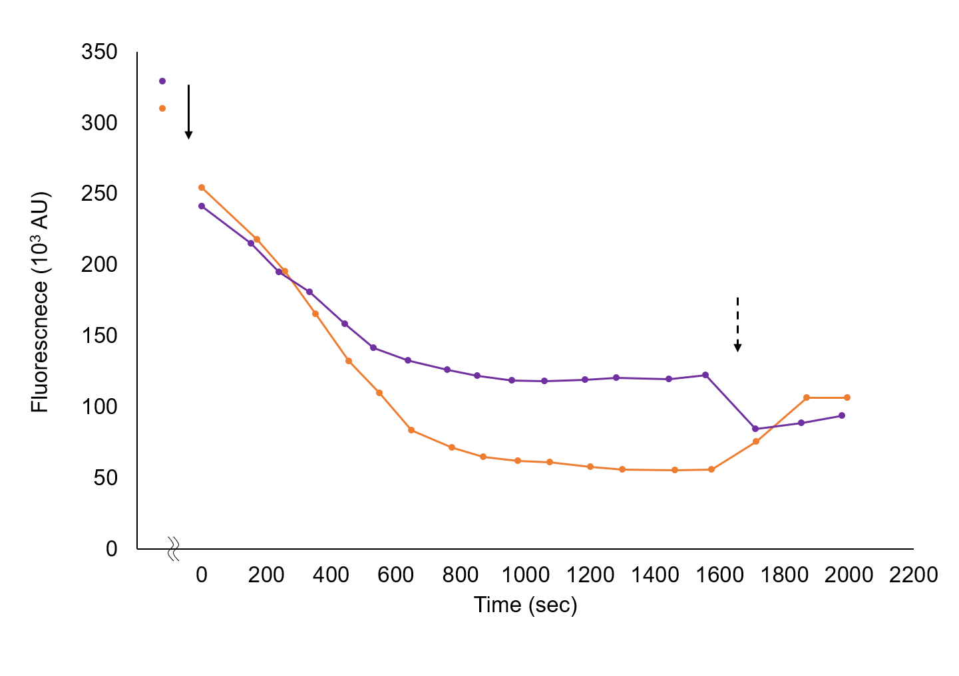
Supplementary Figure 9. Generation of membrane potential of Bacillus cells by size-fractionated supernatant of slr0688i.
Changes in membrane potential of Bacillus cells were monitored following addition of a 5× concentrated supernatant with MW > 3,000 of slr0688i (orange) and a 0.5× concentration of supernatant with MW < 3,000 of slr0688i (purple). Each sample was added at the time indicated by a bold arrow (t = 0 sec). At the time indicated by dotted arrows, 4 µM valinomycin was added to dissipate the membrane potential.

(a) (b)
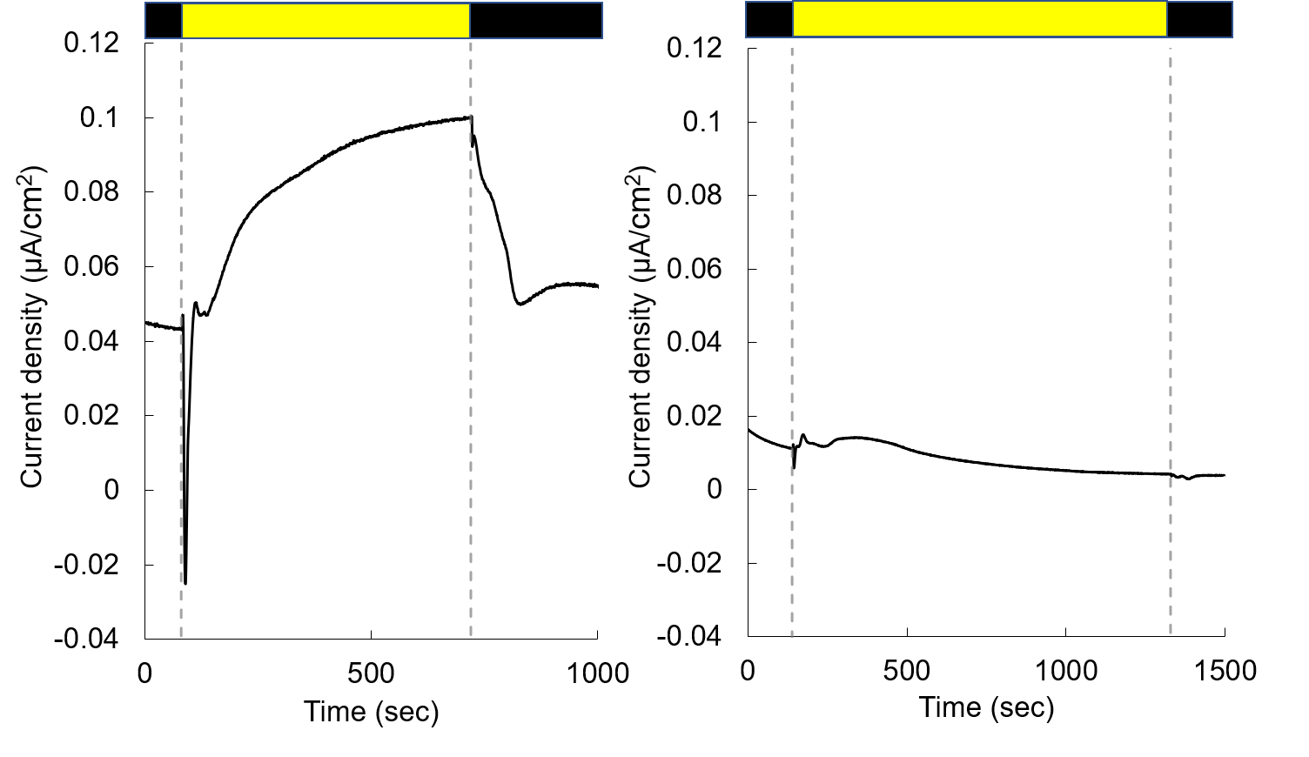
(c)
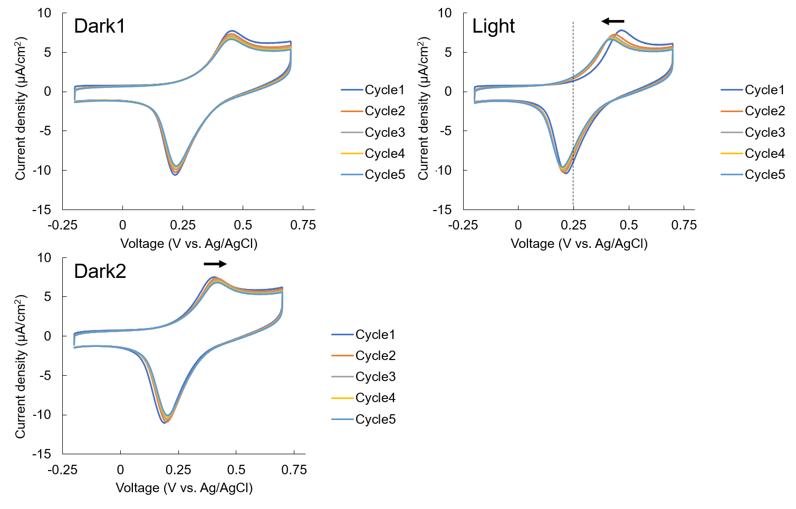

(d)
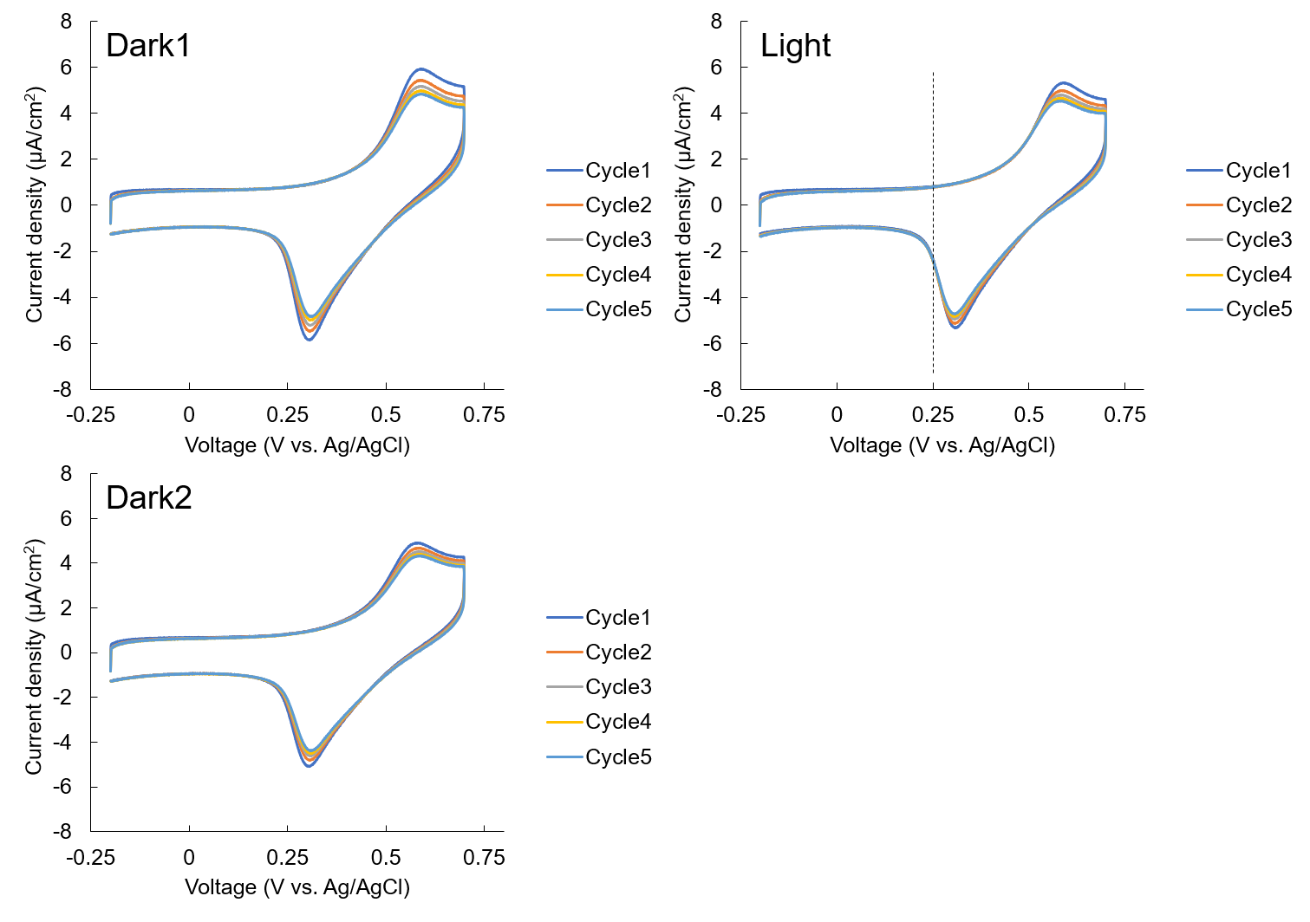
Supplementary Figure 10. The effect of pH of cell suspensions on pseudo-photocurrent generation.
Current generation from slr0688i was examined either (a, c) without adjusting pH (pH 8.6) or (b, d) after adjusting pH to 7.86 by addition of HCl. (a,c) The cell suspension with high pH (8.6) generated pseudo-photocurrent in the chronoamperogram at +0.25V vs Ag/AgCl due to an increase in pH under illumination, which is visualized in the cyclic voltammogram by shifts in the anodic peak potentials (indicated by black arrows in “Light” and “Dark2” conditions) attributed to manganese. (b,d) When pH of the cell suspension was adjusted to below 8, which is within buffering capacity of TES (pH 6.8~8.2), neither pseudo-photocurrent nor shifts in the anodic peak potentials were observed. The black and yellow rectangles in chronoamperograms a-b indicate dark and light (100 µmol photons m⁻² s⁻¹) conditions, respectively. The dotted black lines in cyclic voltammograms c-d indicate +0.25V vs Ag/AgCl.
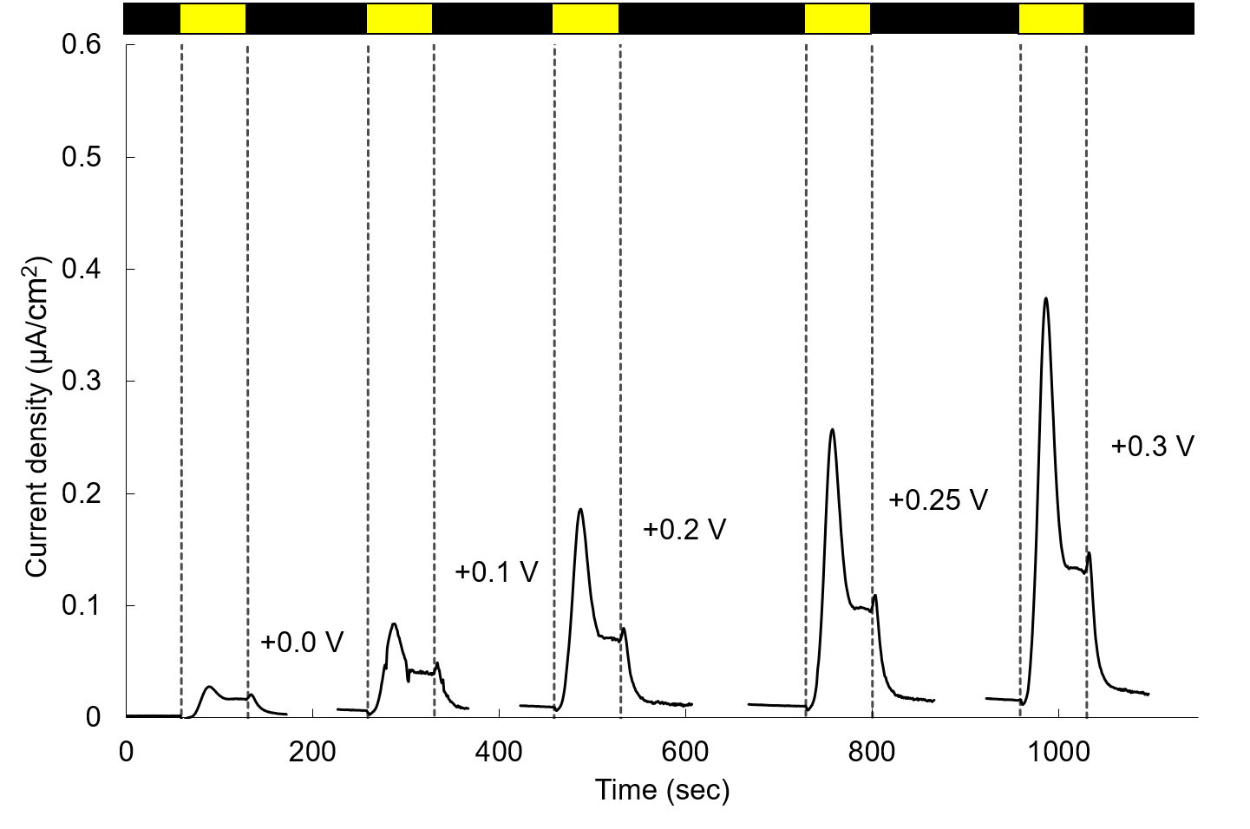
Supplementary Figure 11. Photocurrent generation from slr0688i at various voltages.
Slr0688i (OD730=2.7) was tested for its capacity to generate photocurrent at various voltages. The applied voltage was stepped from +0.0 V to +0.3 V vs Ag/AgCl. The black and yellow rectangles indicate dark and light (120 µmol photons m⁻² s⁻¹) conditions, respectively.

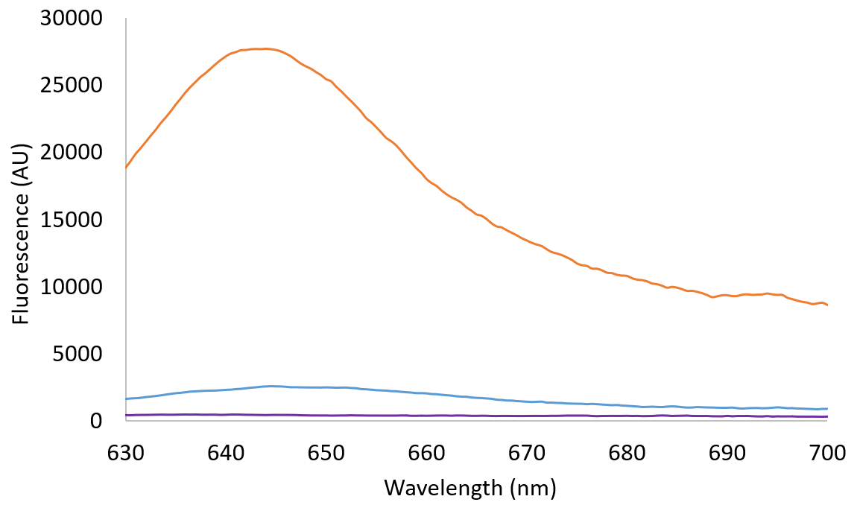 Supplementary Figure 12. Fluorescence spectra of 5× concentrated supernatants of slr0688i.
Shown are fluorescence spectra of non-treated (orange), O₂-purged (blue), and heat-treated (purple) 5× concentrated slr0688i supernatants.

