Supplemental Information

Characteristics of colon crypt stem cells in preserved epithelial cell clumps in dextran sulfate sodium-induced mouse model of ulcerative colitis.

Mio Kobayashi¹, Risako Yamashita¹, Ryo Ichikawa, ¹ Makoto Shibutani¹, Toshinori Yoshida¹

¹Laboratory of Veterinary Pathology, Laboratory of Veterinary Pathology, Tokyo University of Agriculture and Technology, 3-5-8 Saiwai-cho, Fuchu-shi, Tokyo 183-8509, Japan.

Address correspondence to: Toshinori Yoshida, D.V.M., Ph.D.
Laboratory of Veterinary Pathology, Tokyo University of Agriculture and Technology, 3-5-8 Saiwai-cho, Fuchu-shi, Tokyo 183-8509, Japan
Tel: +81-42-367-5874; Fax: +8142-367-5771; E-mail: yoshida7@cc.tuat.ac.jp

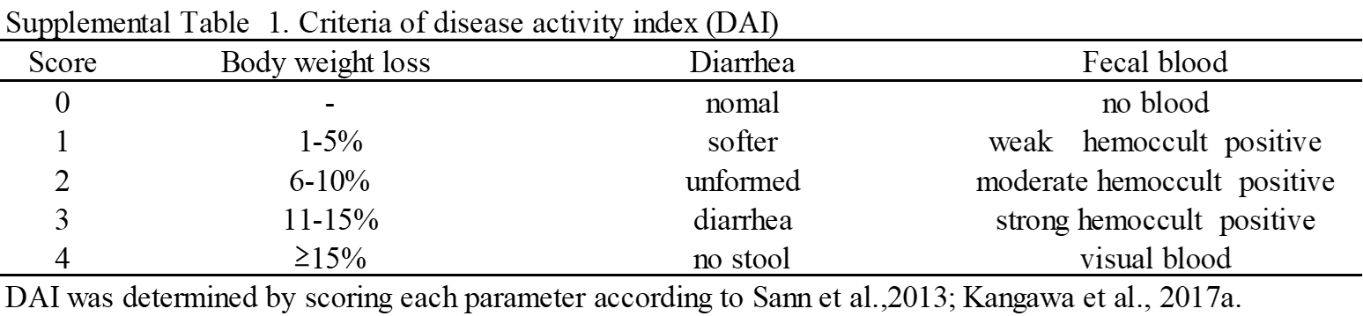

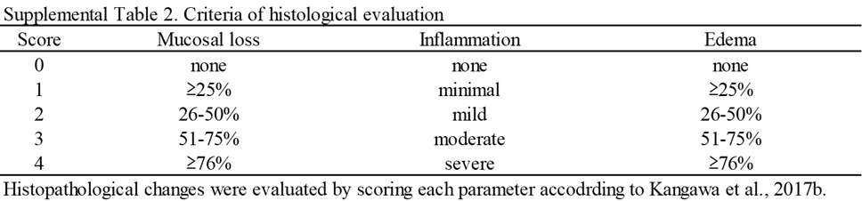

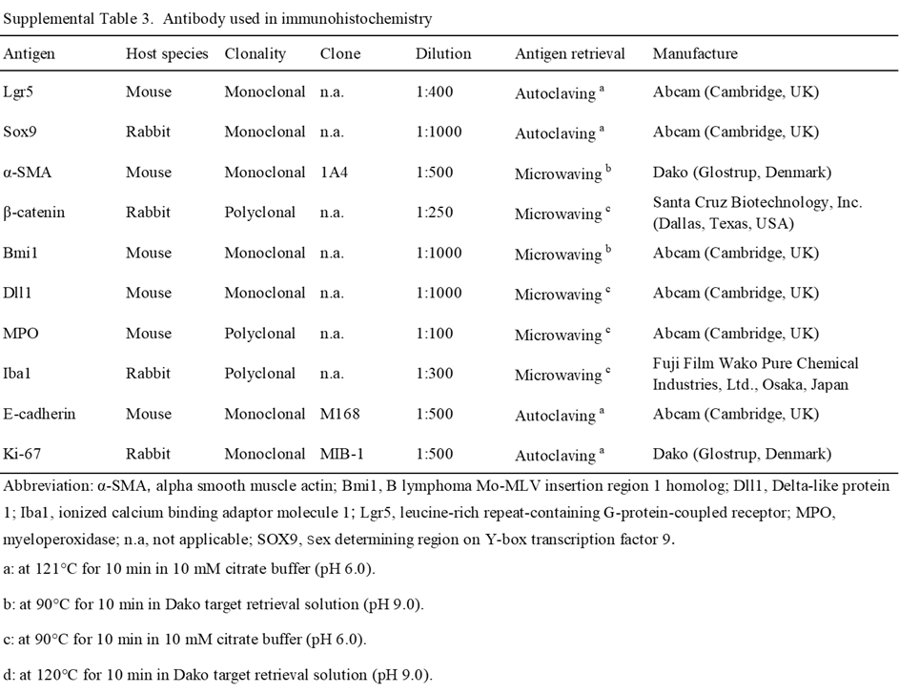

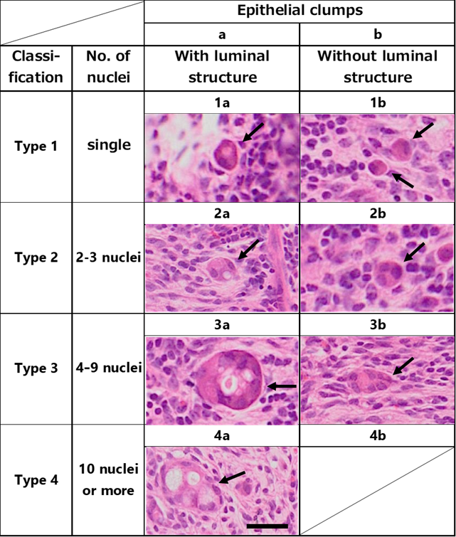
Supplemental Fig 1. Histopathological classification of epithelial clumps in the lamina propria in mice administered 5% DSS in drinking water for 6 days (Day 6), followed by withdrawal of DSS for 6 days (Day 12). Epithelial clumps are classified into types a and b, according to the presence of luminal structure: type a exhibits luminal structure, and type b lacks luminal structure. The clumps are also classified as types 1 to 4, according to the number of nuclei: type 1 has a single nucleus; type 1, two or three nuclei; type 3, 4 to 9 nuclei; and type 4, 10 or more nuclei. Combining types a and b and types 1 to 4, there are seven subtypes of epithelial clumps, as shown in the figure (arrows), except for type 4b. Bar=10 μm.

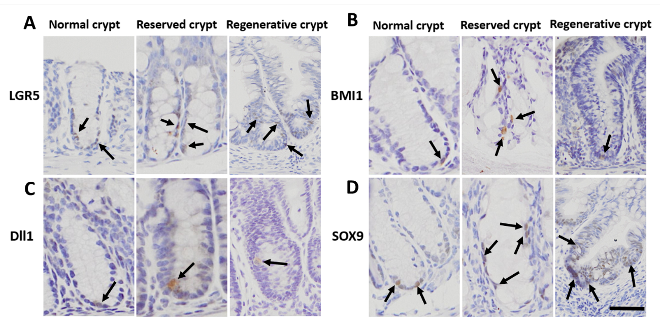
Supplemental Fig 2. Expression of stem cell and progenitor cell markers in colorectal crypts. Normal crypts were observed in the control mice; remaining crypts were observed in the mice administered 5% DSS in drinking water for 6 days; and regenerative crypts were observed in the mice administered 5% DSS in drinking water for 6 days, followed by withdrawal of DSS for 6 days. (A) LGR5. (B) BMI1. (C) DLL1. (D) SOX9. Arrows indicate positive signals for each marker. Bar=30 μm.

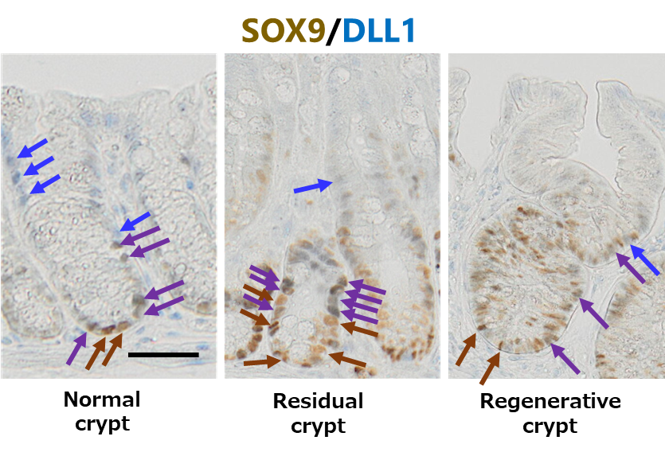

Supplemental Fig 3. Representative images of co-expression of SOX9 and DLL1 in the colorectal crypt. Normal crypts were observed in the control mice; remaining crypts were observed in the mice administered 5% DSS in drinking water for 6 days (Day 6); and regenerative crypts were observed in the mice that were administered 5% DSS in drinking water for 6 days, followed by withdrawal of DSS for 6 days (Day 12). SOX9 was visualized using HRP-DAB staining (brown arrows), and DLL1 was visualized using AP-vector blue (blue arrows). Purple arrows indicate double-positive signals for SOX9 and DLL1 Bar=30 μm.

