Supplementary Information

Atomic-scale tandem regulation of anionic and cationic migration for long-life alkali metal batteries

Pan Xiong^{1,2,6}, Fan Zhang^{2,6}, Xiuyun Zhang^{3,6}, Yifan Liu¹, Yunyan Wu¹, Shijian Wang², Javad Safaei², Bing Sun², Renzhi Ma⁴, Zongwen Liu⁵, Yoshio Bando⁴, Takayoshi Sasaki⁴, Xin Wang¹, Junwu Zhu^{1*}, Guoxiu Wang^{2*}

¹Key Laboratory for Soft Chemistry and Functional Materials of Ministry Education, Nanjing University of Science and Technology, Nanjing, 210094, China
²Centre for Clean Energy Technology, School of Mathematical and Physical Sciences, University of Technology Sydney, NSW 2007, Australia
³College of Physical Science and Technology, Yangzhou University, Yangzhou, 225002, China
⁴International Center for Materials Nanoarchitectonics (WPI-MANA), National Institute for Materials Science (NIMS), Namiki 1-1, Tsukuba, Ibaraki, 305-0044, Japan
⁵School of Chemical and Biomolecular Engineering, The University of Sydney, NSW 2006, Australia
⁶These authors contributed equally: Pan Xiong, Fan Zhang, Xiuyun Zhang
*e-mail: zhujw@njust.edu.cn; guoxiu.wang@uts.edu.au

Experimental section
Synthesis of stable suspensions of anionic nanosheets
Colloidal suspension of Ti_{0.87}O₂ nanosheets was prepared based on exfoliation of a layered titanate crystal^{1,2}. Typically, TiO₂, K₂CO₃, and Li₂CO₃ in a molar ratio of 1.73: 0.4: 0.14 were mixed and calcinated at a high temperature of 900 °C for 20 h. The obtained layered titanate crystal (K_{0.8}Ti_{1.73}Li_{0.27}O₄) was then stirred in a 0.5 M HCl solution at room temperature for 48 h. The acid-exchanged titanate crystal (H_{1.07}Ti_{1.73}O₄·H₂O) was collected by filtration, washed with a copious quantity of pure water, and air dried. Subsequently, the protonic crystal was treated by shaking in a tetrabutylammonium (TBA⁺) hydroxide aqueous solution. The concentration of TBA⁺ was 1:1 in molar ratio with respect to the exchanged protons in the protonic titanate crystals. After 3 days, a stable suspension of Ti_{0.87}O₂ nanosheets was obtained. For comparison, the suspension of anatase TiO₂ nanoparticles was prepared by dispersion of commercial anatase TiO₂ powder (25 nm, Sigma-Aldrich) in water/ethanol solution. The suspension of graphene oxide (GO) nanosheets was prepared from purified natural graphite by a modified Hummers’ method.
Fabrication of functional separators
The functional separators were prepared by vacuum filtration of stable suspensions on a commercial PP separator (Clegard 2400). Taking Ti_{0.87}O₂/PP functional separator as an example, an aqueous suspension of Ti_{0.87}O₂ nanosheets (0.05 mL, 4 mg mL⁻¹) and poly(tetrafluoroethylene) with a mass ratio of 95 : 5 were mixed in water/ethanol mixture (v/v = 4 : 1). After ultrasonication for 0.5 h, the as-prepared dispersion was vacuum filtered on the commercial PP separators and washed with water/ethanol mixture. The obtained Ti_{0.87}O₂/PP separators were dried in vacuum at room temperature and then irradiated with UV-light for 2h before embedded in electrochemical cells. The weight density of the Ti_{0.87}O₂ nanosheets in the Ti_{0.87}O₂/PP separator was estimated to be ~0.016 mg cm⁻². By controlling the volume of the nanosheet suspensions used in the vacuum filtration process, the weight density of the Ti_{0.87}O₂ nanosheets in the Ti_{0.87}O₂/PP separator was controlled correspondingly. For comparison, the other functional separators (anatase TiO₂/PP and GO/PP) with the same weight density were prepared according to the same method.
Characterization
XRD data were collected at ambient temperature on a Bruker D8 Advanced diffractometer at 40 kV, 40 mA for Cu-Kα (λ = 1.5418 Å). The morphologies were studied by a field-emission scanning electron microscope (FE-SEM, Zeiss Supra 55VP) and a JEOL JEM-ARM200F TEM instrument. The zeta-potentials of nanosheet suspensions were determined using an ELS-Z zeta-potential analyzer. AFM measurements were performed on a Dimension 3100 SPM instrument to examine the topography of the nanosheets deposited onto Si wafer substrates. Force curves of the separators are obtained in the force spectroscopy mode using an sQube SiO₂ colloidal probe at a tip velocity of 500 nm s⁻¹ and a trigger point of 0.5 V. Contact angle measurements were conducted by using a KRUSS DSA100 machine. The X-ray absorption near-edge spectroscopy (XANES) and extended X-ray absorption fine structure (EXAFS) at Ti K-edge were recorded in transition mode at beamline Spring-8 at the Japan Synchrotron Radiation Research Institute (JASRI). Commercial rutile TiO₂ (Sigma-Aldrich) were used as reference sample. For the ex situ Raman tests, the Li-S coin cells were disassembled in an argon-filled glove box. The collected separators were washed in 2 ml DMC, left to dry for 2–3 h, sandwiched between two glass objective slides and sealed with epoxy resin. A Raman microscope (Labram Aramis, Japan) with a He-Ne laser (532 nm) was used to investigate the side of separators facing the lithium anode.
Electrochemical measurements
Electrochemical testing of Li-S, Li-Se and Na-Se batteries: Carbon black and carbon nanotube (CNT) were used as host materials for the synthesis of S and Se cathodes. The commercial carbon black powders and sublimed sulfur (w/w = 3: 7) were mixed and sealed in a glass bottle. After heating at 155 °C for 6 h, the carbon black/S composite was obtained. The commercial CNT powders and sublimed sulfur (w/w = 1: 4) were mixed and sealed in a glass bottle. After heating at 155 °C for 6 h, the CNT/S composite was obtained. The commercial carbon black powders and selenium (w/w = 1: 3) was mixed. After heating at 260 °C for 12 h under N₂ atmosphere in a tube furnace, the carbon black/Se composite was obtained. To prepare the S or Se cathodes, the above S or Se composites, carbon black powders, and poly(vinylidene difluoride) (PVDF) binder were mixed with a mass ratio of 80: 15: 5 in N-methyl-2-pyrrolidinone (NMP). Then the mixture slurry was coated on aluminum foil and dried at 60 °C under vacuum. The mass loading of sulfur was controlled to be ~1.5 mg cm⁻² for regular tests and ~3.5, 6.1 and 8.9 mg cm⁻² for the high-sulfur-loading tests. Coin type (CR2032) batteries were fabricated in an argon-filled glovebox using S/Se composite cathodes, metallic Li/Na anodes and functional separators. For the Li-S and Li-Se batteries, the electrolyte was 1 M bis(tri-fluoromethane) sulfonimide lithium (LiTFSI) in a mixed solvent of 1,2-dimethoxyethane (DME) and 1,3-dioxacyclopentane (DOL) (1:1, v/v) with LiNO₃ (1 wt%). For the Na-Se batteries, the electrolyte was 1 M sodium perchlorate (NaClO₄) in ethylene carbonate (EC) and diethyl carbonate (DEC) (1/1, v/v) with 2 % fluoroethylene carbonate (FEC). The CV and electrochemical impedance spectroscopy tests were carried out using a VMP3 electrochemical workstation (Bio-Logic Inc.). The galvanostatic discharge/charge profiles of the batteries were recorded using a LAND CT2001A battery test station.
Electrochemical testing of lithium plating/stripping: To investigate the stripping and plating of Li anode, the symmetric Li//Li and asymmetric Li//Cu cells were assembled using different separators. The electrolyte was the 1 M LiTFSI in a mixture of DOL and DME (1:1, v/v) containing 1 wt% LiNO₃.
Electrochemical testing of sodium plating/stripping: Two-electrode coin cells (CR2032) were assembled in an argon-filled glove box with water and oxygen levels less than 0.1 ppm for electrochemical testing. An electrolyte of 1 M sodium triflate in diglyme was prepared in an argon-filled glove box. The water level of the final electrolyte solution was less than 25 ppm determined by a Mettler Toledo C20 Karl Fischer Titrator. The Na plating/stripping study was conducted on Neware^{(TM)} battery testers at room temperature. For the Coulombic efficiency testing, in each galvanostatic cycle, Na was deposited on different current collectors at the desired current density and capacity, and stripped away by charging to a cut-off voltage of 0.5 V vs. Na⁺/Na.
Polysulfide permeation measurements
The 0.05 M polysulfide (Li₂S₆) solution was prepared by dissolving sublimed sulfur and Li₂S powder (mole ratio = 5: 1) into a mixed solvent of 1,2-dimethoxyethane (DME) and 1,3-dioxacyclopentane (DOL) (1:1, v/v), followed by magnetic stirring at 50 °C for 12 h. Then, the as-prepared Li₂S₆ solution was filled in one side of the U-shaped glass bottles. The other chamber was filled with DME/DOL solvent without Li₂S₆. These two chambers were separated by the pristine PP separator and the functional separators with the same mass loading.
Li-ion transference number
The lithium-ion transference numbers for PP, anatase TiO₂/PP, GO/PP, and Ti_{0.87}O₂/PP separators were determined with chronoamperometry at a constant step potential of 10 mV. Each separator was separately sandwiched between two lithium metal electrodes in a coin type cell (CR 2032). The lithium ion transference number (t_{Li+}) was calculated from the ratio of steady state current (I_{s}) to initial state current (I_{o}) according to the following equation:
$t_{Li+}=\frac{I_{s}}{I_{0}}$ (1)
Ionic conductivity
The ionic conductivities of PP, anatase TiO₂/PP, GO/PP, and Ti_{0.87}O₂/PP separators were calculated from electrochemical impedance spectroscopy (EIS). The separator saturated with electrolyte was sandwiched between two stainless steel electrodes in coin type cells (CR 2032), and its ionic conductivity was calculated according to the following equation:
$σ=\frac{l}{R_{b}A}$ (2)
where σ stood for ionic conductivity, l represented the thickness of the membrane, A was the area of the stainless steel electrode, and R_{b} referred to the bulk resistance.
Young’s modulus
The Young's Modulus of the Ti_{0.87}O₂/PP separators is extracted from the force profiles using a Hertzian model. For paraboloidal indenters, the force-indentation relation is given by
$F=\frac{4E\sqrt{R}}{3\left(1-v^{2}\right)}δ^{3/2}$ (3)
where F is the applied load, E is the Young's Modulus, R the tip radius of curvature, δ the indentation depth, and υ the Poisson's ratio. By making this substitution, Eq. (3) can be rearranged to fit a linear model of force^{2/3} vs. indentation depth;
$F^{2/3}={\left[\frac{4E√R}{3\left(1-v^{2}\right)}\right]}^{2/3}δ$ (4)
The Young's Modulus is therefore extracted from the slope of the linear regime of a force^{2/3} vs. indentation plot given by Eq. (4)³. The probe diameter is 5 µm. The Poisson's ratio of the Ti_{0.87}O₂ is υ=0.31 ^{ref. 4}.
DFT calculations
All the calculations were performed using the framework of spin polarized DFT as implemented in the Vienna Ab initio Simulation Package (VASP)⁵. The exchange correlation potentials were treated by the generalized gradient approximation (GGA)⁶ parameterized by Perdew, Burke and Ernzerhof (PBE)⁷. The interaction between valence electrons and ion cores was described by the projected augmented wave (PAW) method⁸, and the DFT-D2 method considering van der Waals (vdW) interaction was adopted for the adsorption system. The climbing image nudged elastic band (CI-NEB) method implemented in VASP transition state tools is used to determine the metal cationic minimum energy diffusion pathways and the corresponding energy barriers⁹. In this step, the algorithm to relax the ions into their energy minimization transition state is required in agreement with the previous calculation of initial and final state. The electronic wave functions were expanded in a plane-wave basis with a cutoff energy of 400 eV. We adopt completely same k-mesh density and convergence accuracy as ion relaxation both in the geometry optimization calculations and transition state calculations. The Brillouin zone (BZ) is sampled with a 3 × 1 × 3 Monkhorst–Pack scheme k-point mesh¹⁰. The convergence criterion for energy and force was set at 1.0 × 10⁻⁴ eV/atom and 0.01eV/Å, respectively¹⁰. The vacuum space of 20 Å was set to avoid unexpected interactions between atoms in different cells.
Simulations of Li ion transportation
Li ion transport processes in two thin layers of restacked nanosheets were simulated in COMSOL¹¹. The thin layer with a thickness of 80 nm was composed of restacked conventional nanosheets and defective nanosheets. The thickness of a single nanosheet was set as 1 nm. Although most of the Ti vacancies are single vacancies of ~0.2 nm, there are some cluster-like continuous vacancies with larger sizes¹². For the sake of simplification, the size of the defects on defective nanosheets was set as 0.5 nm. The gap and distance of two adjacent nanosheets was set as 5 and 10 nm, respectively. The thin layers were confined in an electrolyte-filled region as a closed system. Time dependent form of the Nernst–Planck equation was employed to describe the transport process and snapshots of concentration profiles in the two models were taken after a fixed electrochemical reaction time elapsed in the simulation. The electrolyte was set with an initial concentration of 1 M, conductivity of 1x10⁻⁴ S m⁻¹, and Li-ion diffusion coefficient of 1x10⁻⁹ m² s^{−1 ref. 13}. Diffusion inside the nanosheets was not considered for simplicity.
Molecular dynamic simulation
The model of the Ti_{0.87}O₂ phase was build using Virtual Molecular Dynamic (VMD) software. A single Ti vacancy was configured in the Ti_{0.87}O₂ slab according to the chemical formula. The bond and angle parameters for S₆ intermolecular interactions were selected based on previous studies^{14,15}. The Lennard-Jones non-bonded parameters were selected based on previous reports¹⁶. The electric field was applied in the Y direction to propel Li⁺ and S₆²⁻. The molecular dynamic simulation was performed via Nanoscale Molecular Dynamics (NAMD) in periodic boundary conditions via the NVT ensemble, and the simulation was visualized using VMD software.

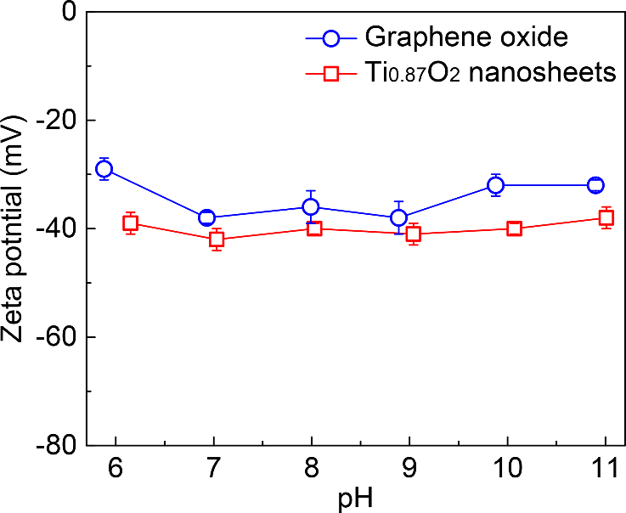
Figure S1. Zeta-potentials of the suspensions of graphene oxide and Ti_{0.87}O₂ nanosheets.

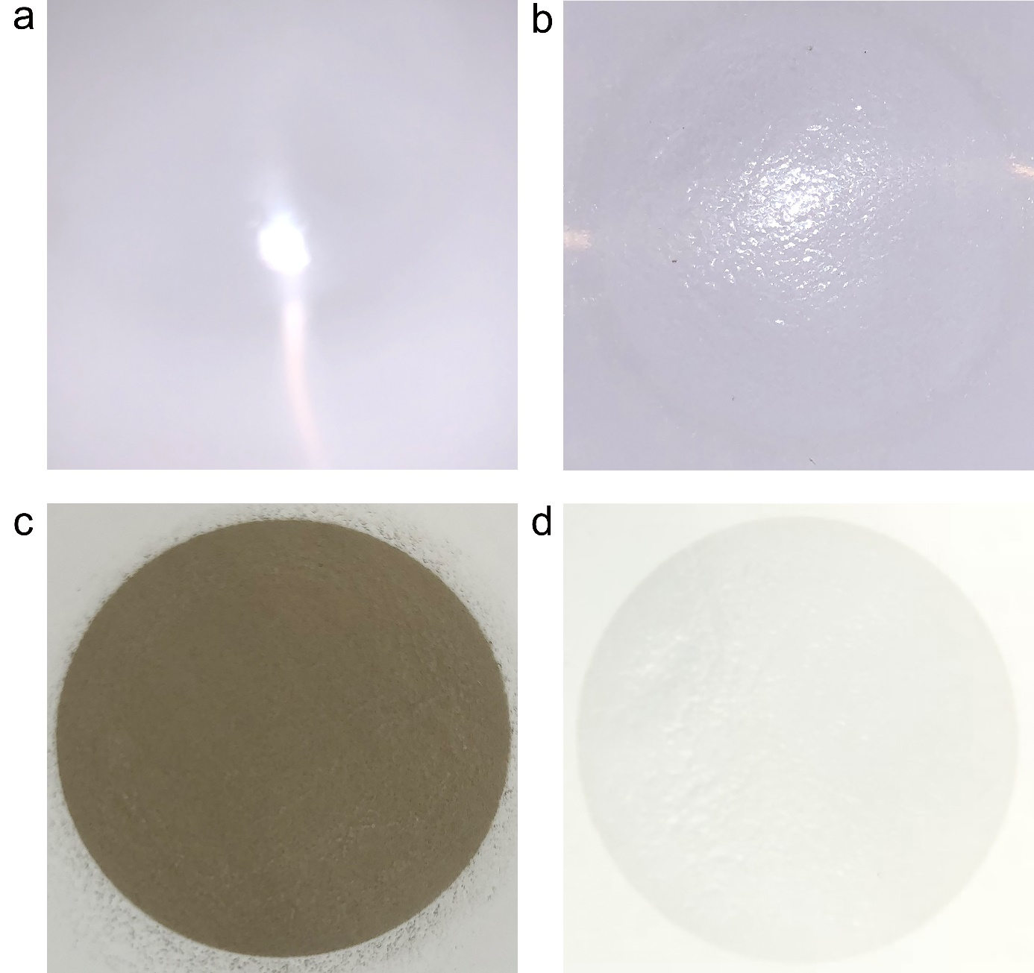
Figure S2. Photographs of the (a) PP, (b) anatase TiO₂/PP, (c) GO/PP, and (d) Ti_{0.87}O₂/PP separators.

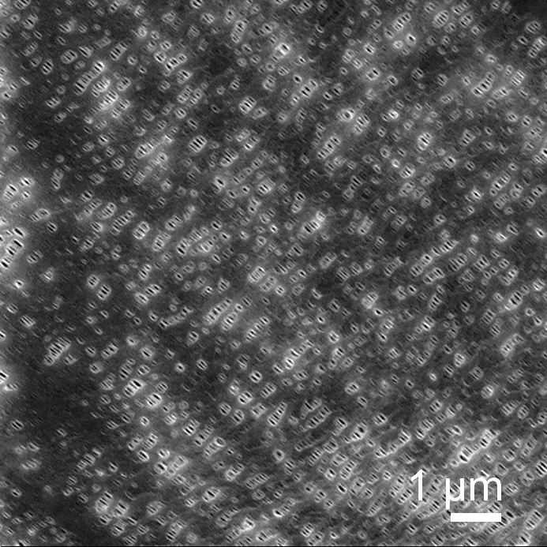
Figure S3. SEM image of the commercial PP separators.

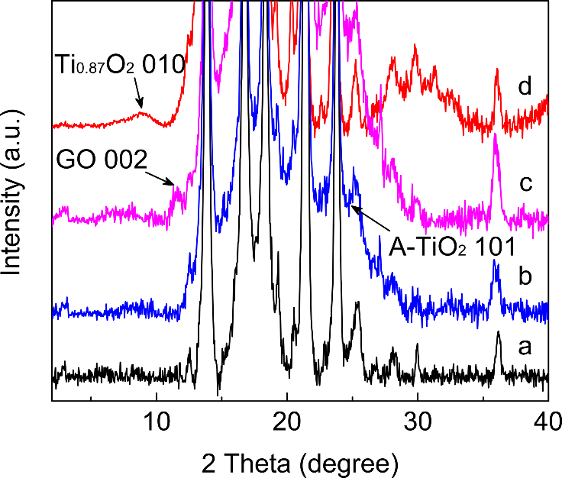
Figure S4. XRD patterns of (a) PP, (b) anatase TiO₂/PP, (c) GO/PP, and (d) Ti_{0.87}O₂/PP separators. The 101 diffraction peak of anatase TiO₂ (A-TiO₂), 002 diffraction peak of GO and 010 diffraction peak of Ti_{0.87}O₂ were marked.

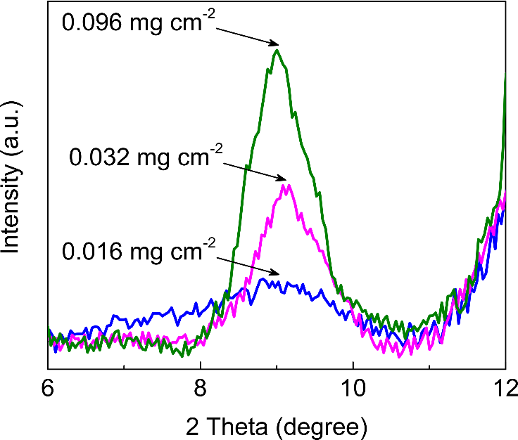
Figure S5. XRD patterns of Ti_{0.87}O₂/PP separators with different weight densities.

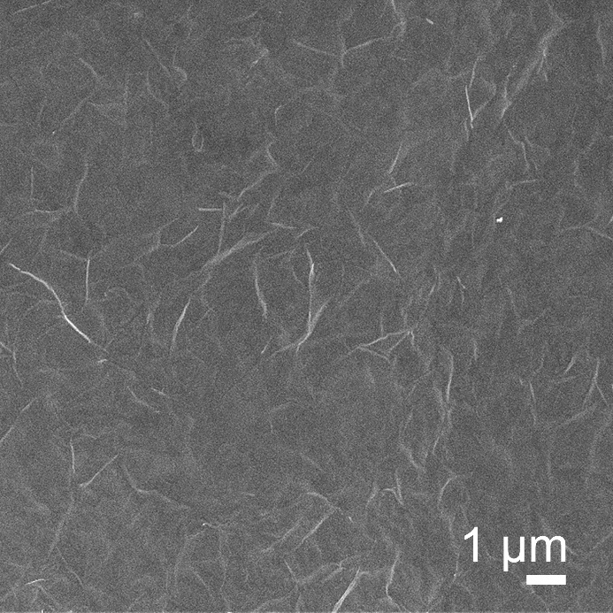
Figure S6. SEM image of Ti_{0.87}O₂/PP separators with a weight density of 0.032 mg cm⁻².

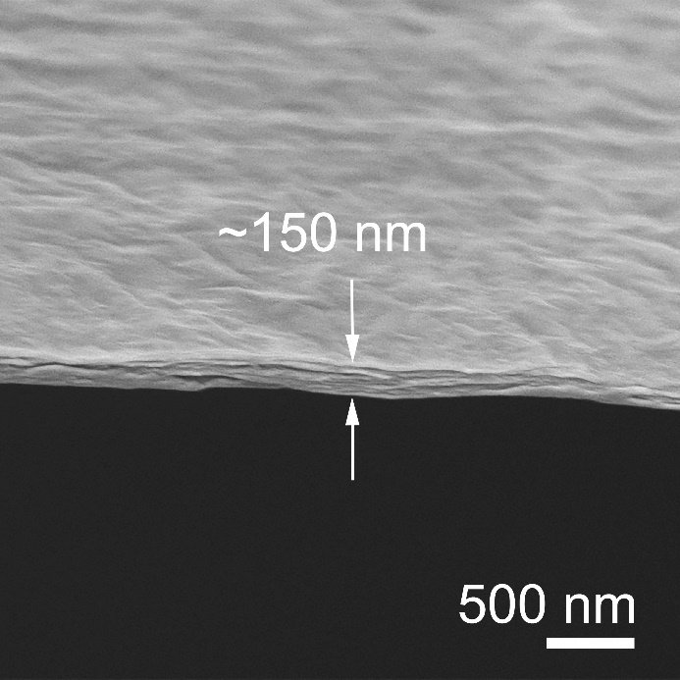
Figure S7. Cross-section SEM image of Ti_{0.87}O₂/PP separators with a weight density of 0.032 mg cm⁻².

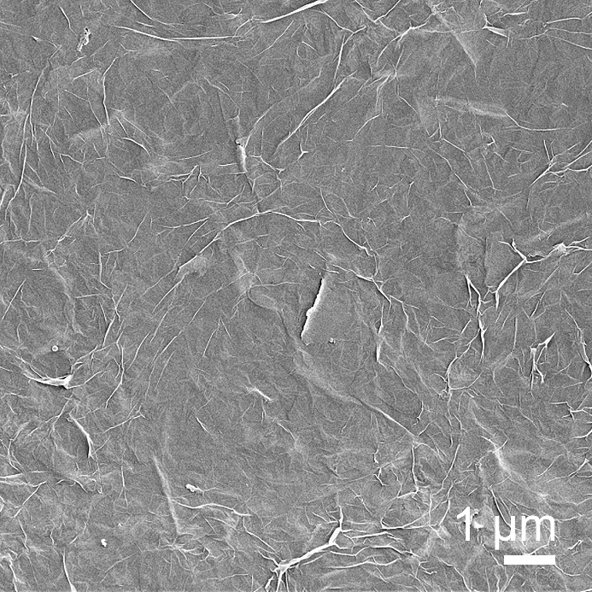
Figure S8. SEM image of Ti_{0.87}O₂/PP separators with a weight density of 0.096 mg cm⁻².

Figure S9. Cross-section SEM image of Ti_{0.87}O₂/PP separators with a weight density of 0.096 mg cm⁻².

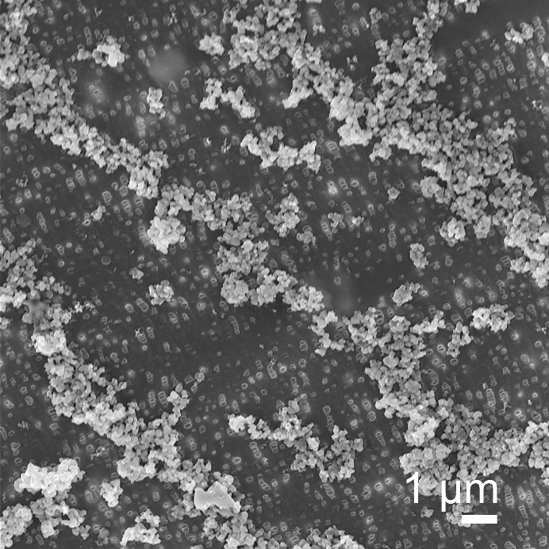
Figure S10. SEM image of anatase TiO₂/PP separators with a weight density of 0.016 mg cm⁻².

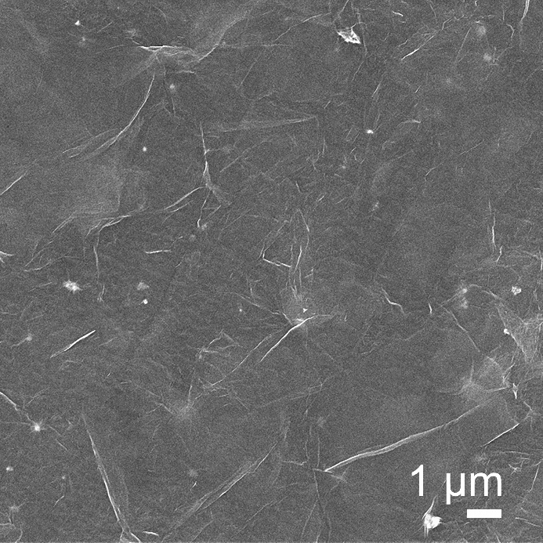
Figure S11. SEM image of GO/PP separators with a weight density of 0.016 mg cm⁻².

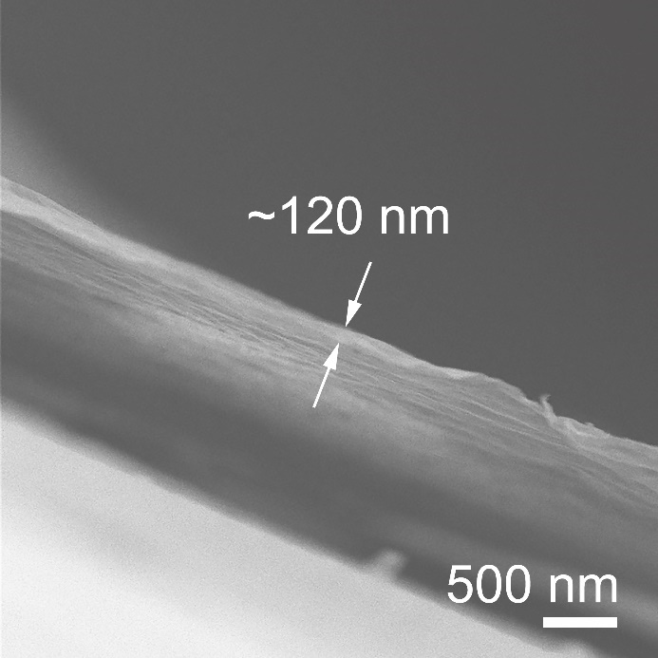
Figure S12. Cross-section SEM image of GO/PP separators with a weight density of 0.016 mg cm⁻².

Figure S13. 2D weight density of Ti_{0.87}O₂ and GO monolayers. (a) In-plane structure of Ti_{0.87}O₂ with a rectangular unit cell: a = 0.38 nm and c = 0.30 nm. (b) In-plane structure of graphene with a hexagonal unit cell: a = 0.25 nm. The ideal graphene structure was used to estimate the 2D weight density of GO. For an approximate calculation, the single layers of Ti_{0.87}O₂ and graphene were assumed to neatly deposit on the PP separator without gap. The 2D weight density of Ti_{0.87}O₂ single layer can be calculated based on the in-plane unit cell area, W_{(Ti0.87O2)} = 2 M_{(Ti0.87O2)} / (a × c × N_{A}). The 2D weight density of GO single layer can be calculated based on the in-plane unit cell area, W_{(GO)} = 2 M_{(C)} / (a × a × sin120°× N_{A}). N_{A} is the Avogadro’s number, M_{(Ti0.87O2)} and M_{(C)} are the formula weights of Ti_{0.87}O₂ and carbon. Under a same weight density, W_{(GO)} × n_{(GO)} = W_{(Ti0.87O2)} × n_{(Ti0.87O2)}. n_{(GO)} and n_{(Ti0.87O2)} are the number of single layers of GO and Ti_{0.87}O₂, respectively. So, the n_{(GO)} / n_{(Ti0.87O2)} = ~2.9. Considering the crystallinity thickness of GO and Ti_{0.87}O₂ is 0.75 and 0.34 nm, respectively. The thickness (h) of the functional layer of GO and Ti_{0.87}O₂ with the same weight density is h_{(GO)} / h_{(Ti0.87O2)} = ~1.36.

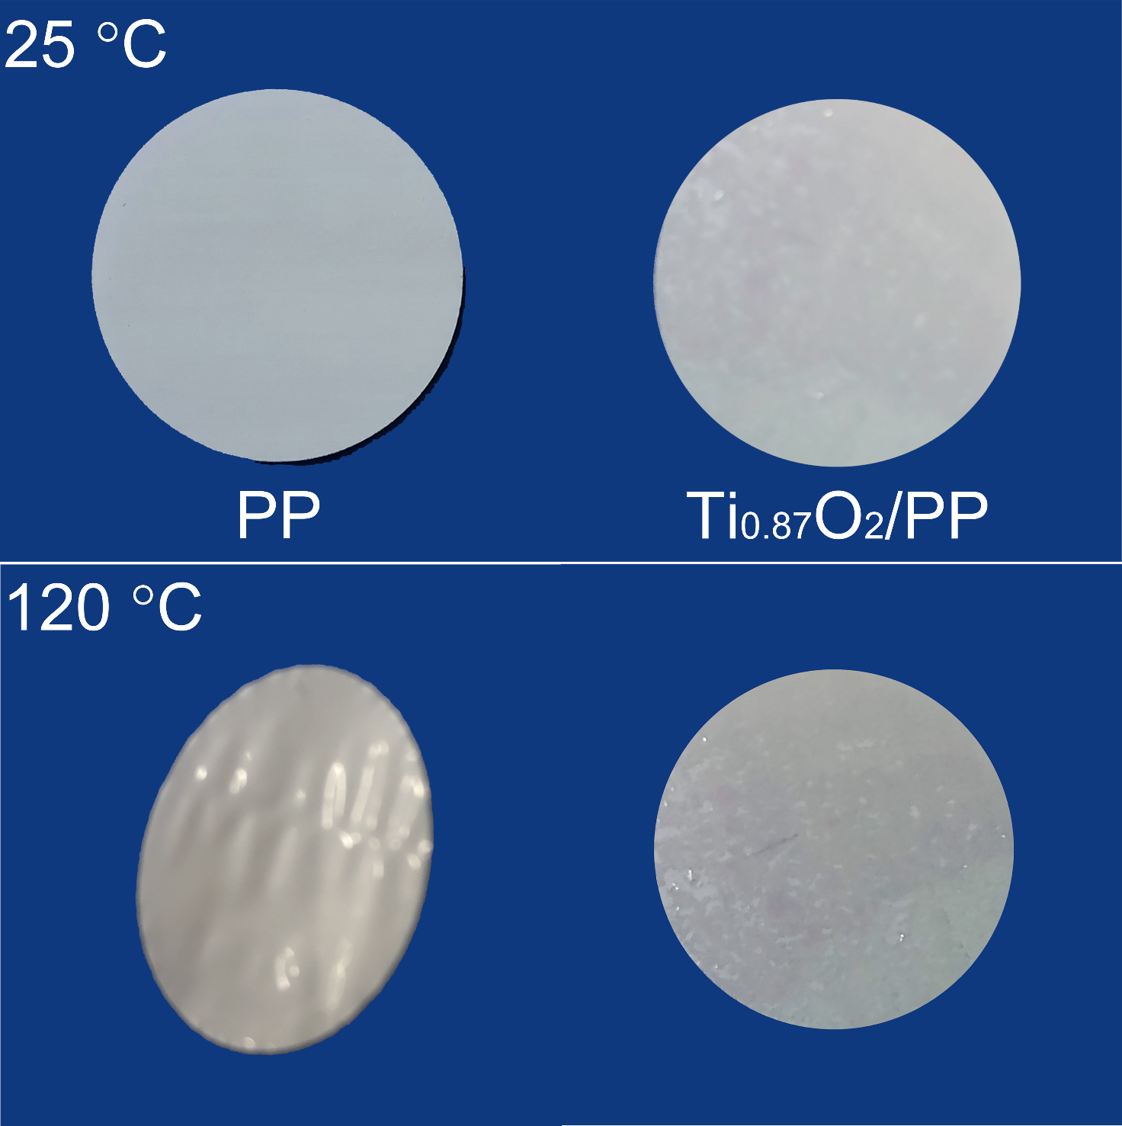
Figure S14. Thermal stability measurements of the PP and Ti_{0.87}O₂/PP separators.

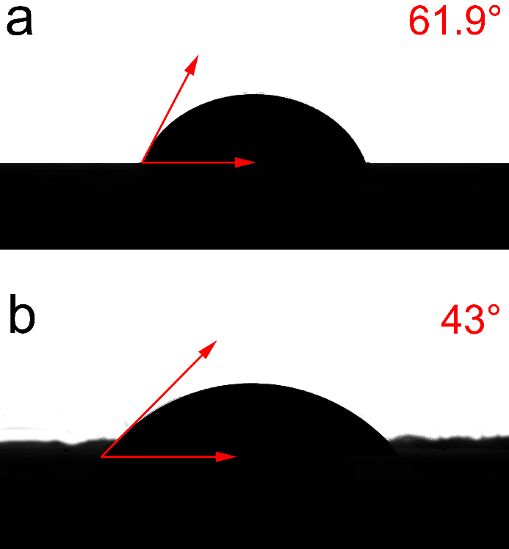
Figure S15. Contact angle measurements for electrolytes on (a) PP and (b) Ti_{0.87}O₂/PP separators.

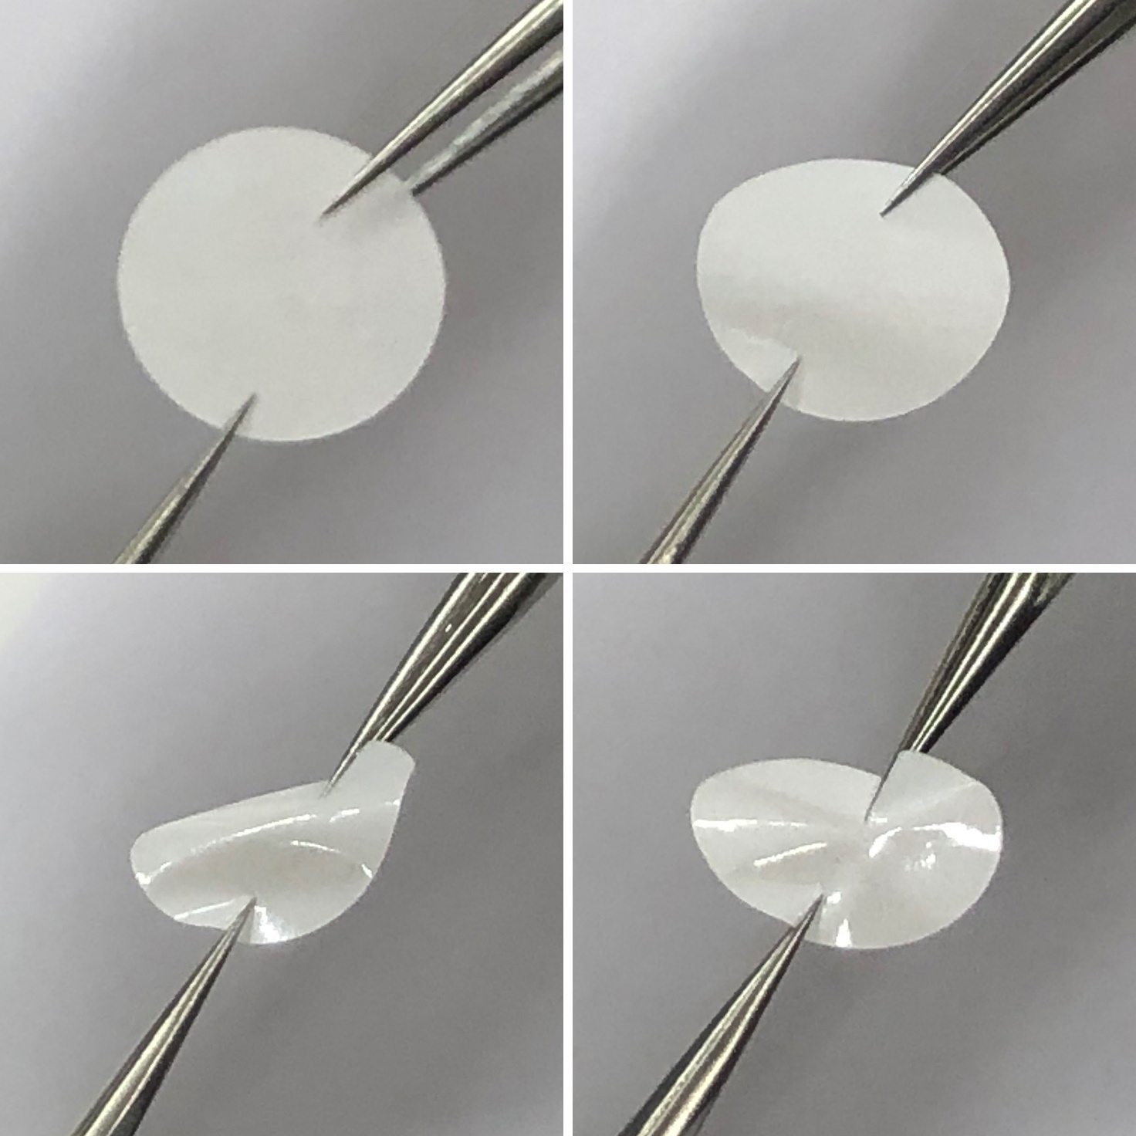
Figure S16. Digital photos of the Ti_{0.87}O₂/PP separator under different bending conditions.

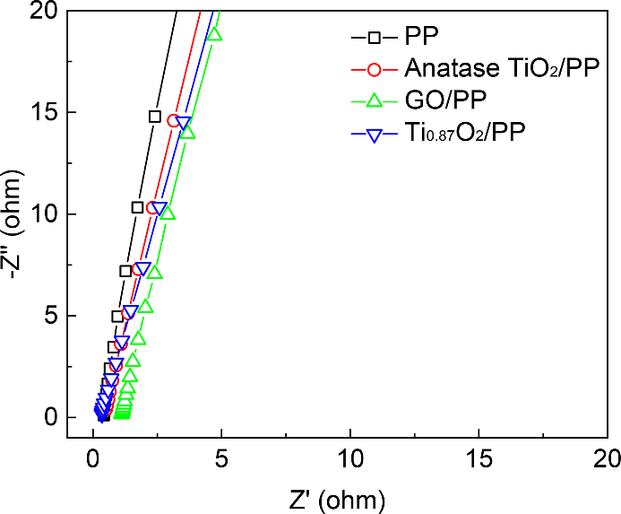
Figure S17. Nyquist plots of PP, anatase TiO₂/PP, GO/PP and Ti_{0.87}O₂/PP separators estimating the lithium ion conductivity.

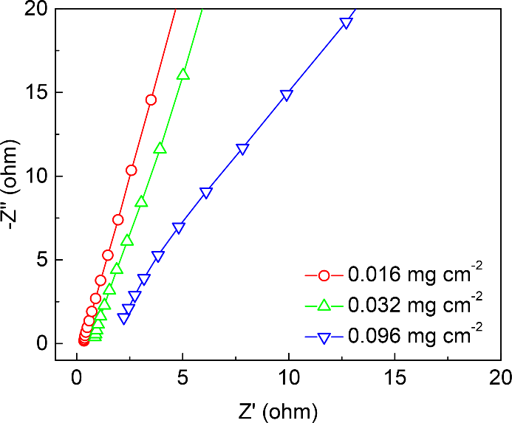
Figure S18. Nyquist plots of Ti_{0.87}O₂/PP separators with different weight densities.

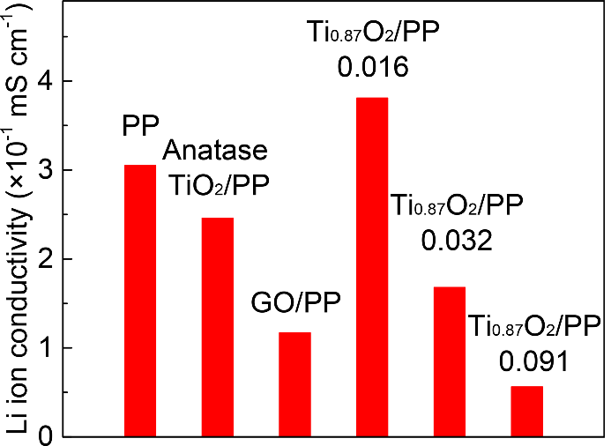
Figure S19. Li ion conductivity of PP, anatase TiO₂/PP, GO/PP and Ti_{0.87}O₂/PP separators with different weight densities.

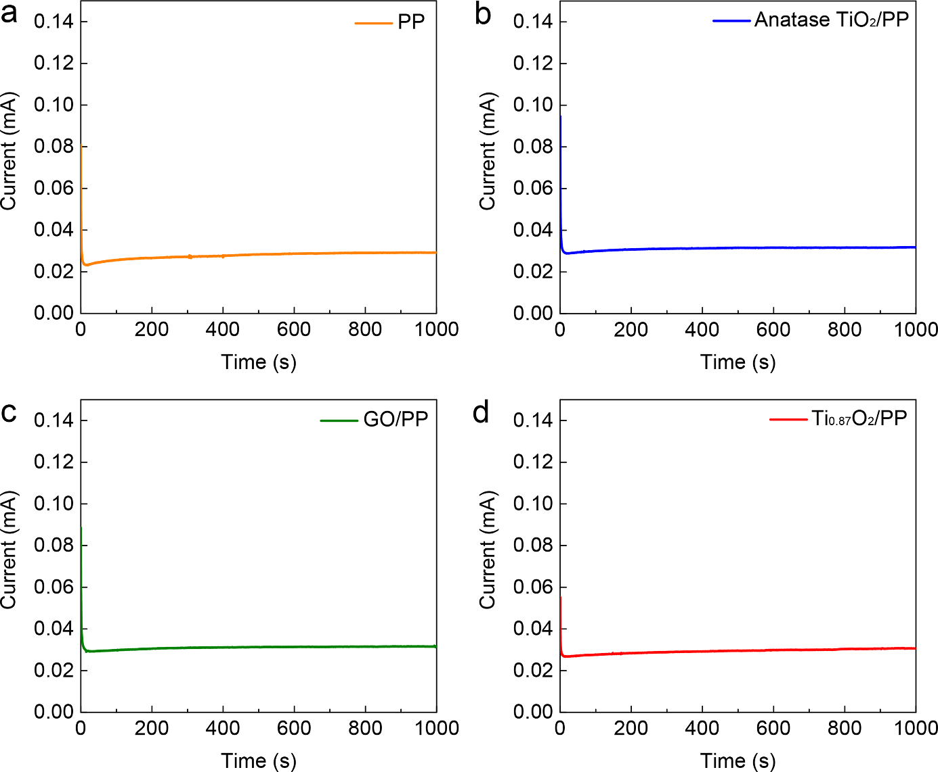
Figure S20. Li ion transference number measurements of PP, anatase TiO₂/PP, GO/PP and Ti_{0.87}O₂/PP separators.

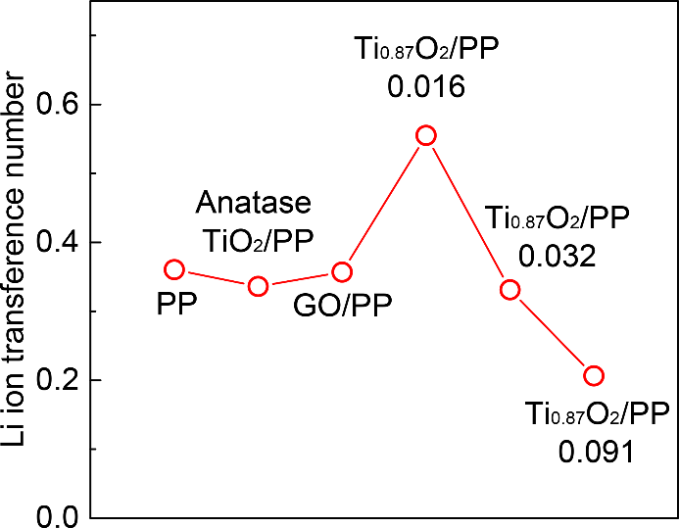
Figure S21. Li ion transference number of PP, anatase TiO₂/PP, GO/PP and Ti_{0.87}O₂/PP separators with different weight densities.

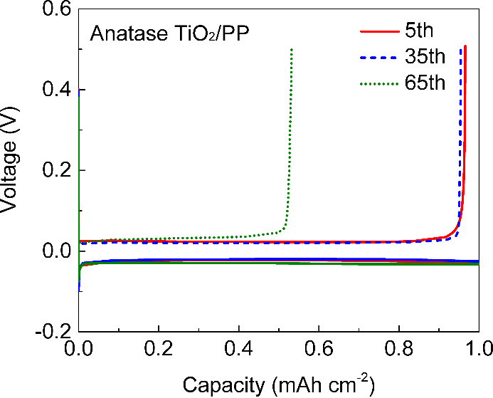
Figure S22. Voltage profiles of Li plating/stripping processes in Li||Cu cells with anatase TiO₂/PP separators with an areal capacity of 1 mAh cm⁻² at 1 mA cm⁻².

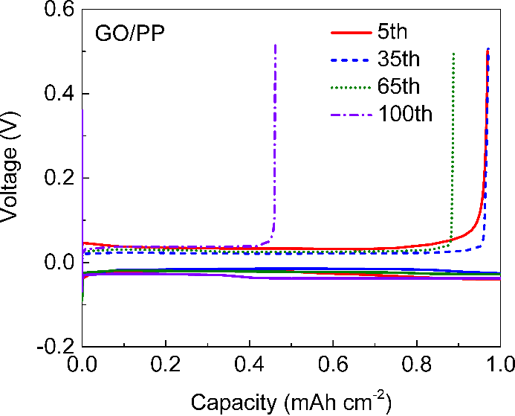
Figure S23. Voltage profiles of Li plating/stripping processes in Li||Cu cells with GO/PP separators with an areal capacity of 1 mAh cm⁻² at 1 mA cm⁻².

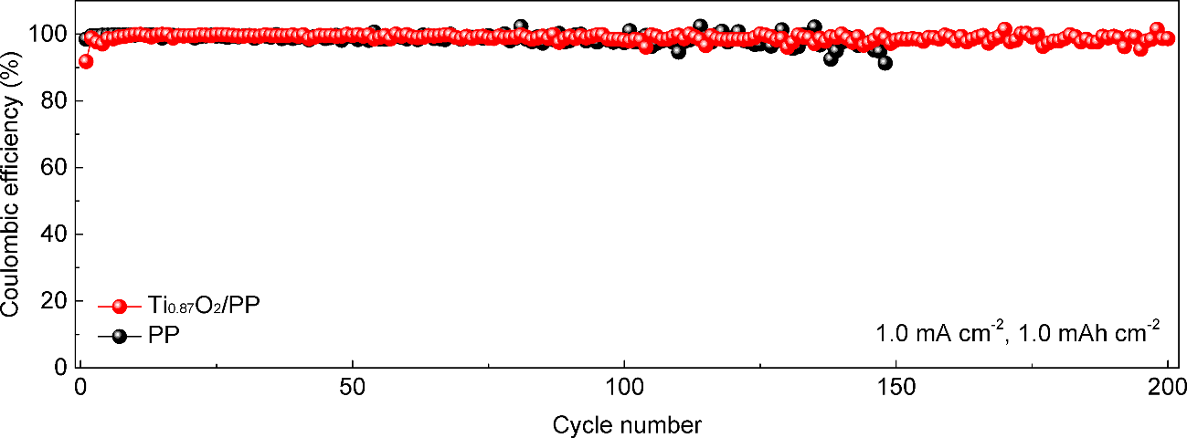
Figure S24. Coulombic efficiencies of Na||Cu cells with PP and Ti_{0.87}O₂/PP separators with an area capacity of 1 mAh cm⁻² at 1 mA cm⁻².

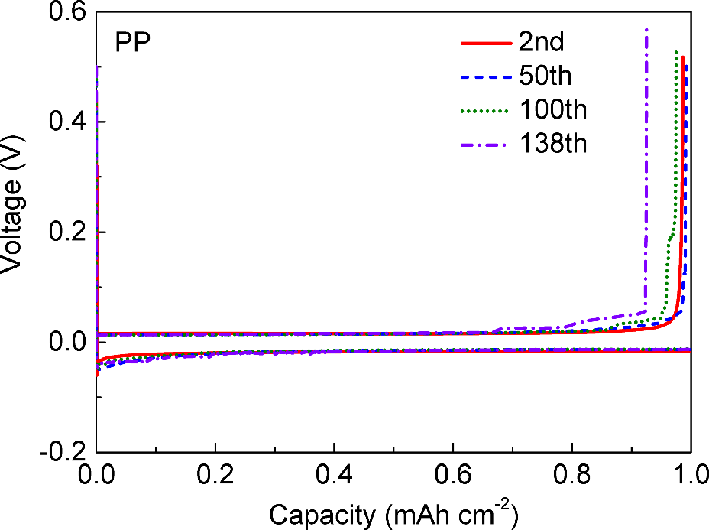
Figure S25. Voltage profiles of Na plating/stripping processes in Na||Cu cells with PP separators with an areal capacity of 1 mAh cm⁻² at 1 mA cm⁻².

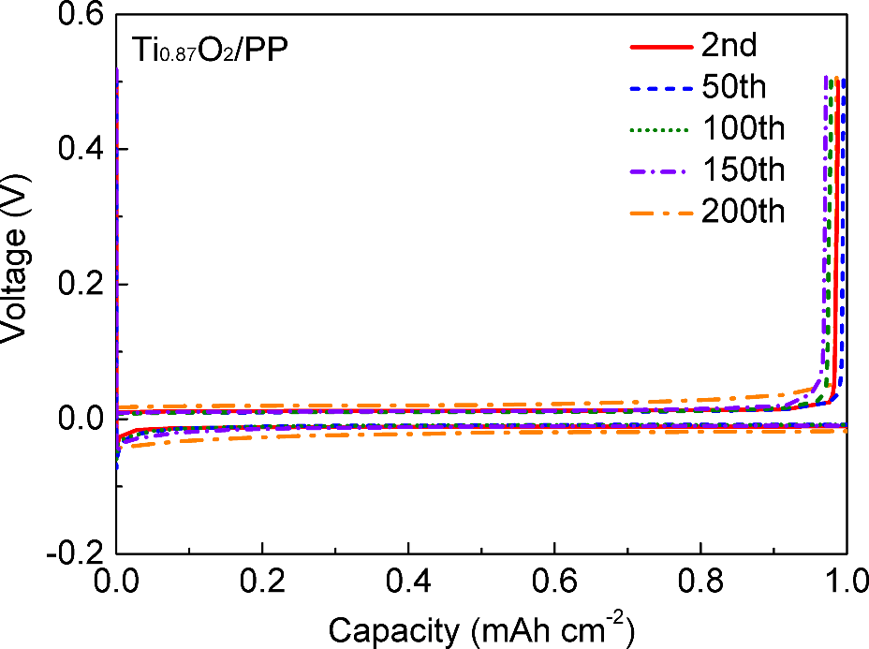
Figure S26. Voltage profiles of Na plating/stripping processes in Na||Cu cells with Ti_{0.87}O₂/PP separators with an areal capacity of 1 mAh cm⁻² at 1 mA cm⁻².

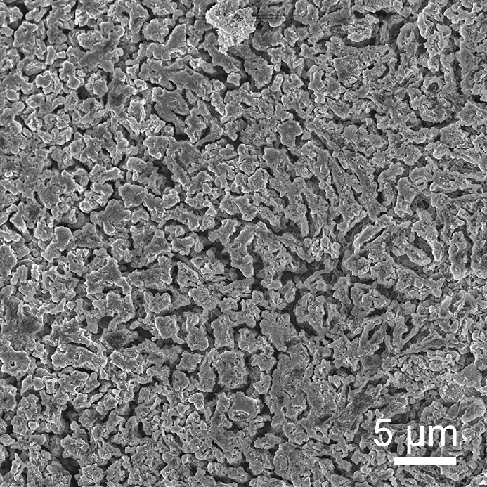
Figure S27. SEM image of the Li metal anodes disassembled from the symmetrical cell with the PP separator at a current density of 2 mA cm⁻² with a capacity of 1 mAh cm⁻² for 20 cycles.

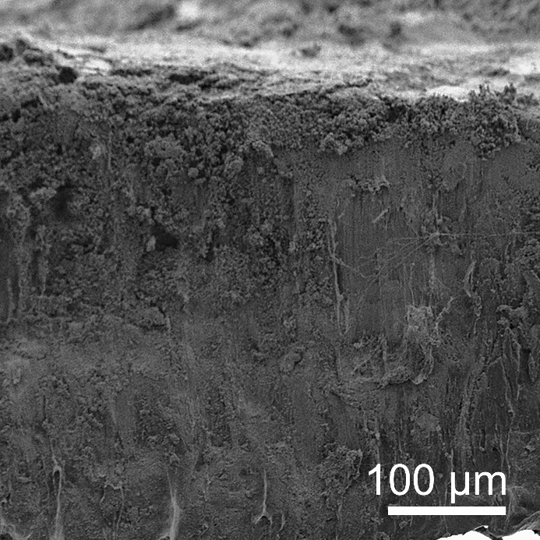
Figure S28. Cross-section SEM image of the Li metal anodes disassembled from the symmetrical cell with the PP separator at a current density of 2 mA cm⁻² with a capacity of 1 mAh cm⁻² for 20 cycles.

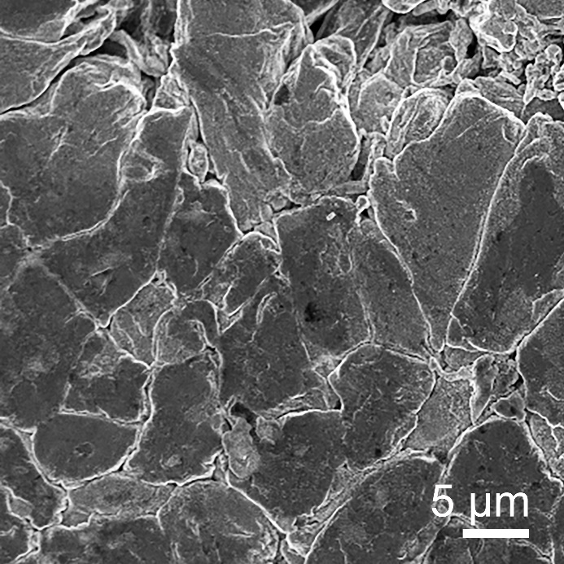
Figure S29. SEM image of the Li metal anodes disassembled from the symmetrical cell with the Ti_{0.87}O₂/PP separator at a current density of 2 mA cm⁻² with a capacity of 1 mAh cm⁻² for 20 cycles.

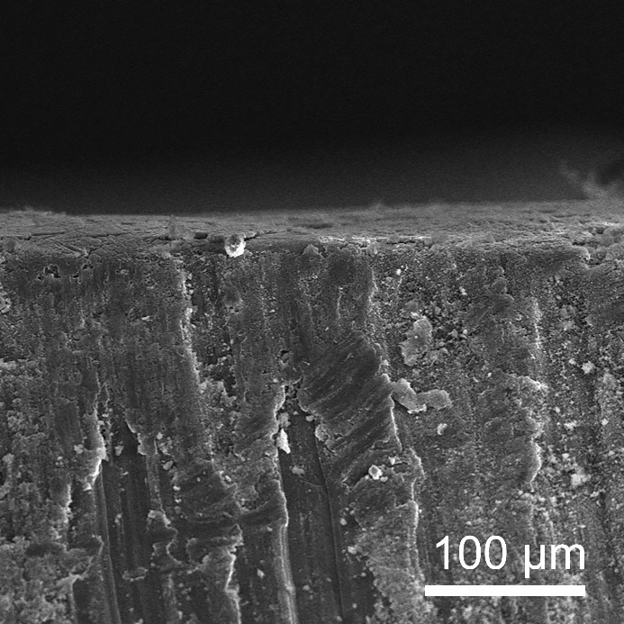
Figure S30. Cross-section SEM image of the Li metal anodes disassembled from the symmetrical cell with the Ti_{0.87}O₂/PP separator at a current density of 2 mA cm⁻² with a capacity of 1 mAh cm⁻² for 20 cycles.

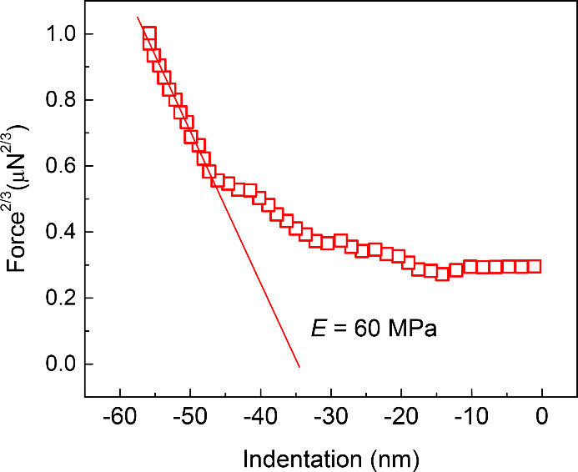
Figure S31. A representative force-indentation curve of the Ti_{0.87}O₂/PP separator. The curve is fitted using the Hertzian model in the linear region.

Figure S32. The models of restacked thin layers for the (a) conventional nanosheets (without defects) and (b) defective nanosheets.

Figure S33. Schematic illustration of mechanism of dendrite-free Li/Na anode by using anionic Ti_{0.87}O₂ nanosheets with atomic Ti vacancies.

Figure S34. Schematic illustration of Li/Na deposition over the bare anode.

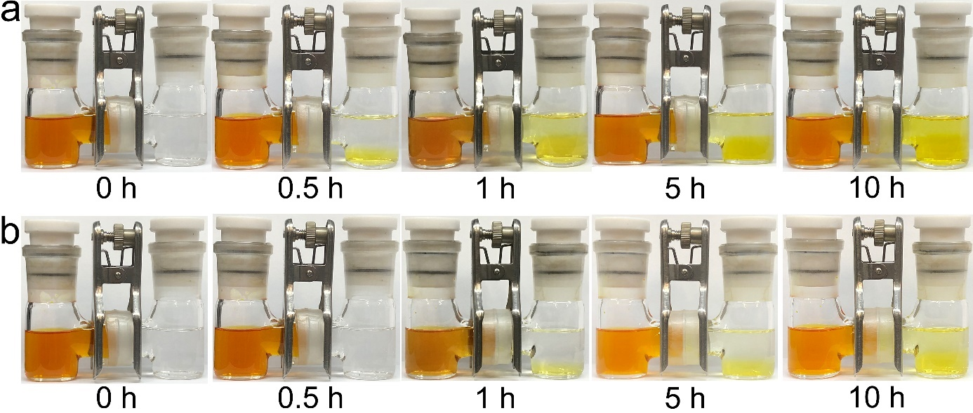
Figure S35. Polysulfide permeation measurements in H-type cells with the (a) anatase TiO₂/PP and (b) GO/PP separators.

Figure S36. Calculation of negative charge density of Ti_{0.87}O₂^{0.52–} nanosheets. In-plane structure of Ti_{0.87}O₂ shows a rectangular unit cell with a = 0.38 nm and c = 0.30 nm. The 2D charge density (ρ) of Ti_{0.87}O₂ can be calculated based on the in-plane unit cell area, ρ_{(Ti0.87O2)} = 2 × 0.52 × 1.60 × 10⁻¹⁹ / (a × c) = 1.46 C m^{–2}.
Figure S37. Optimized conformations of (a) S₂²⁻, (b) S₄²⁻, (c) S₆²⁻ and (d) S₈²⁻ on anatase TiO₂.

Figure S38. Optimized conformations of (a) S₂²⁻, (b) S₄²⁻, (c) S₆²⁻ and (d) S₈²⁻ on GO sheet.

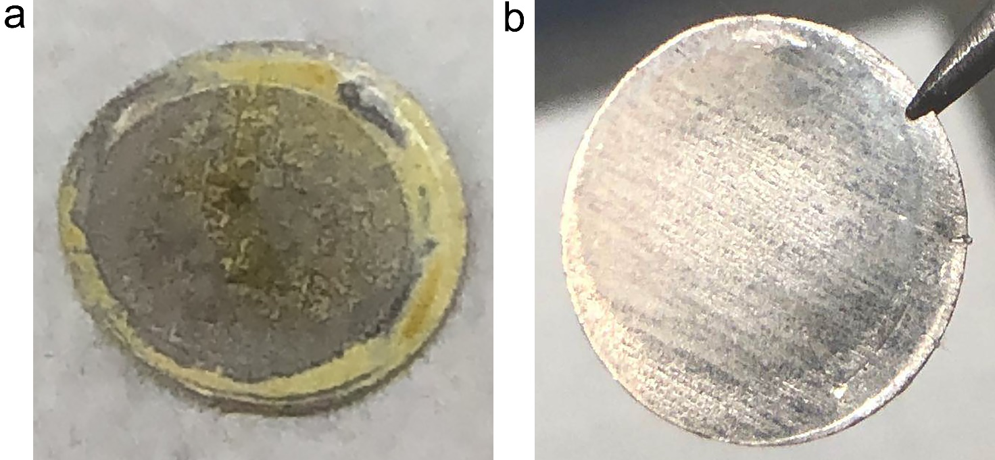
Figure S39. Digital images of the Li metal anodes of the disassembled cells after10 cycles with the (a) PP and (b) Ti_{0.87}O₂/PP separators.

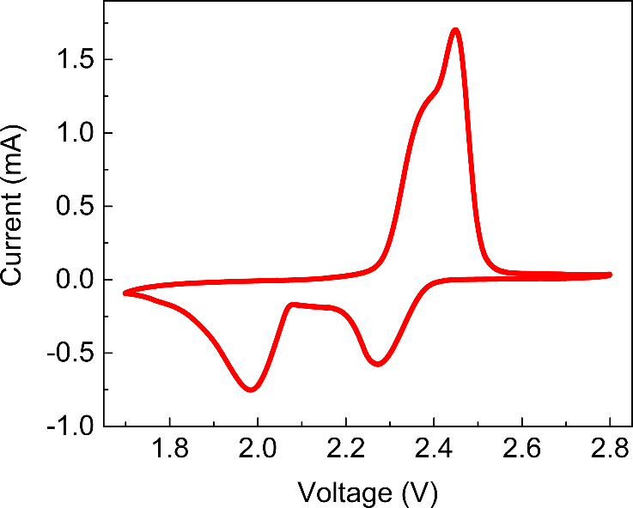
Figure S40. CV curve of the Li–S cell with a Ti_{0.87}O₂/PP separator at 0.1 mV s⁻¹.

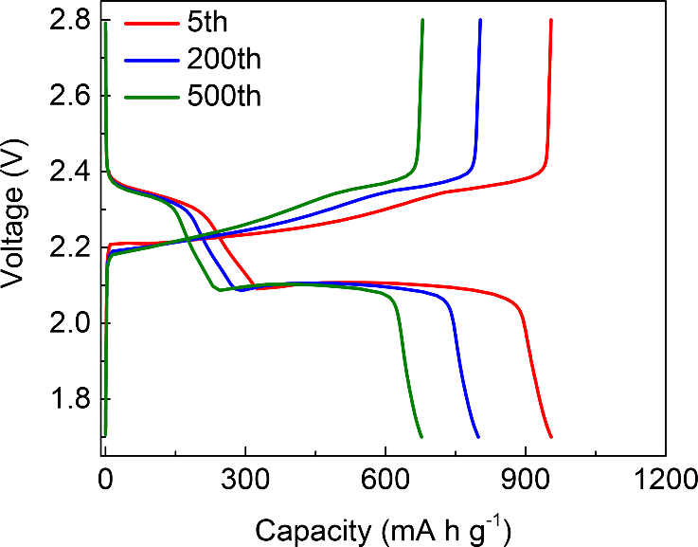
Figure S41. Voltage profiles of the Li–S cell with a Ti_{0.87}O₂/PP separator at 0.2C.

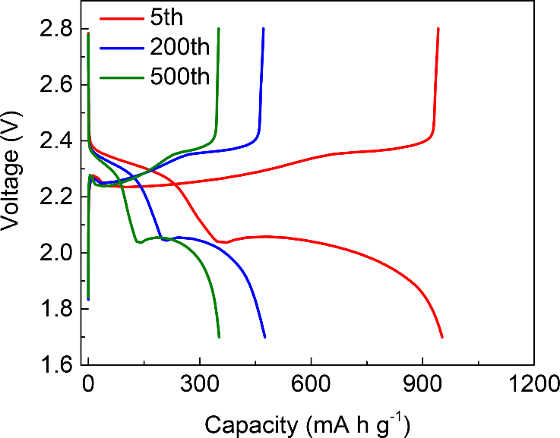
Figure S42. Voltage profiles of the Li–S cell with a PP separator at 0.2C.

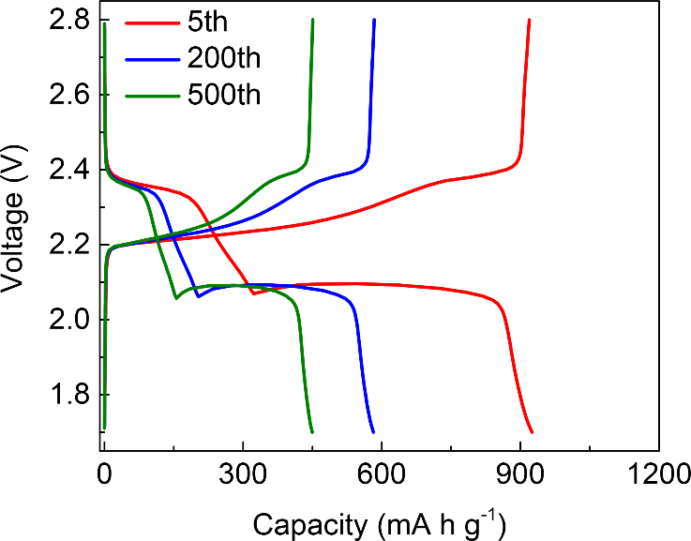
Figure S43. Voltage profiles of the Li–S cell with an anatase TiO₂/PP separator at 0.2C.

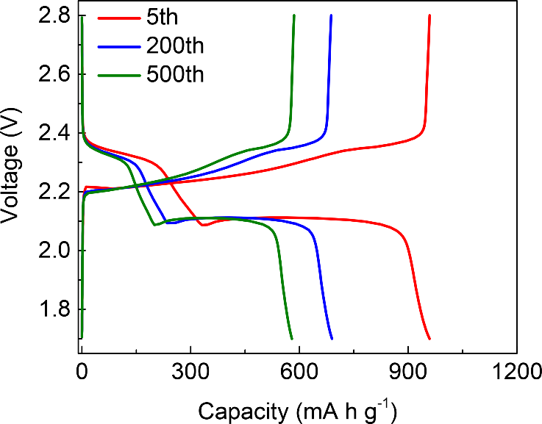
Figure S44. Voltage profiles of the Li–S cell with a GO/PP separator at 0.2C.

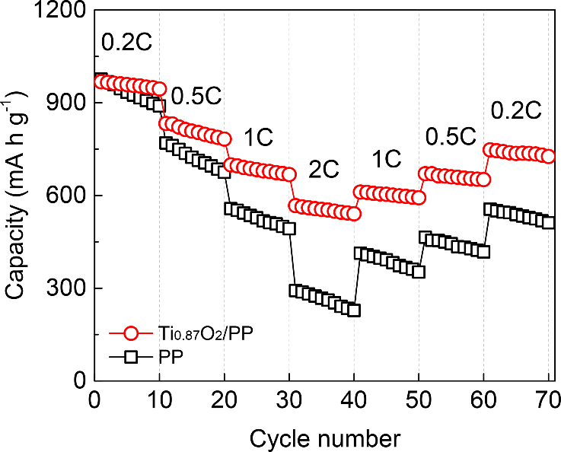
Figure S45. The rate performance of Li–S cells with PP and Ti_{0.87}O₂/PP separators.

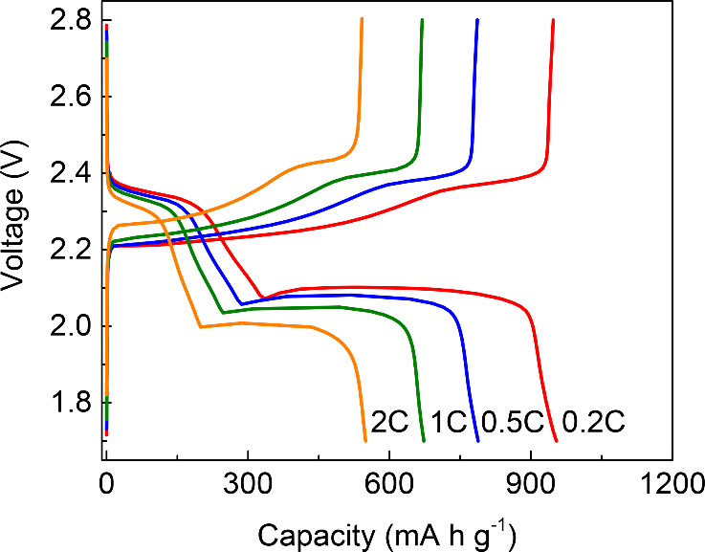
Figure S46. Voltage profiles of the Li–S cell with a Ti_{0.87}O₂/PP separator at various current densities.

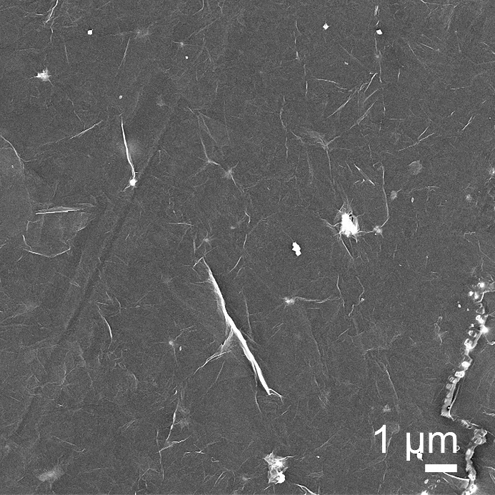
Figure S47. SEM image of the cycled Ti_{0.87}O₂/PP separators from the disassembled cells after cycling.

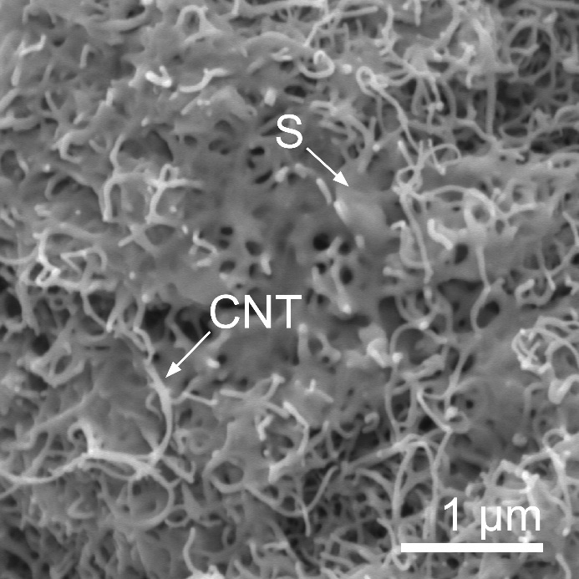
Figure S48. SEM image of the CNT/S cathodes.

Figure S49. Cycling performance of the Li-S batteries at 0.2C using the CNT/S cathodes and the Ti_{0.87}O₂/PP separators.

Figure S50. Areal capacities of the Li-S batteries using the CNT/S cathodes and the Ti_{0.87}O₂/PP separators.

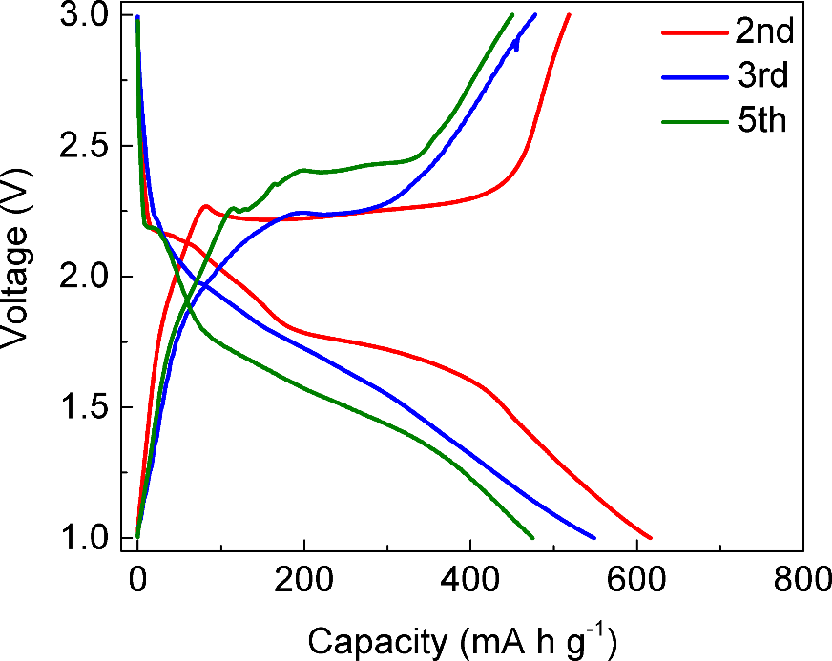
Figure S51. Voltage profiles of the Li–Se cell with a PP separator at 0.2C.

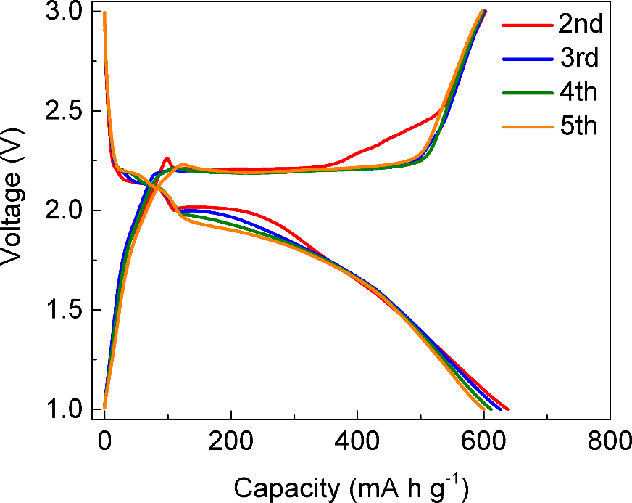
Figure S52. Voltage profiles of the Li–Se cell with a Ti_{0.87}O₂/PP separator at 0.2C.

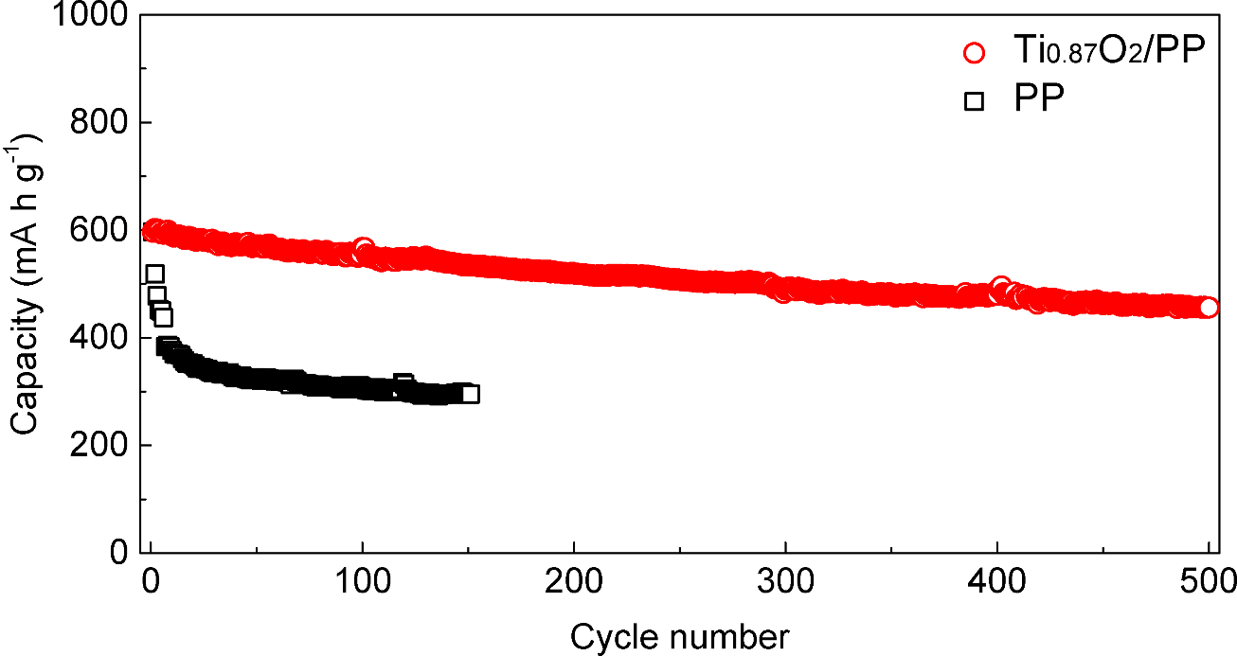
Figure S53. Cycling performance of the Li-Se batteries at 0.2C with PP and Ti_{0.87}O₂/PP separators.

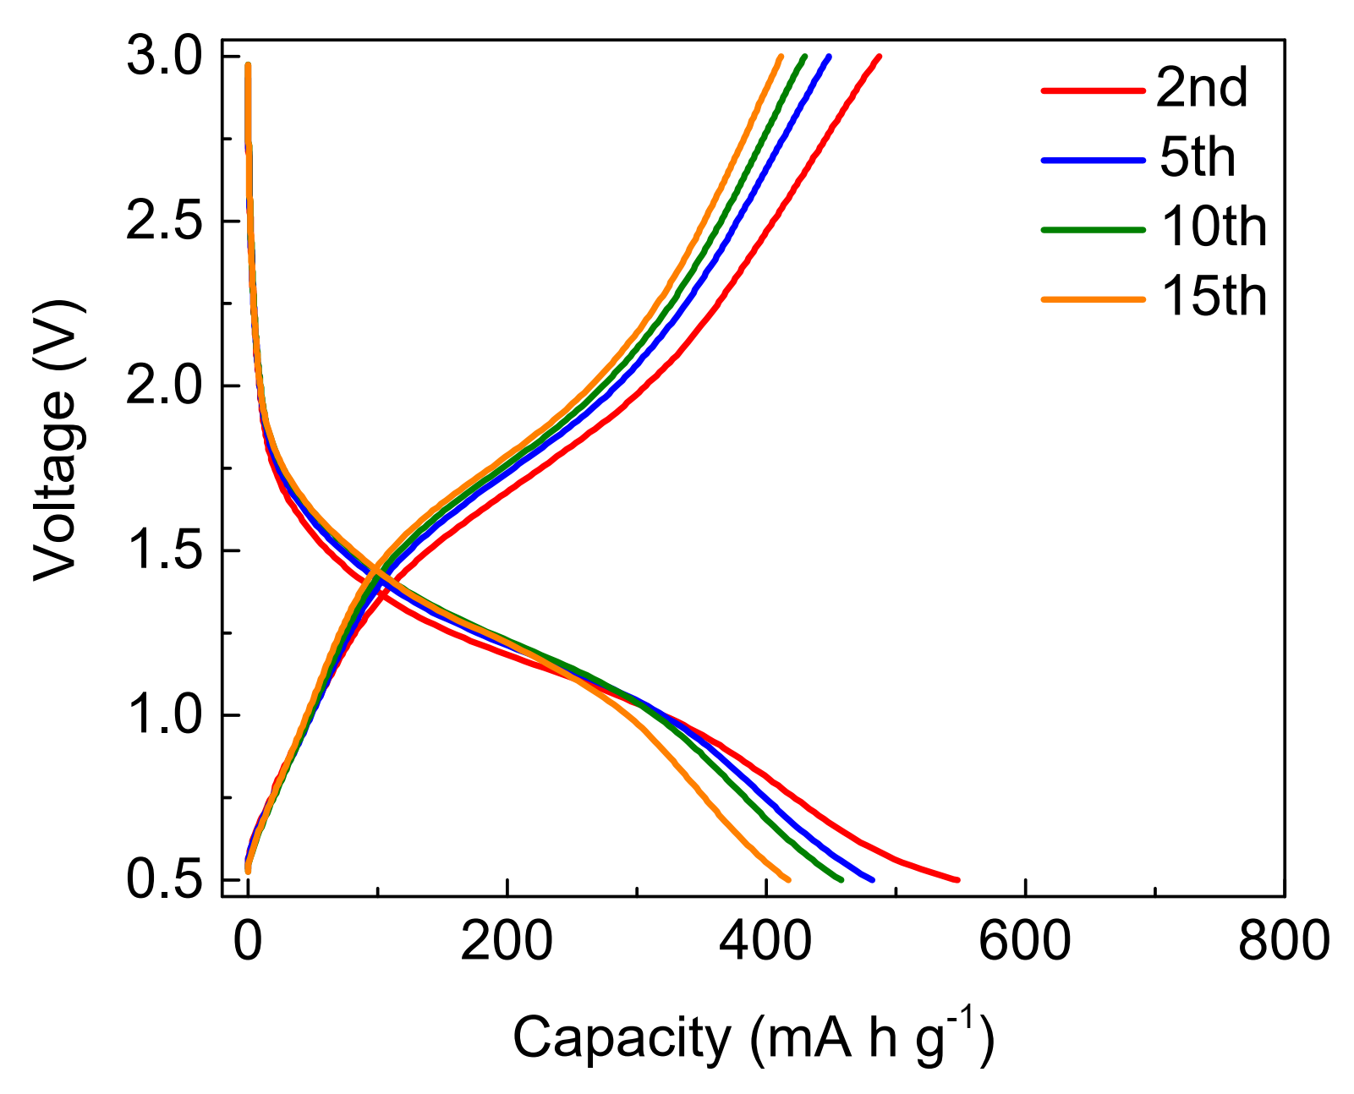
Figure S54. Voltage profiles of the Na–Se cell with a PP separator at 0.2C.

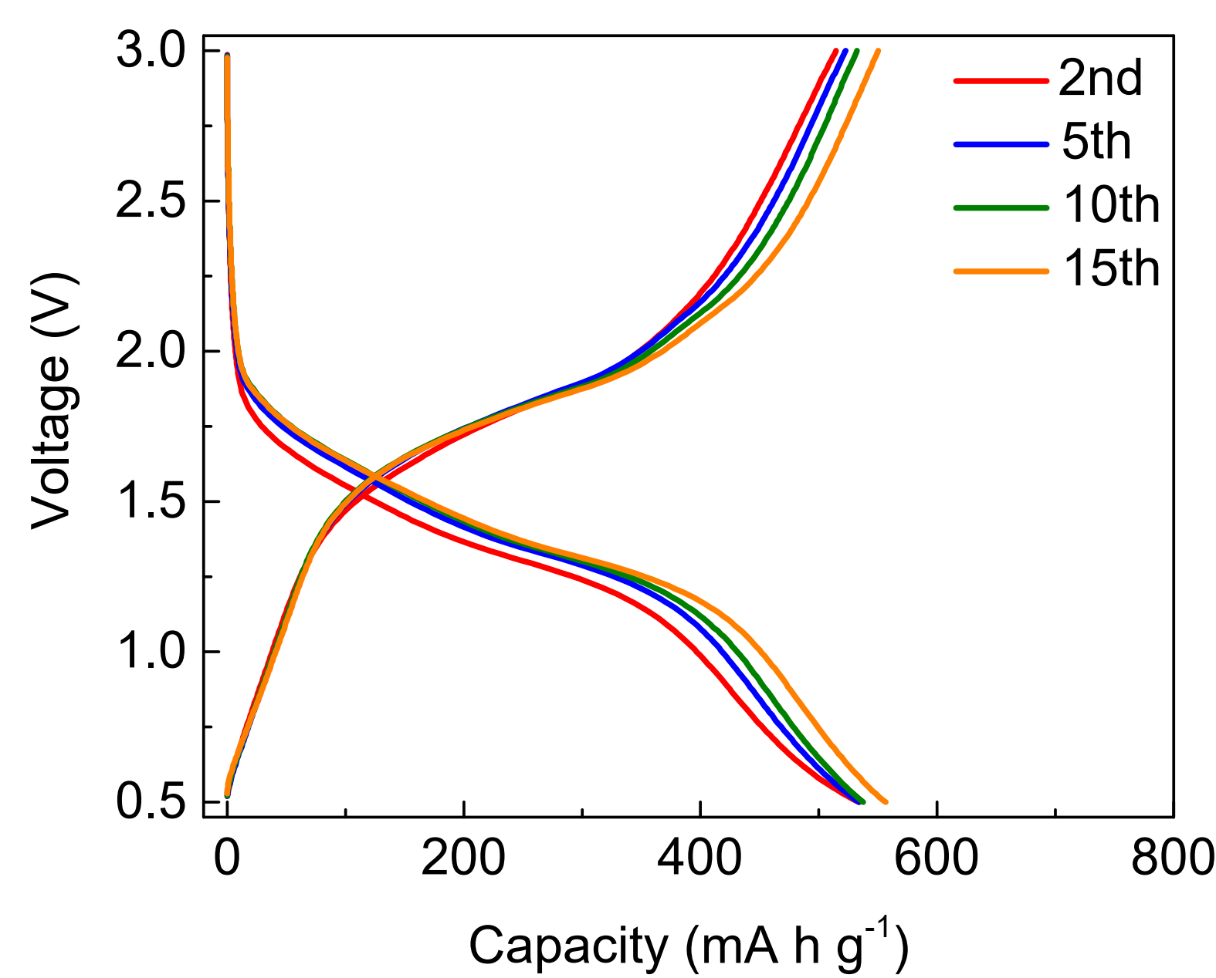
Figure S55. Voltage profiles of the Na–Se cell with a Ti_{0.87}O₂/PP separator at 0.2C.

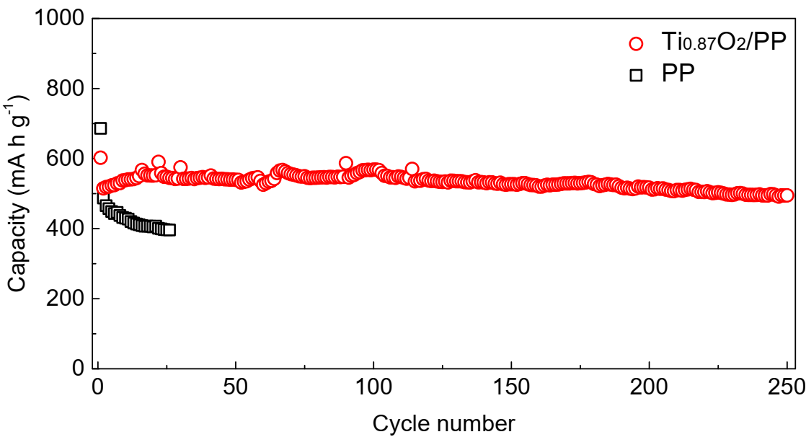
Figure S56. Cycling performance of the Na-Se batteries at 0.2C with PP and Ti_{0.87}O₂/PP separators.

Movie S1. Molecular dynamic simulation of the diffusion of polysulfide anions and Li ions through the anionic Ti_{0.87}O₂ monolayer with one Ti vacancy.

Table S1. Electrochemical properties of various functional separators in Li-S batteries
Functional separators |  |  | Battery performance |  |  | Ref
Materials | Weight density  (mg cm⁻²) | Thickness  (μm) | S cathode | S loading  (mg cm⁻²) | Cycling performance  (cycles, current rate, capacity decay rate)
GO | 0.12 | 5 | Carbon black/S | 1.0-1.5 | 100, 0.1C, 0.23% | 17
Nafion/GO | 0.128 | 0.030 | Garphene/CNT/S | 1.2 | 200, 0.1C, 0.18% | 18
Graphene | 1.3 | 30 | Carbon black/S | 1.5-2.1 | 0.9C, 500, 0.064% | 19
Porous graphene | 0.54 | 10 | CNT/S | 1.8–2.0 | 0.5C, 150, 0.16% | 20
Graphene@porous carbon (G@PC) | 0.075 | 0.9 | Carbon black/S | 3.5 | 100, 0.2C, 0.08% | 21
Co/N-carbon sheets/graphene | 0.2 | 41.3 | CNT/S | 1.0 | 500, 0.2C, 0.07% | 22
Cellular graphene framework | 0.3 | 30 | CNT/S | 1.2 | 300, 0.8375C, 0.085% | 23
B-rGO | 0.2-0.3 | 25 | CNT/S | 1.45-1.56 | 0.1C, 300, 0.1532% | 24
rGO@sodium lignosulfonate (rGO@SL) | 0.2 | ~20 | Carbon black/S | 1.5 | 1000, 2C, 0.026% | 25
CNTs/N‐doped carbon quantum dot (CNT/NCQD) | 0.15 | 25~30 | Carbon black/S | 1.3-1.5 | 0.5C, 1000, 0.05% | 26
CNF-Gum Arabic | 0.25 | 19 | CNF/S | 1.1 | 250, 1C, 0.024% | 27
Mg₂Al-LDH | 0.018 | 0.02-0.03 | Carbon black/S | 1.2-1.4 | 200, 0. 5C, 0.18% | 28
NiFe-LDH/N-doped graphene | 0.3 | 1.5 | Carbon/S | 1.2 | 1000, 2C, 0.06% | 29
MoS₂ | - | 0.350 | Carbon black/S | - | 600, 0.5C, 0.083% | 30
MoS₂-PDDA/PAA | 0.1 | 3 | Carbon black/S | 1.2-4.0 | 2000, 1C, 0.029% | 31
Co₉S₈ | 0.16 | - | Carbon black/S | 2.0 | 1000, 1C, 0.039% | 32
Sb₂Se_{3-x}/rGO | 0.5 | 32 | Carbon black/S | 1.8 | 500, 1C, 0.027% | 33
MoP/rGO | 0.35-0.45 | 10 | Carbon/S | 3.6-4.0 | 120, 0.1C, 0.045% | 34
Ti₃C₂ MXene | 0.1 | 0.522 | Carbon black/S | 1.2 | 500, 0.5C 0.062% | 35
Black Phosphorus | 0.4 | ~0.35 | Carbon black/S | 1.5–2 | 100, 0.2C, 0.14% | 36
Super P/Red phosphorus | 0.3 | 8 | Carbon black/S | 2 | 500, 1C, 0.036% | 37
BN-carbon | - | 6~7 | Carbon black/S | 2.1 | 250, 0.5C, 0.0936% | 38
BaTiO₃ | 2.4 | 18-23 | Carbon black/S | 3.2 | 50, 0.1C, 0.34% | 39
H_{x}MnO_{2+x}/graphene/CNTs | 0.2 | 3 | CNT/S | 1.8 | 1000, 1C, 0.04% | 40
TiO₂/graphene | 0.15 | 3 | CNT/S | 1.2 | 300, 0.5C, 0.01% | 41
Li₄Ti₅O₁₂/Graphene | 0.346 | 35 | Carbon black/S | 1.0-1.2 | 500, 1C, 0.028% | 42
Ni₃(HITP)₂ | 0.066 | 0.34 | CNT/S | 8 | 500, 1C, 0.066% | 43
Cu₂(CuTCPP) nanosheets | 0.1 | 0.5 | Carbon black/S | 2 | 900, 1C, 0.032% | 44
CNT@ZIF-8 | 0.9 | 15 | Carbon black/S | 1.2 | 100, 0.2C, 0.45% | 45
Ce-MOF/CNT | 0.4 | 8 | Carbon black/S | 2.5 | 800, 1C, 0.022% | 46
MOF@PVDF-HFP | None | 28 | Carbon cloth/S | 1-1.5 | 600, 0.5C, 0.0549% | 47
Bacterial cellulose/2D MOF-Co (BC/2D MOF-Co) | 2.53 | 25 | Carbon black/S | 1.5 | 600, 1C, 0.07% | 48
MOF@GO | 0.3 | ~10 | CMK3/S | 0.6-0.8 | 1500, 1C, 0.019% | 49
Laponite nanosheets | 0.7 | 3.5 | Carbon black/S | 1.0-1.2 | 500, 0.2C, 0.06% | 50
Ti_{0.87}O₂ nanosheets | 0.016 | 0.080 | Carbon black/S | 1.5 | 5000, 1C, 0.0036% | This work
 |  |  |  | 3.5 | 4900, 1C, 0.0035%  10000, 2C, 0.0035%

References
[1] Sasaki, T. et al. Macromolecule-like aspects for a colloidal suspension of an exfoliated titanate. pairwise association of nanosheets and dynamic eeassembling process initiated from it. J. Am. Chem. Soc. 118, 8329–8335 (1996).
[2] Sasaki, T. & Watanabe, M. Osmotic swelling to exfoliation. exceptionally high degrees of hydration of a layered titanate. J. Am. Chem. Soc. 120, 4682–4689 (1998).
[3] Weadock, N. et al. Determination of mechanical properties of the SEI in sodium ion batteries via colloidal probe microscopy. Nano Energy 2, 713–719 (2013).
[4] Xiao, W.-Z. et al. Two-dimensional H-TiO₂/MoS₂(WS₂) van der waals heterostructures for visible-light photocatalysis and energy conversion. Appl. Surf. Sci. 504, 144425 (2020).
[5] Kresse, G. & Joubert, D. From ultrasoft pseudopotentials to the projector augmented-wave method. Phys. Rev. B 59, 1758–1775 (1999).
[6] Perdew, J. P., Burke, K. & Ernzerhof, M. Generalized gradient approximation made simple. Phys. Rev. Lett. 77, 3865–3868 (1996).
[7] Ernzerhof, M. & Scuseria, G. E. Assessment of the Perdew-Burke-Ernzerhof exchange-correlation functional. J. Chem. Phys. 110, 5029–5036 (1999).
[8] Blöchl, P. E. Projector augmented-wave method. Phys. Rev. B 50, 17953–17979 (1994).
[9] Henkelman, G., Uberuaga, B. P. & Jónsson, H. A climbing image nudged elastic band method for finding saddle points and minimum energy paths. J. Chem. Phys. 113, 9901–9904 (2000).
[10] Monkhorst, H. J. & Pack, J. D. Special points for Brillouin-zone integrations. Phys. Rev. B 13, 5188–5192 (1976).
[11] Dong, L., Yang, J., Chhowalla, M. & Loh, K. P. Synthesis and reduction of large sized graphene oxide sheets. Chem. Soc. Rev. 46, 7306–7316 (2017).
[12] Ohwada, M., Kimoto, K., Mizoguchi, T., Ebina, Y. & Sasaki, T. Atomic structure of titania nanosheet with vacancies. Sci. Rep. 3, 2801 (2013).
[13] Dudley, J. T. et al. Conductivity of electrolytes for rechargeable lithium batteries. J. Power Sources 35, 59–82 (1991).
[14] Steudel, R. Properties of sulfur-sulfur bonds. Angew, Chem, Int, Ed, 14, 655–664 (1975).
[15] Pastorino, C. & Gamba, Z. Free-energy calculations of elemental sulphur crystals via molecular dynamics simulations. J. Chem. Phys. 119, 2147–2154 (2003).
[16] Rappe, A. K., Casewit, C. J., Colwell, K. S., Goddard, W. A. & Skiff, W. M. UFF, a full periodic table force field for molecular mechanics and molecular dynamics simulations. J. Am. Chem. Soc. 114, 10024–10035 (1992).
[17] Huang, J.-Q. et al. Permselective graphene oxide membrane for highly stable and anti-self-discharge lithium-sulfur batteries. ACS Nano 9, 3002–3011 (2015).
[18] Zhuang, T.-Z. et al. Rational integration of polypropylene/graphene oxide/nafion as ternary-layered separator to retard the shuttle of polysulfides for lithium-sulfur batteries. Small 12, 381–389 (2016).
[19] Zhou, G. et al. A flexible sulfur-graphene-polypropylene separator integrated electrode for ddvanced Li-S batteries. Adv. Mater. 27, 641–647 (2015).
[20] Zhai, P.-Y. et al. Scaled-up fabrication of porous-graphene-modified separators for high-capacity lithium-sulfur batteries. Energy Storage Mater. 7, 56–63 (2017).
[21] Pei, F. et al. A two-dimensional porous carbon-modified separator for high-energy-density Li-S batteries. Joule 2, 323–336 (2018).
[22] Cheng, Z., Pan, H., Chen, J., Meng, X. & Wang, R. Separator modified by cobalt-embedded carbon nanosheets enabling chemisorption and catalytic effects of polysulfides for high-energy-density lithium-sulfur batteries. Adv. Energy Mater. 9, 1901609 (2019).
[23] Peng, H.-J. et al. Janus separator of polypropylene-supported cellular graphene framework for sulfur cathodes with high utilization in lithium-sulfur batteries. Adv. Sci. 3, 1500268 (2016).
[24] Wu, F. et al. Light-weight functional layer on a separator as a polysulfide immobilizer to enhance cycling stability for lithium-sulfur batteries. J. Mater. Chem. A 4, 17033–17041 (2016).
[25] Lei, T. et al. Inhibiting polysulfide shuttling with a graphene composite separator for highly robust lithium-sulfur batteries. Joule 2, 2091–2104 (2018).
[26] Pang, Y., Wei, J., Wang, Y. & Xia, Y. Synergetic protective effect of the ultralight MWCNTs/NCQDs modified separator for highly stable lithium-sulfur batteries. Adv. Energy Mater. 8, 1702288 (2018).
[27] Tu, S. et al. A polysulfide-immobilizing polymer retards the shuttling of polysulfide intermediates in lithium-sulfur batteries. Adv. Mater. 30, 1804581 (2018).
[28] Zhou, Y. et al. Cationic two-dimensional sheets for an ultralight electrostatic polysulfide trap toward high-performance lithium-sulfur batteries. Energy Storage Mater. 9 39–46 (2017).
[29] Peng, H.-J. et al. A Cooperative interface for highly efficient lithium-sulfur batteries. Adv. Mater. 28, 9551–9558 (2016).
[30] Ghazi, Z. A. et al. MoS₂/Celgard separator as efficient polysulfide barrier for long-life lithium-sulfur batteries. Adv. Mater. 29, 1606817 (2017).
[31] Wu, J. et al. Ultralight layer-by-layer self-assembled MoS₂-polymer modified separator for simultaneously trapping polysulfides and suppressing lithium dendrites. Adv. Energy Mater. 8, 1802430 (2018).
[32] He, J., Chen, Y. & Manthiram, A. Vertical Co₉S₈ hollow nanowall arrays grown on a Celgard separator as a multifunctional polysulfide barrier for high-performance Li-S batteries. Energy Environ. Sci. 11, 2560–2568 (2018).
[33] Tian, Y. et al. Low-bandgap se-deficient antimony selenide as a multifunctional polysulfide barrier toward high-performance lithium-sulfur batteries. Adv. Mater. 32, 1904876 (2020).
[34] Li, M. et al. A separator-based lithium polysulfide recirculator for high-loading and high-performance Li-S batteries. J. Mater. Chem. A 6, 5862–5869 (2018).
[35] Song, J. et al. Immobilizing polysulfides with MXene-functionalized separators for stable lithium-sulfur batteries. ACS Appl. Mater. Interfaces 8, 29427–29433 (2016).
[36] Sun, J. et al. Entrapment of polysulfides by a black-phosphorus-modified separator for lithium-sulfur batteries. Adv. Mater. 28, 9797–9803 (2016).
[37] Wang, Z. et al. Constructing metal-free and cost-effective multifunctional separator for high-performance lithium-sulfur batteries. Nano Energy 59, 390–398 (2019).
[38] Kim, P. J. H. et al. Synergistic protective effect of a BN-carbon separator for highly stable lithium sulfur batteries. NPG Asia Mater. 9, e375 (2017).
[39] Yim, T. et al. Effective polysulfide rejection by dipole-aligned BaTiO₃ coated separator in lithium–sulfur batteries. Adv. Funct. Mater. 26, 7817–7823 (2016).
[40] Lu, Q. et al. An “electronegative” bifunctional coating layer: simultaneous regulation of polysulfide and Li-ion adsorption sites for long-cycling and “dendrite-free” Li-S batteries. J. Mater. Chem. A 7, 22463–22474 (2019).
[41] Xiao, Z. et al. A lightweight TiO₂/graphene interlayer, applied as a highly effective polysulfide absorbent for fast, long-life lithium-sulfur batteries. Adv. Mater. 27, 2891–2898 (2015).
[42] Zhao Y. et al. Dense coating of Li₄Ti₅O₁₂ and graphene mixture on the separator to produce long cycle life of lithium-sulfur battery. Nano Energy 30, 1–8 (2016).
[43] Zang, Y. et al. Large-area preparation of crack-free crystalline microporous conductive membrane to upgrade high energy lithium-sulfur batteries. Adv. Energy Mater. 8, 1802052 (2018).
[44] Tian, M. et al. Ultrathin MOF nanosheet assembled highly oriented microporous membrane as an interlayer for lithium-sulfur batteries. Energy Storage Mater. 21, 14–21 (2019).
[45] Wu, F. et al. Metal-organic frameworks composites threaded on the CNT knitted separator for suppressing the shuttle effect of lithium sulfur batteries. Energy Storage Mater. 14, 383–391 (2018).
[46] Hong, X.-J. et al. Cerium based metal-organic frameworks as an efficient separator coating catalyzing the conversion of polysulfides for high performance lithium–sulfur batteries. ACS Nano 13, 1923–1931 (2019).
[47] He, Y. et al. Simultaneously inhibiting lithium dendrites growth and polysulfides shuttle by a flexible MOF-based membrane in Li-S batteries. Adv. Energy Mater. 8, 1802130 (2018).
[48] Li, Y. et al. Single atom array mimic on ultrathin MOF nanosheets boosts the safety and life of lithium-sulfur batteries. Adv. Mater. 32, 1906722 (2020).
[49] Bai, S., Liu, X., Zhu, K., Wu, S. & Zhou, H. Metal-organic framework-based separator for lithium-sulfur batteries. Nat. Energy 1, 16094 (2016).
[50] Yang, Y. & Zhang, J. Highly stable lithium-sulfur batteries based on laponite nanosheet-coated celgard separators. Adv. Energy Mater. 8, 1801778 (2018).

