Table 3 Influence of cutting speed and MQL flow rate on chip shape
$V$ [$m/min$] | MQL1 | MQL2 | MQL3
145
650
1155 |  |  | 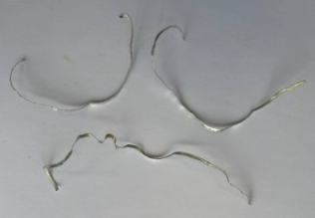

Table 4 Impact of feed rate and MQL flow rate on chip shape
$$f [mm/rev]$$ | MQL1 | MQL2 | MQL3
0.07 |  |  | 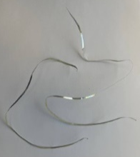
0.19
0.31

Table 5 Effect of cutting speed and MQL flow rate on chip shape
𝐷 [mm] | MQL1 | MQL2 | MQL3
0.66
1.5
2.34

