Supporting Information

Exploring bisphenol S removal mechanism with multi-enzymes extracted from waste sludge and reed sediment
Hong Liu ª, Xin Zheng ª, Guangying Hou ª, Chunguang Liu ^{a,}∗
ª School of Environmental Science and Engineering, Shandong University, No. 72 Jimo Binhai Road, Qingdao, Shandong Province 266237, China

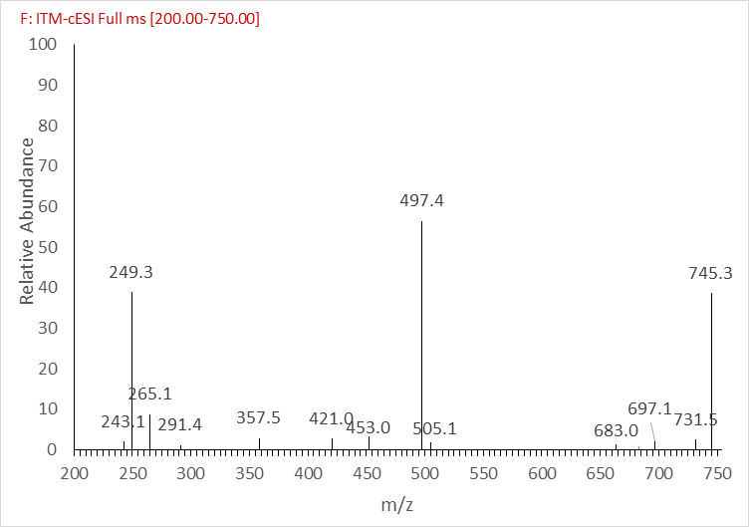

Fig.S1 Mass spectra of bisphenol S and their degradation products.

