Table 3. Chemical structure and characterization of BG4

Chemical structure | 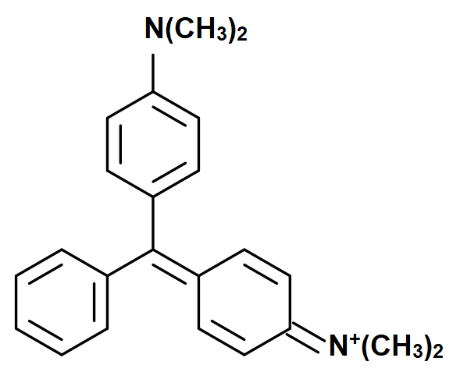
C.I. Name | C.I. Basic green 4
Molecular formula | C₂₃H₂₆N₂O.HCl
C.I. Number | 42000
M_{W} (g/mol) | 382.9
λ_{max} (nm) | 619

