Supplementary Material
Supplementary Figures S1−S128. Forest and funnel plots of the association between EPO gene polymorphisms and diabetic retinopathy.
Supplementary Figures
Figure S1 | Forest plot of the association between the EPO rs1617640 polymorphism and diabetic retinopathy in the overall group analysis, under the dominant genetic model for the minor allele (GG+TG vs. TT) | 20
Figure S2 | Funnel plot of the association between the EPO rs1617640 polymorphism and diabetic retinopathy in the overall group analysis, under the dominant genetic model for the minor allele (GG+TG vs. TT) | 21
Figure S3 | Forest plot of the association between the EPO rs1617640 polymorphism and diabetic retinopathy in the overall group analysis without the cohort #2 by Tong et al. (2008), under the dominant genetic model for the minor allele (GG+TG vs. TT) | 22
Figure S4 | Funnel plot of the association between the EPO rs1617640 polymorphism and diabetic retinopathy in the overall group analysis without the cohort #2 by Tong et al. (2008), under the dominant genetic model for the minor allele (GG+TG vs. TT) | 23
Figure S5 | Forest plot of the association between the EPO rs1617640 polymorphism and diabetic retinopathy in the overall group analysis including only the sets with controls in Hardy-Weinberg equilibrium, under the dominant genetic model for the minor allele (GG+TG vs. TT) | 24
Figure S6 | Funnel plot of the association between the EPO rs1617640 polymorphism and diabetic retinopathy in the overall group analysis including only the sets with controls in Hardy-Weinberg equilibrium, under the dominant genetic model for the minor allele (GG+TG vs. TT) | 25
Figure S7 | Forest plot of the association between the EPO rs1617640 polymorphism and diabetic retinopathy in the overall group analysis, including only the sets with controls in Hardy-Weinberg equilibrium and excluding the cohort #2 by Tong et al. (2008), under the dominant genetic model for the minor allele (GG+TG vs. TT) | 26
Figure S8 | Funnel plot of the association between the EPO rs1617640 polymorphism and diabetic retinopathy in the overall group analysis, including only the sets with controls in Hardy-Weinberg equilibrium and excluding the cohort #2 by Tong et al. (2008), under the dominant genetic model for the minor allele (GG+TG vs. TT) | 27
Figure S9 | Forest plot of the association between the EPO rs1617640 polymorphism and diabetic retinopathy in the overall group analysis, under the recessive genetic model for the minor allele (GG vs. TG+TT) | 28
Figure S10 | Funnel plot of the association between the EPO rs1617640 polymorphism and diabetic retinopathy in the overall group analysis, under the recessive genetic model for the minor allele (GG vs. TG+TT) | 29
Figure S11 | Forest plot of the association between the EPO rs1617640 polymorphism and diabetic retinopathy in the overall group analysis without the cohort #2 by Tong et al. (2008), under the recessive genetic model for the minor allele (GG vs. TG+TT) | 30
Figure S12 | Funnel plot of the association between the EPO rs1617640 polymorphism and diabetic retinopathy in the overall group analysis without the cohort #2 by Tong et al. (2008), under the recessive genetic model for the minor allele (GG vs. TG+TT) | 31
Figure S13 | Forest plot of the association between the EPO rs1617640 polymorphism and diabetic retinopathy in the overall group analysis including only the sets with controls in Hardy-Weinberg equilibrium, under the recessive genetic model for the minor allele (GG vs. TG+TT) | 32
Figure S14 | Funnel plot of the association between the EPO rs1617640 polymorphism and diabetic retinopathy in the overall group analysis including only the sets with controls in Hardy-Weinberg equilibrium, under the recessive genetic model for the minor allele (GG vs. TG+TT) | 33
Figure S15 | Forest plot of the association between the EPO rs1617640 polymorphism and diabetic retinopathy in the overall group analysis, including only the sets with controls in Hardy-Weinberg equilibrium and excluding the cohort #2 by Tong et al. (2008), under the recessive genetic model for the minor allele (GG vs. TG+TT) | 34
Figure S16 | Funnel plot of the association between the EPO rs1617640 polymorphism and diabetic retinopathy in the overall group analysis, including only the sets with controls in Hardy-Weinberg equilibrium and excluding the cohort #2 by Tong et al. (2008), under the recessive genetic model for the minor allele (GG vs. TG+TT) | 35
Figure S17 | Forest plot of the association between the EPO rs1617640 polymorphism and diabetic retinopathy in the overall group analysis, under the homozygous additive genetic model for the minor allele (GG vs. TT) | 36
Figure S18 | Funnel plot of the association between the EPO rs1617640 polymorphism and diabetic retinopathy in the overall group analysis, under the homozygous additive genetic model for the minor allele (GG vs. TT) | 37
Figure S19 | Forest plot of the association between the EPO rs1617640 polymorphism and diabetic retinopathy in the overall group analysis without the cohort #2 by Tong et al. (2008), under the homozygous additive genetic model for the minor allele (GG vs. TT) | 38
Figure S20 | Funnel plot of the association between the EPO rs1617640 polymorphism and diabetic retinopathy in the overall group analysis without the cohort #2 by Tong et al. (2008), under the homozygous additive genetic model for the minor allele (GG vs. TT) | 39
Figure S21 | Forest plot of the association between the EPO rs1617640 polymorphism and diabetic retinopathy in the overall group analysis including only the sets with controls in Hardy-Weinberg equilibrium, under the homozygous additive genetic model for the minor allele (GG vs. TT) | 40
Figure S22 | Funnel plot of the association between the EPO rs1617640 polymorphism and diabetic retinopathy in the overall group analysis including only the sets with controls in Hardy-Weinberg equilibrium, under the homozygous additive genetic model for the minor allele (GG vs. TT) | 41
Figure S23 | Forest plot of the association between the EPO rs1617640 polymorphism and diabetic retinopathy in the overall group analysis, including only the sets with controls in Hardy-Weinberg equilibrium and excluding the cohort #2 by Tong et al. (2008), under the homozygous additive genetic model for the minor allele (GG vs. TT) | 42
Figure S24 | Funnel plot of the association between the EPO rs1617640 polymorphism and diabetic retinopathy in the overall group analysis, including only the sets with controls in Hardy-Weinberg equilibrium and excluding the cohort #2 by Tong et al. (2008), under the homozygous additive genetic model for the minor allele (GG vs. TT) | 43
Figure S25 | Forest plot of the association between the EPO rs1617640 polymorphism and diabetic retinopathy in the overall group analysis, under the heterozygous additive genetic model for the minor allele (TG vs. TT) | 44
Figure S26 | Funnel plot of the association between the EPO rs1617640 polymorphism and diabetic retinopathy in the overall group analysis, under the heterozygous additive genetic model for the minor allele (TG vs. TT) | 45
Figure S27 | Forest plot of the association between the EPO rs1617640 polymorphism and diabetic retinopathy in the overall group analysis without the cohort #2 by Tong et al. (2008), under the heterozygous additive genetic model for the minor allele (TG vs. TT) | 46
Figure S28 | Funnel plot of the association between the EPO rs1617640 polymorphism and diabetic retinopathy in the overall group analysis without the cohort #2 by Tong et al. (2008), under the heterozygous additive genetic model for the minor allele (TG vs. TT) | 47
Figure S29 | Forest plot of the association between the EPO rs1617640 polymorphism and diabetic retinopathy in the overall group analysis including only the sets with controls in Hardy-Weinberg equilibrium, under the heterozygous additive genetic model for the minor allele (TG vs. TT) | 48
Figure S30 | Funnel plot of the association between the EPO rs1617640 polymorphism and diabetic retinopathy in the overall group analysis including only the sets with controls in Hardy-Weinberg equilibrium, under the heterozygous additive genetic model for the minor allele (TG vs. TT) | 49
Figure S31 | Forest plot of the association between the EPO rs1617640 polymorphism and diabetic retinopathy in the overall group analysis, including only the sets with controls in Hardy-Weinberg equilibrium and excluding the cohort #2 by Tong et al. (2008), under the heterozygous additive genetic model for the minor allele (TG vs. TT) | 50
Figure S32 | Funnel plot of the association between the EPO rs1617640 polymorphism and diabetic retinopathy in the overall group analysis, including only the sets with controls in Hardy-Weinberg equilibrium and excluding the cohort #2 by Tong et al. (2008), under the heterozygous additive genetic model for the minor allele (TG vs. TT) | 51
Figure S33 | Forest plot of the association between the EPO rs1617640 polymorphism and diabetic retinopathy in the overall group analysis, under the overdominant genetic model (TG vs. GG+TT) | 52
Figure S34 | Funnel plot of the association between the EPO rs1617640 polymorphism and diabetic retinopathy in the overall group analysis, under the overdominant genetic model (TG vs. GG+TT) | 53
Figure S35 | Forest plot of the association between the EPO rs1617640 polymorphism and diabetic retinopathy in the overall group analysis without the cohort #2 by Tong et al. (2008), under the overdominant genetic model (TG vs. GG+TT) | 54
Figure S36 | Funnel plot of the association between the EPO rs1617640 polymorphism and diabetic retinopathy in the overall group analysis without the cohort #2 by Tong et al. (2008), under the overdominant genetic model (TG vs. GG+TT) | 55
Figure S37 | Forest plot of the association between the EPO rs1617640 polymorphism and diabetic retinopathy in the overall group analysis including only the sets with controls in Hardy-Weinberg equilibrium, under the overdominant genetic model (TG vs. GG+TT) | 56
Figure S38 | Funnel plot of the association between the EPO rs1617640 polymorphism and diabetic retinopathy in the overall group analysis including only the sets with controls in Hardy-Weinberg equilibrium, under the overdominant genetic model (TG vs. GG+TT) | 57
Figure S39 | Forest plot of the association between the EPO rs1617640 polymorphism and diabetic retinopathy in the overall group analysis, including only the sets with controls in Hardy-Weinberg equilibrium and excluding the cohort #2 by Tong et al. (2008), under the overdominant genetic model (TG vs. GG+TT) | 58
Figure S40 | Funnel plot of the association between the EPO rs1617640 polymorphism and diabetic retinopathy in the overall group analysis, including only the sets with controls in Hardy-Weinberg equilibrium and excluding the cohort #2 by Tong et al. (2008), under the overdominant genetic model (TG vs. GG+TT) | 59
Figure S41 | Forest plot of the association between the EPO rs1617640 polymorphism and diabetic retinopathy in the overall group analysis, under the allele contrast genetic model (G vs. T) | 60
Figure S42 | Funnel plot of the association between the EPO rs1617640 polymorphism and diabetic retinopathy in the overall group analysis, under the allele contrast genetic model (G vs. T) | 61
Figure S43 | Forest plot of the association between the EPO rs1617640 polymorphism and diabetic retinopathy in the overall group analysis without the cohort #2 by Tong et al. (2008), under the allele contrast genetic model (G vs. T) | 62
Figure S44 | Funnel plot of the association between the EPO rs1617640 polymorphism and diabetic retinopathy in the overall group analysis without the cohort #2 by Tong et al. (2008), under the allele contrast genetic model (G vs. T) | 63
Figure S45 | Forest plot of the association between the EPO rs1617640 polymorphism and diabetic retinopathy in the overall group analysis including only the sets with controls in Hardy-Weinberg equilibrium, under the allele contrast genetic model (G vs. T) | 64
Figure S46 | Funnel plot of the association between the EPO rs1617640 polymorphism and diabetic retinopathy in the overall group analysis including only the sets with controls in Hardy-Weinberg equilibrium, under the allele contrast genetic model (G vs. T) | 65
Figure S47 | Forest plot of the association between the EPO rs1617640 polymorphism and diabetic retinopathy in the overall group analysis, including only the sets with controls in Hardy-Weinberg equilibrium and excluding the cohort #2 by Tong et al. (2008), under the allele contrast genetic model (G vs. T) | 66
Figure S48 | Funnel plot of the association between the EPO rs1617640 polymorphism and diabetic retinopathy in the overall group analysis, including only the sets with controls in Hardy-Weinberg equilibrium and excluding the cohort #2 by Tong et al. (2008), under the allele contrast genetic model (G vs. T) | 67
Figure S49 | Forest plot of the association between the EPO rs1617640 polymorphism and proliferative diabetic retinopathy, including only the sets with controls in Hardy-Weinberg equilibrium, under the dominant genetic model for the minor allele (GG+TG vs. TT) | 68
Figure S50 | Forest plot of the association between the EPO rs1617640 polymorphism and proliferative diabetic retinopathy, including only the sets with controls in Hardy-Weinberg equilibrium, under the recessive genetic model for the minor allele (GG vs. TG+TT) | 69
Figure S51 | Forest plot of the association between the EPO rs1617640 polymorphism and proliferative diabetic retinopathy, including only the sets with controls in Hardy-Weinberg equilibrium, under the homozygous additive genetic model for the minor allele (GG vs. TT) | 70
Figure S52 | Forest plot of the association between the EPO rs1617640 polymorphism and proliferative diabetic retinopathy, including only the sets with controls in Hardy-Weinberg equilibrium, under the heterozygous additive genetic model for the minor allele (TG vs. TT) | 71
Figure S53 | Forest plot of the association between the EPO rs1617640 polymorphism and proliferative diabetic retinopathy, including only the sets with controls in Hardy-Weinberg equilibrium, under the overdominant genetic model (TG vs. GG+TT) | 72
Figure S54 | Forest plot of the association between the EPO rs1617640 polymorphism and proliferative diabetic retinopathy, including only the sets with controls in Hardy-Weinberg equilibrium, under the allele contrast genetic model (G vs. T) | 73
Figure S55 | Forest plot of the association between the EPO rs1617640 polymorphism and non-proliferative diabetic retinopathy, including only the sets with controls in Hardy-Weinberg equilibrium, under the dominant genetic model for the minor allele (GG+TG vs. TT) | 74
Figure S56 | Forest plot of the association between the EPO rs1617640 polymorphism and non-proliferative diabetic retinopathy, including only the sets with controls in Hardy-Weinberg equilibrium, under the recessive genetic model for the minor allele (GG vs. TG+TT) | 75
Figure S57 | Forest plot of the association between the EPO rs1617640 polymorphism and non-proliferative diabetic retinopathy, including only the sets with controls in Hardy-Weinberg equilibrium, under the homozygous additive genetic model for the minor allele (GG vs. TT) | 76
Figure S58 | Forest plot of the association between the EPO rs1617640 polymorphism and non-proliferative diabetic retinopathy, including only the sets with controls in Hardy-Weinberg equilibrium, under the heterozygous additive genetic model for the minor allele (TG vs. TT) | 77
Figure S59 | Forest plot of the association between the EPO rs1617640 polymorphism and non-proliferative diabetic retinopathy, including only the sets with controls in Hardy-Weinberg equilibrium, under the overdominant genetic model (TG vs. GG+TT) | 78
Figure S60 | Forest plot of the association between the EPO rs1617640 polymorphism and non-proliferative diabetic retinopathy, including only the sets with controls in Hardy-Weinberg equilibrium, under the allele contrast genetic model (G vs. T) | 79
Figure S61 | Forest plot of the association between the EPO rs1617640 polymorphism and diabetic retinopathy in subjects with type 2 diabetes, including only the sets with controls in Hardy-Weinberg equilibrium, under the dominant genetic model for the minor allele (GG+TG vs. TT) | 80
Figure S62 | Forest plot of the association between the EPO rs1617640 polymorphism and diabetic retinopathy in subjects with type 2 diabetes, including only the sets with controls in Hardy-Weinberg equilibrium, under the recessive genetic model for the minor allele (GG vs. TG+TT) | 81
Figure S63 | Forest plot of the association between the EPO rs1617640 polymorphism and diabetic retinopathy in subjects with type 2 diabetes, including only the sets with controls in Hardy-Weinberg equilibrium, under the homozygous additive genetic model for the minor allele (GG vs. TT) | 82
Figure S64 | Forest plot of the association between the EPO rs1617640 polymorphism and diabetic retinopathy in subjects with type 2 diabetes, including only the sets with controls in Hardy-Weinberg equilibrium, under the heterozygous additive genetic model for the minor allele (TG vs. TT) | 83
Figure S65 | Forest plot of the association between the EPO rs1617640 polymorphism and diabetic retinopathy in subjects with type 2 diabetes, including only the sets with controls in Hardy-Weinberg equilibrium, under the overdominant genetic model (TG vs. GG+TT) | 84
Figure S66 | Forest plot of the association between the EPO rs1617640 polymorphism and diabetic retinopathy in subjects with type 2 diabetes, including only the sets with controls in Hardy-Weinberg equilibrium, under the allele contrast genetic model (G vs. T) | 85
Figure S67 | Forest plot of the association between the EPO rs1617640 polymorphism and diabetic retinopathy in subjects with type 1 diabetes, including only the sets with controls in Hardy-Weinberg equilibrium, under the dominant genetic model for the minor allele (GG+TG vs. TT) | 86
Figure S68 | Forest plot of the association between the EPO rs1617640 polymorphism and diabetic retinopathy in subjects with type 1 diabetes, including only the sets with controls in Hardy-Weinberg equilibrium, under the recessive genetic model for the minor allele (GG vs. TG+TT) | 87
Figure S69 | Forest plot of the association between the EPO rs1617640 polymorphism and diabetic retinopathy in subjects with type 1 diabetes, including only the sets with controls in Hardy-Weinberg equilibrium, under the homozygous additive genetic model for the minor allele (GG vs. TT) | 88
Figure S70 | Forest plot of the association between the EPO rs1617640 polymorphism and diabetic retinopathy in subjects with type 1 diabetes, including only the sets with controls in Hardy-Weinberg equilibrium, under the heterozygous additive genetic model for the minor allele (TG vs. TT) | 89
Figure S71 | Forest plot of the association between the EPO rs1617640 polymorphism and diabetic retinopathy in subjects with type 1 diabetes, including only the sets with controls in Hardy-Weinberg equilibrium, under the overdominant genetic model (TG vs. GG+TT) | 90
Figure S72 | Forest plot of the association between the EPO rs1617640 polymorphism and diabetic retinopathy in subjects with type 1 diabetes, including only the sets with controls in Hardy-Weinberg equilibrium, under the allele contrast genetic model (G vs. T) | 91
Figure S73 | Forest plot of the association between the EPO rs1617640 polymorphism and diabetic retinopathy in non-Asians, including only the sets with controls in Hardy-Weinberg equilibrium, under the dominant genetic model for the minor allele (GG+TG vs. TT) | 92
Figure S74 | Forest plot of the association between the EPO rs1617640 polymorphism and diabetic retinopathy in non-Asians, including only the sets with controls in Hardy-Weinberg equilibrium, under the recessive genetic model for the minor allele (GG vs. TG+TT) | 93
Figure S75 | Forest plot of the association between the EPO rs1617640 polymorphism and diabetic retinopathy in non-Asians, including only the sets with controls in Hardy-Weinberg equilibrium, under the homozygous additive genetic model for the minor allele (GG vs. TT) | 94
Figure S76 | Forest plot of the association between the EPO rs1617640 polymorphism and diabetic retinopathy in non-Asians, including only the sets with controls in Hardy-Weinberg equilibrium, under the heterozygous additive genetic model for the minor allele (TG vs. TT) | 95
Figure S77 | Forest plot of the association between the EPO rs1617640 polymorphism and diabetic retinopathy in non-Asians, including only the sets with controls in Hardy-Weinberg equilibrium, under the overdominant genetic model (TG vs. GG+TT) | 96
Figure S78 | Forest plot of the association between the EPO rs1617640 polymorphism and diabetic retinopathy in non-Asians, including only the sets with controls in Hardy-Weinberg equilibrium, under the allele contrast genetic model (G vs. T) | 97
Figure S79 | Forest plot of the association between the EPO rs1617640 polymorphism and diabetic retinopathy in Asians, including only the sets with controls in Hardy-Weinberg equilibrium, under the dominant genetic model for the minor allele (GG+TG vs. TT) | 98
Figure S80 | Forest plot of the association between the EPO rs1617640 polymorphism and diabetic retinopathy in Asians, including only the sets with controls in Hardy-Weinberg equilibrium, under the recessive genetic model for the minor allele (GG vs. TG+TT) | 99
Figure S81 | Forest plot of the association between the EPO rs1617640 polymorphism and diabetic retinopathy in Asians, including only the sets with controls in Hardy-Weinberg equilibrium, under the homozygous additive genetic model for the minor allele (GG vs. TT) | 100
Figure S82 | Forest plot of the association between the EPO rs1617640 polymorphism and diabetic retinopathy in Asians, including only the sets with controls in Hardy-Weinberg equilibrium, under the heterozygous additive genetic model for the minor allele (TG vs. TT) | 101
Figure S83 | Forest plot of the association between the EPO rs1617640 polymorphism and diabetic retinopathy in Asians, including only the sets with controls in Hardy-Weinberg equilibrium, under the overdominant genetic model (TG vs. GG+TT) | 102
Figure S84 | Forest plot of the association between the EPO rs1617640 polymorphism and diabetic retinopathy in Asians, including only the sets with controls in Hardy-Weinberg equilibrium, under the allele contrast genetic model (G vs. T) | 103
Figure S85 | Forest plot of the association between the EPO rs507392 polymorphism and diabetic retinopathy in the overall group analysis, under the dominant genetic model for the minor allele (CC+TC vs. TT) | 104
Figure S86 | Forest plot of the association between the EPO rs507392 polymorphism and diabetic retinopathy in the overall group analysis, under the recessive genetic model for the minor allele (CC vs. TC+TT) | 105
Figure S87 | Forest plot of the association between the EPO rs507392 polymorphism and diabetic retinopathy in the overall group analysis, under the homozygous additive genetic model for the minor allele (CC vs. TT) | 106
Figure S88 | Forest plot of the association between the EPO rs507392 polymorphism and diabetic retinopathy in the overall group analysis, under the heterozygous additive genetic model for the minor allele (TC vs. TT) | 107
Figure S89 | Forest plot of the association between the EPO rs507392 polymorphism and diabetic retinopathy in the overall group analysis, under the overdominant genetic model (TC vs. CC+TT) | 108
Figure S90 | Forest plot of the association between the EPO rs507392 polymorphism and diabetic retinopathy in the overall group analysis, under the allele contrast genetic model (C vs. T) | 109
Figure S91 | Forest plot of the association between the EPO rs507392 polymorphism and diabetic retinopathy in the overall group analysis including only the sets with controls in Hardy-Weinberg equilibrium, under the dominant genetic model for the minor allele (CC+TC vs. TT) | 110
Figure S92 | Forest plot of the association between the EPO rs507392 polymorphism and diabetic retinopathy in the overall group analysis including only the sets with controls in Hardy-Weinberg equilibrium, under the recessive genetic model for the minor allele (CC vs. TC+TT) | 111
Figure S93 | Forest plot of the association between the EPO rs507392 polymorphism and diabetic retinopathy in the overall group analysis including only the sets with controls in Hardy-Weinberg equilibrium, under the homozygous additive genetic model for the minor allele (CC vs. TT) | 112
Figure S94 | Forest plot of the association between the EPO rs507392 polymorphism and diabetic retinopathy in the overall group analysis including only the sets with controls in Hardy-Weinberg equilibrium, under the heterozygous additive genetic model for the minor allele (TC vs. TT) | 113
Figure S95 | Forest plot of the association between the EPO rs507392 polymorphism and diabetic retinopathy in the overall group analysis including only the sets with controls in Hardy-Weinberg equilibrium, under the overdominant genetic model (TC vs. CC+TT) | 114
Figure S96 | Forest plot of the association between the EPO rs507392 polymorphism and diabetic retinopathy in the overall group analysis including only the sets with controls in Hardy-Weinberg equilibrium, under the allele contrast genetic model (C vs. T) | 115
Figure S97 | Forest plot of the association between the EPO rs507392 polymorphism and diabetic retinopathy in subjects with type 2 diabetes, including only the sets with controls in Hardy-Weinberg equilibrium, under the dominant genetic model for the minor allele (CC+TC vs. TT) | 116
Figure S98 | Forest plot of the association between the EPO rs507392 polymorphism and diabetic retinopathy in subjects with type 2 diabetes, including only the sets with controls in Hardy-Weinberg equilibrium, under the recessive genetic model for the minor allele (CC vs. TC+TT) | 117
Figure S99 | Forest plot of the association between the EPO rs507392 polymorphism and diabetic retinopathy in subjects with type 2 diabetes, including only the sets with controls in Hardy-Weinberg equilibrium, under the homozygous additive genetic model for the minor allele (CC vs. TT) | 118
Figure S100 | Forest plot of the association between the EPO rs507392 polymorphism and diabetic retinopathy in subjects with type 2 diabetes, including only the sets with controls in Hardy-Weinberg equilibrium, under the heterozygous additive genetic model for the minor allele (TC vs. TT) | 119
Figure S101 | Forest plot of the association between the EPO rs507392 polymorphism and diabetic retinopathy in subjects with type 2 diabetes, including only the sets with controls in Hardy-Weinberg equilibrium, under the overdominant genetic model (TC vs. CC+TT) | 120
Figure S102 | Forest plot of the association between the EPO rs507392 polymorphism and diabetic retinopathy in subjects with type 2 diabetes, including only the sets with controls in Hardy-Weinberg equilibrium, under the allele contrast genetic model (C vs. T) | 121
Figure S103 | Forest plot of the association between the EPO rs551238 polymorphism and diabetic retinopathy in the overall group analysis, under the dominant genetic model for the minor allele (CC+AC vs. AA) | 122
Figure S104 | Forest plot of the association between the EPO rs551238 polymorphism and diabetic retinopathy in the overall group analysis, under the recessive genetic model for the minor allele (CC vs. AC+AA) | 123
Figure S105 | Forest plot of the association between the EPO rs551238 polymorphism and diabetic retinopathy in the overall group analysis, under the homozygous additive genetic model for the minor allele (CC vs. AA) | 124
Figure S106 | Forest plot of the association between the EPO rs551238 polymorphism and diabetic retinopathy in the overall group analysis, under the heterozygous additive genetic model for the minor allele (AC vs. AA) | 125
Figure S107 | Forest plot of the association between the EPO rs551238 polymorphism and diabetic retinopathy in the overall group analysis, under the overdominant genetic model (AC vs. CC+AA) | 126
Figure S108 | Forest plot of the association between the EPO rs551238 polymorphism and diabetic retinopathy in the overall group analysis, under the allele contrast genetic model (C vs. A) | 127
Figure S109 | Forest plot of the association between the EPO rs551238 polymorphism and diabetic retinopathy in the overall group analysis including only the sets with controls in Hardy-Weinberg equilibrium, under the dominant genetic model for the minor allele (CC+AC vs. AA) | 128
Figure S110 | Forest plot of the association between the EPO rs551238 polymorphism and diabetic retinopathy in the overall group analysis including only the sets with controls in Hardy-Weinberg equilibrium, under the recessive genetic model for the minor allele (CC vs. AC+AA) | 129
Figure S111 | Forest plot of the association between the EPO rs551238 polymorphism and diabetic retinopathy in the overall group analysis including only the sets with controls in Hardy-Weinberg equilibrium, under the homozygous additive genetic model for the minor allele (CC vs. AA) | 130
Figure S112 | Forest plot of the association between the EPO rs551238 polymorphism and diabetic retinopathy in the overall group analysis including only the sets with controls in Hardy-Weinberg equilibrium, under the heterozygous additive genetic model for the minor allele (AC vs. AA) | 131
Figure S113 | Forest plot of the association between the EPO rs551238 polymorphism and diabetic retinopathy in the overall group analysis including only the sets with controls in Hardy-Weinberg equilibrium, under the overdominant genetic model (AC vs. CC+AA) | 132
Figure S114 | Forest plot of the association between the EPO rs551238 polymorphism and diabetic retinopathy in the overall group analysis including only the sets with controls in Hardy-Weinberg equilibrium, under the allele contrast genetic model (C vs. A) | 133
Figure S115 | Forest plot of the association between the EPO rs551238 polymorphism and diabetic retinopathy in subjects with type 2 diabetes, including only the sets with controls in Hardy-Weinberg equilibrium, under the dominant genetic model for the minor allele (CC+AC vs. AA) | 134
Figure S116 | Forest plot of the association between the EPO rs551238 polymorphism and diabetic retinopathy in subjects with type 2 diabetes, including only the sets with controls in Hardy-Weinberg equilibrium, under the recessive genetic model for the minor allele (CC vs. AC+AA) | 135
Figure S117 | Forest plot of the association between the EPO rs551238 polymorphism and diabetic retinopathy in subjects with type 2 diabetes, including only the sets with controls in Hardy-Weinberg equilibrium, under the homozygous additive genetic model for the minor allele (CC vs. AA) | 136
Figure S118 | Forest plot of the association between the EPO rs551238 polymorphism and diabetic retinopathy in subjects with type 2 diabetes, including only the sets with controls in Hardy-Weinberg equilibrium, under the heterozygous additive genetic model for the minor allele (AC vs. AA) | 137
Figure S119 | Forest plot of the association between the EPO rs551238 polymorphism and diabetic retinopathy in subjects with type 2 diabetes, including only the sets with controls in Hardy-Weinberg equilibrium, under the overdominant genetic model (AC vs. CC+AA) | 138
Figure S120 | Forest plot of the association between the EPO rs551238 polymorphism and diabetic retinopathy in subjects with type 2 diabetes, including only the sets with controls in Hardy-Weinberg equilibrium, under the allele contrast genetic model (C vs. A) | 139
Figure S121 | Forest plot of the association between the EPO rs551238 polymorphism and diabetic retinopathy in non-Asians, including only the sets with controls in Hardy-Weinberg equilibrium, under the dominant genetic model for the minor allele (CC+AC vs. AA) | 140
Figure S122 | Forest plot of the association between the EPO rs551238 polymorphism and diabetic retinopathy in non-Asians, including only the sets with controls in Hardy-Weinberg equilibrium, under the recessive genetic model for the minor allele (CC vs. AC+AA) | 141
Figure S123 | Forest plot of the association between the EPO rs551238 polymorphism and diabetic retinopathy in non-Asians, including only the sets with controls in Hardy-Weinberg equilibrium, under the homozygous additive genetic model for the minor allele (CC vs. AA) | 142
Figure S124 | Forest plot of the association between the EPO rs551238 polymorphism and diabetic retinopathy in non-Asians, including only the sets with controls in Hardy-Weinberg equilibrium, under the heterozygous additive genetic model for the minor allele (AC vs. AA) | 143
Figure S125 | Forest plot of the association between the EPO rs551238 polymorphism and diabetic retinopathy in non-Asians, including only the sets with controls in Hardy-Weinberg equilibrium, under the overdominant genetic model (AC vs. CC+AA) | 144
Figure S126 | Forest plot of the association between the EPO rs551238 polymorphism and diabetic retinopathy in non-Asians, including only the sets with controls in Hardy-Weinberg equilibrium, under the allele contrast genetic model (C vs. A) | 145
Figure S127 | Forest plot of the association between the EPO polymorphisms and diabetic retinopathy in the overall group analysis, by comparing the GCC haplotype with TTA haplotype | 146
Figure S128 | Forest plot of the association between the EPO polymorphisms and diabetic retinopathy, including only the sets with controls in Hardy-Weinberg equilibrium, by comparing the GCC haplotype with TTA haplotype | 147

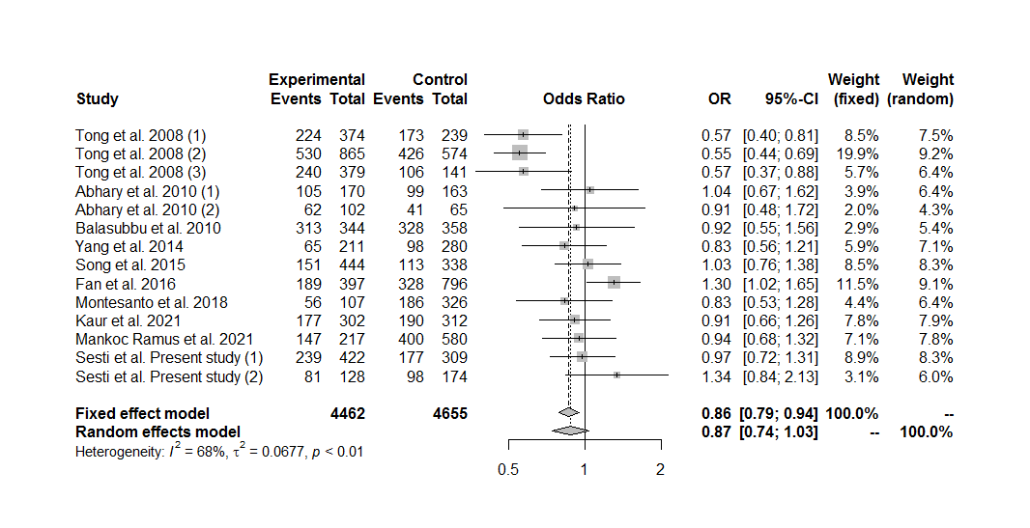
Figure S1. Forest plot of the association between the EPO rs1617640 polymorphism and diabetic retinopathy in the overall group analysis, under the dominant genetic model for the minor allele (GG+TG vs. TT).

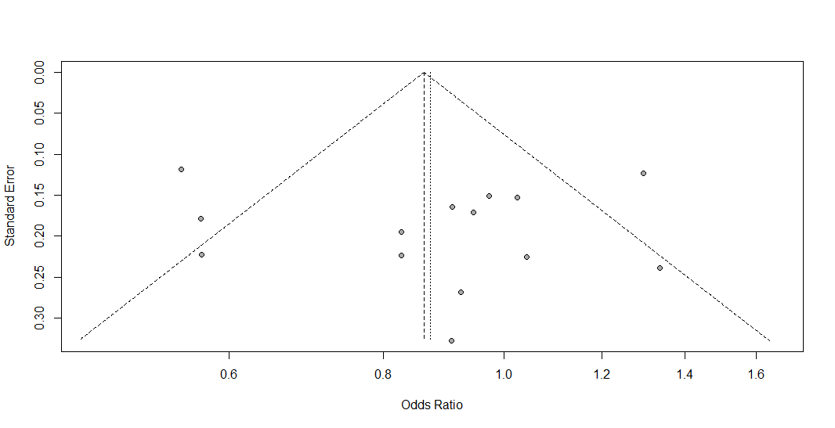
Figure S2. Funnel plot of the association between the EPO rs1617640 polymorphism and diabetic retinopathy in the overall group analysis, under the dominant genetic model for the minor allele (GG+TG vs. TT).

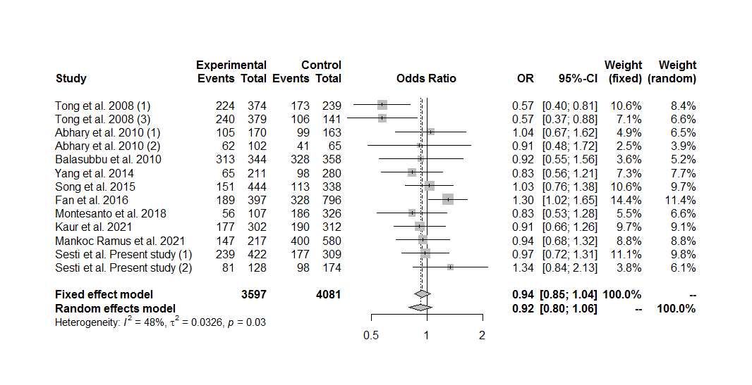
Figure S3. Forest plot of the association between the EPO rs1617640 polymorphism and diabetic retinopathy in the overall group analysis without the cohort #2 by Tong et al. (2008), under the dominant genetic model for the minor allele (GG+TG vs. TT).

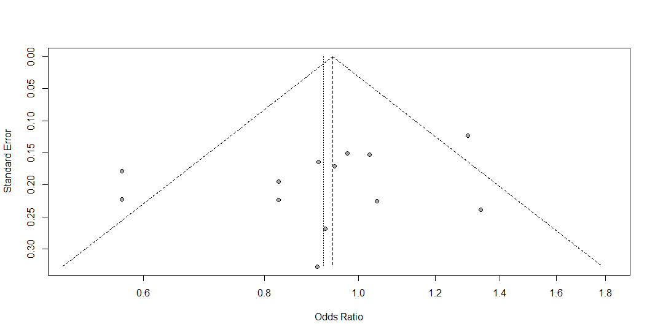
Figure S4. Funnel plot of the association between the EPO rs1617640 polymorphism and diabetic retinopathy in the overall group analysis without the cohort #2 by Tong et al. (2008), under the dominant genetic model for the minor allele (GG+TG vs. TT).

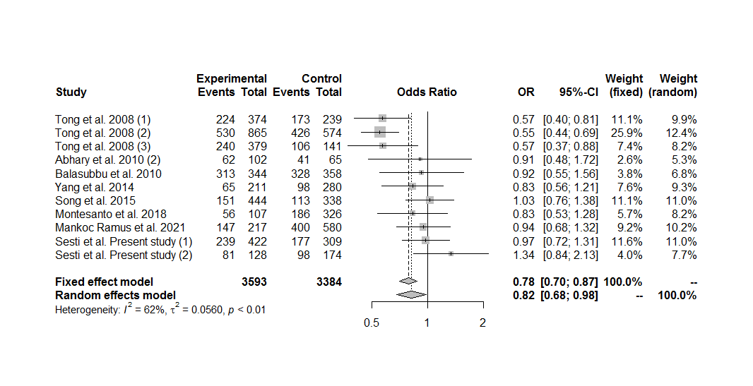
Figure S5. Forest plot of the association between the EPO rs1617640 polymorphism and diabetic retinopathy in the overall group analysis including only the sets with controls in Hardy-Weinberg equilibrium, under the dominant genetic model for the minor allele (GG+TG vs. TT).

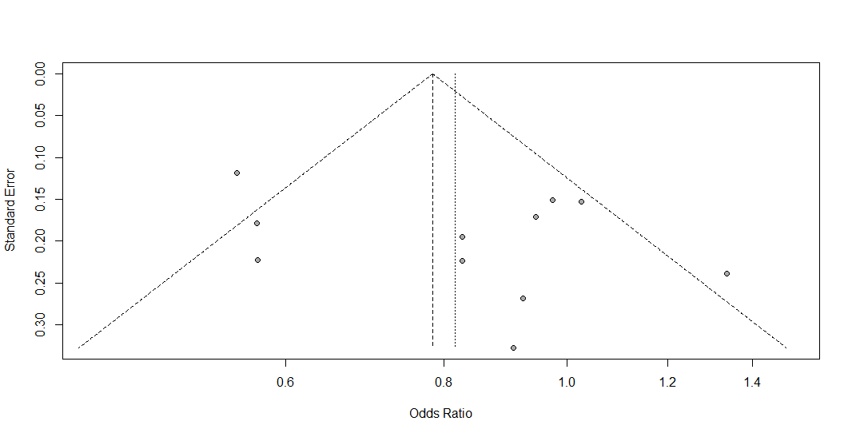
Figure S6. Funnel plot of the association between the EPO rs1617640 polymorphism and diabetic retinopathy in the overall group analysis including only the sets with controls in Hardy-Weinberg equilibrium, under the dominant genetic model for the minor allele (GG+TG vs. TT).

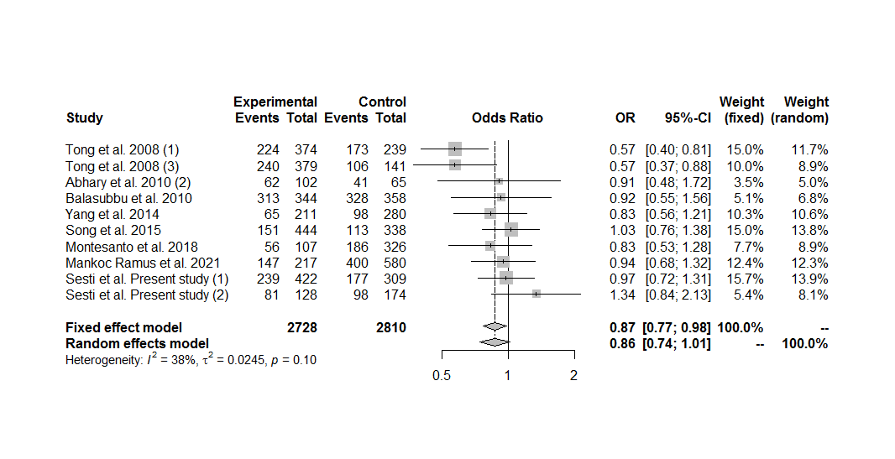
Figure S7. Forest plot of the association between the EPO rs1617640 polymorphism and diabetic retinopathy in the overall group analysis, including only the sets with controls in Hardy-Weinberg equilibrium and excluding the cohort #2 by Tong et al. (2008), under the dominant genetic model for the minor allele (GG+TG vs. TT).

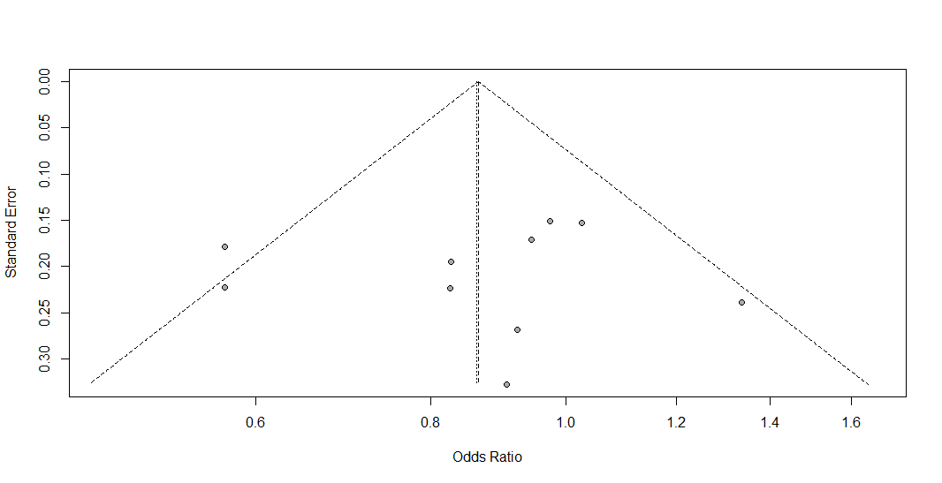
Figure S8. Funnel plot of the association between the EPO rs1617640 polymorphism and diabetic retinopathy in the overall group analysis, including only the sets with controls in Hardy-Weinberg equilibrium and excluding the cohort #2 by Tong et al. (2008), under the dominant genetic model for the minor allele (GG+TG vs. TT).

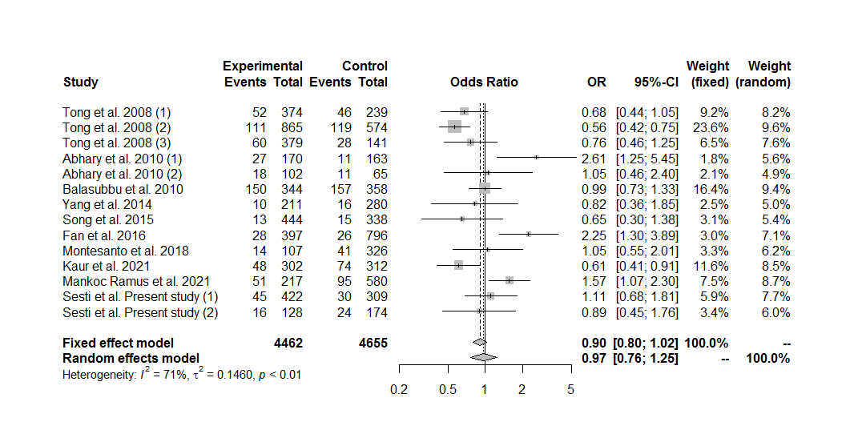
Figure S9. Forest plot of the association between the EPO rs1617640 polymorphism and diabetic retinopathy in the overall group analysis, under the recessive genetic model for the minor allele (GG vs. TG+TT).

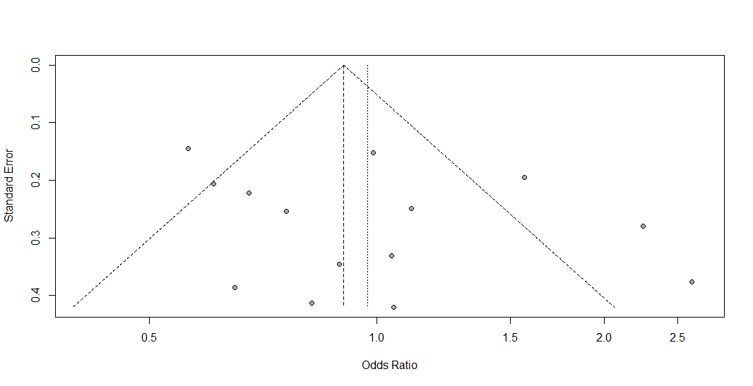
Figure S10. Funnel plot of the association between the EPO rs1617640 polymorphism and diabetic retinopathy in the overall group analysis, under the recessive genetic model for the minor allele (GG vs. TG+TT).

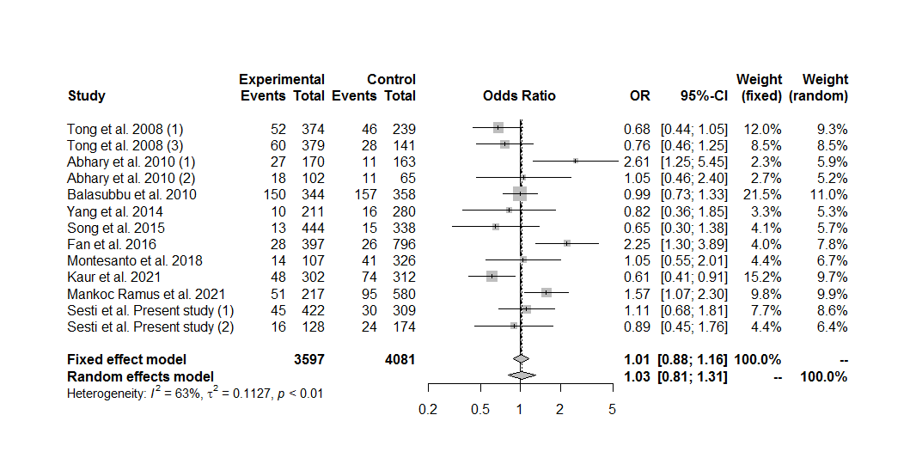
Figure S11. Forest plot of the association between the EPO rs1617640 polymorphism and diabetic retinopathy in the overall group analysis without the cohort #2 by Tong et al. (2008), under the recessive genetic model for the minor allele (GG vs. TG+TT).

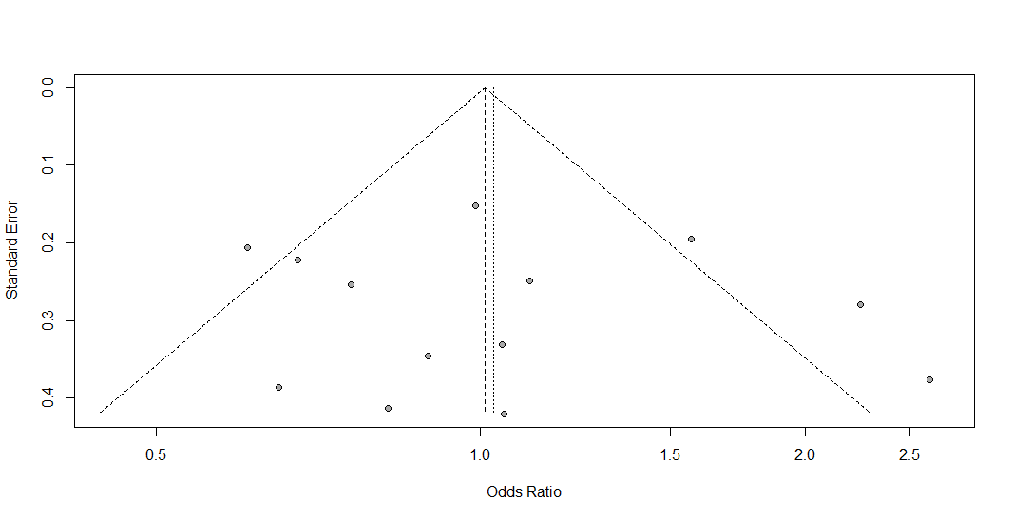
Figure S12. Funnel plot of the association between the EPO rs1617640 polymorphism and diabetic retinopathy in the overall group analysis without the cohort #2 by Tong et al. (2008), under the recessive genetic model for the minor allele (GG vs. TG+TT).

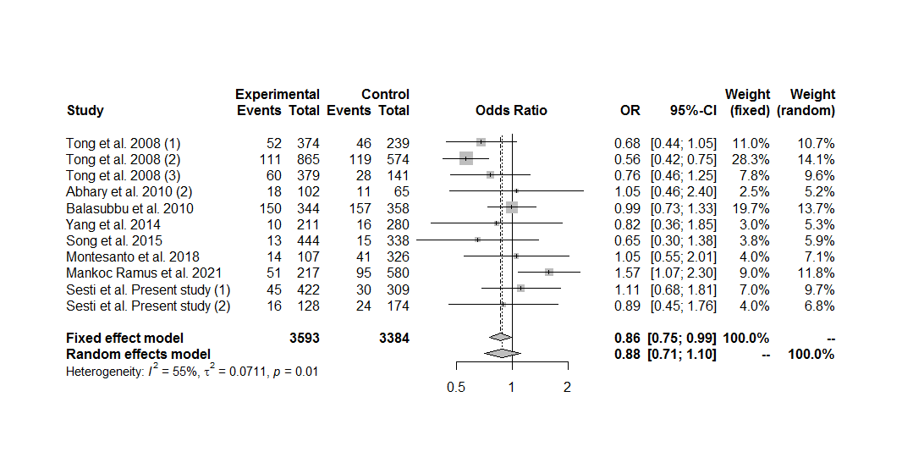
Figure S13. Forest plot of the association between the EPO rs1617640 polymorphism and diabetic retinopathy in the overall group analysis including only the sets with controls in Hardy-Weinberg equilibrium, under the recessive genetic model for the minor allele (GG vs. TG+TT).

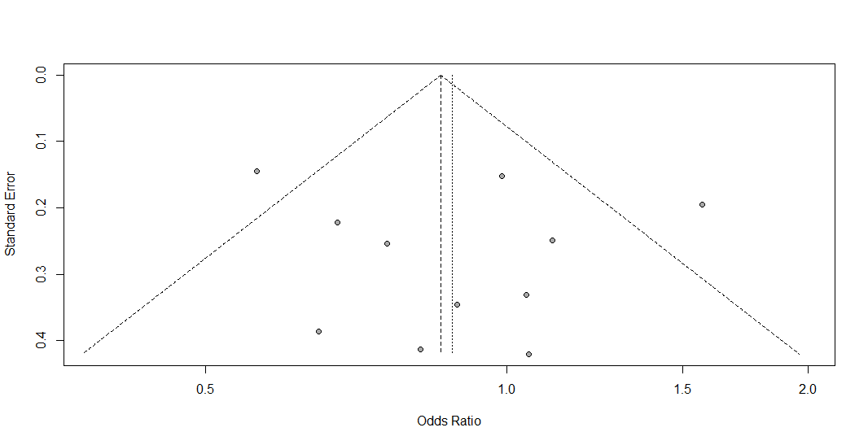
Figure S14. Funnel plot of the association between the EPO rs1617640 polymorphism and diabetic retinopathy in the overall group analysis including only the sets with controls in Hardy-Weinberg equilibrium, under the recessive genetic model for the minor allele (GG vs. TG+TT).

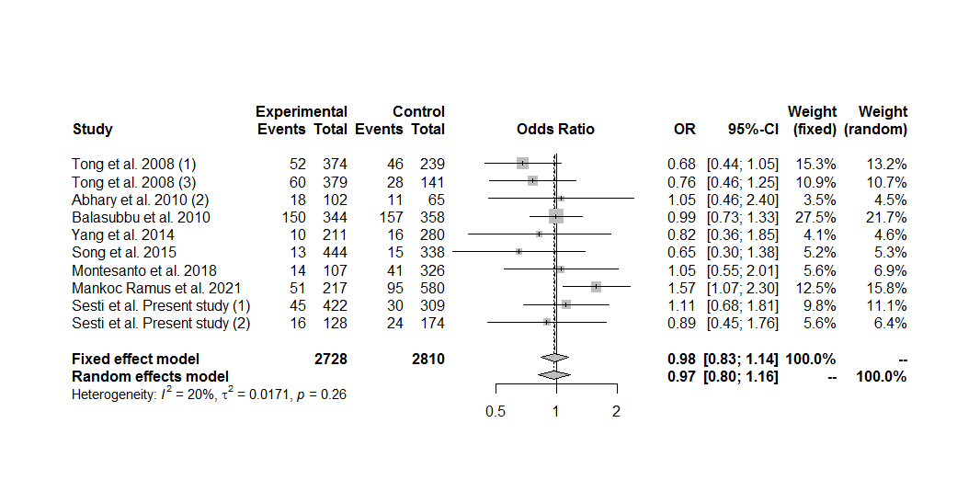
Figure S15. Forest plot of the association between the EPO rs1617640 polymorphism and diabetic retinopathy in the overall group analysis, including only the sets with controls in Hardy-Weinberg equilibrium and excluding the cohort #2 by Tong et al. (2008), under the recessive genetic model for the minor allele (GG vs. TG+TT).

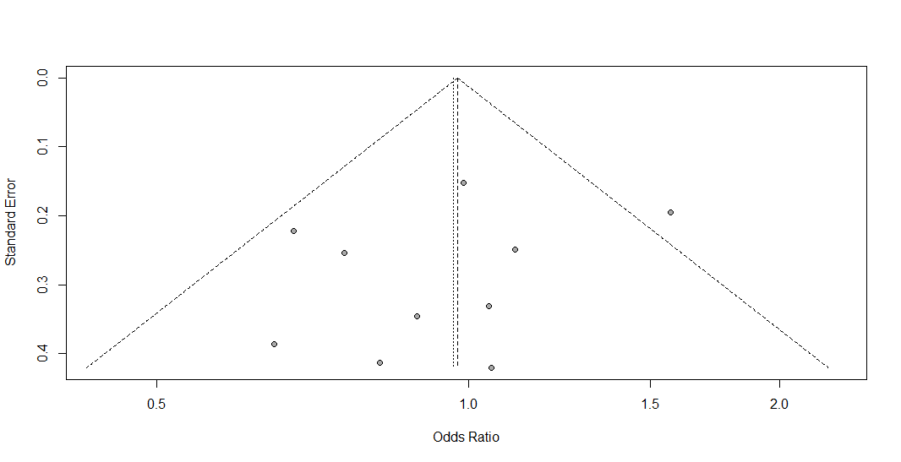
Figure S16. Funnel plot of the association between the EPO rs1617640 polymorphism and diabetic retinopathy in the overall group analysis, including only the sets with controls in Hardy-Weinberg equilibrium and excluding the cohort #2 by Tong et al. (2008), under the recessive genetic model for the minor allele (GG vs. TG+TT).

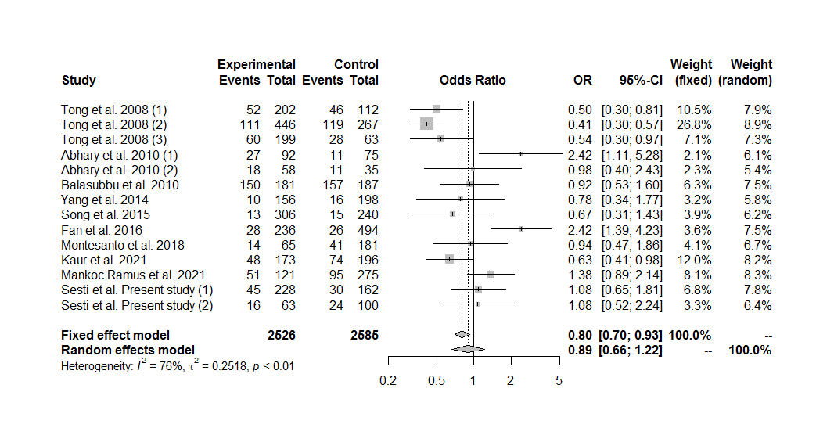
Figure S17. Forest plot of the association between the EPO rs1617640 polymorphism and diabetic retinopathy in the overall group analysis, under the homozygous additive genetic model for the minor allele (GG vs. TT).

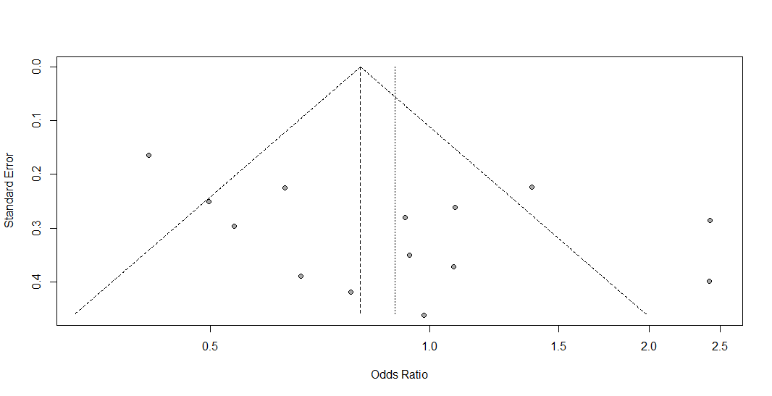
Figure S18. Funnel plot of the association between the EPO rs1617640 polymorphism and diabetic retinopathy in the overall group analysis, under the homozygous additive genetic model for the minor allele (GG vs. TT).

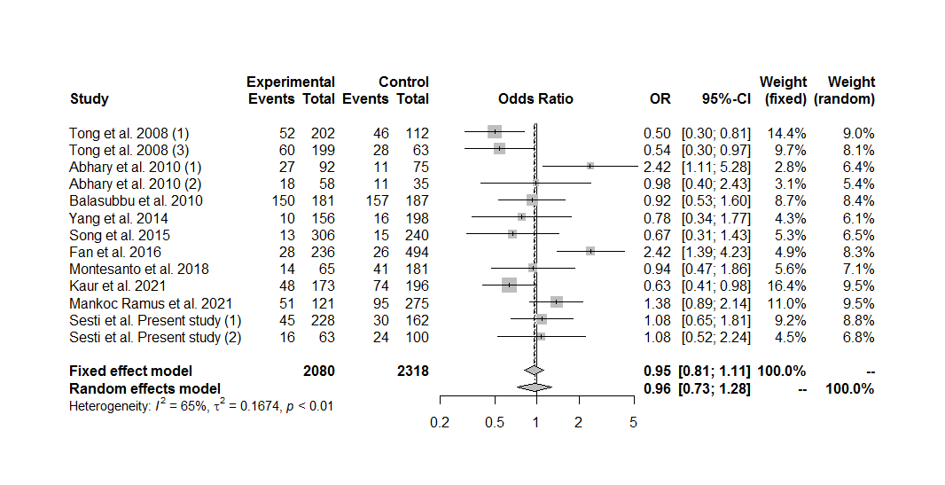
Figure S19. Forest plot of the association between the EPO rs1617640 polymorphism and diabetic retinopathy in the overall group analysis without the cohort #2 by Tong et al. (2008), under the homozygous additive genetic model for the minor allele (GG vs. TT).

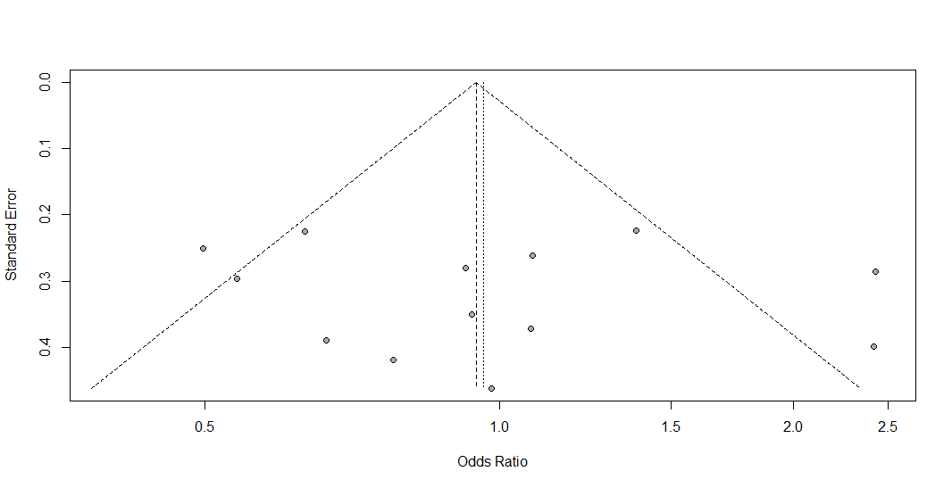
Figure S20. Funnel plot of the association between the EPO rs1617640 polymorphism and diabetic retinopathy in the overall group analysis without the cohort #2 by Tong et al. (2008), under the homozygous additive genetic model for the minor allele (GG vs. TT).

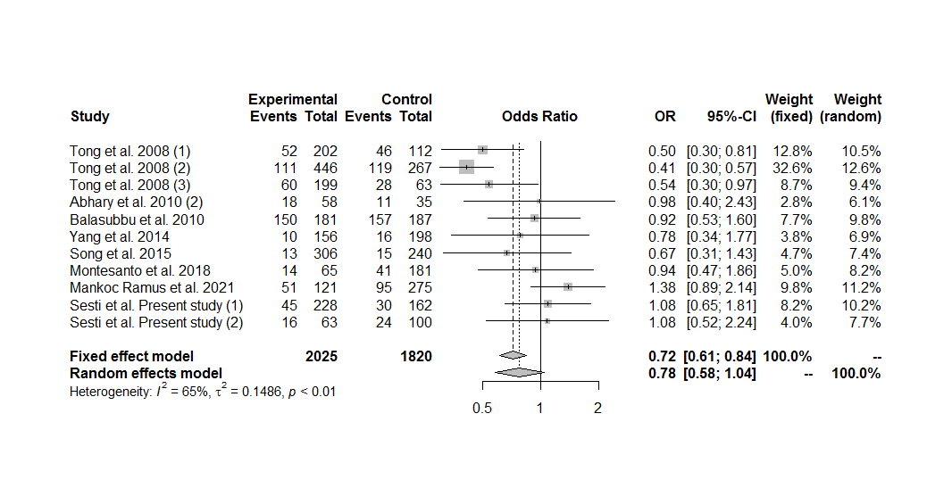
Figure S21. Forest plot of the association between the EPO rs1617640 polymorphism and diabetic retinopathy in the overall group analysis including only the sets with controls in Hardy-Weinberg equilibrium, under the homozygous additive genetic model for the minor allele (GG vs. TT).

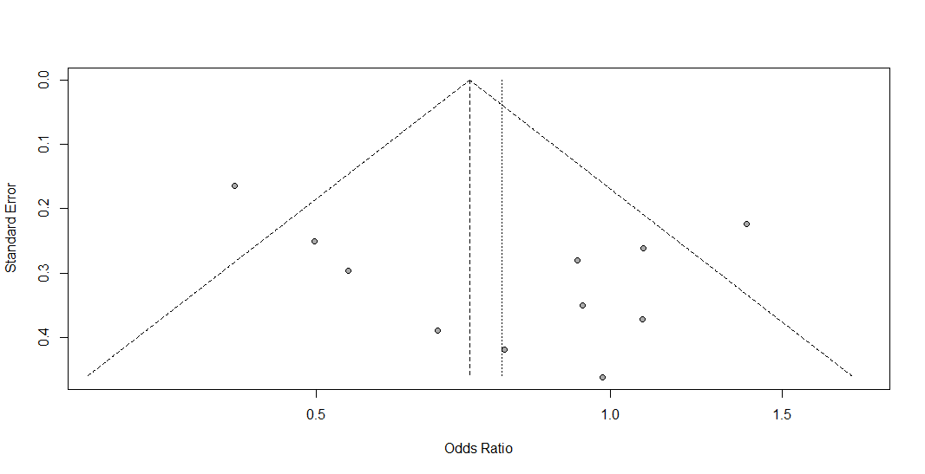
Figure S22. Funnel plot of the association between the EPO rs1617640 polymorphism and diabetic retinopathy in the overall group analysis including only the sets with controls in Hardy-Weinberg equilibrium, under the homozygous additive genetic model for the minor allele (GG vs. TT).

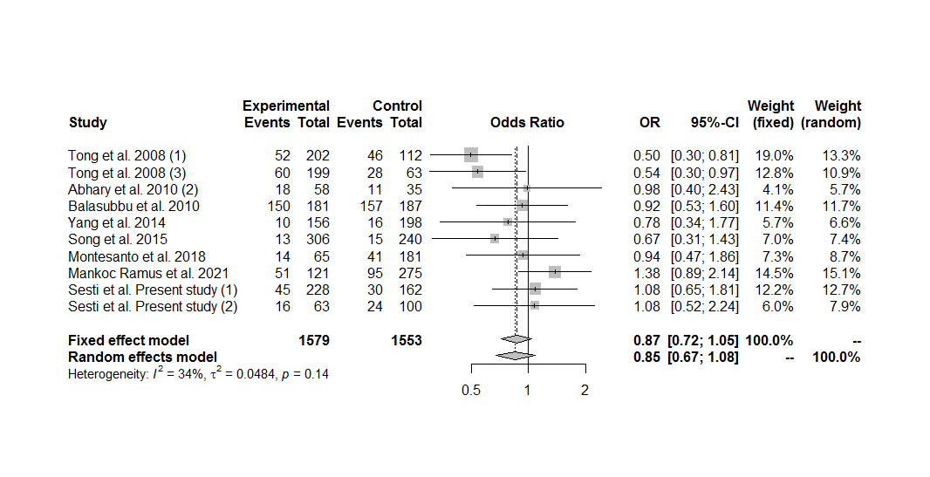
Figure S23. Forest plot of the association between the EPO rs1617640 polymorphism and diabetic retinopathy in the overall group analysis, including only the sets with controls in Hardy-Weinberg equilibrium and excluding the cohort #2 by Tong et al. (2008), under the homozygous additive genetic model for the minor allele (GG vs. TT).

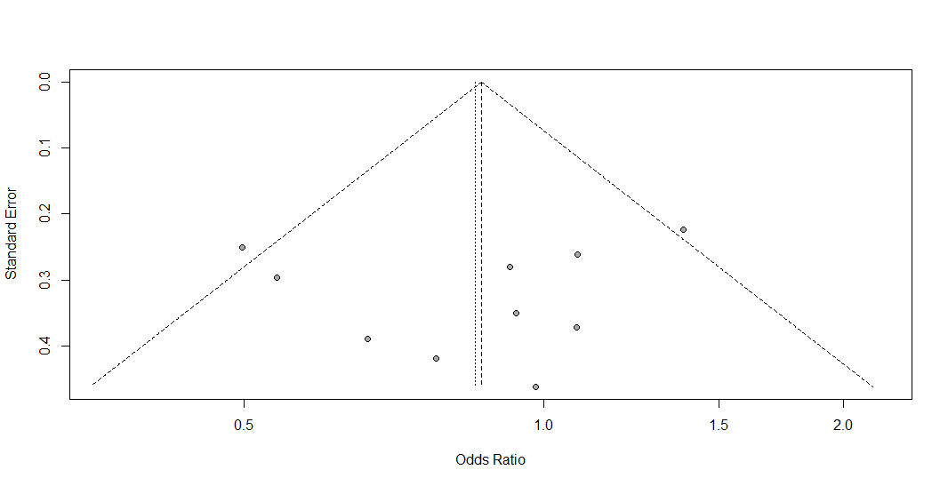
Figure S24. Funnel plot of the association between the EPO rs1617640 polymorphism and diabetic retinopathy in the overall group analysis, including only the sets with controls in Hardy-Weinberg equilibrium and excluding the cohort #2 by Tong et al. (2008), under the homozygous additive genetic model for the minor allele (GG vs. TT).

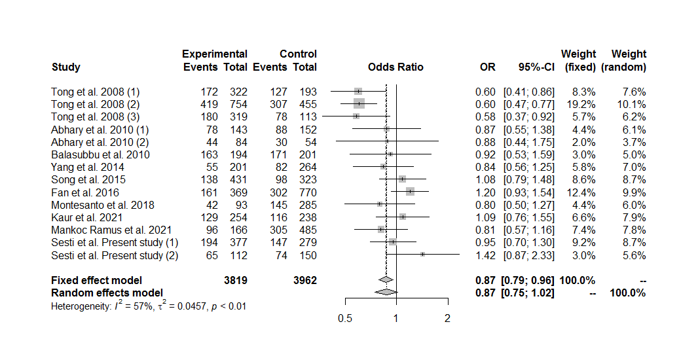
Figure S25. Forest plot of the association between the EPO rs1617640 polymorphism and diabetic retinopathy in the overall group analysis, under the heterozygous additive genetic model for the minor allele (TG vs. TT).

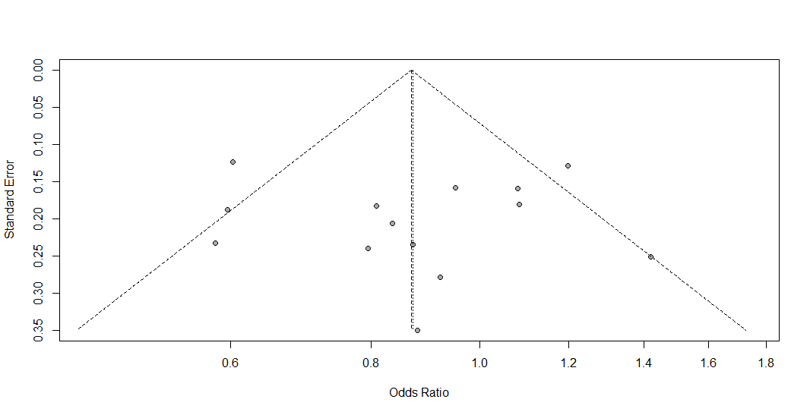
Figure S26. Funnel plot of the association between the EPO rs1617640 polymorphism and diabetic retinopathy in the overall group analysis, under the heterozygous additive genetic model for the minor allele (TG vs. TT).

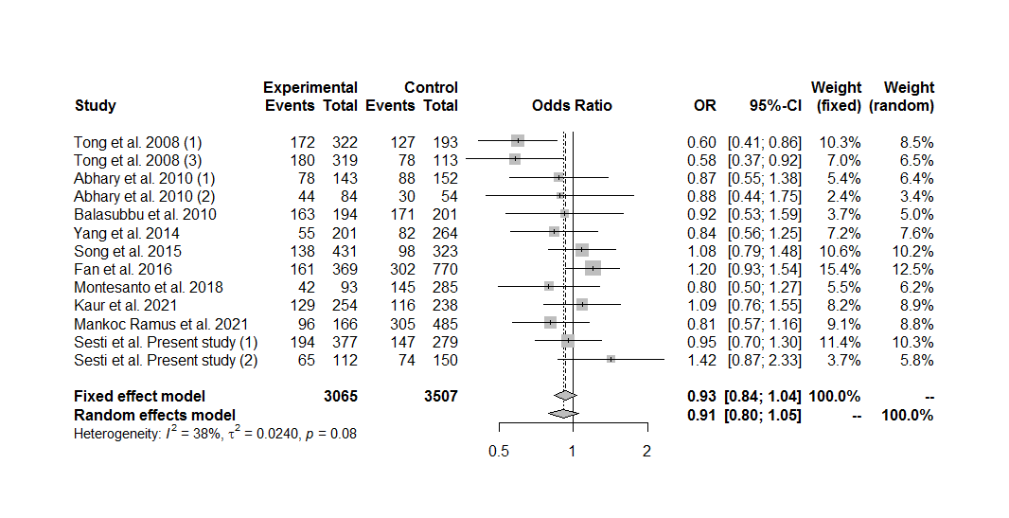
Figure S27. Forest plot of the association between the EPO rs1617640 polymorphism and diabetic retinopathy in the overall group analysis without the cohort #2 by Tong et al. (2008), under the heterozygous additive genetic model for the minor allele (TG vs. TT).

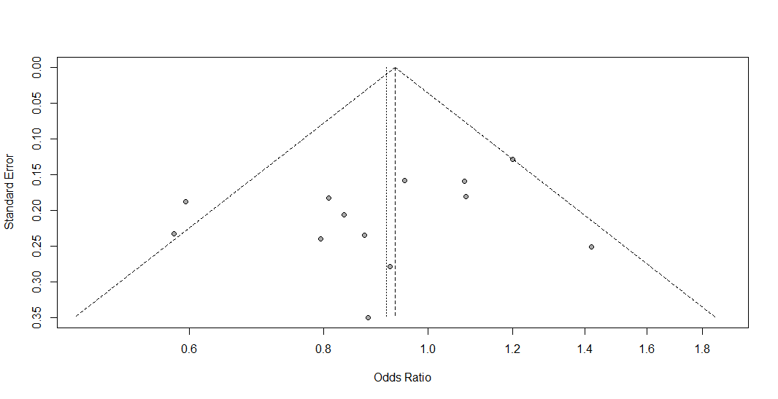
Figure S28. Funnel plot of the association between the EPO rs1617640 polymorphism and diabetic retinopathy in the overall group analysis without the cohort #2 by Tong et al. (2008), under the heterozygous additive genetic model for the minor allele (TG vs. TT).

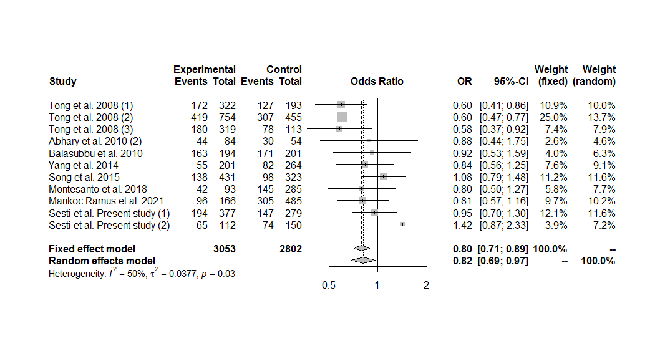
Figure S29. Forest plot of the association between the EPO rs1617640 polymorphism and diabetic retinopathy in the overall group analysis including only the sets with controls in Hardy-Weinberg equilibrium, under the heterozygous additive genetic model for the minor allele (TG vs. TT).

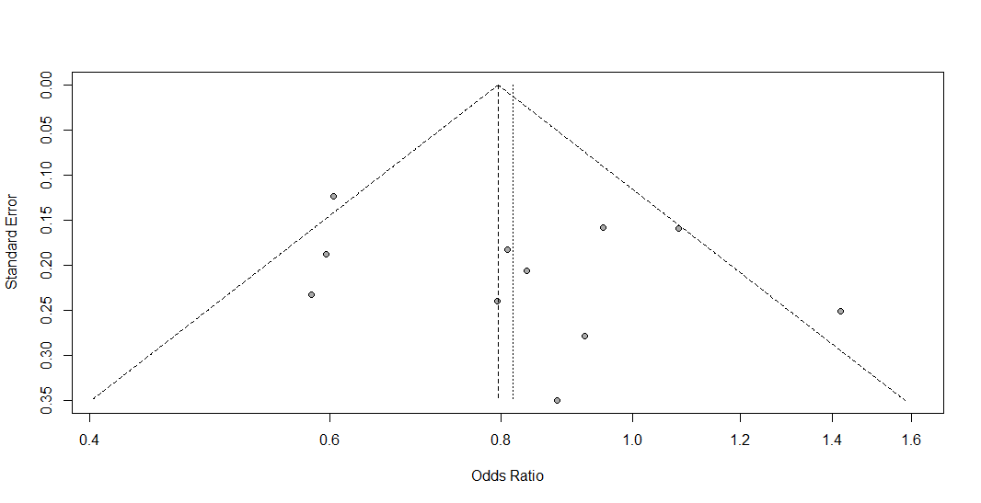
Figure S30. Funnel plot of the association between the EPO rs1617640 polymorphism and diabetic retinopathy in the overall group analysis including only the sets with controls in Hardy-Weinberg equilibrium, under the heterozygous additive genetic model for the minor allele (TG vs. TT).

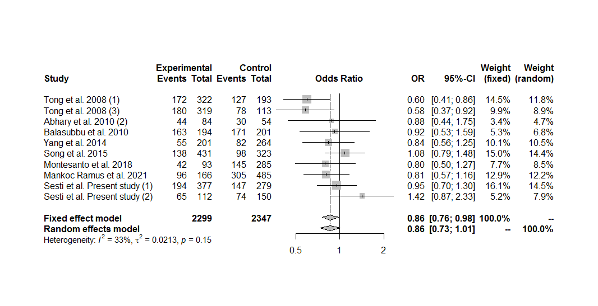
Figure S31. Forest plot of the association between the EPO rs1617640 polymorphism and diabetic retinopathy in the overall group analysis, including only the sets with controls in Hardy-Weinberg equilibrium and excluding the cohort #2 by Tong et al. (2008), under the heterozygous additive genetic model for the minor allele (TG vs. TT).

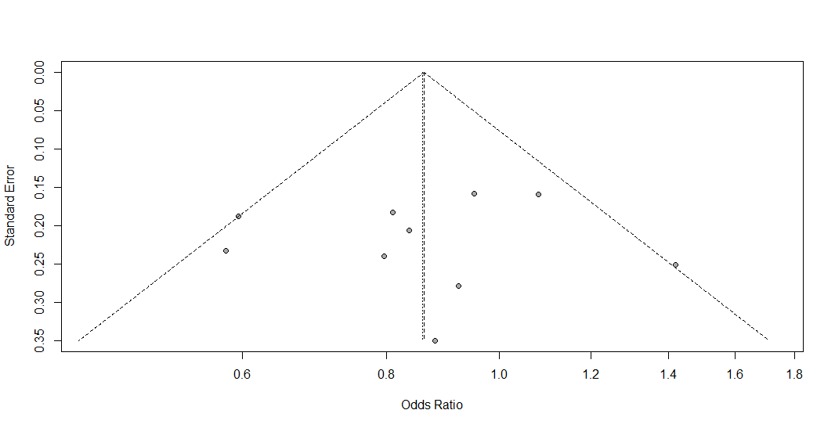
Figure S32. Funnel plot of the association between the EPO rs1617640 polymorphism and diabetic retinopathy in the overall group analysis, including only the sets with controls in Hardy-Weinberg equilibrium and excluding the cohort #2 by Tong et al. (2008), under the heterozygous additive genetic model for the minor allele (TG vs. TT).

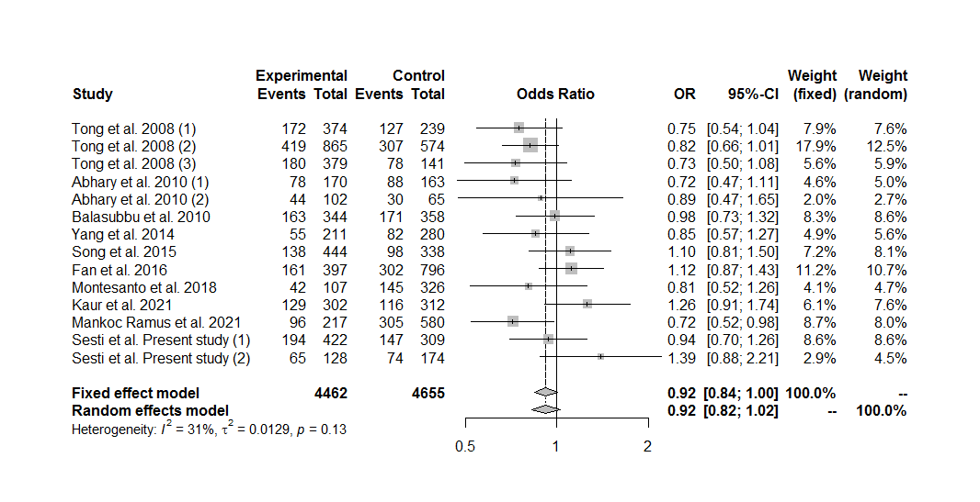
Figure S33. Forest plot of the association between the EPO rs1617640 polymorphism and diabetic retinopathy in the overall group analysis, under the overdominant genetic model (TG vs. GG+TT).

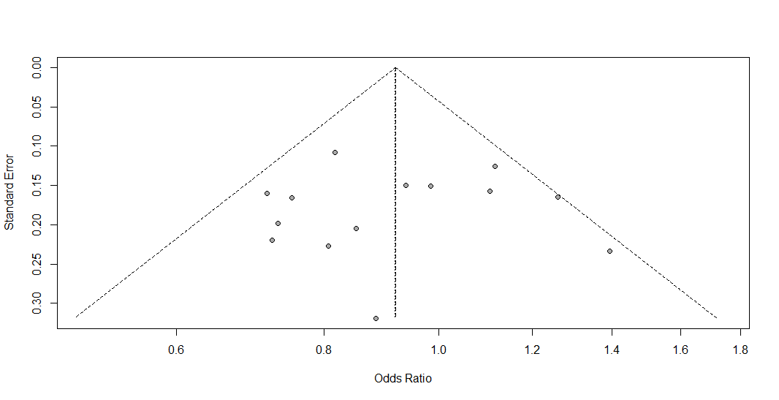
Figure S34. Funnel plot of the association between the EPO rs1617640 polymorphism and diabetic retinopathy in the overall group analysis, under the overdominant genetic model (TG vs. GG+TT).

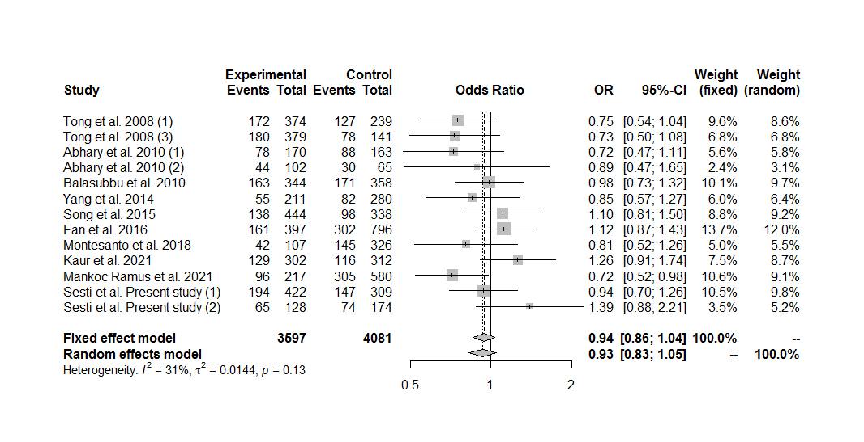
Figure S35. Forest plot of the association between the EPO rs1617640 polymorphism and diabetic retinopathy in the overall group analysis without the cohort #2 by Tong et al. (2008), under the overdominant genetic model (TG vs. GG+TT).

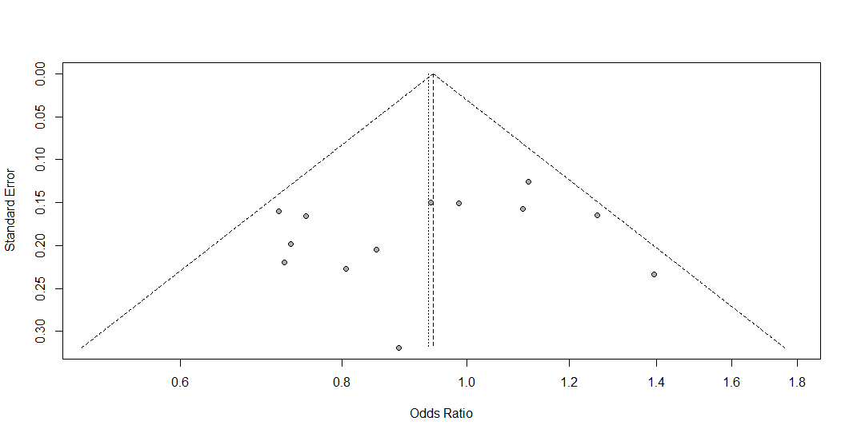
Figure S36. Funnel plot of the association between the EPO rs1617640 polymorphism and diabetic retinopathy in the overall group analysis without the cohort #2 by Tong et al. (2008), under the overdominant genetic model (TG vs. GG+TT).

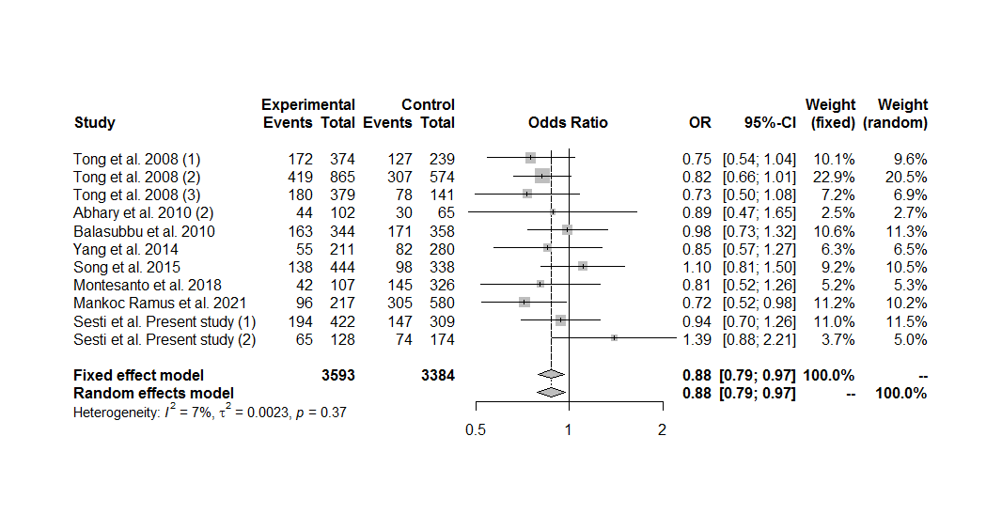
Figure S37. Forest plot of the association between the EPO rs1617640 polymorphism and diabetic retinopathy in the overall group analysis including only the sets with controls in Hardy-Weinberg equilibrium, under the overdominant genetic model (TG vs. GG+TT).

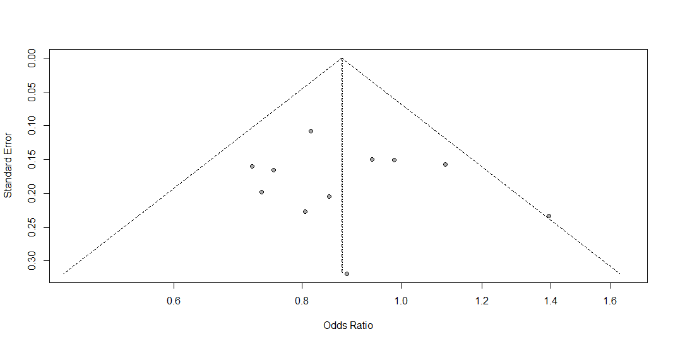
Figure S38. Funnel plot of the association between the EPO rs1617640 polymorphism and diabetic retinopathy in the overall group analysis including only the sets with controls in Hardy-Weinberg equilibrium, under the overdominant genetic model (TG vs. GG+TT).

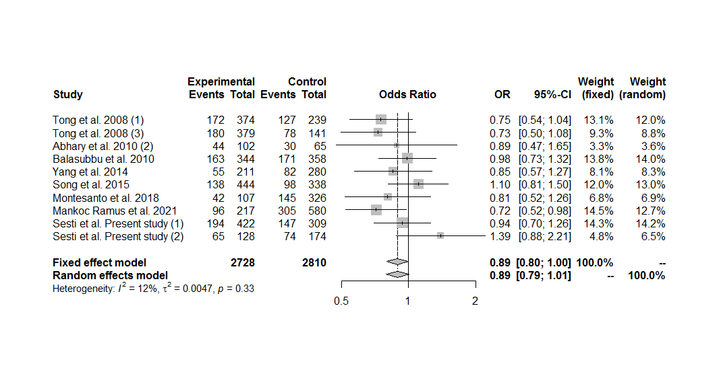
Figure S39. Forest plot of the association between the EPO rs1617640 polymorphism and diabetic retinopathy in the overall group analysis, including only the sets with controls in Hardy-Weinberg equilibrium and excluding the cohort #2 by Tong et al. (2008), under the overdominant genetic model (TG vs. GG+TT).

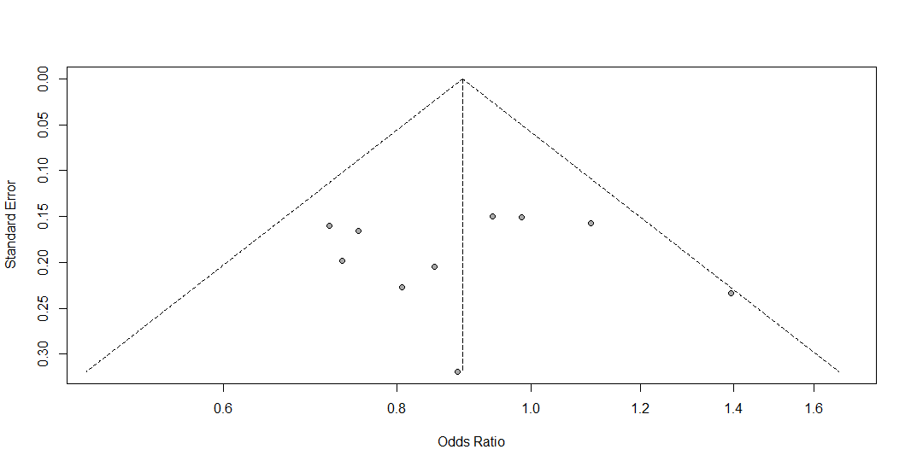
Figure S40. Funnel plot of the association between the EPO rs1617640 polymorphism and diabetic retinopathy in the overall group analysis, including only the sets with controls in Hardy-Weinberg equilibrium and excluding the cohort #2 by Tong et al. (2008), under the overdominant genetic model (TG vs. GG+TT).

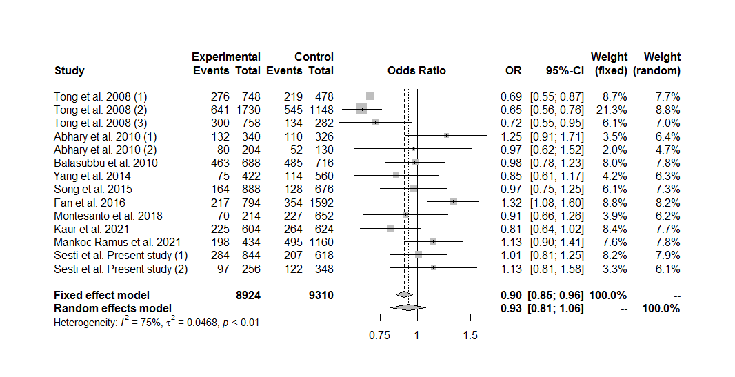
Figure S41. Forest plot of the association between the EPO rs1617640 polymorphism and diabetic retinopathy in the overall group analysis, under the allele contrast genetic model (G vs. T).

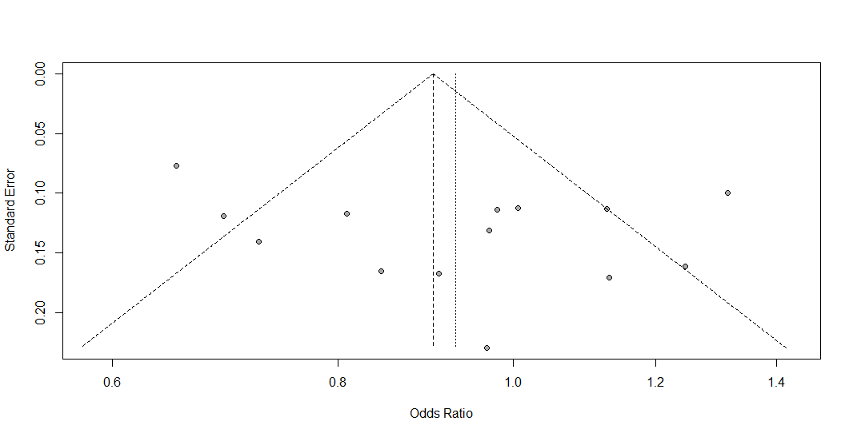
Figure S42. Funnel plot of the association between the EPO rs1617640 polymorphism and diabetic retinopathy in the overall group analysis, under the allele contrast genetic model (G vs. T).

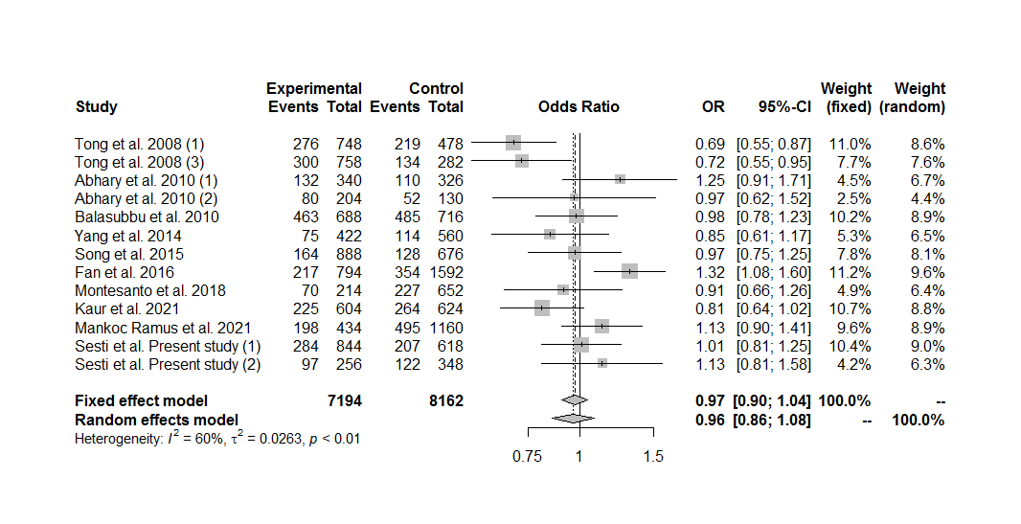
Figure S43. Forest plot of the association between the EPO rs1617640 polymorphism and diabetic retinopathy in the overall group analysis without the cohort #2 by Tong et al. (2008), under the allele contrast genetic model (G vs. T).

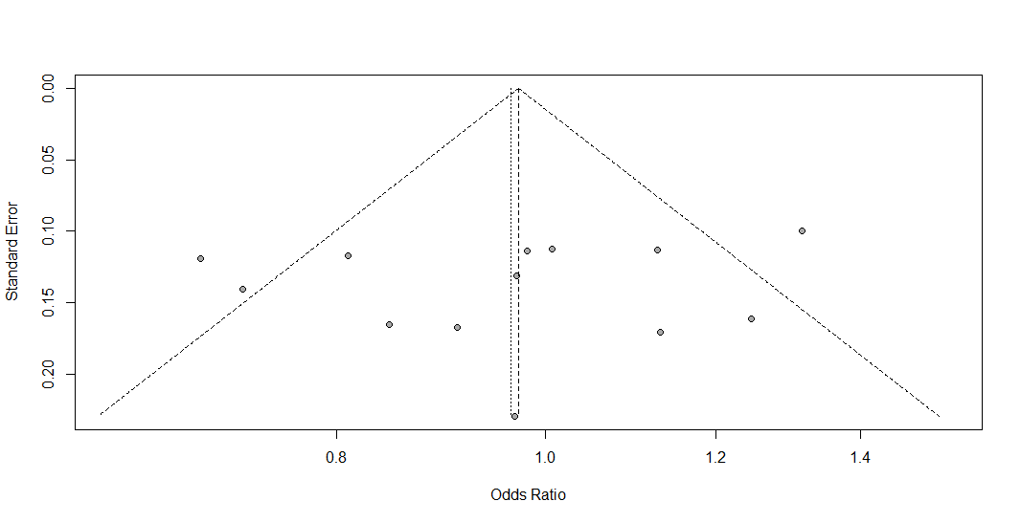
Figure S44. Funnel plot of the association between the EPO rs1617640 polymorphism and diabetic retinopathy in the overall group analysis without the cohort #2 by Tong et al. (2008), under the allele contrast genetic model (G vs. T).

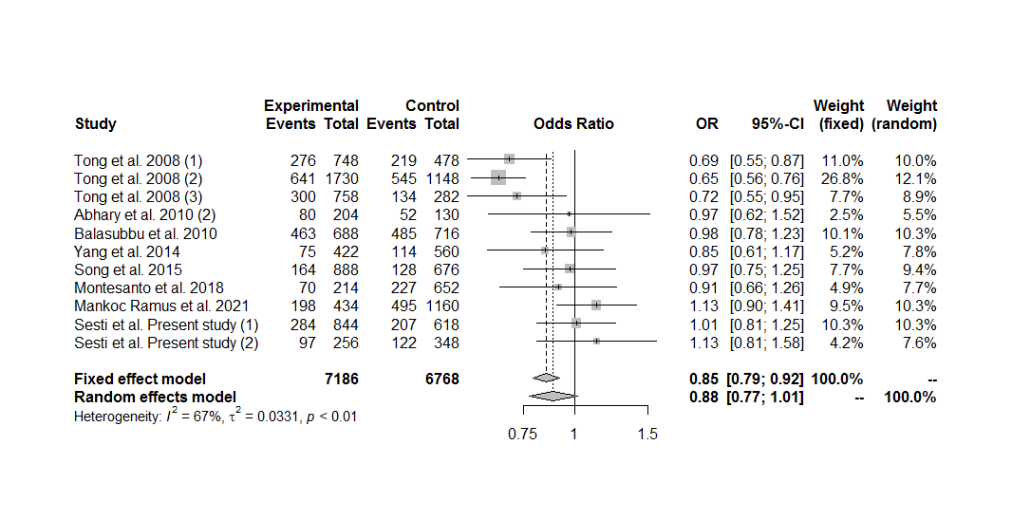
Figure S45. Forest plot of the association between the EPO rs1617640 polymorphism and diabetic retinopathy in the overall group analysis including only the sets with controls in Hardy-Weinberg equilibrium, under the allele contrast genetic model (G vs. T).

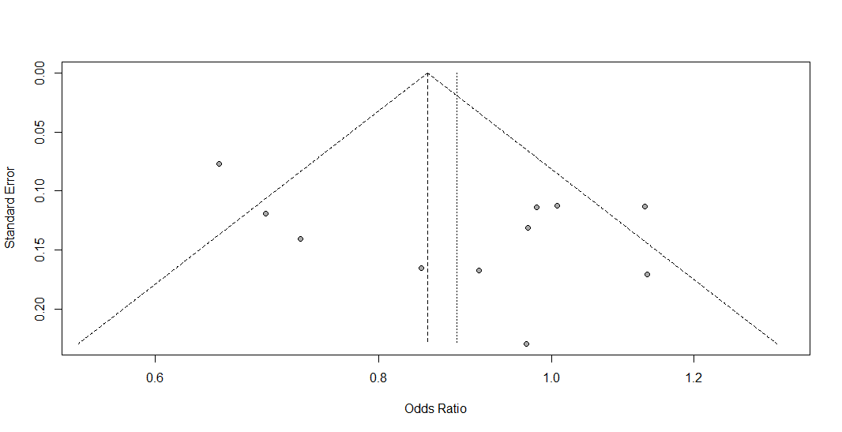
Figure S46. Funnel plot of the association between the EPO rs1617640 polymorphism and diabetic retinopathy in the overall group analysis including only the sets with controls in Hardy-Weinberg equilibrium, under the allele contrast genetic model (G vs. T).

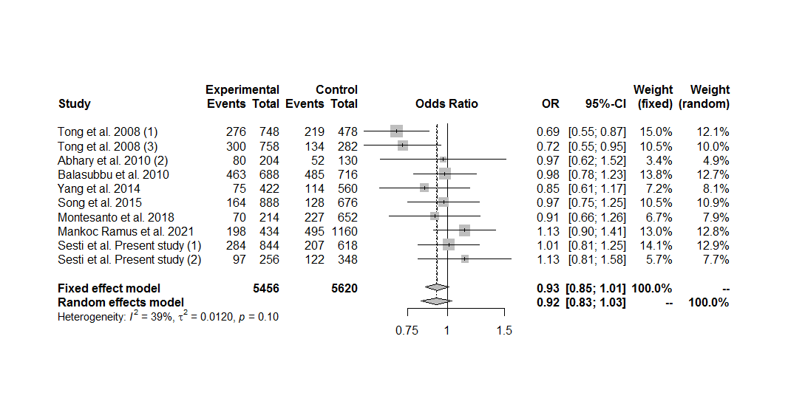
Figure S47. Forest plot of the association between the EPO rs1617640 polymorphism and diabetic retinopathy in the overall group analysis, including only the sets with controls in Hardy-Weinberg equilibrium and excluding the cohort #2 by Tong et al. (2008), under the allele contrast genetic model (G vs. T).

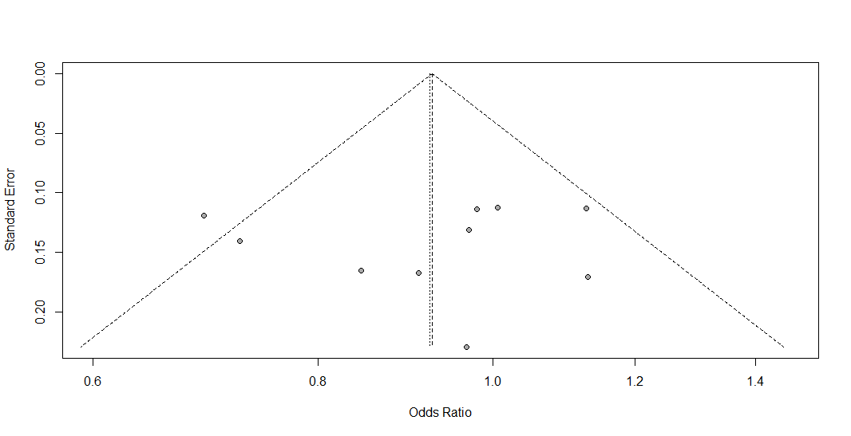
Figure S48. Funnel plot of the association between the EPO rs1617640 polymorphism and diabetic retinopathy in the overall group analysis, including only the sets with controls in Hardy-Weinberg equilibrium and excluding the cohort #2 by Tong et al. (2008), under the allele contrast genetic model (G vs. T).

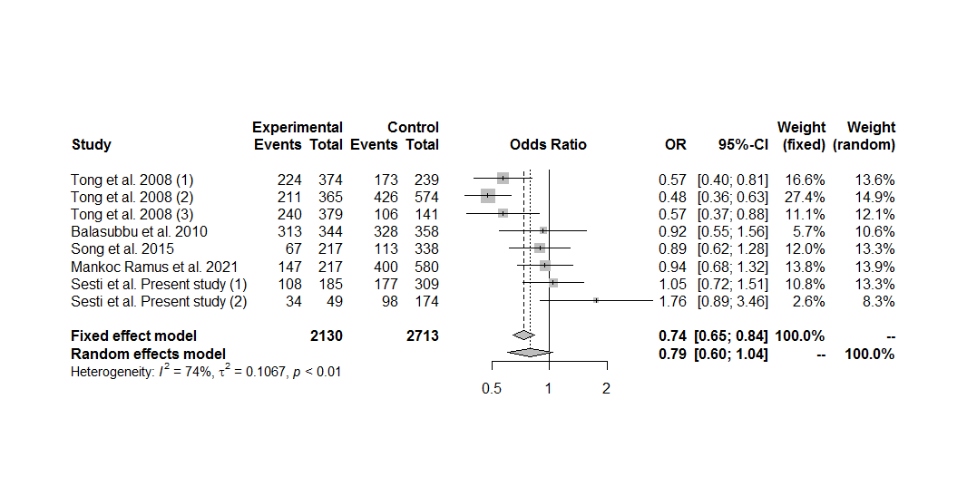
Figure S49. Forest plot of the association between the EPO rs1617640 polymorphism and proliferative diabetic retinopathy, including only the sets with controls in Hardy-Weinberg equilibrium, under the dominant genetic model for the minor allele (GG+TG vs. TT).

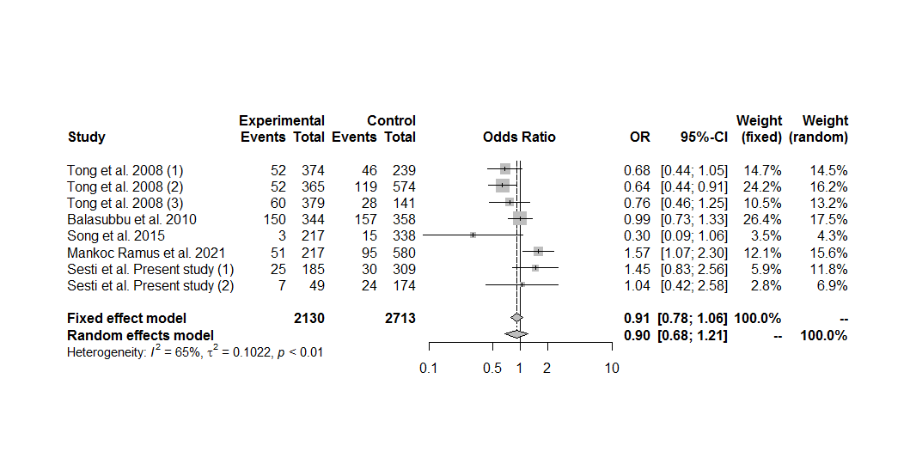
Figure S50. Forest plot of the association between the EPO rs1617640 polymorphism and proliferative diabetic retinopathy, including only the sets with controls in Hardy-Weinberg equilibrium, under the recessive genetic model for the minor allele (GG vs. TG+TT).

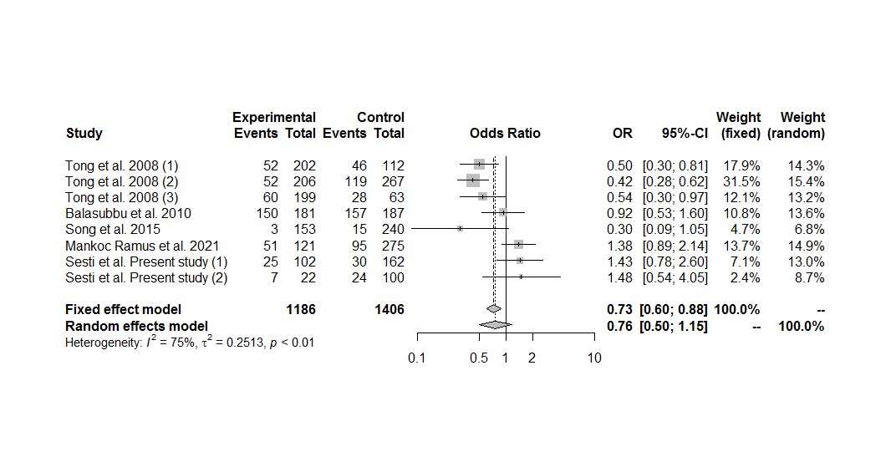
Figure S51. Forest plot of the association between the EPO rs1617640 polymorphism and proliferative diabetic retinopathy, including only the sets with controls in Hardy-Weinberg equilibrium, under the homozygous additive genetic model for the minor allele (GG vs. TT).

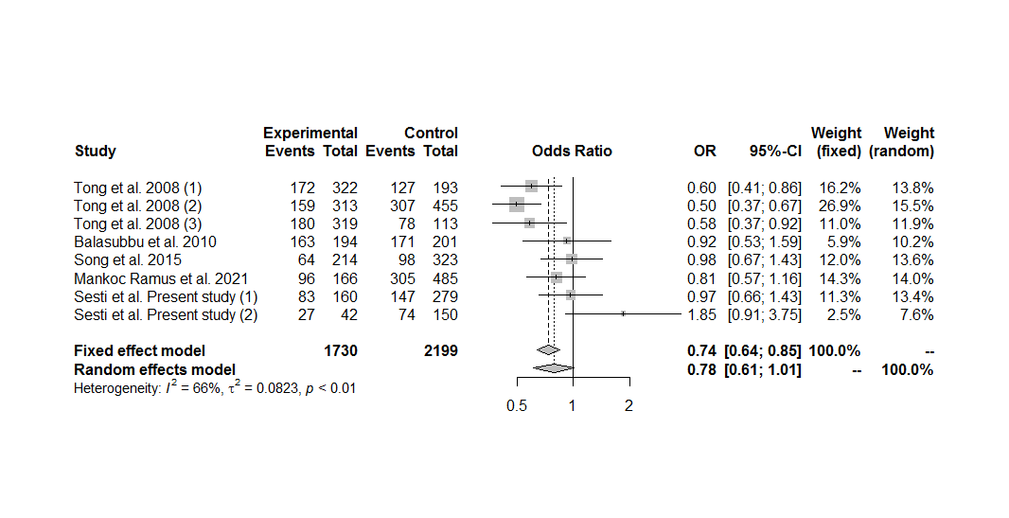
Figure S52. Forest plot of the association between the EPO rs1617640 polymorphism and proliferative diabetic retinopathy, including only the sets with controls in Hardy-Weinberg equilibrium, under the heterozygous additive genetic model for the minor allele (TG vs. TT).

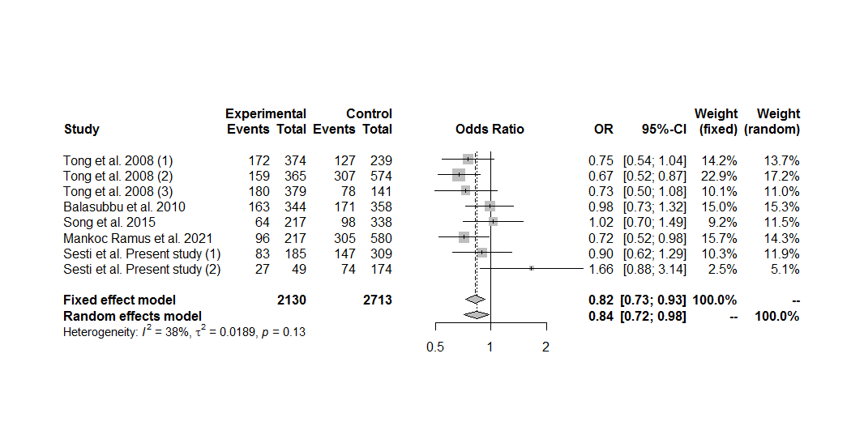
Figure S53. Forest plot of the association between the EPO rs1617640 polymorphism and proliferative diabetic retinopathy, including only the sets with controls in Hardy-Weinberg equilibrium, under the overdominant genetic model (TG vs. GG+TT).

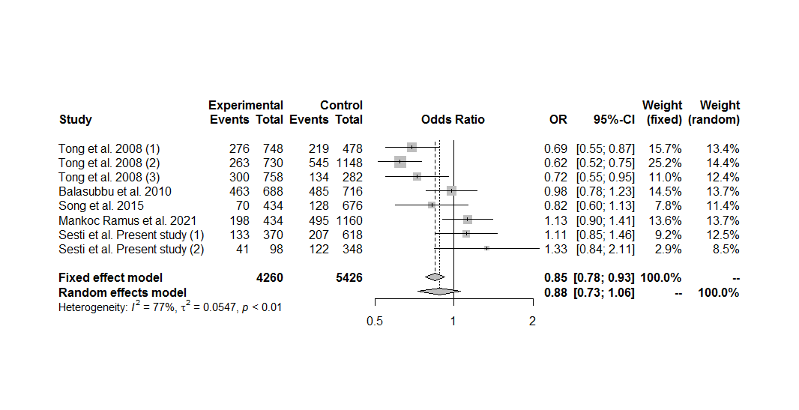
Figure S54. Forest plot of the association between the EPO rs1617640 polymorphism and proliferative diabetic retinopathy, including only the sets with controls in Hardy-Weinberg equilibrium, under the allele contrast genetic model (G vs. T).

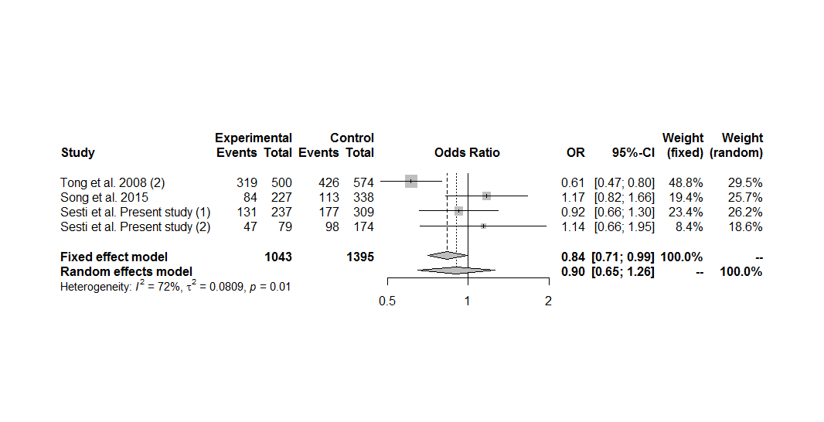
Figure S55. Forest plot of the association between the EPO rs1617640 polymorphism and non-proliferative diabetic retinopathy, including only the sets with controls in Hardy-Weinberg equilibrium, under the dominant genetic model for the minor allele (GG+TG vs. TT).

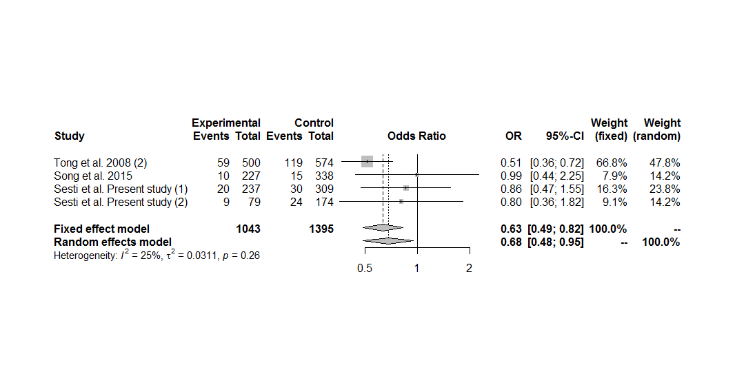
Figure S56. Forest plot of the association between the EPO rs1617640 polymorphism and non-proliferative diabetic retinopathy, including only the sets with controls in Hardy-Weinberg equilibrium, under the recessive genetic model for the minor allele (GG vs. TG+TT).

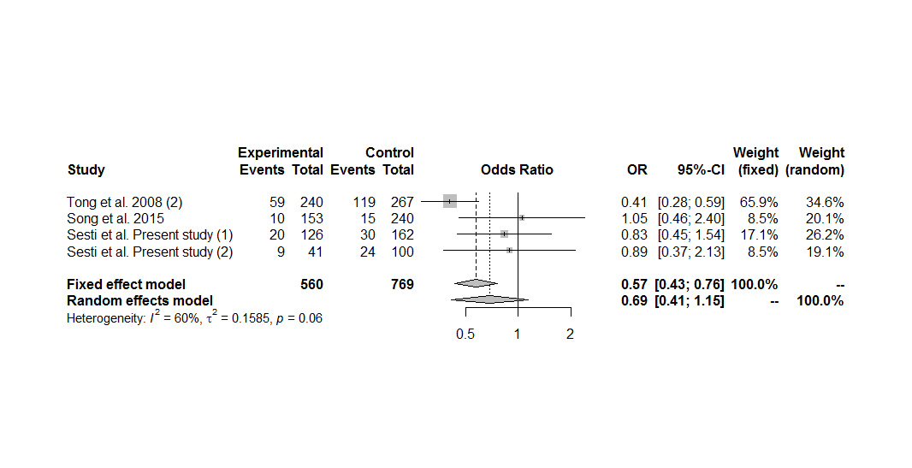
Figure S57. Forest plot of the association between the EPO rs1617640 polymorphism and non-proliferative diabetic retinopathy, including only the sets with controls in Hardy-Weinberg equilibrium, under the homozygous additive genetic model for the minor allele (GG vs. TT).

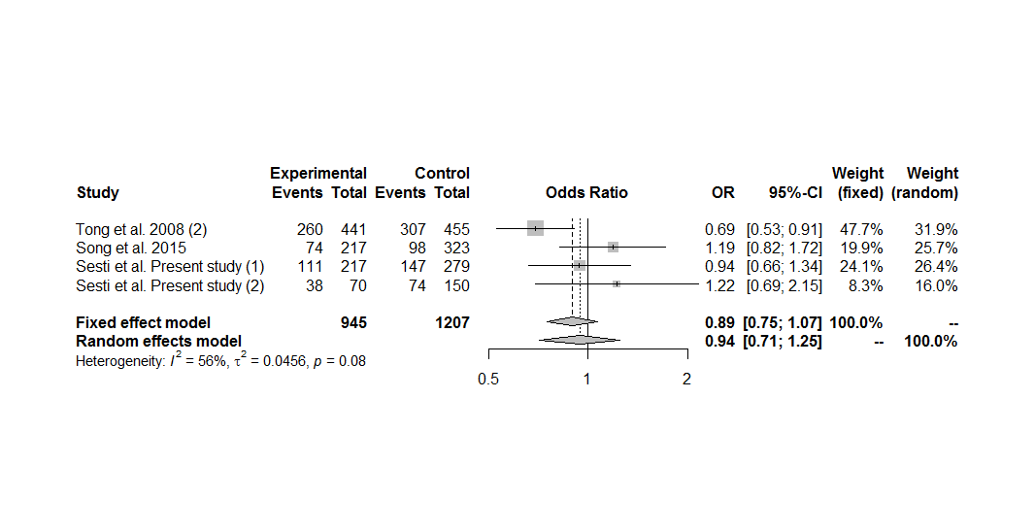
Figure S58. Forest plot of the association between the EPO rs1617640 polymorphism and non-proliferative diabetic retinopathy, including only the sets with controls in Hardy-Weinberg equilibrium, under the heterozygous additive genetic model for the minor allele (TG vs. TT).

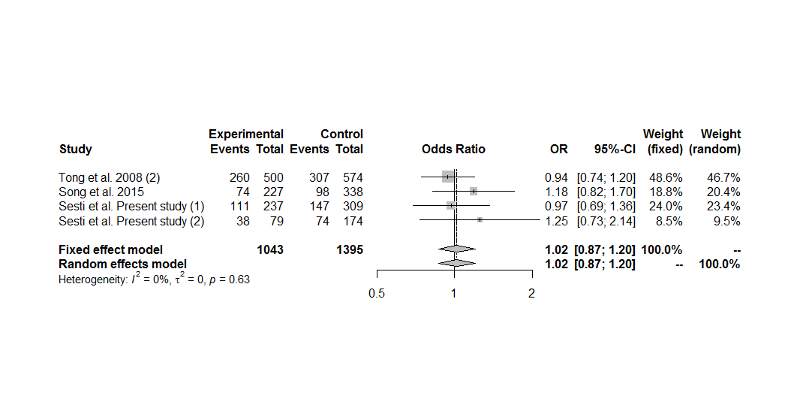
Figure S59. Forest plot of the association between the EPO rs1617640 polymorphism and non-proliferative diabetic retinopathy, including only the sets with controls in Hardy-Weinberg equilibrium, under the overdominant genetic model (TG vs. GG+TT).

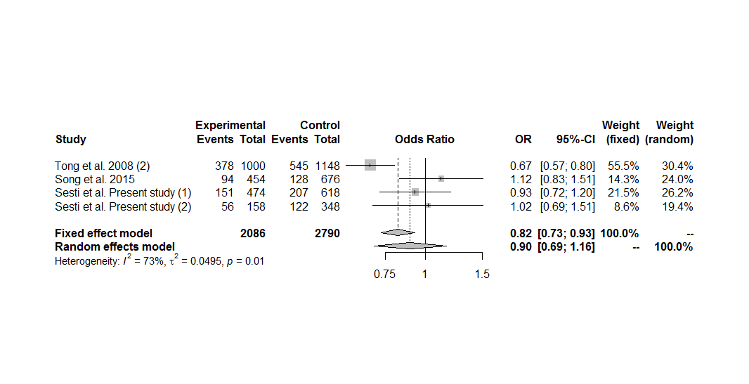
Figure S60. Forest plot of the association between the EPO rs1617640 polymorphism and non-proliferative diabetic retinopathy, including only the sets with controls in Hardy-Weinberg equilibrium, under the allele contrast genetic model (G vs. T).

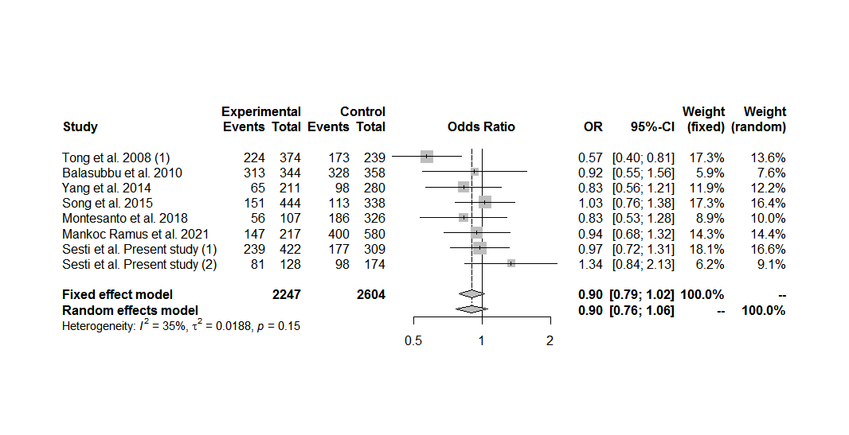
Figure S61. Forest plot of the association between the EPO rs1617640 polymorphism and diabetic retinopathy in subjects with type 2 diabetes, including only the sets with controls in Hardy-Weinberg equilibrium, under the dominant genetic model for the minor allele (GG+TG vs. TT).

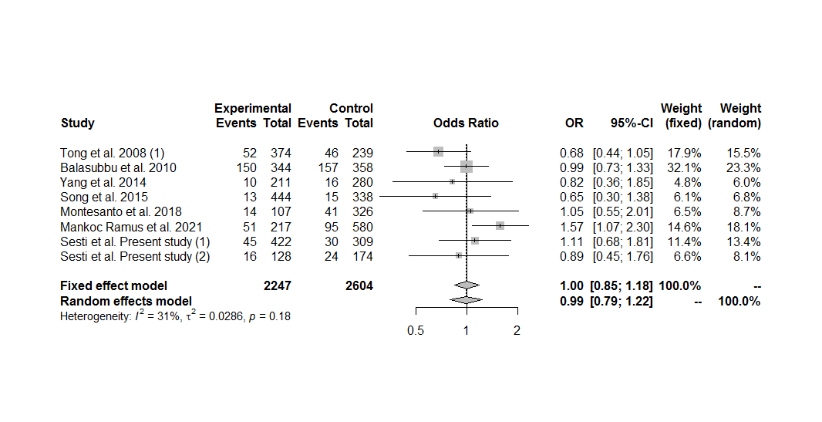
Figure S62. Forest plot of the association between the EPO rs1617640 polymorphism and diabetic retinopathy in subjects with type 2 diabetes, including only the sets with controls in Hardy-Weinberg equilibrium, under the recessive genetic model for the minor allele (GG vs. TG+TT).

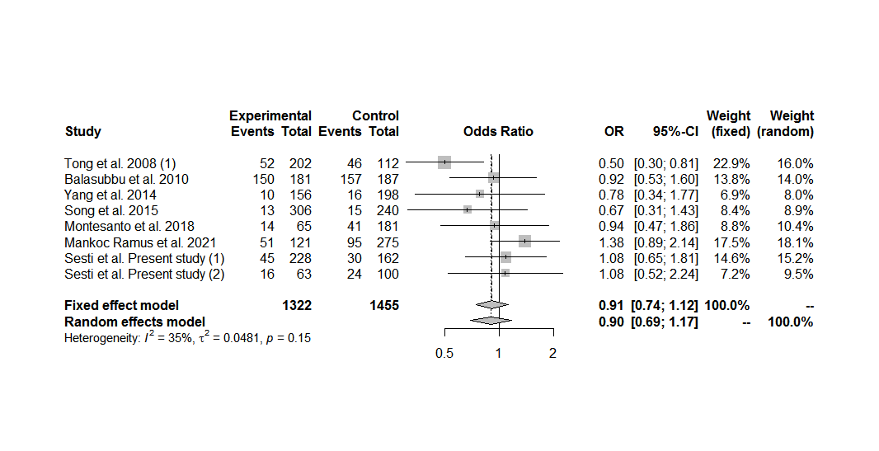
Figure S63. Forest plot of the association between the EPO rs1617640 polymorphism and diabetic retinopathy in subjects with type 2 diabetes, including only the sets with controls in Hardy-Weinberg equilibrium, under the homozygous additive genetic model for the minor allele (GG vs. TT).

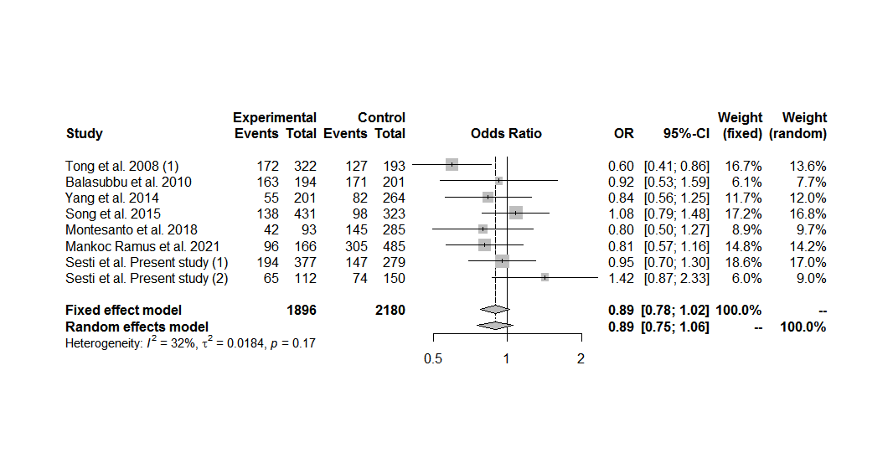
Figure S64. Forest plot of the association between the EPO rs1617640 polymorphism and diabetic retinopathy in subjects with type 2 diabetes, including only the sets with controls in Hardy-Weinberg equilibrium, under the heterozygous additive genetic model for the minor allele (TG vs. TT).

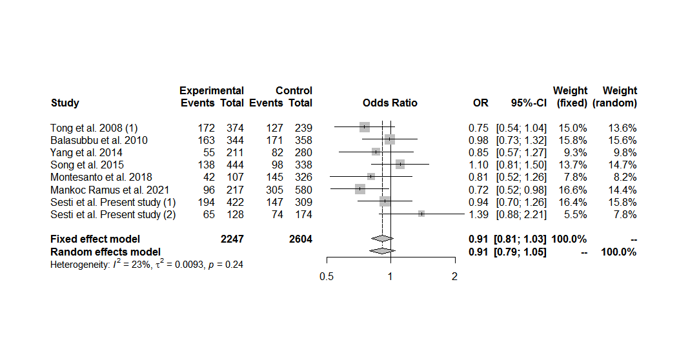
Figure S65. Forest plot of the association between the EPO rs1617640 polymorphism and diabetic retinopathy in subjects with type 2 diabetes, including only the sets with controls in Hardy-Weinberg equilibrium, under the overdominant genetic model (TG vs. GG+TT).

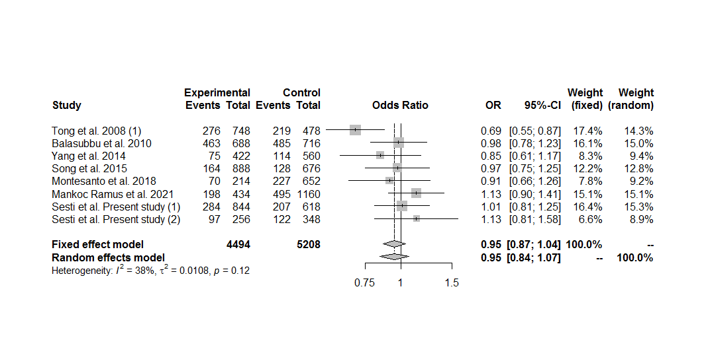
Figure S66. Forest plot of the association between the EPO rs1617640 polymorphism and diabetic retinopathy in subjects with type 2 diabetes, including only the sets with controls in Hardy-Weinberg equilibrium, under the allele contrast genetic model (G vs. T).

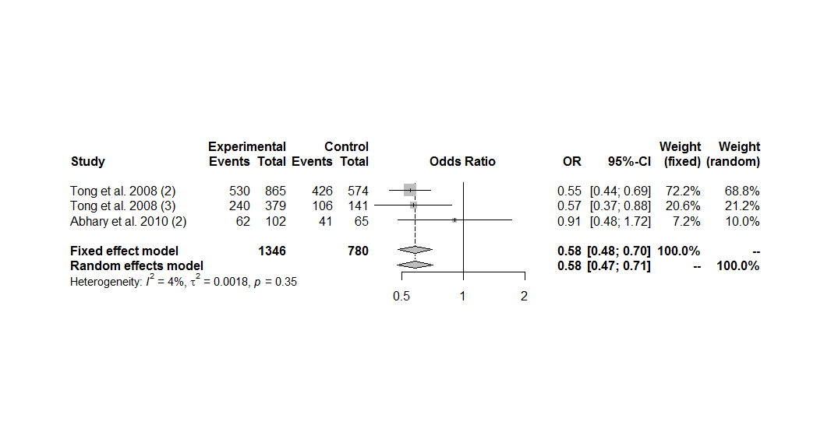
Figure S67. Forest plot of the association between the EPO rs1617640 polymorphism and diabetic retinopathy in subjects with type 1 diabetes, including only the sets with controls in Hardy-Weinberg equilibrium, under the dominant genetic model for the minor allele (GG+TG vs. TT).

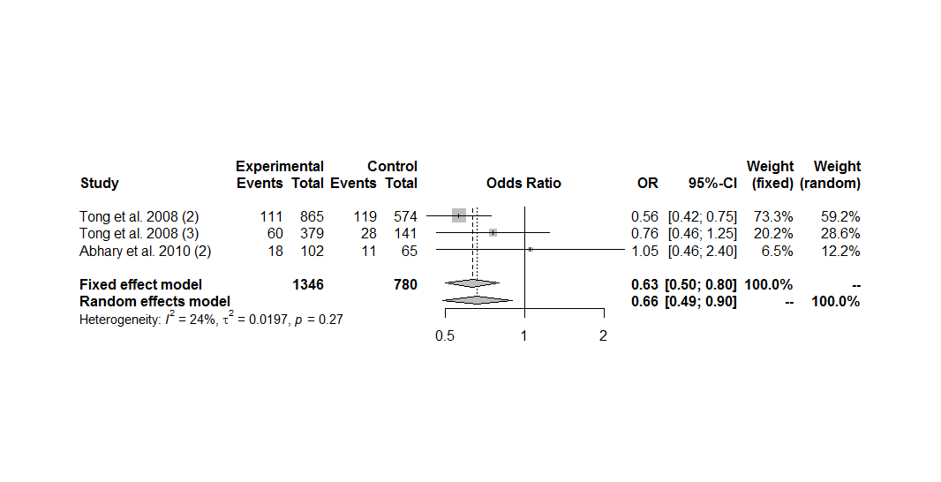
Figure S68. Forest plot of the association between the EPO rs1617640 polymorphism and diabetic retinopathy in subjects with type 1 diabetes, including only the sets with controls in Hardy-Weinberg equilibrium, under the recessive genetic model for the minor allele (GG vs. TG+TT).

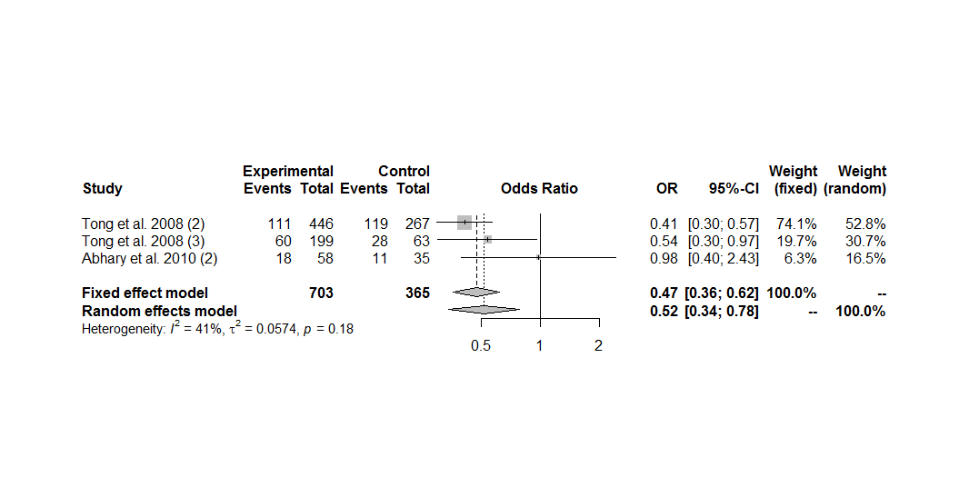
Figure S69. Forest plot of the association between the EPO rs1617640 polymorphism and diabetic retinopathy in subjects with type 1 diabetes, including only the sets with controls in Hardy-Weinberg equilibrium, under the homozygous additive genetic model for the minor allele (GG vs. TT).

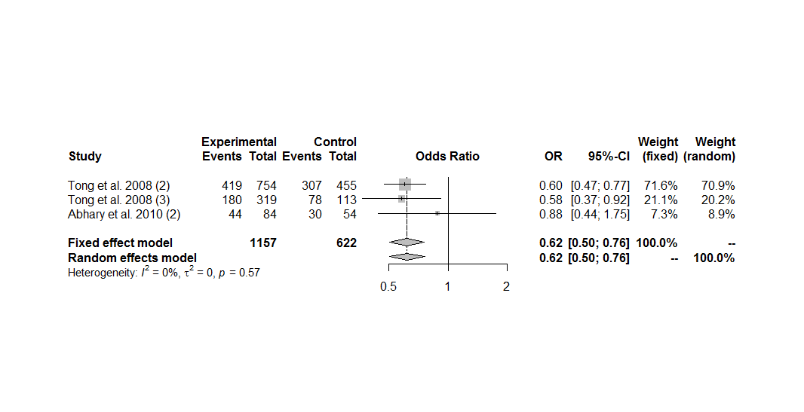
Figure S70. Forest plot of the association between the EPO rs1617640 polymorphism and diabetic retinopathy in subjects with type 1 diabetes, including only the sets with controls in Hardy-Weinberg equilibrium, under the heterozygous additive genetic model for the minor allele (TG vs. TT).

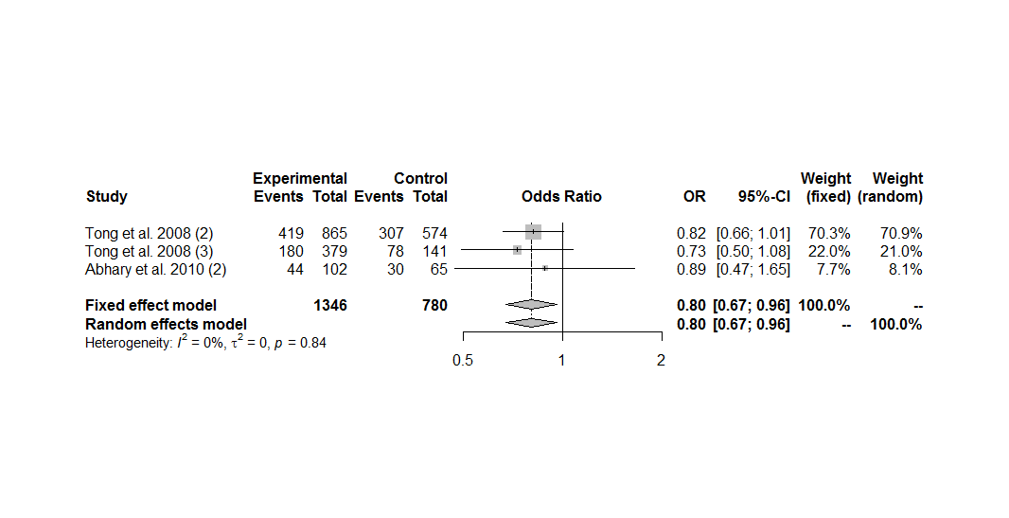
Figure S71. Forest plot of the association between the EPO rs1617640 polymorphism and diabetic retinopathy in subjects with type 1 diabetes, including only the sets with controls in Hardy-Weinberg equilibrium, under the overdominant genetic model (TG vs. GG+TT).

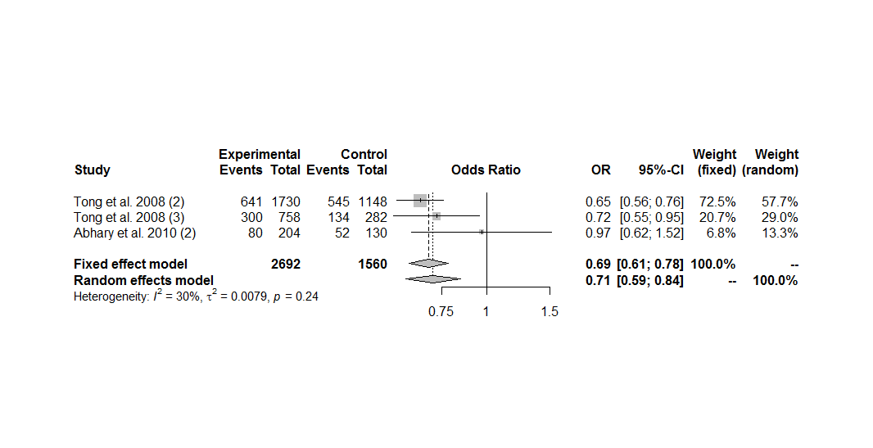
Figure S72. Forest plot of the association between the EPO rs1617640 polymorphism and diabetic retinopathy in subjects with type 1 diabetes, including only the sets with controls in Hardy-Weinberg equilibrium, under the allele contrast genetic model (G vs. T).

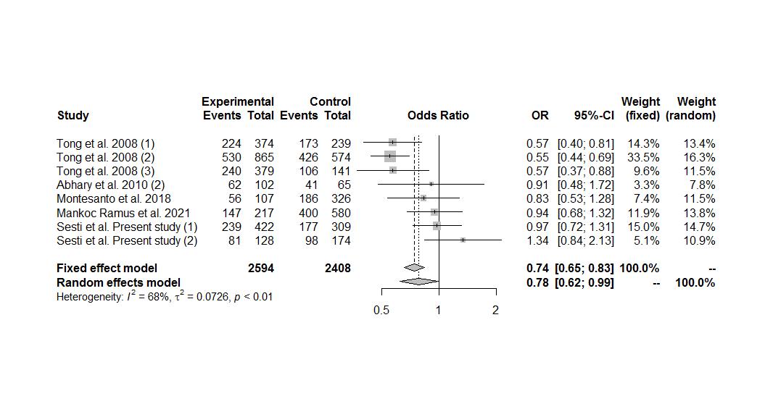
Figure S73. Forest plot of the association between the EPO rs1617640 polymorphism and diabetic retinopathy in non-Asians, including only the sets with controls in Hardy-Weinberg equilibrium, under the dominant genetic model for the minor allele (GG+TG vs. TT).

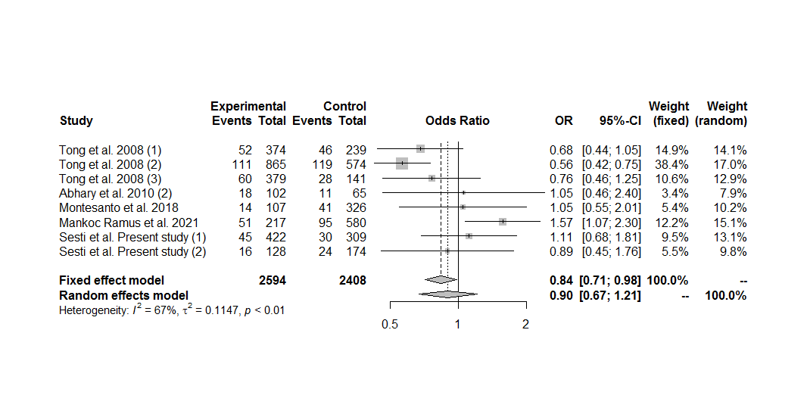
Figure S74. Forest plot of the association between the EPO rs1617640 polymorphism and diabetic retinopathy in non-Asians, including only the sets with controls in Hardy-Weinberg equilibrium, under the recessive genetic model for the minor allele (GG vs. TG+TT).

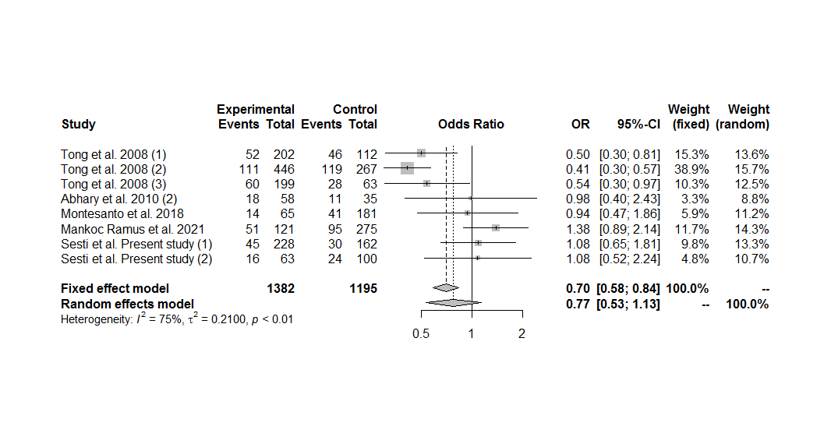
Figure S75. Forest plot of the association between the EPO rs1617640 polymorphism and diabetic retinopathy in non-Asians, including only the sets with controls in Hardy-Weinberg equilibrium, under the homozygous additive genetic model for the minor allele (GG vs. TT).

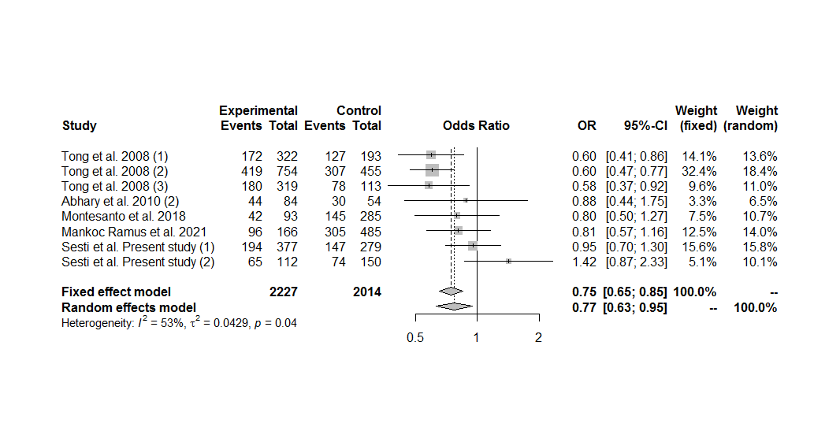
Figure S76. Forest plot of the association between the EPO rs1617640 polymorphism and diabetic retinopathy in non-Asians, including only the sets with controls in Hardy-Weinberg equilibrium, under the heterozygous additive genetic model for the minor allele (TG vs. TT).

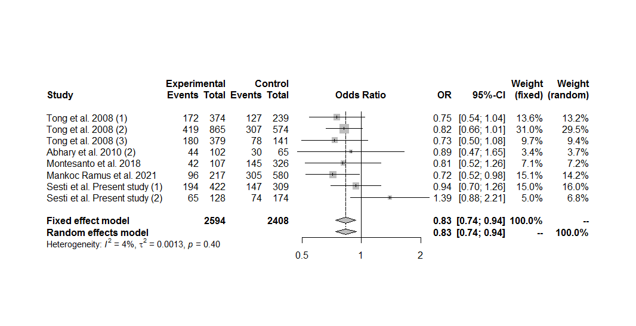
Figure S77. Forest plot of the association between the EPO rs1617640 polymorphism and diabetic retinopathy in non-Asians, including only the sets with controls in Hardy-Weinberg equilibrium, under the overdominant genetic model (TG vs. GG+TT).

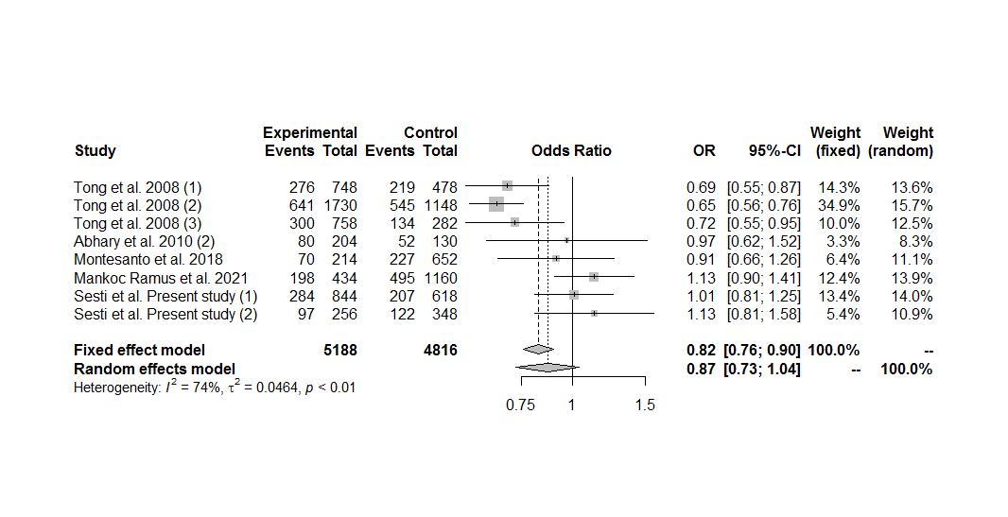
Figure S78. Forest plot of the association between the EPO rs1617640 polymorphism and diabetic retinopathy in non-Asians, including only the sets with controls in Hardy-Weinberg equilibrium, under the allele contrast genetic model (G vs. T).

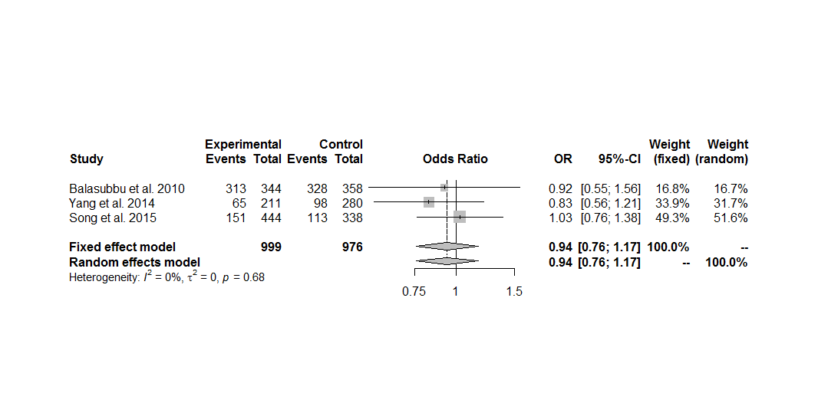
Figure S79. Forest plot of the association between the EPO rs1617640 polymorphism and diabetic retinopathy in Asians, including only the sets with controls in Hardy-Weinberg equilibrium, under the dominant genetic model for the minor allele (GG+TG vs. TT).

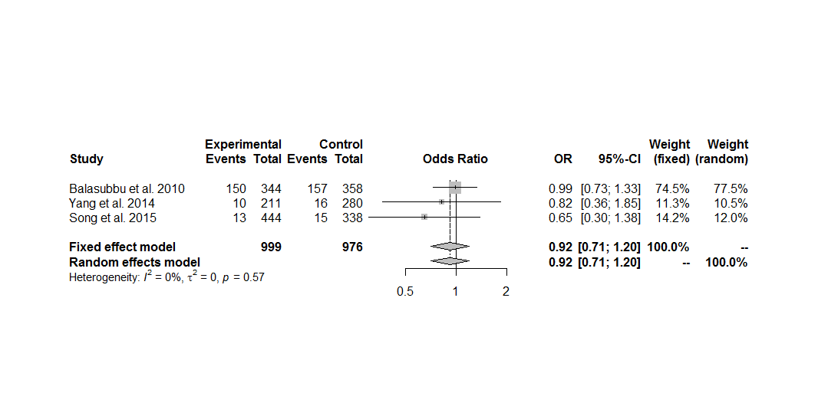
Figure S80. Forest plot of the association between the EPO rs1617640 polymorphism and diabetic retinopathy in Asians, including only the sets with controls in Hardy-Weinberg equilibrium, under the recessive genetic model for the minor allele (GG vs. TG+TT).

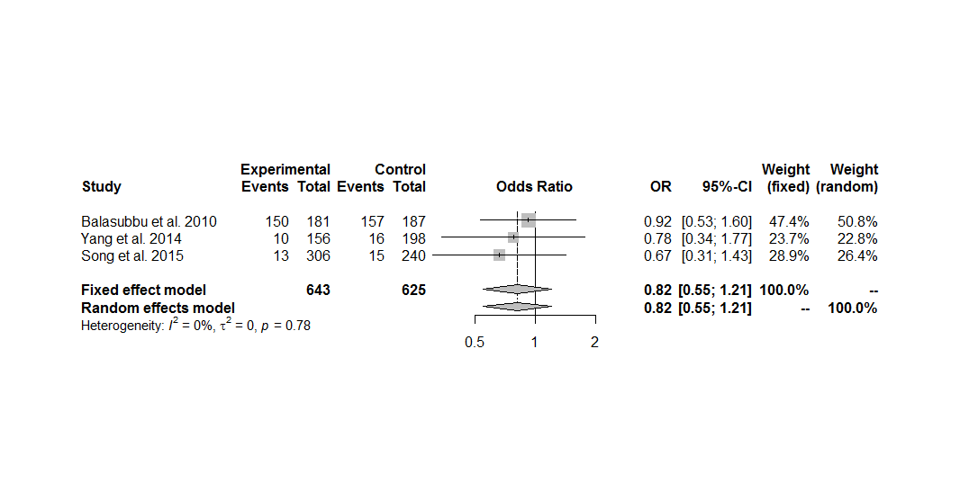
Figure S81. Forest plot of the association between the EPO rs1617640 polymorphism and diabetic retinopathy in Asians, including only the sets with controls in Hardy-Weinberg equilibrium, under the homozygous additive genetic model for the minor allele (GG vs. TT).

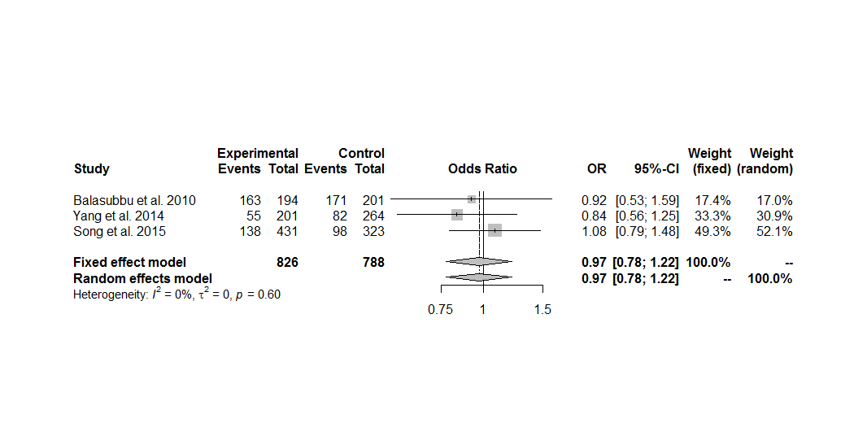
Figure S82. Forest plot of the association between the EPO rs1617640 polymorphism and diabetic retinopathy in Asians, including only the sets with controls in Hardy-Weinberg equilibrium, under the heterozygous additive genetic model for the minor allele (TG vs. TT).

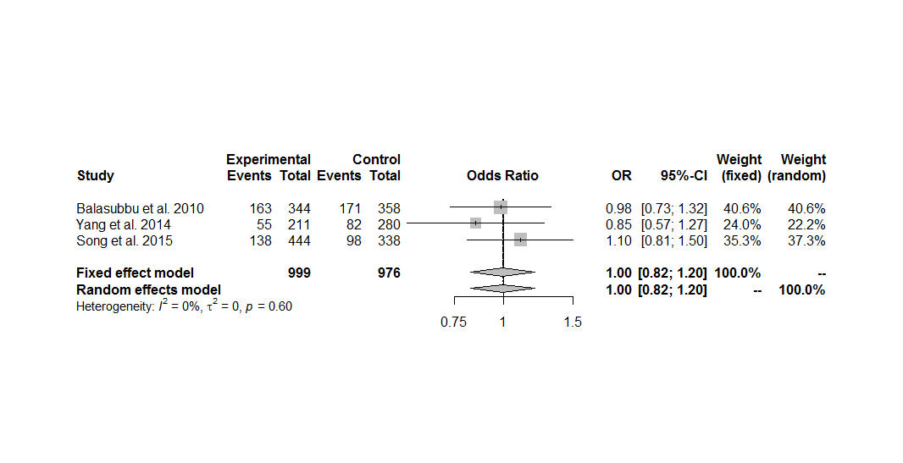
Figure S83. Forest plot of the association between the EPO rs1617640 polymorphism and diabetic retinopathy in Asians, including only the sets with controls in Hardy-Weinberg equilibrium, under the overdominant genetic model (TG vs. GG+TT).

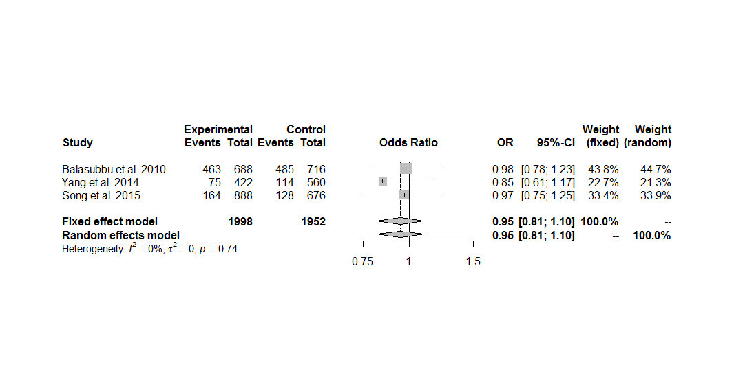
Figure S84. Forest plot of the association between the EPO rs1617640 polymorphism and diabetic retinopathy in Asians, including only the sets with controls in Hardy-Weinberg equilibrium, under the allele contrast genetic model (G vs. T).

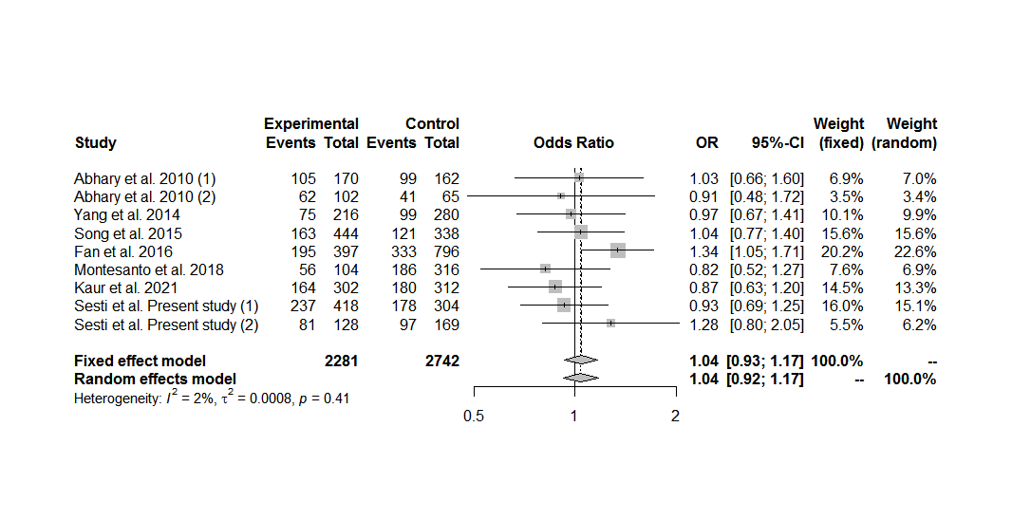
Figure S85. Forest plot of the association between the EPO rs507392 polymorphism and diabetic retinopathy in the overall group analysis, under the dominant genetic model for the minor allele (CC+TC vs. TT).

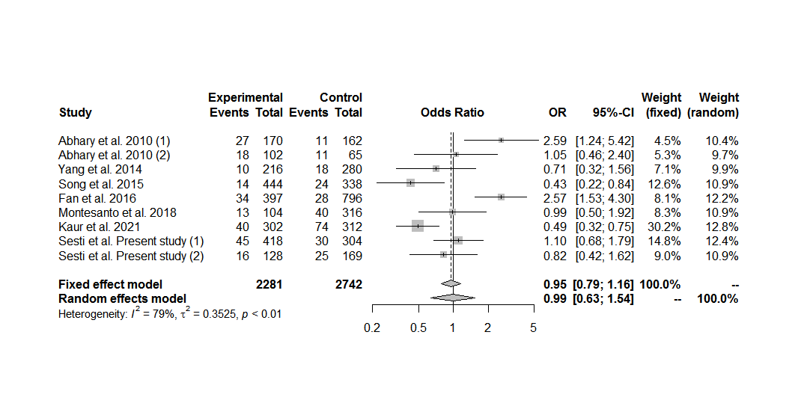
Figure S86. Forest plot of the association between the EPO rs507392 polymorphism and diabetic retinopathy in the overall group analysis, under the recessive genetic model for the minor allele (CC vs. TC+TT).

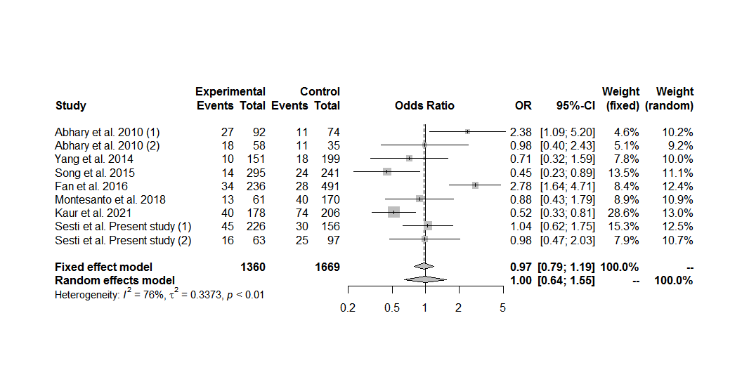
Figure S87. Forest plot of the association between the EPO rs507392 polymorphism and diabetic retinopathy in the overall group analysis, under the homozygous additive genetic model for the minor allele (CC vs. TT).

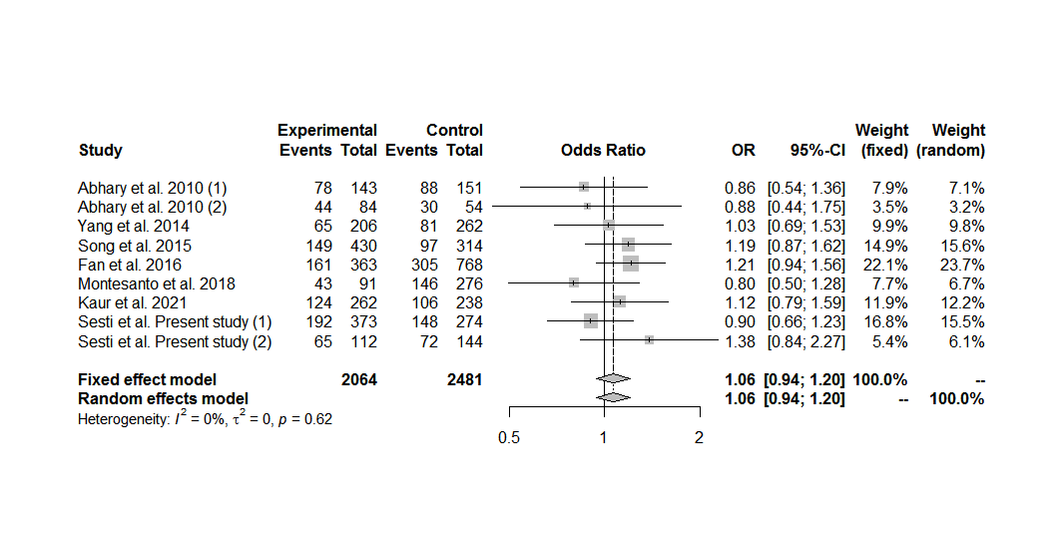
Figure S88. Forest plot of the association between the EPO rs507392 polymorphism and diabetic retinopathy in the overall group analysis, under the heterozygous additive genetic model for the minor allele (TC vs. TT).

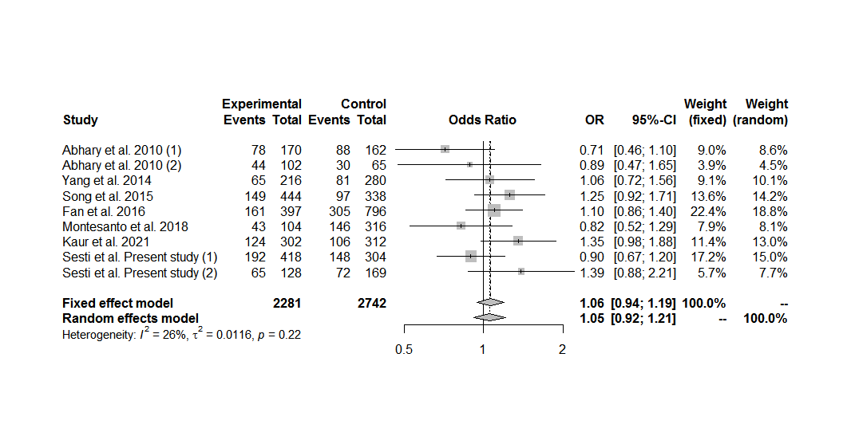
Figure S89. Forest plot of the association between the EPO rs507392 polymorphism and diabetic retinopathy in the overall group analysis, under the overdominant genetic model (TC vs. CC+TT).

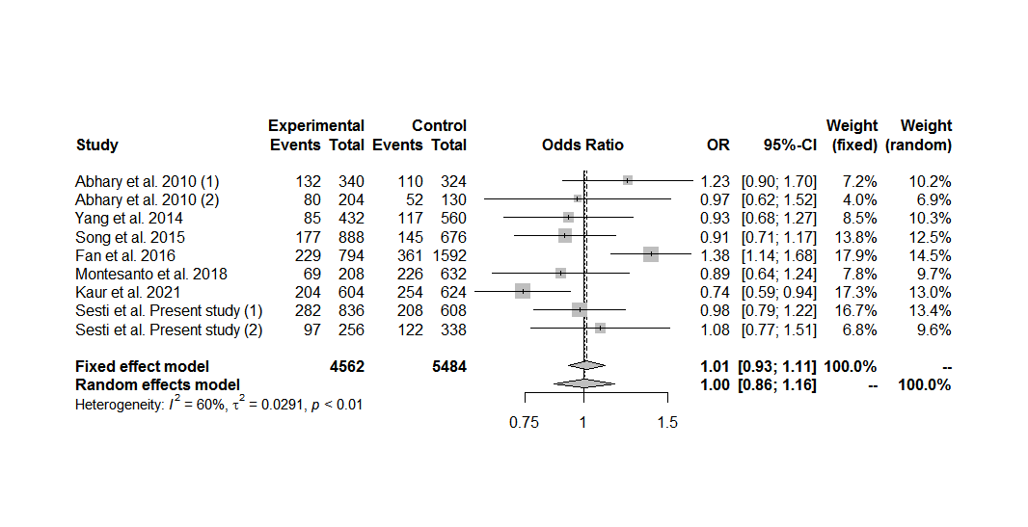
Figure S90. Forest plot of the association between the EPO rs507392 polymorphism and diabetic retinopathy in the overall group analysis, under the allele contrast genetic model (C vs. T).

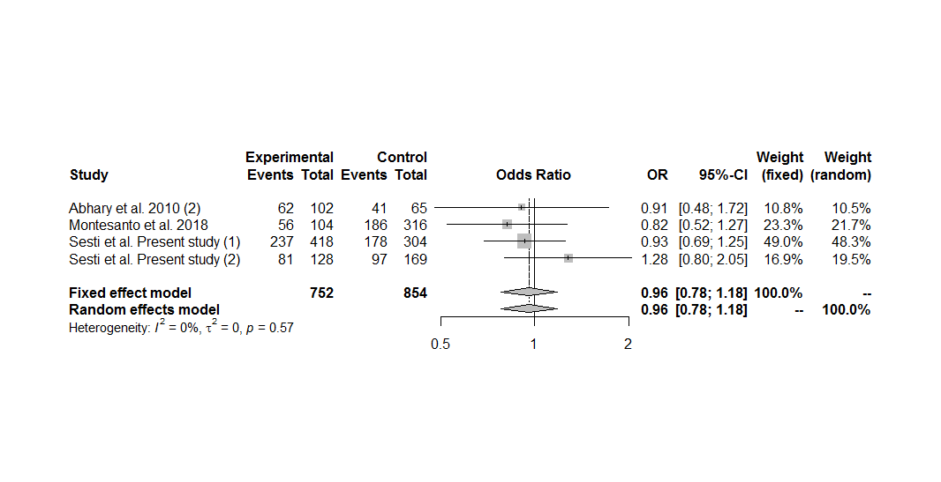
Figure S91. Forest plot of the association between the EPO rs507392 polymorphism and diabetic retinopathy in the overall group analysis including only the sets with controls in Hardy-Weinberg equilibrium, under the dominant genetic model for the minor allele (CC+TC vs. TT).

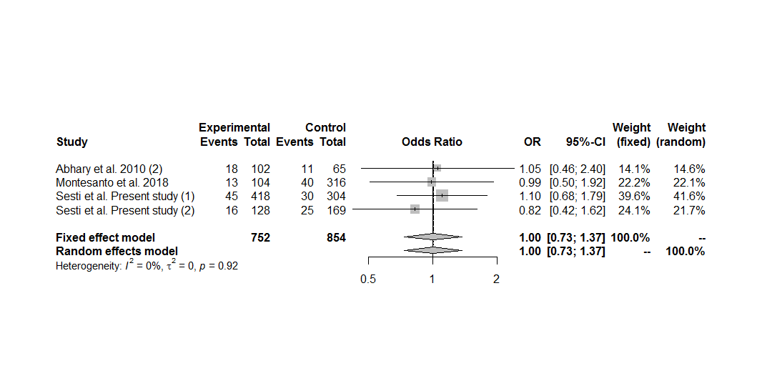
Figure S92. Forest plot of the association between the EPO rs507392 polymorphism and diabetic retinopathy in the overall group analysis including only the sets with controls in Hardy-Weinberg equilibrium, under the recessive genetic model for the minor allele (CC vs. TC+TT).

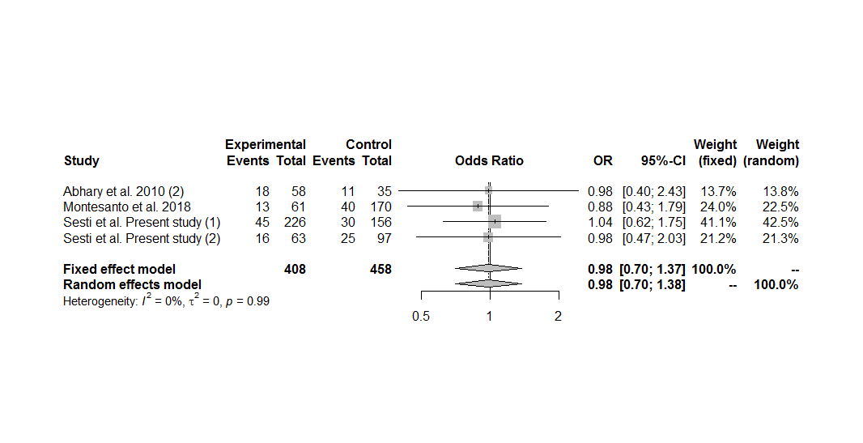
Figure S93. Forest plot of the association between the EPO rs507392 polymorphism and diabetic retinopathy in the overall group analysis including only the sets with controls in Hardy-Weinberg equilibrium, under the homozygous additive genetic model for the minor allele (CC vs. TT).

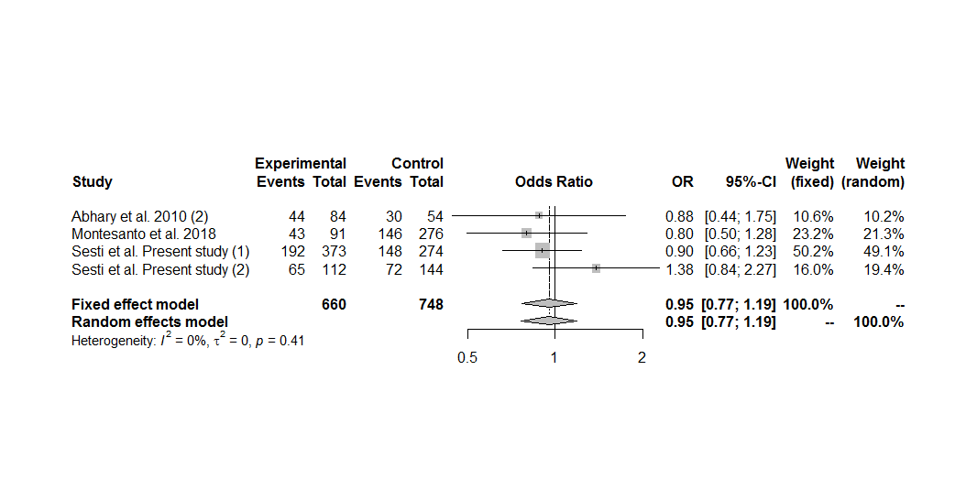
Figure S94. Forest plot of the association between the EPO rs507392 polymorphism and diabetic retinopathy in the overall group analysis including only the sets with controls in Hardy-Weinberg equilibrium, under the heterozygous additive genetic model for the minor allele (TC vs. TT).

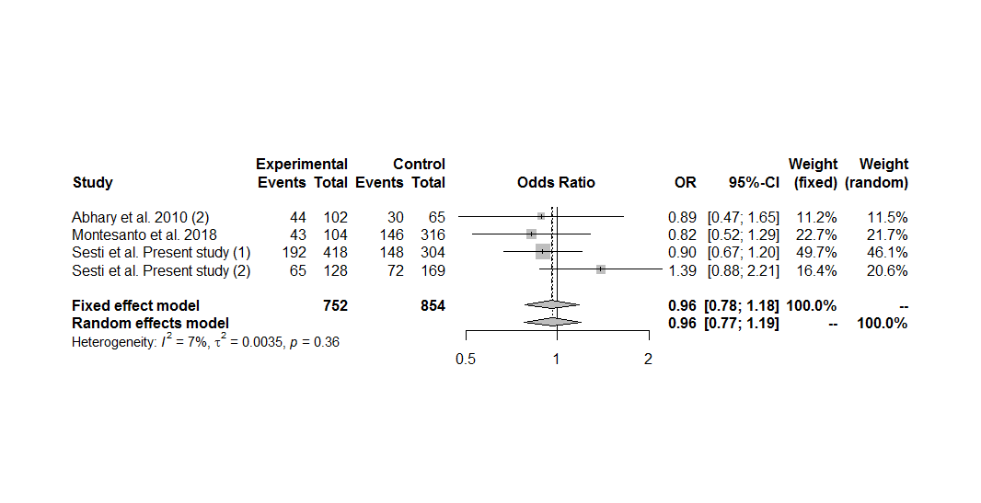
Figure S95. Forest plot of the association between the EPO rs507392 polymorphism and diabetic retinopathy in the overall group analysis including only the sets with controls in Hardy-Weinberg equilibrium, under the overdominant genetic model (TC vs. CC+TT).

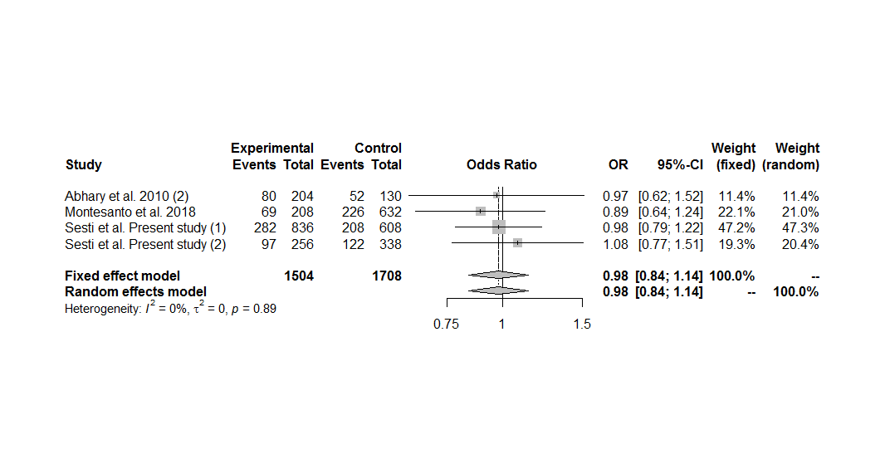
Figure S96. Forest plot of the association between the EPO rs507392 polymorphism and diabetic retinopathy in the overall group analysis including only the sets with controls in Hardy-Weinberg equilibrium, under the allele contrast genetic model (C vs. T).

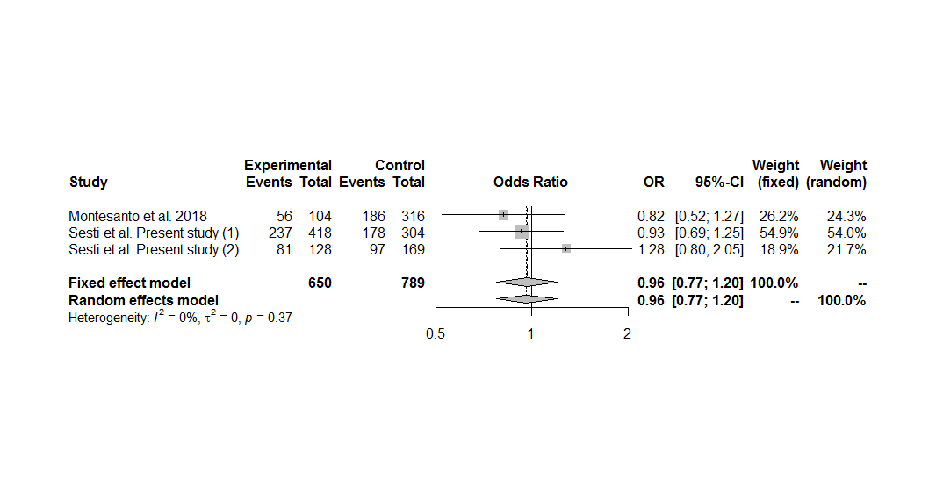
Figure S97. Forest plot of the association between the EPO rs507392 polymorphism and diabetic retinopathy in subjects with type 2 diabetes, including only the sets with controls in Hardy-Weinberg equilibrium, under the dominant genetic model for the minor allele (CC+TC vs. TT).

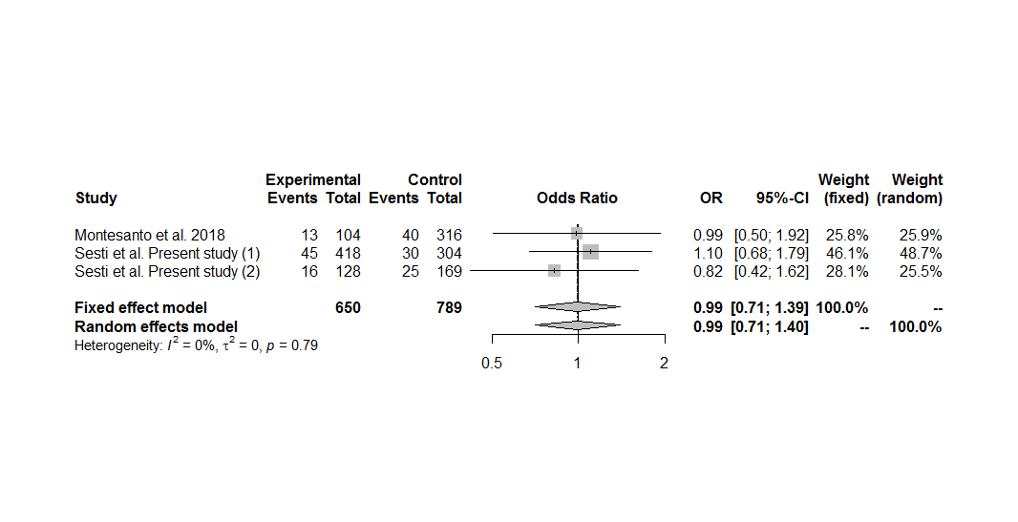
Figure S98. Forest plot of the association between the EPO rs507392 polymorphism and diabetic retinopathy in subjects with type 2 diabetes, including only the sets with controls in Hardy-Weinberg equilibrium, under the recessive genetic model for the minor allele (CC vs. TC+TT).

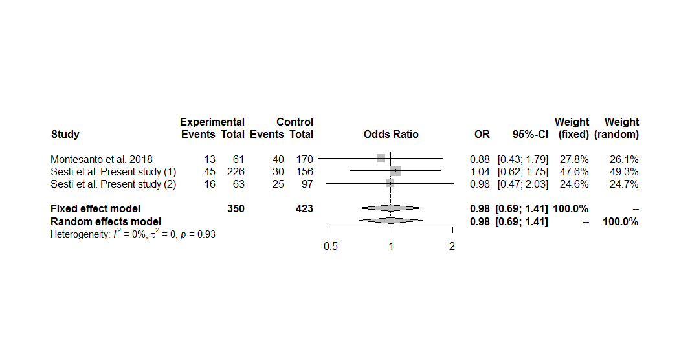
Figure S99. Forest plot of the association between the EPO rs507392 polymorphism and diabetic retinopathy in subjects with type 2 diabetes, including only the sets with controls in Hardy-Weinberg equilibrium, under the homozygous additive genetic model for the minor allele (CC vs. TT).

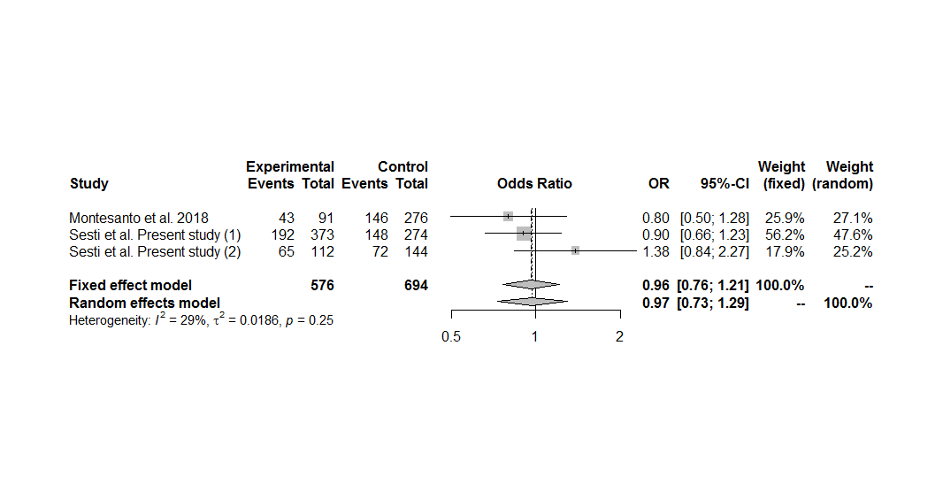
Figure S100. Forest plot of the association between the EPO rs507392 polymorphism and diabetic retinopathy in subjects with type 2 diabetes, including only the sets with controls in Hardy-Weinberg equilibrium, under the heterozygous additive genetic model for the minor allele (TC vs. TT).

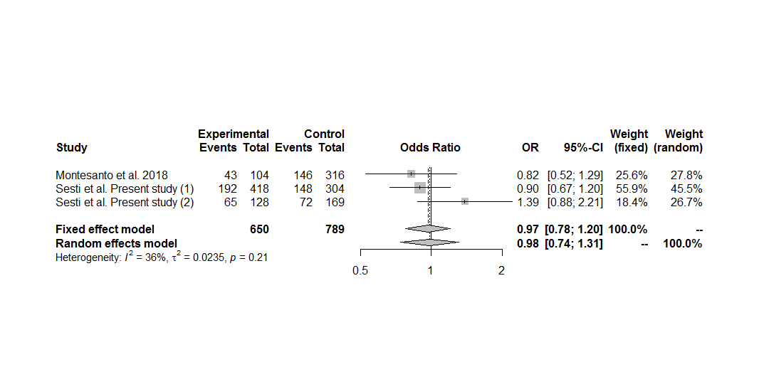
Figure S101. Forest plot of the association between the EPO rs507392 polymorphism and diabetic retinopathy in subjects with type 2 diabetes, including only the sets with controls in Hardy-Weinberg equilibrium, under the overdominant genetic model (TC vs. CC+TT).

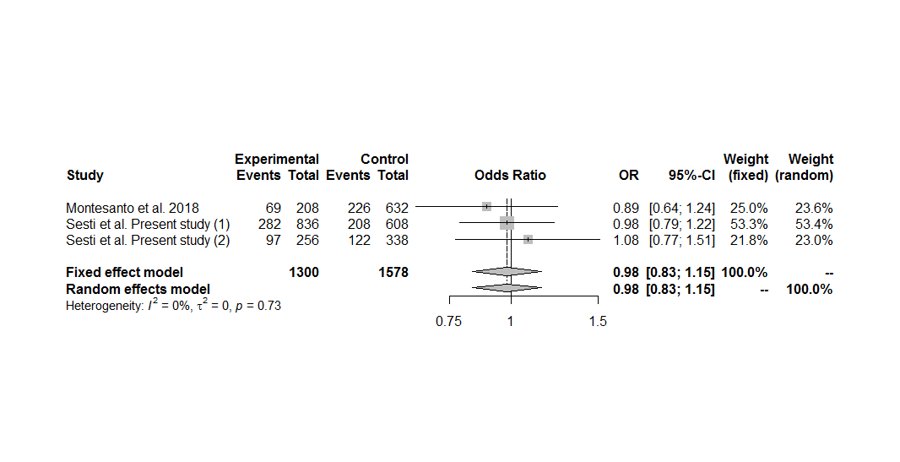
Figure S102. Forest plot of the association between the EPO rs507392 polymorphism and diabetic retinopathy in subjects with type 2 diabetes, including only the sets with controls in Hardy-Weinberg equilibrium, under the allele contrast genetic model (C vs. T).

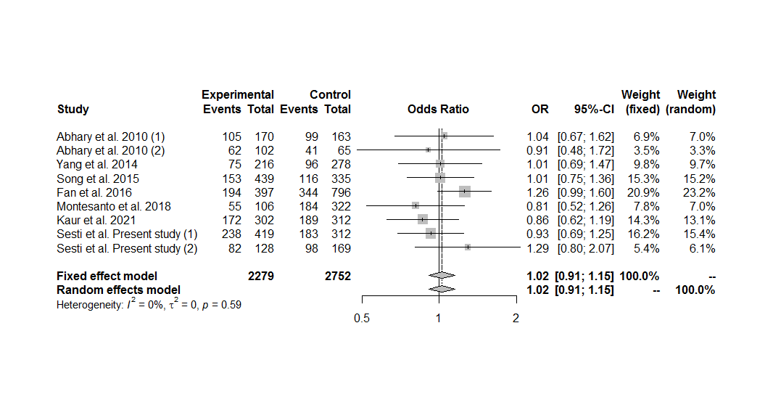
Figure S103. Forest plot of the association between the EPO rs551238 polymorphism and diabetic retinopathy in the overall group analysis, under the dominant genetic model for the minor allele (CC+AC vs. AA).

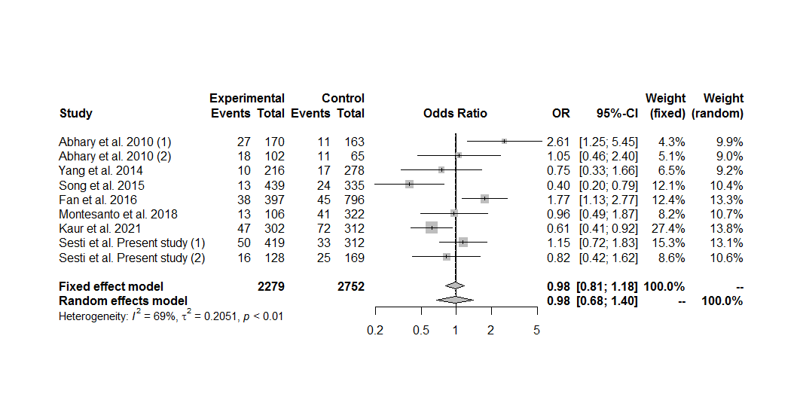
Figure S104. Forest plot of the association between the EPO rs551238 polymorphism and diabetic retinopathy in the overall group analysis, under the recessive genetic model for the minor allele (CC vs. AC+AA).

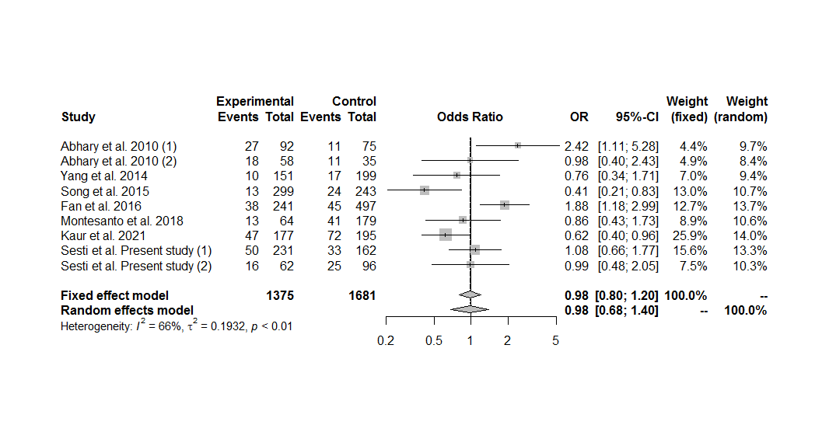
Figure S105. Forest plot of the association between the EPO rs551238 polymorphism and diabetic retinopathy in the overall group analysis, under the homozygous additive genetic model for the minor allele (CC vs. AA).

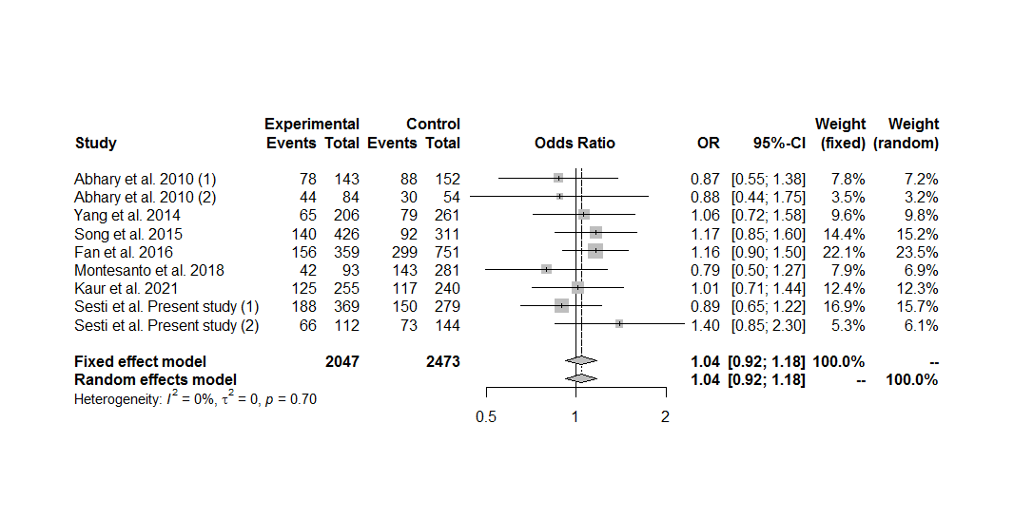
Figure S106. Forest plot of the association between the EPO rs551238 polymorphism and diabetic retinopathy in the overall group analysis, under the heterozygous additive genetic model for the minor allele (AC vs. AA).

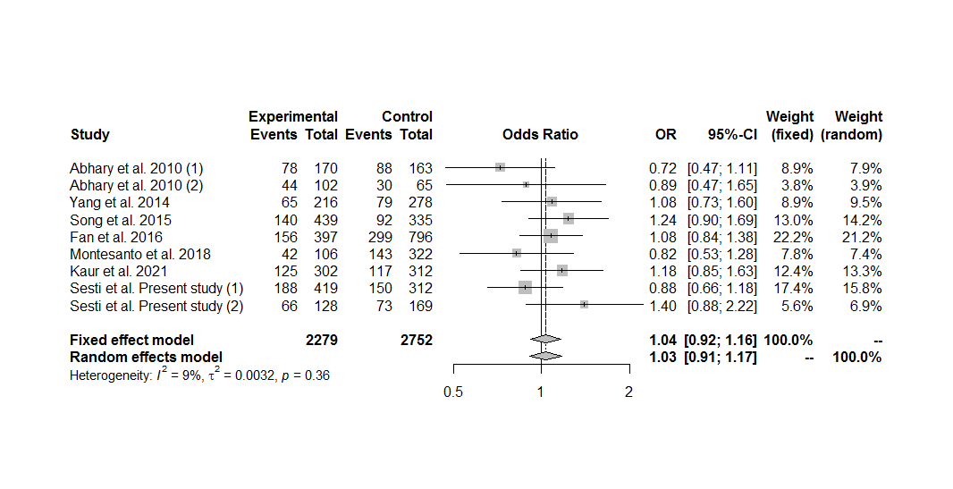
Figure S107. Forest plot of the association between the EPO rs551238 polymorphism and diabetic retinopathy in the overall group analysis, under the overdominant genetic model (AC vs. CC+AA).

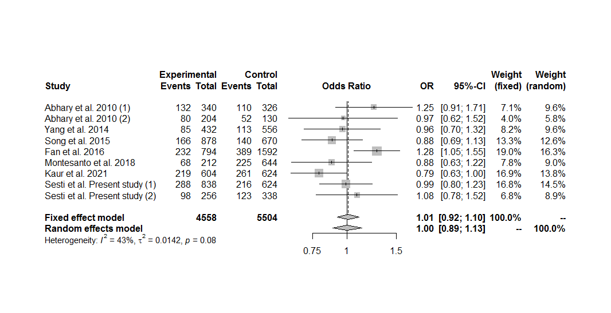
Figure S108. Forest plot of the association between the EPO rs551238 polymorphism and diabetic retinopathy in the overall group analysis, under the allele contrast genetic model (C vs. A).

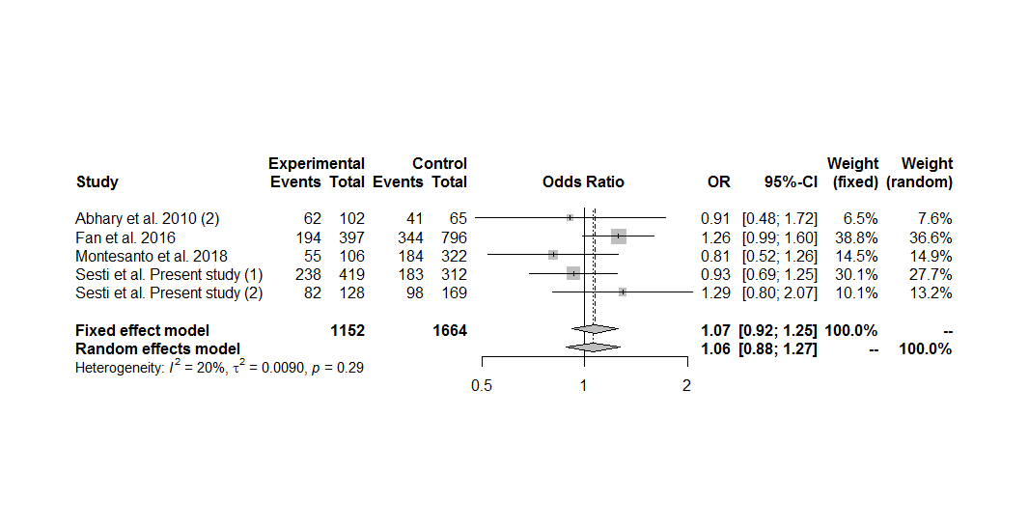
Figure S109. Forest plot of the association between the EPO rs551238 polymorphism and diabetic retinopathy in the overall group analysis including only the sets with controls in Hardy-Weinberg equilibrium, under the dominant genetic model for the minor allele (CC+AC vs. AA).

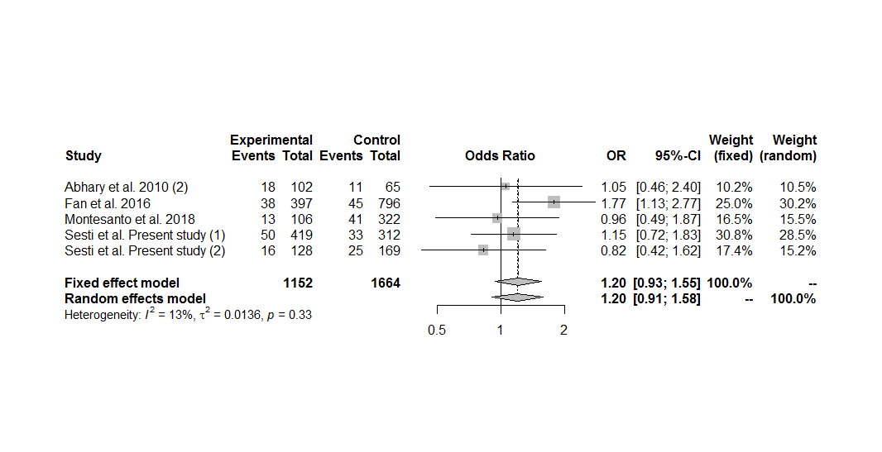
Figure S110. Forest plot of the association between the EPO rs551238 polymorphism and diabetic retinopathy in the overall group analysis including only the sets with controls in Hardy-Weinberg equilibrium, under the recessive genetic model for the minor allele (CC vs. AC+AA).

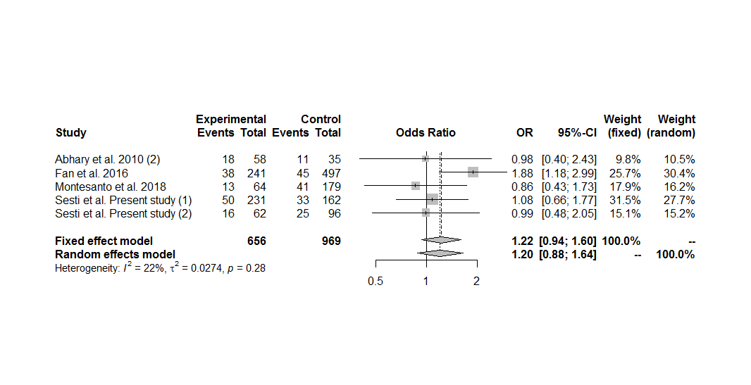
Figure S111. Forest plot of the association between the EPO rs551238 polymorphism and diabetic retinopathy in the overall group analysis including only the sets with controls in Hardy-Weinberg equilibrium, under the homozygous additive genetic model for the minor allele (CC vs. AA).

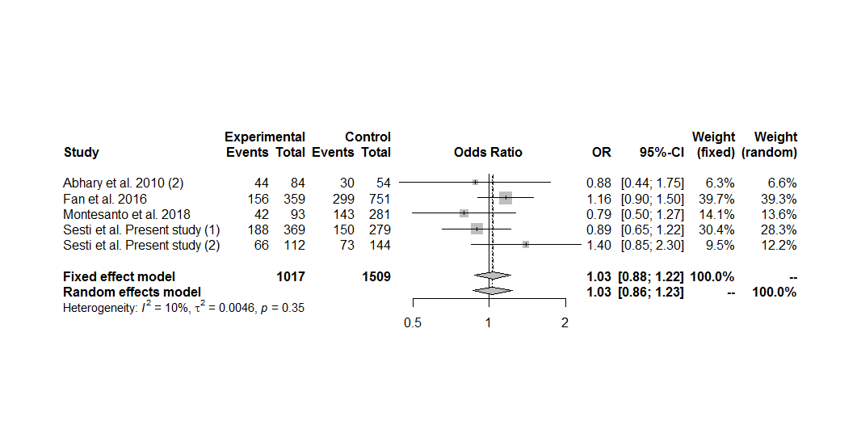
Figure S112. Forest plot of the association between the EPO rs551238 polymorphism and diabetic retinopathy in the overall group analysis including only the sets with controls in Hardy-Weinberg equilibrium, under the heterozygous additive genetic model for the minor allele (AC vs. AA).

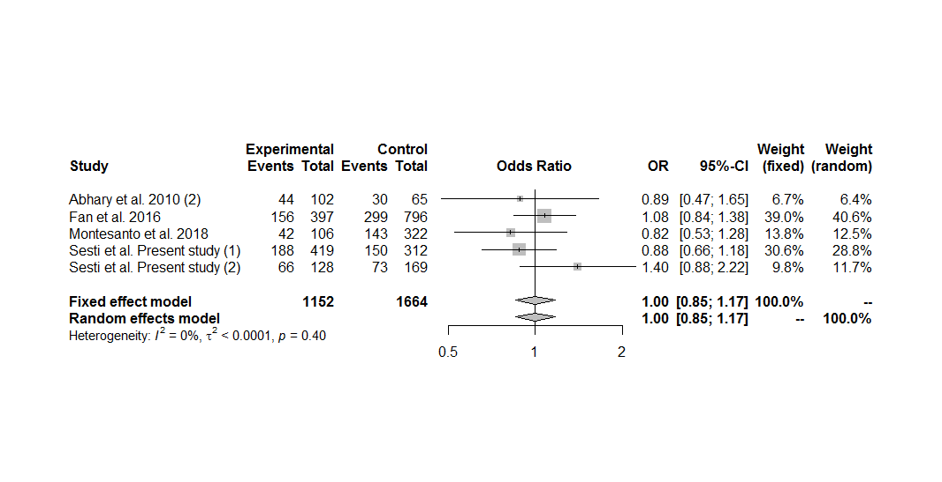
Figure S113. Forest plot of the association between the EPO rs551238 polymorphism and diabetic retinopathy in the overall group analysis including only the sets with controls in Hardy-Weinberg equilibrium, under the overdominant genetic model (AC vs. CC+AA).

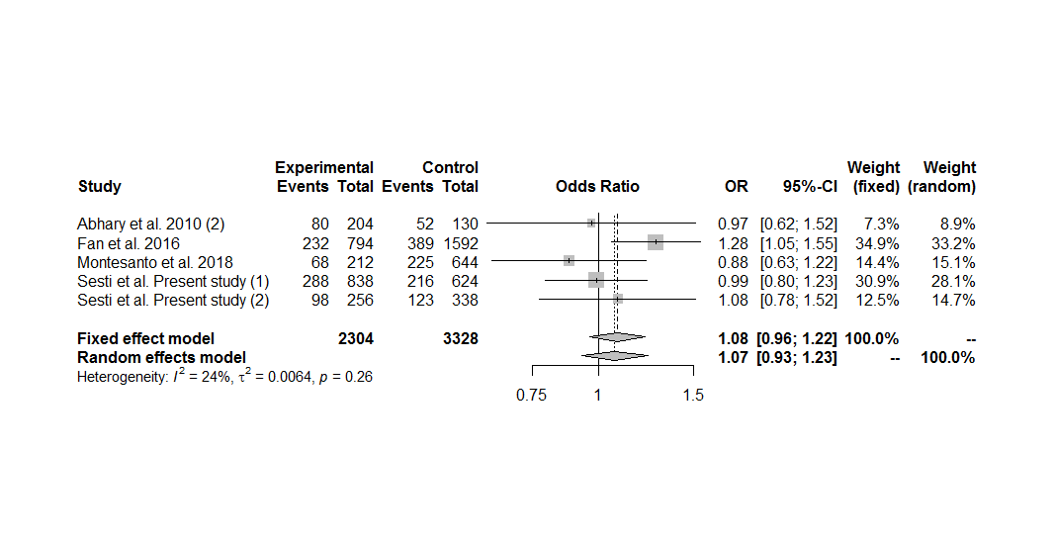
Figure S114. Forest plot of the association between the EPO rs551238 polymorphism and diabetic retinopathy in the overall group analysis including only the sets with controls in Hardy-Weinberg equilibrium, under the allele contrast genetic model (C vs. A).

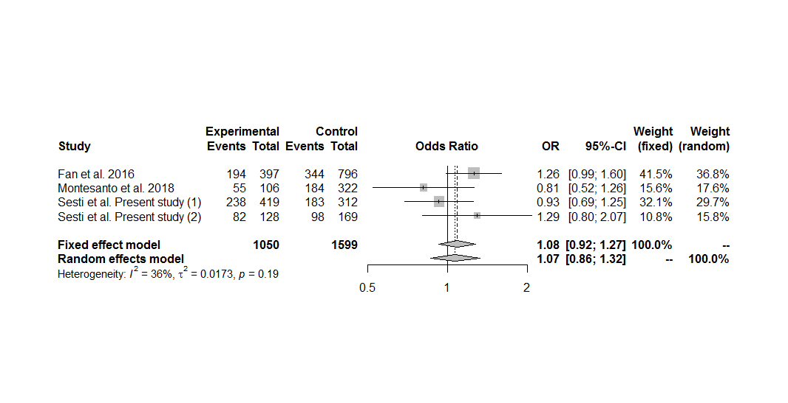
Figure S115. Forest plot of the association between the EPO rs551238 polymorphism and diabetic retinopathy in subjects with type 2 diabetes, including only the sets with controls in Hardy-Weinberg equilibrium, under the dominant genetic model for the minor allele (CC+AC vs. AA).

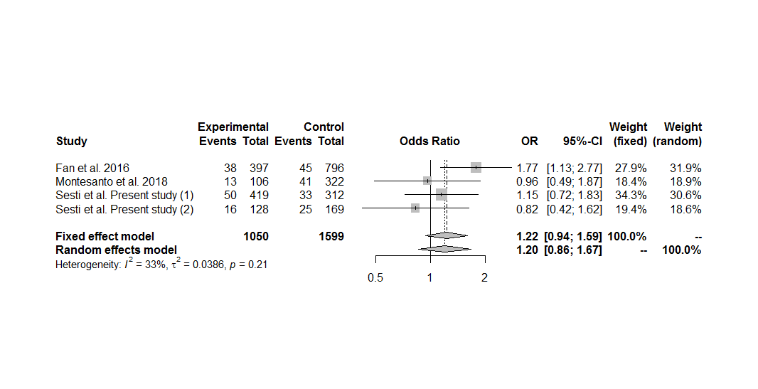
Figure S116. Forest plot of the association between the EPO rs551238 polymorphism and diabetic retinopathy in subjects with type 2 diabetes, including only the sets with controls in Hardy-Weinberg equilibrium, under the recessive genetic model for the minor allele (CC vs. AC+AA).

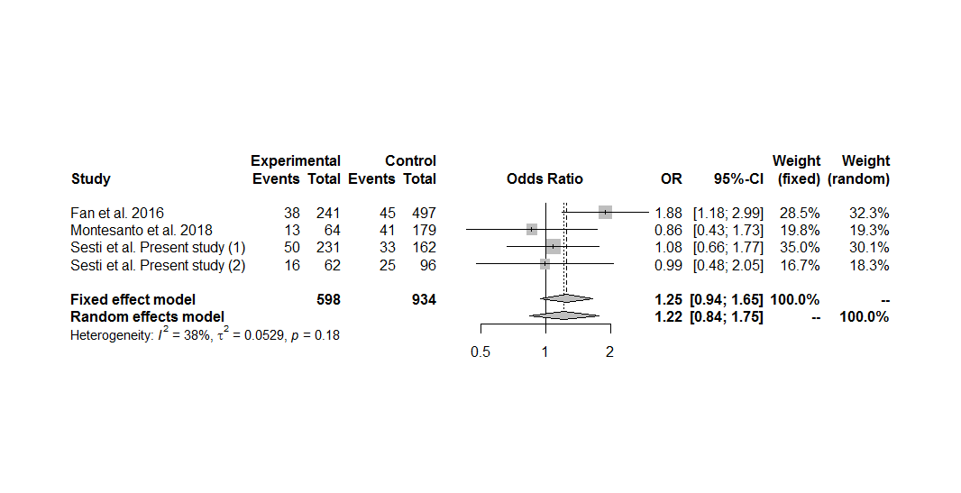
Figure S117. Forest plot of the association between the EPO rs551238 polymorphism and diabetic retinopathy in subjects with type 2 diabetes, including only the sets with controls in Hardy-Weinberg equilibrium, under the homozygous additive genetic model for the minor allele (CC vs. AA).

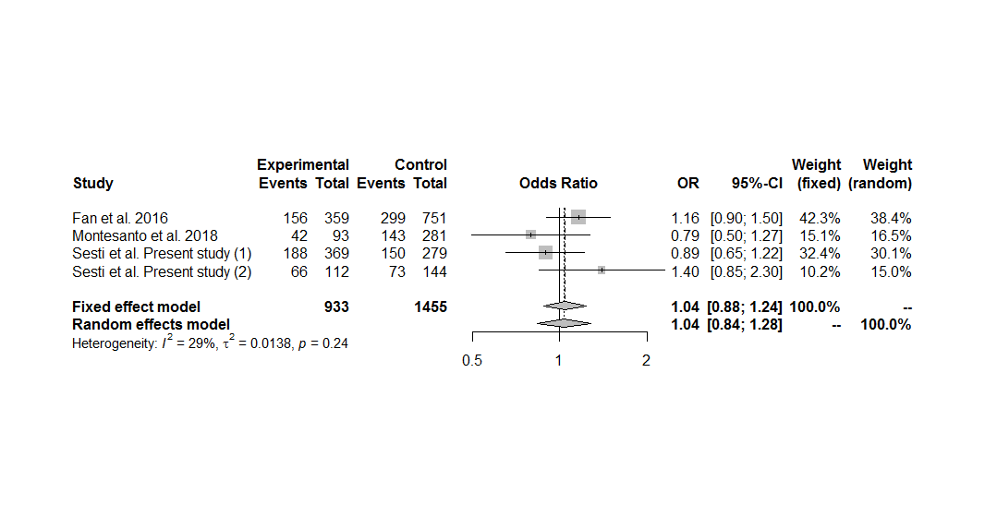
Figure S118. Forest plot of the association between the EPO rs551238 polymorphism and diabetic retinopathy in subjects with type 2 diabetes, including only the sets with controls in Hardy-Weinberg equilibrium, under the heterozygous additive genetic model for the minor allele (AC vs. AA).

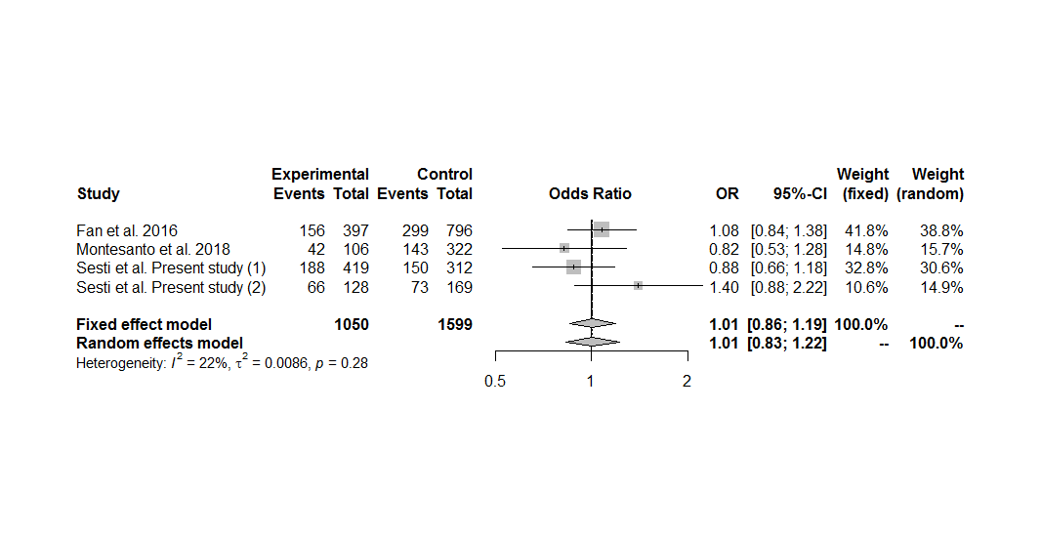
Figure S119. Forest plot of the association between the EPO rs551238 polymorphism and diabetic retinopathy in subjects with type 2 diabetes, including only the sets with controls in Hardy-Weinberg equilibrium, under the overdominant genetic model (AC vs. CC+AA).

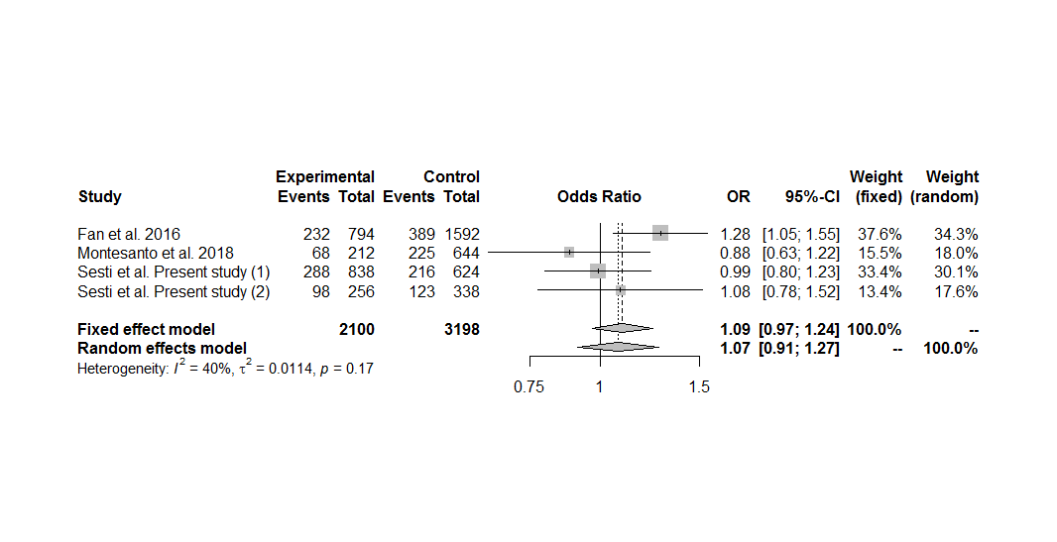
Figure S120. Forest plot of the association between the EPO rs551238 polymorphism and diabetic retinopathy in subjects with type 2 diabetes, including only the sets with controls in Hardy-Weinberg equilibrium, under the allele contrast genetic model (C vs. A).

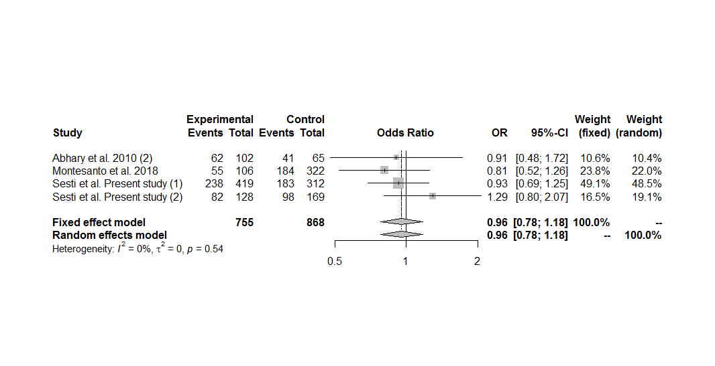
Figure S121. Forest plot of the association between the EPO rs551238 polymorphism and diabetic retinopathy in non-Asians, including only the sets with controls in Hardy-Weinberg equilibrium, under the dominant genetic model for the minor allele (CC+AC vs. AA).

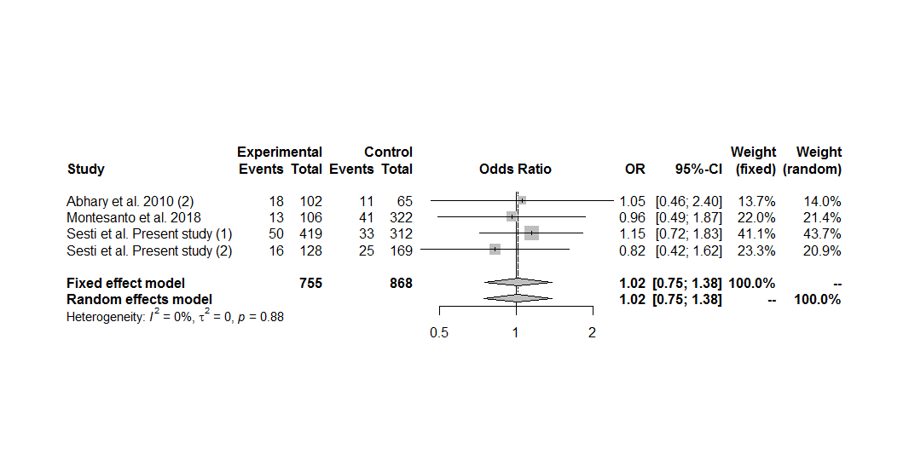
Figure S122. Forest plot of the association between the EPO rs551238 polymorphism and diabetic retinopathy in non-Asians, including only the sets with controls in Hardy-Weinberg equilibrium, under the recessive genetic model for the minor allele (CC vs. AC+AA).

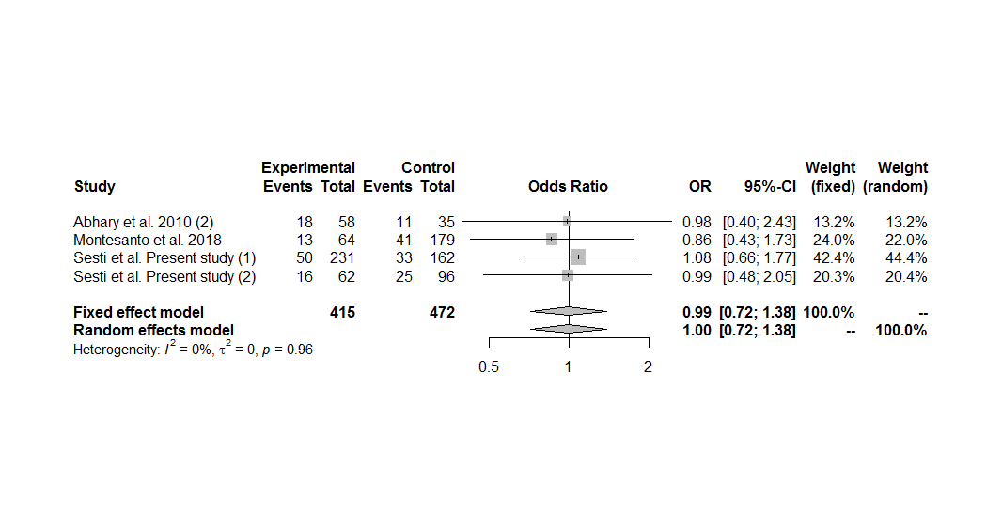
Figure S123. Forest plot of the association between the EPO rs551238 polymorphism and diabetic retinopathy in non-Asians, including only the sets with controls in Hardy-Weinberg equilibrium, under the homozygous additive genetic model for the minor allele (CC vs. AA).

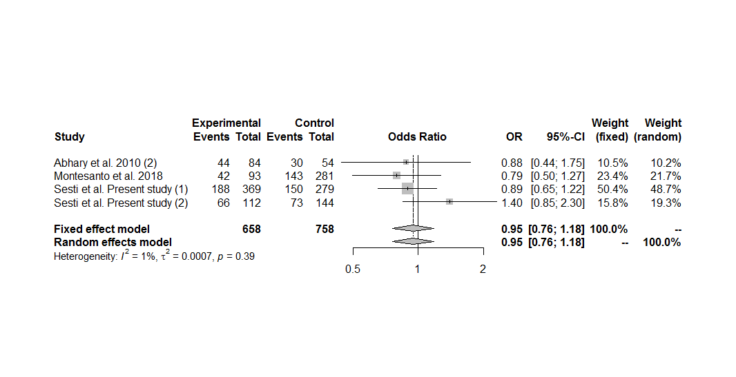
Figure S124. Forest plot of the association between the EPO rs551238 polymorphism and diabetic retinopathy in non-Asians, including only the sets with controls in Hardy-Weinberg equilibrium, under the heterozygous additive genetic model for the minor allele (AC vs. AA).

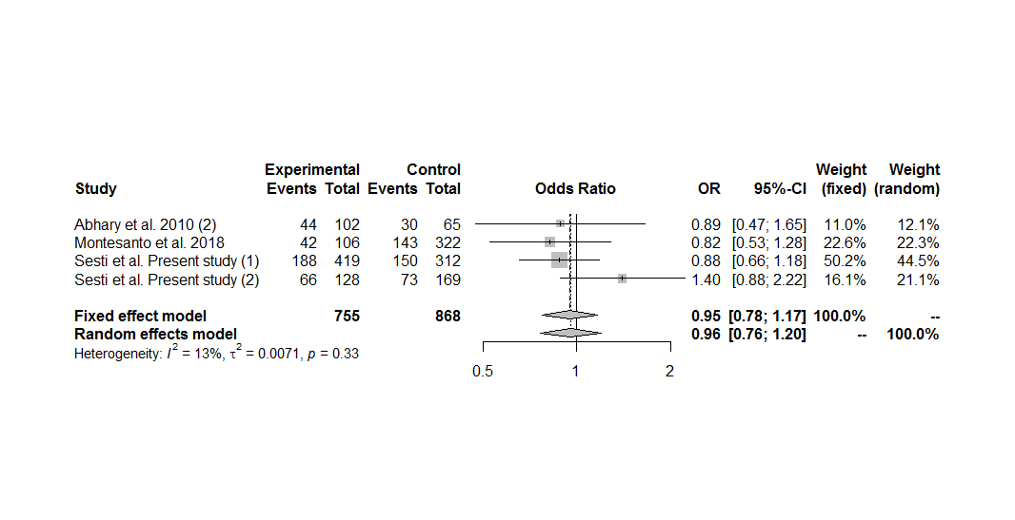
Figure S125. Forest plot of the association between the EPO rs551238 polymorphism and diabetic retinopathy in non-Asians, including only the sets with controls in Hardy-Weinberg equilibrium, under the overdominant genetic model (AC vs. CC+AA).

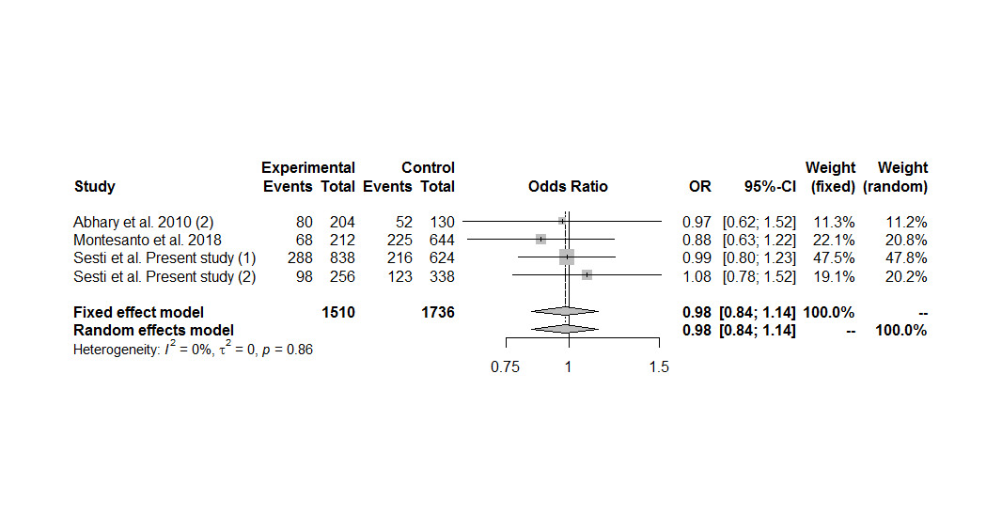
Figure S126. Forest plot of the association between the EPO rs551238 polymorphism and diabetic retinopathy in non-Asians, including only the sets with controls in Hardy-Weinberg equilibrium, under the allele contrast genetic model (C vs. A).

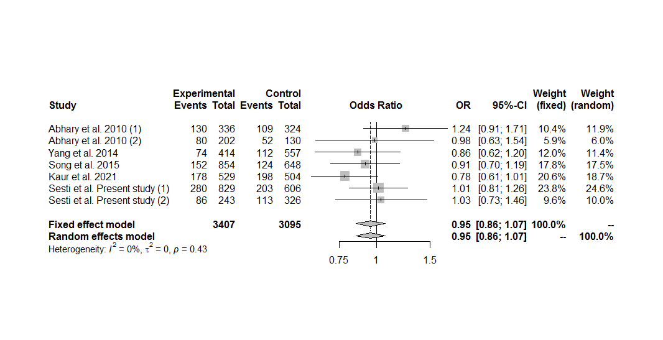
Figure S127. Forest plot of the association between the EPO polymorphisms and diabetic retinopathy in the overall group analysis, by comparing the GCC haplotype with TTA haplotype.

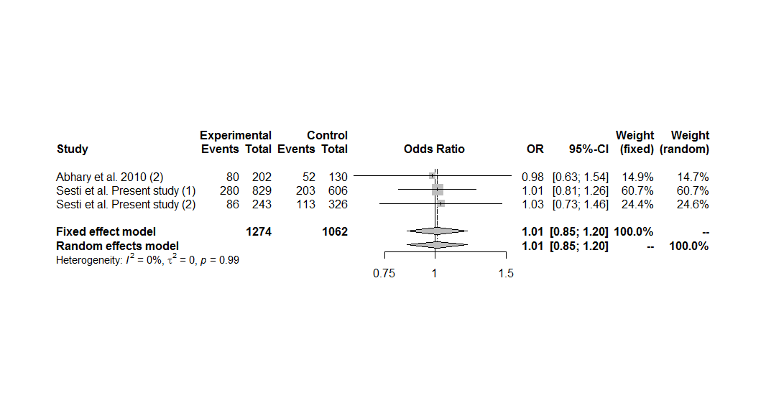
Figure S128. Forest plot of the association between the EPO polymorphisms and diabetic retinopathy, including only the sets with controls in Hardy-Weinberg equilibrium, by comparing the GCC haplotype with TTA haplotype.

