The Histone H2B Arg95 residue links the Pheromone Response Pathway to Rapamycin-Induced G₁ Arrest in Yeast
Abdallah Alhaj Sulaiman¹, Reem Ali¹, Mustapha Aouida¹, and Dindial Ramotar^{1, a}
¹Division of Biological and Biomedical Sciences, College of Health and Life Sciences, Hamad Bin Khalifa University, Education City, Qatar Foundation, Doha, Qatar, P.O.Box: 34110

ª Corresponding author Email: dramotar@hbku.edu.qa

Table S1. Yeast strains and mutants used in this study
Strains | Genotype | Source
BY4741 | Parent, Mat a, his3-1, leu2-0, met15-0, ura3-0 | Euroscarf (Frankfurt, Germany)
ste5Δ::KANMX | isogenic to BY4741, except deleted for the STE5 | This work (resistant to rapamycin)
ste2Δ::KANMX | isogenic to BY4741, except deleted for the STE2 | This work
FY406 | The H2A/H2B collection is in FY406 MATa (hta1-htb1)Δ::LEU2, (hta2-htb2) Δ::TRP1, his3 Δ 200 leu2 Δ 1 ura3-52 trp1 Δ 63 lys2-128 Δ <pSAB6 (HTA1-HTB1-URA3). The covering plasmid for H2A/H2B uses the His marker. | Ali Shilatifard (Kansas, USA)
YBL574 | The H3/H4 collection is in Winston’s YBL574 (MATa, leu2Δ1, his3Δ200, ura3-52, trp1Δ63, lys2-128δ, (hht1-hhf1)ΔLEU2 (hht2-hhf2)Δ::HIS3 Ty912Δ35-lacZ::his4, {pDM9-HHT1-HHF1-URA3}. The covering plasmid for H3/H4 uses the Trp marker. | Ali Shilatifard
TAP tag strains collection | MATa his3Δ1 leu2Δ0 met15Δ0 ura3Δ0 | Dharmacon
Y1a | Parent W303 (leu2-3, 112, trp1-1, can1-100, ura3-1, ade2-1, his3-11,15) | Lab strain
ste5Δ::LEU2 | Isogenic to W303, except deleted for STE5 | This work (resistant to rapamycin)

Table S2. GO analysis for genes differentially regulated in the H2B WT and H2B R95A in untreated and rapamycin treated
Gene Ontology (GO) terms significantly represented among up-regulated genes in H2B wild type in rapamycin treatment
Biological Pathways | GO term | Genes | Fold Enrichment | p Value | FDR
Organic acid transport | GO:0015849 | DAL5, GAP1, DIP5, CAN1, AGP1, PTR2 | 19.55823 | 6.71E-06 | 0.007968
Amine transport | GO:0015837 | GAP1, DIP5, DUR3, CAN1, AGP1 | 23.32375 | 3.84E-05 | 0.045602
Carboxylic acid transport | GO:0046942 | DAL5, GAP1, DIP5, CAN1, AGP1 | 19.3254 | 8.09E-05 | 0.096019
Amino acid transport | GO:0006865 | GAP1, DIP5, CAN1, AGP1 | 21.64444 | 6.26E-04 | 0.740503
Gene Ontology (GO) terms significantly represented among down-regulated genes in H2B wild type under rapamycin treatment
Biological Pathways | GO term | Genes | Fold Enrichment | p Value | FDR
rRNA processing | GO:0006364 | RRB1, GAR1, UTP15, CSL4, UTP14, UTP13, SAS10, ESF2, MAK16, IMP4, RRP3, RPS9A, RRP1, EMG1, MPP6, RRP8, RRP9, NOC2, BUD22, RCL1, BUD23, MRT4, ENP1, NOP8, BFR2, NHP2, UTP8, SNU13, NSR1, FCF2, SOF1, EBP2, DRS1, DIP2, KRI1, SLX9, RRP14, RRP17, RLP7, RRP15, NOP53, HCA4, RPF2, PWP1, NOP15, NOP12, NOP16, DBP3, DBP6, FYV7 | 13.23154 | 4.38E-47 | 5.87E-44
Ribosome biogenesis | GO:0042254 | SSF1, RRB1, GAR1, UTP15, CSL4, UTP14, UTP13, SAS10, ESF2, MAK16, IMP4, RRP3, RPS9A, RRP1, EMG1, MPP6, RRP8, RRP9, NOC2, BUD22, RCL1, BUD23, MRT4, ENP1, NOP8, BFR2, CIC1, REI1, LTV1, NHP2, UTP8, SNU13, NSR1, FCF2, EBP2, SOF1, DRS1, DIP2, KRI1, SLX9, RRP14, RRP17, RLP7, RRP15, NOP53, HCA4, RPF2, PWP1, NOP15, NOP12, NOP16, DBP3, RLP24, DBP6, FYV7 | 9.91046 | 6.79E-46 | 9.10E-43
RNA processing | GO:0006396 | RRB1, GAR1, UTP15, CSL4, UTP14, UTP13, SAS10, ESF2, MAK16, IMP4, RRP3, RPS9A, RRP1, EMG1, MPP6, RRP8, RRP9, NOC2, BUD22, RCL1, BUD23, MRT4, TRM82, ENP1, NOP8, BFR2, CIC1, NHP2, TRM1, UTP8, SNU13, NSR1, FCF2, TRM8, EBP2, SOF1, DRS1, DIP2, KRI1, SLX9, RRP14, TRM10, RRP17, RLP7, RRP15, NOP53, HCA4, RPF2, PWP1, NOP15, NOP12, NOP16, DUS3, DBP3, DBP6, FYV7 | 6.877317 | 5.19E-38 | 6.95E-35
Maturation of SSU-rRNA from tricistronic rRNA transcript (SSU-rRNA, 5.8S rRNA, LSU-rRNA) | GO:0000462 | RRP3, RPS9A, EMG1, UTP8, UTP15, SNU13, UTP14, FCF2, UTP13, SAS10, RCL1, SOF1, ESF2, BUD23, ENP1, DIP2, KRI1, SLX9, FYV7 | 14.47817 | 1.19E-16 | 1.44E-13
Ribosome assembly | GO:0042255 | SSF1, DRS1, ESF2, RLP7, DBP3, NSR1, RLP24, DBP6, RPF2, NOC2 | 9.166196 | 9.05E-07 | 0.001213
Ribosome export from nucleus | GO:0000054 | BUD23, NOP53, LTV1, REI1, NOC2 | 7.354274 | 0.004264 | 5.566975
tRNA methylation | GO:0030488 | TRM10, TRM1, TRM82, TRM8 | 14.05483 | 0.002518 | 3.323055
Cytokinesis during cell cycle | GO:0033205 | BUD22, NOP15, ATC1, BUD23, BUD27 | 4.273429 | 0.027694 | 31.36973
Gene Ontology (GO) terms significantly represented among up-regulated genes in R95A mutant under rapamycin treatment
Biological Pathways | GO term | Genes | Fold Enrichment | p Value | FDR
Ammonium transport | GO:0015696 | MEP2, MEP1, ATO2 | 43.48214 | 0.001825 | 2.417298
Organic cation transport | GO:0015695 | MEP2, MEP1, ATO2 | 32.61161 | 0.003357 | 4.405357
Organic acid transport | GO:0015849 | PXA1, DAL5, GAP1, DIP5, CAN1, PTR2 | 6.286575 | 0.002272 | 3.000955
Amine transport | GO:0015837 | GAP1, DIP5, DUR3, CAN1 | 5.997537 | 0.027162 | 30.85116
Cofactor catabolic process | GO:0051187 | HMX1, CIT2, CIT3, IDP3 | 9.938776 | 0.00691 | 8.871038
Response to temperature stimulus | GO:0009266 | SPL2, SRL3, IKS1, CRG1, AFR1, TKL2, HBT1 | 2.8053 | 0.03428 | 37.33028
Gene Ontology (GO) terms significantly represented among down-regulated genes in R95A mutant under rapamycin treatment
Biological Pathways | GO term | Genes | Fold Enrichment | p Value | FDR
Ribosome biogenesis | GO:0042254 | RPS8A, RPS8B, SSF1, ARX1, EFG1, RRB1, MRD1, NOG1, NOG2, NUG1, ESF1, RPS27B, IMP3, ESF2, MAK16, ALB1, PXR1, ERB1, CBF5, IMP4, RPS27A, RPS7B, MAK11, RPS9A, RRP3, KRR1, RPS9B, FAL1, RRP1, EMG1, RRP5, RPS0B, SPB1, RPS0A, RRP8, RRP9, SPB4, KRE33, RSA4, RCL1, RPL8A, NOP1, RPS26B, NOP2, NOP4, HAS1, MRT4, RSA3, NOP6, MPP10, NOP7, NOP8, RPS13, NOP9, CIC1, MAK21, RPL8B, ECM16, NAN1, RPS11A, RPS11B, YAR1, BRX1, PUS7, RPS1B, EBP2, SOF1, DRS1, DIP2, RPL5, BCP1, KRI1, SLX9, RPS19A, RPS19B, UTP30, UTP23, UTP21, RPS10B, TSR1, TSR2, RPS10A, RNT1, ECM1, RPF2, NOP10, RPF1, NOP14, ROK1, TMA23, NOP15, NOP12, NOP16, DBP2, RPL6A, DBP3, RRS1, RPL6B, DBP6, RPS18A, RPS18B, FYV7, DBP9, MTR3, RPS17B, MTR4, YTM1, UTP18, GAR1, UTP15, UTP14, RPS2, UTP11, CMS1, UTP10, UTP13, DBP10, RPS3, RPL12A, SAS10, RPL12B, RLI1, URB2, URB1, RPS23A, RPS23B, RPS16A, NIP7, FAP7, MPP6, DIM1, NOC4, NOC2, RPS16B, NOC3, BUD22, BUD21, RPL11A, BUD23, RPL11B, ENP1, ENP2, LCP5, PRP43, BFR2, TIF5, REI1, LTV1, NHP2, RPS21A, UTP4, UTP7, UTP8, UTP5, UTP6, NOB1, SNU13, UTP9, NSR1, SDA1, FCF2, BMS1, TRM7, RPL30, LSG1, NSA2, NMD3, RPL40B, RRP14, MAK5, RIX7, RRP12, IPI1, RRP17, RIX1, RLP7, PNO1, RPP1, RPS14B, HCA4, CGR1, RPL40A, PWP2, RPS7A, PWP1, RPS6A, RPS6B, NOP58, YVH1, RPS24A, IPI3, RLP24, RPS24B | 8.028096 | 1.57E-143 | 2.37E-140
rRNA metabolic process | GO:0016072 | RPS8A, RPS8B, EFG1, RRB1, MRD1, NOG1, NUG1, ESF1, RPS27B, IMP3, ESF2, MAK16, PXR1, ERB1, CBF5, IMP4, RPS27A, RPS7B, MAK11, RPS9A, RRP3, KRR1, FAL1, RPS9B, RRP1, EMG1, RRP5, RPS0B, SPB1, RPS0A, RRP8, RRP9, SPB4, RCL1, NOP1, NOP2, NOP4, HAS1, MRT4, NOP6, MPP10, NOP7, NOP8, RPS13, NOP9, ECM16, NAN1, RPS11A, RPS11B, BRX1, PUS7, RPS1B, EBP2, SOF1, DRS1, DIP2, KRI1, SLX9, UTP30, UTP23, UTP21, TSR1, TSR2, AIR1, RNT1, RPF2, NOP10, RPF1, NOP14, ROK1, TMA23, NOP15, NOP12, NOP16, DBP2, RRS1, DBP3, DBP6, RPS18A, RPS18B, FYV7, DBP9, MTR3, MTR4, YTM1, UTP18, GAR1, UTP15, UTP14, RPS2, UTP11, UTP10, UTP13, DBP10, SAS10, RLI1, URB2, URB1, RPS23A, RPS23B, RPS16A, NIP7, FAP7, MPP6, DIM1, NOC4, NOC2, RPS16B, NOC3, BUD22, BUD21, BUD23, ENP1, ENP2, LCP5, PRP43, BFR2, NHP2, RPS21A, UTP4, UTP7, UTP8, UTP5, UTP6, NOB1, SNU13, UTP9, NSR1, FCF2, BMS1, TRM7, RPL30, NSA2, RRP14, MAK5, RRP12, IPI1, RRP17, RIX1, RLP7, PNO1, RPP1, RPS14B, HCA4, CGR1, PWP2, RPS7A, PWP1, RPS6A, RPS6B, NOP58, RPS24A, IPI3, RPS24B | 9.077526 | 2.02E-120 | 3.04E-117
RNA processing | GO:0006396 | RPS8A, RPS8B, EFG1, RRB1, MRD1, NOG1, NUG1, ESF1, RPS27B, IMP3, ESF2, MAK16, PXR1, ERB1, CBF5, IMP4, RPS27A, RPS7B, MAK11, RPS9A, RRP3, KRR1, RPS9B, FAL1, RRP1, EMG1, RRP5, RPS0B, SPB1, RPS0A, RRP8, RRP9, SPB4, RCL1, NOP1, NOP2, NOP4, HAS1, MRT4, NOP6, MPP10, NOP7, NOP8, RPS13, NOP9, CIC1, ECM16, NAN1, RPS11A, PUS1, RPS11B, BRX1, PUS7, LHP1, RPS1B, EBP2, SOF1, DRS1, DIP2, KRI1, SLX9, UTP30, UTP23, UTP21, TSR1, TSR2, AIR1, RNT1, RPF2, NOP10, RPF1, NOP14, ROK1, TMA23, NOP15, NOP12, NOP16, DBP2, DBP3, RRS1, DBP6, RPS18A, RPS18B, FYV7, DBP9, MTR3, MTR4, YTM1, UTP18, GAR1, UTP15, UTP14, RPS2, UTP11, UTP10, UTP13, NCS2, DBP10, SAS10, RLI1, URB2, URB1, RPS23A, RPS23B, RPS16A, ELP3, ELP2, ELP6, NIP7, FAP7, MPP6, DIM1, NOC4, NOC2, RPS16B, NOC3, BUD22, BUD21, BUD23, GCD10, ENP1, TRM82, ENP2, LCP5, SUA5, PRP43, BFR2, NHP2, RPS21A, UTP4, TRM3, TRM1, UTP7, UTP8, TRM2, UTP5, UTP6, NOB1, SNU13, UTP9, NSR1, TRM9, FCF2, BMS1, TRM7, TRM8, NCL1, RPL30, NSA2, RRP14, MAK5, TRM11, TRM10, RRP12, IPI1, RRP17, RIX1, RLP7, PNO1, RPP1, RPS14B, HCA4, CGR1, PWP2, RPS7A, PWP1, RPS6A, RPS6B, DUS3, NOP58, RPS24A, IPI3, RPS24B | 4.936313 | 1.36E-84 | 2.04E-81
Maturation of SSU-rRNA | GO:0030490 | RPS8A, RPS8B, EFG1, UTP18, MRD1, UTP15, UTP14, UTP11, UTP10, UTP13, SAS10, RPS27B, ESF2, RPS23A, RPS23B, RPS27A, RPS16A, KRR1, RPS9A, RRP3, RPS9B, FAL1, EMG1, RRP5, RPS0B, RPS0A, FAP7, NOC4, RPS16B, RCL1, BUD21, NOP1, BUD23, MPP10, NOP7, ENP1, RPS13, NOP9, PRP43, ECM16, RPS21A, NAN1, UTP4, UTP7, RPS11A, UTP8, RPS11B, UTP5, UTP6, NOB1, SNU13, UTP9, FCF2, RPS1B, SOF1, DIP2, KRI1, SLX9, UTP23, RRP12, TSR2, PNO1, RPS14B, PWP2, NOP14, RPS6A, RPS6B, RRS1, NOP58, RPS24A, RPS24B, RPS18A, RPS18B, FYV7 | 12.0714 | 8.04E-64 | 1.21E-60
Ribosome assembly | GO:0042255 | SSF1, RPS17B, RPS11A, RPS11B, MRD1, NSR1, BRX1, NOG1, SDA1, BMS1, DBP10, RPL12A, RPS27B, RPL12B, DRS1, ESF2, URB1, RPL5, RPS27A, MAK11, NMD3, MAK5, IPI1, RIX1, NIP7, RLP7, RPS0B, RPS14B, RPS0A, SPB4, RPF2, RPF1, NOC2, RSA4, RPL11A, RPL11B, HAS1, RSA3, RPL6A, DBP3, YVH1, RPL6B, IPI3, MAK21, DBP6, TIF5, RLP24, DBP9 | 10.20964 | 1.07E-37 | 1.61E-34
Regulation of translation | GO:0006417 | RPS8A, RPG1, RPS8B, CAF20, RPS2, SXM1, RPL12A, RPL12B, RLI1, PUF6, NIP1, RPS23A, RPS23B, RPS16A, RPS9A, RPS9B, RPL4B, RPS0B, RPS0A, CDC60, RPL31B, PRT1, RPS16B, RPL16A, RPL8A, GCD10, PRO1, TIF5, RPL8B, RPS11A, RPS11B, RPL20B, RPL20A, RPL27B, WRS1, RPL24A, ARO4, RPS1B, SRO9, RPL30, RPL17B, RPL14B, RPL5, RBG1, RPL2B, URA7, RPL2A, RPS14B, PWP1, MES1, RPL18A, RPL18B, RPL13A, NEW1, RPL6A, DBP2, RPL6B, RPS24A, RPS24B | 4.254018 | 3.62E-19 | 5.44E-16
Posttranscriptional regulation of gene expression | GO:0010608 | RPS8A, RPG1, RPS8B, CAF20, RPS2, SXM1, RPL12A, RPL12B, RLI1, PUF6, NIP1, RPS23A, RPS23B, RPS16A, RPS9A, RPS9B, RPL4B, RPS0B, RPS0A, CDC60, RPL31B, PRT1, RPS16B, RPL16A, RPL8A, GCD10, PRO1, TIF5, RPL8B, RPS11A, RPS11B, RPL20B, RPL20A, RPL27B, WRS1, RPL24A, ARO4, RPS1B, SRO9, RPL30, RPL17B, RPL14B, RPL5, RBG1, RPL2B, URA7, RPL2A, RPS14B, PWP1, MES1, RPL18A, RPL18B, RPL13A, NEW1, RPL6A, DBP2, RPL6B, RPS24A, RPS24B | 3.988142 | 6.94E-18 | 1.04E-14
Regulation of cellular protein metabolic process | GO:0032268 | RPS8A, RPG1, RPS8B, CAF20, RPS2, SXM1, RPL12A, RPL12B, RLI1, PUF6, NIP1, RPS23A, RPS23B, RPS16A, RPS9A, RPS9B, RPL4B, RPS0B, RPS0A, CDC60, RPL31B, PRT1, RPS16B, RPL16A, RPL8A, GCD10, PRO1, TIF5, RPL8B, RPS11A, RPS11B, RPL20B, RPL20A, RPL27B, WRS1, RPL24A, FPR4, ARO4, RPS1B, SRO9, RPL30, RPL17B, RPL14B, RPL5, RBG1, RPL2B, URA7, RPL2A, RPS14B, PWP1, MES1, RPL18A, RPL18B, RPL13A, NEW1, RPL6A, DBP2, RPL6B, RPS24A, RPS24B | 3.88576 | 9.90E-18 | 1.49E-14
tRNA methylation | GO:0030488 | NCL1, TRM3, TRM11, TRM10, TRM1, GCD10, TRM82, TRM9, TRM7, TRM8 | 8.508036 | 5.41E-07 | 8.13E-04
Ribosome export from nucleus | GO:0000054 | IPI1, RIX7, RIX1, FAP7, NOG1, SDA1, NOG2, ECM1, RPF1, NOC2, RSA4, RLI1, BUD23, LSG1, RRS1, NOP9, BCP1, REI1, LTV1, NMD3 | 7.123007 | 3.23E-12 | 4.86E-09

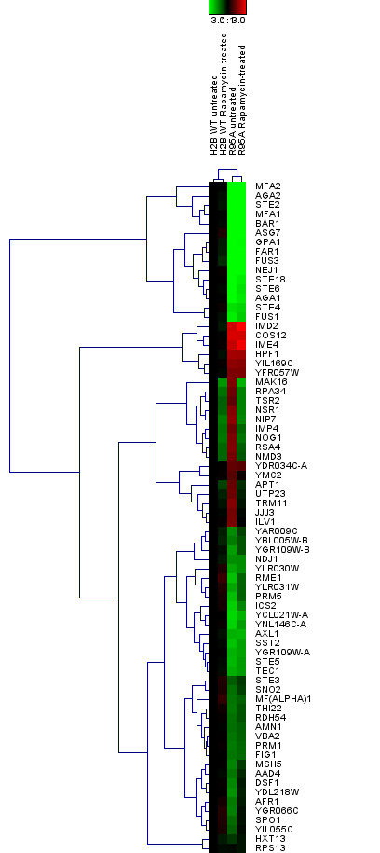

Figure S1: Heat map visualization obtained by hierarchical clustering of the genes differentially regulated in H2B R95A mutant under no treatment or rapamycin treatment as compared to H2B WT. This analysis is based on a subset of n=73 genes (rows) which were found to be differentially expressed in H2B R95A mutant. Hierarchical clustering generated a tree (dendrogram) and group similar genes together. The color-ratio bar at the top indicates intensity of gene up-regulation (red), down-regulation (green) and no change (black).

Figure S2: α-factor induces G₁ cell cycle arrest in the H2B WT, but not in the H2B R95A mutant strain. A and B, Briefly, overnight cells were sub-cultured for 3 hours and samples were taken for asynchronous growth followed by treatment with α-factor (4 µg/ml for 3 hours). Cells were washed free of the α-factor, released into fresh media and samples taken at the indicated times were processed using FACS analysis and the image treated by the Flowjo software. The results are representative of two independent analyses.

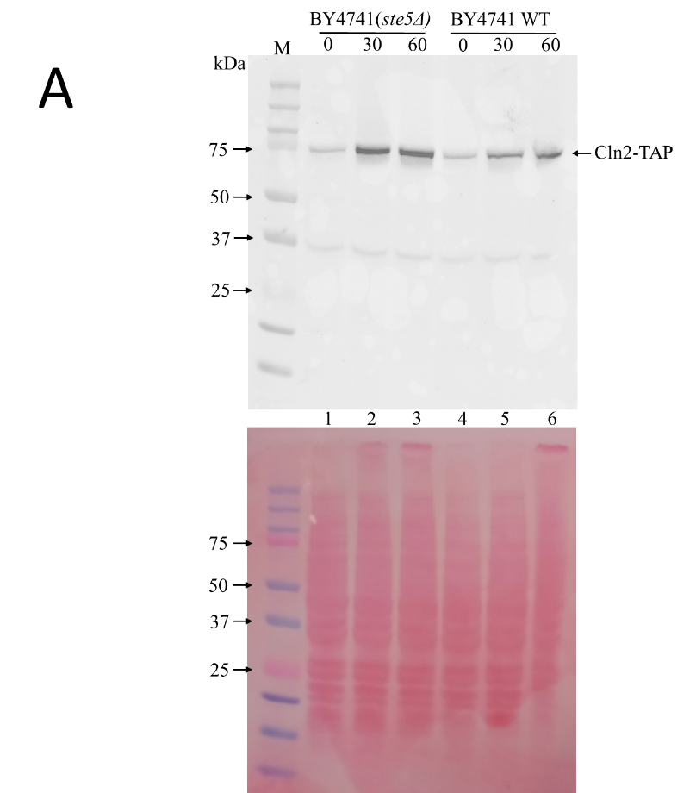
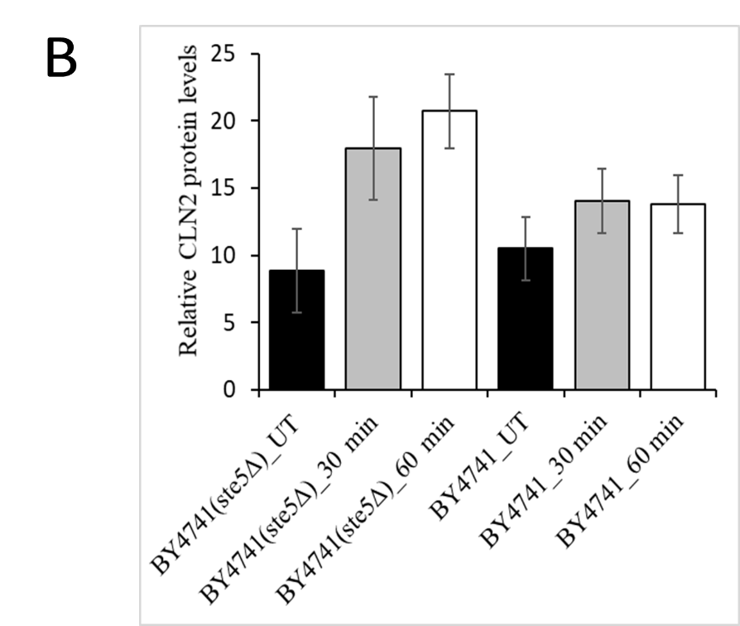

Figure S3: Rapamycin treatment accumulates cyclin Cln2 at a higher level in the ste5Δ mutant, as compared to the WT. Exponentially growing cells derived from strain BY4741 (WT) carrying the TAP tag at the endogenous CLN2 gene locus and the isogenic strain (ste5Δ) deleted for the STE5 gene were treated without (time zero) and with rapamycin (200 ng/ml). Samples were taken at 30 and 60 mins for total protein extraction by TCA. The TCA extracted proteins were analyzed by immunoblot and probed with anti-TAP, which recognizes the protein A domain of the Cln2-TAP tagged fusion protein (see Materials and Methods). The lower panel was stained with Ponceau to monitor for equal protein loading from the TCA samples. M, prestained protein markers in kDa.

