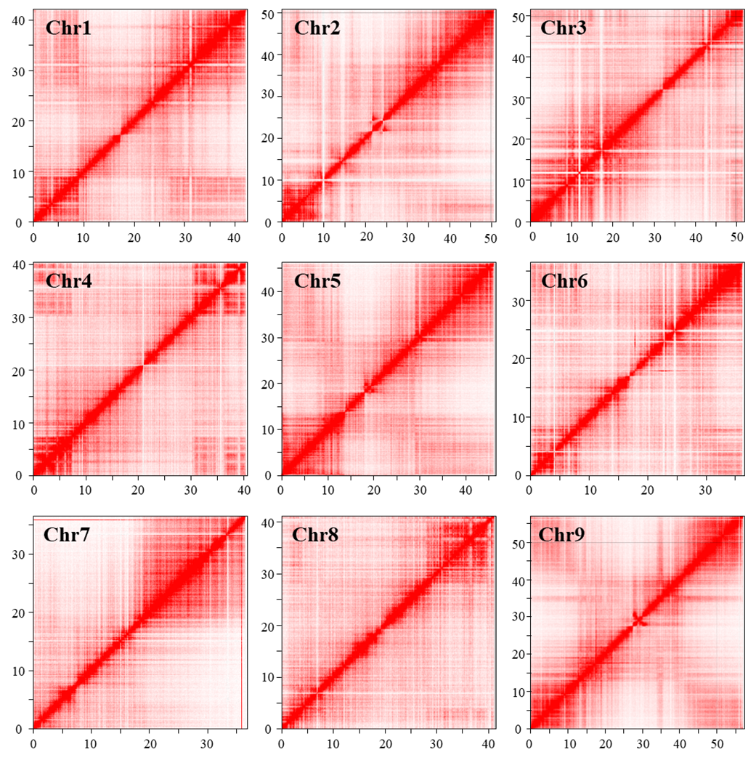
Figure S2. Hi C linkage density heat map of assembled contigs.

