Omega & MDD MR: Supplementary Materials
Table of Contents
Omega & MDD MR: Supplementary Materials 1
S1: Supplementary Methods 1
Assessing instrument strength and validity 1
Additional Methods specific to CHARGE Exposure Data 2
Validation Methods 2
S2: SNP- exposure associations for Omega fatty acids from UKBB 5
a. Total Omega 3 5
b. DHA UKBB 7
c. Omega 3 (%) 9
d. Total Omega 6 11
e. Linoleic Acid (LA) 13
f. DHA Lemaitre (MVMR models) 14
g. EPA Lemaitre 16
h. FADS and ELOVL analyses 18
S3. Data Sources 18
S4: Cochran’s Q Statistics and MR Egger Intercepts for MDD analyses. 20
S5: Comparison between MR analyses using complete MDD outcome sample (n=807,553), and MDD sample removing UKBB sample overlap (n=480,359) 21
S6 Comparison of multivariable MR models using different instruments. 22
S7: Individual MR sensitivity plots for causal effects of specific fatty acid exposures on MDD 22
Total Omega 3 23
Omega 3(%) 24
DHA 25
Omega 6 26
LA 27
EPA 28
S8 Colocalization 29
S9 Phewas results 32
Supplement References 33

S1: Supplementary Methods

Assessing instrument strength and validity
- Calculating variance
The variance explained in our exposure by each SNP was calculated by using the GWAS effect size (beta) effect allele frequency (EAF), standard error (SE), and sample size (N) for each SNP using the following equation:

2 x beta²x EAF x (1-EAF) / (2 x beta² x EAF x (1-EAF) + SE² x 2 x N x EAF x (1-EAF))

The total variance explained in each exposure (R²) was calculated as the sum of individual SNP variances.

- Instrument Strength (F)

F-statistics for each exposure were calculated using the formula:

F= (Σ r²/nSNP)/ ((1-Σ r²)/(N-nSNP-1))

Where Σ r² is the sum of the variance explained in the exposure for each SNP, nSNP is the number of SNPs and N is the sample size of the exposure GWAS instrument strength was quantified using the mean F statistic ($\overline{F}$)¹, and the conditional F statistic^{2, 3} for MVMR analyses. We considered the conventional threshold ($\overline{F}$ <10) as weak instruments for our exposure of interest, and at risk of bias.

Additional Methods specific to CHARGE Exposure Data
Identifying Instruments
As the GWAS study of EPA in the Cohorts for Heart and Aging Research in Genomic Epidemiology (CHARGE) Consortium were on a much smaller sample (n=8,866), only 2 SNPs for EPA remained after clumping, prohibiting the use of sensitivity analyses requiring more SNPs. We therefore took the instruments identified from the UKBB total omega 3 GWAS and extracted the SNP-EPA effect sizes from the EPA GWAS study. For the multivariable analysis of EPA and DHA, conditional F statistics were very low using UKBB SNPs (F_{EPA} =6, and F_{DHA} =4). We confirmed the findings using instruments derived from a previous GWAS of total omega 3 by Kettunen et al.⁴ 5 genome wide significant SNPs were identified from this GWAS, and the SNP-exposure effect sizes were extracted from the CHARGE consortium EPA and DHA GWAS summary statistics. Conditional F statistics were stronger for this analysis, and hence are reported in the main paper, with the details of supplementary MVMR analysis in the supplementary S8 (‘MVMR.xls’).

Standardizing Effect Estimates
As CHARGE Consortium GWAS effect estimates are presented as % of total fatty acids- they were converted to standardized units (SD (mmol/L)) to help interpretation. This was achieved using GWIS (Genome-wide Inferred Study),⁵ a method that approximates GWAS summary statistics from phenotypes for which GWAS summary statistics, phenotypic means, and covariances are available. SD (mmol/L) SNP-effect estimates were derived as a linear function of the allele frequencies, population means of the fatty acid concentrations, and SNP-% fatty acid effect estimates.

Validation Methods
Effect Direction
We used two methods to confirm that the association between the SNPs and MDD resulted from an effect on the exposure, and not the reverse. Firstly, we used ‘Steiger filtering’⁶ to retain only SNPs explaining a greater amount of variance in the exposure than the outcome, as would be expected for a true causal effect in this direction. Secondly, we used ‘reverse MR’ to consider whether genetic liability to MDD affected circulating omega 3, potentially causing a spurious result. For MR in the reverse direction, we identified genome wide significant SNPs (p<5x10⁻⁸) from the PGC MDD GWAS (minus UKBB samples). After clumping (r2<0.001) 27 MDD SNPs remained. Outcome data for these 27 SNPs were then extracted from the total omega-3 and DHA UKBB GWASs, and MR undertaken using the TwoSampleMR package as described above.

Biological Plausibility and Potential Pleiotropy
To investigate the biological plausibility of the effect, we restricted MR to biologically defined pathways relating to omega-3 fatty acid biosynthesis, using only the strongest single SNP within the FADS gene cluster on chromosome 11 (rs174564), and the ELOVL2 gene on chromosome 6 (rs2295602). These genes code enzymes that convert shorter chain fatty acids (derived from dietary sources, such as alpha-linoleic acid (ALA)), into longer chain fatty acids (such as EPA and DHA,) thought to be the most relevant biological omega-3 fatty acids for the development of MDD.

Multivariable MR is a method used to account for genetically correlated traits in MR, and establish the direct effect of an exposure, after accounting for the effect of the instruments on genetically correlated exposures.⁷ We used the TwoSampleMR package mv_multiple function to estimate the direct effects of omega-3 FA after accounting for correlated traits. MVMR models were limited to a few simultaneous exposures, as an increasing number of exposures reduced the conditional F statistics and therefore the precision of our estimates. To calculate conditional F statistics, we used the PhenoSpD R package(ref) to estimate the correlation between phenotypes using summary statistics,, and input the covariance matrices into the MVMR package.⁸

We fitted three MVMR models (see table 1). The first model looked at differential effects between omega 3 and omega 6 fatty acids, using SNPs identified from our primary analyses.

In the second model, we included the commonly measured lipids in clinical practice- triglycerides, high-density lipoprotein (HDL) and low-density lipoprotein (LDL) cholesterol- to establish a direct effect of omega-3 fatty acids on MDD, adjusting for broader lipid profile. Genome wide significant SNPs for triglycerides, HDL and LDL cholesterol were obtained from a GWAS study of these exposures among UKBB participants.⁹

In the third model we considered whether there was a difference in effect between EPA and DHA on MDD, using effect sizes for each exposure derived from the CHARGE consortium.¹⁰ As MVMR models using SNP-exposure effect sizes of UKBB instruments gave poor conditional F statistics and high heterogeneity (model 3a), we compared these results with MVMR models using alternative instruments. In model 3b, SNPs were selected from a GWAS study of total omega 3, as EPA was unavailable. In both models the SNP-exposure effects were extracted from the relevant CHARGE GWAS. We used a pairwise t-test to calculate the likelihood that the difference between the observed effect sizes for each exposure in the model had occurred by chance.

Exploring Biological Pathways - FADS and ELOVL Analyses
To explore biological mechanisms, we identified SNPs for the FADS gene cluster and ELOVL2 gene which encode key desaturase and elongase enzymes involved in omega-3 and omega-6 fatty acid biosynthesis pathways. SNP-exposure data for SNPs within the FADS gene cluster locus (chr11:61560452-61659523 ± 500kb) and ELOVL2 gene locus (chr6:10980992-11044624 ± 500kb) were extracted from the UKBB DHA GWAS. SNP-outcome data was then extracted from the MDD GWAS, followed by LD clumping to identify the single strongest SNP for each genetic locus. As no SNPs on the ELOVL2 gene were strongly associated with UKBB GWAS Omega-3 or -6 measures, none of the SNPs identified through this approach gave satisfactory F statistics, leading to extreme confidence intervals and highly variable point estimates. We therefore have omitted ELOVL2 analyses.
Colocalization
Linkage disequilibrium (LD) could lead to biased results in Mendelian randomization if, by chance, the selected genetic instrument influencing fatty acids is correlated (i.e. in LD) with another genetic variant influencing the risk of MDD independently. We used the ‘coloc’ R package,¹¹ a method for pairwise genetic colocalization analysis, to estimate the posterior probability for the association with both traits being explained by the same causal variant in the FADS region. To do this, we selected the top SNP in the FADS region (rs174564), and all SNPs within a 500kbp radius. We used the ‘gassocplot’ R package to plot the SNPs for total omega 3, EPA and DHA, along with MDD, rMDD and the MDD sample including UKBB.

Colocalization methods apply Bayesian probabilities to the SNP-trait associations of all SNPs within a defined region, to establish the likelihood that two traits are genetically linked. The coloc package in R uses prior probabilities that a SNP is associated with a trait (with a default of 1E⁻⁴) for each trait, and presents four distinct posterior probabilities of association (PPA):
H0 There is no causal variant for either trait in the region
H1 Causal variant for trait 1 only
H2 Causal variant for trait 2 only
H3 Both traits are associated, but have distinct causal variants
H4 Both traits are associated and share a single common causal variant
The coloc package provides a ‘posterior probability of association’ (PPA), with ≥ 70% (PPA for H4) considered as suggestive of a shared single causal variant between omega-3 fatty acids and MDD risk. This method assumes that a single common genetic variant exists for both traits, which may be unrealistic. An extension to this method ‘runsusie’ relaxes the single causal variant assumption,¹² however, excessive prior probability in the outcome, (possibly as a result of the binary outcome measure, inherent to large scale psychiatric genomics research,) prohibited its use.

Results for the colocalization analyses are presented in S7: Colocalization, below.
PheWAS
As a supplementary, post-hoc analysis, we used the ieugwasr R package to undertake a Phenome Wide Association Study ‘PheWAS’ of the FADS SNP driving the apparent causal effect on depression (rs174564). A PheWAS is a technique used to scan multiple GWAS studies for association of a given SNP with multiple different phenotypes, to identify other potential phenotypes of interest. For our analyses, the PheWAS served two purposes. The first was to confirm variables included within our MVMR models were relevant, and the second was to consider potential mediating mechanisms and intermediate phenotypes on the biological pathway between omega-3 fatty acids and MDD, to facilitate further mechanistic research.

The ieugwasr package in R scans all traits contained within the IEU Open GWAS Database,¹³ which contains 14,582 harmonized GWAS datasets across a range of phenotypes and disease outcomes. By nature of the data, there are often multiple GWAS studies for traits (for example blood pressure, pulse rate or obesity). We used the default p-value threshold given in the ieugwasr package (p<5e-5). There are multiple highly correlated phenotypes that appear as individual ‘hits’. As the FADS2 SNP contained many correlated traits relating to lipid metabolism, we have presented this as a separate category.
Results for the PheWAS are attached as the supplementary material S10 (‘PheWAS.xls’), with an annotated plot of some key associations shown in S8 below.

S2: SNP- exposure associations for Omega fatty acids from UKBB
The following tables contain details of the instruments used for each exposure, along with estimated variance they each explain, and Steiger p values for the MR analysis with MDD. SNP-exposure associations for total omega 3 fatty acids, total omega 6 fatty acids, DHA, LA and omega 3% were selected from the UKBB GWAS (Borges 2020) using the ieugwasr:: R package. Instruments for analyses of EPA (and DHA in MVMR model 3), were identified from the UKBB total Omega 3 GWAS, and SNP-exposure associations were extracted from the relevant CHARGE consortium GWAS study.

Betas for each exposure are given in SD units. SNPs excluded from the analyses are denoted in strikethrough.

Total Omega 3
 | SNP | EA |  | eaf |  | beta |  |  | se |  |  |  | pval |  | samplesize |  |  | exposure |  | Steiger p
1 | rs6693447 | G |  | 0.46 |  | 0.02 |  |  | 0.004 |  |  |  | 4.80E-09 |  | 115078 |  |  | 0.03% |  | 3.52E-05
2 | rs1167998 | A |  | 0.64 |  | 0.07 |  |  | 0.004 |  |  |  | 3.60E-66 |  | 115078 |  |  | 0.24% |  | 1.57E-35
3 | rs629301 | T |  | 0.78 |  | 0.04 |  |  | 0.005 |  |  |  | 1.30E-14 |  | 115078 |  |  | 0.05% |  | 1.68E-08
4 | rs1260326 | C |  | 0.60 |  | -0.08 |  |  | 0.004 |  |  |  | 8.40E-88 |  | 115078 |  |  | 0.34% |  | 2.16E-47
5 | rs11681659 | T |  | 0.72 |  | -0.03 |  |  | 0.004 |  |  |  | 2.00E-08 |  | 115078 |  |  | 0.03% |  | 5.8E-05
6 | rs35135293 | T |  | 0.52 |  | -0.02 |  |  | 0.004 |  |  |  | 3.90E-08 |  | 115078 |  |  | 0.02% |  | 0.000125
7 | rs13424225 | T |  | 0.45 |  | 0.02 |  |  | 0.004 |  |  |  | 2.20E-08 |  | 115078 |  |  | 0.03% |  | 0.00074
8 | rs10184054 | G |  | 0.22 |  | -0.04 |  |  | 0.005 |  |  |  | 5.60E-15 |  | 115078 |  |  | 0.05% |  | 3.41E-07
9 | rs11563251 | T |  | 0.11 |  | 0.03 |  |  | 0.006 |  |  |  | 3.20E-08 |  | 115078 |  |  | 0.03% |  | 0.002718
10 | rs4860987 | T |  | 0.26 |  | 0.05 |  |  | 0.005 |  |  |  | 1.20E-21 |  | 115078 |  |  | 0.08% |  | 9.77E-16
11 | rs11242109 | T |  | 0.48 |  | 0.02 |  |  | 0.004 |  |  |  | 2.40E-09 |  | 115078 |  |  | 0.03% |  | 5.65E-05
12 | rs6882345 | A |  | 0.63 |  | 0.03 |  |  | 0.004 |  |  |  | 1.90E-13 |  | 115078 |  |  | 0.04% |  | 1.69E-06
13 | rs10455872 | G |  | 0.08 |  | -0.06 |  |  | 0.008 |  |  |  | 2.80E-17 |  | 115078 |  |  | 0.06% |  | 5.16E-10
14 | rs117733303 | G |  | 0.02 |  | -0.12 |  |  | 0.015 |  |  |  | 1.40E-15 |  | 115078 |  |  | 0.05% |  | 8.54E-08
15 | rs62466318 | T |  | 0.20 |  | -0.07 |  |  | 0.005 |  |  |  | 1.20E-45 |  | 115078 |  |  | 0.18% |  | 1.9E-24
16 | rs73109460 | A |  | 0.12 |  | -0.03 |  |  | 0.006 |  |  |  | 9.20E-10 |  | 115078 |  |  | 0.03% |  | 2.54E-05
17 | rs4000713 | A |  | 0.30 |  | -0.03 |  |  | 0.004 |  |  |  | 1.00E-11 |  | 115078 |  |  | 0.04% |  | 2.43E-06
18 | rs112875651 | A |  | 0.39 |  | -0.09 |  |  | 0.004 |  |  |  | 3.50E-98 |  | 115078 |  |  | 0.37% |  | 4.06E-56
19 | rs9987289 | G |  | 0.91 |  | 0.06 |  |  | 0.007 |  |  |  | 3.20E-16 |  | 115078 |  |  | 0.06% |  | 1.96E-08
20 | rs7819706 | G |  | 0.12 |  | -0.04 |  |  | 0.006 |  |  |  | 1.80E-10 |  | 115078 |  |  | 0.03% |  | 3.14E-06
21 | rs1800978 | G |  | 0.12 |  | -0.04 |  |  | 0.006 |  |  |  | 5.20E-09 |  | 115078 |  |  | 0.03% |  | 3.62E-05
22 | rs7924036 | T |  | 0.50 |  | 0.02 |  |  | 0.004 |  |  |  | 5.50E-10 |  | 115078 |  |  | 0.03% |  | 0.000106
23 | rs6601924 | C |  | 0.85 |  | 0.04 |  |  | 0.006 |  |  |  | 8.50E-10 |  | 115078 |  |  | 0.03% |  | 2.7E-05
24 | rs673335 | C |  | 0.16 |  | -0.07 |  |  | 0.006 |  |  |  | 1.10E-34 |  | 115078 |  |  | 0.13% |  | 1.14E-17
25 | rs12226389 | C |  | 0.19 |  | -0.05 |  |  | 0.005 |  |  |  | 1.10E-22 |  | 115078 |  |  | 0.08% |  | 7.04E-13
26 | rs3018731 | G |  | 0.72 |  | -0.04 |  |  | 0.005 |  |  |  | 2.00E-14 |  | 115078 |  |  | 0.05% |  | 7.27E-07
27 | rs144018203 | C |  | 0.01 |  | 0.11 |  |  | 0.020 |  |  |  | 4.20E-08 |  | 115078 |  |  | 0.02% |  | 0.0001
28 | rs143355652 | T |  | 0.01 |  | -0.15 |  |  | 0.020 |  |  |  | 9.40E-14 |  | 115078 |  |  | 0.05% |  | 4.78E-08
29 | rs174564 | G |  | 0.35 |  | -0.34 |  |  | 0.004 |  |  |  | 1.00E-200 |  | 115078 |  |  | 5.20% |  | 0
30 | rs964184 | C |  | 0.87 |  | -0.12 |  |  | 0.006 |  |  |  | 8.90E-87 |  | 115078 |  |  | 0.33% |  | 2.42E-47
31 | rs7970695 | A |  | 0.62 |  | -0.03 |  |  | 0.004 |  |  |  | 1.20E-10 |  | 115078 |  |  | 0.03% |  | 1.05E-05
32 | rs261290 | C |  | 0.65 |  | -0.11 |  |  | 0.004 |  |  |  | 3.90E-161 |  | 115078 |  |  | 0.62% |  | 3.33E-89
33 | rs139974673 | C |  | 0.03 |  | 0.12 |  |  | 0.013 |  |  |  | 2.30E-21 |  | 115078 |  |  | 0.07% |  | 1.3E-11
34 | rs34663616 | A |  | 0.14 |  | 0.04 |  |  | 0.006 |  |  |  | 4.40E-10 |  | 115078 |  |  | 0.03% |  | 6.86E-06
35 | rs633695 | G |  | 0.29 |  | 0.08 |  |  | 0.004 |  |  |  | 9.10E-80 |  | 115078 |  |  | 0.30% |  | 2.96E-44
36 | rs1672811 | C |  | 0.75 |  | 0.03 |  |  | 0.005 |  |  |  | 3.00E-08 |  | 115078 |  |  | 0.02% |  | 0.001885
37 | rs72789541 | A |  | 0.30 |  | -0.08 |  |  | 0.004 |  |  |  | 5.60E-75 |  | 115078 |  |  | 0.29% |  | 3E-40
38 | rs9304381 | T |  | 0.82 |  | 0.05 |  |  | 0.005 |  |  |  | 5.20E-24 |  | 115078 |  |  | 0.09% |  | 1.88E-13
39 | rs77960347 | G |  | 0.01 |  | 0.16 |  |  | 0.018 |  |  |  | 7.20E-22 |  | 115078 |  |  | 0.07% |  | 7.25E-11
40 | rs737338 | T |  | 0.04 |  | -0.07 |  |  | 0.011 |  |  |  | 3.50E-11 |  | 115078 |  |  | 0.04% |  | 6.09E-05
41 | rs1132899 | C |  | 0.51 |  | 0.03 |  |  | 0.004 |  |  |  | 8.60E-11 |  | 115078 |  |  | 0.04% |  | 1.79E-06
10 | rs6129624 | A |  | 0.34 |  | -0.03 |  |  | 0.004 |  |  |  | 5.10E-10 |  | 115078 |  |  | 0.03% |  | 1.13E-05
11 | rs117143374 | C |  | 0.14 |  | -0.04 |  |  | 0.006 |  |  |  | 2.20E-10 |  | 115078 |  |  | 0.03% |  | 1.5E-05
 |  |  |  |  |  |  |  |  |  |  |  |  | Total Variance Explained |  | 9.13%
1 | rs2394976 |  | T |  | 0.16 |  | -0.05 |  |  |  | 0.01 |  |  | 1.20E-15 |  | 115078 |  |  | Not in Outcome sample
2 | rs3129962 |  | A |  | 0.13 |  | -0.04 |  |  | 0.01 |  |  |  | 1.80E-09 |  | 115078 |  |  | Not in Outcome sample
3 | rs55891451 |  | C |  | 0.20 |  | 0.03 |  |  |  |  | 0.01 |  | 4.60E-12 |  | 115078 |  |  | Not in Outcome sample
4 | rs11230829 |  | G |  | 0.03 |  | -0.10 |  |  |  |  | 0.01 |  | 3.40E-12 |  | 115078 |  |  | Not in Outcome sample
5 | rs16940904 |  | T |  | 0.23 |  | -0.04 |  |  |  |  | 0.00 |  | 3.90E-14 |  | 115078 |  |  | Not in Outcome sample
6 | rs182611493 |  | G |  | 0.01 |  | -0.21 |  |  |  |  | 0.02 |  | 1.10E-27 |  | 115078 |  |  | Not in Outcome sample
7 | rs157592 |  | C |  | 0.19 |  | 0.03 |  |  |  |  | 0.01 |  | 3.60E-09 |  | 115078 |  |  | Not in Outcome sample
8 | rs58542926 |  | T |  | 0.07 |  | -0.17 |  |  |  |  | 0.008 |  | 1.40E-113 |  | 115078 |  |  | Not in Outcome sample
9 | rs5112 |  | G |  | 0.53 |  | 0.05 |  |  |  |  | 0.004 |  | 9.10E-30 |  | 115078 |  |  | Ambiguous palindrome

DHA UKBB
 | SNP | EA | EAF | BETA | SE | P | N | % VARIANCE | STEIGER P
1 | rs629301 | T | 0.78 | 0.04 | 0.005 | 1.40E-19 | 115078 | 0.07% | 8.92E-11
2 | rs11122450 | G | 0.61 | 0.02 | 0.004 | 3.40E-08 | 115078 | 0.03% | 0.000799
3 | rs638714 | T | 0.35 | -0.04 | 0.004 | 5.40E-20 | 115078 | 0.07% | 1.65E-10
4 | rs13424225 | T | 0.45 | 0.02 | 0.004 | 1.10E-08 | 115078 | 0.03% | 0.000634
5 | rs1260326 | C | 0.60 | -0.05 | 0.004 | 8.70E-30 | 115078 | 0.11% | 9.02E-16
6 | rs34722314 | A | 0.14 | -0.05 | 0.006 | 6.80E-18 | 115078 | 0.06% | 1.85E-09
7 | rs11681659 | T | 0.72 | -0.03 | 0.004 | 5.30E-12 | 115078 |  | 2.03E-06
8 | rs4860987 | T | 0.26 | 0.04 | 0.005 | 3.90E-16 | 115078 | 0.06% | 8.95E-11
9 | rs273912 | T | 0.71 | 0.03 | 0.004 | 6.60E-10 | 115078 | 0.03% | 2.84E-05
10 | rs6931604 | T | 0.60 | 0.02 | 0.004 | 2.70E-08 | 115078 | 0.03% | 0.001318
11 | rs73109460 | A | 0.12 | -0.04 | 0.006 | 7.30E-11 | 115078 | 0.03% | 8.92E-06
12 | rs9987289 | G | 0.91 | 0.06 | 0.007 | 1.30E-17 | 115078 | 0.06% | 7.35E-09
13 | rs112875651 | A | 0.39 | -0.05 | 0.004 | 1.60E-32 | 115078 | 0.12% | 9.07E-19
14 | rs325 | C | 0.10 | 0.04 | 0.007 | 3.80E-09 | 115078 | 0.03% | 3.11E-05
15 | rs1800978 | G | 0.12 | -0.03 | 0.006 | 4.80E-08 | 115078 | 0.03% | 0.000238
16 | rs7924036 | T | 0.50 | 0.04 | 0.004 | 4.80E-21 | 115078 | 0.07% | 7.48E-10
17 | rs2807967 | C | 0.72 | 0.03 | 0.004 | 1.20E-08 | 115078 | 0.03% | 0.000136
18 | rs12226389 | C | 0.19 | -0.04 | 0.005 | 3.80E-18 | 115078 | 0.06% | 5.86E-10
19 | rs145786300 | A | 0.01 | -0.13 | 0.019 | 4.00E-12 | 115078 | 0.04% | 3.63E-06
20 | rs149820547 | G | 0.04 | -0.05 | 0.010 | 4.80E-08 | 115078 | 0.03% | 0.000452
21 | rs143355652 | T | 0.01 | -0.15 | 0.020 | 6.60E-14 | 115078 | 0.05% | 8.49E-08
22 | rs2232143 | C | 0.02 | 0.08 | 0.014 | 6.60E-09 | 115078 | 0.03% | 5.15E-06
23 | rs174564 | G | 0.35 | -0.29 | 0.004 | 1.00E-200 | 115078 | 4.02% | 0
24 | rs673335 | C | 0.16 | -0.06 | 0.005 | 8.10E-25 | 115078 | 0.09% | 2.75E-12
25 | rs145659493 | A | 0.02 | 0.09 | 0.016 | 1.70E-09 | 115078 | 0.03% | 5.45E-05
26 | rs525028 | A | 0.71 | -0.03 | 0.004 | 2.70E-12 | 115078 | 0.04% | 9.32E-06
27 | rs139974673 | C | 0.03 | 0.07 | 0.013 | 8.80E-09 | 115078 | 0.03% | 6.3E-05
28 | rs261291 | C | 0.36 | 0.12 | 0.004 | 5.40E-172 | 115078 | 0.66% | 2.46E-90
29 | rs1560390 | C | 0.22 | -0.05 | 0.005 | 2.50E-26 | 115078 | 0.09% | 4.25E-14
30 | rs12914626 | T | 0.70 | -0.06 | 0.004 | 7.50E-45 | 115078 | 0.17% | 1.61E-24
31 | rs72789541 | A | 0.30 | -0.08 | 0.004 | 5.60E-71 | 115078 | 0.27% | 4.21E-37
32 | rs3764261 | A | 0.32 | 0.04 | 0.004 | 1.90E-21 | 115078 | 0.07% | 0.000198
33 | rs4986970 | T | 0.03 | -0.07 | 0.011 | 1.30E-10 | 115078 | 0.03% | 1.19E-05
34 | rs72836561 | T | 0.03 | -0.06 | 0.011 | 3.60E-08 | 115078 | 0.03% | 0.000108
35 | rs9304381 | T | 0.82 | 0.05 | 0.005 | 5.80E-23 | 115078 | 0.08% | 2.49E-12
36 | rs77960347 | G | 0.01 | 0.14 | 0.017 | 2.50E-17 | 115078 | 0.06% | 1.4E-08
37 | rs73045691 | A | 0.30 | 0.03 | 0.005 | 3.60E-10 | 115078 | 0.04% | 8.59E-07
38 | rs2278426 | T | 0.04 | -0.06 | 0.011 | 3.70E-08 | 115078 | 0.03% | 0.001319
39 | rs58542926 | T | 0.07 | -0.12 | 0.008 | 1.40E-57 | 115078 | 0.21% | 2.73E-28
40 | rs7412 | T | 0.08 | -0.08 | 0.007 | 5.40E-26 | 115078 | 0.09% | 3.32E-13
 |  |  |  |  |  | Total Variance Explained |  | 7.04%
1 | rs2394976 | T | 0.16 | -0.03 | 0.0054 | 5.60E-11 | 115078 |  | Not in Outcome
2 | rs35177659 | T | 0.52 | 0.02 | 0.0042 | 2.70E-08 | 115078 |  | Not in Outcome
3 | rs55891451 | C | 0.20 | 0.03 | 0.005 | 5.60E-11 | 115078 |  | Not in Outcome
4 | rs11230829 | G | 0.03 | -0.09 | 0.0146 | 9.60E-11 | 115078 |  | Not in Outcome
5 | rs78689694 | C | 0.13 | 0.04 | 0.0059 | 4.40E-10 | 115078 |  | Not in Outcome
6 | rs16940904 | T | 0.23 | -0.04 | 0.0048 | 2.10E-17 | 115078 |  | Not in Outcome
7 | rs182611493 | G | 0.01 | -0.16 | 0.0192 | 1.60E-16 | 115078 |  | Not in Outcome

Omega 3 (%)
 | SNP | EA | EAF | BETA | SE | P | N | % VARIANCE | STEIGER P
1 | rs638714 | T | 0.35 | -0.03 | 0.004 | 4.9E-15 | 115078 | 0.05% | 3.31908E-08
2 | rs6693447 | G | 0.46 | 0.03 | 0.004 | 8.3E-12 | 115078 | 0.04% | 1.91472E-06
3 | rs2011946 | A | 0.73 | -0.03 | 0.005 | 2.6E-09 | 115078 | 0.03% | 4.79373E-05
4 | rs1260326 | C | 0.60 | -0.04 | 0.004 | 2.3E-19 | 115078 | 0.07% | 1.55163E-10
5 | rs4860987 | T | 0.26 | 0.04 | 0.005 | 8.1E-17 | 115078 | 0.06% | 6.78285E-07
6 | rs272888 | C | 0.71 | 0.03 | 0.004 | 1.8E-11 | 115078 | 0.04% | 2.96549E-06
7 | rs7444298 | G | 0.24 | 0.03 | 0.005 | 2.4E-08 | 115078 | 0.03% | 0.000451764
8 | rs662138 | G | 0.19 | -0.03 | 0.005 | 6.6E-11 | 115078 | 0.04% | 8.42159E-06
9 | rs4000713 | A | 0.30 | -0.03 | 0.004 | 1.6E-10 | 115078 | 0.03% | 8.07789E-06
10 | rs73109460 | A | 0.12 | -0.03 | 0.006 | 7.8E-09 | 115078 | 0.02% | 0.000116707
11 | rs2236514 | G | 0.66 | -0.02 | 0.004 | 3.1E-08 | 115078 | 0.02% | 0.000284196
12 | rs7924036 | T | 0.50 | 0.04 | 0.004 | 4.0E-23 | 115078 | 0.08% | 2.34484E-11
13 | rs56233220 | C | 0.20 | 0.04 | 0.005 | 4.4E-13 | 115078 | 0.04% | 2.25181E-34
14 | rs11236512 | A | 0.06 | -0.07 | 0.009 | 5.3E-15 | 115078 | 0.05% | 1.03174E-20
15 | rs2232143 | C | 0.02 | 0.11 | 0.014 | 1.3E-13 | 115078 | 0.05% | 6.55812E-09
16 | rs191623731 | G | 0.02 | 0.12 | 0.016 | 9.8E-14 | 115078 | 0.05% | 2.56548E-07
17 | rs964184 | C | 0.87 | -0.04 | 0.006 | 1.2E-10 | 115078 | 0.04% | 5.49707E-06
18 | rs143355652 | T | 0.01 | -0.18 | 0.020 | 1.2E-18 | 115078 | 0.07% | 1.47775E-10
19 | rs174564 | G | 0.35 | -0.39 | 0.004 | 1.0E-200 | 115078 | 6.93% | 0
20 | rs12226389 | C | 0.19 | -0.06 | 0.005 | 2.2E-32 | 115078 | 0.12% | 1.77867E-18
21 | rs149402055 | T | 0.02 | -0.17 | 0.015 | 9.2E-30 | 115078 | 0.11% | 3.78988E-18
22 | rs145786300 | A | 0.01 | -0.19 | 0.019 | 1.3E-22 | 115078 | 0.08% | 7.41607E-12
23 | rs9563335 | G | 0.86 | -0.04 | 0.008 | 5.5E-09 | 115078 | 0.03% | 2.53136E-07
24 | rs261291 | C | 0.36 | 0.08 | 0.004 | 1.8E-83 | 115078 | 0.31% | 1.19163E-44
25 | rs11632618 | A | 0.07 | 0.08 | 0.008 | 1.1E-22 | 115078 | 0.08% | 2.91717E-12
26 | rs1560390 | C | 0.22 | -0.03 | 0.005 | 6.9E-12 | 115078 | 0.04% | 1.32929E-06
27 | rs139974673 | C | 0.03 | 0.08 | 0.013 | 1.3E-11 | 115078 | 0.04% | 1.90682E-06
28 | rs72789541 | A | 0.30 | -0.10 | 0.004 | 3.5E-106 | 115078 | 0.41% | 1.80914E-57
29 | rs8074191 | C | 0.76 | -0.03 | 0.005 | 2.3E-08 | 115078 | 0.03% | 0.00011768
30 | rs9947684 | G | 0.65 | 0.03 | 0.004 | 2.8E-12 | 115078 | 0.04% | 1.12342E-06
31 | rs58542926 | T | 0.07 | -0.13 | 0.008 | 1.2E-67 | 115078 | 0.25% | 3.04205E-08
32 | rs72654473 | A | 0.11 | 0.04 | 0.007 | 6.1E-09 | 115078 | 0.03% | 0.000211995
33 | rs190921611 | A | 0.31 | 0.03 | 0.005 | 2.0E-11 | 115078 | 0.04% | 1.04825E-07
 |  |  |  |  |  | Total Variance Explained |  |  | 9.34%
8 | rs2394976 | T | 0.16 | -0.03 | 0.006 | 5E-09 | 115078 |  | Not in outcome
23 | rs11230829 | G | 0.03 | -0.12 | 0.015 | 2E-15 | 115078 |  | Not in outcome
34 | rs16940904 | T | 0.23 | -0.04 | 0.005 | 2E-19 | 115078 |  | Not in outcome
39 | rs182611493 | G | 0.01 | -0.17 | 0.020 | 9E-19 | 115078 |  | Not in outcome
11 | rs112875651 | A | 0.39 | -0.05 | 0.004 | 5.70E-35 | 115078 |  | Not in outcome
10 | rs62466318 | T | 0.20 | -0.04 | 0.005 | 3.10E-16 | 115078 |  | Not in outcome
28 | rs35390787 | C | 0.56 | -0.03 | 0.004 | 5.60E-11 | 115078 |  | Not in outcome

Total Omega 6
 | SNP | EA | EAF | BETA | SE | P | N | % VARIANCE | STEIGER P
1 | rs1002687 | A | 0.64 | 0.09 | 0.004 | 1.0E-107 | 115078 | 0.40% | 3.7E-57
2 | rs534417 | G | 0.88 | 0.04 | 0.006 | 9.3E-11 | 115078 | 0.04% | 1.7E-05
3 | rs12740374 | T | 0.22 | -0.06 | 0.005 | 1.5E-32 | 115078 | 0.12% | 1.5E-17
4 | rs1260326 | C | 0.60 | -0.06 | 0.004 | 3.9E-55 | 115078 | 0.21% | 3.0E-29
5 | rs870526 | T | 0.52 | -0.03 | 0.004 | 7.7E-16 | 115078 | 0.05% | 1.5E-08
6 | rs4299376 | T | 0.68 | -0.04 | 0.004 | 1.1E-16 | 115078 | 0.06% | 1.8E-09
7 | rs6547409 | T | 0.05 | -0.08 | 0.009 | 2.4E-20 | 115078 | 0.07% | 7.6E-11
8 | rs672889 | G | 0.86 | 0.08 | 0.006 | 1.3E-41 | 115078 | 0.15% | 1.4E-22
9 | rs3770586 | T | 0.48 | -0.02 | 0.004 | 7.1E-09 | 115078 | 0.03% | 5.3E-05
10 | rs13108218 | G | 0.62 | -0.04 | 0.004 | 3.6E-18 | 115078 | 0.06% | 6.9E-09
11 | rs4704210 | C | 0.37 | 0.05 | 0.004 | 6.1E-30 | 115078 | 0.11% | 6.4E-16
12 | rs6882345 | A | 0.63 | 0.04 | 0.004 | 1.2E-27 | 115078 | 0.10% | 2.1E-14
13 | rs6934962 | T | 0.40 | 0.02 | 0.004 | 2.2E-08 | 115078 | 0.03% | 1.4E-04
14 | rs3734854 | A | 0.06 | 0.05 | 0.008 | 5.9E-11 | 115078 | 0.03% | 3.9E-04
15 | rs7750288 | G | 0.29 | 0.02 | 0.004 | 1.3E-08 | 115078 | 0.03% | 1.1E-04
16 | rs9295128 | T | 0.02 | -0.20 | 0.016 | 3.4E-36 | 115078 | 0.13% | 1.7E-18
17 | rs114863007 | A | 0.09 | -0.05 | 0.007 | 7.3E-12 | 115078 | 0.04% | 1.3E-05
18 | rs28383314 | C | 0.62 | 0.04 | 0.004 | 1.7E-18 | 115078 | 0.08% | 3.4E-09
19 | rs6938647 | C | 0.78 | -0.05 | 0.005 | 1.9E-23 | 115078 | 0.08% | 3.5E-13
20 | rs55747707 | A | 0.20 | -0.05 | 0.005 | 1.7E-22 | 115078 | 0.08% | 6.1E-12
21 | rs6471717 | A | 0.66 | -0.03 | 0.004 | 4.0E-12 | 115078 | 0.04% | 4.9E-06
22 | rs112875651 | A | 0.39 | -0.06 | 0.004 | 2.2E-53 | 115078 | 0.20% | 1.5E-30
23 | rs2737245 | T | 0.28 | -0.03 | 0.005 | 1.4E-09 | 115078 | 0.03% | 9.3E-06
24 | rs1461729 | G | 0.90 | 0.08 | 0.007 | 2.8E-36 | 115078 | 0.13% | 1.2E-19
25 | rs4008004 | A | 0.22 | 0.03 | 0.005 | 8.4E-12 | 115078 | 0.04% | 6.1E-07
26 | rs11789603 | T | 0.11 | 0.05 | 0.006 | 9.7E-14 | 115078 | 0.05% | 5.3E-07
27 | rs2740488 | C | 0.27 | -0.05 | 0.005 | 5.4E-28 | 115078 | 0.10% | 3.0E-15
28 | rs75406471 | A | 0.15 | -0.03 | 0.006 | 2.7E-08 | 115078 | 0.03% | 2.1E-04
29 | rs141469619 | G | 0.01 | 0.11 | 0.021 | 1.4E-08 | 115078 | 0.02% | 6.9E-05
30 | rs964184 | C | 0.87 | -0.14 | 0.006 | 1.1E-125 | 115078 | 0.47% | 9.4E-67
31 | rs72997616 | A | 0.09 | -0.05 | 0.007 | 1.6E-13 | 115078 | 0.05% | 3.1E-08
32 | rs3817335 | A | 0.35 | -0.03 | 0.004 | 9.8E-12 | 115078 | 0.04% | 4.3E-06
33 | rs7139079 | A | 0.59 | -0.03 | 0.004 | 3.3E-13 | 115078 | 0.05% | 3.2E-07
34 | rs6602911 | T | 0.36 | 0.03 | 0.004 | 1.3E-09 | 115078 | 0.03% | 1.9E-05
35 | rs633695 | G | 0.29 | 0.07 | 0.004 | 1.3E-59 | 115078 | 0.23% | 3.0E-33
36 | rs261290 | C | 0.65 | -0.10 | 0.004 | 1.0E-116 | 115078 | 0.45% | 7.6E-64
37 | rs183130 | T | 0.32 | 0.06 | 0.004 | 1.4E-48 | 115078 | 0.18% | 3.3E-25
38 | rs740516 | G | 0.15 | -0.03 | 0.006 | 1.4E-08 | 115078 | 0.03% | 1.2E-04
39 | rs4439799 | T | 0.50 | 0.02 | 0.004 | 1.3E-08 | 115078 | 0.03% | 1.6E-04
40 | rs77960347 | G | 0.01 | 0.28 | 0.018 | 2.8E-56 | 115078 | 0.21% | 8.5E-30
41 | rs9304381 | T | 0.82 | 0.07 | 0.005 | 7.2E-42 | 115078 | 0.16% | 7.8E-23
42 | rs56322906 | A | 0.04 | -0.10 | 0.011 | 1.2E-19 | 115078 | 0.07% | 3.6E-09
43 | rs142158911 | A | 0.12 | -0.09 | 0.006 | 5.2E-52 | 115078 | 0.19% | 3.3E-27
44 | rs58542926 | T | 0.07 | -0.13 | 0.008 | 2.5E-65 | 115078 | 0.24% | 8.9E-33
45 | rs1081105 | C | 0.03 | 0.12 | 0.012 | 1.8E-22 | 115078 | 0.08% | 7.5E-13
46 | rs79429216 | A | 0.01 | 0.15 | 0.018 | 1.3E-17 | 115078 | 0.06% | 1.4E-09
47 | rs1883711 | C | 0.03 | 0.09 | 0.012 | 3.2E-16 | 115078 | 0.05% | 1.1E-07
48 | rs1800961 | T | 0.03 | -0.07 | 0.012 | 3.3E-10 | 115078 | 0.03% | 9.1E-06
49 | rs5754102 | A | 0.18 | -0.03 | 0.005 | 9.9E-10 | 115078 | 0.03% | 1.2E-05
50 | rs9616847 | T | 0.39 | 0.02 | 0.004 | 1.4E-08 | 115078 | 0.03% | 3.9E-04
 |  |  |  |  |  | Total Variance Explained |  | 4.85%
1 | rs200730299 | C | 0.19 | -0.04 | 0.01 | 7.1E-12 | 115078 |  | Not in outcome
2 | rs2986164 | A | 0.54 | -0.03 | 0 | 3.4E-09 | 115078 |  | Not in outcome
3 | rs4860948 | A | 0.24 | 0.03 | 0 | 1.9E-09 | 115078 |  | Not in outcome
4 | rs35603463 | C | 0.57 | 0.03 | 0 | 4.6E-10 | 115078 |  | Not in outcome
5 | rs7831074 | G | 0.76 | 0.03 | 0.01 | 4.6E-08 | 115078 |  | Not in outcome
6 | rs115478735 | T | 0.18 | 0.04 | 0.01 | 2.2E-17 | 115078 |  | Not in outcome
7 | rs1065853 | T | 0.08 | -0.2 | 0.01 | 4E-160 | 115078 |  | Not in outcome
8 | rs2378390 | A | 0.14 | -0.03 | 0.01 | 3.2E-09 | 115078 |  | Not in outcome
9 | rs4766578 | A | 0.5 | 0.03 | 0 | 1.5E-12 | 115078 |  | Not in outcome
10 | rs7707394 | A | 0.36 | 0.03 | 0 | 1.2E-12 | 115078 |  | Not in outcome

Linoleic Acid (LA)
 | SNP | EA | EAF | BETA | SE | P | N | % VARIANCE | STEIGER P
1 | rs34232196 | T | 0.25 | -0.03 | 0.005 | 8.3E-11 | 115078 | 0.04% | 8.02E-06
2 | rs534417 | G | 0.88 | 0.04 | 0.006 | 2.5E-09 | 115078 | 0.03% | 8.66E-05
3 | rs1002687 | A | 0.64 | 0.09 | 0.004 | 1.8E-97 | 115078 | 0.36% | 3.58E-52
4 | rs602633 | G | 0.78 | 0.05 | 0.005 | 7.5E-28 | 115078 | 0.10% | 2.09E-14
5 | rs35633876 | T | 0.48 | -0.03 | 0.004 | 2.4E-17 | 115078 | 0.06% | 4.54E-10
6 | rs4665972 | C | 0.60 | -0.05 | 0.004 | 1.3E-35 | 115078 | 0.13% | 4.9E-19
7 | rs693 | A | 0.52 | 0.06 | 0.004 | 3.4E-54 | 115078 | 0.20% | 3.99E-29
8 | rs4299376 | T | 0.68 | -0.04 | 0.004 | 2.5E-19 | 115078 | 0.07% | 4.29E-11
9 | rs13108218 | G | 0.62 | -0.03 | 0.004 | 5.9E-16 | 115078 | 0.05% | 8.85E-08
10 | rs4704210 | C | 0.37 | 0.05 | 0.004 | 2.0E-35 | 115078 | 0.13% | 7.24E-19
11 | rs6882345 | A | 0.63 | 0.04 | 0.004 | 2.0E-26 | 115078 | 0.10% | 5.92E-14
12 | rs3011437 | G | 0.29 | 0.04 | 0.004 | 1.3E-16 | 115078 | 0.06% | 8.39E-09
13 | rs186696265 | T | 0.01 | -0.23 | 0.017 | 2.2E-41 | 115078 | 0.15% | 2.28E-23
14 | rs36018387 | T | 0.11 | -0.04 | 0.007 | 6.4E-12 | 115078 | 0.04% | 4.63E-06
15 | rs7750288 | G | 0.29 | 0.03 | 0.004 | 1.1E-09 | 115078 | 0.03% | 3.28E-05
16 | rs55747707 | A | 0.20 | -0.04 | 0.005 | 1.5E-18 | 115078 | 0.07% | 5.45E-10
17 | rs1461729 | G | 0.90 | 0.07 | 0.007 | 5.4E-26 | 115078 | 0.09% | 3.01E-14
18 | rs112875651 | A | 0.39 | -0.05 | 0.004 | 5.0E-35 | 115078 | 0.13% | 3.32E-20
19 | rs7816447 | C | 0.10 | -0.05 | 0.007 | 8.2E-13 | 115078 | 0.05% | 2.08E-07
20 | rs6471717 | A | 0.66 | -0.03 | 0.004 | 1.4E-13 | 115078 | 0.04% | 1.02E-06
21 | rs11789603 | T | 0.11 | 0.05 | 0.007 | 1.7E-12 | 115078 | 0.04% | 2.26E-06
22 | rs4008004 | A | 0.22 | 0.03 | 0.005 | 1.9E-10 | 115078 | 0.03% | 2.99E-06
23 | rs2740488 | C | 0.27 | -0.05 | 0.005 | 1.0E-25 | 115078 | 0.10% | 3.25E-14
24 | rs10838724 | T | 0.37 | -0.03 | 0.004 | 1.6E-10 | 115078 | 0.03% | 0.000004
25 | rs174564 | G | 0.35 | 0.08 | 0.004 | 5.1E-88 | 115078 | 0.34% | 2.29E-40
26 | rs964184 | C | 0.87 | -0.15 | 0.006 | 2.0E-136 | 115078 | 0.51% | 2.79E-73
27 | rs141469619 | G | 0.01 | 0.12 | 0.021 | 3.8E-10 | 115078 | 0.03% | 7.71E-06
28 | rs7139079 | A | 0.59 | -0.03 | 0.004 | 4.8E-10 | 115078 | 0.03% | 9.67E-06
29 | rs6602911 | T | 0.36 | 0.02 | 0.004 | 1.4E-08 | 115078 | 0.03% | 8.43E-05
30 | rs261290 | C | 0.65 | -0.09 | 0.004 | 7.9E-99 | 115078 | 0.38% | 1.47E-54
31 | rs633695 | G | 0.29 | 0.07 | 0.004 | 2.0E-54 | 115078 | 0.21% | 8.44E-31
32 | rs247617 | A | 0.32 | 0.05 | 0.004 | 6.5E-33 | 115078 | 0.12% | 1.78E-17
33 | rs9302635 | C | 0.18 | -0.03 | 0.005 | 3.4E-08 | 115078 | 0.03% | 0.000728
34 | rs740516 | G | 0.15 | -0.03 | 0.006 | 1.9E-09 | 115078 | 0.03% | 3.68E-05
35 | rs77960347 | G | 0.01 | 0.25 | 0.018 | 1.1E-45 | 115078 | 0.17% | 2.06E-24
36 | rs9304381 | T | 0.82 | 0.06 | 0.005 | 1.0E-33 | 115078 | 0.12% | 1.62E-18
37 | rs79429216 | A | 0.01 | 0.15 | 0.018 | 1.6E-16 | 115078 | 0.06% | 3.8E-09
38 | rs142158911 | A | 0.12 | -0.09 | 0.006 | 1.2E-48 | 115078 | 0.18% | 1.2E-25
39 | rs56322906 | A | 0.04 | -0.09 | 0.011 | 2.9E-15 | 115078 | 0.06% | 3.85E-07
40 | rs58542926 | T | 0.07 | -0.11 | 0.008 | 7.5E-48 | 115078 | 0.18% | 3.36E-24
41 | rs1081105 | C | 0.03 | 0.12 | 0.012 | 8.2E-23 | 115078 | 0.08% | 3.2E-13
42 | rs1883711 | C | 0.03 | 0.09 | 0.012 | 3.7E-15 | 115078 | 0.05% | 2.52E-07
 |  |  |  |  | Total Variance Explained |  |  | 4.75%
1 | rs2986164 | A | 0.54 | -0.03 | 0.004 | 5.0E-10 | 115078 |  | Not in outcome
2 | rs7707394 | A | 0.36 | 0.03 | 0.004 | 3.9E-14 | 115078 |  | Not in outcome
3 | rs13217434 | C | 0.26 | 0.04 | 0.005 | 4.3E-20 | 115078 |  | Not in outcome
4 | rs115478735 | T | 0.18 | 0.04 | 0.005 | 1.2E-17 | 115078 |  | Not in outcome
5 | rs12948283 | C | 0.30 | 0.03 | 0.005 | 6.4E-09 | 115078 |  | Not in outcome
6 | rs1065853 | T | 0.08 | -0.19 | 0.007 | 1.9E-143 | 115078 |  | Not in outcome
7 | rs2378390 | A | 0.14 | -0.03 | 0.006 | 7.0E-09 | 115078 |  | Not in outcome
8 | rs35599691 | A | 0.58 | 0.04 | 0.005 | 6.6E-12 | 115078 |  | Not in outcome
9 | rs4947302 | T | 0.06 | 0.05 | 0.008 | 4.8E-10 | 115078 |  | Not in outcome
10 | rs2389599 | C | 0.52 | 0.02 | 0.004 | 6.8E-09 | 115078 | 0.03% | Ambiguous palindrome
11 | rs4766578 | A | 0.50 | 0.03 | 0.004 | 1.9E-10 | 115078 | 0.03% | Ambiguous palindrome
12 | rs9848779 | G | 0.53 | -0.02 | 0.004 | 3.4E-08 | 115078 | 0.02% | Ambiguous palindrome

DHA Lemaitre (MVMR models)

 | SNP | EA | BETA | EAF | SE | P | N | % VARIANCE | STEIGER DIR | STEIGER P
1 | rs10184054 | G | -0.047 | 0.26 | 0.017 | 0.007 | 8866 | 0.08% | TRUE | 1.36E-02
2 | rs10455872 | G | 0.003 | 0.06 | 0.031 | 0.920 | 8866 | 0.00% | TRUE | 9.43E-01
3 | rs11242109 | T | 0.016 | 0.43 | 0.015 | 0.282 | 8866 | 0.01% | TRUE | 3.68E-01
4 | rs112875651 | A | -0.061 | 0.40 | 0.015 | 7.10E-05 | 8866 | 0.18% | TRUE | 1.14E-04
5 | rs1132899 | C | -0.002 | 0.51 | 0.015 | 0.880 | 8866 | 0.00% | TRUE | 9.49E-01
6 | rs11563251 | T | 0.024 | 0.12 | 0.023 | 0.289 | 8866 | 0.01% | TRUE | 5.08E-01
7 | rs1167998 | A | 0.081 | 0.68 | 0.016 | 4.81E-07 | 8866 | 0.28% | TRUE | 1.38E-06
8 | rs11681659 | T | -0.026 | 0.54 | 0.015 | 0.083 | 8866 | 0.03% | TRUE | 1.03E-01
9 | rs117143374 | C | -0.019 | 0.13 | 0.022 | 0.386 | 8866 | 0.01% | TRUE | 4.97E-01
10 | rs117733303 | G | -0.063 | 0.01 | 0.079 | 0.421 | 8866 | 0.01% | TRUE | 5.28E-01
11 | rs12226389 | C | -0.027 | 0.19 | 0.019 | 0.160 | 8866 | 0.02% | TRUE | 1.83E-01
12 | rs1260326 | C | -0.068 | 0.58 | 0.015 | 7.84E-06 | 8866 | 0.22% | TRUE | 2.57E-05
13 | rs13424225 | T | -0.019 | 0.47 | 0.015 | 0.203 | 8866 | 0.02% | TRUE | 3.20E-01
14 | rs1672811 | C | 0.044 | 0.74 | 0.017 | 0.011 | 8866 | 0.07% | TRUE | 3.19E-02
15 | rs174564 | G | -0.072 | 0.37 | 0.016 | 0.000 | 8866 | 0.24% | TRUE | 7.50E-05
16 | rs1800978 | G | 0.003 | 0.12 | 0.023 | 0.911 | 8866 | 0.00% | FALSE | 9.67E-01
17 | rs261290 | C | -0.058 | 0.68 | 0.016 | 3.00E-04 | 8866 | 0.15% | TRUE | 5.23E-04
18 | rs3018731 | G | -0.039 | 0.79 | 0.018 | 0.036 | 8866 | 0.05% | TRUE | 8.63E-02
19 | rs34663616 | A | 0.024 | 0.13 | 0.023 | 0.284 | 8866 | 0.01% | TRUE | 3.05E-01
20 | rs35135293 | T | -0.032 | 0.49 | 0.015 | 0.032 | 8866 | 0.05% | TRUE | 3.74E-02
21 | rs4000713 | A | -0.007 | 0.32 | 0.016 | 0.677 | 8866 | 0.00% | TRUE | 7.26E-01
23 | rs58542926 | T | -0.099 | 0.07 | 0.029 | 0.001 | 8866 | 0.13% | TRUE | 1.80E-03
24 | rs6129624 | A | -0.050 | 0.31 | 0.016 | 0.002 | 8866 | 0.11% | TRUE | 2.99E-03
25 | rs62466318 | T | -0.031 | 0.20 | 0.019 | 0.098 | 8866 | 0.03% | TRUE | 1.58E-01
26 | rs629301 | T | 0.044 | 0.79 | 0.018 | 0.016 | 8866 | 0.07% | TRUE | 2.39E-02
27 | rs633695 | G | 0.039 | 0.28 | 0.017 | 0.018 | 8866 | 0.06% | TRUE | 2.59E-02
28 | rs6601924 | C | -0.002 | 0.87 | 0.022 | 0.945 | 8866 | 0.00% | FALSE | 9.16E-01
29 | rs6693447 | G | 0.003 | 0.47 | 0.015 | 0.839 | 8866 | 0.00% | TRUE | 8.71E-01
30 | rs673335 | C | -0.052 | 0.18 | 0.019 | 0.008 | 8866 | 0.08% | TRUE | 1.67E-02
31 | rs6882345 | A | 0.036 | 0.67 | 0.016 | 0.024 | 8866 | 0.06% | TRUE | 3.86E-02
32 | rs72789541 | A | -0.023 | 0.31 | 0.016 | 0.151 | 8866 | 0.02% | TRUE | 2.14E-01
33 | rs73109460 | A | 0.000 | 0.09 | 0.026 | 0.992 | 8866 | 0.00% | FALSE | 9.94E-01
34 | rs737338 | T | -0.027 | 0.04 | 0.038 | 0.471 | 8866 | 0.01% | TRUE | 7.12E-01
35 | rs77960347 | G | 0.077 | 0.01 | 0.074 | 0.298 | 8866 | 0.01% | TRUE | 3.70E-01
36 | rs7819706 | G | -0.057 | 0.16 | 0.020 | 0.005 | 8866 | 0.09% | TRUE | 7.36E-03
37 | rs7924036 | T | 0.000 | 0.49 | 0.015 | 0.979 | 8866 | 0.00% | FALSE | 8.96E-01
38 | rs7970695 | A | -0.018 | 0.59 | 0.015 | 0.243 | 8866 | 0.02% | TRUE | 2.76E-01
39 | rs9304381 | T | 0.035 | 0.82 | 0.019 | 0.068 | 8866 | 0.04% | TRUE | 8.73E-02
40 | rs964184 | C | -0.136 | 0.85 | 0.021 | 8.19E-11 | 8866 | 0.47% | TRUE | 4.09E-10
41 | rs9987289 | G | 0.042 | 0.93 | 0.029 | 0.141 | 8866 | 0.02% | TRUE | 1.98E-01
 |  |  |  |  |  | Total Variance |  | 2.7%
22 | rs5112 | G | 0.018 | 0.56 | TRUE | RClMh5 | 0.0064 | 0.08819 | Ambiguous palindrome

EPA Lemaitre
 | SNP | EA | BETA | EAF | SE | P | N | % VARIANCE | STEIGER DIR | STEIGER P
1 | rs10184054 | G | 0.01 | 0.26 | 0.02 | 0.55 | 8866 | 0.00% | TRUE | 0.68
2 | rs10455872 | G | 0.03 | 0.06 | 0.03 | 0.35 | 8866 | 0.01% | TRUE | 0.37
3 | rs11242109 | T | 0.03 | 0.43 | 0.02 | 0.02 | 8866 | 0.06% | TRUE | 0.04
4 | rs112875651 | A | -0.04 | 0.40 | 0.02 | 0.02 | 8866 | 0.06% | TRUE | 0.02
5 | rs1132899 | C | 0.01 | 0.51 | 0.02 | 0.70 | 8866 | 0.00% | TRUE | 0.77
6 | rs11563251 | T | -0.02 | 0.12 | 0.02 | 0.45 | 8866 | 0.01% | TRUE | 0.72
7 | rs1167998 | A | -0.01 | 0.68 | 0.02 | 0.72 | 8866 | 0.00% | TRUE | 0.78
8 | rs11681659 | T | -0.01 | 0.54 | 0.02 | 0.36 | 8866 | 0.01% | TRUE | 0.41
9 | rs117143374 | C | 0.01 | 0.13 | 0.02 | 0.80 | 8866 | 0.00% | TRUE | 0.94
10 | rs117733303 | G | -0.04 | 0.01 | 0.08 | 0.61 | 8866 | 0.00% | TRUE | 0.73
11 | rs12226389 | C | -0.05 | 0.19 | 0.02 | 0.01 | 8866 | 0.07% | TRUE | 0.01
12 | rs1260326 | C | -0.05 | 0.58 | 0.02 | 0.00 | 8866 | 0.15% | TRUE | 0.00
13 | rs13424225 | T | 0.01 | 0.47 | 0.02 | 0.43 | 8866 | 0.01% | TRUE | 0.60
14 | rs1672811 | C | 0.02 | 0.74 | 0.02 | 0.33 | 8866 | 0.01% | TRUE | 0.54
15 | rs174564 | G | -0.25 | 0.37 | 0.02 | 1.00E-200 | 8866 | 2.91% | TRUE | 0.00
16 | rs1800978 | G | 0.02 | 0.12 | 0.02 | 0.46 | 8866 | 0.01% | TRUE | 0.57
17 | rs261290 | C | -0.04 | 0.68 | 0.02 | 0.01 | 8866 | 0.07% | TRUE | 0.02
18 | rs3018731 | G | -0.02 | 0.79 | 0.02 | 0.24 | 8866 | 0.02% | TRUE | 0.41
19 | rs34663616 | A | -0.03 | 0.13 | 0.02 | 0.21 | 8866 | 0.02% | TRUE | 0.23
20 | rs35135293 | T | -0.02 | 0.49 | 0.02 | 0.16 | 8866 | 0.02% | TRUE | 0.18
21 | rs4000713 | A | 0.01 | 0.32 | 0.02 | 0.42 | 8866 | 0.01% | TRUE | 0.47
23 | rs58542926 | T | -0.04 | 0.07 | 0.03 | 0.16 | 8866 | 0.02% | TRUE | 0.23
24 | rs6129624 | A | -0.02 | 0.31 | 0.02 | 0.32 | 8866 | 0.01% | TRUE | 0.35
25 | rs62466318 | T | 0.02 | 0.20 | 0.02 | 0.24 | 8866 | 0.02% | TRUE | 0.35
26 | rs629301 | T | 0.00 | 0.79 | 0.02 | 0.91 | 8866 | 0.00% | TRUE | 0.98
27 | rs633695 | G | 0.00 | 0.28 | 0.02 | 0.82 | 8866 | 0.00% | TRUE | 0.88
28 | rs6601924 | C | -0.01 | 0.87 | 0.02 | 0.74 | 8866 | 0.00% | TRUE | 0.88
29 | rs6693447 | G | 0.03 | 0.47 | 0.02 | 0.08 | 8866 | 0.04% | TRUE | 0.09
30 | rs673335 | C | -0.05 | 0.18 | 0.02 | 0.02 | 8866 | 0.06% | TRUE | 0.04
31 | rs6882345 | A | -0.02 | 0.67 | 0.02 | 0.23 | 8866 | 0.02% | TRUE | 0.30
32 | rs72789541 | A | -0.04 | 0.31 | 0.02 | 0.03 | 8866 | 0.05% | TRUE | 0.05
33 | rs73109460 | A | -0.02 | 0.09 | 0.03 | 0.38 | 8866 | 0.01% | TRUE | 0.40
34 | rs737338 | T | 0.01 | 0.04 | 0.04 | 0.78 | 8866 | 9E-06 | FALSE | 0.95
35 | rs77960347 | G | 0.03 | 0.01 | 0.07 | 0.69 | 8866 | 0.00% | TRUE | 0.79
36 | rs7819706 | G | 0.02 | 0.16 | 0.02 | 0.23 | 8866 | 0.02% | TRUE | 0.25
37 | rs7924036 | T | -0.01 | 0.49 | 0.02 | 0.71 | 8866 | 0.00% | TRUE | 0.84
38 | rs7970695 | A | 0.02 | 0.59 | 0.02 | 0.28 | 8866 | 0.01% | TRUE | 0.31
39 | rs9304381 | T | -0.02 | 0.82 | 0.02 | 0.25 | 8866 | 0.02% | TRUE | 0.29
40 | rs964184 | C | 0.04 | 0.85 | 0.02 | 0.06 | 8866 | 0.04% | TRUE | 0.07
41 | rs9987289 | G | 0.02 | 0.93 | 0.03 | 0.52 | 8866 | 0.00% | TRUE | 0.63
 |  |  |  |  |  | Total Variance |  | 3.77%
22 | rs5112 | G | -0.01 | 0.56 | 0.547 | FALSE | Ambiguous Palindrome

FADS and ELOVL analyses
Pathway | SNP | Chr | EA | exposure | EAF | beta | se | pval | N | % variance
FADS2 | rs174564 | 11 | G | UKBB_Omega3 | 0.35 | -0.34 | 0.00 | 1.00E-200 | 115078 | 5.20%
 |  |  |  | UKBB_DHA | 0.35 | -0.29 | 0.00 | 1E-200 | 115078 | 4.02%
 |  |  |  | UKBB_Omega_pct | 0.35 | -0.39 | 0.00 | 1.00E-200 | 115078 | 6.93%
 |  |  |  | UKBB_Total_Omega6 | 0.35 | -0.02 | 0.00 | 2.40E-05 | 115078 | 0.01%
 |  |  |  | UKBB_LA | 0.35 | 0.08 | 0.00 | 5.1E-88 | 115078 | 0.34%
 |  |  |  | Lemaitre_DHA | 0.37 | -0.07 | 0.02 | 3.66E-06 | 115078 | 0.02%
 |  |  |  | Lemaitre_EPA | 0.37 | -0.25 | 0.02 | 1E-200 | 115078 | 0.23%
ELOVL2 | rs4711171 | 6 | T | UKBB_Total_Omega3 | 0.43 | 0.00 | 0.00 | 0.92 | 115078 | 0.00001%
 |  |  |  | UKBB_Omega_pct | 0.43 | 0.00 | 0.00 | 0.93 | 115078 | 0.0000001%
 |  |  |  | UKBB_DHA | 0.43 | -0.01 | 0.00 | 0.002 | 115078 | 0.01%
 |  |  |  | UKBB_Total_Omega6 | 0.43 | 0.00 | 0.00 | 0.56 | 115078 | 0.001%
 |  |  |  | UKBB_LA | 0.43 | -0.01 | 0.00 | 0.016 | 115078 | 0.01%
 |  |  |  | Lemaitre_DHA | 0.44 | -0.09 | 0.02 | 1.78E-09 | 8866 | 0.41%
 |  |  |  | Lemaitre_EPA | 0.44 | 0.10 | 0.02 | 8.22E-11 | 8866 | 0.47%

S3. Data Sources

- Further details on cohorts used for Analyses

Cohorts included within the CHARGE consortium
Atherosclerosis Risk in Communities (ARIC) Study | 3,268
Cardiovascular Health Study (CHS) | 2,326
Coronary Artery Risk Development in Young Adults (CARDIA) | 1,507
Invecchiare in Chianti (InCHIANTI) Study | 1,075
Multi-Ethnic Study of Atherosclerosis (MESA) | 690
Numbers in columns do no add up to final sample size due to the presence of sample overlap and shared controls.

Cohorts included within the PGC MDD Samples | Cases | Controls | Total
UK Biobank (UKBB- removed for primary Analyses)
23andMe | 70,813 | 217,316 | 288,129
GERA | 7,162 | 38,307 | 45,469
DeCODE | 1,980 | 9,536 | 11,516
Generation Scotland (GenScot) | 951 | 6,114 | 7,065
iPsych | 18,629 | 17,841 | 36,470
Mdd29 (With UKBB Removed) | 16,674 | 25,452 | 42,126
Genetic Association Information Network (GAIN)-MDD | 1,696 | 1,765 | 3,461
Genetics of Recurrent Early-Onset Depression (GENRED) | 1,030 | 1,253 | 2,283
Glaxo-Smith-Kline (GSK) | 887 | 864 | 1,751
MDD 2000-qimr_610 | 433 | 751 | 1,184
MDD 2000-qimr_317 | 1,017 | 960 | 1,977
Max Planck Instutute of Psychiatry, Munich | 376 | 537 | 913
RADIANT + Bonn/Manheim | 935 | 1,290 | 2,225
RADIANT | 1,625 | 1,588 | 3,213
Sequenced Treatment Alternatives to Relieve Depression (STAR*D) | 1,241 | 511* | 1,752
GenPod/NEWMEDS | 477 | 5,462 | 5,939
Harvard i2b2 | 460 | 442 | 902
PsyCoLaus | 1,303 | 1,491 | 2,794
Study of Health in Pomerania (SHIP-LEGEND) | 313 | 1,493 | 1,806
TwinGene | 1,861 | 7,701 | 9,562
Genetics of Recurrent Early Onset Depression (GenRED) Phase 2/Depression Genes and Networks | 1,302 | 944 | 2,246
 | 14,956 | 27,052 | 42,008

Exposure |  | GWAS  mean (SD) | nSNPs | Variance explained (%) | $$\overline{F}$$ | Cochran’s Q (p) | Rucker’s Q (p) | Egger Intercept (p)
UKBB Omega 3
Total Omega 3 |  | 0.53 mmol/l (0.22) | 43 | 9.84 | 241 | 65 (0.01) | 64 (0.01) | 0.001 (0.71)
 |  |  | FADS | 5.20 | 6315 | NA | NA | NA
Omega 3 % |  | 4.42% (1.56) | 33 | 9.81 | 316 | 33 (0.39) | 33 (0.37) | 0.001 (0.47)
 |  |  | FADS | 6.93 | 8572 | NA | NA | NA
DHA |  | 0.23 mmol/l (0.08) | 40 | 7.47 | 189 | 55 (0.05) | 54 (0.04) | 0.002 (0.53)
 |  |  | FADS | 4.20 | 4826 | NA | NA | NA
EPA |  | 0.67% (0.41) | 39 | 0.65 | 9 | 63 (0.01) | 60 (0.01) | 0.001 (0.16)
 |  |  | FADS | 2.91 | 266 | NA | NA | NA
Total Omega 6 |  | 4.45 mmol/l (0.68) | 50 | 6.31 | 120 | 62 (0.11) | 61 (0.10) | 0.001 (0.44)
 |  |  | FADS | 0.01 | 15 | NA | NA | NA
LA |  | 3.41mmol/l (0.69) | 42 | 4.75 | 124 | 61 (0.02) | 60 (0.02) | -0.002 (0.46)
 |  |  | FADS | 0.34 | 394 | NA | NA | NA
Reverse MR
MDD |  | NA | 25 | 0.87 | 37 | 25 (0.39) | 23 (0.48) | 0.005 (0.12)

S4: Cochran’s Q Statistics and MR Egger Intercepts for MDD analyses.
Instrument strength for single SNP analyses was variable. The FADS SNP (rs174564) explained a large proportion of the variance in all exposures, with mean F statistics between 15- 6,315 (see supplement S3).
In contrast, no ELOVL2 SNPs were strongly associated with omega 3 measures in UK Biobank, and poor F statistics across all exposures led to extreme confidence intervals among analyses, which are therefore unreported.

S5: Comparison between MR analyses using complete MDD outcome sample (n=807,553), and MDD sample removing UKBB sample overlap (n=480,359)

 |  |  |  | MDD with UKBB removed (n=480,359) |  |  | MDD inc. UKBB (n=807,553)
 | nSNP | Method |  | OR (95%CI) | p |  | OR (95%CI) | p
OMEGA 3
Total Omega 3 | 43 | IVW |  | 0.96 (0.93-0.98) | 0.003 | 42 | 0.96 (0.95 -0.98) | 0.0005
 |  | Egger |  | 0.95(0.92-0.99) | 0.02 |  | 0.96 (0.93 -0.99) | 0.007
 |  | Weighted Median |  | 0.93 (0.92- 0.96) | 0.00001 |  | 0.95 (0.93 -0.97) | 0.0000009
 |  | Weighted Mode |  | 0.94 (0.91 -0.97) | 0.0001 |  | 0.95 (0.93 -0.97) | 0.00004
Omega 3 % | 33 | IVW |  | 0.96 (0.93-0.98) | 0.0002 | 28 | 0.96 (0.94 -0.98) | 0.00004
 |  | Egger |  | 0.95 (0.92-0.98) | 0.002 |  | 0.95 (0.93 -0.97) | 0.0003
 |  | Weighted Median |  | 0.94 (0.92-0.97) | 0.00001 |  | 0.95 (0.94 -0.97) | 0.0000005
 |  | Weighted Mode |  | 0.94 (0.92-0.97) | 0.0002 |  | 0.96 (0.94 -0.97) | 0.00006
DHA | 40 | IVW |  | 0.95 (0.92-0.98) | 0.001 | 37 | 0.96 (0.94 -0.98) | 0.00019
 |  | Egger |  | 0.94 (0.89-0.98) | 0.01 |  | 0.94 (0.91 -0.97) | 0.00048
 |  | Weighted Median |  | 0.93(0.89-0.96) | 0.00003 |  | 0.94 (0.92 -0.96) | 0.00000069
 |  | Weighted Mode |  | 0.92(0.89-0.96) | 0.0001 |  | 0.94 (0.92 -0.97) | 0.000050
EPA | 40 | IVW |  | 0.92 (0.88 - 0.96) | 0.0002 | 39 | 0.94 (0.91 - 0.97) | 0.0003
 |  | Egger |  | 0.91 (0.87 - 0.96) | 0.002 |  | 0.93 (0.89 - 0.96) | 0.0004
 |  | Weighted Median |  | 0.91 (0.88 - 0.95) | 0.00001 |  | 0.93 (0.9 - 0.96) | 0.000008
 |  | Weighted Mode |  | 0.92 (0.87 - 0.96) | 0.001 |  | 0.94 (0.91 - 0.97) | 0.0002
OMEGA 6
Omega 6 | 50 | IVW |  | 1.01 (0.97-1.05) | 0.60 | 49 | 1.02 (0.99 -1.04) | 0.24
 |  | Egger |  | 1.01 (0.92-1.06) | 0.68 |  | 0.97 (0.92 -1.02) | 0.23
 |  | Weighted Median |  | 0.99 (0.94-1.03) | 0.61 |  | 1.00 (0.97 -1.03) | 0.92
 |  | Weighted Mode |  | 0.98 (0.93-1.04) | 0.48 |  | 1.00 (0.96 -1.04) | 0.95

S6 Comparison of multivariable MR models using different instruments.

As MVMR models using SNP-exposure effect sizes of UKBB instruments gave poor conditional F statistics and high heterogeneity (model 3a), we compared these results with MVMR models using alternative instruments. In model 3b, SNPs were selected from a GWAS study of total omega 3, as EPA was unavailable. In both models the SNP-exposure effects were extracted from the relevant CHARGE GWAS. Conditional F statistics were calculated assuming phenotypic covariance of 0.46, which was calculated using the PhenoSpD R package.

We used a pairwise t-test to calculate the likelihood that the difference between the observed effect sizes for each exposure in the model had occurred by chance. A t-test for differences between EPA and DHA effects sizes in model 3b suggested differential effects (p=0.02), but this was not found in Model 3a (p=0.14).

 |  | Instruments | nSNP | OR (95% CI) | p | p value for difference | Conditional F | Q (p)
MODEL 3a. | EPA | UK Biobank | 40 | 0.93(0.88-0.97) | 0.002 | 0.14 | 10 | 52 (0.05)
 | DHA |  |  | 0.98 (0.92-1.04) | 0.46 |  | 7
MODEL 3a | EPA | Kettunen et al⁴ | 4 | 0.92(0.91-0.94) | 1.42E-20 | 0.02 | 35 | 2 (0.16)
 | DHA |  |  | 0.96 (0.93-0.99) | 0.02 |  | 14

S7: Individual MR sensitivity plots for causal effects of specific fatty acid exposures on MDD
For each exposure, the following plots are shown:

i) Scatter plot showing how MR estimates compare between MR methods.
ii) Funnel plot depicting instrumental variable presicion. The log(odds ratios) of each IV is plotted on the x-axis (β_{IV}) against instrument strength on the y axis (1/ SE_{IV}). Asymmetry may suggest directional pleiotropy.
iii) Forest plot showing individual SNP ratio estimates (SNP-outcome estimate / SNP-exposure estimate), and
iv) Leave one out plot showing inverse variance weighted (IVW) estimates after omitting each SNP

Total Omega 3
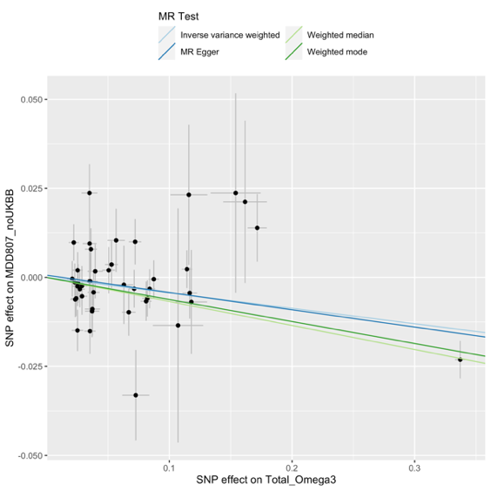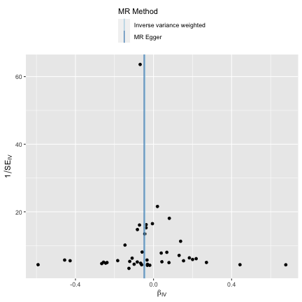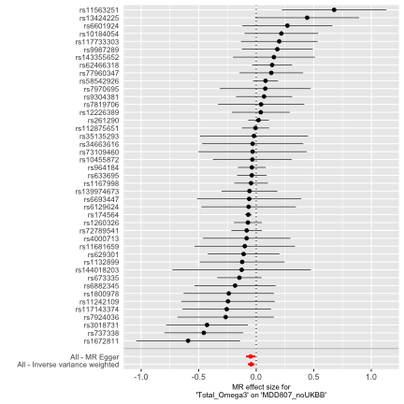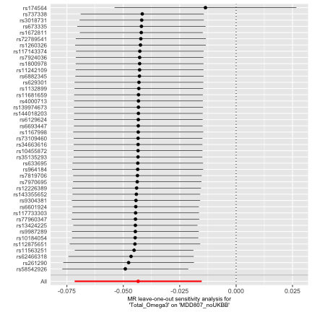

Omega 3(%)
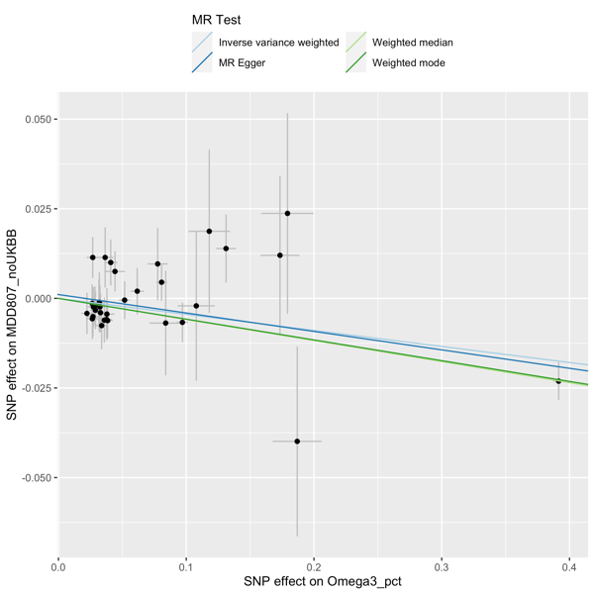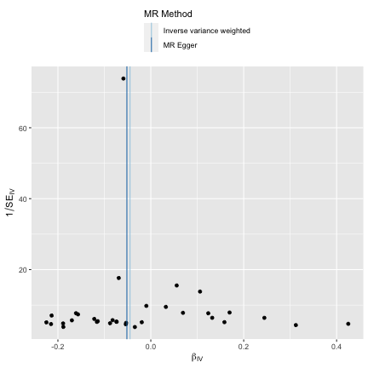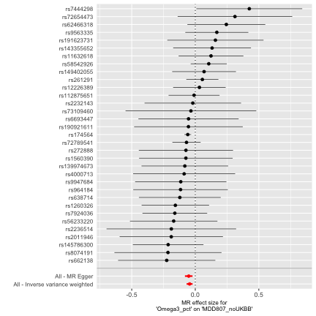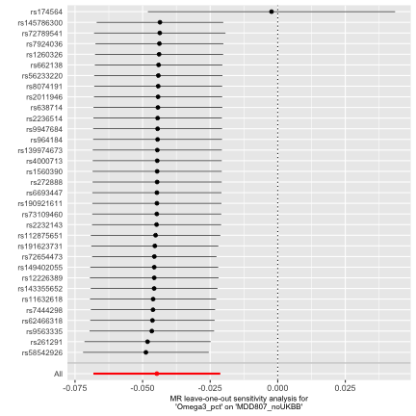

DHA
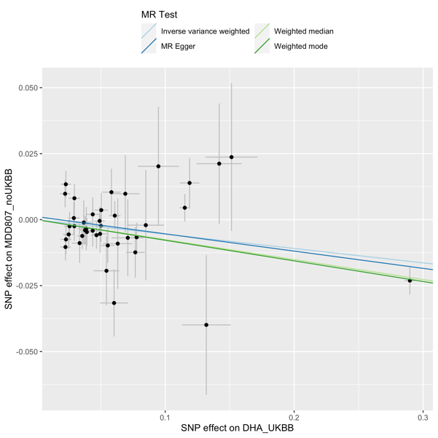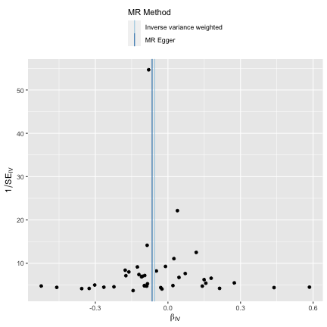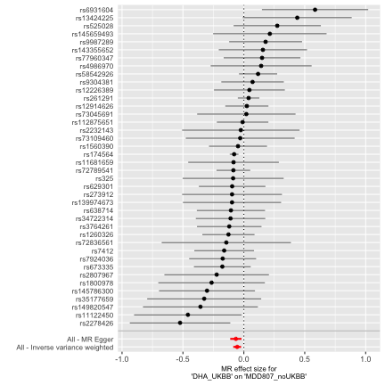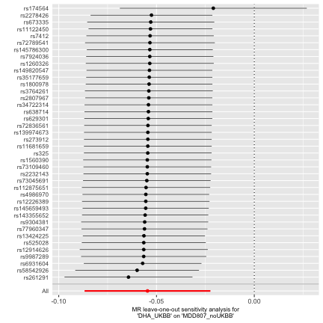

Omega 6
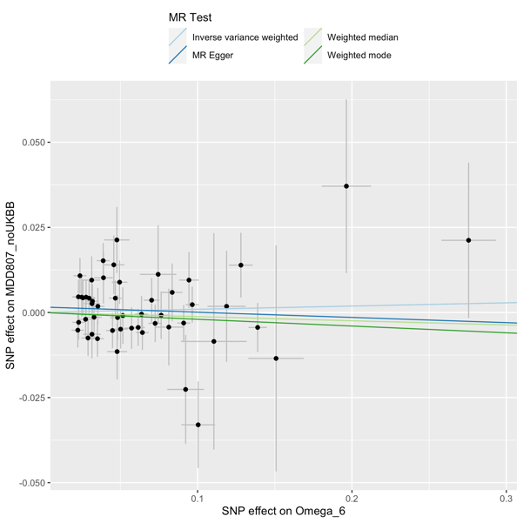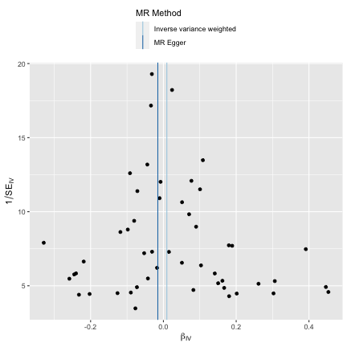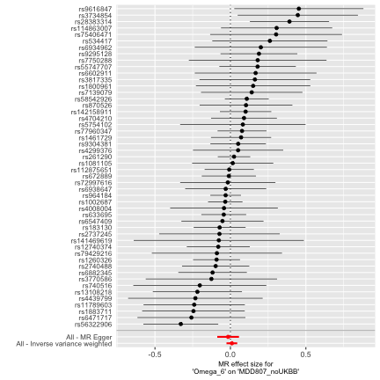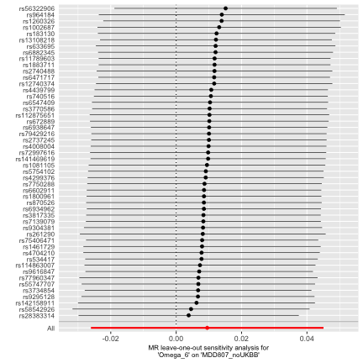

LA

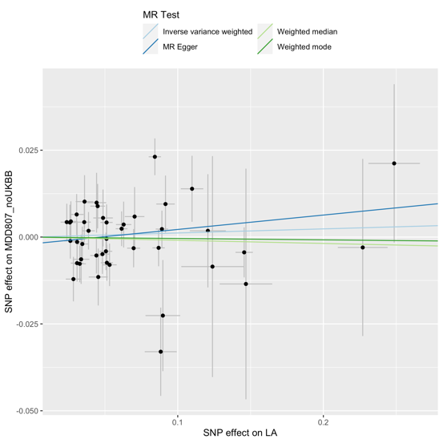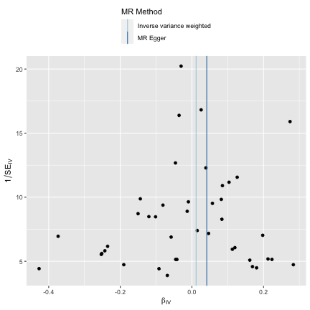

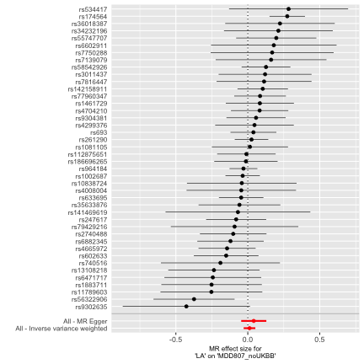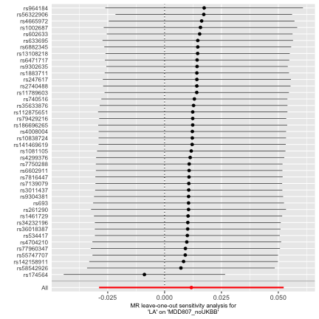

EPA
As EPA is not measured in UK Biobank, these analyses use instruments identified from UK Biobank GWAS of Total Omega 3, with SNP-effect sizes taken from the Cohorts for Heart and Aging Consortium (CHARGE)¹⁴

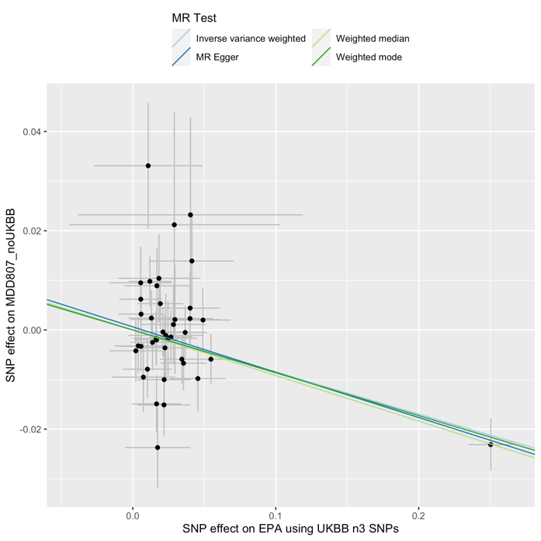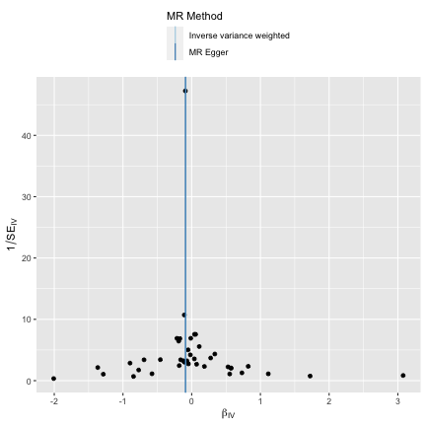
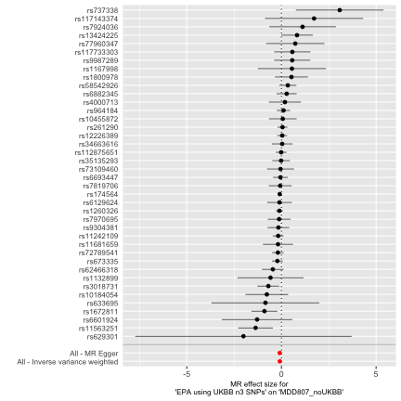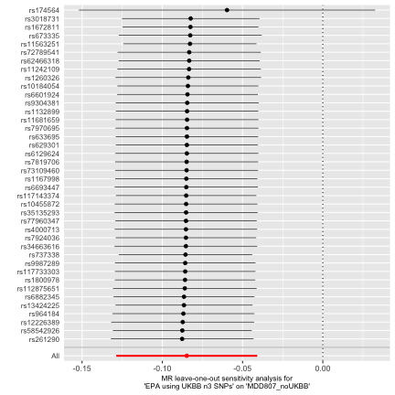

S8 Colocalization
Results for the colocalization analysis are shown below, using a 500,000 base pair region around FADS2 (Ensemble reference ENSG00000134824). The posterior probability of association is given in columns H0 to H4.

Analyses using the primary outcome sample (MDD without UKBB, n=480,359), suggested a high likelihood for a shared causal variant between MDD and total omega 3 (88.9%), DHA (88.9%) and EPA (97.1%). This variant localised to the FADS2 gene (‘rs174564’), strengthening evidence for the association. However, colocalization analyses using the complete MDD (including UKBB participants, n=807,553), and rMDD (n=80,933) samples were less consistent with the hypothesis of a shared causal variant (see table S8a). For rMDD, the high probability of H1 (ie a causal variant for omega 3 only) suggests that this discrepancy is due to low power, in keeping with the smaller sample size. Reasons for the discrepancies between MDD samples with and without UKBB are less clear, with ‘H3’ (i.e. the traits are related but have distinct causal variants) the most likely in the larger sample. As the colocalization plots of these traits appear very similar (figure 2,) we used the gassocplot R package for a more detailed view of the region (Figure S8c). These plots highlight a further variant (rs198457) in the region, located on the DAGLA gene. Excluding the variant in sensitivity analyses yielded similar results to colocalization using the primary outcome. As the SNP is moderate LD with the FADS2 variant (r² 0.1), it remains possible that our findings are driven by Linkage Disequilibrium. However, it could represent an additional independent locus in the region, which would violate coloc’s underlying assumption of a single common causal variant.

Table S8a. Probability for a single shared causal variant between traits as given by the ‘coloc’ R package.

Exposure | Outcome Sample | N | SNPs | H0 (%) | H1 (%) | H2 (%) | H3 (%) | H4 (%)
Omega 3 | No UKBB | 480,359 | 2,051 | 0.0% | 2.5% | 0.0% | 8.6% | 88.9%
 | UKBB included | 807,553 | 2,051 | 0.0% | 0.1% | 0.0% | 72.5% | 27.4%
 | rMDD | 80,933 | 2,051 | 0.0% | 91.9% | 0.0% | 4.8% | 3.4%
 | UKBB included (minus DAGLA) | 807,553 | 2,050 | 0.0% | 2.5% | 0.0% | 8.6% | 88.9%
DHA | No UKBB | 480,359 | 2,051 | 0.0% | 2.5% | 0.0% | 8.6% | 88.9%
 | UKBB included | 807,553 | 2,051 | 0.0% | 0.1% | 0.0% | 72.5% | 27.4%
 | rMDD | 80,933 | 2,051 | 0.0% | 91.9% | 0.0% | 4.8% | 3.4%
 | UKBB included (minus DAGLA SNP) | 807,553 | 2,050 | 0.0% | 0.2% | 0.0% | 5.6% | 94.3%
EPA | No UKBB | 480,359 | 2,051 | 0.0% | 0.7% | 0.0% | 2.2% | 97.1%
 | UKBB included | 807,553 | 2,051 | 0.0% | 0.1% | 0.0% | 83.6% | 16.3%
 | rMDD | 80,933 | 2,051 | 0.0% | 92.8% | 0.0% | 4.8% | 2.4%
 | UKBB included (minus DAGLA SNP) | 807,553 | 2,050 | 0.0% | 0.7% | 0.0% | 2.2% | 97.1%

Figure S8b. Gassocplots to compare MDD (with and without UKBB) and Omega 3. MDD807 is the complete sample including UKBB (n=807,553), MDD is the sample with UKBB removed (n=480,539). 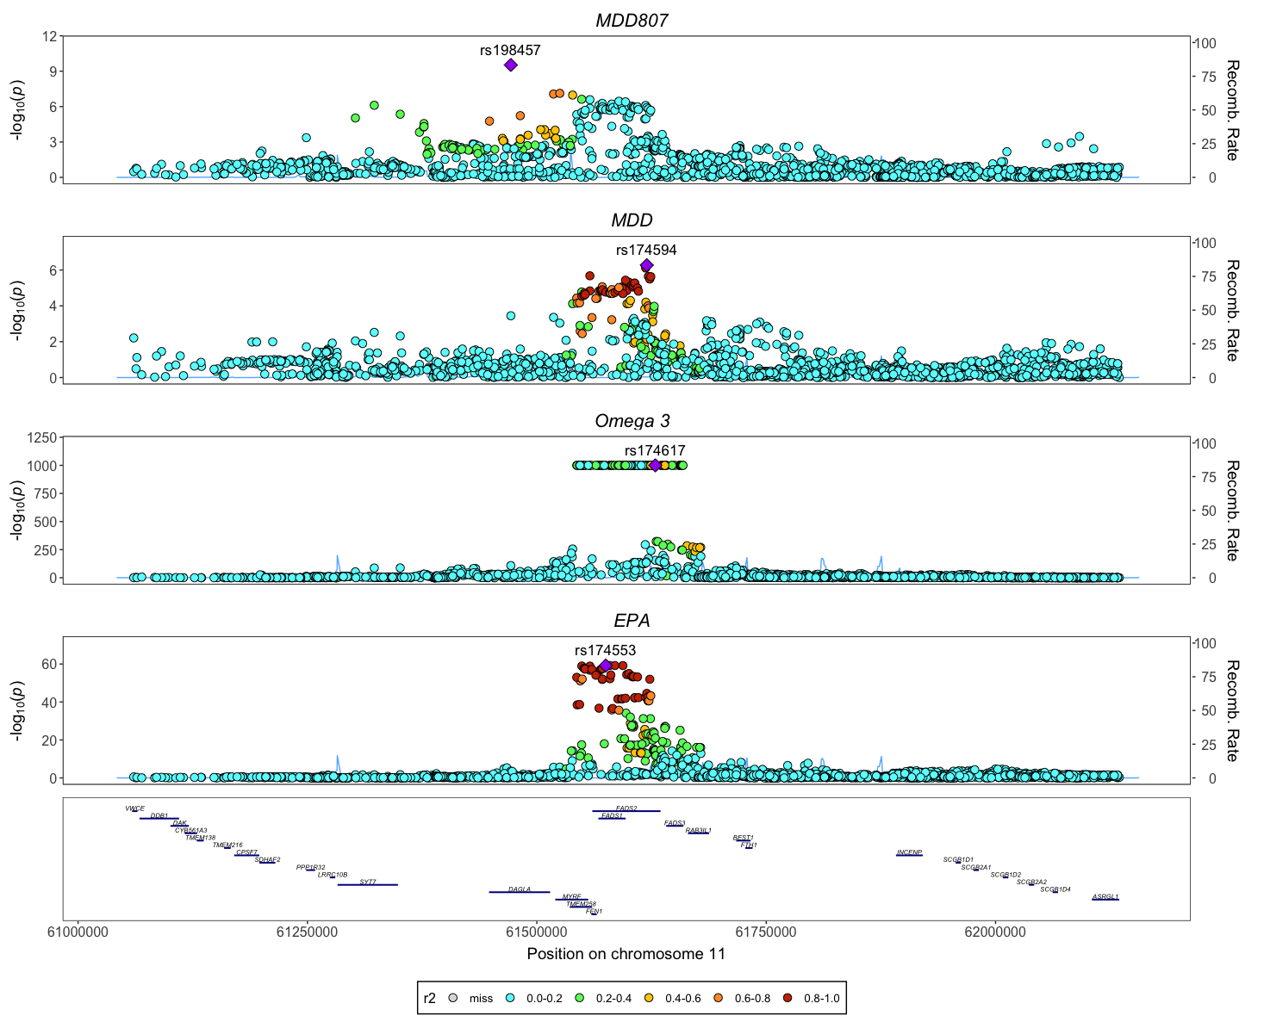

S9 Phewas results
Complete output from the PheWAS is provided in an excel spreadsheet (“phewas.xlsx”). A plot of the top results by category is shown below. Several psychiatrically relevant phenotypes associated with rs174564 included bipolar disorder (p=8.35E-7, n=51,710), intelligence (p=6.2E-6, n=269,867), cognitive performance (p=5.27E-6, n=257,841), irritability (p=1.8E-7, n=51,710), sleep duration (p=6.3E-9, n=460,099), and daytime naps (p=1.11E-10, n= 337,074).

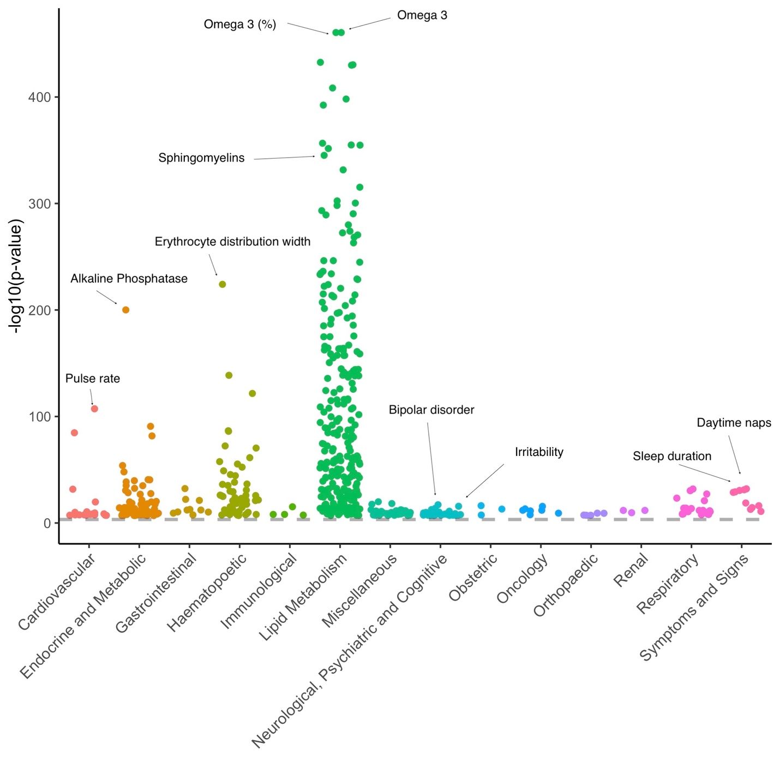

Supplement References

1. Bowden J, Del Greco MF, Minelli C, Davey Smith G, Sheehan NA, Thompson JR. Assessing the suitability of summary data for two-sample Mendelian randomization analyses using MR-Egger regression: the role of the I² statistic. Int J Epidemiol. 2016;45(6):1961-74.
2. Sanderson E, Davey Smith G, Windmeijer F, Bowden J. An examination of multivariable Mendelian randomization in the single-sample and two-sample summary data settings. Int J Epidemiol. 2019;48(3):713-27.
3. Sanderson E, Windmeijer F. A weak instrument F-test in linear IV models with multiple endogenous variables. J Econometrics. 2016;190(2):212-21.
4. Kettunen J, Demirkan A, Wurtz P, Draisma HH, Haller T, Rawal R, et al. Genome-wide study for circulating metabolites identifies 62 loci and reveals novel systemic effects of LPA. Nat Commun. 2016;7:11122.
5. Nieuwboer HA, Pool R, Dolan CV, Boomsma DI, Nivard MG. GWIS: genome-wide inferred statistics for functions of multiple phenotypes. Am J Hum Genet. 2016;99(4):917-27.
6. Hemani G, Tilling K, Davey Smith G. Orienting the causal relationship between imprecisely measured traits using GWAS summary data. Plos Genet. 2017;13(11):e1007081.
7. Burgess S, Freitag DF, Khan H, Gorman DN, Thompson SG. Using Multivariable Mendelian Randomization to Disentangle the Causal Effects of Lipid Fractions. Plos One. 2014;9(10).
8. Sanderson E, Spiller W, Bowden J. Testing and correcting for weak and pleiotropic instruments in two-sample multivariable Mendelian randomization. Stat Med. 2021;40(25):5434-52.
9. Richardson TG, Sanderson E, Palmer TM, Ala-Korpela M, Ference BA, Davey Smith G, et al. Evaluating the relationship between circulating lipoprotein lipids and apolipoproteins with risk of coronary heart disease: A multivariable Mendelian randomisation analysis. Plos Med. 2020;17(3):e1003062.
10. Lemaitre RN, Tanaka T, Tang W, Manichaikul A, Foy M, Kabagambe EK, et al. Genetic loci associated with plasma phospholipid n-3 fatty acids: a meta-analysis of genome-wide association studies from the CHARGE Consortium. Plos Genet. 2011;7(7):e1002193.
11. Wallace C. Eliciting priors and relaxing the single causal variant assumption in colocalisation analyses. Plos Genet. 2020;16(4):e1008720.
12. Wallace C. A more accurate method for colocalisation analysis allowing for multiple causal variants. Plos Genet. 2021;17(9):e1009440.
13. Elsworth B, Lyon M, Alexander T, Liu Y, Matthews P, Hallett J, et al. The MRC IEU OpenGWAS data infrastructure. bioRxiv. 2020:2020.08.10.244293.
14. Guan WH, Steffen BT, Lemaitre RN, Wu JHY, Tanaka T, Manichaikul A, et al. Genome-Wide Association Study of Plasma N6 Polyunsaturated Fatty Acids Within the Cohorts for Heart and Aging Research in Genomic Epidemiology Consortium. Circ-Cardiovasc Gene. 2014;7(3):321-31.

