Supplementary Materials for
Global patterns in human exposure to greenspace: Contrasting inequality between cities of the South and North
Bin Chen^{1,*}, Shengbiao Wu¹, Yimeng Song^{2,3}, Chris Webster⁴, Bing Xu⁵, Peng Gong^{6,*}
1. Division of Landscape Architecture, Faculty of Architecture, The University of Hong Kong, Hong Kong SAR
2. Department of Land Surveying and Geo-Informatics, The Hong Kong Polytechnic University, Hong Kong SAR
3. Smart Cities Research Institute, The Hong Kong Polytechnic University, Hong Kong SAR
4. HKUrbanLabs, Faculty of Architecture, The University of Hong Kong, Hong Kong SAR
5. Department of Earth System Science, Tsinghua University, Beijing, China
6. Department of Geography, and Department of Earth Sciences, The University of Hong Kong, Hong Kong SAR

*Corresponding author: Bin Chen (binley.chen@hku.hk) and Peng Gong (penggong@hku.hk)

Submission to Nature Communications

1. Supplementary Materials
1.1. Calculation of Gini Index
As shown in Fig. S7, Gini index is mathematically calculated as the ratio of the area that lies between the line of equality and the Lorenz curve (region A) over the total area under the line of equality (region A plus region B):
$Gini= \frac{{Area}_{A}}{{Area}_{A}+{Area}_{B}}$ (S1)
where ${Area}_{A}$ and ${Area}_{B}$ represent the areas of regions A and B, respectively.
Since the scale of both x- and y-axis in Fig. S5 ranges from 0 to 1, we have Area_{A} + Area_{B} = 0.5. Thus, the Gini index can be formulated as:
$Gini= \frac{{Area}_{A}}{0.5}=\frac{0.5-{Area}_{B}}{0.5}=1- 2×{Area}_{B}$ (S2)
We moved to the area calculation of region B that is bounded by the cumulative share of greenspace exposure and the cumulative share of residents from lowest to highest greenspace exposure. To this end, we first used the numerical integration approach to calculate the area of trapezoid B_{i} that contributed by the ith resident, and then summed each trapezoid area across all residents. The area of trapezoid B_{i} (Area_{Bi}) is calculated as follows:
${Area}_{Bi}= \frac{1}{2} ×\left(\frac{\sum_{j=1}^{i-1}{g_{j}}}{\sum_{j=1}^{n}{g_{j}}}+\frac{\sum_{j=1}^{i}{g_{j}}}{\sum_{j=1}^{n}{g_{j}}}\right)×\frac{1}{n}$ (S3)
where $g_{j}$ is the greenspace that exposed to jth resident and n is the total resident number.
Thus, the area of region B is calculated as
${Area}_{B}= \sum_{i=1}^{n}{{Area}_{Bi}}=\sum_{i=1}^{n}{\frac{1}{2} ×\left(\frac{\sum_{j=1}^{i-1}{g_{j}}}{\sum_{j=1}^{n}{g_{j}}}+\frac{\sum_{j=1}^{i}{g_{j}}}{\sum_{j=1}^{n}{g_{j}}}\right)×\frac{1}{n}}$ (S4)
By substituting Eq. (S4) into Eq. (S1), we finally derive the Gini index using the following formula.
$Gini= 1- \frac{\sum_{i=1}^{n}{\sum_{j=1}^{i-1}{g_{j}}} + \sum_{i=1}^{n}{\sum_{j=1}^{i}{g_{j}}}}{n × \sum_{j=1}^{n}{g_{j}}}$ (S5)

1.2. Comparison between tree and shrub/grass exposure
We first categorized two key components of urban greenspace into 1) forest/tree (shadowed greens), and 2) shrub/grass (non-shadowed greens) from WorldCover maps and calculated the different greenspace exposure using the Eq. (2). We further calculated the percentage of tree exposure regarding the total greenspace exposure for global 1028 cities and quantified the correlation between these two types of greenspace exposure and the total greenspace exposure.
Supplementary figures
Fig. S1. Difference between population-weighted greenspace exposure and greenspace coverage rate across different administrative divisions of (a) country, (b) state, and (c) county.

Fig. S2. Comparison of greenspace exposure inequality measured by Gini index between different seasons for global urban areas. a, Summer vs Spring. b, Summer vs Fall. c, Summer vs Winter. d, Spring vs Fall. e, Spring vs Winter. f, Fall vs Winter. The fitting lines are derived from a linear regression to justify the correlation of Gini index of greenspace exposure between two seasons.

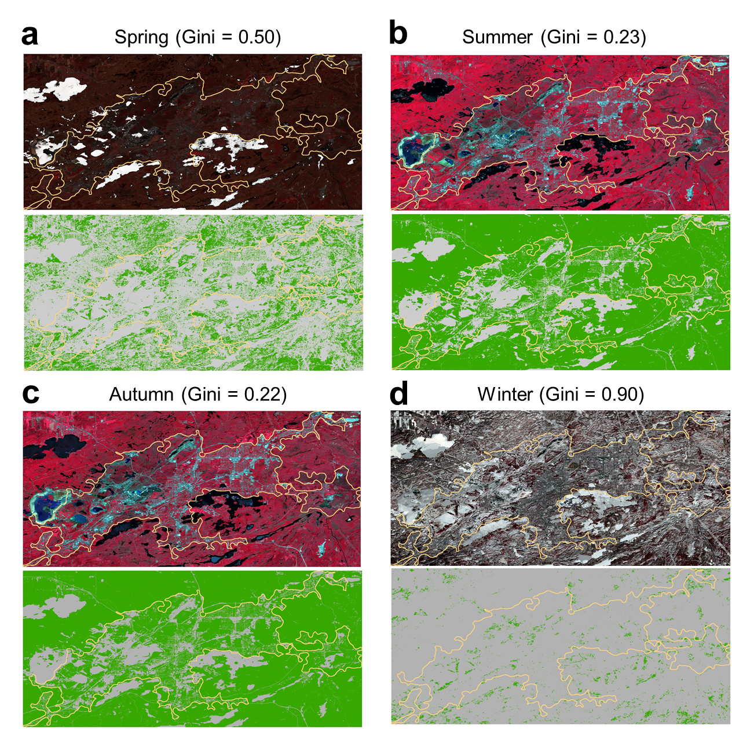
Fig. S3. Seasonal changes of greenspace coverage and the associated Gini index of greenspace exposure using an example in Greater Sudbury, Ontario, Canada.

Fig. S4. Results of variable partition (100%) for two scenarios including different combinations of explanatory variables. a. Inclusion of latitude (lat), vapor pressure deficit (vpd), greenspace coverage rate (gcr), and edge density (ed). b. Inclusion of grc and ed.

Fig. S5. Percentage of tree exposure regarding the total greenspace exposure levels for global 1028 cities.

Fig. S6. The association of tree exposure (green dots) and shrub/grass exposure (yellow dots) with total greenspace exposure for global 1028 cities.

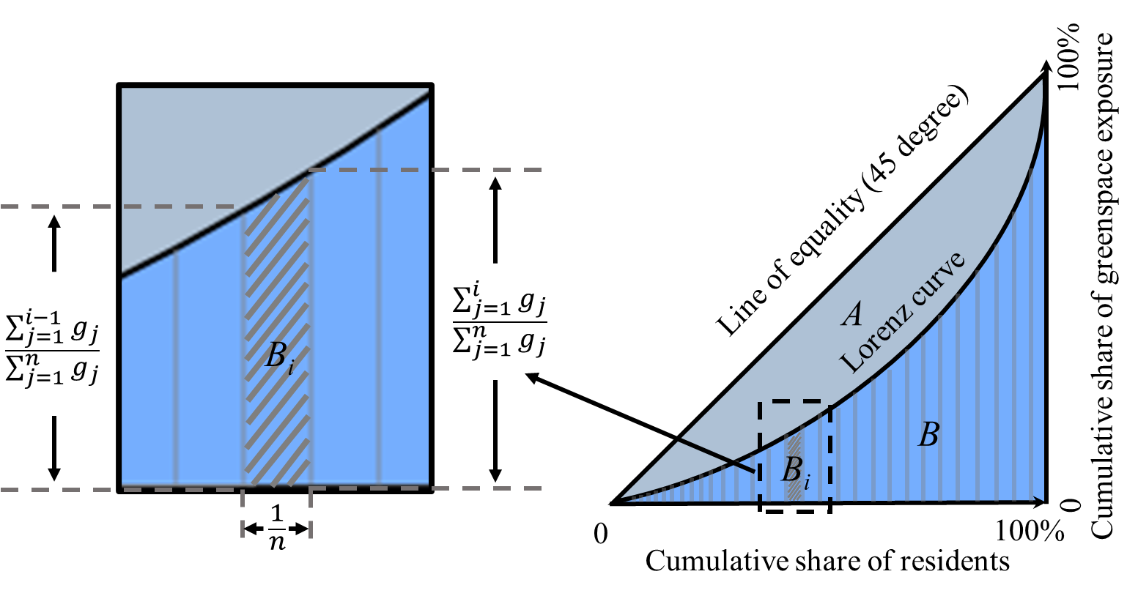
Fig. S7. Illustrative diagram of Gini index-based inequality assessments of greenspace exposure. The Gini index is defined as the ratio of the area that lies between the line of equality and the Lorenz curve (region A) over the total area under the line of equality (region A plus region B), where Lorenz curve plots the proportion of the greenspace exposure (y-axis) that is cumulatively shared by the residents (x-axis). B_{i} indicates the contribution of ith residents to the accumulated greenspace exposure and is estimated by the trapezoid area as shown in the left panel, where g_{i} represents the greenspace that is exposed to ith resident, and n represents the total resident number. Y-axis shows the cumulative share of greenspace exposure; X-axis shows the cumulative share of residents from lowest to highest greenspace exposure.

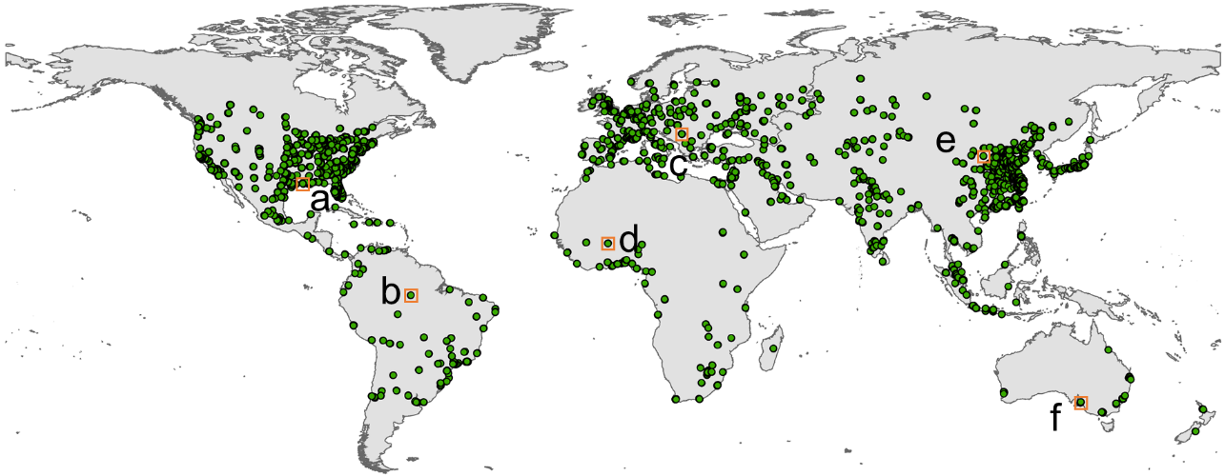
Fig. S8. Geographic distribution of validation samples (greenspace and non-greenspace) across 1028 cities globally. a-e, Locations of zoomed-in subsets of Figure S2.
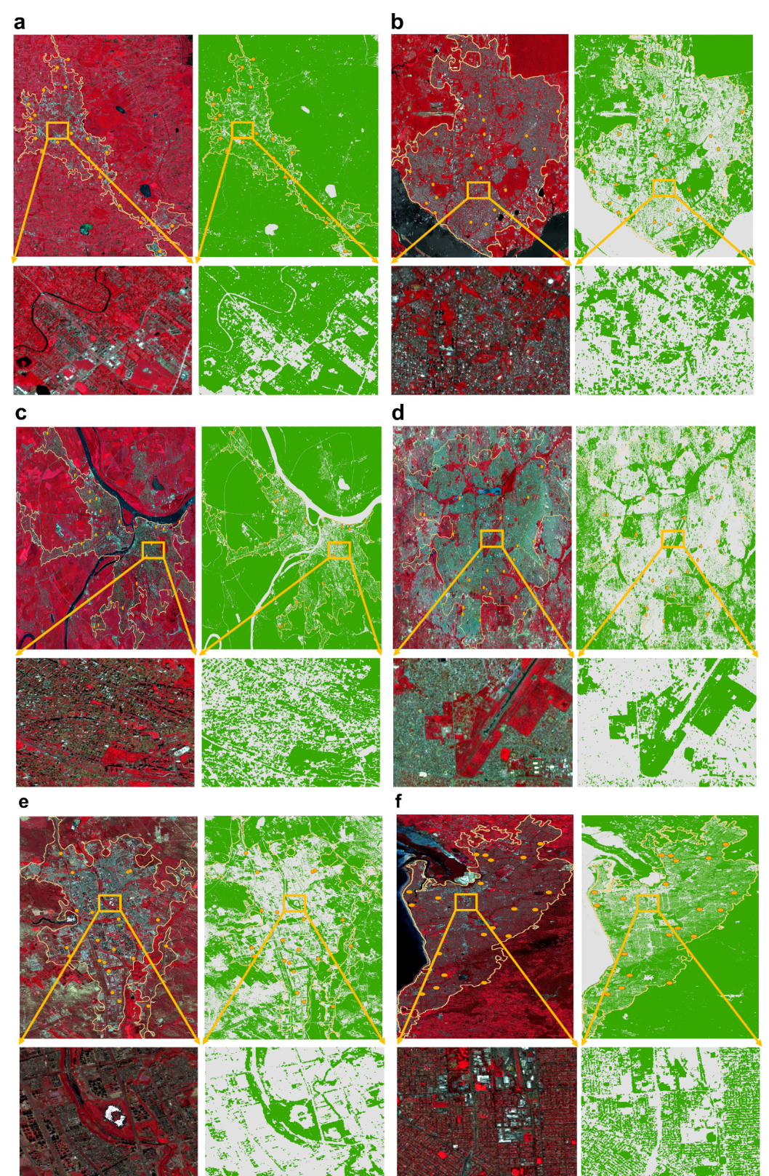
Fig. S9. Comparison of Sentinel-2 imagery and the associated greenspace and non-greenspace classification in zoomed-in cities (a-e) across the globe. The green color represents the greenspace coverage and gray color represents non-greenspace coverage. The yellow dots are validation samples derived from visual inspections.
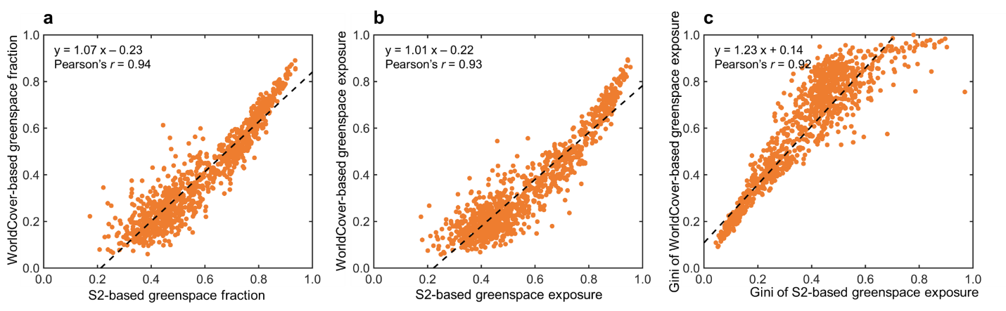
Fig. S10. Comparison of greenspace fraction (a), greenspace exposure estimates (b), and Gini index of greenspace exposure inequality (c) derived from Sentinel-2 imagery (x-axis) and WorldCover product (y-axis) across global 1028 cities. Linear regression was used to measure their correlation with Pearson’s r coefficient.

Fig. S11. Correlation matrix between explanatory variables and urban greenspace exposure inequality (measured by Gini of greenspace exposure). a, Pearson’s correlation matrix and b, Partial correlation matrix.

Fig. S12. Bar summary of Variance Inflation Factors (VIF) for five inclusive variables in the multiple linear regression model.

Fig. S13. Variable importance from the random forest model, measured by x-axis (the increase of mean square error after excluding specific variable), and y-axis (the increase of node purity after including specific variable). The dot size represents the number of trees in which the specific variable is used for splitting the root node.

Fig. S14. Sensitivity of buffer distance and grid size to the assessment of greenspace exposure inequality, as measured by Gini index for global urban areas. a, Gini of greenspace exposure estimated using buffer zones from 100 m to 2000 m with an interval of 100 m. The list of 1028 urban areas are ordered by the Gini of Greenspace exposure measured using the 500-m buffer zone. b, Gini of greenspace exposure estimated using grid sizes from 100m, 250 m to 2000 m with an interval of 250 m, without considering buffer zones. The list of 1028 urban areas are ordered by the Gini of Greenspace exposure measured using the 500-m grid size. c, The variation of Gini of greenspace exposure to buffer distance. d, The variation of Gini of greenspace exposure to grid size.

Supplementary tables
Table S1. Correlation coefficients between explanatory variables and the Gini of greenspace exposure. The partial correlation coefficient is derived by controlling all the other variables.
Category | Variable | Correlation | Partial correlation
Geographic | lat | 0.51*** | 0.19***
 | long | -0.19*** | 0.01
Topographic | elev | 0.18*** | 0.01
 | slope | 0.04 | 0.24***
Socio-economic | ntl | 0.10* | 0.16***
 | pop | 0.36*** | 0.10*
 | road | -0.08* | 0.10**
Climatic | prcp | -0.25*** | -0.16***
 | tmean | 0.31*** | 0.07
 | vpd | 0.49*** | 0.15***
Landscape | grc | -0.87*** | -0.22***
 | lpi | -0.70*** | 0.05***
 | mpa | -0.40*** | 0.002
 | mpar | 0.44*** | -0.12*
 | shape | -0.53*** | -0.04
 | ed | -0.76*** | -0.32***
Note: *** p-value < 0.0001, ** p-value < 0.001, * p-value < 0.01
Table S2. Accuracy validation of WorldCover-based greenspace mapping across global urban areas.
Reference  WorldCover | Greenspace | Non-greenspace
Greenspace | 11,070 | 542
Non-greenspace | 688 | 8226
Note: Overall accuracy: 0.94, Precision: 0.94, Recall: 0.95, and F1-score: 0.95.

