**Supporting information**

**Conversation from anti-ferromagnetic Mn­Br2 to ferromagnetic** **Mn­3Br8 monolayer with large MAE**

*Y. Hu, 1 S. Jin, 2 Z. F. Luo ,1* *H. H. Zeng,1 J. H. Wang1, X.L. Fan1\**

1 State Key Laboratory of Solidification Processing, Center for advanced lubrication and seal Materials, School of Material Science and Engineering, Northwestern Polytechnical University, 127 YouYi Western Road, Xi’an, Shaanxi 710072, China

2 Queen Mary University of London Engineering School, Northwestern Polytechnical University, 127 YouYi Western Road, Xi’an, Shaanxi 710072, China

**Calculation of the vacancy formation energy**

Vacancy formation energy under Mn-rich and Br-rich environments are calculated via following equations,





where  and  are the total energies of the Mn3Br8 and MnBr2 monolayers,  is the chemical potential of Mn under Mn-rich environment, which is calculated as , the energy of Mn atom in its bulk structure,  is the chemical potential of Mn under the Br-rich environment, which is calculated as:



where  is the chemical potential of Br and calculated as the energy of Br atom in gas phase.

Table S1. The calculated elements of 2D elastic constants matrix and the in-plane stiffness for MnBr2 monolayer.

|  |  |  |  |  |  |  |  |
| --- | --- | --- | --- | --- | --- | --- | --- |
|  |  |  |  |  |  |  |  |
|  | (J∙m-2) | (J∙m-2) | (J∙m-2) | (J∙m-2) | (J∙m-2) | (J∙m-2) | (J∙m-2) |
| MnBr2 | 29.42 | 29.42 | 10.48 | 8.47 | 8.47 | 26.98 | 26.98 |

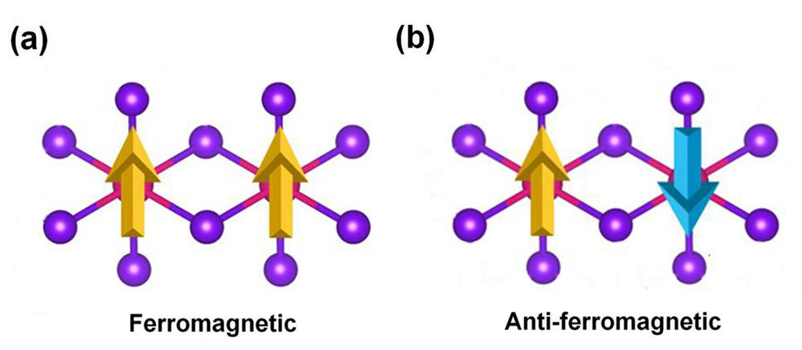

Fig. S1. Schematic diagrams for (a) ferromagnetic and (b) anti-ferromagnetic configurations for MnBr2 monolayer.

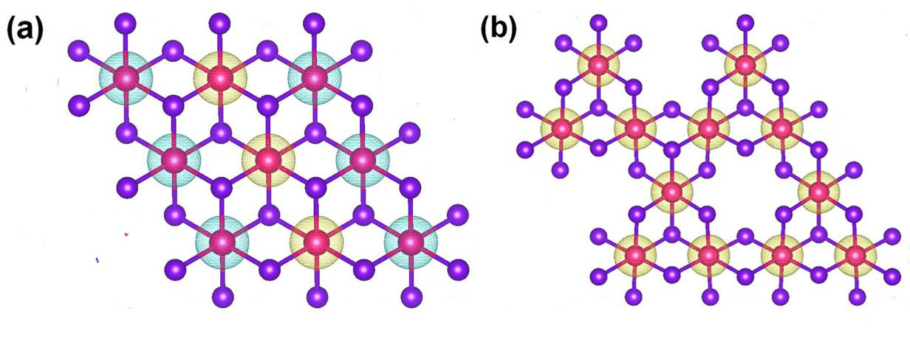

Fig. S2. (a) Spin-resolved charge density (SCD) for (a) MnBr2 and (b) Mn3Br8 monolayers. The isosurface value for SCD is set as 0.014 eÅ-3.

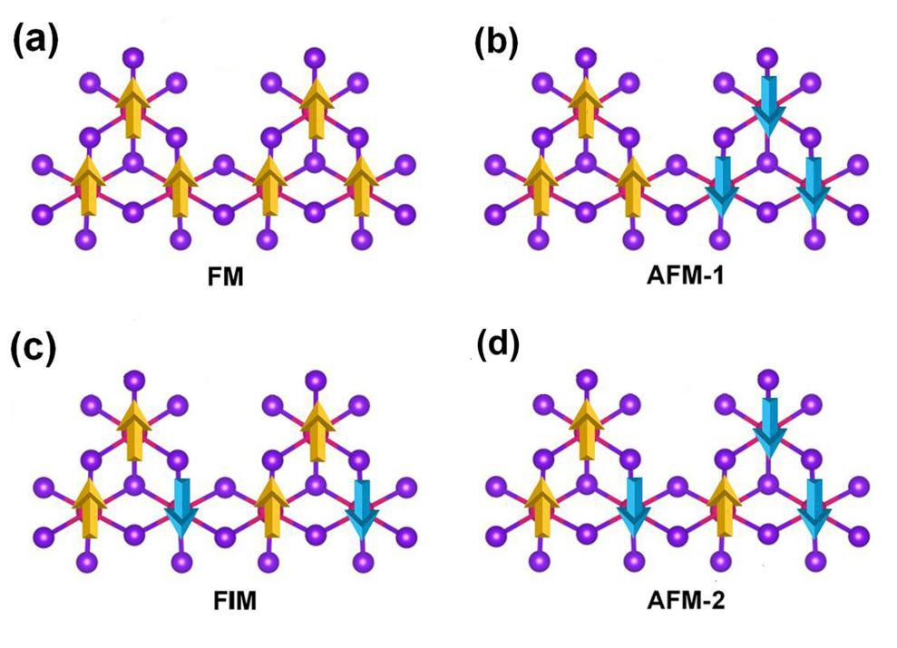

Fig. S3. Schematic diagrams for (a) ferromagnetic, (b) anti-ferromagnetic-1, (c) ferrimagnetic, and (d) anti-ferromagnetic-2 configurations for Mn3Br8 monolayer.

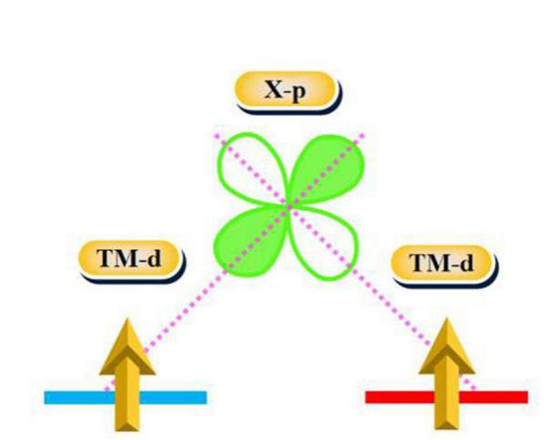

Fig. S4. The ferromagnetic super-exchange interaction according to the Goodenough-Kanamori-Anderson (GKA) rule.

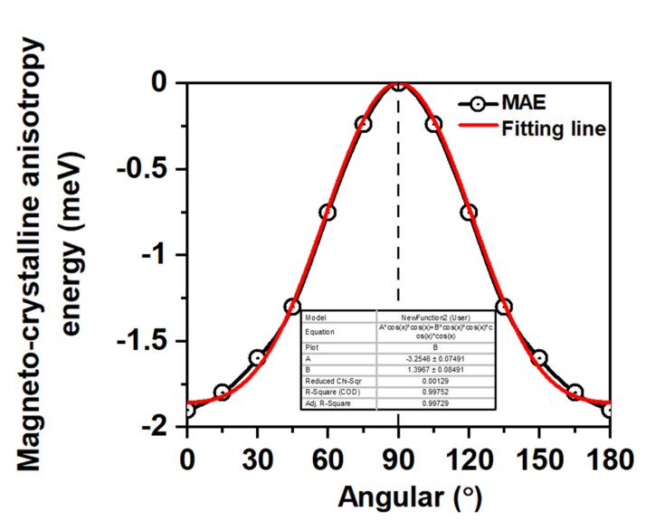

Fig. S5. The variation of magneto-crystalline anisotropy energy (MCE) with respect to azimuthal angle. Red solid line is the fitting line, the inset table lists the standard errors for the fitting slope.

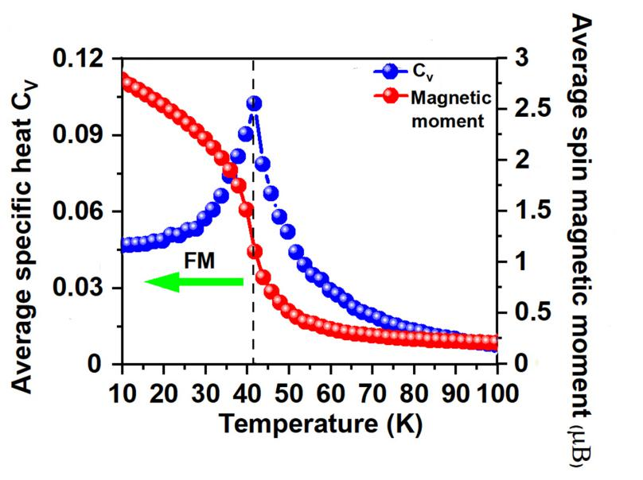

Fig. S6. On-site magnetic moments of Cr atoms and the specific heat  as function of temperature based on Heisenberg model for CrI3 monolayer, the value of  and  are obtained from J. Am. Chem. Soc, 2018, 140, 2417.

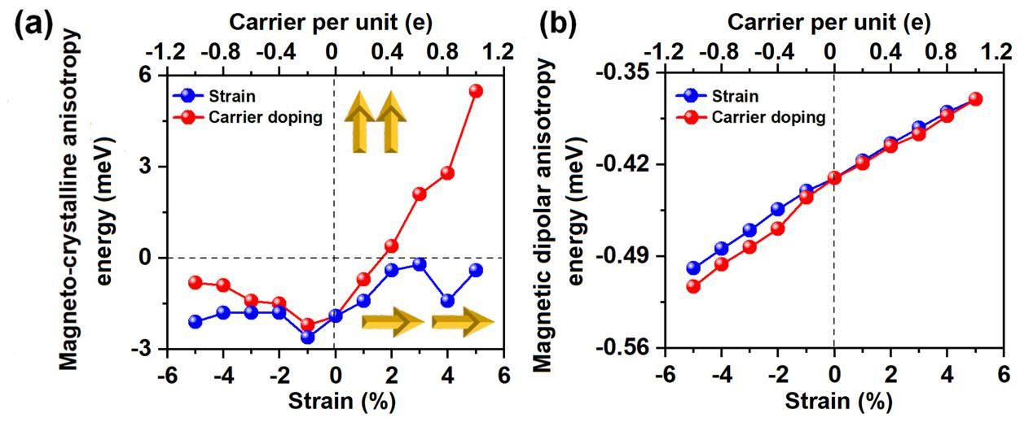

Fig. S7. The variations of (a) magneto-crystalline anisotropy energy (MCE) and (b) magnetic dipolar anisotropy (MDE) with respect to the applied biaxial strain and carrier doping. Positive and negative values of carrier doping represent the electron and hole doping, respectively.