Supporting Information
A double-layer of stable coral-like PSi@C(N) anodes for lithium-ion Batteries synthesized from microsilica

Zhao Zhang ^{1,2}, Fengshuo Xi ^{1,2}, Xiuhua Chen ³, Shaoyuan Li ^{1,2,4}*, Wenhui Ma ^{1,2}*, Zhao Ding⁵*, Tao Qu ¹, Yongnian Dai ¹, Rong Deng ⁴
¹ Faculty of Metallurgical and Energy Engineering/State Key Laboratory of Complex Nonferrous Metal Resources Clean Utilization, Kunming University of Science and Technology, Kunming 650093, China
² Silicon Material Industry Research Institution (Innovation Center) of Yunnan Province, Kunming 650093, China
³ School of Materials Science and Engineering, Yunnan University, Kunming 650091, China
⁴ School of Photovoltaic and Renewable Energy Engineering (SPREE), University of New South Wales, Sydney, 2052, Australia
⁵ The State Key Laboratory of Refractories and Metallurgy, Institute of Advanced Materials and Nanotechnology, Wuhan University of Science and Technology, Wuhan 430081, China

* Corresponding Authors: lsy415808550@163.com (S. Li); mwhsilicon@126.com (W. Ma);

Figure S1. (a) The schematic of the industrial silicon production, (b-e) TEM image and elemental mapping of microsilica.

Experimental
Material Preparation
Preparation of optimized PSi@C(N). In a typical synthesis, nano-sized granular microsilica (1.0 g, 100~500 nm), NaCl (6.0 g) and magnesium (80 nm, 1.0 g) were fully grinded and annealed at 650 °C for 8 h with a heating rate of 5 °C min⁻¹ and then tempered at this temperature for 8 h under Ar atmosphere. The resulting brown powder (Mg₂Si) is washed with hydrochloric acid to remove MgO and NaCl to obtain porous silicon powder. The RF resin polymer layer with controllable thickness was coated by surfactant template sol-gel method and carbonized. For carbon coating, 0.5 g of porous silicon nanoparticles and 0.92 g of cetyltrimethylammonium bromide (CTAB) surfactant were added into 28.16 mL of deionized water and stirred with ultrasonic probe for 30 min. Then, resorcinol (0.28 g) was added, and the solution was stirred at 35 ℃ for 30 min. Next, 0.4 mL formaldehyde was dropwise added into the solution. The solution was continuously stirred at 35 ℃ for 24 h followed by aging at room temperature for 12 h without any disturbance. Si@RF core-shell nanoparticles were collected by centrifugation and washed with deionized water and ethanol multiple times. Finally, PSi@C(N) composites were achieved by carbonization of RF at 900 ℃ for 6 h in N₂ atmosphere with a heating rate of 5 ℃ min⁻¹.

Material characterization
The phase identification was performed by Philips PANanalytical X’Pert 3 X-ray diffractometer (XRD). The surface states of Si/C composites were analyzed with Thermo Fisher Scientific™ K-Alpha⁺ X-ray Photoelectron Spectrometer (XPS). Fourier-transform infrared spectroscopy (FTIR) was done between 4000 and 400 cm⁻¹ wavenumbers in transmittance mode using Thermo Fisher Scientific™ Nicolet™ iS™ 10 FTIR Spectrometer. Surface area, pore size and pore size distribution were measured by Quantachrome NOVA2200e surface area and pore size analyzer. Samples were degassed under vacuum at 300 °C for 2 h. To observe changes in morphologies of particles during synthesis and track the elemental distributions, microscopy imaging/analysis was carried out with both FEI® Quanta 200 field emission scanning electron microscope (FE-SEM) and FEI® Tecnai G2 F30 S-TWIN transmission electron microscope (TEM). The Carbon content of the PSi@C(N) composite was determined using a simultaneous thermal analyzer (TGA, DSC, 1600LF) in an air atmosphere in the temperature range from 100 °C to 800 °C.

Electrochemical Characterization
The slurry formula for electrode fabrication consists of 60 wt. % active materials (PSi@C(N)), 20 wt. % carbon black (Aladdin, AR, C) as conducting agent and 20 wt. % sodium alginates (Aladdin, AR, (C₆H₇O₆Na)_{n}) as binder. The loading capacity of the active material for the electrode is 0.68mg/cm². All materials were mixed in deionized water and stirred for 30 min to obtain a uniform slurry. Then, the slurry was casted on copper foil followed by vacuum drying at 80 °C for 12 h. Half cells were prepared using CR2025 coin cells inside Ar-filled glovebox. Coin cells were charged/discharged in the voltage range of 0.01-2.0 V vs. Li⁺/Li with Neware® BTS-4000 cell testers. Galvanostatic intermittent titration technique (GITT) tests were carried out at a current density of 200 mA g⁻¹ using a 30 min pulse time and an interval of 2 h. Cyclic voltammetry (CV) and electrochemical impedance spectroscopy (EIS) measurements were performed using AMETEK® PARSTAT PMC-1000. For comparison purpose, two sets of cells were fabricated from microsilica and porous Si following the same recipe mentioned above.

Table S1. The impurities present in microsilica collected from the silicon production dust. The elements were detected by energy-dispersive spectroscopy (EDS).
Sample | K | S | Mg | Ca | p | Al | Na | Fe
Content (%) | 0.6049 | 0.3555 | 0.2049 | 0.1468 | 0.1254 | 0.0553 | 0.0391 | 0.0279

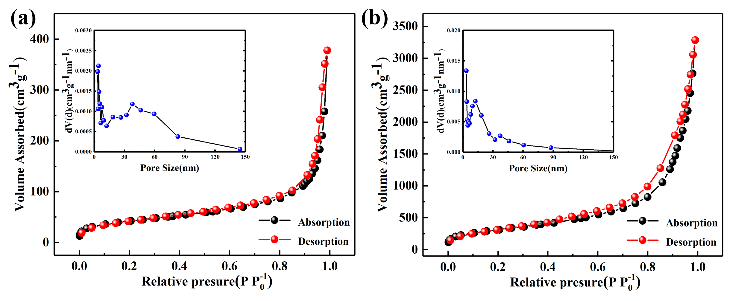
Figure S2. Nitrogen adsorption-desorption isotherms and BJH-derived pore size distribution curves for (a) Microsilica, and (b) PSi@C(N).

Table S2. Specific surface area, pore volume and pore size for both microsilica and PSi@C(N) particles.
Sample | Specific surface area (m² g⁻¹) | Pore volume (cm³ g⁻¹) | Pore size (nm)
Microsilica | 22.225 | 0.080 | 4.256
PSi@C(N) | 63.942 | 0.265 | 3.385
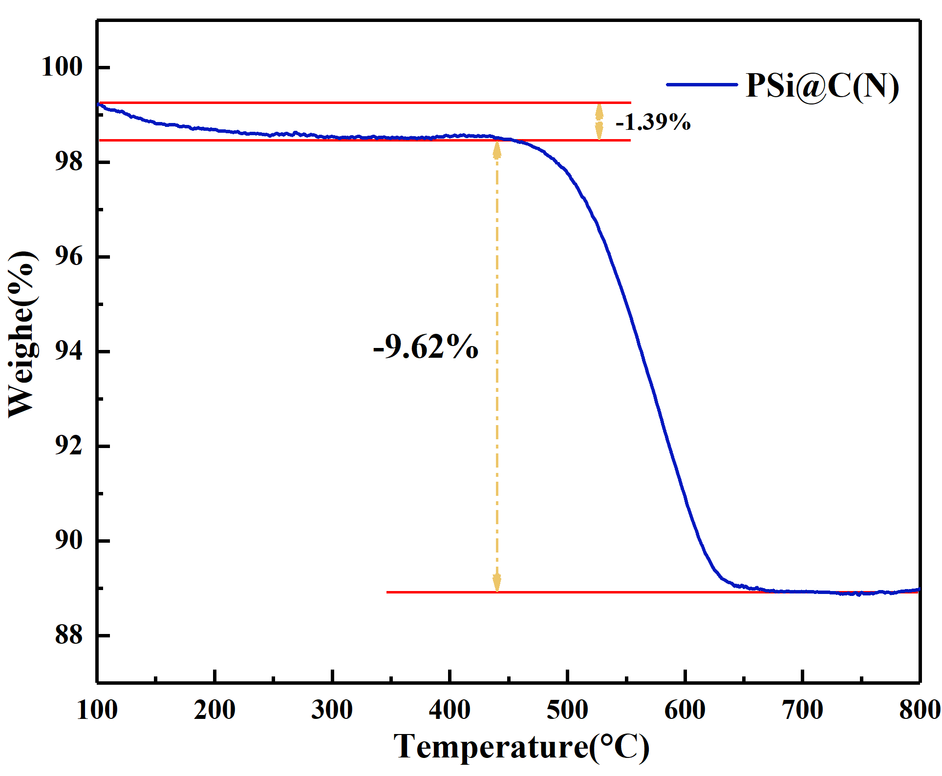
Figure S3. TGA curves of PSi@C(N) composite.

The electrochemical impedance spectroscopy (EIS) of the electrode prepared with microsilica, porous Si and PSi@C(N) as active materials in the range of 100 kHz to 0.1Hz in the half-cell is shown in Fig 4a. In the EIS impedance graph, the semicircle in the high frequency region is associated with charge transfer resistance (Rct), and the straight line in the low frequency region is associated with Li⁺ diffusion. Compared with microsilica with large resistance, porous Si and PSi@C(N) electrodes showed higher lithium ion transfer velocity and smaller semi-circulation radius (Fig. 4b), indicating that doped N and C improved the conductivity of the overall electrode and had better lithium ion transfer rate and electrode stability. Through theoretical calculation in Fig. 4c, corresponding results are obtained. The ratio of diffusion coefficients of Li+ ion (D_{Li+}) can be determined by equations (1) and (2).
$D_{Li}=\frac{R^{2}T^{2}}{2A^{2}n^{2}F^{4}C^{2}σ^{2}}$ Eq. (1)
$Z^{,}=R_{e}+R_{ct}+σω^{-1/2}$ Eq. (2)
In the formula, R is the gas constant (8.314 J mol⁻¹ K⁻¹),T is the temperature (298.15 K),A is the surface area of the electrode in the half cell, N is the number of electrons transferred (per molecule) in the electrochemical reaction, F is the Faraday constant (96,485 C mol⁻¹), C is the concentration of lithium ions in the electrode, ω represents the angular frequency, and σ is the Warburg factor (the slope of Z 'and ω−1/2). The concentration of lithium ion is calculated by the density of the material, as shown in Formula (3).
$C=n/V={m/M}/V={{ρV}/M}/V=ρ/M$ Eq. (3)
Through these equations (Fig. 4c and Fig. S4), D_{Li+} of the PSi@C(N) is calculated as 8.54 × 10⁻¹² cm² s⁻¹. This indicates that the electrode with PSi@C(N) as active material has better dynamic behavior (highly ion transfer rate). The results are consistent with the cycling performances comparison shown in Fig. 4b, which confirms the improvement of the properties by the enhanced structure of PSi@C(N). In order to further explore the storage behavior of electrochemical Li⁺ in the electrode, the CV curves of PSi@C(N) electrode at different scanning rates were detected (Fig. 5d). When the scanning rate increases from 0.1 mV s⁻¹ to 0.5 mV S⁻¹, the redox peak current increases gradually, indicating the rapid reaction kinetics and high reversibility of the Li⁺ storage process. In CV test, the relationship between peak current (I) and scanning speed (ν) is described by equation (4) [38,39]:
I = aν^{b} Eq. (4)
The slope of log(I)-log(ν) is b. When b = 0.5, the electrode reaction is influenced by diffusion control, while when b = 1.0, the electrochemical reaction is influenced by surface reaction control. As shown in Fig. 4e, when the scanning rate is 0.1 ~ 0.6 mV s⁻¹, there is a good linear relationship between log(i) and log(ν). The values of b are 0.67 and 0.87 respectively, indicating that the electrochemical reaction kinetics of PSi@C(N) electrode may be controlled by diffusion. In addition, the PSi@C(N) electrode achieves high rate capacity at high current density, which may be related to the capacity control mechanism of lithium storage. The capacitive contribution was obtained with the following equation:
i = k₁ν + k₂ν^{1/2} Eq. (5)
Where i (V) represents the total current response, k₁ν and k₂ν^{1/2} respectively represent the capacitor contribution and diffusion control process under a given voltage V. After plotting ν^{1/2} and i/ν^{1/2}, the values of k₁and k₂ are calculated. Contribution rates of capacitance control and diffusion control charges at different scanning rates are shown in Fig. 4f. The results show that capacitive behavior plays a dominant role in the storage/release of Li⁺ at high scanning rates, and reveal the fast charge-discharge characteristics of capacitive storage mechanism. The behavior may be attributed to the insertion of N-doped carbon layer, which has enhanced the connection between the electrolyte and active materials, as well as improved the pseudocapacitive behavior. Thus, the kinetic evaluation was used to account for the performance of improving ion transport rates in the electrode at large currents. Fig. 4g-4i shows the analysis results of Li⁺ diffusion coefficient (D_{Li+}) by constant current intermittent titration (GITT) when the current density is 200 mA g⁻¹, pulse time is 30 min and interval rest is 2 h. are shown in. Compared with Microsilica, improved lithium diffusion kinetics has been confirmed for the PSi@C(N), which indicates appropriate long-term cycling of this material.

The diffusivity coefficient of Li⁺ ions were calculated based on the Fick’s second law (Eq. S1).
$D=\frac{4}{πτ}{\left(\frac{m_{B}V_{M}}{M_{B}S}\right)}^{2}{\left(\frac{∆E_{S}}{{∆E}_{τ}}\right)}^{2}$ (Eq. S.1)

where m_{B} and M_{B} are the active mass and molar mass, respectively, V_{M} is the molar volume, S is the active surface area of the electrodes (taken as the geometric area of electrode), and τ, ΔE_{S}, and ΔE_{τ} are the pulse time, voltage change between steps, and voltage change during the pulse period, respectively.

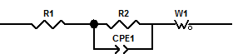
Figure S4. The equivalent circuit model used to fit the EIS data.
Figure S5. (a) Schematic illustration of lithiation/delithiation of PSi@C(N); SEM images of (b) pristine electrode, and (c) PSi@C(N) electrode after 100 cycles at 1000 mA g⁻¹.

Declaration of Interest Statement
The authors declare that they have no known competing financial interests or personal relationships that could have appeared to influence the work reported in this paper.

