Supplementary Materials:

Table S1. Hemolytic activity of Triton X-100, solvent, Cyclosaplin-2A and Cyclosaplin-7G on RBC
RBC+7G  (15 µg/ml) | RBC+2A  (90 µg/ml) | RBC+Triton X-100 | RBC+Solvent
0.463 | 0.466 | 0.771 | 0.454 | Hemolytic activity (Mean)

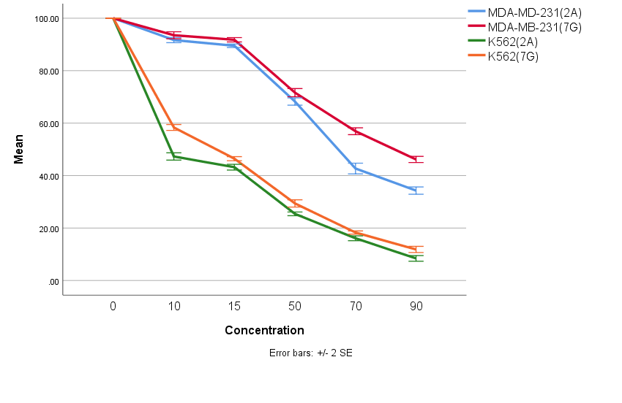
Fig. S1. Mean of cytotoxic activity of Cyclosaplin-2A and Cyclosaplin-7G on MDA-MB-231 and K562 cells. The cell viability of both cancer cells was determined by MTT assay. According to the results of the MTT assay, cell viability decreased with increasing peptide concentration in both peptides.Three independent experiments were performed. Results are given as means ± SEM.
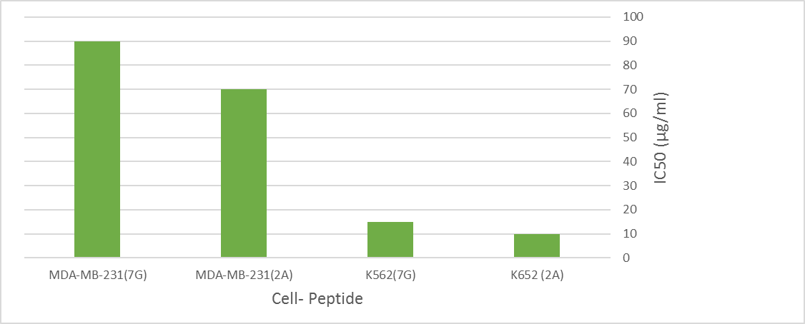
Fig. S2. Cyclosaplin-2A and Cyclosaplin-7G IC₅₀ on MDA-MB-231 and K562 cell lines

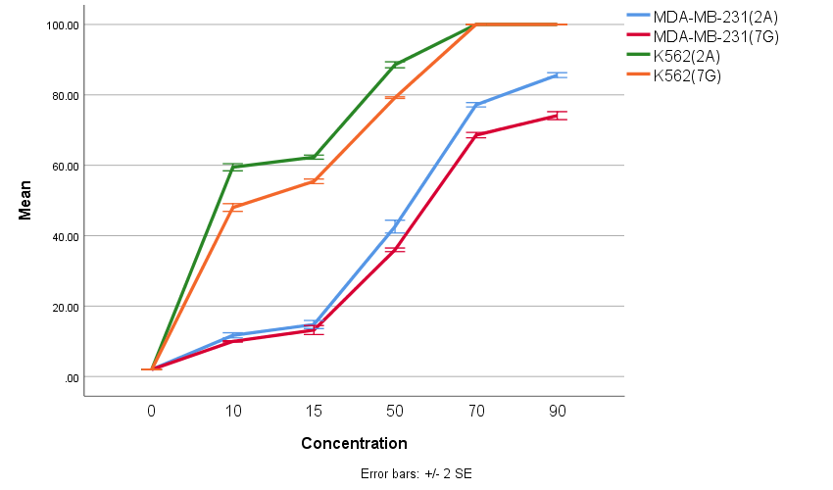Fig. S3. Mean of LDH release in the cell culture medium after exposure of MDA-MB-231 and K562 cells to Cyclosaplin-2A and Cyclosaplin-7G. Increasing the concentration of analogs led to a larger amount of LDH leakage in the LDH assay, according to results.

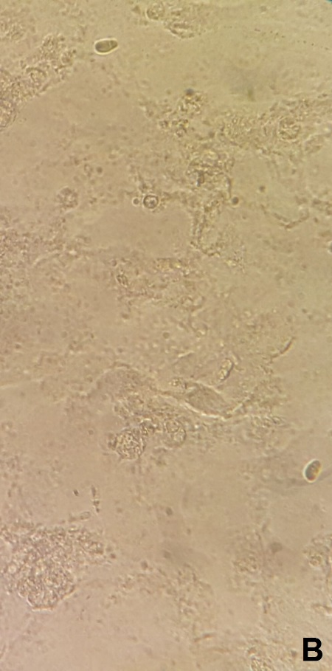
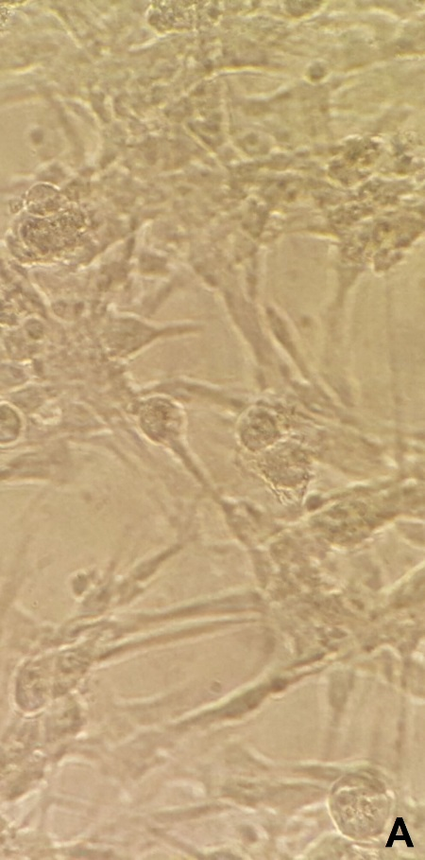
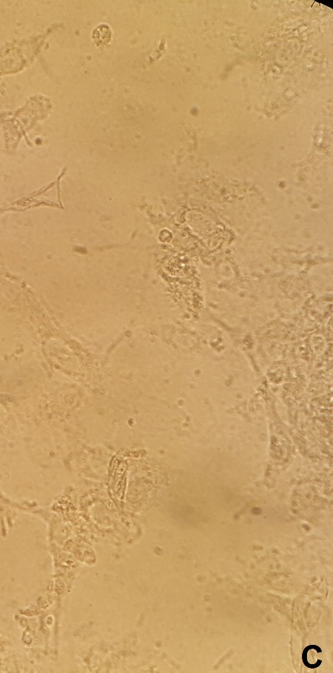

Fig. S4. Morphological changes in MDA-MB-231 observed by inverted microscope (magnification ×100). A) Control Cell line (untreated). B) Treated cells by IC₅₀ concentration of Cyclosaplin-2A. C) Treated cells by IC50 concentration of Cyclosaplin-7G.

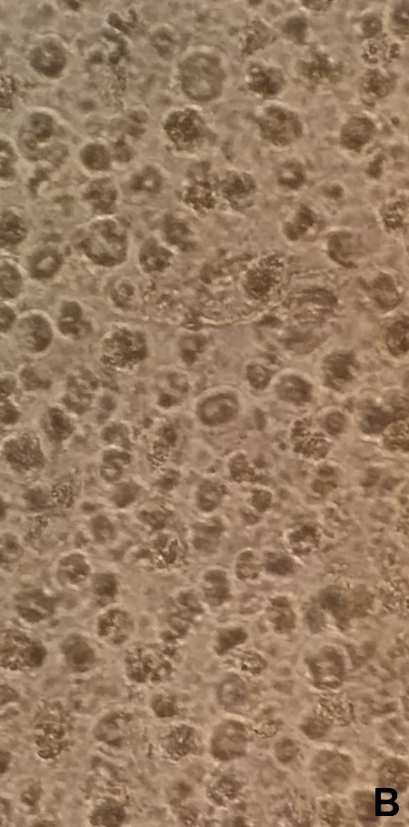
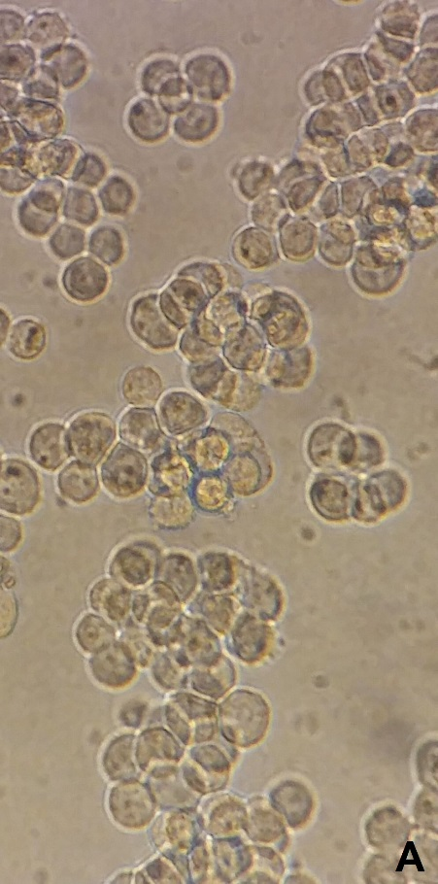
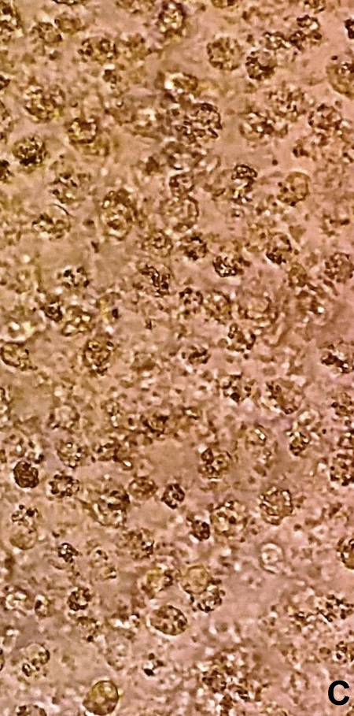
Fig. S5. Morphological changes in K562 observed by inverted microscope (magnification ×100). A) Control Cell line (untreated). B) Treated cells by IC₅₀ concentration of Cyclosaplin-2A. C) Treated cells by IC₅₀ concentration of Cyclosaplin-7G.

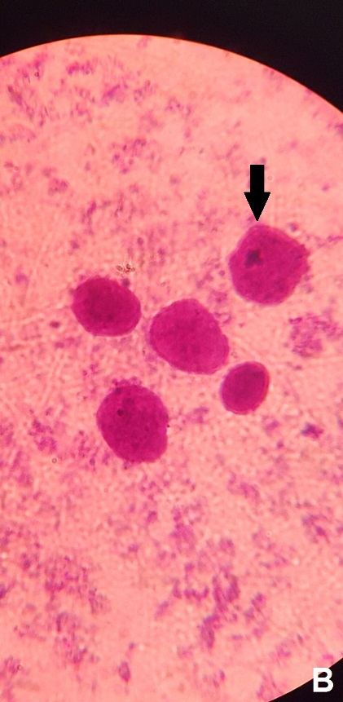
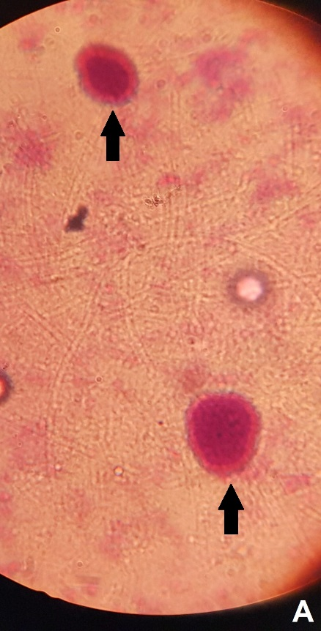
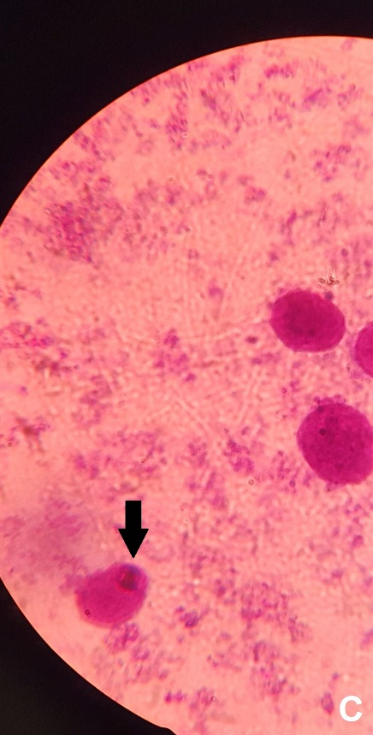
Fig. S6. Giemsa staining in MDA-MB-231 cells observed by light microscope (magnification ×100). A) Control Cell line (untreated). B) Treated cells by IC₅₀ concentration of Cyclosaplin-2A. C) Treated cells by IC₅₀ concentration of Cyclosaplin-7G. The treated cells exhibited distinct differences, such as chromatin condensation, loss of cell size, disrupted membrane integrity, and apoptotic bodies, compared to the controls.

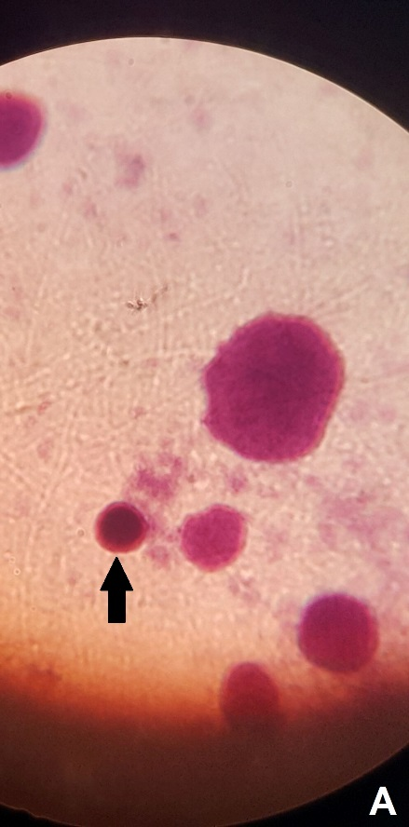
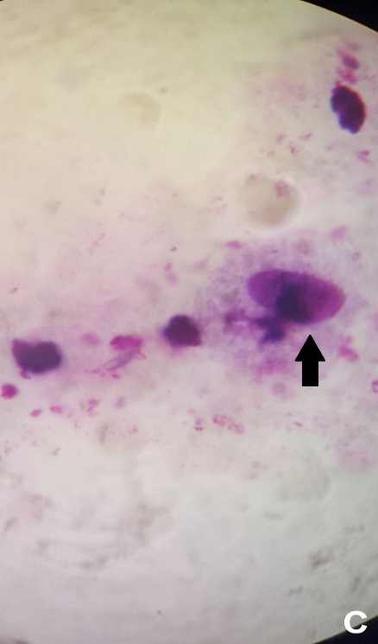
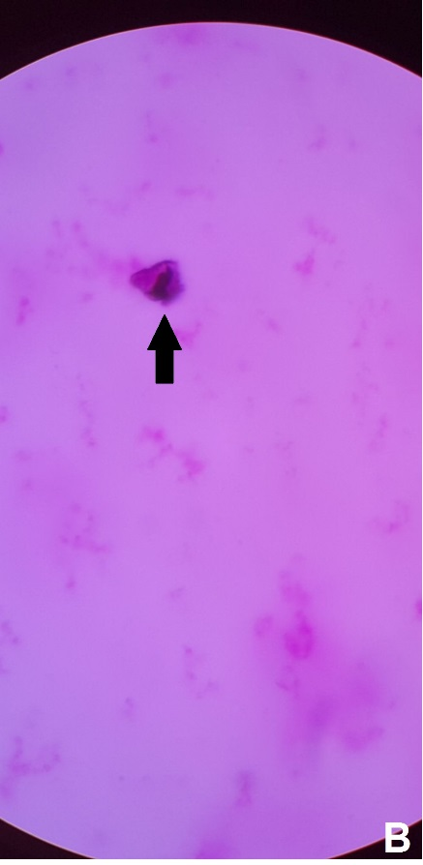
Fig. S7. Giemsa staining in K562 cells observed by light microscope (magnification ×100). A) Control Cell line (untreated). B) Treated cells by IC₅₀ concentration of Cyclosaplin-2A. C) Treated cells by IC₅₀ concentration of Cyclosaplin-7G. These cells also showed distinct differences, such as chromatin condensation, loss of cell size, disrupted membrane integrity, and apoptotic bodies, when compared to controls.

