Supplementary files

Captions

Figure 9: Example for continuous training (CON, upper figure) and interval training (INT, lower figure) micro cycle. Day 1 of the training micro cycle is presented in blue, Day 2 in green, and day 3 in red color. The lag is provided on the x-axis in seconds (s) and treadmill on the y-axis in kilometer per hours (km h⁻¹).

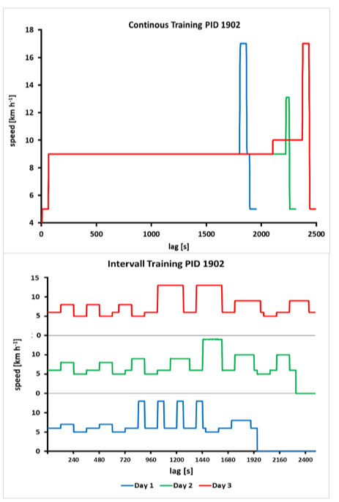
Figure 9: Example for continuous training (CON, upper figure) and interval training (INT, lower figure) micro cycle. Day 1 of the training micro cycle is presented in blue, Day 2 in green, and day 3 in red color. The lag is provided on the x-axis in seconds (s) and treadmill on the y-axis in kilometer per hours (km h⁻¹).

